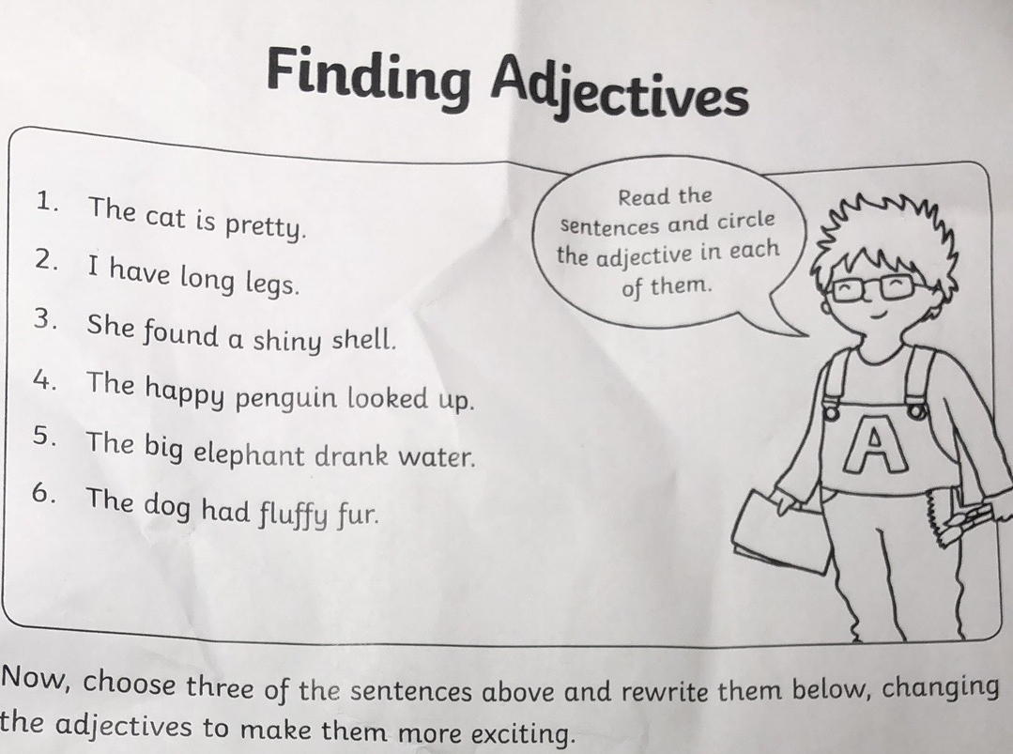

Example：

The cat is beautiful.

-----------------------------------------------------------

-----------------------------------------------------------

-----------------------------------------------------------

-----------------------------------------------------------

-----------------------------------------------------------

-----------------------------------------------------------