**kvm虚拟化学习笔记(七)之kvm虚拟机克隆**

* kvm虚拟机的克隆分为两种情况，本文也就通过以下两种情况进行克隆，克隆虚拟机为OEL5.8X64。

**(1) KVM主机本机虚拟机直接克隆。**

**(2) 通过复制配置文件与磁盘文件的虚拟机复制克隆(适用于异机的静态迁移)。**

**1. 本机虚拟机直接克隆**

**(1) 查看虚拟机配置文件**

[root@node1 ~]# cat /etc/libvirt/qemu/oeltest01.xml

[view source](http://www.it165.net/os/html/201309/6186.html#viewSource)[print](http://www.it165.net/os/html/201309/6186.html#printSource)[?](http://www.it165.net/os/html/201309/6186.html#about)

01.&lt;!--

02.WARNING: THIS IS AN AUTO-GENERATED FILE. CHANGES TO IT ARE LIKELY TO BE

03.OVERWRITTEN AND LOST. Changes to this xml configuration should be made using:

04.virsh edit oeltest01

05.or other application using the libvirt API.

06.--&gt;

07.&lt;domain type='kvm'&gt;

08.&lt;name&gt;oeltest01&lt;/name&gt;

09.&lt;uuid&gt;8f2bb4a7-c7ed-32aa-3676-9fb05923269d&lt;/uuid&gt;

10.&lt;memory unit='KiB'&gt;524288&lt;/memory&gt;

11.&lt;currentMemory unit='KiB'&gt;524288&lt;/currentMemory&gt;

12.&lt;vcpu placement='static'&gt;1&lt;/vcpu&gt;

13.&lt;os&gt;

14.&lt;type arch='x86_64' machine='rhel6.4.0'&gt;hvm&lt;/type&gt;

15.&lt;boot dev='hd'/&gt;

16.&lt;/os&gt;

17.&lt;features&gt;

18.&lt;acpi/&gt;

19.&lt;apic/&gt;

20.&lt;pae/&gt;

21.&lt;/features&gt;

22.&lt;clock offset='utc'/&gt;

23.&lt;on_poweroff&gt;destroy&lt;/on_poweroff&gt;

24.&lt;on_reboot&gt;restart&lt;/on_reboot&gt;

25.&lt;on_crash&gt;restart&lt;/on_crash&gt;

26.&lt;devices&gt;

27.&lt;emulator&gt;/usr/libexec/qemu-kvm&lt;/emulator&gt;

28.&lt;disk type='file' device='disk'&gt;

29.&lt;driver name='qemu' type='raw' cache='none'/&gt;

30.&lt;source file='/data/test01.img'/&gt;

31.&lt;target dev='hda' bus='ide'/&gt;

32.&lt;address type='drive' controller='0' bus='0' target='0' unit='0'/&gt;

33.&lt;/disk&gt;

34.&lt;disk type='block' device='cdrom'&gt;

35.&lt;driver name='qemu' type='raw'/&gt;

36.&lt;target dev='hdc' bus='ide'/&gt;

37.&lt;readonly/&gt;

38.&lt;address type='drive' controller='0' bus='1' target='0' unit='0'/&gt;

39.&lt;/disk&gt;

40.&lt;controller type='usb' index='0'&gt;

41.&lt;address type='pci' domain='0x0000' bus='0x00' slot='0x01' function='0x2'/&gt;

42.&lt;/controller&gt;

43.&lt;controller type='ide' index='0'&gt;

44.&lt;address type='pci' domain='0x0000' bus='0x00' slot='0x01' function='0x1'/&gt;

45.&lt;/controller&gt;

46.&lt;interface type='bridge'&gt;

47.&lt;mac address='52:54:00:82:39:01'/&gt;

48.&lt;source bridge='br0'/&gt;

49.&lt;model type='virtio'/&gt;

50.&lt;address type='pci' domain='0x0000' bus='0x00' slot='0x03' function='0x0'/&gt;

51.&lt;/interface&gt;

52.&lt;serial type='pty'&gt;

53.&lt;target port='0'/&gt;

54.&lt;/serial&gt;

55.&lt;console type='pty'&gt;

56.&lt;target type='serial' port='0'/&gt;

57.&lt;/console&gt;

58.&lt;input type='tablet' bus='usb'/&gt;

59.&lt;input type='mouse' bus='ps2'/&gt;

60.&lt;graphics type='vnc' port='5910' autoport='no' listen='0.0.0.0'&gt;

61.&lt;listen type='address' address='0.0.0.0'/&gt;

62.&lt;/graphics&gt;

63.&lt;video&gt;

64.&lt;model type='cirrus' vram='9216' heads='1'/&gt;

65.&lt;address type='pci' domain='0x0000' bus='0x00' slot='0x02' function='0x0'/&gt;

66.&lt;/video&gt;

67.&lt;memballoon model='virtio'&gt;

68.&lt;address type='pci' domain='0x0000' bus='0x00' slot='0x04' function='0x0'/&gt;

69.&lt;/memballoon&gt;

70.&lt;/devices&gt;

71.&lt;/domain&gt;

**虚拟机磁盘文件: /data/test01.img**

**虚拟机名称：oeltest01**

[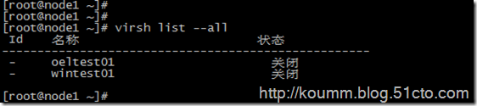](http://www.it165.net/uploadfile/2013/0908/20130908074005766.png)

**(2) 开始克隆**

# virt-clone -o oeltest01 -n oeltest02 -f /data/test02.img

说明：以oeltest01做为源，克隆oeltest01虚拟机，并创建名称为oeltest02虚拟机，使用磁盘文件/data/test02.img

[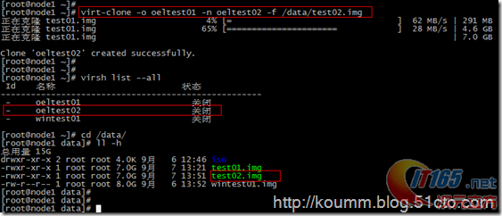](http://www.it165.net/uploadfile/2013/0908/20130908074005322.png)

**(3) 启动虚拟机并配置主机名，IP地址等**

[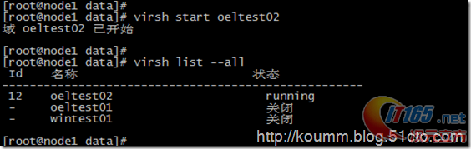](http://www.it165.net/uploadfile/2013/0908/20130908074007191.png)

[root@node1 data]# **virsh console oeltest02**  
kvm控制台配置请见[**kvm虚拟化学习笔记(六)之kvm虚拟机控制台登录配置**](http://www.it165.net/os/html/201309/6185.html)。

[view source](http://www.it165.net/os/html/201309/6186.html#viewSource)[print](http://www.it165.net/os/html/201309/6186.html#printSource)[?](http://www.it165.net/os/html/201309/6186.html#about)

01.连接到域 oeltest02

02.Escape character is ^]

03.Found volume group "vg" using metadata type lvm2

04.2 logical volume(s) in volume group "vg" now active

05.Welcome to Oracle Linux Oracle Linux Server release 5.8

06.Press 'I' to enter interactive startup.

07.Starting udev: [  OK  ]

08.Loading default keymap (us): [  OK  ]

09.Setting hostname test01:  [  OK  ]

10.Setting up Logical Volume Management:   2 logical volume(s) in volume group "vg" now active

11.[  OK  ]

12.Checking filesystems

13.Checking all file systems.

14.[/sbin/fsck.ext3 (1) -- /] fsck.ext3 -a /dev/vg/root

15./dev/vg/root: clean, 135384/1540096 files, 851398/1540096 blocks

16.[/sbin/fsck.ext3 (1) -- /boot] fsck.ext3 -a /dev/hda1

17./boot: clean, 39/26104 files, 26897/104388 blocks

18.[  OK  ]

19.Remounting root filesystem in read-write mode:  [  OK  ]

20.Mounting local filesystems:  [  OK  ]

21.Enabling local filesystem quotas:  [  OK  ]

22.Enabling /etc/fstab swaps:  [  OK  ]

23.INIT: Entering runlevel: 5

24.Entering non-interactive startup

25.Applying Intel CPU microcode update: [  OK  ]

26.Starting background readahead: [  OK  ]

27.Checking for hardware changes [  OK  ]

28.[  OK  ] iSCSI daemon: [  OK  ]

29.[  OK  ]

30.Bringing up loopback interface:  [  OK  ]

31.Bringing up interface eth0:

32.Determining IP information for eth0... done.

33.[  OK  ]

34.Starting auditd: [  OK  ]

35.Starting system logger: [  OK  ]

36.Starting kernel logger: [  OK  ]

37.Starting irqbalance: [  OK  ]

38.iscsid (pid  1555) is running...

39.Setting up iSCSI targets: iscsiadm: No records found

40.[  OK  ]

41.Starting portmap: [  OK  ]

42.Starting NFS statd: [  OK  ]

43.Starting RPC idmapd: [  OK  ]

44.Starting system message bus: [  OK  ]

45.Starting o2cb:  [  OK  ]

46.[  OK  ] Bluetooth services:[  OK  ]

47.Mounting other filesystems:  [  OK  ]

48.Starting PC/SC smart card daemon (pcscd): [  OK  ]

49.Starting acpi daemon: [  OK  ]

50.Starting HAL daemon: [  OK  ]

51.Starting hidd: [  OK  ]

52.Starting monitoring for VG vg:   2 logical volume(s) in volume group "vg" monitored

53.[  OK  ]

54.Starting autofs:  Loading autofs4: [  OK  ]

55.Starting automount: [  OK  ]

56.[  OK  ]

57.Starting hpiod: [  OK  ]

58.Starting hpssd: [  OK  ]

59.Starting sshd: [  OK  ]

60.Starting cups: [  OK  ]

61.Starting xinetd: [  OK  ]

62.Starting console mouse services: [  OK  ]

63.Starting crond: [  OK  ]

64.Starting xfs: [  OK  ]

65.Starting anacron: [  OK  ]

66.[  OK  ] atd: [  OK  ]

67.Starting background readahead: [  OK  ]

68.Starting yum-updatesd: [  OK  ]

69.Starting Avahi daemon... [  OK  ]

70.Starting smartd: hdc: drive_cmd: status=0x41 { DriveReady Error }

71.hdc: drive_cmd: error=0x04 { AbortedCommand }

72.ide: failed opcode was: 0xec

73.[  OK  ]

74.Oracle Linux Server release 5.8

75.Kernel 2.6.18-308.el5 on an x86_64

76.test01 login: mtrr: type mismatch for f0000000,100000 old: uncachable new: write-combining

77.mtrr: type mismatch for f0000000,400000 old: uncachable new: write-combining

78.Oracle Linux Server release 5.8

79.Kernel 2.6.18-308.el5 on an x86_64

80.test01 login:

81.Oracle Linux Server release 5.8

82.Kernel 2.6.18-308.el5 on an x86_64

83.test01 login: root

84.Password:

85.Last login: Sat Sep  7 05:21:11 on ttyS0

86.[root@test01 ~]#

87.[root@test01 ~]#

88.[root@test01 ~]#

**(4) 修改主机名，IP地址等**

# **vi /etc/hosts**

# Do not remove the following line, or various programs  
# that require network functionality will fail.  
127.0.0.1 **test02** localhost.localdomain localhost  
::1 localhost6.localdomain6 localhost6

# **vi /etc/sysconfig/network**

NETWORKING=yes  
NETWORKING_IPV6=no  
HOSTNAME=**test02**   
GATEWAY=192.168.233.2

**修改IP地址**

**# vi /etc/sysconfig/network-script/ifcfg-eth0**

# Virtio Network Device  
DEVICE=eth0  
BOOTPROTO=static  
ONBOOT=yes  
HWADDR=52:54:00:56:bd:2b  
IPADDR=192.168.233.142  
NETMASK=255.255.255.0

[root@test01 ~]# **service network restart**  
Shutting down interface eth0: [ OK ]  
Shutting down loopback interface: [ OK ]  
Bringing up loopback interface: [ OK ]  
Bringing up interface eth0: [ OK ]  
[root@test01 ~]#

**2. 复制配置文件与磁盘文件克隆**

**(1) 导入kvm虚拟机配置文件**

这里采用oeltest01做为模板，进行克隆。

# virsh shutdown oeltest01

[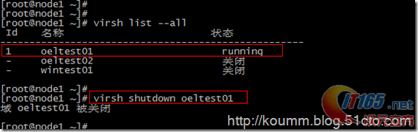](http://www.it165.net/uploadfile/2013/0908/20130908074008532.png)

# virsh dumpxml oeltest01 > /etc/libvirt/qemu/oeltest03.xml

[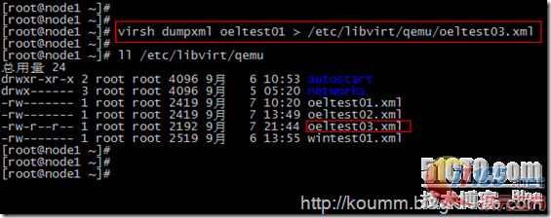](http://www.it165.net/uploadfile/2013/0908/20130908074009116.png)

**(2) 复制kvm虚拟机磁盘文件**

本系列文章都是采用虚拟磁盘文件进行测试，没有使用lvm卷。

**通过查看配置文件：虚拟磁盘位置<source file='/data/test01.img'/>**

[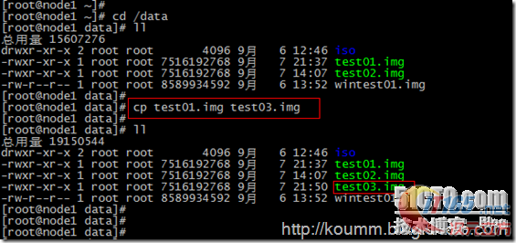](http://www.it165.net/uploadfile/2013/0908/20130908074010987.png)

**(3) 直接编辑修改配置文件**

**修改name,uuid,disk位置,vnc端口**

**此时还是将该配置文件注册进来，无法通过virsh edit进行编辑。**

[root@node1 data]# vi /etc/libvirt/qemu/oeltest03.xml

[view source](http://www.it165.net/os/html/201309/6186.html#viewSource)[print](http://www.it165.net/os/html/201309/6186.html#printSource)[?](http://www.it165.net/os/html/201309/6186.html#about)

01.<domain type='kvm'>

02.  <name>oeltest03</name>

03.  <uuid>8f2bb4a7-c7ed-32aa-3676-9fb05923260d</uuid>

04.  <memory unit='KiB'>524288</memory>

05.  <currentMemory unit='KiB'>524288</currentMemory>

06.  <vcpu placement='static'>1</vcpu>

07.  <os>

08.    <type arch='x86_64' machine='rhel6.4.0'>hvm</type>

09.    <boot dev='hd'/>

10.  </os>

11.  <features>

12.    <acpi/>

13.    <apic/>

14.    <pae/>

15.  </features>

16.  <clock offset='utc'/>

17.  <on_poweroff>destroy</on_poweroff>

18.  <on_reboot>restart</on_reboot>

19.  <on_crash>restart</on_crash>

20.  <devices>

21.    <emulator>/usr/libexec/qemu-kvm</emulator>

22.    <disk type='file' device='disk'>

23.      <driver name='qemu' type='raw' cache='none'/>

24.      <source file='/data/test03.img'/>

25.      <target dev='hda' bus='ide'/>

26.      <address type='drive' controller='0' bus='0' target='0' unit='0'/>

27.    </disk>

28.    <disk type='block' device='cdrom'>

29.      <driver name='qemu' type='raw'/>

30.      <target dev='hdc' bus='ide'/>

31.      <readonly/>

32.      <address type='drive' controller='0' bus='1' target='0' unit='0'/>

33.    </disk>

34.    <controller type='usb' index='0'>

35.      <address type='pci' domain='0x0000' bus='0x00' slot='0x01' function='0x2'/>

36.    </controller>

37.    <controller type='ide' index='0'>

38.      <address type='pci' domain='0x0000' bus='0x00' slot='0x01' function='0x1'/>

39.    </controller>

40.    <interface type='bridge'>

41.      <mac address='52:54:00:82:39:01'/>

42.      <source bridge='br0'/>

43.      <model type='virtio'/>

44.      <address type='pci' domain='0x0000' bus='0x00' slot='0x03' function='0x0'/>

45.    </interface>

46.    <serial type='pty'>

47.      <target port='0'/>

48.    </serial>

49.    <console type='pty'>

50.      <target type='serial' port='0'/>

51.    </console>

52.    <input type='tablet' bus='usb'/>

53.    <input type='mouse' bus='ps2'/>

54.    <graphics type='vnc' port='5911' autoport='no' listen='0.0.0.0'>

55.      <listen type='address' address='0.0.0.0'/>

56.    </graphics>

57.    <video>

58.      <model type='cirrus' vram='9216' heads='1'/>

59.      <address type='pci' domain='0x0000' bus='0x00' slot='0x02' function='0x0'/>

60.    </video>

61.    <memballoon model='virtio'>

62.      <address type='pci' domain='0x0000' bus='0x00' slot='0x04' function='0x0'/>

63.    </memballoon>

64.  </devices>

65.</domain>

**(4) 定义新虚拟机配置文件**

[root@node1 data]# virsh define /etc/libvirt/qemu/oeltest03.xml

[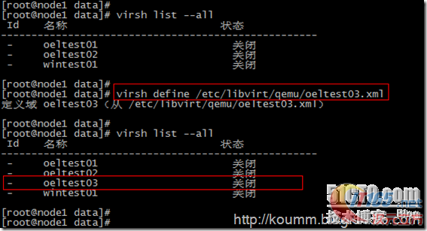](http://www.it165.net/uploadfile/2013/0908/20130908074011427.png)

**启动虚拟机**

[root@node1 data]# virsh start oeltest03  
域 oeltest03 已开始

**(5) 登录虚拟机进行主机名，IP等修改**

[root@node1 data]# virsh console oeltest03  
连接到域 oeltest03  
Escape character is ^]

Oracle [Linux](http://www.it165.net/os/oslin/) Server release 5.8  
Kernel 2.6.18-308.el5 on an x86_64

test01 login: mtrr: type mismatch for f0000000,100000 old: uncachable new: write-combining  
mtrr: type mismatch for f0000000,400000 old: uncachable new: write-combining

Oracle [Linux](http://www.it165.net/os/oslin/) Server release 5.8  
Kernel 2.6.18-308.el5 on an x86_64

test01 login: root  
Pass[word](http://www.it165.net/edu/ebg/):  
Last login: Sat Sep 7 05:21:11 on ttyS0

[root@test01 ~]#  
[root@test01 ~]#

**修改主机名**

# **vi /etc/hosts**

# Do not remove the following line, or various programs  
# that require network functionality will fail.  
127.0.0.1 **test03** localhost.localdomain localhost  
::1 localhost6.localdomain6 localhost6

# **vi /etc/sysconfig/network**

NETWORKING=yes  
NETWORKING_IPV6=no  
HOSTNAME=**test03**   
GATEWAY=192.168.233.2

**修改IP地址**

**# vi /etc/sysconfig/network-script/ifcfg-eth0**

# Virtio Network Device  
DEVICE=eth0  
BOOTPROTO=static  
ONBOOT=yes  
HWADDR=52:54:00:56:bd:3b  
IPADDR=192.168.233.143  
NETMASK=255.255.255.0

**service network restart**  
Shutting down interface eth0: [ OK ]  
Shutting down loopback interface: [ OK ]  
Bringing up loopback interface: [ OK ]  
Bringing up interface eth0: [ OK ]  
本文到此通过两种方式进行kvm虚拟机克隆，其实各有用处。

再次说明：本文克隆的虚拟机是oel5.8,如果克隆的虚拟机是RHEL/CentOS/OEL6.x操作系统，还需要修改/etc/udev/rules.d/70-persistent-net.rules文件。