京东、腾讯答题

绿盟科技 https://app.mokahr.com/campus_apply/nsfocus/29118#/
亚信科技2024
https://xyz.51job.com/External/MyResume/ResumeEnd.aspx?ctmid=5cefea63-843f-4cb4-89de-f334f285a446&css=%2f%2fimg03.51jobcdn.com%2fehireplus%2f2022%2fstyle%2fehireplus2009%2fnewcp1_1%2finc%2f&CtmName=%e4%ba%9a%e4%bf%a1%e7%a7%91%e6%8a%802024&resumeid=0032b410
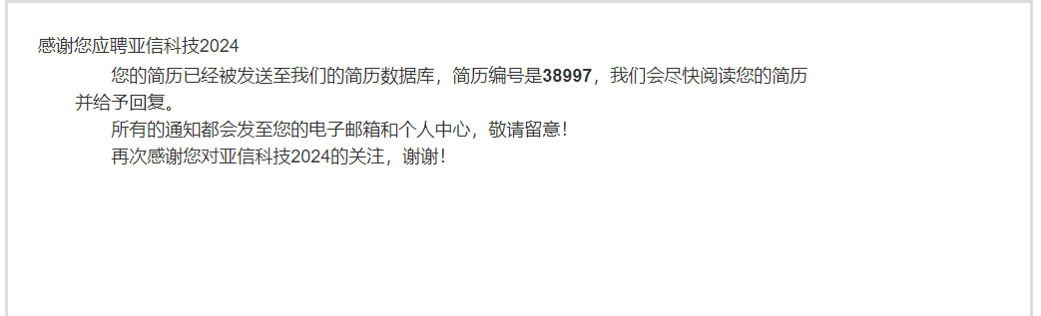

安恒信息 culybk 牛客
https://ahzp.dbappsecurity.com.cn/SU62650bb00dcad47b9fd43f04/pb/account.html#/myDeliver
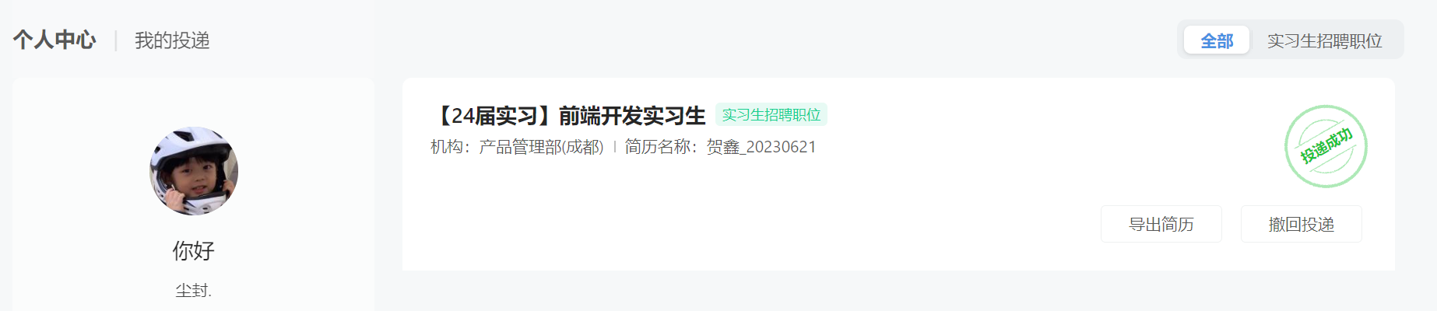

快手科技 https://zhaopin.kuaishou.cn/recruit/e/#/official/my-apply/
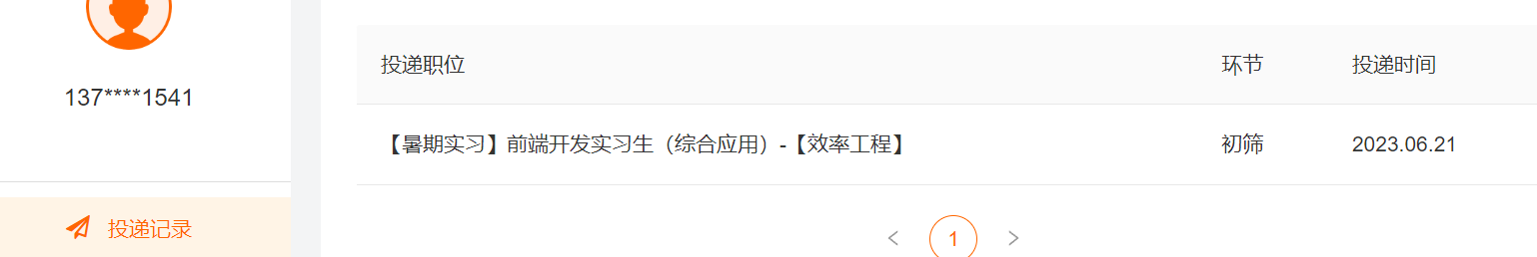

腾讯子公司云智研发公司 NTAAd3T
https://app-tc.mokahr.com/campus-recruitment/csig/20001#/job/b755bdfb-e09a-4961-bd40-1228d0ba2c89/campus_apply/thanks?jobId=b755bdfb-e09a-4961-bd40-1228d0ba2c89&recommendCode=NTAAd3T&codeType=1&applyInfo%5BaimWorkCity%5D=%E8%A5%BF%E5%AE%89%E5%B8%82&applyIn
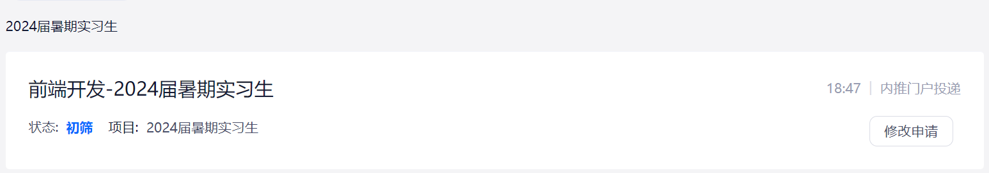

未来校招
https://www.weilaixiaozhao.com/#/job/detail?id=10371
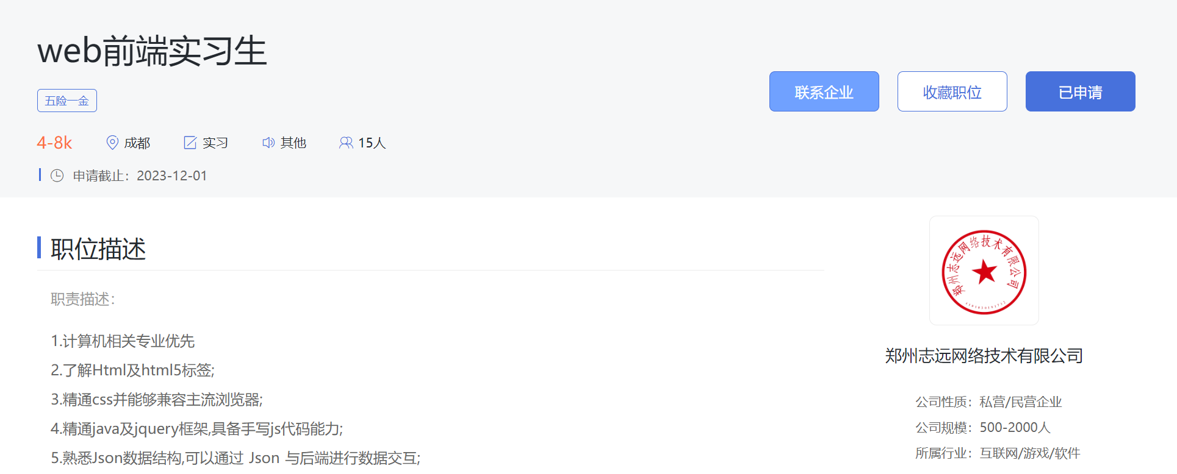

JD https://campus.jd.com/#/myDeliver?type=present
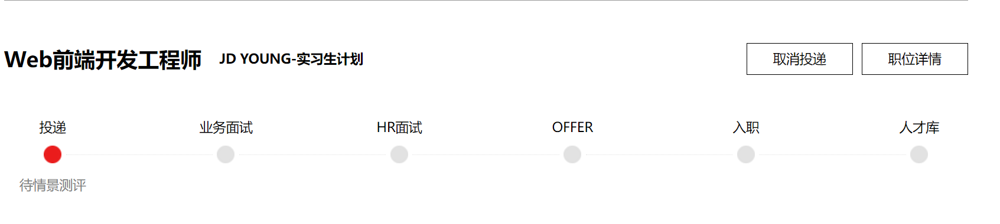

字节 V6T75AW
https://jobs.bytedance.com/campus/position/application

腾讯校招 https://join.qq.com/progress.html

科大讯飞 U6X6761
小米
邮箱发了一份
B站
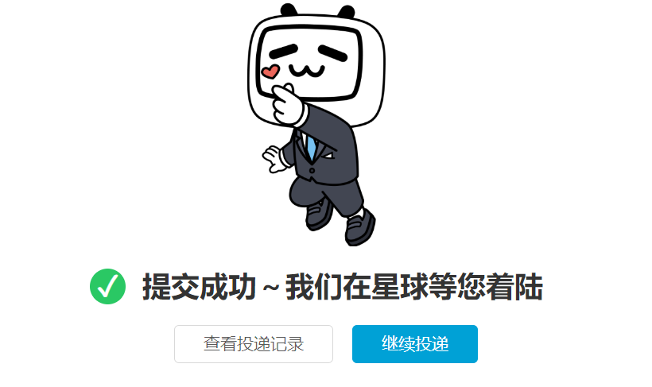

东方财富
https://zhaopin.eastmoney.com/campus-recruitment/eastmoney/57971#/candidateHome/applications
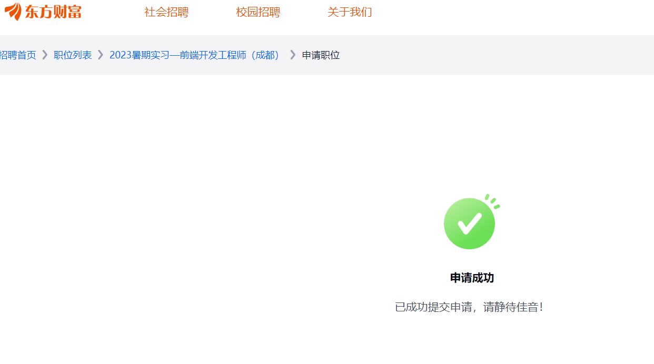

早鸟计划 https://talent.alibaba.com/personal/social-application?lang=zh

中国平安 已投
https://campus.pingan.com/securities/positionDetail?positionId=70b52cab5221309eae5c02e2252fa3cf

北森

