**Developer Guide: SwarmBot**

**A project by**

**Charlie Wu,** [**chw357@ucsd.edu**](mailto:chw357@ucsd.edu) **[team lead]**

**Wesley Xiao,** [**wex057@ucsd.edu**](mailto:wex057@ucsd.edu) **[software]**

**Carl Villegas,** [**cavilleg@ucsd.edu**](mailto:cavilleg@ucsd.edu) **[hardware design]**

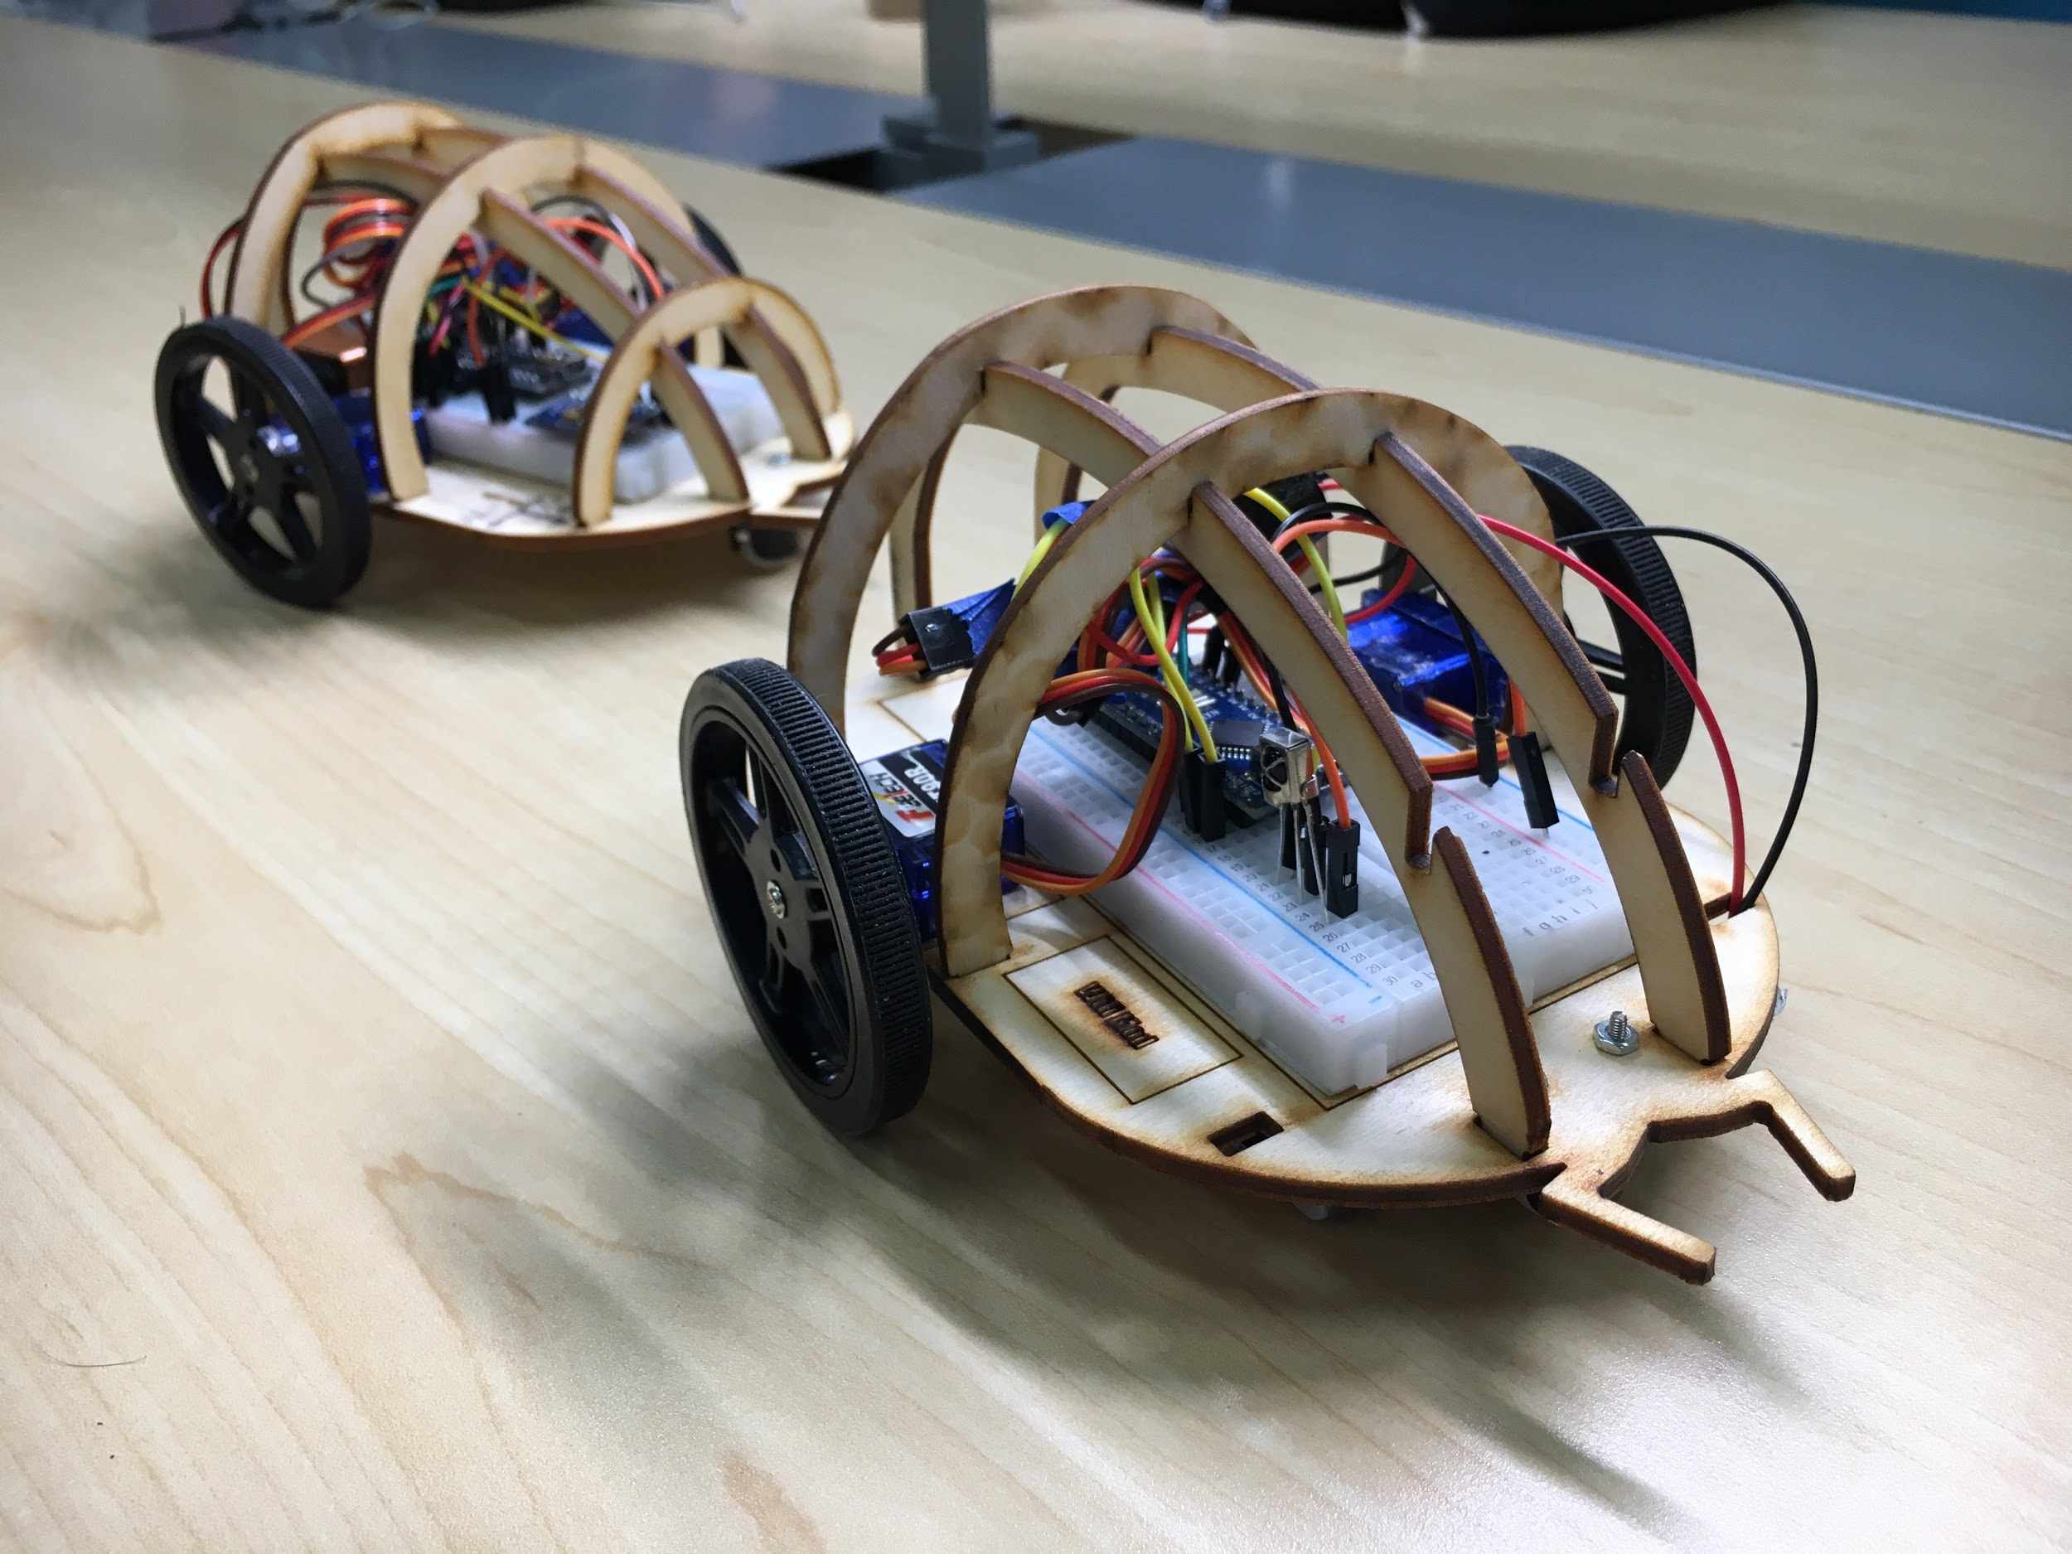

# **Table of Content**

**Introduction** **2**

**Hardware** **3**

**Navigate Google Drive** **3**

**Assembly and Code** **4**

Leader Robot 4

1. Connect two servos 4

2. Connect IR receiver 4

3. Decode signal from IR remote 5

4. Example code 5

5. Attach magnet 6

6. Connect battery 6

Follower Robot 7

1. Connect two servos 7

2. Connect magnetometer 7

3. How it works? 7

4. To Be Continued 7

# 

# 

# **Introduction**

The idea of this project is to build two robots that can follow each other. Scheme is simple:

1. Leader robot can be controlled via IR remote.
2. Follower robot will follow the leader robot.

# 

# **Hardware**

* Arduino Nano
* Servo + Wheels → allow robots to move around
* Caster Ball ½” → support the robot
* IR Remote
* IR Receiver
* MPU-9250 3-Axis Accelerometer, Gyro, & Magnetometer → location tracking
  + We only use the magnetometer. At least for now.
  + Magnetometer measures magnetic field (intensity, direction)
  + This sensor is installed on **follower robot**. It tracks the location of leader robot
* Breadboard
* Magnet → This is only installed on **leader robot**. It allows follower robot

to track leader robot’s location using magnetometer.

For more details. Visit [**Parts List**](https://docs.google.com/spreadsheets/d/1NqEvrNKO_gMEPasWNwXx2zeLknJX9tPNbHTAOnMAJZo/edit?usp=sharing)**.**

# **Assembly and Code**

## **Leader Robot**

### **1. Connect two servos**

Example code us pin 10 and 11.

### **2. Connect IR receiver**

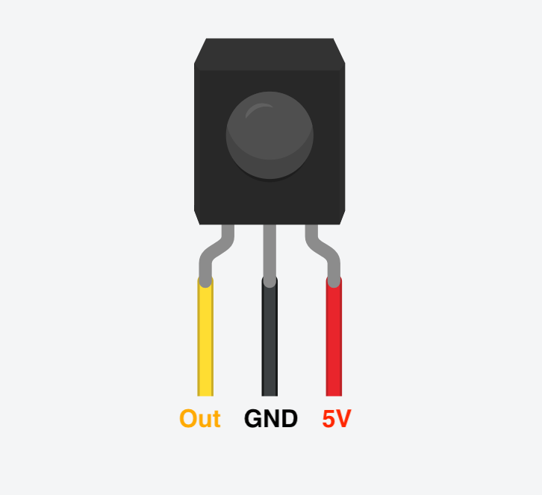

Out → Any digital pin. Example code use pin 12.

### 

### **3. Decode signal from IR remote**

You need to decode signal from IR remote because arduino needs to know what command (in the form of he1x code) it will receive if a particular button is pressed. Upload [**this**](https://drive.google.com/open?id=1AXYjp2VjIomgsrT9obVaNcW725ZbAg6O) code to arduino and press up (forward), down (backward), left, right, and ok button (stop). Record the hex code for above five buttons.

You will get something like this. **Note** hex code might vary depending on model and manufacturer of the IR remote.

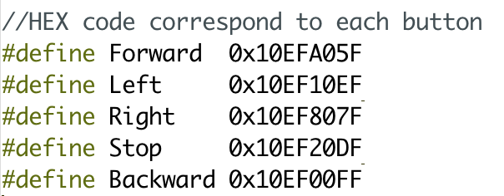

### **4. Example code**

[**This**](https://drive.google.com/open?id=1gZRHQ2_GfLfcMuxNQJJNoBGQa_A_u39-) code allows you to control the leader robot with IR remote. You might need to update the hex code for each button if yours are different. 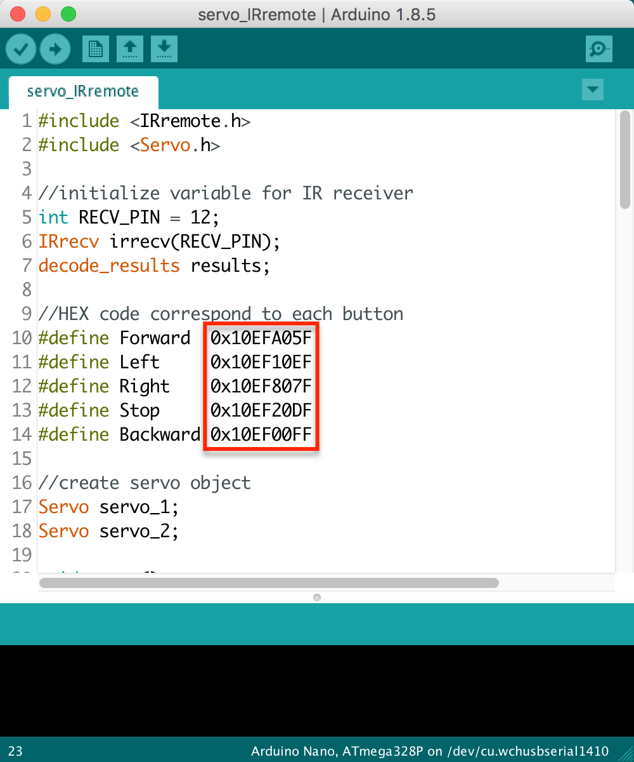

### **5. Attach magnet**

Make sure the **north** pole of magnet is pointing away from the robot itself. Sensor will have different readings if polarity of magnet is reversed. 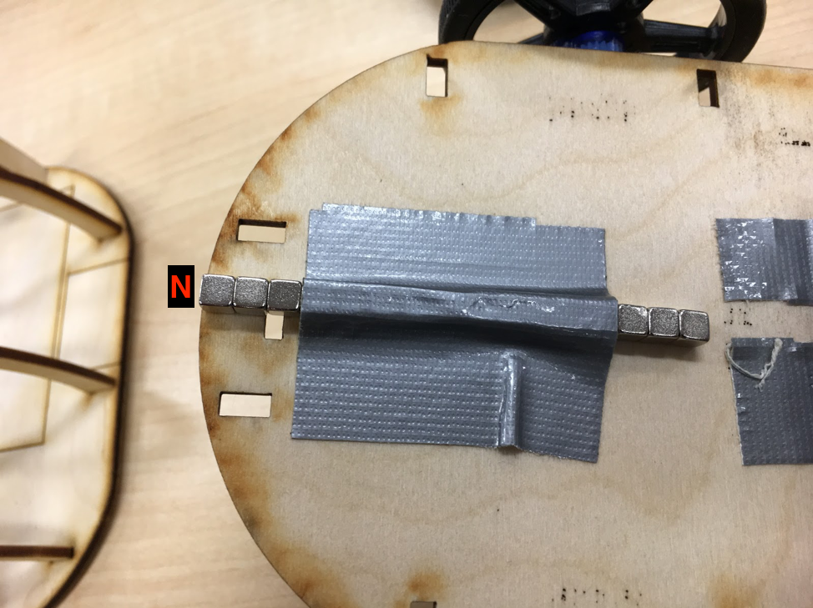

### **6. Connect battery**

Positive (**red**) → VIN

Negative (**black**) → GND

## **Follower Robot**

### **1. Connect two servos**

Same as the**leader robot****.**

### **2. Connect magnetometer**

See instructions[**here**](https://docs.google.com/document/d/1IYGILpsgvbroK8GGHBjo8NjsGsv3-QTXstASRPQ_MX0/edit?usp=sharing)**.**

### **3. How it works?**

Check out [**this**](https://drive.google.com/file/d/15Zu0gopNMs2UIob8NH0R6qpCf3xnDXz-/view?usp=sharing)demo video. As the leader robot moves, you can see the change of reading on follower robot.

* Absolute value of reading tells distance
  + Leader robot is further → absolute value of reading gets **smaller**
  + Leader robot is cloer → absolute value of reading gets **larger**
* Sign of Y reading tells direction
  + Leader robot moving left → Y is **negative**
  + Leader robot moving right → Y is **positive**