**How to use**

**MPU9250**

**3-Axis Accelerometer, Gyro, & Magnetometer (fancy compass)**

1. Install Library

2. Wiring

3. Upload sample code

4. Orientation of Axes for Magnetometer (3 axes fancy compass)

# **1. Install Library**

**Go to sketch→ Manage Libraries**

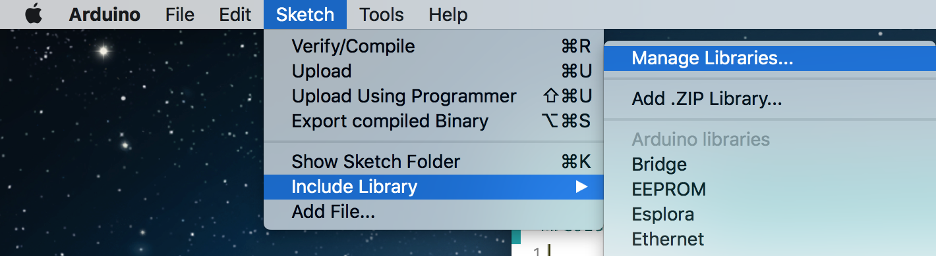

**Search for MPU9250**

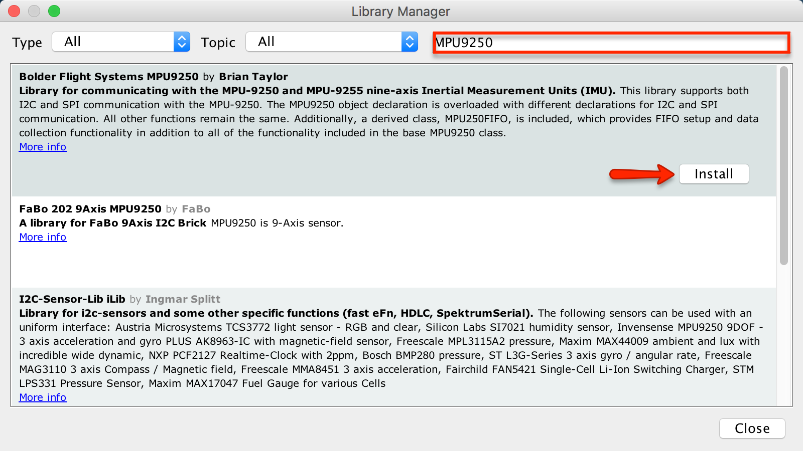

# **2. Wiring**

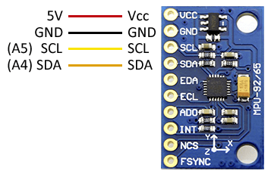

# 

# 

# 

# 

# 

# 

# 

# 

# 

# 

# 

# 

# 

# **3. Upload sample code**

**Use sample code from this website** [**http://robojax.com/learn/arduino/?vid=robojax-MPU9250**](http://robojax.com/learn/arduino/?vid=robojax-MPU9250)

**It’s also in the google drive→ software→** [**MPU9250_demo**](https://drive.google.com/file/d/17B_PLvefqjMnydQRSjd7fMmn04P0QMeY/view?usp=sharing)

# **4. Orientation of Axes for Magnetometer (3 axes fancy compass)**

