Analysing IoT Protocol Implementation

based on Fuzzing

Fengyu Chen. Author
School of Information Technology and Electrical Engineering
The University of Queensland, Qld., 4072, Australia

Abstract

As IoT becomes popular in many domains, security of IoT protocol has become an important research topic. IoT protocols include application-layer protocols like CoAP and MQTT, and communication-layer protocols like Bluetooth and Zigbee. These protocols may be implemented differently by various manufacturers, who may realize their own requirements in the implementations. Nonetheless, failing to follow the protocols’ official specifications may introduce bugs and potential security problems. In this project, our goal is to analyze IoT protocol implementations using a fuzzing framework.

Fuzzing has shown its effectiveness in analysing binaries, OS kernels, and many other programs, but has not been widely used in analysing IoT protocols, due to some non-trivial IoT-specific challenges. Our fuzzing framework is proposed to bridge this gap. We take discrepancies and rules from RFCs as the oracles of our testing to address the ineffectiveness of crash-based oracle that current fuzzing techniques heavily rely on. We have applied our methodology to analyse several implementations of MQTT.

1 Introduction
Paragraph text is in 10 point Roman with an additional 2 points of line spacing, fully justified. The section headings are 12 point bold. Leave one blank line before and one blank line after the heading but leave two blank lines between the end of the abstract and the first heading.

2 Literature Review
The conference paper should be formatted for A4 size paper. A4 measures 210mm wide by 297mm high. Each paper should be no longer than the maximum number of pages specified and no shorter than one page less than this.
The left and right margins will be 25 mm. The top and bottom margins are 30 mm. There will be a header on every page, except the first page, which contains the title of the paper. You will need to add this header to your document. The page number is centered at the bottom of each page.

3 Motivation and Problem Statement
The body of the paper is printed in two columns with a space between columns of 7 mm. The resulting columns will be 7.64 cm wide.
Where footnotes have to be inserted, they must run across the entire bottom of the page. On the final page, the two columns should be balanced in length.
To give a balanced indent to paragraphs, the first tab stop should be set to 5 mm.

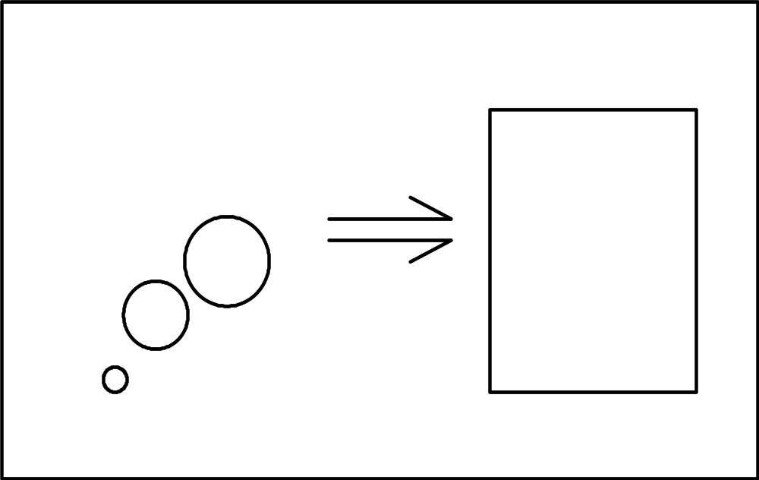
Fig 1. Meaningful diagram (10 pt itl Times New Roman)

4 Methodology
Figures can be fitted within the columns (see Fig. 1) or, if necessary, they can spread across the full page but keep the text to the two-column format. It is best to place a full-width graphic at the top or the bottom of the page to avoid visual confusion with broken columns – as shown in Fig. 2.
Captions are in 10-point Times New Roman. Use italics to emphasis these captions.
Any images must be included as part of the file. Carefully consider the size of lines and fonts used in diagrams and plots to ensure they remain clear in the final copy. When selecting colour images or using colour in diagrams and plots, give some thought to legibility and clarity were the paper to be printed in black-and-white.

5 Experiments
A reference is made with a number in square brackets [1]. If the reference is important to the discussion—say, you intend to spend most of the paragraph discussing it—then you should use the author names as well. For instance, Shannon [5] was the first to show that a noisy channel can be used to communicate information at a non-zero rate without error. Wolniansky et al.[6] advanced the start of the art significantly when they described the V-BLAST scheme for wireless MIMO communications…

6 Results and Discussion
A reference is made with a number in square brackets [1]. If the reference is important to the discussion—say, you intend to spend most of the paragraph discussing it—then you should use the author names as well. For instance, Shannon [5] was the first to show that a noisy channel can be used to communicate information at a non-zero rate without error. Wolniansky et al.[6] advanced the start of the art significantly when they described the V-BLAST scheme for wireless MIMO communications…

7 Conclusion
A reference is made with a number in square brackets [1]. If the reference is important to the discussion—say, you intend to spend most of the paragraph discussing it—then you should use the author names as well. For instance, Shannon [5] was the first to show that a noisy channel can be used to communicate information at a non-zero rate without error. Wolniansky et al.[6] advanced the start of the art significantly when they described the V-BLAST scheme for wireless MIMO communications…

Acknowledgment
You may wish to add an acknowledgment before the references.
The references should be typed in 10 point text after a 12 point bold heading.

References
- A. B. Smith, C. D. Jones, and E. F. Roberts, “Article title,” Journal, vol. 1, no. 1, pp. 1-10, Date.
- C. D. Jones, A.B. Smith, and E.F. Roberts, Book Title, Publisher, Location, Date.
- C. D. Jones, A. B. Smith, and E. F. Roberts, “Article title,” in Proceedings Title. IEEE, 2003, vol. II, pp. 803–806.
- Gene H. Golub and Charles F. Van Loan, Matrix Computations, Johns-Hopkins University Press, 3rd ed., 1996.
- Claude E. Shannon, “A mathematical theory of communication,” Bell Syst. Tech. J., vol. 27, pp. 379–423, 623–656, Jul./Oct. 1948.
- P. W. Wolniansky, G. J. Foschini, G. D. Golden, and R. A. Valenzuela, “V-BLAST: An architecture for realizing very high data rates over the rich-scattering wireless channel,” in Proc. URSI Internat. Sympos. Signals Syst. Electronics, pp. 295–300, Sept. 1998.
- Motorola, Inc.: DSP56002 Users Manual, 1993.

Biography
You should add a biography after all other material. The biography should focus on your professional accomplishments and interests, although can add some personal notes as well. Please keep it to less than 100 words.

Fig 2. Further and deeper thoughts (10 pt italic Times New Roman)

