**Problem # 1(b)**

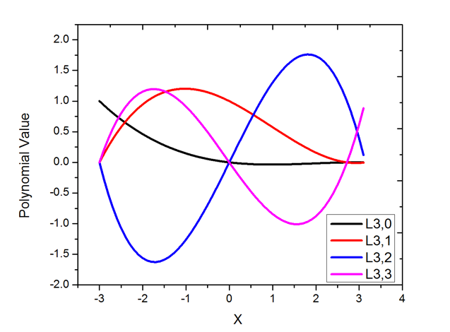

**Problem #2(b)**

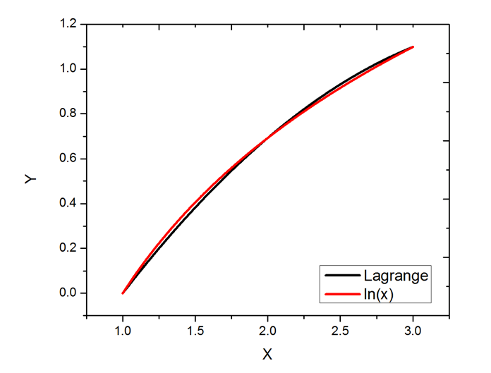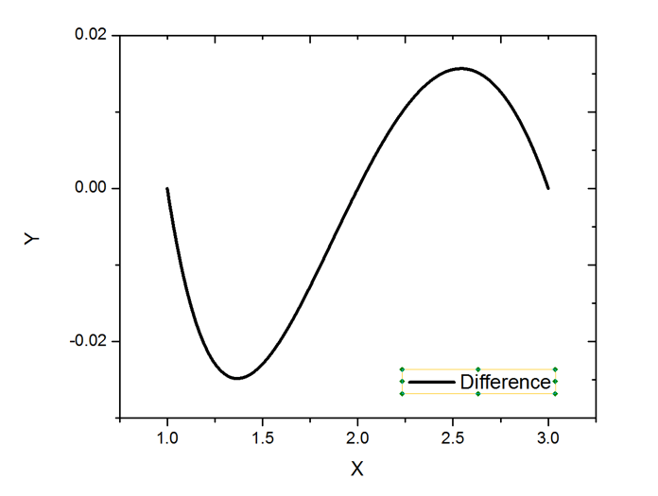

**Problem #5**

The C code for this problem:

#include <iostream>

using namespace std;

int main( ) {

double tx[] = {0.005, 0.01, 0.02, 0.05, 0.1, 0.2, 0.5, 1.0, 2.0 };

double ty[] = {0.924, 0.896, 0.859, 0.794, 0.732, 0.656, 0.536, 0.43, 0.316};

int len = 9 ;

// Initiate a matrix;

double M[len][len];

for(int i=0; i<len; ++i) {

for (int j=0; j<len; ++j) {

M[i][j] = 0;

}

}

for(int i=0; i<len; ++i) {

M[i][0] = ty[i];

}

//double inter = 0.032;

double inter = 1.682;

for (int i = 1; i < len; i++) {

for (int j = 1; j <= i; j++) {

M[i][j] = ((inter - tx[i-j])*(M[i][j-1])

- (inter - tx[i])*(M[i-1][j-1]))/(tx[i] - tx[i - j]);

}

}

cout << M[8][8] << endl;

return 0;

}

Results:

F(x=0.032) = 0.83067

F(x=1.682) = -216712

**Problem # 7**

T Surface Tension

5 489.573

10 488.55

15 487.527

20 486.503

25 485.48

30 484.456

35 483.432

40 482.408

45 481.384

50 480.36

55 479.335

60 478.311

65 477.287

70 476.264

75 475.241

80 474.219

85 473.198

90 472.177

95 471.158

100 470.141

Given data:

10 488.55 0

25 485.48 0

50 480.36 0

75 475.23 -0.011

100 470.11 -0.031

