HW08

Problem#1

(b)

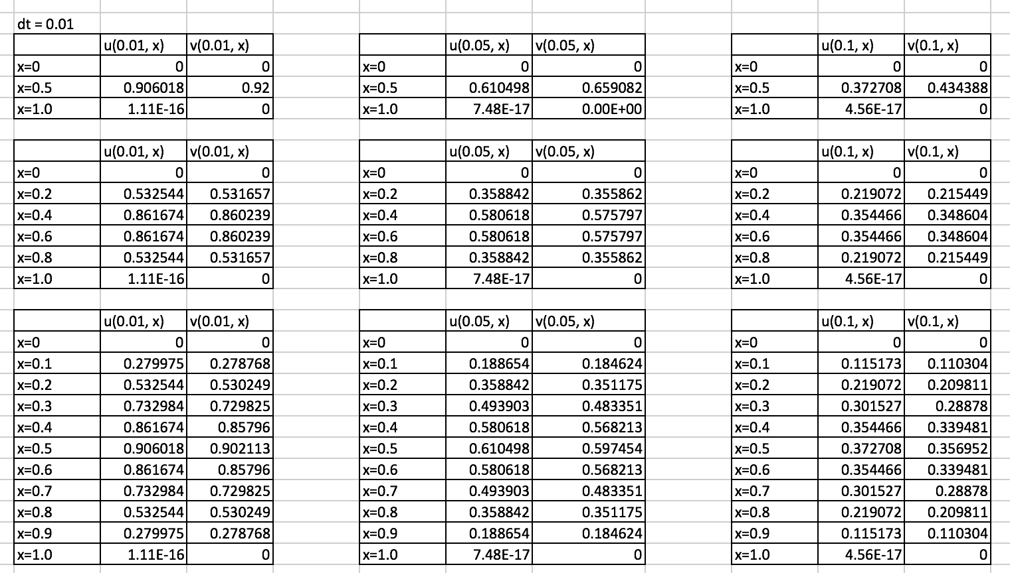

(c)

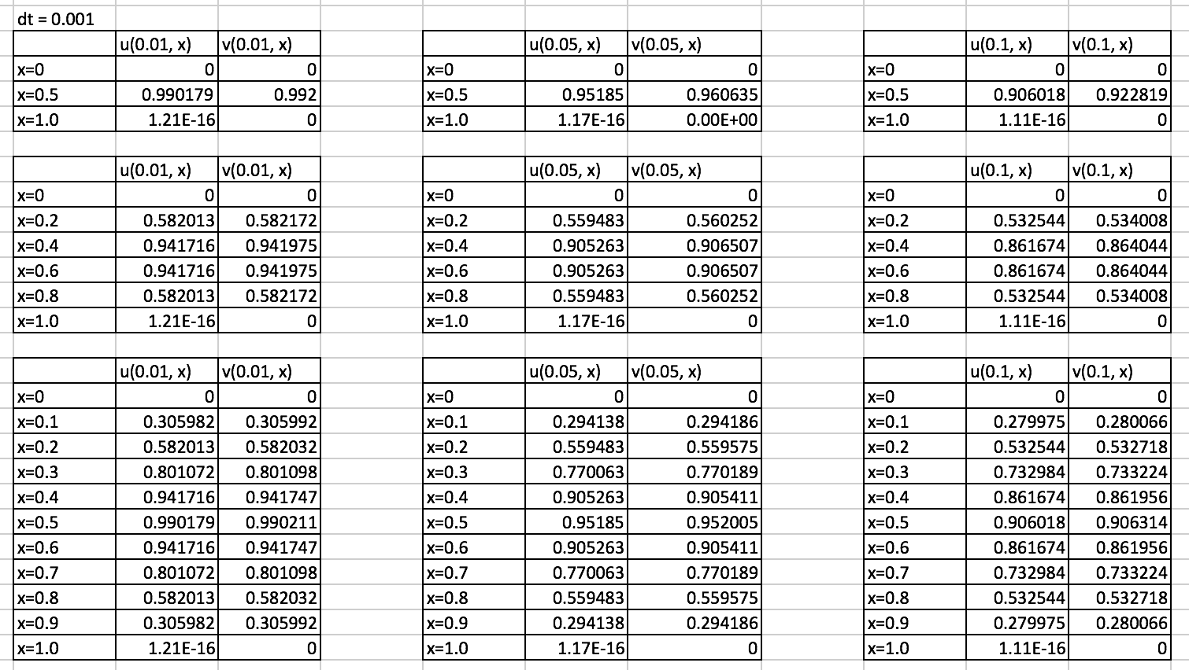

Problem#2

(b)

The solution:

|  |  |  |  |  |  |
| --- | --- | --- | --- | --- | --- |
|  | x= 1/6 | x= 2/6 | x= 3/6 | x= 4/6 | x= 5/6 |
| y = 1/6 | 0.0167 | 0.0288 | 0.0358 | 0.0497 | 0.0264 |
| y = 2/6 | 0.0288 | 0.0489 | 0.0598 | 0.0361 | 0.0419 |
| y = 3/6 | 0.0358 | 0.0598 | 0.0721 | 0.0590 | 0.0497 |
| y = 4/6 | 0.0361 | 0.0590 | 0.0706 | 0.0706 | 0.0491 |
| y = 5/6 | 0.0264 | 0.0419 | 0.0497 | 0.0691 | 0.0361 |
|  |  |  |  |  |  |

Problem #3

