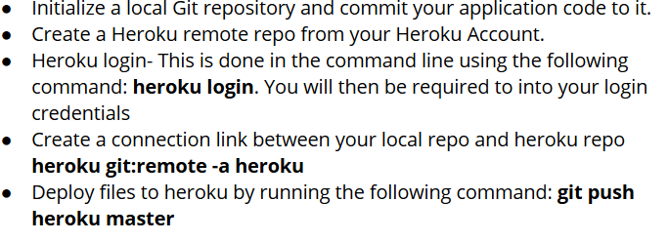

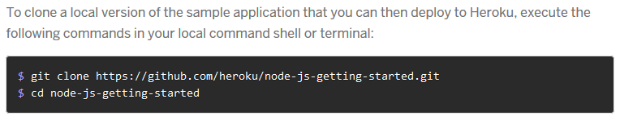

2,

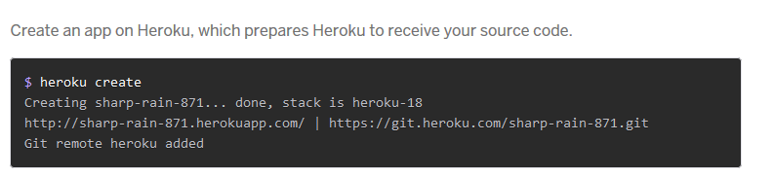

3，

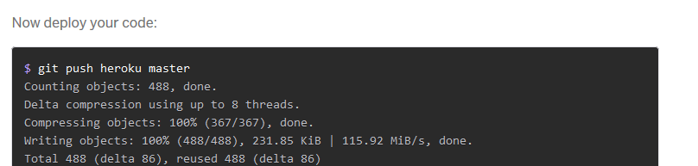

4，heroku ps:scale web=1

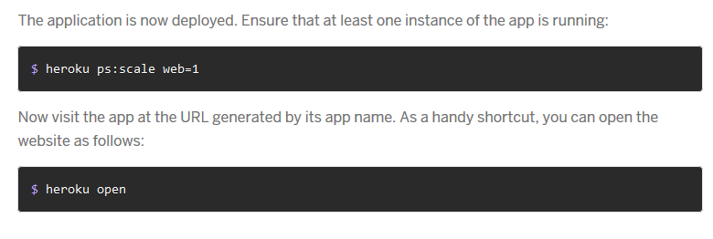

5，

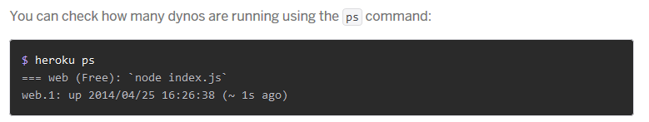

6，

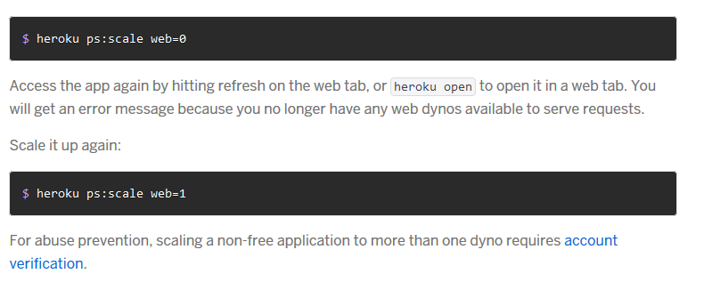

7，

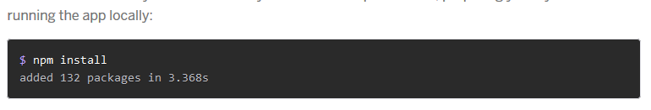

8，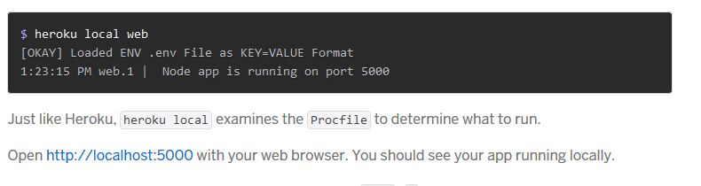

9,

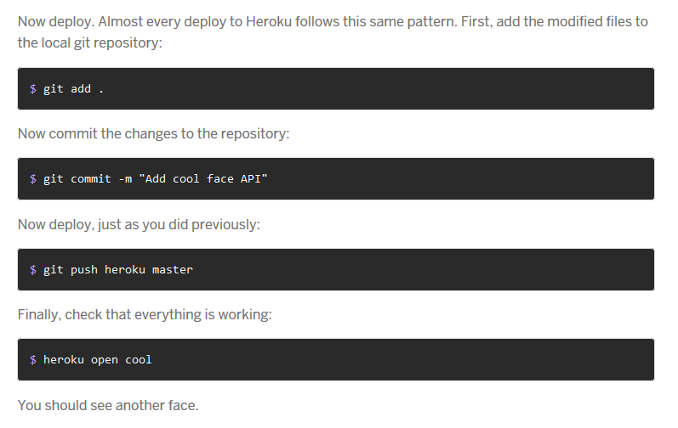

10,

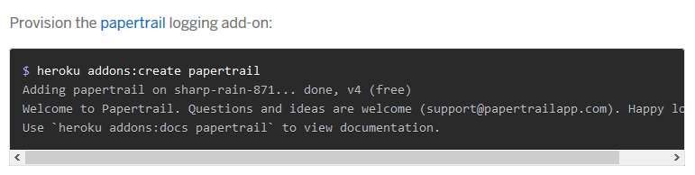

git - - version

git init : create repository

git add . : add files to staging area

git status: the state of the working directory and the staging area.

git commit -m “ ” : make the change, must commit the change before push

Git checkout “commit ref”: Navigate between commit history

git log: Viewing the commit history

git remote add origin master remoteURL: Create a link between your local repository and Remote repo

git push -u origin master: upload local files (first time)

git push origin master: upload local files continuously

git remote rm origin: redo add origin

git clone URL: clone a remote repo

git pull origin master: pull new data from a remote repository

git: is a distributed version-control system for tracking changes in source code during software development.

GitHub:  provides hosting for software development version control using Git.

.gitignore: a file that Git uses it to determine which files and directories to ignore, before you make a commit.

**Heroku** : is a platform as a service (PaaS) that enables developers to build, run, and operate applications entirely in the cloud.

SQL:

pro: 1. standardization. 2. strong reporting tools 3. well-defined community 4. efficient for non-changing data

cons: 1. difficulty with high volume 2. difficult to scale 3. requires specialized personnel 4. problematic in rapid development environments.

NoSQL

pro: 1. easier to manage 2. open-source 3. quick development 4. easy to scale 5. quick setup 6 extreme flexibility

cons: 1. difficult migration 2. less mature 3. less support 4. no standardized reporting

The **document**:  is the unit of storing data in a MongoDB database. Often, the term "object" is used to refer a document.

A **collection** may store a number of documents. A collection is analogous to a table of an RDBMS.

ORM (Object Relational Mapper: Sequelize) relational representation of the data, where as ODM (Object Document Mapper) document representation of the data. Mongoose is an example of an ODM for MongoDB

In mongoose,

**Schema** represents the structure of a particular document.

**model** defines a programming interface for interacting with the collection (read, insert, update, etc)

A **database** is an organized collection of data, generally stored and accessed electronically from a computer or computing device.