Table of contents:

I. Add/Update Interface 1
A. Open Add/Update interface UI 1
Step 1: Click on the profile link on the top right of app screens 1
Step 2: Click on Manage Interfaces on the dropdown 2
Step 3: Open Add/Update Interface Wizard 2
Step 3.1: Open Add interface wizard 2
Step 3.2: Open Edit interface popup 3
II. Fill in the form 4
1. Name: 5
2. Machines: 5
3. Commands: 6
4. Algorithms: 7
5. Sensors: 9
6. Destinations: 10
6. Multi Destinations: 12

Add/Update Interface

Open Add/Update interface UI
Precondition: You need to log in as an Admin first

Step 1: Click on the profile link on the top right of app screens
- Once logging in as an Admin, user will be automatically redirected to the Homepage. To access additional options, navigate to the top right of the Header and click on the Profile link. This action will trigger a dropdown menu to appear.
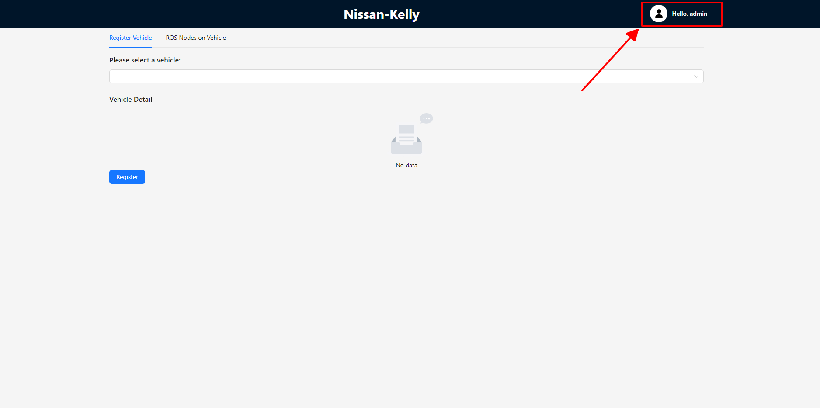

Step 2: Click on Manage Interfaces on the dropdown
- Click on the "Manage Interfaces" option from the dropdown menu that has just appeared to be redirected to the "Manage Interface" page.
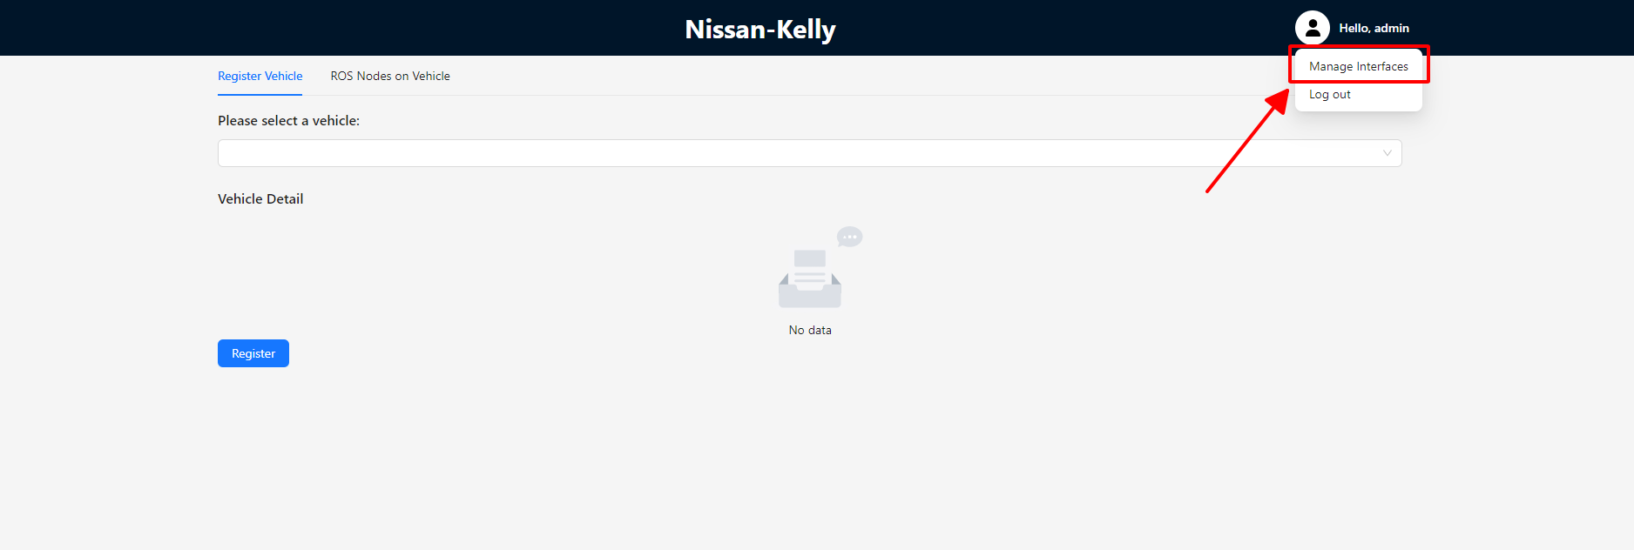

Step 3: Open Add/Update Interface Wizard

Step 3.1: Open Add interface wizard
- Once successfully redirected to the "Manage Interface" page, click on the "Add new interface" option to open the interface creation wizard. The resulting interface will resemble the second image displayed below.
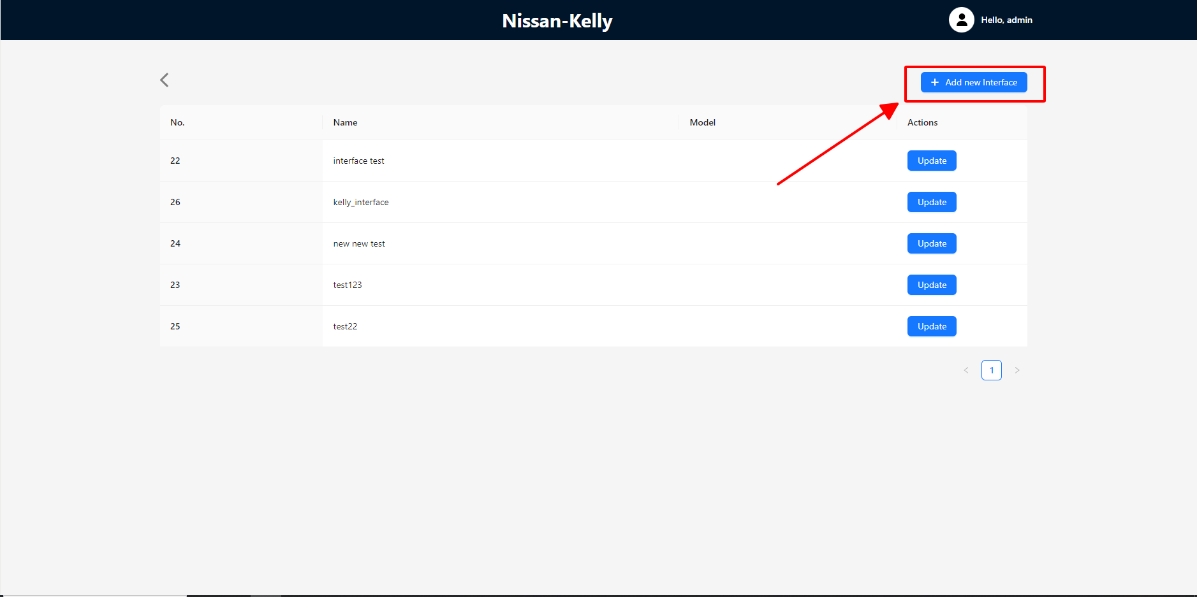
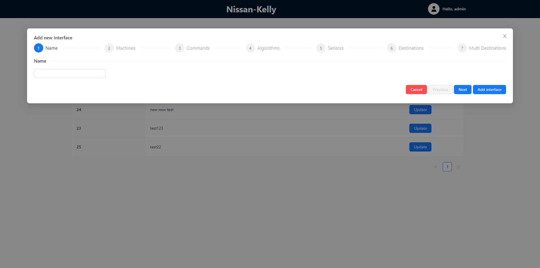

Step 3.2: Open Edit interface popup
- Similarly to adding an interface, click on the "Update" button instead. This action will allow the user to view the details of the interface that is ready for editing.
- 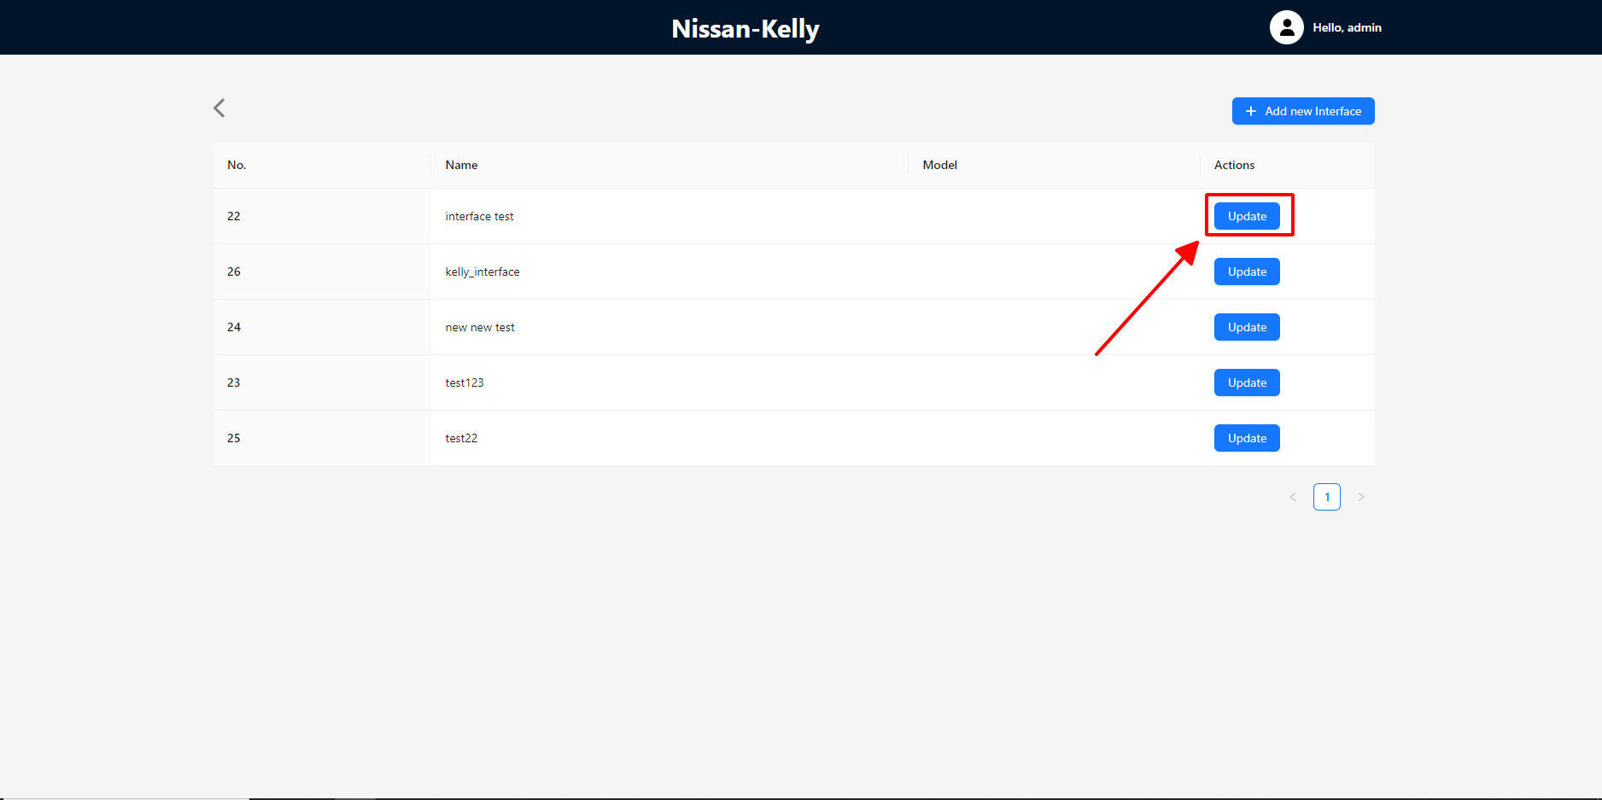
- 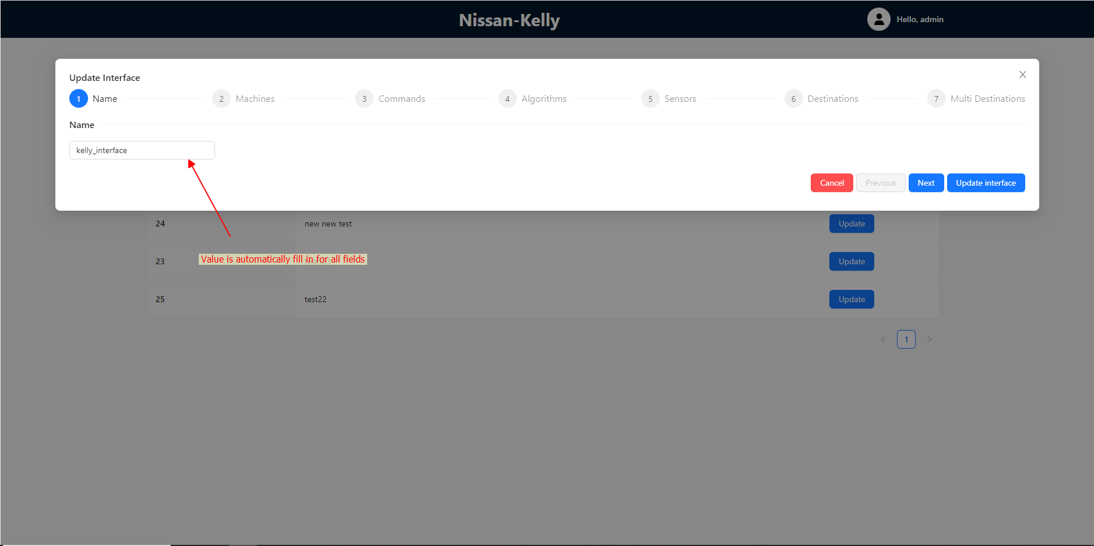

II. Fill in the form
The form has the following sections:
- Name
- Machines
- Commands
- Algorithms
- Sensors
- Destinations
- Multi Destinations
The details of each sections are described as the below.
Prior to proceeding with the sections, it is important to understand the expected behavior of the form.
- Validation will be triggered whenever the user clicks on the "Previous," "Next," or "Add Interface" buttons.
- If the current form contains any errors, the user will be unable to proceed to the previous/next step or submit the form.
- Upon clicking on "Add Interface," the user will be prompted to confirm their submission before the form is submitted.

Name:
- There are no specific naming conventions required
- Note that the interface name must be unique among the stored interface names. The input field for the interface name will undergo automatic validation when it loses focus.

Machines:
- The Machine's field can be left blank, but if it is populated, it must be a valid value.
- Each machine requires the following mandatory attributes: name and address
- To add a new machine, simply click on the "Add Machine" button.
- 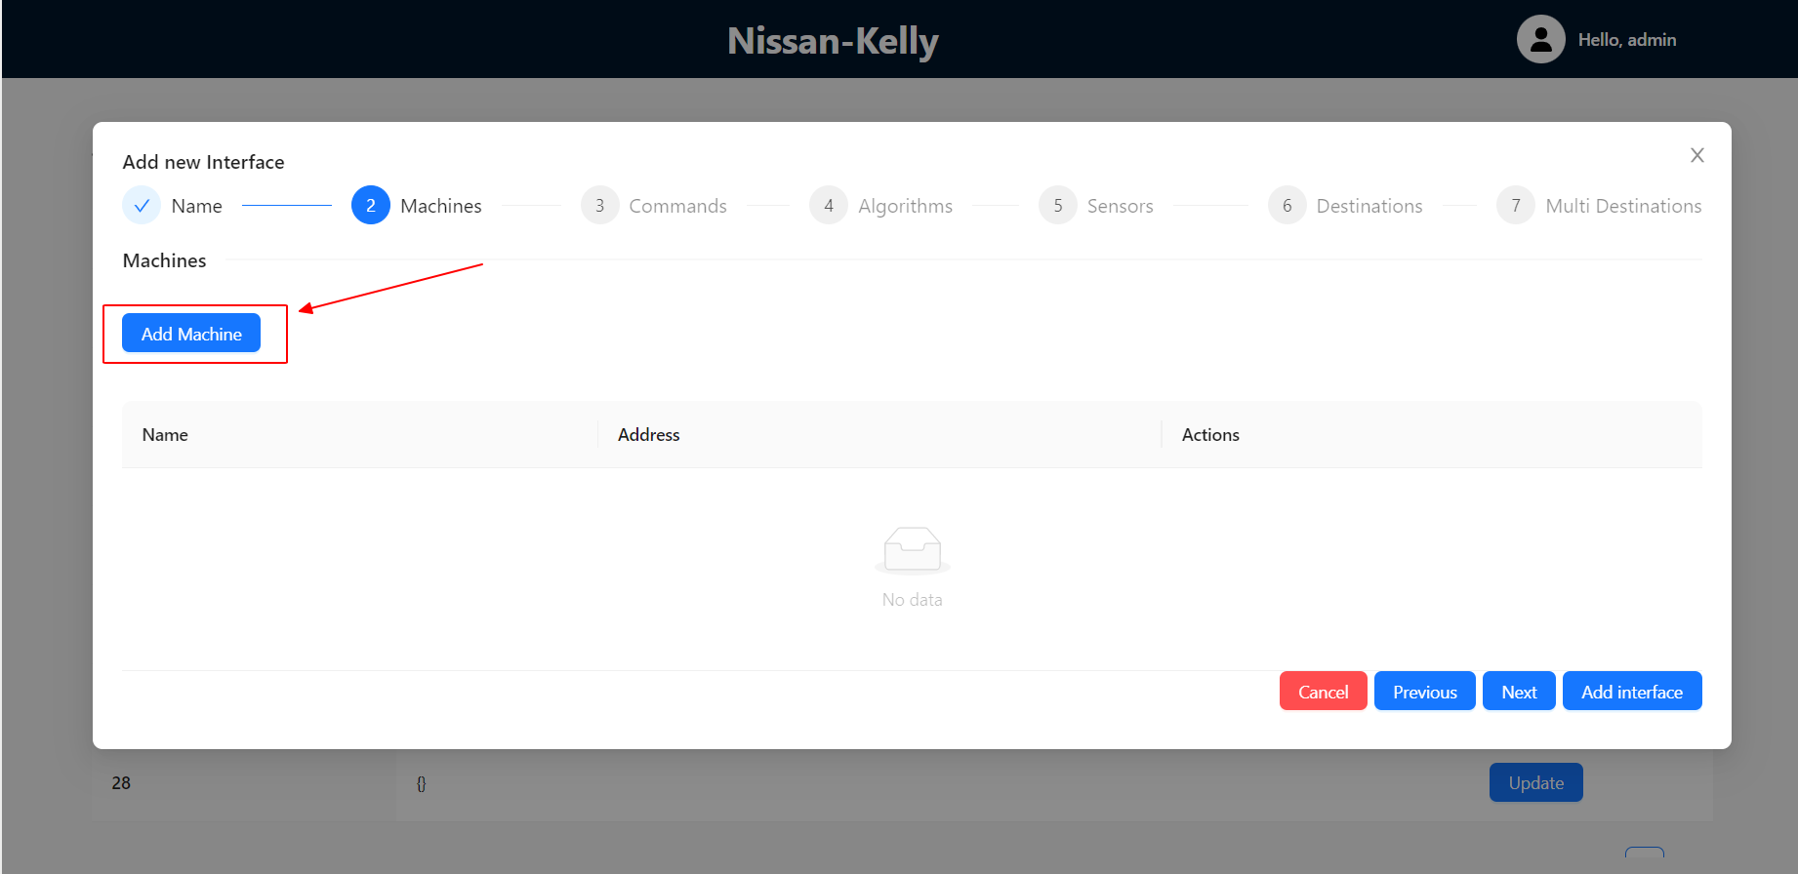
- User can refer to a sample interface to obtain the necessary values.
- 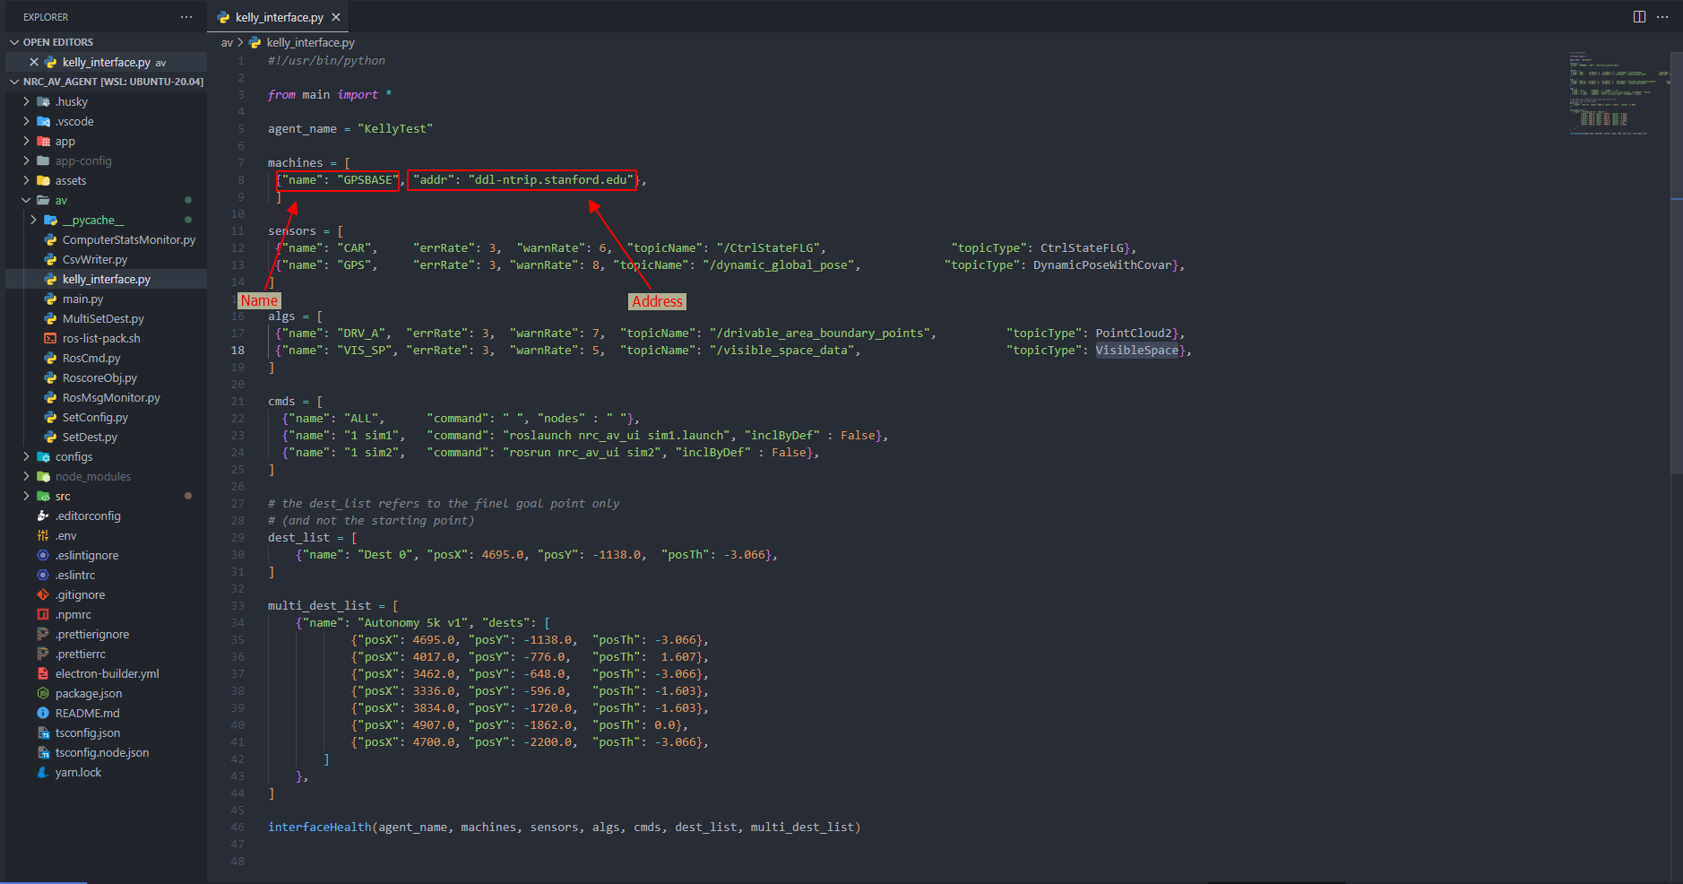

3. Commands:
- Commands field can be left blank, if populated, it must be in the correct format.
- Each command has the following attributes:
  - Name
    - type: String
    - require: true
    - Description: Name of the command that will be shown on the UI
  - Command
    - type: String
    - require: false
    - Description: Command that will be run on the agent
  - Nodes:
    - type: String
    - require: false
    - Description:
  - inclByDef:
    - type: Select
    - default: No (false)
    - Description: true if you want the command is run when run all
  - autoStart:
    - type: Select
    - default: No (false)
    - Description:
  - autoRecord:
    - type: Select
    - default: No (false)
    - Description:
- To add a new command, simply click on “Add Command” button
- 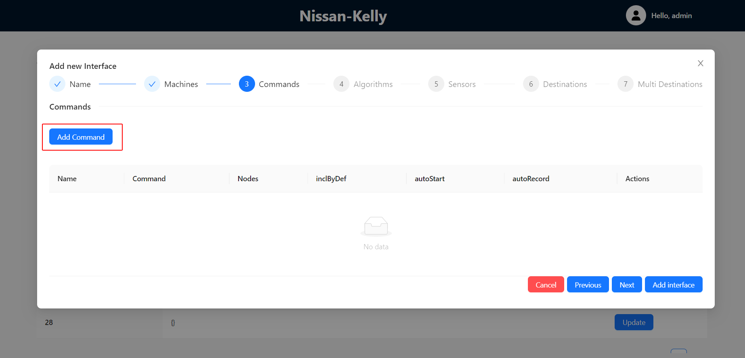
- User can refer to a sample interface to obtain the values.
- 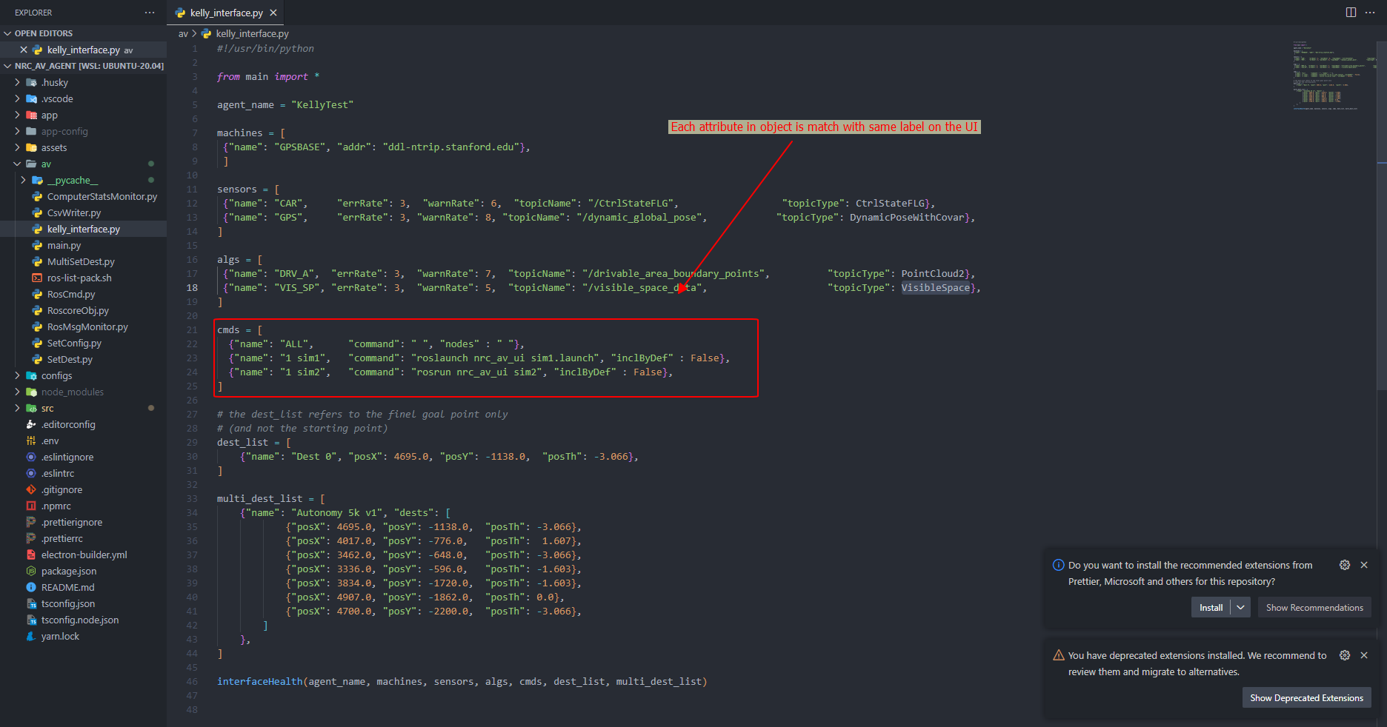

4. Algorithms:
- Algorithms field can be left blank, if populated, it must be in the correct format.
- Each Algorithm have the following attributes:
  - Name
    - type: String
    - require: true
    - Description: Name of algorithms that will be shown on UI
  - Error Rate
    - type: String
    - require: true
    - Description: Desired error rate for the sensor, indicating the frequency of errors.
  - Warn Rate
    - type: String
    - require: true
    - Description: Desired warning rate for the sensor, indicating the frequency of potential issues.
  - Topic Name
    - type: String
    - require: true
    - Description: the name of topic for listening to get status
  - Topic Type
    - type: String
    - require: true
    - Description: the type of message in topic
- To add a new Algorithm, simply click on “Add Algorithm” button
- 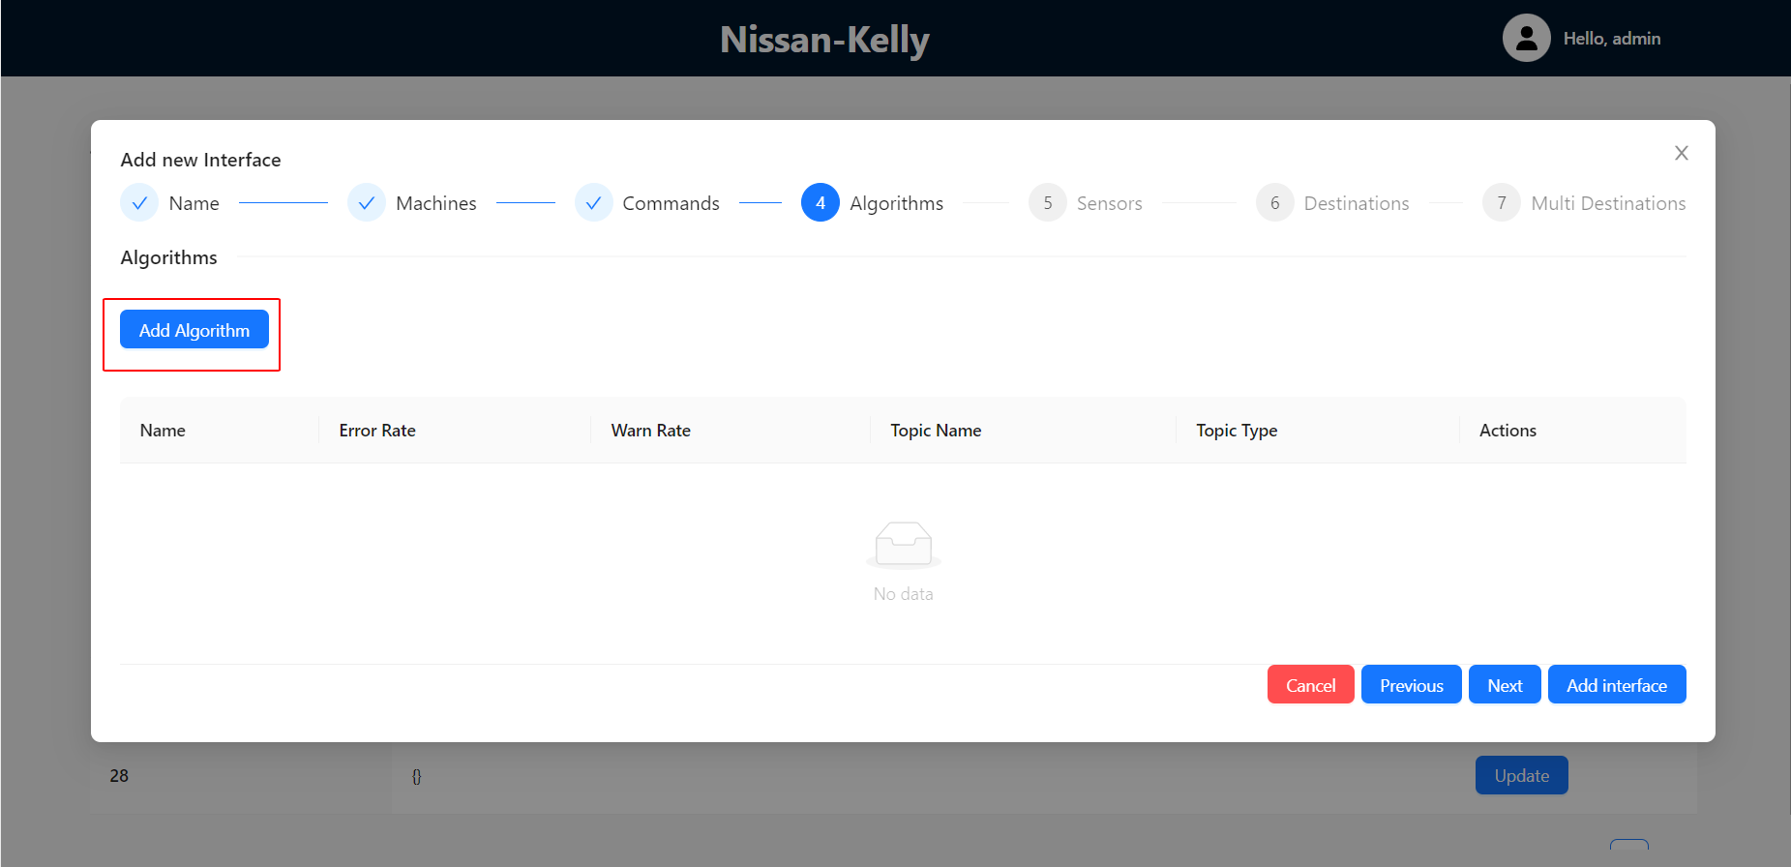
- User can refer to a sample interface to obtain the values.
- 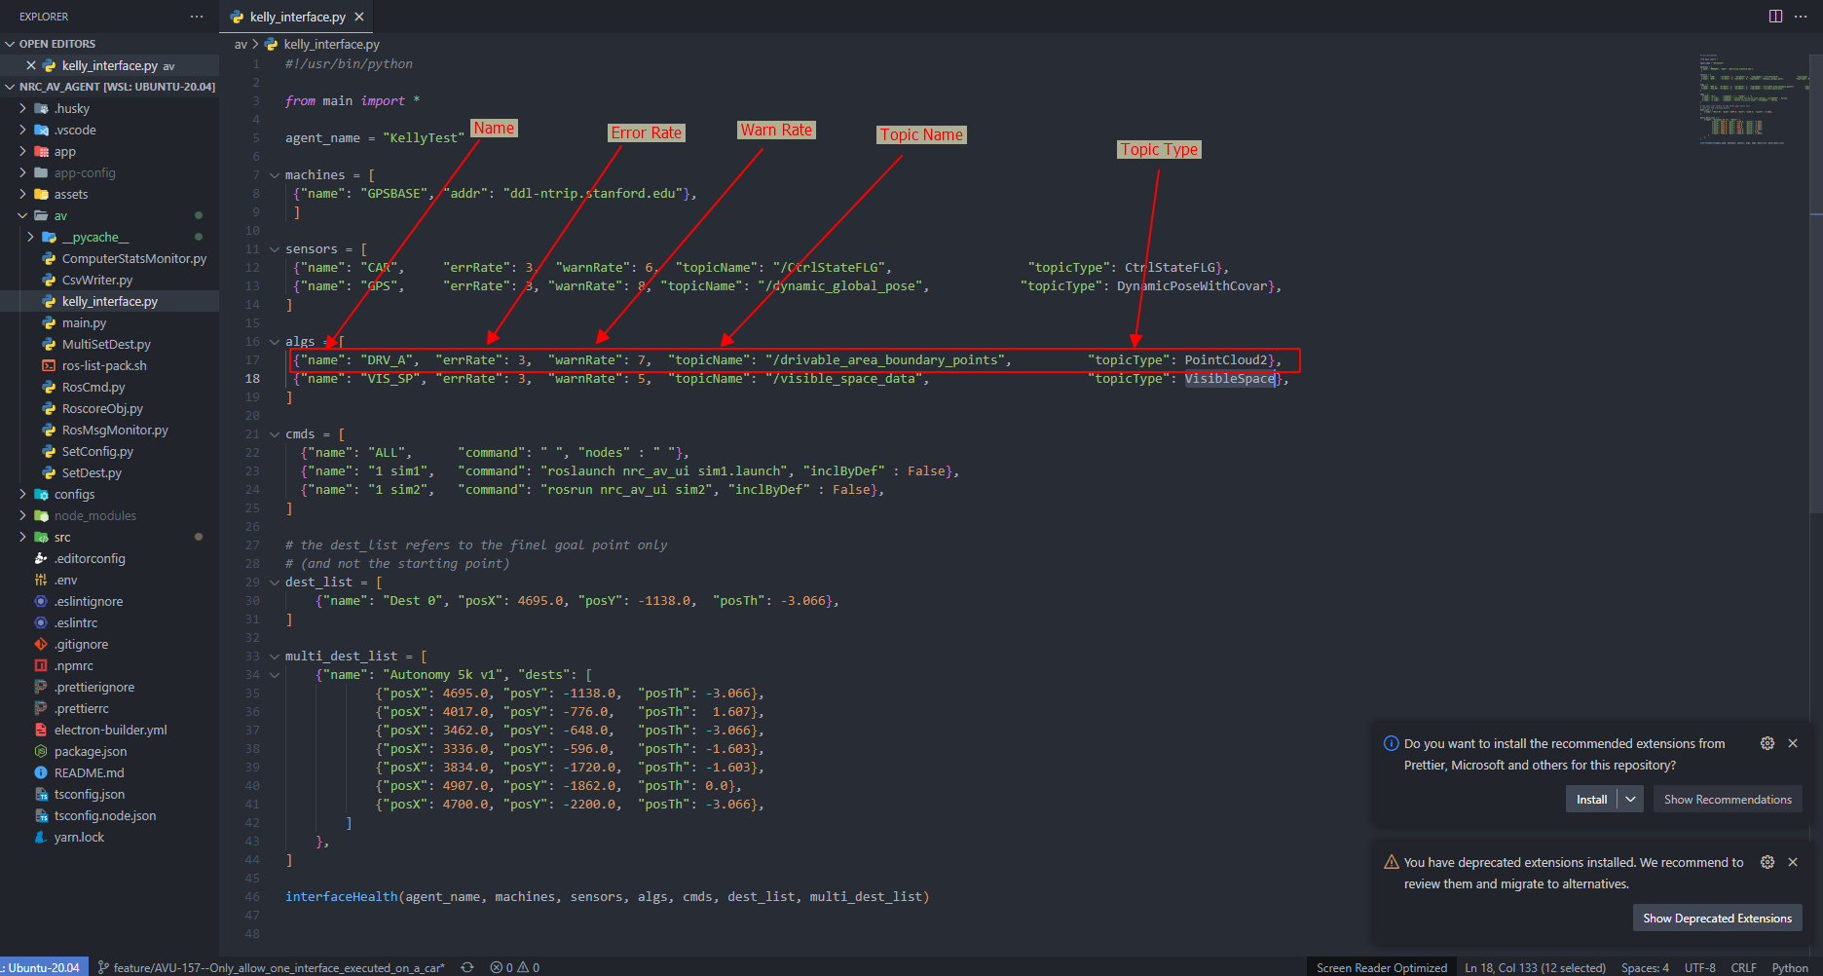

5. Sensors:
- Sensors field can be left blank, if populated, it must be in the correct format.
- Each Sensor has the following attributes:
  - Name
    - type: String
    - require: true
    - Description: name of the sensors that will be shown on UI
  - Error Rate
    - type: String
    - require: true
    - Description: Desired error rate for the sensor, indicating the frequency of errors.
  - Warn Rate
    - type: String
    - require: true
    - Description: Desired warning rate for the sensor, indicating the frequency of potential issues.
  - Topic Name
    - type: String
    - require: true
    - Description: the name of topic for listening to get status
  - Topic Type
    - type: String
    - require: true
    - Description: the type of message in topic
- To add a new Sensor, simply click on “Add Sensor” button
- 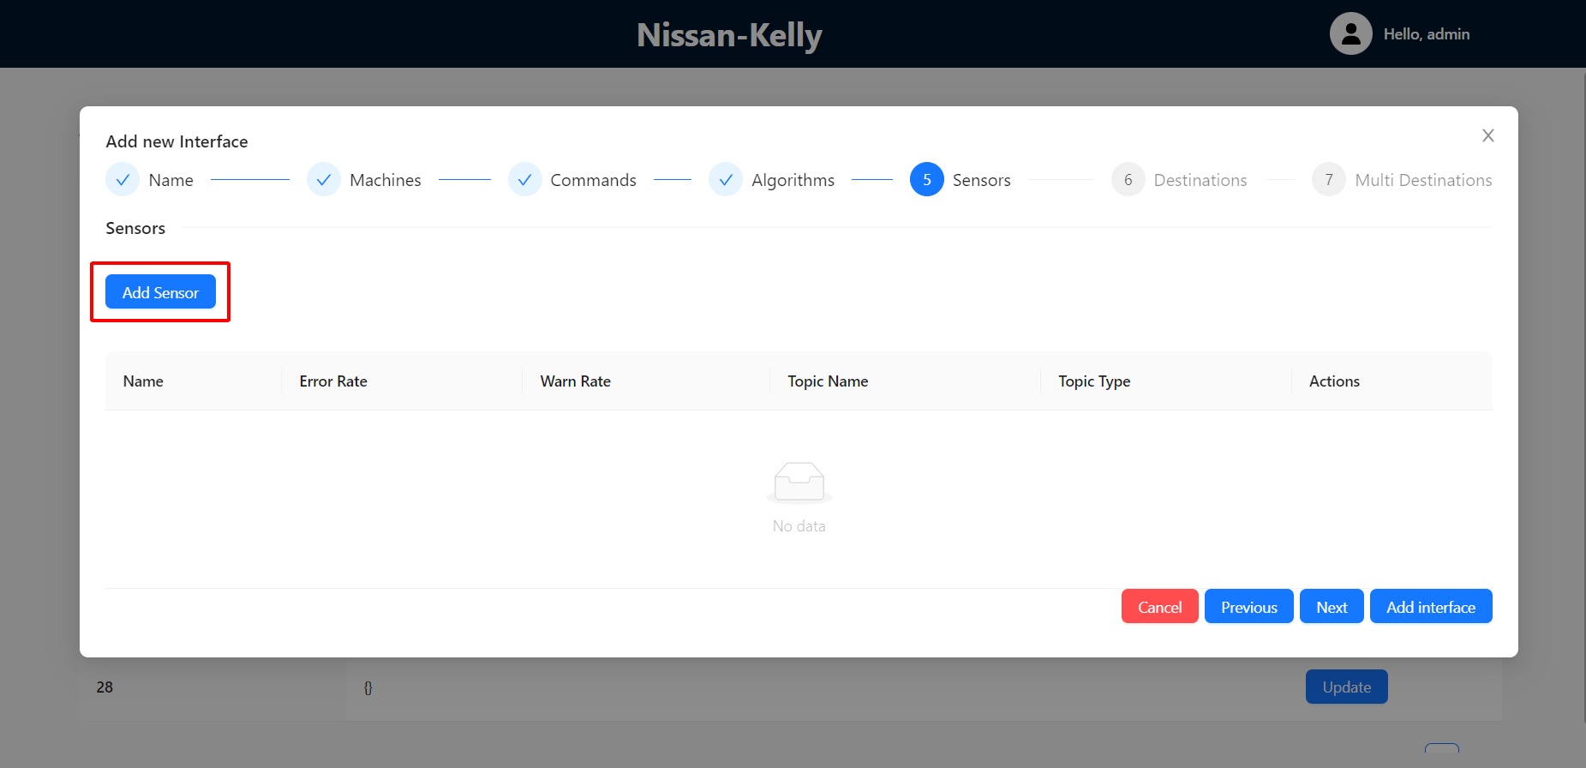
- User can refer to the sample interface to obtain the values.
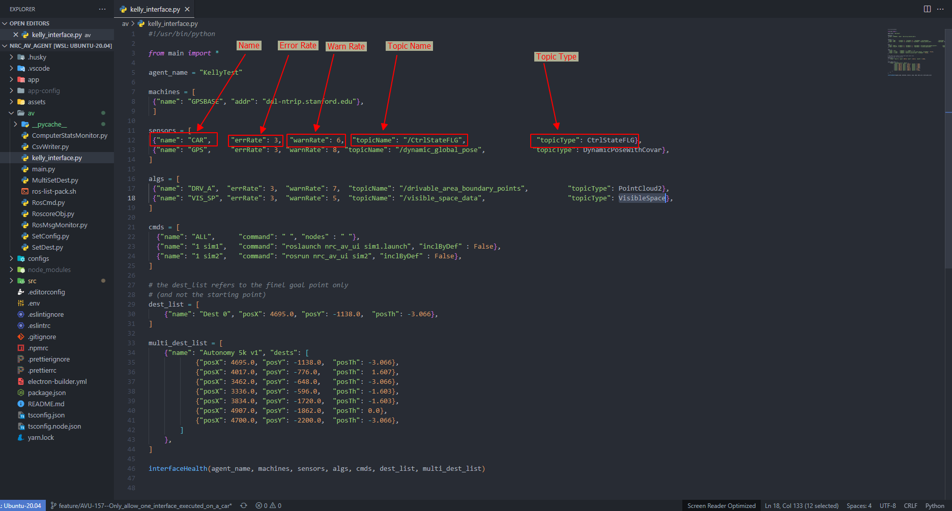

6. Destinations:
- The Destinations field can be left blank, if populated, it must be in the correct format.
- Each Destination has the following attributes:
  - Name
    - type: String
    - require: true
    - Description: Name of destinations that will be shown on UI
  - posX
    - type: number
    - required: true
    - Description:
  - posY
    - type: number
    - required: true
    - Description:
  - posTh
    - type: number
    - required: true
    - Description:
- To add a new Destination, simply click on “Add Destination” button
- 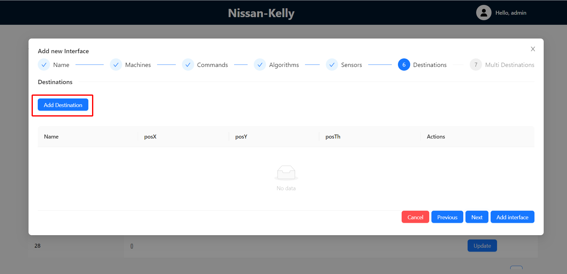
- You can refer to the sample interface to obtain the values.
- 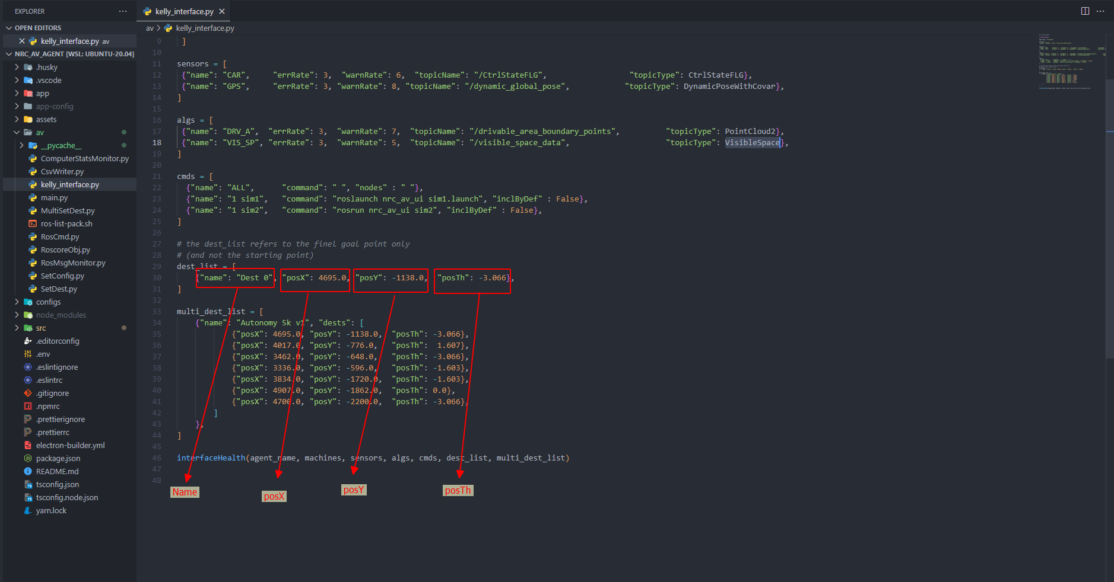

6. Multi Destinations:
- The structure of multi destinations includes:
  - name
  - list of destinations, which each destination includes:
    - posX
    - poxY
    - posTh
- Each Destination has following attributes:
  - Name
    - type: String
    - require: true
    - Description: Name of single Destinations that will be shown on UI
  - posX
    - type: number
    - required: true
    - Description:
  - posY
    - type: number
    - required: true
    - Description:
  - posTh
    - type: number
    - required: true
    - Description:
- To add a new Multi-Destination, simply click on “Add Multi Destination” button
- 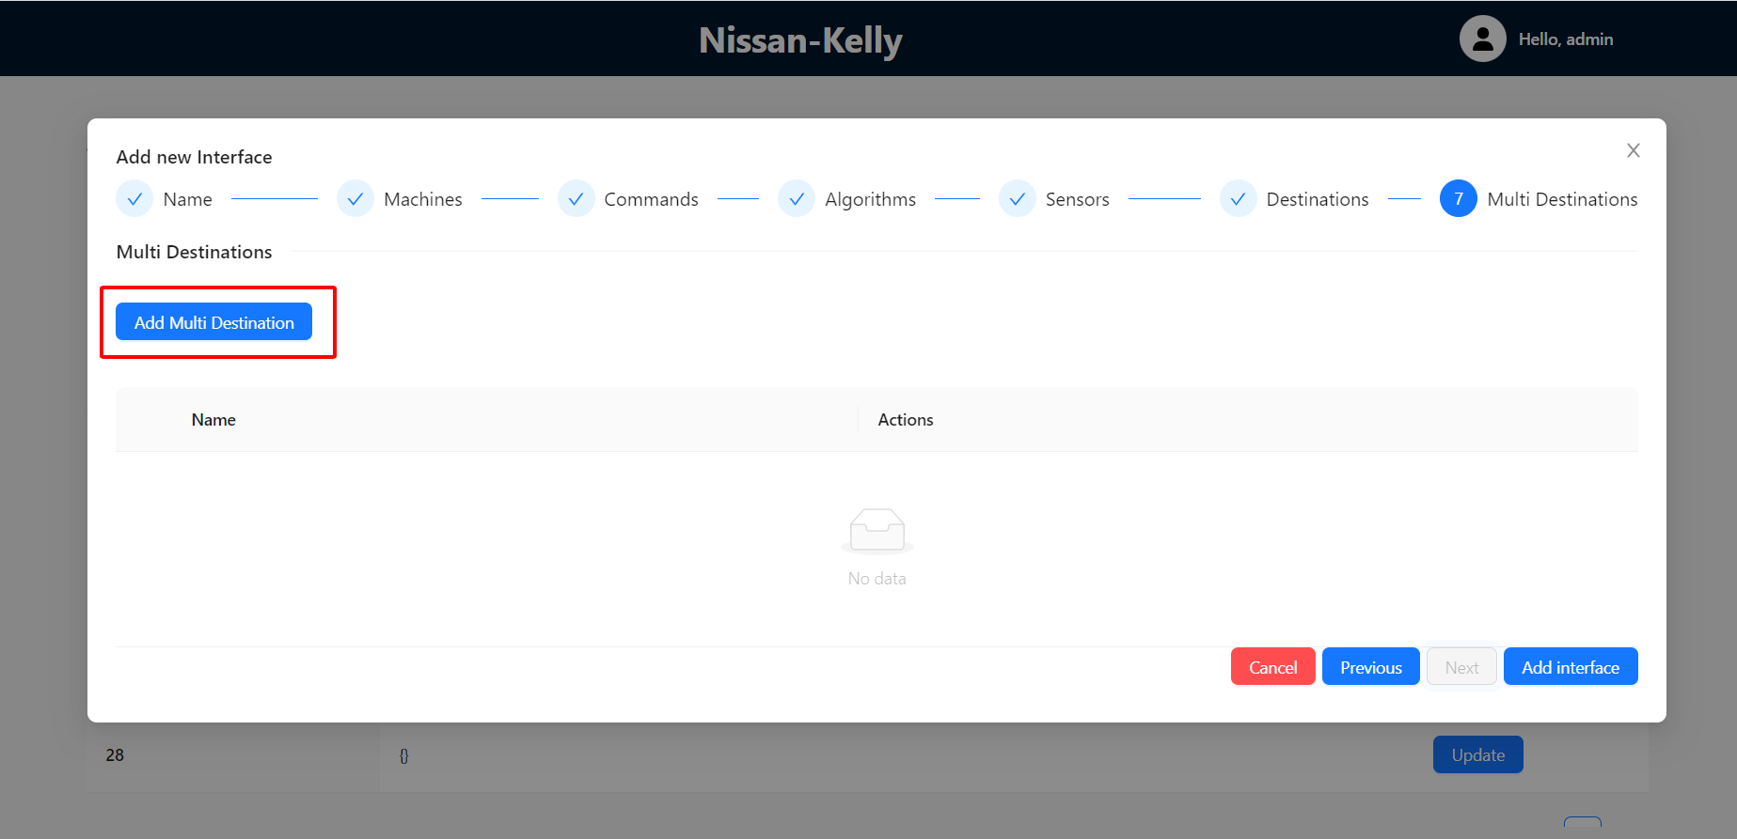
- To expand or collapse the details of a multi-destination, simply click on the "+" or "-" button located on the left side of each row
- 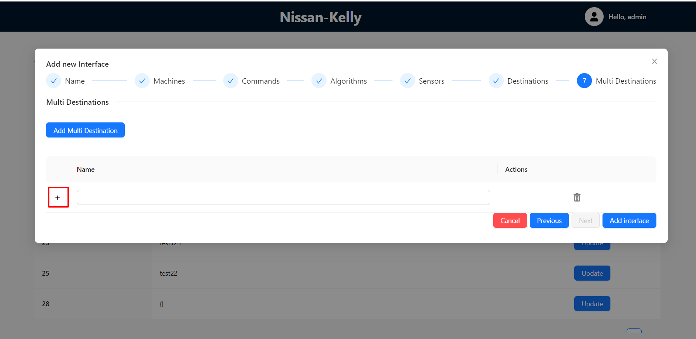
- 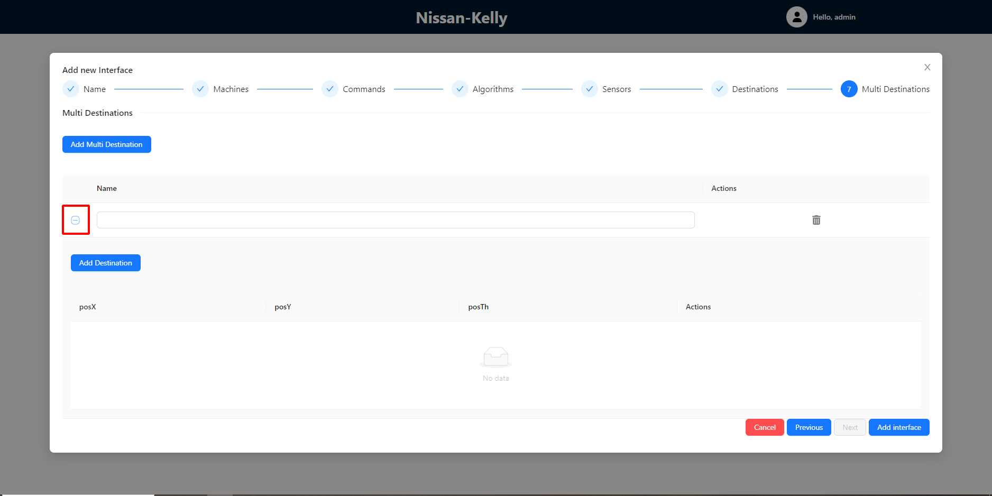
- User can refer to a sample interface to obtain the values.
- 