Integrated Circuit Design HW2 Report B12901185 謝承恩

- NAND
When v(a) = v(b) = 1 (0.125 ~ 0.225 ns), v(y) = 0. Otherwise, v(y) = 1.
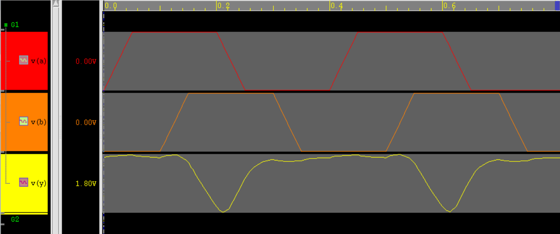
- Oscillator
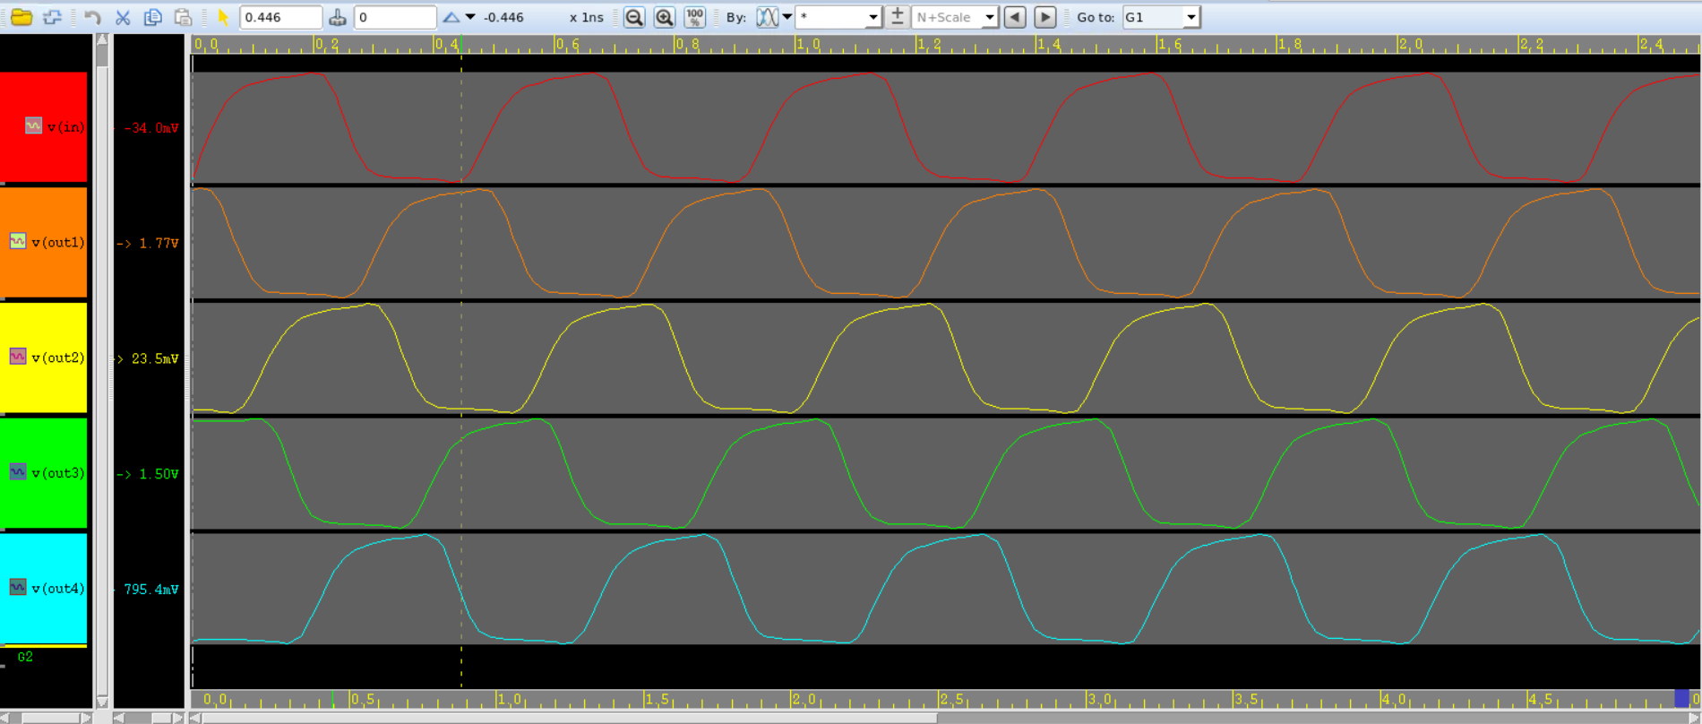
Period: 0.46 ns = 460 ps -> Frequency: 2.174 GHz

