ICD_HW5 B12901185 謝承恩
DRC Result
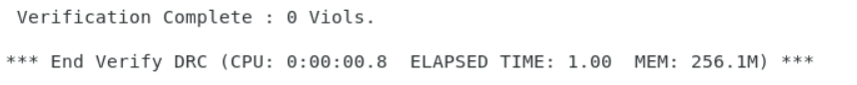
Verify Regular Connectivity Result
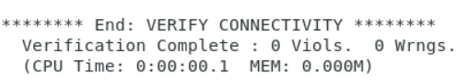
Analyze Floorplan
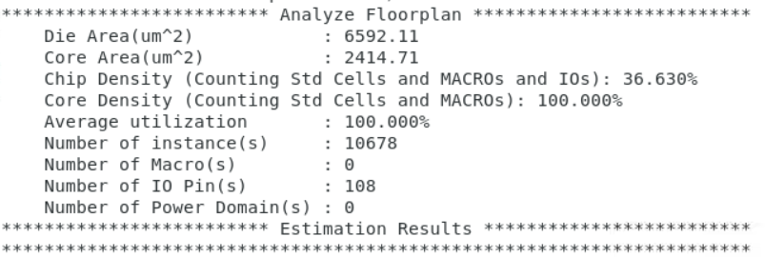
Testbench
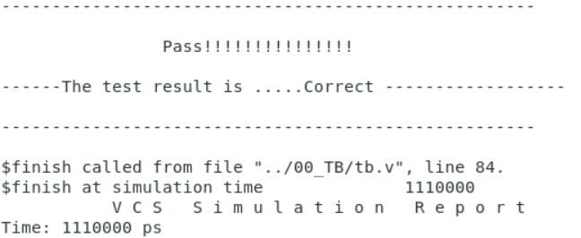
Cycle Time: 10 ns

