Integrated Circuit Design HW3 B12901185 謝承恩
- Testbench Result
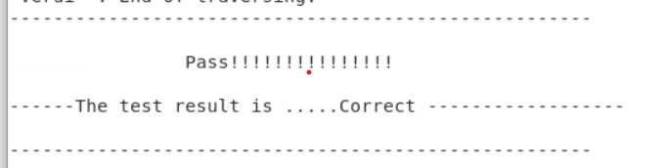
- Check Design Result
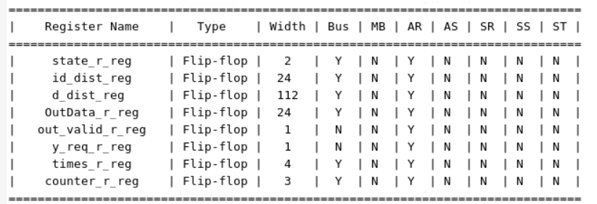
- Implementation (I’m used to using “_r” for the now state while “_w” for the next state)
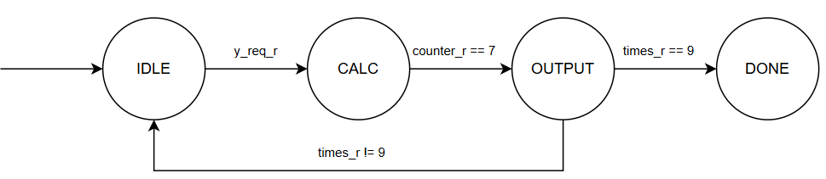
State | Explanation
IDLE | Wait for y_req to rise to start calc
CALC | Calculate the pred_y, distance, and sort the distance
OUTPUT | Output the answer
DONE | Done

Variable | Explanation
y_req | Being 1 when needs to accept the data
counter | Count the number of the data
times | Count the number of the testing data
- Calculate the data:
For the eight x’s, I calculated them separately, which makes the variable less but takes more time to calculate. Hence, there is a variable called “counter” to help me count which x is calculated now. When counter == 7, which means all eight x’s are calculated, then we can output the result.

- Sorting
Since there is not much data, I use bubble sort to sort the data.

- Times
There are 10 testing data in total, so there is a variable named “times” to help me memorize how many testing data I have been working with.

