ICD HW4 B12901185 謝承恩
- Area Report & Timing Report
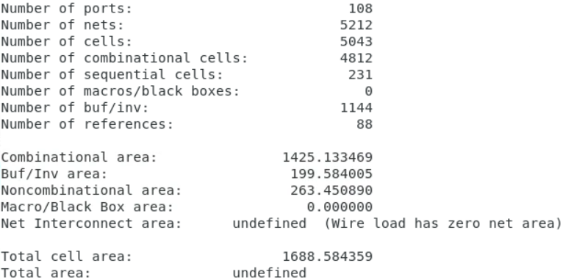
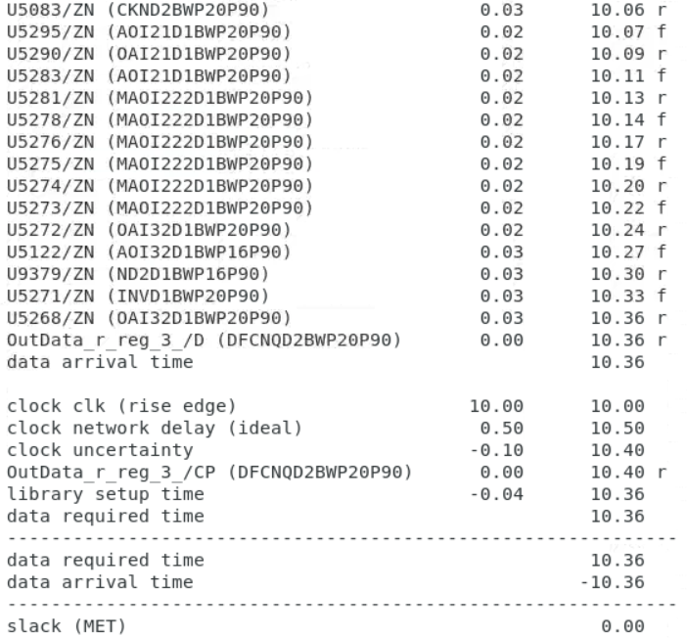
- Testbench
