Supplementary Material

Exploring modifiable risk factors for osteomyelitis: a Mendelian randomization study

**Hanwen Cheng1†, Gang Zeng1†, Haoyu Wu1†, Li Shui2, Di Zhang1, Zhuojie Liu1, Ning Wang1, Chunhai Li1,3\***

**\* Correspondence:** Chunhai Li: lichhai@mail.sysu.edu.cn.

# Supplementary Data

None

# Supplementary Figures and Tables

## Supplementary Figures

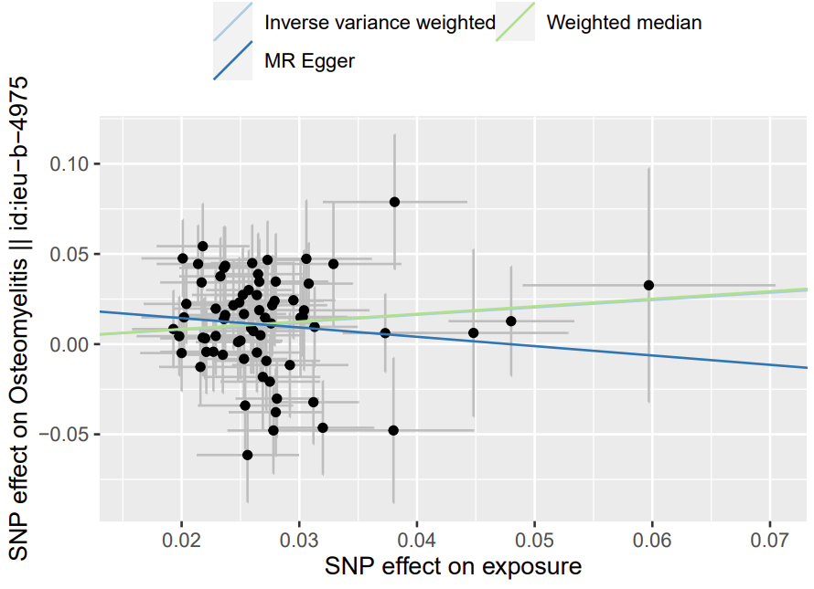

Supplementary Figure 1. Scatterplot picture (MDD lead to osteomyelitis).

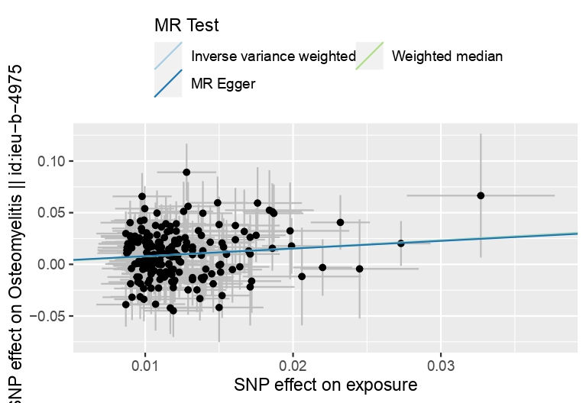

Supplementary Figure 2. Scatterplot picture (Smoking initiation lead to osteomyelitis).

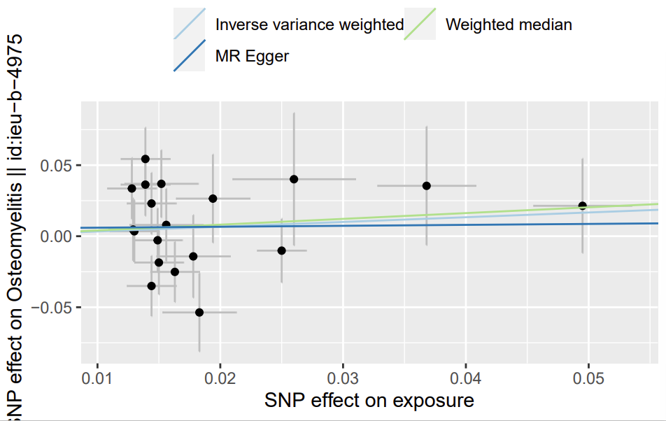

Supplementary Figure 3. Scatterplot picture (Smoking cessation lead to osteomyelitis).

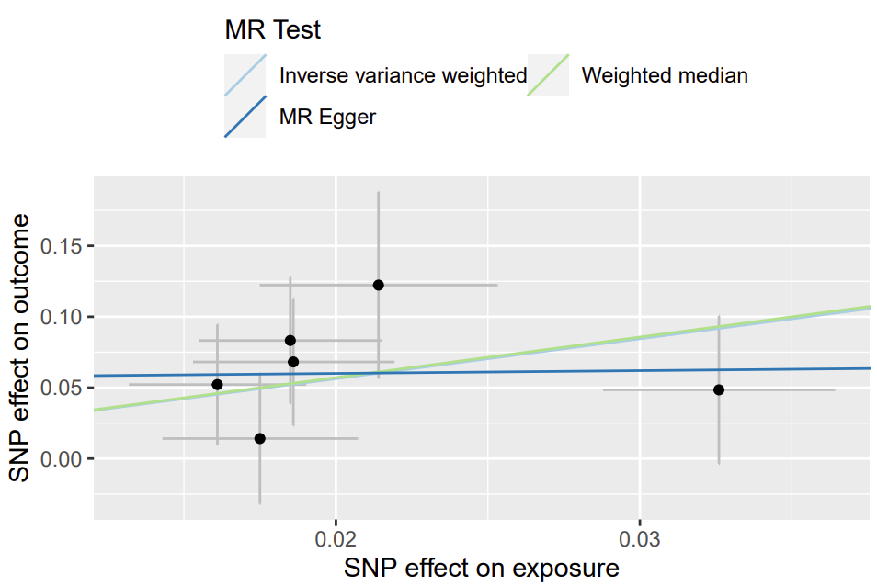

Supplementary Figure 4. Scatterplot picture (Breakfast skipping lead to osteomyelitis).

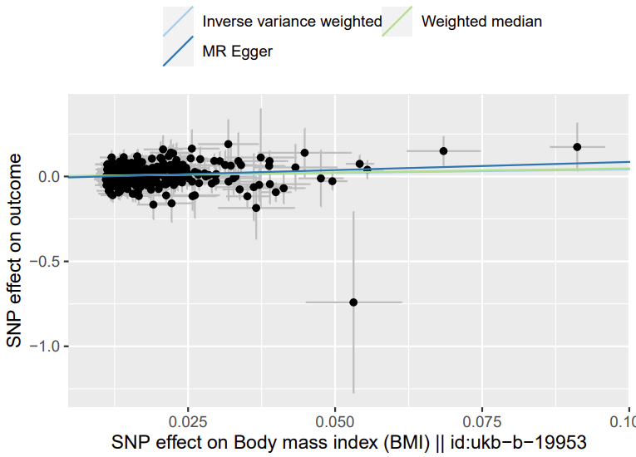

Supplementary Figure 5. Scatterplot picture (BMI lead to osteomyelitis).

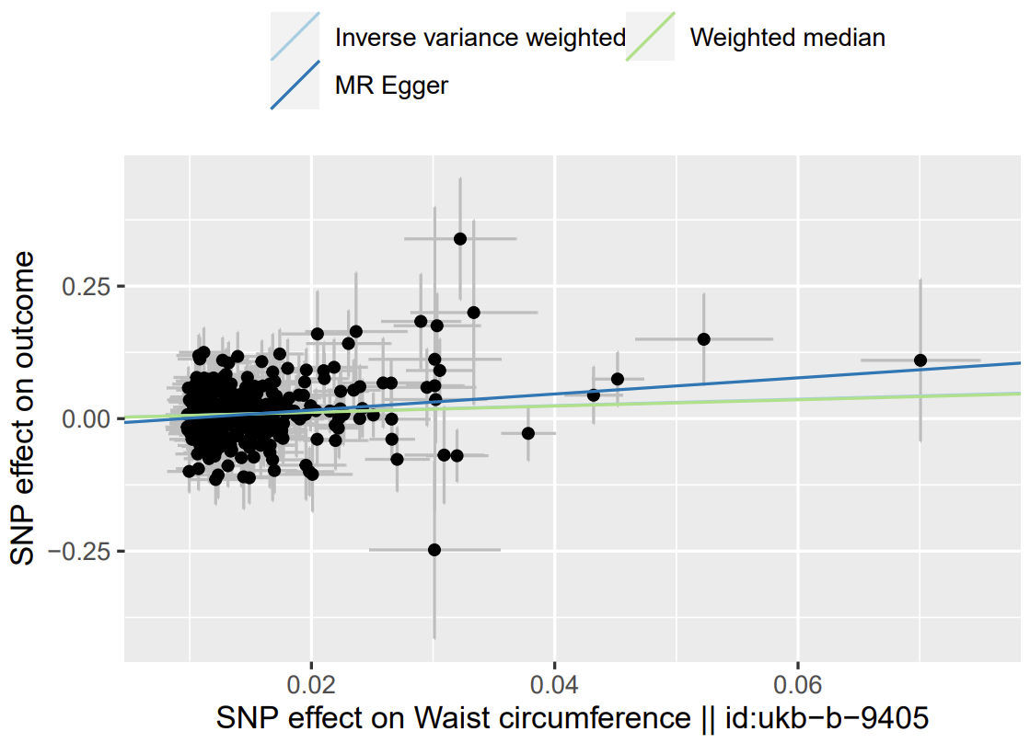

Supplementary Figure 6. Scatterplot picture (Waist circumference lead to osteomyelitis).

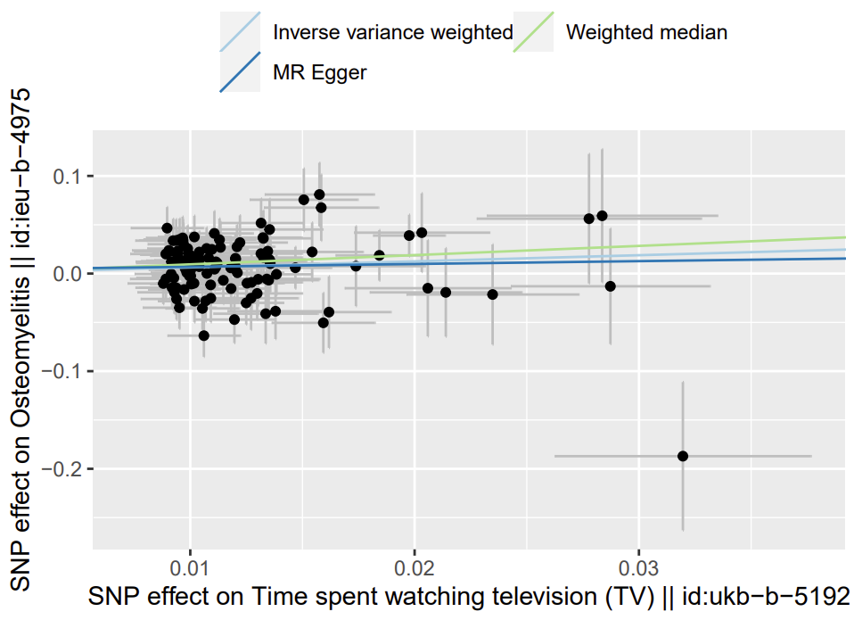

Supplementary Figure 7. Scatterplot picture (Watching TV lead to osteomyelitis).

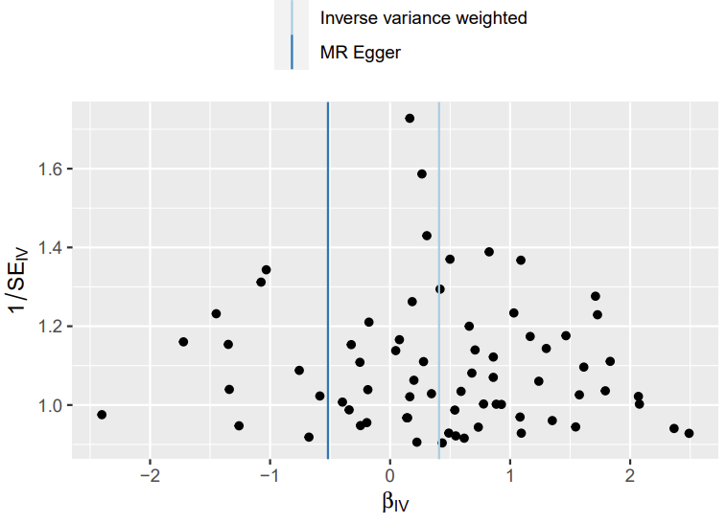

Supplementary Figure 8. Funnel plot picture (MDD lead to osteomyelitis).

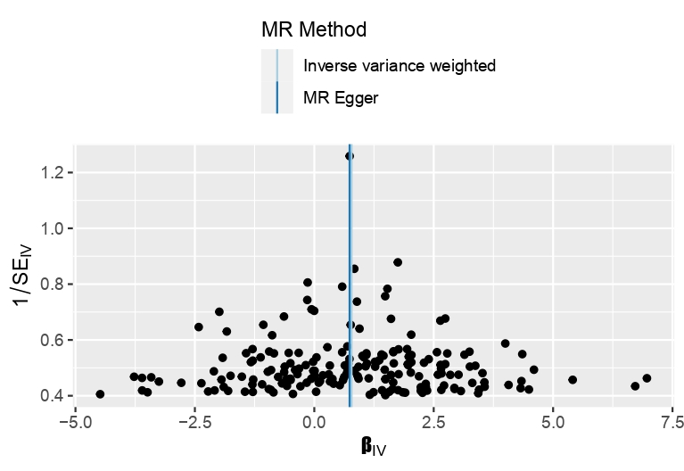

Supplementary Figure 9. Funnel plot picture (Smoking initiation lead to osteomyelitis).

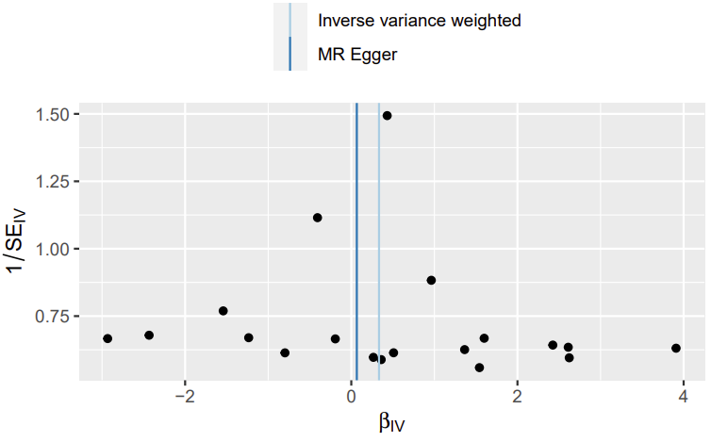

Supplementary Figure 10. Funnel plot picture (Smoking cessation lead to osteomyelitis).

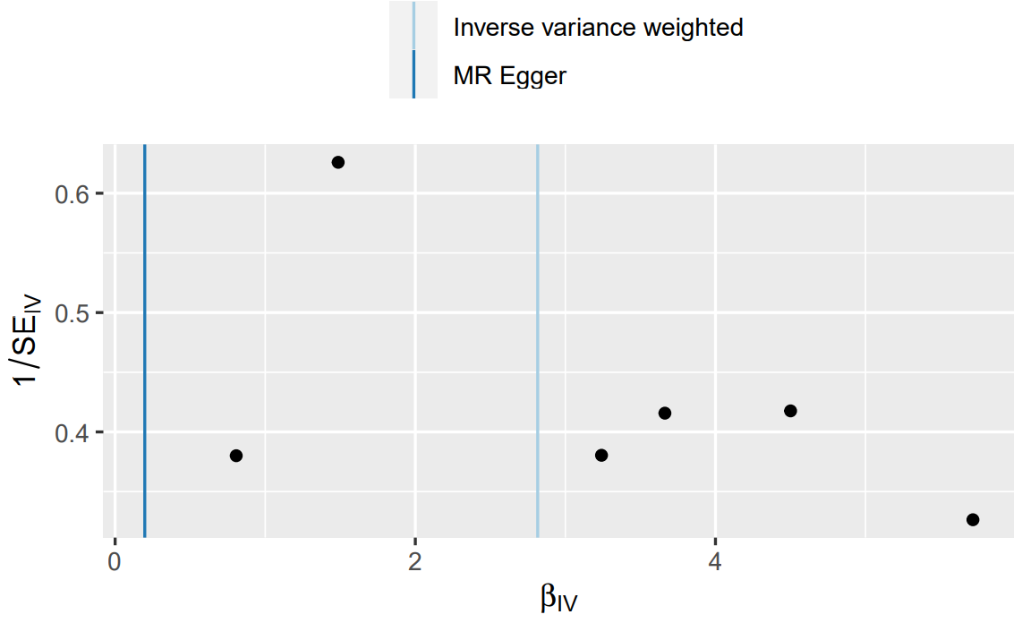

Supplementary Figure 11. Funnel plot picture (Breakfast skipping lead to osteomyelitis).

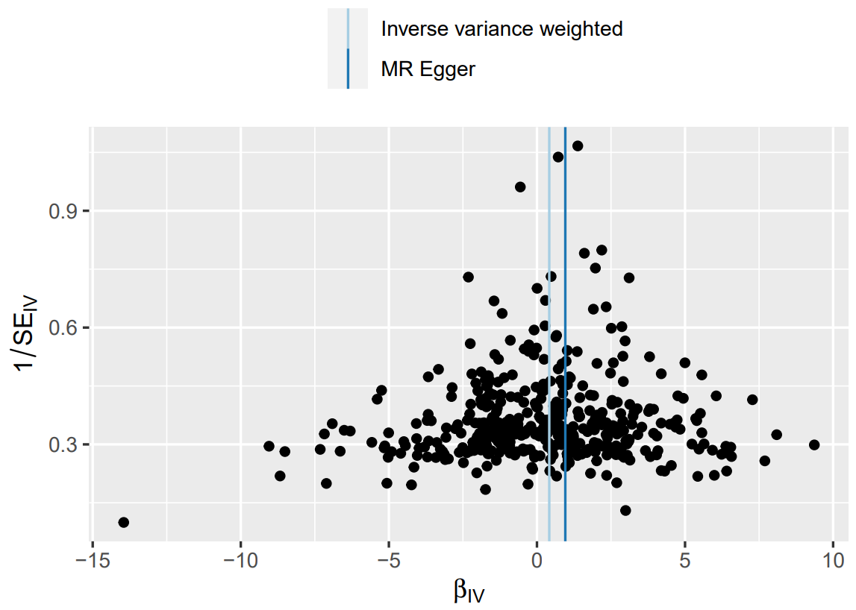

Supplementary Figure 12. Funnel plot picture (BMI lead to osteomyelitis).

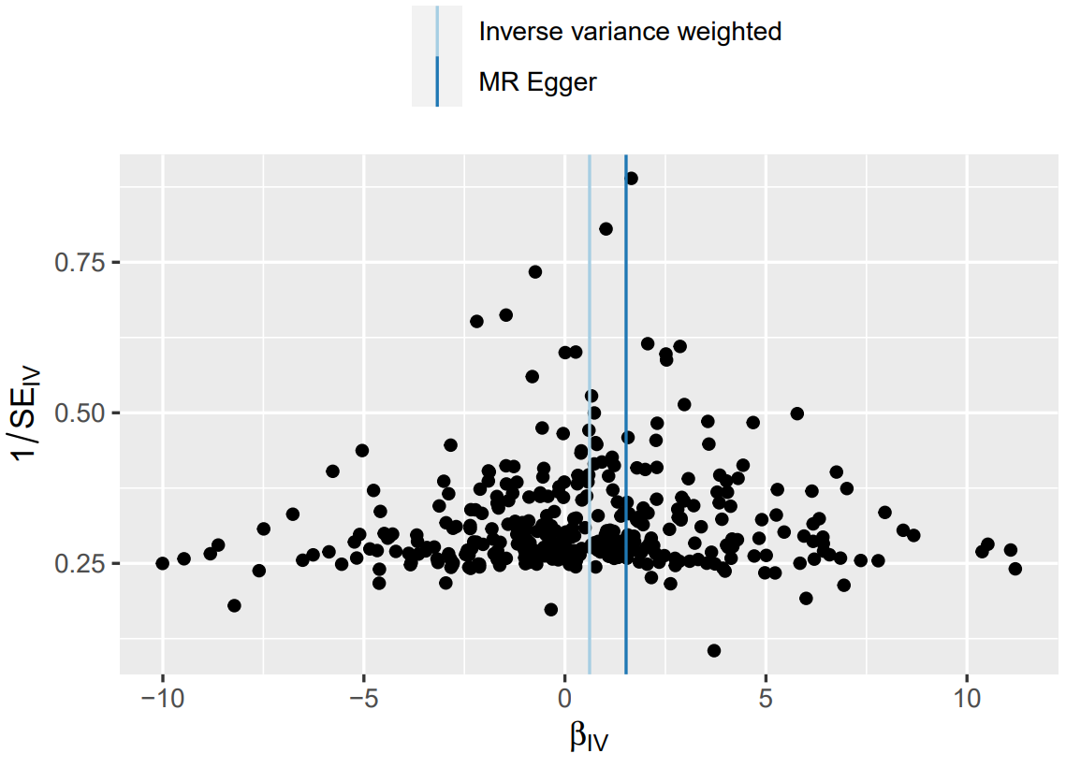

Supplementary Figure 13. Funnel plot picture (Waist circumference lead to osteomyelitis).

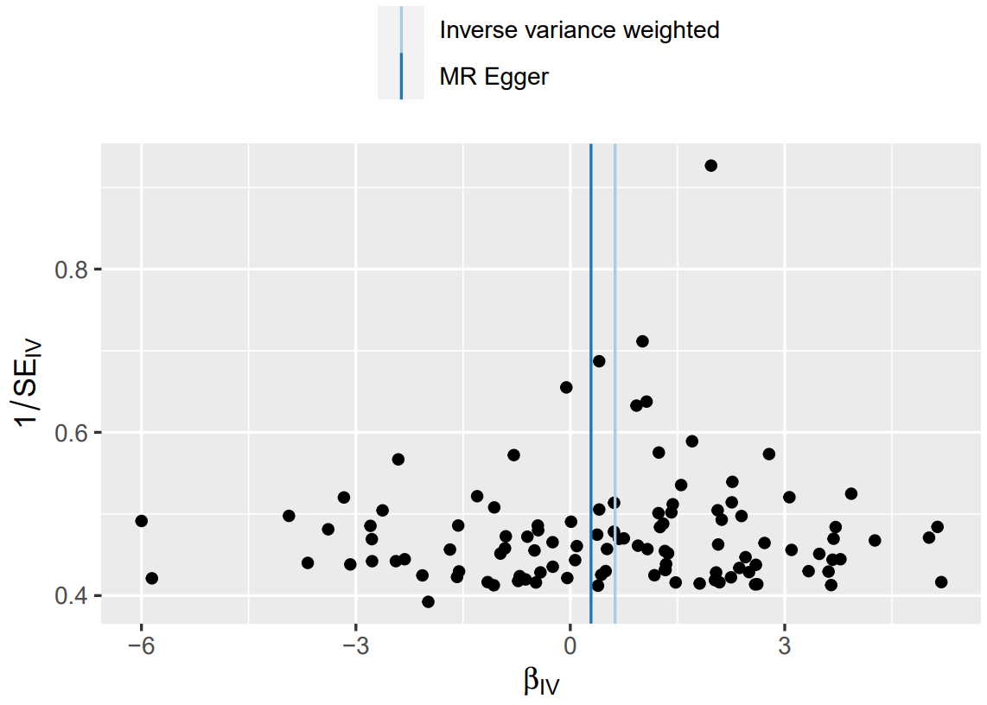

Supplementary Figure 14. Funnel plot picture (Watching TV lead to osteomyelitis).

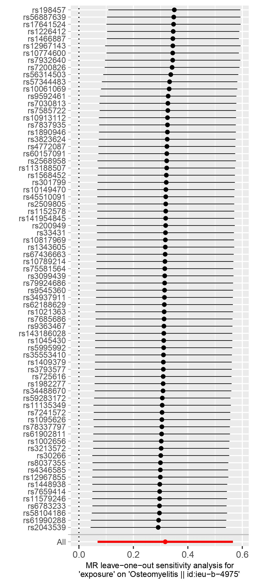

Supplementary Figure 15. Leave-one-out analysis (MDD lead to osteomyelitis).

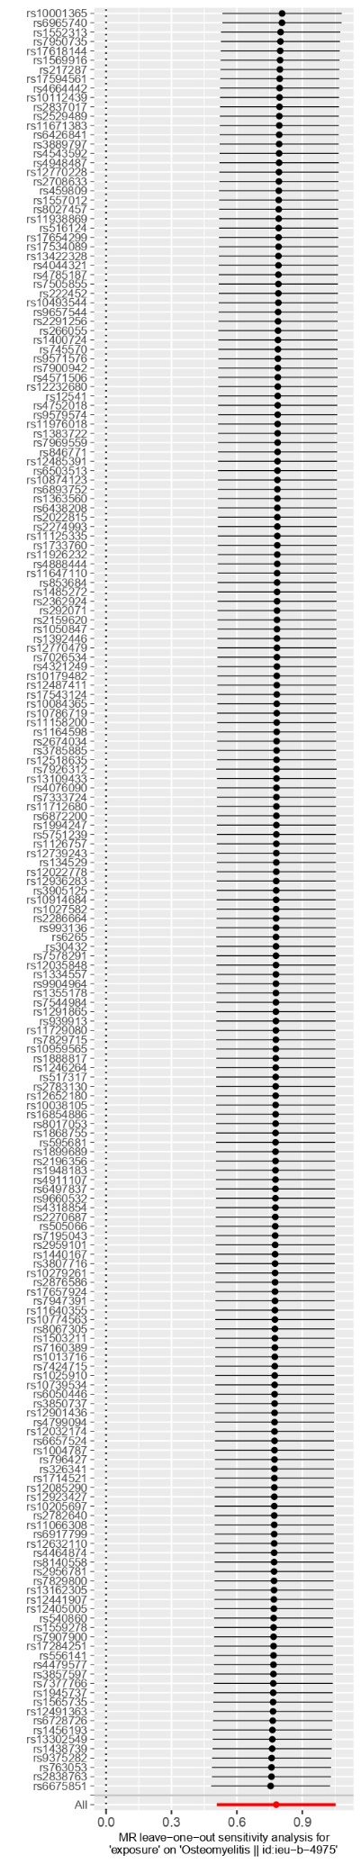

Supplementary Figure 16. Leave-one-out analysis (smoking initiation lead to osteomyelitis).

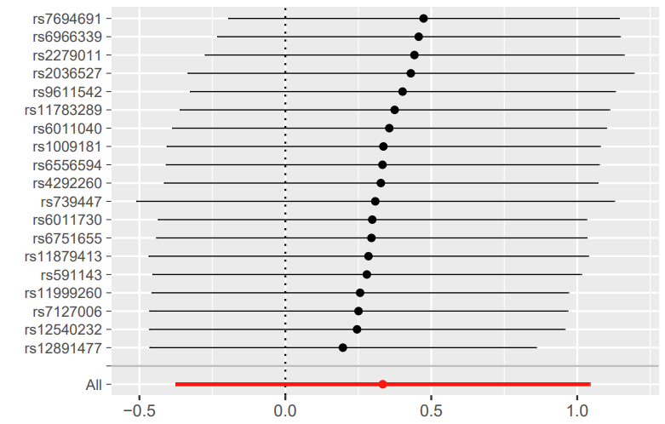

Supplementary Figure 17. Leave-one-out analysis (smoking cessation lead to osteomyelitis).

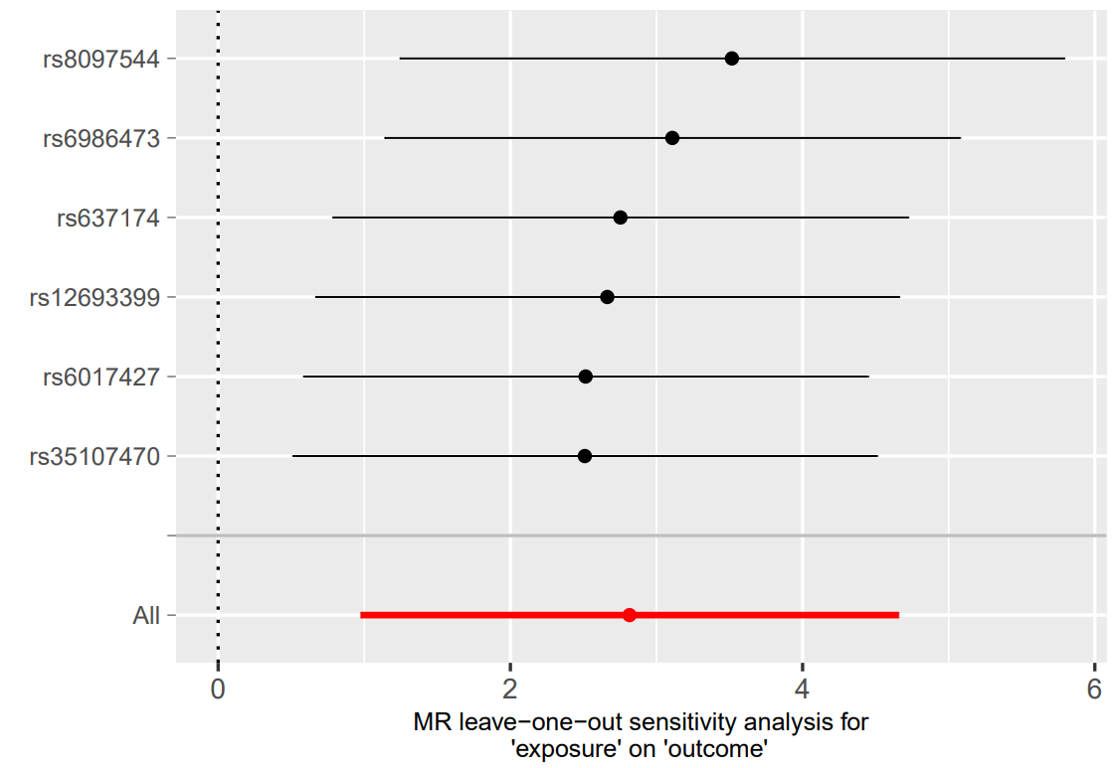

Supplementary Figure 18. Leave-one-out analysis (Breakfast skipping lead to osteomyelitis).



Supplementary Figure 19. Leave-one-out analysis (BMI lead to osteomyelitis).

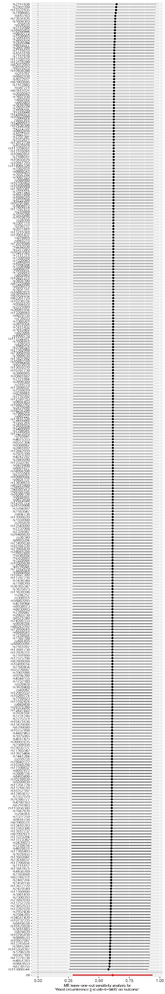

Supplementary Figure 20. Leave-one-out analysis (Waist circumference lead to osteomyelitis).

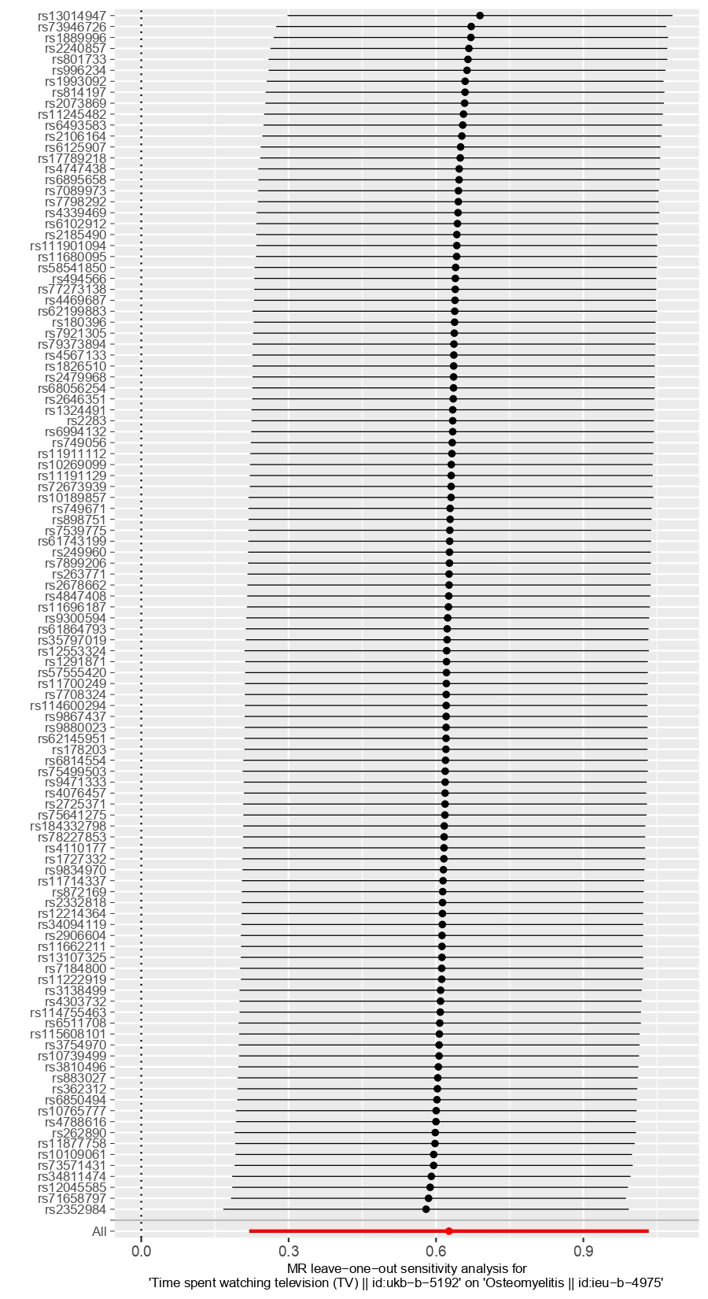

Supplementary Figure 21. Leave-one-out analysis (Watching TV lead to osteomyelitis).