Homework1

Cheng-Han Yu

July 17, 2017

## Load the data

data <- read.csv("../Data/priemelDataReconstruction.csv", header = TRUE)

## Show the data

head(data)

## SerumLevelInNgPerMl OV.BV  
## 1 7.49 0  
## 2 12.00 0  
## 3 7.49 0  
## 4 2.09 0  
## 5 9.12 0  
## 6 4.59 0

## Plot the physiologic response (OV/BV) as a function of serum level.

plot(data$SerumLevelInNgPerMl, data$OV.BV,  
 xlab = "serum", ylab = "physiologic response (OV/BV)")

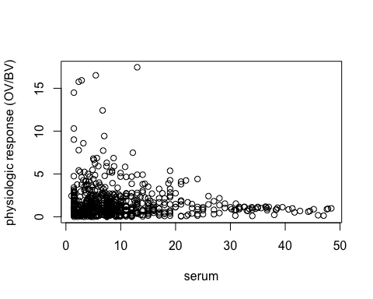

## Describe the trend

The higher the serum level is, the lower the physiologic response is. It seems that the physiologic response and serum level are negatively correlated.

## Logistic Regression

# create a binary variable  
data$OV.BV.bin <- 0  
data$OV.BV.bin[data$OV.BV > 2] <- 1  
# View(data)  
out <- glm(OV.BV.bin ~ SerumLevelInNgPerMl,   
 family = binomial(link = "logit"), data = data)  
summary(out)

##   
## Call:  
## glm(formula = OV.BV.bin ~ SerumLevelInNgPerMl, family = binomial(link = "logit"),   
## data = data)  
##   
## Deviance Residuals:   
## Min 1Q Median 3Q Max   
## -0.8963 -0.8260 -0.7576 1.4874 2.0360   
##   
## Coefficients:  
## Estimate Std. Error z value Pr(>|z|)   
## (Intercept) -0.63719 0.13751 -4.634 3.59e-06 ***  
## SerumLevelInNgPerMl -0.04646 0.01257 -3.696 0.000219 ***  
## ---  
## Signif. codes: 0 '***' 0.001 '**' 0.01 '*' 0.05 '.' 0.1 ' ' 1  
##   
## (Dispersion parameter for binomial family taken to be 1)  
##   
## Null deviance: 768.35 on 674 degrees of freedom  
## Residual deviance: 751.53 on 673 degrees of freedom  
## AIC: 755.53  
##   
## Number of Fisher Scoring iterations: 4

data2 <- data[data$SerumLevelInNgPerMl > 10, ]  
out2 <- glm(OV.BV.bin ~ SerumLevelInNgPerMl,   
 family = binomial(link = "logit"), data = data2)  
summary(out2)

##   
## Call:  
## glm(formula = OV.BV.bin ~ SerumLevelInNgPerMl, family = binomial(link = "logit"),   
## data = data2)  
##   
## Deviance Residuals:   
## Min 1Q Median 3Q Max   
## -0.9827 -0.8103 -0.5375 -0.1977 2.1759   
##   
## Coefficients:  
## Estimate Std. Error z value Pr(>|z|)   
## (Intercept) 0.58182 0.49743 1.170 0.242138   
## SerumLevelInNgPerMl -0.10181 0.02837 -3.588 0.000333 ***  
## ---  
## Signif. codes: 0 '***' 0.001 '**' 0.01 '*' 0.05 '.' 0.1 ' ' 1  
##   
## (Dispersion parameter for binomial family taken to be 1)  
##   
## Null deviance: 217.25 on 207 degrees of freedom  
## Residual deviance: 197.88 on 206 degrees of freedom  
## AIC: 201.88  
##   
## Number of Fisher Scoring iterations: 5

The answer changes much if we restrict the set of patients to exclude those with serum values far from the target level (e.g., 10 nmol/L or less). I would trust the result that excludes higher serum level.

## Describe the fit in text. State what the coefficient values are inline, rounded to 3 decimal places.

The estimated coefficients of the first fit are -0.637 and -0.046. The estimated coefficients of the second fit are 0.582 and -0.102.

## Invoke the earlier plot chunk to set things up, and then superimpose the regression fit.

plot(data$SerumLevelInNgPerMl, data$OV.BV,  
 xlab = "serum", ylab = "physiologic response (OV/BV)")  
abline(h = 2, col = "red")

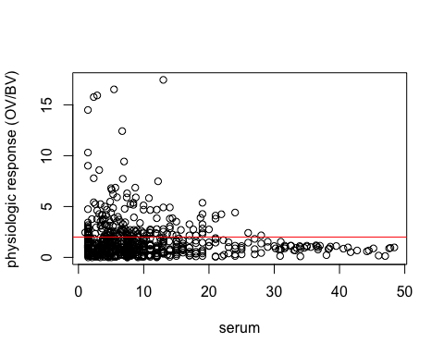

## Use abline to add a horizontal line at your estimate of the serum level at which 97.5% of the people would have their requirements met.

iomreview <- read.csv("../Data/iomReview.csv")  
iomreview <- iomreview[complete.cases(iomreview), ]  
plot(iomreview$IOMIntake, iomreview$IOMLevel)

