SCR Data Summary

library(purrr)  
library(skimr)  
library(here)  
library(tidyverse)  
load(here("data", "clean", "data_xlsx.RData"), verbose = TRUE)

Loading objects:  
 data_xlsx

load(here("data", "clean", "data_1_no_repeat_all.RData"), verbose = TRUE)

Loading objects:  
 data_no_repeat_all

load(here("data", "clean", "data_2_combine_ext.RData"), verbose = TRUE)

Loading objects:  
 data_combine_ext

load(here("data", "clean", "data_3_no_missing.RData"), verbose = TRUE)

Loading objects:  
 data_no_missing

## 1 Data Cleaning

### 1.1 Raw data data_xlsx

The raw data data_xlsx loaded from ./data/raw/2024-07-16_FSARS_EDA_Long_V2_101-269.xlsx contains 124 subjects.

data_xlsx

# A tibble: 20,574 × 11  
 id run condition trial cs_stim_time cs_scl cs_latency cs_amplitude  
 <dbl> <chr> <chr> <dbl> <dbl> <dbl> <dbl> <dbl>  
 1 101 Learning fear 1 95.9 9.91 2.20 0.735  
 2 101 Learning fear 2 259. 7.68 2.26 2.31   
 3 101 Learning fear 3 NA NA NA NA   
 4 101 Learning fear 4 NA NA NA NA   
 5 101 Learning fear 5 NA NA NA NA   
 6 101 Learning fear 6 NA NA NA NA   
 7 101 Learning fear 7 NA NA NA NA   
 8 101 Learning fear 8 NA NA NA NA   
 9 101 Learning fear_safety 1 NA NA NA NA   
10 101 Learning fear_safety 2 NA NA NA NA   
# ℹ 20,564 more rows  
# ℹ 3 more variables: cs_rise_time <dbl>, cs_size <dbl>, cs_onset <dbl>

length(unique(data_xlsx[["id"]]))

[1] 124

### 1.2 Cleaned data data_no_repeat_all

I first clean the dataset. I found that some trial numbers are repeated twice. One has reaction and cs variable values, and the other has no or missing values. I keep the row whose trial has values. The data set that removes all repeated trials with no values is saved in data_no_repeat_all.

data_no_repeat_all

# A tibble: 19,840 × 11  
 id run condition trial cs_stim_time cs_scl cs_latency cs_amplitude  
 <chr> <chr> <fct> <int> <dbl> <dbl> <dbl> <dbl>  
 1 101 Learning fear 1 95.9 9.91 2.20 0.735  
 2 101 Learning fear 2 259. 7.68 2.26 2.31   
 3 101 Learning fear 3 NA NA NA NA   
 4 101 Learning fear 4 NA NA NA NA   
 5 101 Learning fear 5 NA NA NA NA   
 6 101 Learning fear 6 NA NA NA NA   
 7 101 Learning fear 7 NA NA NA NA   
 8 101 Learning fear 8 NA NA NA NA   
 9 101 Learning fear_safety 1 NA NA NA NA   
10 101 Learning fear_safety 2 NA NA NA NA   
# ℹ 19,830 more rows  
# ℹ 3 more variables: cs_rise_time <dbl>, cs_size <dbl>, cs_onset <dbl>

Note that each subject has 4 runs, 5 conditions, and 8 trials, so we have $124×4×5×8=19840$ rows.

Also, we usually use snake_case to name variables, and set character values. So the variable condition has values “safety”, “reward_safety”, “fear_safety”, “reward”, “fear”. The variable run will later change its values to “learn”, “run1”, “run2”, and “run3”.

The variable condition is of type factor having levels

class(data_no_repeat_all$condition)

[1] "factor"

levels(data_no_repeat_all$condition)

[1] "safety" "reward_safety" "fear_safety" "reward"   
[5] "fear"

Levels: safety reward_safety fear_safety reward fear

### 1.3 Cleaned data data_combine_ext

Based on data_no_repeat_all, with Jacklynn’s comments, for the run variable, I further merge Extincti and Run3, renaming all Ectinctis as Run3. The saved data set is data_combine_ext. Also note that the variable run’s value has been changed to learn, run1, run2, run3.

table(data_no_repeat_all$run)

Extincti Learning Run1 Run2 Run3   
 2720 4960 4960 4960 2240

table(data_combine_ext$run)

learn run1 run2 run3   
 4960 4960 4960 4960

### 1.4 Cleaned data data_no_missing

The data further cleaned is data_no_missing that removes all rows with no reaction values or physiological response. There are 2229 trials among 224 subjects that have physiological responses.

data_no_missing

# A tibble: 2,229 × 11  
 id run condition trial cs_stim_time cs_scl cs_latency cs_amplitude  
 <chr> <chr> <fct> <int> <dbl> <dbl> <dbl> <dbl>  
 1 101 learn fear 1 95.9 9.91 2.20 0.735  
 2 101 learn fear 2 259. 7.68 2.26 2.31   
 3 101 learn fear_safety 6 484. 9.05 1.34 3.66   
 4 101 learn reward 1 82.8 10.7 2.19 0.371  
 5 101 learn reward 4 365. 8.56 3.40 1.71   
 6 101 run1 fear 4 979. 10.7 2.35 1.15   
 7 101 run1 fear_safety 3 1030. 10.9 4.18 0.911  
 8 101 run2 fear_safety 6 1762. 13.1 2.53 0.528  
 9 101 run2 reward 5 1718. 9.58 1.48 3.61   
10 101 run2 reward_safety 7 1875. 10.2 3.40 0.789  
# ℹ 2,219 more rows  
# ℹ 3 more variables: cs_rise_time <dbl>, cs_size <dbl>, cs_onset <dbl>

In the experiment, ID 238 and 239 do not have any reaction values, or physiological response to any trials. Both participants are removed.

setdiff(unique(data_xlsx$id), unique(data_no_missing$id))

[1] 238 239

Later we use data_no_missing for analysis. We can always go back to other data sets or the raw data when we need to. The code for cleaning data is saved in 01-data.R.

## 2 Data Summary

### 2.1 Frequency

The frequency table of run is

data <- data_no_missing  
(freq_react_run <- data |> select(run) |> table() )

run  
learn run1 run2 run3   
 823 534 451 421

**Findings**: (Just observed results from data, not formal statistical inference)

* **Learning round has more reactions, and frequency of reaction decays with time passed.**

We can check the contingency table of run and condition.

freq_react_run_cond <- data |> group_by(run) |> select(run, condition) |>   
 table()  
freq_react_run_cond <- cbind(freq_react_run_cond, freq_react_run)  
freq_react_run_cond <- rbind(freq_react_run_cond, apply(freq_react_run_cond, 2, sum))  
freq_react_run_cond

safety reward_safety fear_safety reward fear freq_react_run  
learn 140 120 149 137 277 823  
run1 61 91 87 104 191 534  
run2 92 83 70 82 124 451  
run3 80 73 90 72 106 421  
 373 367 396 395 698 2229

round(freq_react_run_cond / max(freq_react_run_cond), 2)

safety reward_safety fear_safety reward fear freq_react_run  
learn 0.06 0.05 0.07 0.06 0.12 0.37  
run1 0.03 0.04 0.04 0.05 0.09 0.24  
run2 0.04 0.04 0.03 0.04 0.06 0.20  
run3 0.04 0.03 0.04 0.03 0.05 0.19  
 0.17 0.16 0.18 0.18 0.31 1.00

**Findings**: (Just observed results from data, not formal statistical inference)

* **Participants have more physiological responses to condition fear.**
* **For other conditions, their number of responses are not very different.**
* **The number of responses with fear and reward decreases faster. (Check their percentage).**

I then check how condition and trial are associated with the response frequencies. Frequencies with and without Learning run are both considered.

**Findings**: (Just observed results from data, not formal statistical inference)

* **Participants tend to have reactions in the first trial, especially for “fear” condition.**
* **The number of physiological response is decreasing with trial orders when the learning run is included.**
* **The decreasing pattern is not obvious for other condition types when the learning run is not included.**
* **The number seems to increase back a little bit in 7th and 8th trial.**

data_cond_trial <- data |> group_by(condition) |> select(trial) |> table()  
  
par(mfrow = c(2, 3), mar = c(4, 4, 2, 1))  
for (i in seq_along(rownames(data_cond_trial))) {  
 barplot(data_cond_trial[i, ],   
 main = paste(rownames(data_cond_trial)[i], "w/ learn"), las = 1,  
 xlab = "trial", ylab = "number of reactions", ylim = c(0, 120))  
}

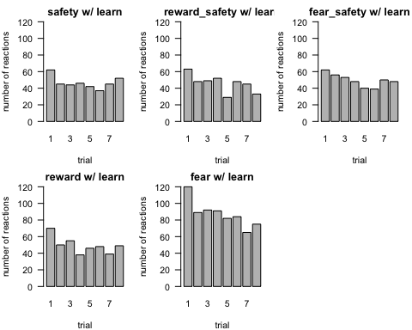

## remove learn run  
data_cond_trial_no_learn <- data |> group_by(condition) |>   
 filter(run != "learn") |>   
 select(trial) |>   
 table()  
  
par(mfrow = c(2, 3), mar = c(4, 4, 2, 1))  
for (i in seq_along(rownames(data_cond_trial_no_learn))) {  
 barplot(data_cond_trial_no_learn[i, ],   
 main = paste(rownames(data_cond_trial)[i], "w/o learn"), las = 1,  
 xlab = "trial", ylab = "number of reactions", ylim = c(0, 85))  
}

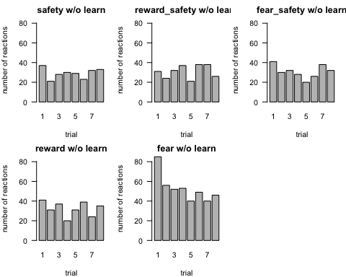

### 2.2 Summary statistics for CS related variables

[Note:] *The learning run is removed from the analysis*.

Here I summarize all the CS related variables except cs_stim_time that is irrelevant to our study. The summary statistics include the minimum value, 1st quartile (25% percentile), median (50% percentile), 3rd quartile (75% percentile), maximum value, and the standard deviation.

Here the statistics are summarized by trial condition.

**Findings**: (Just observed results from data, not formal statistical inference)

* Hard to see and conclude any effect of condition on the cs related variables. We can discuss it later.
* One thing I’m confused is that some amplitudes are ZERO. I wonder if it is a typo.

data_split_cond <- data |>   
 filter(run != "learn") %>%  
 split(.$condition)  
  
cs_sum_cond <- lapply(data_split_cond, function(x) apply(x[, -c(1:5)], 2, summary))  
cs_sd_cond <- lapply(data_split_cond, function(x) apply(x[, -c(1:5)], 2, sd))  
cs_summ_cond <- vector("list", 5)  
for (i in 1:5) {  
 cs_summ_cond[[i]] <- rbind(cs_sum_cond[[i]], cs_sd_cond[[i]])  
 rownames(cs_summ_cond[[i]]) <-  
 c("min", "1stQ", "med", "mean", "3rdQ", "max", "sd")  
}  
names(cs_summ_cond) <- levels(data$condition)  
lapply(cs_summ_cond, function(x) round(x, digits = 3))

$safety  
 cs_scl cs_latency cs_amplitude cs_rise_time cs_size cs_onset  
min 0.211 1.023 0.000 0.012 0.470 0.117  
1stQ 5.258 1.782 0.319 1.287 5.537 5.165  
med 8.823 2.546 0.771 2.727 10.100 8.961  
mean 8.773 2.710 1.179 3.782 9.906 8.727  
3rdQ 12.459 3.586 1.465 4.843 13.434 12.299  
max 25.539 4.960 12.703 24.185 28.032 25.600  
sd 4.806 1.114 1.435 3.772 5.270 4.814  
  
$reward_safety  
 cs_scl cs_latency cs_amplitude cs_rise_time cs_size cs_onset  
min 0.409 1.014 0.000 0.000 0.621 0.406  
1stQ 5.660 1.692 0.285 1.241 6.399 5.678  
med 9.183 2.348 0.691 2.455 10.127 8.926  
mean 9.119 2.510 1.093 3.863 10.172 9.079  
3rdQ 12.447 3.228 1.425 5.479 13.678 12.317  
max 25.275 4.891 10.481 21.797 26.624 25.067  
sd 4.907 0.986 1.402 3.583 5.237 4.867  
  
$fear_safety  
 cs_scl cs_latency cs_amplitude cs_rise_time cs_size cs_onset  
min -0.105 1.017 0.002 0.050 0.652 -0.012  
1stQ 5.756 1.801 0.362 1.366 6.699 5.717  
med 9.525 2.493 0.674 2.227 10.718 9.520  
mean 9.409 2.624 1.061 3.250 10.446 9.384  
3rdQ 12.979 3.435 1.273 4.338 14.080 12.876  
max 24.583 4.945 12.119 20.726 28.145 25.478  
sd 4.721 1.048 1.285 2.938 5.086 4.676  
  
$reward  
 cs_scl cs_latency cs_amplitude cs_rise_time cs_size cs_onset  
min 0.540 1.025 0.000 0.005 1.181 0.494  
1stQ 6.265 1.800 0.333 1.306 6.890 6.340  
med 9.136 2.525 0.671 2.383 10.211 9.114  
mean 9.337 2.601 1.043 3.383 10.353 9.310  
3rdQ 12.282 3.282 1.216 4.303 13.236 12.231  
max 24.588 4.947 9.590 23.538 29.082 24.272  
sd 4.359 0.976 1.265 3.253 4.769 4.354  
  
$fear  
 cs_scl cs_latency cs_amplitude cs_rise_time cs_size cs_onset  
min 0.768 1.033 0.002 0.026 0.862 0.784  
1stQ 5.495 1.999 0.427 1.433 6.694 5.421  
med 9.329 2.420 0.822 3.135 10.414 9.279  
mean 9.176 2.576 1.217 3.414 10.362 9.145  
3rdQ 12.486 3.032 1.654 4.855 13.776 12.502  
max 24.986 4.975 11.244 17.596 26.611 24.844  
sd 4.704 0.900 1.308 2.373 5.108 4.701

Here shows the data that have amplitude value zero.

lapply(data_split_cond, function(x) {  
 if (length(which(x$cs_amplitude == 0)) > 0) {  
 x[which(x$cs_amplitude == 0), ]  
 }})

$safety  
# A tibble: 1 × 11  
 id run condition trial cs_stim_time cs_scl cs_latency cs_amplitude  
 <chr> <chr> <fct> <int> <dbl> <dbl> <dbl> <dbl>  
1 158 run1 safety 3 984. 12.5 1.43 0  
# ℹ 3 more variables: cs_rise_time <dbl>, cs_size <dbl>, cs_onset <dbl>  
  
$reward_safety  
# A tibble: 2 × 11  
 id run condition trial cs_stim_time cs_scl cs_latency cs_amplitude  
 <chr> <chr> <fct> <int> <dbl> <dbl> <dbl> <dbl>  
1 103 run3 reward_safety 5 2405. 14.8 2.74 0  
2 250 run1 reward_safety 3 964. 8.62 1.80 0  
# ℹ 3 more variables: cs_rise_time <dbl>, cs_size <dbl>, cs_onset <dbl>  
  
$fear_safety  
NULL  
  
$reward  
# A tibble: 2 × 11  
 id run condition trial cs_stim_time cs_scl cs_latency cs_amplitude  
 <chr> <chr> <fct> <int> <dbl> <dbl> <dbl> <dbl>  
1 200 run2 reward 3 1892. 11.9 1.72 0  
2 256 run3 reward 1 2377. 15.8 2.06 0  
# ℹ 3 more variables: cs_rise_time <dbl>, cs_size <dbl>, cs_onset <dbl>  
  
$fear  
NULL

cs_var_name <- c("Base Level",  
 "Latency",  
 "Amplitude",  
 "Rise Time",  
 "Reaction Size",  
 "Onset")  
for (k in seq_along(names(data_split_cond[[1]][-c(1:5)]))) {  
 par(mfrow = c(2, 3), mar = c(4, 4, 2, 1))  
 lapply(1:5, function(x) hist(data_split_cond[[x]][[k+5]],  
 main = names(data_split_cond)[x],  
 xlab = cs_var_name[k], las = 1,   
 font.lab = 2, breaks = 15))  
}

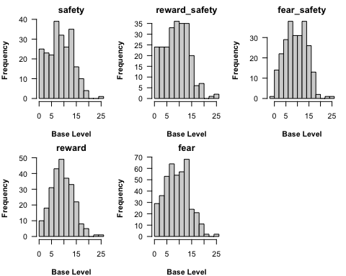

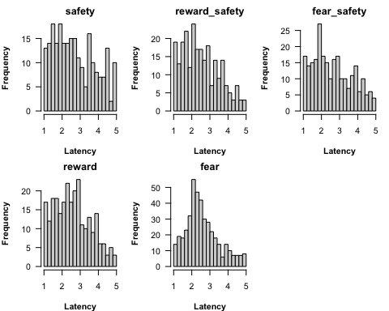

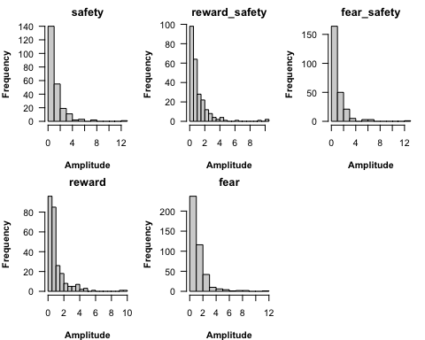

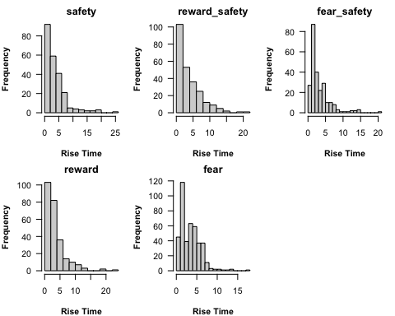

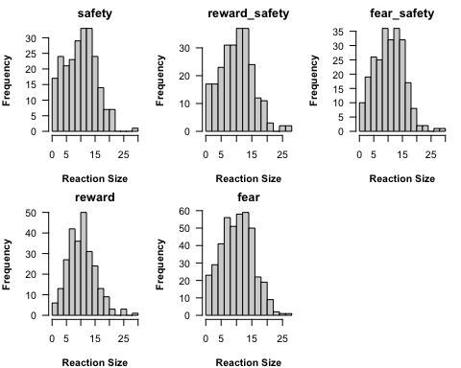

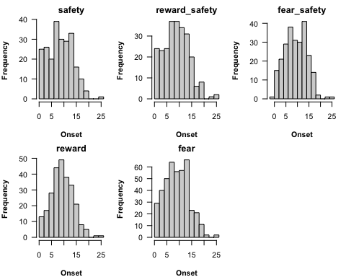

The summary grouped by cs variables is shown below.

cs_summ_cond_var <- vector("list", length(names(data_split_cond[[1]][-c(1:5)])))  
  
for (k in seq_along(names(data_split_cond[[1]][-c(1:5)]))) {  
 cs_summ_cond_var[[k]] <- sapply(cs_summ_cond, function(x) x[, k])  
}  
names(cs_summ_cond_var) <- colnames(data_no_missing)[-c(1:5)]  
lapply(cs_summ_cond_var, function(x) round(x, digits = 3))

$cs_scl  
 safety reward_safety fear_safety reward fear  
min 0.211 0.409 -0.105 0.540 0.768  
1stQ 5.258 5.660 5.756 6.265 5.495  
med 8.823 9.183 9.525 9.136 9.329  
mean 8.773 9.119 9.409 9.337 9.176  
3rdQ 12.459 12.447 12.979 12.282 12.486  
max 25.539 25.275 24.583 24.588 24.986  
sd 4.806 4.907 4.721 4.359 4.704  
  
$cs_latency  
 safety reward_safety fear_safety reward fear  
min 1.023 1.014 1.017 1.025 1.033  
1stQ 1.782 1.692 1.801 1.800 1.999  
med 2.546 2.348 2.493 2.525 2.420  
mean 2.710 2.510 2.624 2.601 2.576  
3rdQ 3.586 3.228 3.435 3.282 3.032  
max 4.960 4.891 4.945 4.947 4.975  
sd 1.114 0.986 1.048 0.976 0.900  
  
$cs_amplitude  
 safety reward_safety fear_safety reward fear  
min 0.000 0.000 0.002 0.000 0.002  
1stQ 0.319 0.285 0.362 0.333 0.427  
med 0.771 0.691 0.674 0.671 0.822  
mean 1.179 1.093 1.061 1.043 1.217  
3rdQ 1.465 1.425 1.273 1.216 1.654  
max 12.703 10.481 12.119 9.590 11.244  
sd 1.435 1.402 1.285 1.265 1.308  
  
$cs_rise_time  
 safety reward_safety fear_safety reward fear  
min 0.012 0.000 0.050 0.005 0.026  
1stQ 1.287 1.241 1.366 1.306 1.433  
med 2.727 2.455 2.227 2.383 3.135  
mean 3.782 3.863 3.250 3.383 3.414  
3rdQ 4.843 5.479 4.338 4.303 4.855  
max 24.185 21.797 20.726 23.538 17.596  
sd 3.772 3.583 2.938 3.253 2.373  
  
$cs_size  
 safety reward_safety fear_safety reward fear  
min 0.470 0.621 0.652 1.181 0.862  
1stQ 5.537 6.399 6.699 6.890 6.694  
med 10.100 10.127 10.718 10.211 10.414  
mean 9.906 10.172 10.446 10.353 10.362  
3rdQ 13.434 13.678 14.080 13.236 13.776  
max 28.032 26.624 28.145 29.082 26.611  
sd 5.270 5.237 5.086 4.769 5.108  
  
$cs_onset  
 safety reward_safety fear_safety reward fear  
min 0.117 0.406 -0.012 0.494 0.784  
1stQ 5.165 5.678 5.717 6.340 5.421  
med 8.961 8.926 9.520 9.114 9.279  
mean 8.727 9.079 9.384 9.310 9.145  
3rdQ 12.299 12.317 12.876 12.231 12.502  
max 25.600 25.067 25.478 24.272 24.844  
sd 4.814 4.867 4.676 4.354 4.701

### 2.3 Summary statistics for CS related variables with trials

In this section, I examine the summary statistics for CS related variables a bit further by including trial orders to see if there is any trial effect. Again, this is a descriptive analysis that help us somewhat know the data. A formal statistical inference is needed if we would like to make any inference conclusions.

The followings show the histograms of cs related variables by trial condition and trial order. At the bottom we have numerical summaries. Maybe there is some interesting pattern or result out there, but I can’t find them at this moment. We can check more later.

cond_levels <- levels(data$condition)  
  
cs_cond_trial_lst <- vector("list", length(cond_levels))  
  
for (j in seq_along(cond_levels)) {  
 data_cond <- data |>   
 filter(condition == cond_levels[j]) |>   
 filter(run != "learn") |>   
 select(-c(id, run, condition, cs_stim_time))  
   
 data_cond_trial <- data_cond %>% split(.$trial)  
 data_cond_trial <- lapply(data_cond_trial, function(x) select(x, -trial))  
   
   
 cs_sum_trial <- lapply(data_cond_trial, function(x) apply(x, 2, summary))  
 cs_sd_trial <- lapply(data_cond_trial, function(x) apply(x, 2, sd))  
 cs_summ_trial <- vector("list", 8)  
 for (i in 1:8) {  
 cs_summ_trial[[i]] <- rbind(cs_sum_trial[[i]], cs_sd_trial[[i]])  
 rownames(cs_summ_trial[[i]]) <-  
 c("min", "1stQ", "med", "mean", "3rdQ", "max", "sd")  
 }  
   
 names(cs_summ_trial) <- paste("trial", 1:8, sep = "_")  
 names(data_cond_trial) <- paste("trial", 1:8, sep = "_")  
   
 cs_cond_trial_lst[[j]] <- cs_summ_trial  
 par(mfrow = c(2, 4), mar = c(4, 4, 2, 1))  
 for (k in seq_along(names(data_cond_trial[[1]]))) {  
 lapply(1:8, function(x) hist(data_cond_trial[[x]][[k]],  
 main = paste(names(data_cond_trial)[x],   
 cond_levels[j]),  
 xlab = cs_var_name[k], las = 1,  
 font.lab = 2))  
 }  
}

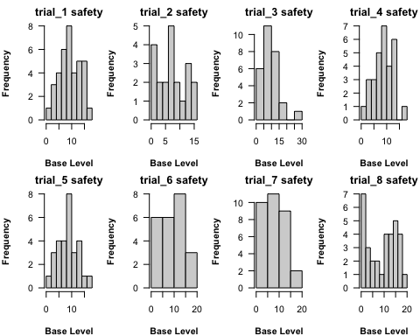

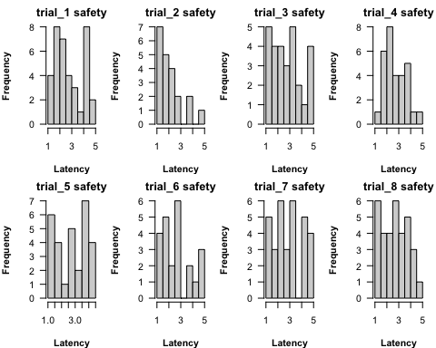

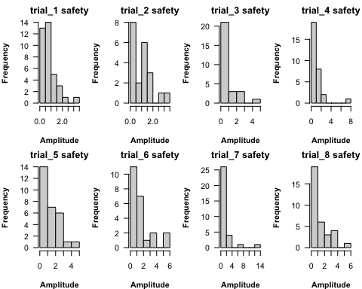

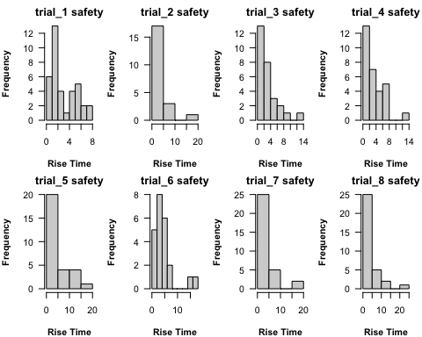

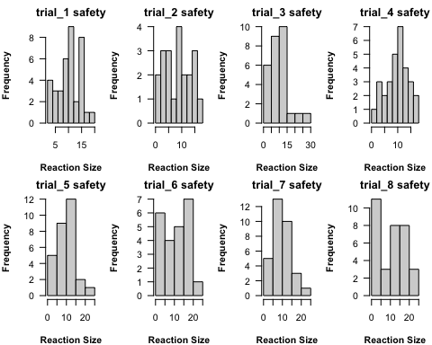

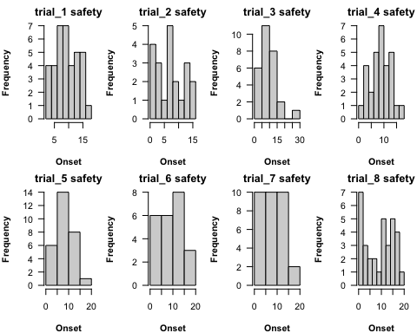

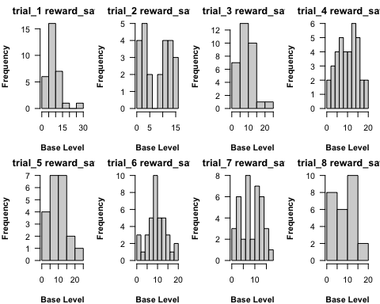

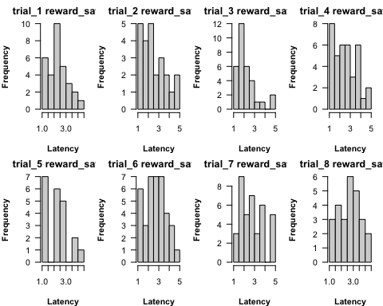

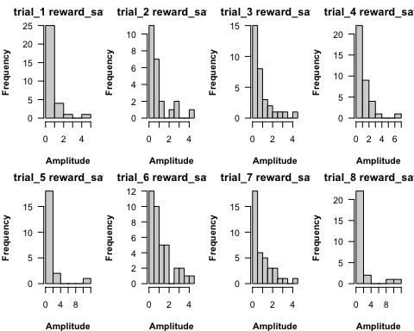

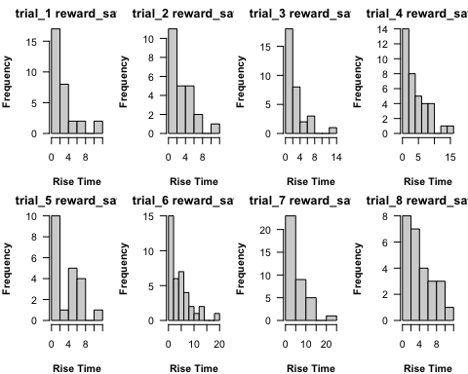

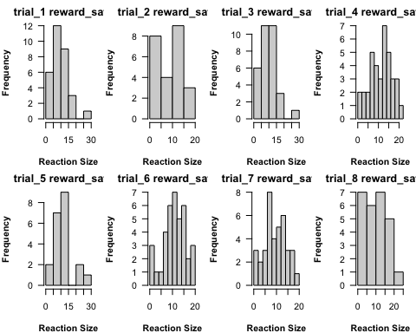

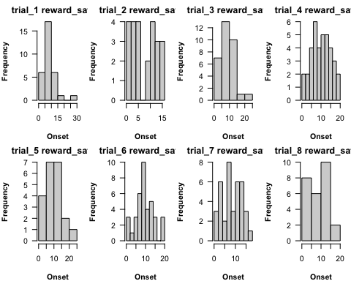

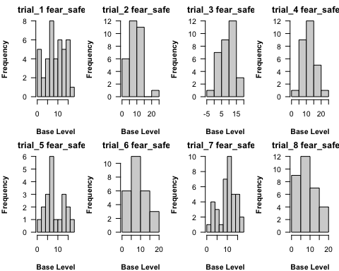

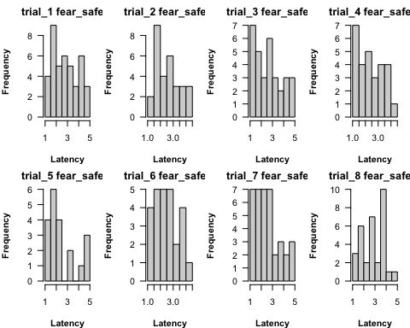

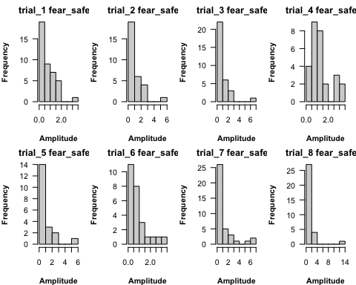

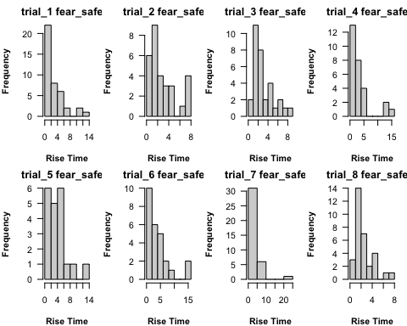

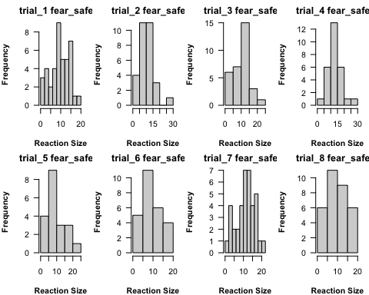

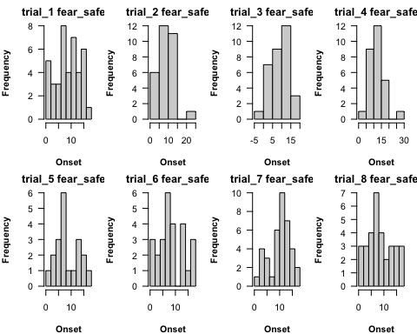

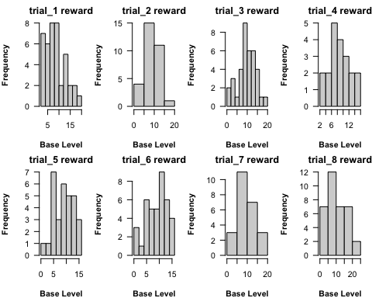

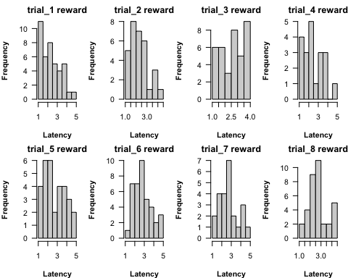

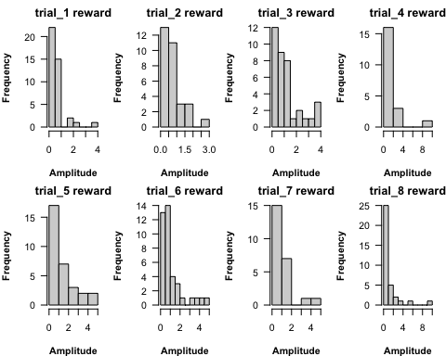

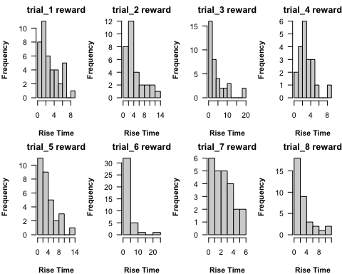

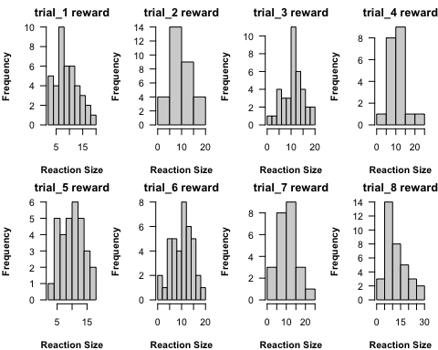

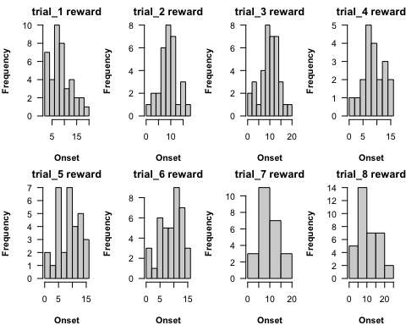

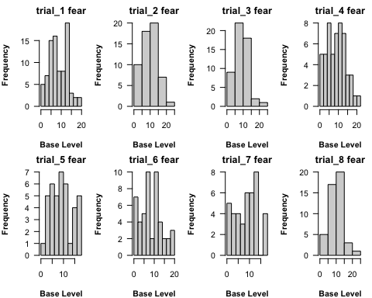

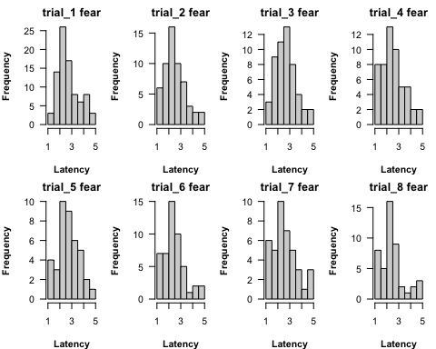

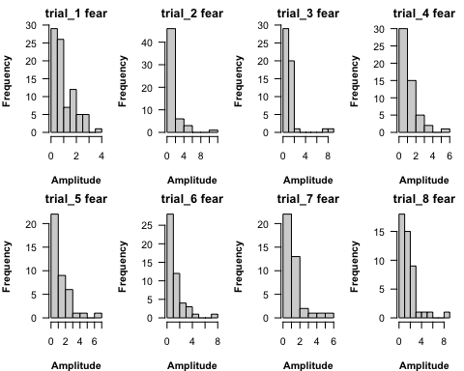

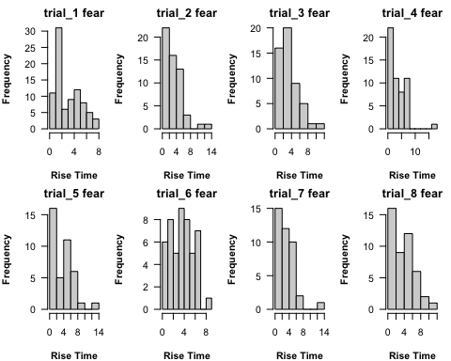

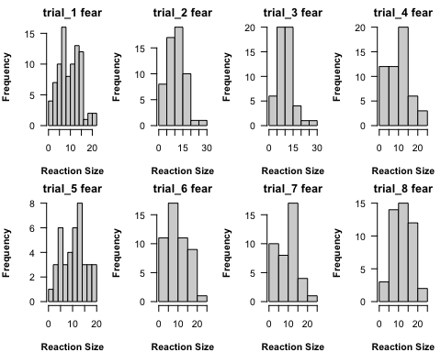

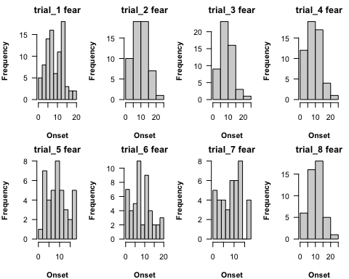

names(cs_cond_trial_lst) <- cond_levels  
lapply(cs_cond_trial_lst, function(x) lapply(x, function(y) round(y, digits = 3)))

$safety  
$safety$trial_1  
 cs_scl cs_latency cs_amplitude cs_rise_time cs_size cs_onset  
min 1.158 1.157 0.002 0.072 3.191 2.859  
1stQ 7.063 1.840 0.407 1.250 7.742 7.043  
med 9.604 2.448 0.813 1.757 10.136 9.560  
mean 9.527 2.813 0.877 2.854 10.431 9.553  
3rdQ 12.938 4.050 1.199 4.805 14.471 12.782  
max 17.511 4.957 3.455 7.626 18.669 17.204  
sd 3.980 1.193 0.682 2.235 4.173 3.879  
  
$safety$trial_2  
 cs_scl cs_latency cs_amplitude cs_rise_time cs_size cs_onset  
min 0.427 1.035 0.002 0.012 1.328 0.401  
1stQ 3.958 1.277 0.169 0.756 4.169 3.960  
med 7.758 1.841 1.031 1.557 8.516 7.678  
mean 7.505 2.049 0.947 3.028 8.416 7.469  
3rdQ 11.833 2.451 1.147 3.817 12.445 11.752  
max 15.195 4.779 3.172 19.633 16.243 15.199  
sd 4.576 1.001 0.884 4.299 4.769 4.533  
  
$safety$trial_3  
 cs_scl cs_latency cs_amplitude cs_rise_time cs_size cs_onset  
min 0.745 1.023 0.000 0.026 0.873 0.768  
1stQ 5.751 1.719 0.226 1.196 6.408 5.774  
med 7.726 2.571 0.497 2.187 9.077 7.660  
mean 8.979 2.738 0.863 2.970 9.845 8.983  
3rdQ 11.834 3.532 1.056 3.922 12.677 11.803  
max 25.539 4.870 4.323 13.783 28.032 25.600  
sd 5.593 1.167 1.023 2.955 6.042 5.621  
  
$safety$trial_4  
 cs_scl cs_latency cs_amplitude cs_rise_time cs_size cs_onset  
min 0.880 1.225 0.087 0.405 1.031 0.919  
1stQ 6.305 2.013 0.275 1.223 6.641 6.283  
med 8.962 2.517 0.548 2.307 10.155 8.900  
mean 8.736 2.714 1.059 3.455 9.753 8.695  
3rdQ 11.590 3.360 1.440 5.285 13.031 11.367  
max 16.191 4.960 7.718 13.846 17.323 16.190  
sd 3.822 0.919 1.433 2.946 4.388 3.807  
  
$safety$trial_5  
 cs_scl cs_latency cs_amplitude cs_rise_time cs_size cs_onset  
min 0.890 1.034 0.015 0.198 0.470 0.417  
1stQ 5.815 1.558 0.272 1.560 5.527 5.229  
med 9.082 2.764 1.019 3.066 10.590 9.050  
mean 8.618 2.758 1.296 4.782 9.679 8.383  
3rdQ 10.609 3.651 2.013 5.594 12.769 10.608  
max 17.587 4.472 4.469 18.879 21.115 17.419  
sd 3.847 1.112 1.199 4.550 4.887 4.062  
  
$safety$trial_6  
 cs_scl cs_latency cs_amplitude cs_rise_time cs_size cs_onset  
min 0.476 1.260 0.198 0.145 1.251 0.497  
1stQ 4.398 1.779 0.519 2.270 4.977 4.354  
med 9.363 2.558 1.086 3.955 10.527 9.341  
mean 8.956 2.702 1.470 4.517 10.432 8.961  
3rdQ 13.487 3.423 1.350 4.918 15.256 13.538  
max 19.128 4.957 5.618 16.857 21.606 19.069  
sd 5.727 1.173 1.510 4.012 6.227 5.734  
  
$safety$trial_7  
 cs_scl cs_latency cs_amplitude cs_rise_time cs_size cs_onset  
min 0.211 1.099 0.079 0.561 1.367 0.117  
1stQ 3.820 2.136 0.381 1.616 6.549 3.804  
med 7.053 2.796 0.652 3.130 8.224 7.163  
mean 7.940 2.956 1.574 4.229 9.506 7.932  
3rdQ 12.168 4.149 1.453 4.849 12.875 12.029  
max 19.394 4.871 12.703 18.358 20.738 19.482  
sd 4.825 1.195 2.500 4.167 4.812 4.814  
  
$safety$trial_8  
 cs_scl cs_latency cs_amplitude cs_rise_time cs_size cs_onset  
min 1.161 1.059 0.008 0.828 1.433 1.088  
1stQ 3.609 1.892 0.415 1.694 4.460 3.674  
med 10.751 2.662 0.786 2.963 12.334 10.602  
mean 9.408 2.712 1.351 4.463 10.676 9.325  
3rdQ 14.214 3.586 1.921 4.570 16.069 14.151  
max 18.898 4.891 5.466 24.185 21.275 19.380  
sd 5.999 1.038 1.339 4.550 6.820 5.995  
  
  
$reward_safety  
$reward_safety$trial_1  
 cs_scl cs_latency cs_amplitude cs_rise_time cs_size cs_onset  
min 1.392 1.014 0.003 0.866 1.508 1.427  
1stQ 5.621 1.628 0.194 1.182 5.774 5.625  
med 8.348 2.177 0.455 1.754 9.578 8.273  
mean 8.841 2.295 0.711 2.918 9.499 8.788  
3rdQ 10.706 2.897 0.874 3.387 11.069 10.526  
max 25.275 4.262 4.753 11.387 25.966 25.067  
sd 4.918 0.838 0.906 2.777 5.245 4.864  
  
$reward_safety$trial_2  
 cs_scl cs_latency cs_amplitude cs_rise_time cs_size cs_onset  
min 1.205 1.264 0.015 0.689 1.607 1.427  
1stQ 3.180 1.761 0.257 1.127 4.065 3.217  
med 9.100 2.180 0.534 2.062 8.401 7.102  
mean 8.090 2.547 0.873 3.141 8.647 7.774  
3rdQ 12.405 3.337 0.941 5.054 12.786 11.906  
max 15.614 4.778 4.147 10.726 18.628 15.953  
sd 5.140 1.085 1.025 2.598 5.265 5.038  
  
$reward_safety$trial_3  
 cs_scl cs_latency cs_amplitude cs_rise_time cs_size cs_onset  
min 1.271 1.134 0.000 0.000 1.591 1.427  
1stQ 5.800 1.604 0.314 0.951 6.216 5.820  
med 8.600 1.831 0.587 1.640 9.346 8.525  
mean 8.721 2.153 0.904 2.609 9.641 8.737  
3rdQ 11.605 2.407 1.233 3.573 13.077 11.654  
max 23.962 4.891 4.147 12.286 26.512 23.857  
sd 5.019 0.932 0.970 2.726 5.347 4.990  
  
$reward_safety$trial_4  
 cs_scl cs_latency cs_amplitude cs_rise_time cs_size cs_onset  
min 1.283 1.040 0.002 0.257 1.767 1.321  
1stQ 6.500 1.625 0.510 1.151 7.457 6.813  
med 10.205 2.490 0.864 2.585 12.524 10.075  
mean 10.063 2.520 1.194 3.965 11.341 10.147  
3rdQ 13.780 3.319 1.677 6.518 14.621 13.759  
max 19.701 4.608 6.145 14.193 20.830 19.667  
sd 4.927 1.033 1.178 3.636 5.207 4.818  
  
$reward_safety$trial_5  
 cs_scl cs_latency cs_amplitude cs_rise_time cs_size cs_onset  
min 0.778 1.160 0.000 0.059 4.230 0.639  
1stQ 5.656 1.428 0.346 1.231 7.149 5.769  
med 9.727 2.248 0.658 3.596 10.736 9.741  
mean 10.174 2.302 1.358 3.699 11.530 10.172  
3rdQ 12.459 2.742 1.682 5.880 14.087 12.442  
max 24.220 4.366 10.481 11.598 26.624 24.170  
sd 5.822 0.908 2.220 3.059 5.780 5.830  
  
$reward_safety$trial_6  
 cs_scl cs_latency cs_amplitude cs_rise_time cs_size cs_onset  
min 0.990 1.062 0.069 0.516 1.091 1.016  
1stQ 7.703 2.034 0.440 1.376 8.136 7.661  
med 9.195 2.689 0.870 3.351 11.113 9.122  
mean 9.786 2.704 1.206 4.577 10.980 9.774  
3rdQ 12.803 3.376 1.659 6.197 14.374 12.793  
max 19.313 4.811 4.457 18.418 19.771 19.362  
sd 4.479 0.964 1.117 4.200 4.779 4.490  
  
$reward_safety$trial_7  
 cs_scl cs_latency cs_amplitude cs_rise_time cs_size cs_onset  
min 1.025 1.074 0.002 0.027 1.033 1.031  
1stQ 5.316 1.772 0.266 1.959 7.267 5.213  
med 8.579 2.723 0.720 3.711 9.194 8.497  
mean 8.748 2.778 1.006 5.171 9.672 8.666  
3rdQ 12.102 3.616 1.440 6.631 12.972 12.014  
max 17.462 4.817 4.382 21.797 19.562 17.334  
sd 4.384 1.074 0.989 4.713 4.610 4.281  
  
$reward_safety$trial_8  
 cs_scl cs_latency cs_amplitude cs_rise_time cs_size cs_onset  
min 0.409 1.097 0.027 0.785 0.621 0.406  
1stQ 4.200 1.978 0.254 1.819 5.381 4.152  
med 8.614 2.607 0.792 3.049 10.266 8.624  
mean 8.262 2.648 1.593 4.227 9.824 8.231  
3rdQ 12.365 3.231 1.558 6.007 13.620 12.374  
max 17.387 4.495 10.017 10.093 24.960 17.375  
sd 5.191 0.921 2.523 2.999 6.058 5.153  
  
  
$fear_safety  
$fear_safety$trial_1  
 cs_scl cs_latency cs_amplitude cs_rise_time cs_size cs_onset  
min 1.308 1.339 0.002 0.050 1.410 1.308  
1stQ 5.939 1.733 0.331 1.256 6.621 5.916  
med 8.456 2.738 0.536 1.820 9.665 8.374  
mean 8.953 2.820 0.761 3.105 9.661 8.900  
3rdQ 12.715 3.818 1.073 4.511 13.171 12.686  
max 17.783 4.686 3.476 12.197 19.611 17.728  
sd 4.506 1.095 0.681 2.921 4.799 4.487  
  
$fear_safety$trial_2  
 cs_scl cs_latency cs_amplitude cs_rise_time cs_size cs_onset  
min 0.258 1.017 0.070 0.067 2.005 0.323  
1stQ 5.386 1.898 0.282 1.366 5.648 5.387  
med 8.026 2.478 0.628 2.000 9.464 8.017  
mean 8.829 2.601 1.040 2.882 9.841 8.801  
3rdQ 12.408 3.259 1.265 4.181 13.055 12.140  
max 23.685 4.468 5.597 7.724 26.414 23.711  
sd 4.772 0.929 1.146 2.236 5.138 4.754  
  
$fear_safety$trial_3  
 cs_scl cs_latency cs_amplitude cs_rise_time cs_size cs_onset  
min -0.105 1.079 0.076 0.145 1.938 -0.012  
1stQ 6.101 1.605 0.431 1.491 6.693 6.101  
med 8.934 2.591 0.755 2.485 10.699 8.949  
mean 9.463 2.658 1.104 3.031 10.548 9.444  
3rdQ 12.943 3.357 1.367 4.090 13.329 12.747  
max 19.476 4.945 6.558 8.291 23.705 18.282  
sd 4.996 1.163 1.215 2.048 5.154 4.854  
  
$fear_safety$trial_4  
 cs_scl cs_latency cs_amplitude cs_rise_time cs_size cs_onset  
min 3.078 1.024 0.226 0.832 4.193 3.258  
1stQ 9.121 1.489 0.704 1.362 9.992 9.048  
med 12.129 2.297 1.021 2.257 13.510 12.098  
mean 11.807 2.424 1.271 3.668 13.117 11.846  
3rdQ 14.302 3.228 1.559 3.928 15.591 14.257  
max 24.583 4.299 3.473 14.531 28.145 25.478  
sd 4.516 0.989 0.902 3.762 4.820 4.607  
  
$fear_safety$trial_5  
 cs_scl cs_latency cs_amplitude cs_rise_time cs_size cs_onset  
min 1.891 1.053 0.064 0.882 2.068 1.906  
1stQ 5.762 1.819 0.300 1.866 6.231 5.800  
med 7.235 2.062 0.588 3.286 8.337 7.281  
mean 8.615 2.544 0.986 4.025 9.562 8.576  
3rdQ 12.732 3.190 1.058 4.765 13.320 12.698  
max 17.964 4.895 5.431 13.408 23.375 17.944  
sd 4.501 1.223 1.231 3.054 5.164 4.416  
  
$fear_safety$trial_6  
 cs_scl cs_latency cs_amplitude cs_rise_time cs_size cs_onset  
min 0.874 1.062 0.029 0.621 1.241 1.083  
1stQ 5.190 1.780 0.300 1.515 5.514 5.209  
med 7.761 2.355 0.595 2.677 8.334 7.805  
mean 8.647 2.450 0.812 4.027 9.462 8.650  
3rdQ 13.025 3.037 0.989 5.001 13.713 12.852  
max 17.725 4.249 3.134 14.534 19.611 17.499  
sd 4.872 0.915 0.805 3.669 5.327 4.833  
  
$fear_safety$trial_7  
 cs_scl cs_latency cs_amplitude cs_rise_time cs_size cs_onset  
min 1.477 1.044 0.015 0.398 1.521 1.506  
1stQ 8.237 1.828 0.370 1.265 9.373 8.193  
med 10.544 2.272 0.727 2.231 11.755 10.538  
mean 10.089 2.540 1.315 3.270 11.377 10.062  
3rdQ 13.437 3.149 1.694 4.092 15.070 13.267  
max 17.870 4.741 6.145 20.726 20.117 17.709  
sd 4.240 1.085 1.553 3.508 4.915 4.183  
  
$fear_safety$trial_8  
 cs_scl cs_latency cs_amplitude cs_rise_time cs_size cs_onset  
min 0.470 1.082 0.029 0.137 0.652 0.623  
1stQ 4.721 1.904 0.367 1.383 5.792 4.812  
med 7.841 2.885 0.626 1.940 9.047 7.832  
mean 8.691 2.828 1.189 2.495 9.823 8.635  
3rdQ 13.393 3.647 1.099 3.197 14.400 13.297  
max 17.952 4.843 12.119 7.800 17.496 16.977  
sd 5.084 0.997 2.107 1.782 5.056 4.953  
  
  
$reward  
$reward$trial_1  
 cs_scl cs_latency cs_amplitude cs_rise_time cs_size cs_onset  
min 2.171 1.025 0.000 0.006 2.763 2.283  
1stQ 5.623 1.459 0.172 1.141 6.303 5.630  
med 7.710 2.311 0.467 2.162 8.339 7.761  
mean 8.623 2.337 0.612 2.834 9.220 8.608  
3rdQ 11.407 3.050 0.676 4.404 11.989 11.394  
max 19.418 4.727 3.763 8.809 19.548 19.412  
sd 4.293 1.018 0.707 2.213 4.215 4.257  
  
$reward$trial_2  
 cs_scl cs_latency cs_amplitude cs_rise_time cs_size cs_onset  
min 0.914 1.032 0.061 0.274 2.017 1.207  
1stQ 7.441 1.534 0.332 1.922 7.739 7.429  
med 8.931 2.259 0.638 2.831 9.837 8.931  
mean 9.195 2.275 0.765 4.099 9.951 9.185  
3rdQ 11.044 2.709 0.923 4.477 11.626 11.040  
max 17.929 4.048 2.827 13.257 19.720 17.834  
sd 3.615 0.824 0.639 3.385 3.924 3.601  
  
$reward$trial_3  
 cs_scl cs_latency cs_amplitude cs_rise_time cs_size cs_onset  
min 1.430 1.034 0.000 0.005 1.639 1.436  
1stQ 7.509 1.770 0.203 0.934 8.363 7.448  
med 9.882 2.848 0.781 2.360 11.229 10.036  
mean 9.938 2.622 1.094 4.145 10.986 9.893  
3rdQ 12.691 3.394 1.448 5.166 13.496 12.601  
max 18.661 3.990 3.699 18.106 19.145 18.568  
sd 4.157 0.950 1.092 4.753 4.330 4.098  
  
$reward$trial_4  
 cs_scl cs_latency cs_amplitude cs_rise_time cs_size cs_onset  
min 2.147 1.177 0.076 0.707 2.786 1.892  
1stQ 6.214 1.655 0.503 1.655 6.864 6.301  
med 9.561 2.193 0.699 2.875 10.400 9.553  
mean 8.903 2.485 1.398 3.027 10.261 8.863  
3rdQ 11.452 3.414 1.202 3.611 12.267 11.539  
max 14.920 4.720 9.590 8.214 24.084 14.514  
sd 3.750 1.051 2.088 1.793 4.739 3.723  
  
$reward$trial_5  
 cs_scl cs_latency cs_amplitude cs_rise_time cs_size cs_onset  
min 0.540 1.157 0.017 0.097 3.023 0.494  
1stQ 5.650 1.851 0.513 1.458 6.764 5.101  
med 9.401 2.235 0.877 2.613 10.188 9.378  
mean 8.838 2.767 1.356 3.678 10.047 8.691  
3rdQ 11.538 3.703 1.922 4.421 13.274 11.720  
max 15.605 4.947 4.872 12.650 17.470 15.407  
sd 3.859 1.109 1.250 3.022 3.921 4.051  
  
$reward$trial_6  
 cs_scl cs_latency cs_amplitude cs_rise_time cs_size cs_onset  
min 1.147 1.241 0.002 0.173 1.181 1.160  
1stQ 5.873 2.125 0.346 1.581 6.705 5.904  
med 9.973 2.708 0.751 2.386 10.980 9.915  
mean 9.005 2.832 1.080 3.535 10.053 8.972  
3rdQ 12.078 3.375 1.204 3.710 12.852 12.034  
max 14.807 4.789 4.655 23.538 19.157 14.798  
sd 3.880 0.945 1.161 3.995 4.477 3.862  
  
$reward$trial_7  
 cs_scl cs_latency cs_amplitude cs_rise_time cs_size cs_onset  
min 1.587 1.090 0.020 0.395 1.666 1.646  
1stQ 6.946 2.103 0.444 1.095 7.681 6.906  
med 9.107 2.856 0.689 2.112 10.409 9.128  
mean 9.542 2.750 1.022 2.358 10.563 9.541  
3rdQ 12.924 3.096 1.181 3.304 13.593 12.907  
max 18.996 4.921 4.829 5.938 20.639 19.034  
sd 4.489 0.999 1.066 1.517 4.991 4.528  
  
$reward$trial_8  
 cs_scl cs_latency cs_amplitude cs_rise_time cs_size cs_onset  
min 1.239 1.315 0.003 0.185 1.279 1.276  
1stQ 6.322 2.259 0.314 0.985 6.950 6.500  
med 8.446 2.615 0.607 1.992 10.947 8.476  
mean 10.586 2.736 1.233 3.059 11.883 10.651  
3rdQ 14.849 3.001 1.418 3.897 16.164 14.891  
max 24.588 4.494 9.200 11.713 29.082 24.272  
sd 6.126 0.861 1.813 2.903 6.887 6.044  
  
  
$fear  
$fear$trial_1  
 cs_scl cs_latency cs_amplitude cs_rise_time cs_size cs_onset  
min 0.853 1.384 0.005 0.147 1.357 0.784  
1stQ 5.374 2.080 0.385 1.234 6.104 5.371  
med 7.967 2.494 0.711 2.182 8.902 7.887  
mean 8.726 2.713 0.997 2.931 9.680 8.683  
3rdQ 12.439 3.195 1.558 4.246 12.978 12.360  
max 19.714 4.928 3.818 7.489 20.625 19.145  
sd 4.378 0.882 0.819 2.042 4.729 4.341  
  
$fear$trial_2  
 cs_scl cs_latency cs_amplitude cs_rise_time cs_size cs_onset  
min 0.768 1.088 0.037 0.673 0.862 0.810  
1stQ 6.305 1.913 0.398 1.447 7.133 6.282  
med 9.822 2.274 0.832 3.107 11.263 9.747  
mean 9.869 2.489 1.324 3.269 11.158 9.834  
3rdQ 12.412 2.909 1.275 4.367 14.393 12.440  
max 24.986 4.794 11.244 13.212 25.101 24.844  
sd 5.034 0.876 1.788 2.317 5.462 5.053  
  
$fear$trial_3  
 cs_scl cs_latency cs_amplitude cs_rise_time cs_size cs_onset  
min 0.978 1.201 0.031 0.759 1.033 1.003  
1stQ 6.482 2.040 0.512 1.885 7.249 6.504  
med 8.880 2.549 0.887 3.332 10.072 8.894  
mean 9.225 2.645 1.205 3.517 10.397 9.192  
3rdQ 12.374 3.066 1.451 4.832 13.511 12.373  
max 24.646 4.975 8.963 11.002 26.611 24.562  
sd 4.718 0.872 1.542 2.065 5.011 4.697  
  
$fear$trial_4  
 cs_scl cs_latency cs_amplitude cs_rise_time cs_size cs_onset  
min 0.928 1.046 0.006 0.137 1.204 1.047  
1stQ 5.281 1.825 0.380 1.409 5.598 5.197  
med 9.329 2.232 0.818 2.378 10.428 9.280  
mean 8.957 2.516 1.094 3.520 10.072 8.978  
3rdQ 12.402 3.014 1.488 5.642 13.197 12.463  
max 20.042 4.841 5.116 17.596 22.247 20.955  
sd 4.896 0.918 0.998 2.914 5.428 4.950  
  
$fear$trial_5  
 cs_scl cs_latency cs_amplitude cs_rise_time cs_size cs_onset  
min 1.634 1.059 0.002 0.026 1.729 1.646  
1stQ 5.247 2.242 0.443 1.656 6.430 4.774  
med 9.460 2.515 0.890 3.301 10.829 9.381  
mean 9.326 2.711 1.303 3.754 10.484 9.181  
3rdQ 12.196 3.470 1.957 5.331 13.525 12.151  
max 17.879 4.541 6.236 13.622 19.513 17.963  
sd 4.573 0.880 1.295 2.807 4.782 4.542  
  
$fear$trial_6  
 cs_scl cs_latency cs_amplitude cs_rise_time cs_size cs_onset  
min 0.853 1.033 0.014 0.071 1.299 0.916  
1stQ 5.156 1.934 0.430 1.607 6.029 5.185  
med 7.825 2.364 0.716 3.697 8.687 7.823  
mean 8.482 2.435 1.226 3.622 9.690 8.464  
3rdQ 11.827 2.980 1.439 5.088 12.680 11.732  
max 18.799 4.909 7.115 8.349 21.332 18.710  
sd 5.049 0.898 1.328 2.088 5.396 5.035  
  
$fear$trial_7  
 cs_scl cs_latency cs_amplitude cs_rise_time cs_size cs_onset  
min 1.274 1.057 0.006 0.683 1.389 1.289  
1stQ 5.050 1.934 0.372 1.355 6.344 5.020  
med 9.817 2.420 0.875 3.292 10.284 9.787  
mean 8.804 2.585 1.168 3.396 9.922 8.754  
3rdQ 12.739 3.117 1.596 4.576 13.692 12.624  
max 17.303 4.847 5.029 12.108 21.947 17.148  
sd 4.780 0.979 1.166 2.319 5.147 4.739  
  
$fear$trial_8  
 cs_scl cs_latency cs_amplitude cs_rise_time cs_size cs_onset  
min 1.221 1.138 0.040 0.407 1.288 1.248  
1stQ 6.986 1.951 0.573 1.509 8.344 6.937  
med 10.656 2.197 1.344 3.376 12.022 10.487  
mean 10.289 2.446 1.608 3.740 11.941 10.333  
3rdQ 13.517 2.839 2.072 5.152 15.301 13.860  
max 21.843 4.903 8.051 10.328 23.436 21.454  
sd 4.330 0.932 1.475 2.583 4.894 4.370