Car Parking Management System

**Problem Statement:** You have to write a program to develop a Car Parking Management System for a busy commercial area. In general, the system shall be able to

1.) Record car plate number when it enters the parking lot

2.) Record date and time when it enters and/or exits the parking lot 3.) Calculate parking duration

4.) Calculate and generate bill with the parking rate mentioned below when it exits the parking lot

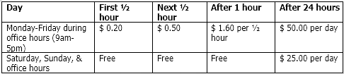

5.) Calculate total amount of money earned for a particular period

6.) Count the number of cars parked in the parking lot for a particular period.

Please note that only maximum of 100 cars can be parked at any given time. The program can be written in any programming language. However, extra marks will be given if the program is written in **C++/C#.**

Bill Calculation Examples:

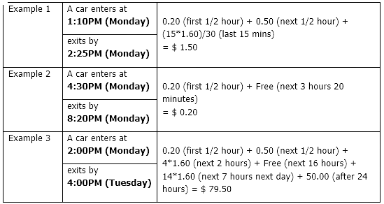

Overview of car parking management system

|  |  |
| --- | --- |
| Application used | Visual Studio |
| Programming language | C++ |
| Database | File handling |

This system can record all the parking details such as the car plate number, the datetime of the cars enter and exit, and the total fare need to pay by driver.

When the system starts, users need to read the 'CarRecord.txt' file to retrieve data from the database and save it to a list. Users can input the car plate number into the system, which indicates that the car is entering the parking lot. The entry time will be recorded. The system will check whether there are more than 100 cars inside the parking lot or not. Additionally, the system will verify if there is a car with the same plate number already inside. If so, the data will not be saved.

Users can input the car plate number again to indicate that the car is exiting the parking lot. If the car's entry data is not found in the database, the system will return to the main menu. Otherwise, the system will calculate the total fare that the driver needs to pay and the parking duration. These details will then be displayed on the system.

If the car exit, it can enter again the parking lot.

User key in the period to find there have how many cars are there in the period.

User can also key in the period to calculate the total amount of money earned for a particular period.

When the user closes the system properly, the data in list will be update to the “CarRecord.txt” file.

For the calculation of fare, will follow the figure above. If drivers enter the parking lot not at office hours and on the weekend, they cannot enjoy the benefit of first hour is $0.20 and $0.50.

The interface of the system

The menu of the system.

The “Read the file” page

The “Car enter the parking lot” page

The “Car exit the parking lot” page

The “Check the total amount of money earned” page

The “Count the number of cars parked in the parking lot” page

The “Exit” page

Testing and results

The figure above shown that the “CarRecord.txt” file cannot be read again to avoid the duplicate date to the list.

The figure above shown that the data save successfully into system.

The figure above shown that the car with ABC1234 already in parking lot.

The figure above shown that the car exits the parking lot. The datetime, parking duration and the fare displayed on the screen. The fare is zero because 26th August 2023 is weekend.

Test the calculations.

Condition1:

* Enter when office hours on weekday and exit when weekend.
* Parking duration more than 24 hours.

Total fare = 0.2(first ½ hour) + 0.5 (next 1/2) + 1.6 (next 1/2 hour) + 1.6*15/30 (next 15min) + free (next 16 hours) + 1.6*16 (8 hours on 24th) + free (16 hours) + 1.6*16 (8 hours on 25th) + free (16 hours) + free (4 hours and 46 mins) + 50*2 (>24 hours on 24th and 25th)

= $154.30

Condition2:

* Enter when office hours on weekday and exit when office hours on weekday.
* Parking duration more than 24 hours.

Total fare = free (1 hour and 30 mins) + 1.6*16 (8 hours on 22th) + free (16 hours) + 1.6*16 (8 hours on 23th) + free (16 hours) + 1.6*3 (1 hour and 30 mins) + 1.6*16/30 (16 mins) + 50*2 (>24 hours on 23th and 24th)

= $156.85

Condition3:

* Enter when office hours on weekday and exit before office hours on weekday.
* Parking duration more than 24 hours.

Total fare = free (3 hours and 30 mins on 23th) + free (9 hours on 24th) + 1.6*16 (8 hours on 24th) + free (7 hours on 24th) + free (8 hours and 22 mins on 25th) + 50 (>24 hours on 24th)

= $75.60

Condition4:

* Enter when weekend and exit when office hours on weekday.
* Parking duration more than 24 hours.

Total fare = free (16 hours and 20 mins) + free (24 hours on 20th) + free (9 hours on 21th) + 1.6*16 (8 hours on 21th) + free (16 hours) + 1.6*16 (8 hours on 22th) + free (16 hours) + 1.6*12 (6 hours on 23th) + 1.6*24/30 (24 mins) + 25 (>24 hours on 20th) + 50*2 (>24 hours on 21th and 22th)

= $246.68

Condition5:

* Enter when weekend and exit when weekend.
* Parking duration more than 24 hours.

Total fare = free (weekend) + 25 (>24 hours on 20th)

= $25

Condition6:

* Enter when weekend and exit when office hours on weekday.
* Parking duration less than 24 hours.
* Date of enter and exit is different.

Total fare = free (20th) + free (9 hours on 21th) + 1.6*4 (2 hours) + 1.6*23/30 (23 mins)

= $7.63

Condition7:

* Enter before office hours on weekday and exit when office hours on weekday.
* Parking duration less than 24 hours.
* Date of enter and exit is same.

Total fare = free (2 hours and 27 mins) + 1.6*8 (4 hours) + 1.6*19/30 (19 mins)

= $13.81

Error handling when exit the parking lot

Testing of check the total amount of money earned.

Total fare = 156.85 (ABB1234) + 246.68 (ABC133) + 13.81 (ABC163)

= $417.34

Testing of count the number of cars parked in the parking lot.

The cars are ABC123, ABC124, ABC173, ABC183, ABC223, ABC323, ABC423, SSS1921

The figure above shown the user close the system and the data save from the list into file “CarRecord.txt” file.