MVC基础知识

Servlet中MVC的流程
M：Model 数据模型
V：View 视图
C：Controller 控制器

客户端----->HttpRequest请求------>Servlet------->View页面---->HttpReponse结束
Servlet组件的主要功能
A：获取请求参数
B：参数封装到一个对象中
C：调用相应的业务方法
D：将方法的数据模型放到相应的作用域中
E：请求转发或者重定向到相应的View
View组件的主要功能
A：将作用域中的Model显示出来

SpringMVC中的主要对象
SpringMVC要完成以上的功能，需要运用SpringMVC中几个重要对象
- DispatcherServlet：SpringMVC的总控制器。所有的请求都会先经过此控制器(HttpServlet)
DispatcherServlet 会读取相应的XX-Servlet.xml配置文件。
XX-Servlet.xml会定义很多的具体的Controller。[2阶段的写的具体的Servlet]
- HandlerMapping：将请求中地址与Controller进行映射查找。类似servlet-mapping
- HandlerAdapter：处理方法的适配器。Controller与Servlet的区别。Servlet中主要处理的方法

- ViewResolver：视图渲染器用于定义页面是用什么视图展现。

SpringMVC的流程
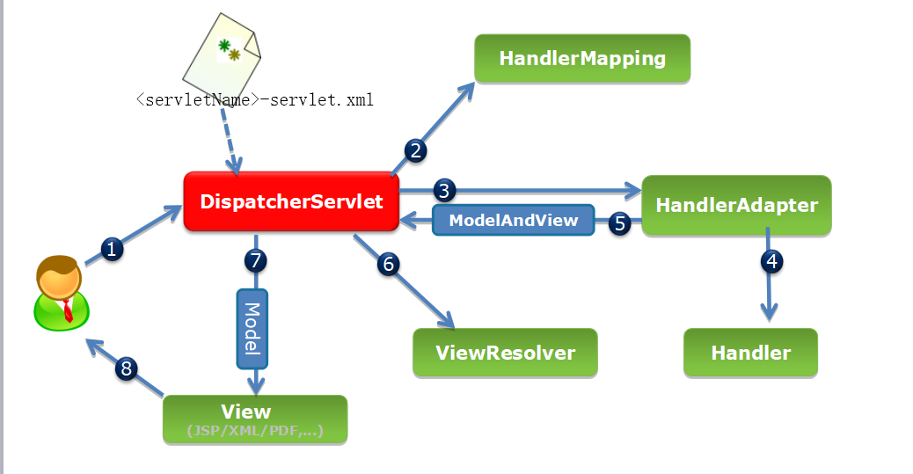

SpringMVC的搭建方案

纯配置文件的方式

新建一个Maven的WEB工程

POM.XML
<project xmlns="http://maven.apache.org/POM/4.0.0"
xmlns:xsi="http://www.w3.org/2001/XMLSchema-instance"
xsi:schemaLocation="http://maven.apache.org/POM/4.0.0 http://maven.apache.org/xsd/maven-4.0.0.xsd">
<modelVersion>4.0.0</modelVersion>
<groupId>com.java1909</groupId>
<artifactId>SpringMvc_Project_1</artifactId>
<packaging>war</packaging>
<version>0.0.1-SNAPSHOT</version>
<name>SpringMvc_Project_1</name>
<url>http://maven.apache.org</url>
<properties>
<project.build.sourceEncoding>
UTF-8
</project.build.sourceEncoding>
<maven.compiler.source>1.7</maven.compiler.source>
<maven.compiler.target>1.7</maven.compiler.target>
</properties>
<dependencies>
<!--
<dependency>
<groupId>javax.servlet</groupId>
<artifactId>servlet-api</artifactId>
<version>2.5</version>
<scope>provided</scope>
</dependency>
<dependency>
<groupId>javax.servlet.jsp</groupId>
<artifactId>jsp-api</artifactId>
<version>2.1</version>
<scope>provided</scope>
</dependency>
-->
<dependency>
<groupId>javax.servlet</groupId>
<artifactId>javax.servlet-api</artifactId>
<version>3.1.0</version>
<scope>provided</scope>
</dependency>

<dependency>
<groupId>javax.servlet.jsp</groupId>
<artifactId>javax.servlet.jsp-api</artifactId>
<version>2.3.1</version>
<scope>provided</scope>
</dependency>

<dependency>
<groupId>javax.servlet</groupId>
<artifactId>jstl</artifactId>
<version>1.2</version>
</dependency>
<dependency>
<groupId>commons-beanutils</groupId>
<artifactId>commons-beanutils</artifactId>
<version>1.8.3</version>
</dependency>
<dependency>
<groupId>commons-codec</groupId>
<artifactId>commons-codec</artifactId>
<version>1.9</version>
</dependency>
<dependency>
<groupId>commons-collections</groupId>
<artifactId>commons-collections</artifactId>
<version>3.2</version>
</dependency>
<dependency>
<groupId>commons-dbcp</groupId>
<artifactId>commons-dbcp</artifactId>
<version>1.4</version>
</dependency>
<dependency>
<groupId>commons-dbutils</groupId>
<artifactId>commons-dbutils</artifactId>
<version>1.3</version>
</dependency>
<dependency>
<groupId>commons-pool</groupId>
<artifactId>commons-pool</artifactId>
<version>1.5.6</version>
</dependency>
<dependency>
<groupId>commons-io</groupId>
<artifactId>commons-io</artifactId>
<version>2.4</version>
</dependency>
<dependency>
<groupId>commons-fileupload</groupId>
<artifactId>commons-fileupload</artifactId>
<version>1.3.1</version>
</dependency>
<dependency>
<groupId>commons-lang</groupId>
<artifactId>commons-lang</artifactId>
<version>2.5</version>
</dependency>
<dependency>
<groupId>org.apache.commons</groupId>
<artifactId>commons-lang3</artifactId>
<version>3.6</version>
</dependency>

<dependency>
<groupId>org.springframework</groupId>
<artifactId>spring-aop</artifactId>
<version>4.3.22.RELEASE</version>
</dependency>
<dependency>
<groupId>org.springframework</groupId>
<artifactId>spring-aspects</artifactId>
<version>4.3.22.RELEASE</version>
</dependency>
<dependency>
<groupId>org.springframework</groupId>
<artifactId>spring-beans</artifactId>
<version>4.3.22.RELEASE</version>
</dependency>
<dependency>
<groupId>org.springframework</groupId>
<artifactId>spring-context</artifactId>
<version>4.3.22.RELEASE</version>
</dependency>
<dependency>
<groupId>org.springframework</groupId>
<artifactId>spring-context-support</artifactId>
<version>4.3.22.RELEASE</version>
</dependency>
<dependency>
<groupId>org.springframework</groupId>
<artifactId>spring-core</artifactId>
<version>4.3.22.RELEASE</version>
</dependency>
<dependency>
<groupId>org.springframework</groupId>
<artifactId>spring-expression</artifactId>
<version>4.3.22.RELEASE</version>
</dependency>
<dependency>
<groupId>org.springframework</groupId>
<artifactId>spring-jdbc</artifactId>
<version>4.3.22.RELEASE</version>
</dependency>
<dependency>
<groupId>org.springframework</groupId>
<artifactId>spring-orm</artifactId>
<version>4.3.22.RELEASE</version>
</dependency>
<dependency>
<groupId>org.springframework</groupId>
<artifactId>spring-tx</artifactId>
<version>4.3.22.RELEASE</version>
</dependency>
<dependency>
<groupId>org.springframework</groupId>
<artifactId>spring-web</artifactId>
<version>4.3.22.RELEASE</version>
</dependency>

<dependency>
<groupId>org.springframework</groupId>
<artifactId>spring-webmvc</artifactId>
<version>4.3.22.RELEASE</version>
</dependency>

<dependency>
<groupId>mysql</groupId>
<artifactId>mysql-connector-java</artifactId>
<version>5.1.47</version>
<scope>runtime</scope>
</dependency>
</dependencies>
<build>
<finalName>SpringMvc_Project_1</finalName>
<plugins>
<plugin>
<artifactId>maven-clean-plugin</artifactId>
<version>3.1.0</version>
</plugin>
<plugin>
<artifactId>maven-resources-plugin</artifactId>
<version>3.0.2</version>
</plugin>
<plugin>
<artifactId>maven-compiler-plugin</artifactId>
<version>3.7.0</version>
<configuration>
<source>1.7</source>
<target>1.7</target>
<encoding>UTF-8</encoding>
</configuration>
</plugin>
<plugin>
<artifactId>maven-jar-plugin</artifactId>
<version>3.0.2</version>
</plugin>
<plugin>
<artifactId>maven-surefire-plugin</artifactId>
<version>2.22.1</version>
</plugin>
<plugin>
<artifactId>maven-install-plugin</artifactId>
<version>2.5.2</version>
</plugin>

<plugin>
<artifactId>maven-deploy-plugin</artifactId>
<version>2.8.2</version>
</plugin>

<plugin>
<artifactId>maven-site-plugin</artifactId>
<version>3.7.1</version>
</plugin>
<plugin>
<artifactId>
maven-project-info-reports-plugin
</artifactId>
<version>3.0.0</version>
</plugin>
<plugin>
<artifactId>maven-war-plugin</artifactId>
<version>2.4</version>
<configuration>
<version>2.5</version>
</configuration>
</plugin>

<plugin>
<groupId>org.apache.tomcat.maven</groupId>
<artifactId>tomcat7-maven-plugin</artifactId>
<version>2.2</version>
<configuration>
<port>8080</port>
<path>/SpringMvc_Project_1</path>
<uriEncoding>UTF-8</uriEncoding>
</configuration>
</plugin>

</plugins>
</build>
</project>

配置DispatchServlet
web.xml中配置DispatchServlet
<?xml version="1.0" encoding="UTF-8"?>
<web-app xmlns:xsi="http://www.w3.org/2001/XMLSchema-instance"
xmlns="http://xmlns.jcp.org/xml/ns/javaee"
xsi:schemaLocation="http://xmlns.jcp.org/xml/ns/javaee http://xmlns.jcp.org/xml/ns/javaee/web-app_3_1.xsd"
id="WebApp_ID" version="3.1">

<servlet>
<servlet-name>DispatcherServlet</servlet-name>
<servlet-class>org.springframework.web.servlet.DispatcherServlet</servlet-class>
</servlet>

<servlet-mapping>
<servlet-name>DispatcherServlet</servlet-name>
<url-pattern>/</url-pattern>
</servlet-mapping>

<welcome-file-list>
<welcome-file>/index.jsp</welcome-file>
</welcome-file-list>
</web-app>

DispatcherServlet默认会解析/WEB-INF/目录下的<servletName>-servlet.xml的配置文件
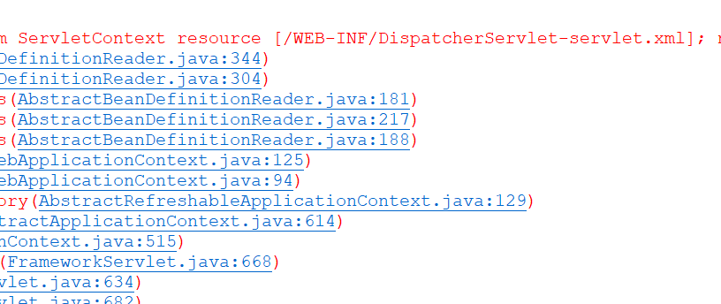

SpringMVC的配置文件
Web.xml中更改配置文件的读取路径。
<servlet>
<servlet-name>DispatcherServlet</servlet-name>
<servlet-class>org.springframework.web.servlet.DispatcherServlet</servlet-class>
<init-param>
<param-name>contextConfigLocation</param-name>
<param-value>classpath:springmvc-config.xml</param-value>
</init-param>
</servlet>
Springmvc-config.xml中配置相应的HandleMapping和HandlerAdapter
<?xml version="1.0" encoding="UTF-8"?>
<beans xmlns="http://www.springframework.org/schema/beans"
xmlns:xsi="http://www.w3.org/2001/XMLSchema-instance"
xmlns:mvc="http://www.springframework.org/schema/mvc"
xsi:schemaLocation="http://www.springframework.org/schema/beans http://www.springframework.org/schema/beans/spring-beans.xsd
http://www.springframework.org/schema/mvc http://www.springframework.org/schema/mvc/spring-mvc.xsd">
<bean
class="org.springframework.web.servlet.handler.BeanNameUrlHandlerMapping"></bean>
<bean
class="org.springframework.web.servlet.mvc.SimpleControllerHandlerAdapter"></bean>
</beans>

编写Controller
package com.controller;

import javax.servlet.http.HttpServletRequest;
import javax.servlet.http.HttpServletResponse;

import org.springframework.web.servlet.ModelAndView;
import org.springframework.web.servlet.mvc.Controller;

public class TestController implements Controller {

@Override
public ModelAndView handleRequest(HttpServletRequest request, HttpServletResponse response) throws Exception {
ModelAndView mv = new ModelAndView();
System.out.println("执行TestController中的handleRequest方法");
request.setAttribute("key_1", "放到Request作用域");
//viewname中的succ拼凑ViewResolver中的prefix和suffix /succ.jsp
//mv.addObject也是将数据放到Request作用域中。
mv.addObject("key_2", "放到Spring的模型对象中");
mv.setViewName("succ");
return mv;
}
}

将Controller映射成URL地址
客户端就可以通过URL地址来访问Controller
<?xml version="1.0" encoding="UTF-8"?>
<beans xmlns="http://www.springframework.org/schema/beans"
xmlns:xsi="http://www.w3.org/2001/XMLSchema-instance"
xmlns:mvc="http://www.springframework.org/schema/mvc"
xsi:schemaLocation="http://www.springframework.org/schema/beans http://www.springframework.org/schema/beans/spring-beans.xsd
http://www.springframework.org/schema/mvc http://www.springframework.org/schema/mvc/spring-mvc.xsd">
<bean
class="org.springframework.web.servlet.handler.BeanNameUrlHandlerMapping"></bean>
<bean
class="org.springframework.web.servlet.mvc.SimpleControllerHandlerAdapter"></bean>
<bean name="/testController" class="com.controller.TestController"></bean>
</beans>

<a href="${pageContext.request.contextPath}/testController">访问TestController</a>

ModelAndView
返回数据模型和视图，需要通过视图的渲染器来进行配置。
<bean name="viewResolver"
class="org.springframework.web.servlet.view.InternalResourceViewResolver">
<property name="prefix" value="/"></property>
<property name="suffix" value=".jsp"></property>
<property name="viewClass"
value="org.springframework.web.servlet.view.JstlView" />
</bean>

页面view显示
<%@ page language="java" contentType="text/html; charset=UTF-8" pageEncoding="UTF-8"%>
<%@ taglib prefix="c" uri="http://java.sun.com/jsp/jstl/core" %>
<!DOCTYPE html PUBLIC "-//W3C//DTD HTML 4.01 Transitional//EN" "http://www.w3.org/TR/html4/loose.dtd">
<html>
<head>
<meta http-equiv="Content-Type" content="text/html; charset=UTF-8">
<title>Insert title here</title>
</head>
<body>
<pre>
key_1 = <c:out value="${key_1}"></c:out>
key_2 = <c:out value="${requestScope.key_2}"></c:out>
</pre>
</body>
</html>

配置文件+注解的方式

更改HandlerMappting和HandlerAdapter
<?xml version="1.0" encoding="UTF-8"?>
<beans xmlns="http://www.springframework.org/schema/beans"
xmlns:xsi="http://www.w3.org/2001/XMLSchema-instance"
xmlns:mvc="http://www.springframework.org/schema/mvc"
xmlns:context="http://www.springframework.org/schema/context"
xsi:schemaLocation="http://www.springframework.org/schema/mvc http://www.springframework.org/schema/mvc/spring-mvc.xsd
http://www.springframework.org/schema/beans http://www.springframework.org/schema/beans/spring-beans.xsd
http://www.springframework.org/schema/context http://www.springframework.org/schema/context/spring-context.xsd">
<bean
class="org.springframework.web.servlet.mvc.method.annotation.RequestMappingHandlerMapping"></bean>
<bean
class="org.springframework.web.servlet.mvc.method.annotation.RequestMappingHandlerAdapter"></bean>

<context:annotation-config></context:annotation-config>
<context:component-scan
base-package="com.controller"></context:component-scan>

<mvc:annotation-driven></mvc:annotation-driven>

<bean name="viewResolver"
class="org.springframework.web.servlet.view.InternalResourceViewResolver">
<property name="prefix" value="/"></property>
<property name="suffix" value=".jsp"></property>
<property name="viewClass"
value="org.springframework.web.servlet.view.JstlView" />
</bean>
</beans>

编写Controller，使用注解
package com.controller;

import javax.servlet.http.HttpServletRequest;
import javax.servlet.http.HttpServletResponse;

import org.springframework.web.bind.annotation.RequestMapping;
import org.springframework.web.servlet.ModelAndView;

@org.springframework.stereotype.Controller
public class TestController {
@RequestMapping(value = "/testController")
public ModelAndView handleRequest(HttpServletRequest request, HttpServletResponse response) throws Exception {
ModelAndView mv = new ModelAndView();
System.out.println("执行注解的Controller");
request.setAttribute("key_1", "放到Request作用域");
//viewname中的succ拼凑ViewResolver中的prefix和suffix /succ.jsp
//mv.addObject也是将数据放到Request作用域中。
mv.addObject("key_2", "放到Spring的模型对象中");
mv.setViewName("succ");
return mv;
}
}

访问Controller
<a href="${pageContext.request.contextPath}/testController">访问TestController</a>

配置类+注解的方式
由于SpringMVC的配置文件是通过web.xml进行加载的。所以要使用配置类的情况，要完成2个操作。

将web.xml加载SpringMVC的的方式进行更改。
package com.config;

import javax.servlet.ServletContext;
import javax.servlet.ServletException;
import javax.servlet.ServletRegistration;

import org.springframework.web.WebApplicationInitializer;
import org.springframework.web.context.support.AnnotationConfigWebApplicationContext;
import org.springframework.web.servlet.DispatcherServlet;

public class WebInitConfig implements WebApplicationInitializer {

@Override
public void onStartup(ServletContext container) throws ServletException {
System.out.println("WebInitConfig启动。。。。");
// <servlet>
// <servlet-name>DispatcherServlet</servlet-name>
// <servlet-class>org.springframework.web.servlet.DispatcherServlet</servlet-class>
// <init-param>
// <param-name>contextConfigLocation</param-name>
// <param-value>classpath:springmvc-config.xml</param-value>
// </init-param>
// </servlet>
// <servlet-mapping>
// <servlet-name>DispatcherServlet</servlet-name>
// <url-pattern>/</url-pattern>
// </servlet-mapping>

AnnotationConfigWebApplicationContext dispatcherContext = new AnnotationConfigWebApplicationContext();
dispatcherContext.register(SpringMvcConfig.class);
ServletRegistration.Dynamic dispatcher = container.addServlet("dispatcher", new DispatcherServlet(dispatcherContext));
dispatcher.setLoadOnStartup(1);
dispatcher.addMapping("/");
}

}

使用配置类替换完成SpringMVC的配置。
package com.config;

import org.springframework.context.annotation.Bean;
import org.springframework.context.annotation.ComponentScan;
import org.springframework.context.annotation.Configuration;
import org.springframework.web.servlet.ViewResolver;
import org.springframework.web.servlet.config.annotation.DefaultServletHandlerConfigurer;
import org.springframework.web.servlet.config.annotation.EnableWebMvc;
import org.springframework.web.servlet.config.annotation.ResourceHandlerRegistry;
import org.springframework.web.servlet.config.annotation.WebMvcConfigurerAdapter;
import org.springframework.web.servlet.view.InternalResourceViewResolver;
import org.springframework.web.servlet.view.JstlView;

// <context:annotation-config></context:annotation-config>
@Configuration
//<context:component-scan base-package="com.controller"></context:component-scan>
@ComponentScan(basePackages = "com.controller")
//<mvc:annotation-driven></mvc:annotation-driven>
@EnableWebMvc
public class SpringMvcConfig extends WebMvcConfigurerAdapter {
// <bean name="viewResolver"
// class="org.springframework.web.servlet.view.InternalResourceViewResolver">
// <property name="prefix" value="/"></property>
// <property name="suffix" value=".jsp"></property>
// <property name="viewClass"
// value="org.springframework.web.servlet.view.JstlView" />
// </bean>

@Bean(name = "viewResolver")
public ViewResolver getViewResolver() {
InternalResourceViewResolver viewResolver = new InternalResourceViewResolver();
viewResolver.setPrefix("/");
viewResolver.setSuffix(".jsp");
viewResolver.setViewClass(JstlView.class);
return viewResolver;
}

@Override
public void configureDefaultServletHandling(DefaultServletHandlerConfigurer configurer) {
configurer.enable();
}

@Override
public void addResourceHandlers(ResourceHandlerRegistry registry) {
super.addResourceHandlers(registry);
}
}

使用Jetty9或者部署到Tomcat中运行
不能使用Tomcat7的插件，。
<plugin>
<groupId>org.eclipse.jetty</groupId>
<artifactId>jetty-maven-plugin</artifactId>
<version>9.2.8.v20150217</version>
<configuration>
<httpConnector>
<port>8080</port>
</httpConnector>
<scanIntervalSeconds>3</scanIntervalSeconds>
<reload>manual</reload>
<dumpOnStart>true</dumpOnStart>
<webApp>
<contextPath>/${project.artifactId}</contextPath>
<!--
<resourceBases>
<resourceBase>${project.basedir}/src/main/resource</resourceBase>
</resourceBases>
-->
</webApp>
</configuration>
</plugin>
</plugins>
运行Jetty:run即可完成配置类+注解的方式。

SpringMVC的热加载
在程序运行过程中，如果代码有发生变动时，能够自动的加载最新的更改结果，而不需要重新启动应用容器。
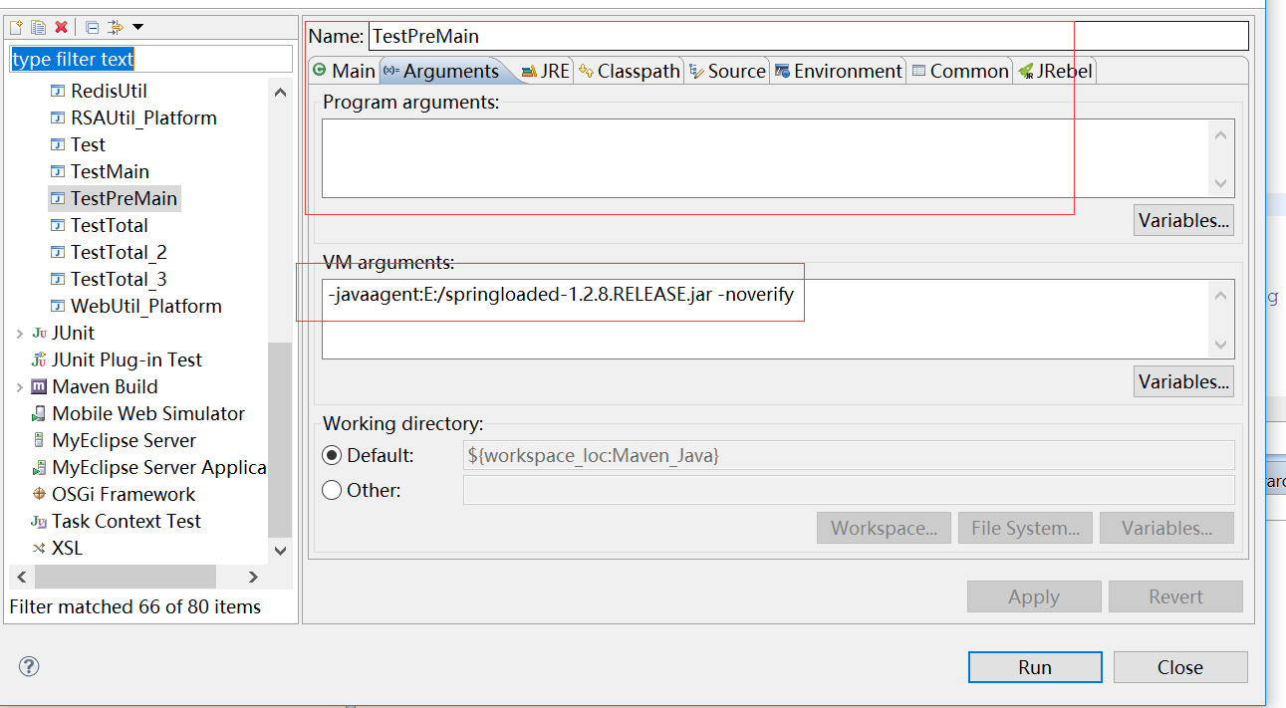
打开Run Configuration的配置。
-javaagent:E:/java_tools/HotDeploy/springloaded-1.2.8.RELEASE.jar -noverify

请求转发与重定向
package com.controller;
import javax.servlet.http.HttpServletRequest;

import org.springframework.stereotype.Controller;
import org.springframework.web.bind.annotation.RequestMapping;
import org.springframework.web.servlet.ModelAndView;
import org.springframework.web.servlet.view.RedirectView;

@Controller
@RequestMapping(value = "/forwardAndRedirect")
public class ForwardAndRedirect {

@RequestMapping(value = "/forward_one")
public ModelAndView forward_one() throws Exception {
System.out.println("forward_one...");
ModelAndView mv = new ModelAndView();
mv.addObject("key_1", "键一");
mv.addObject("key_2", "键二");
mv.setViewName("succ");
return mv;
}

@RequestMapping(value = "/forward_two")
public String forward_two(HttpServletRequest request) throws Exception {
System.out.println("forward_two...");
request.setAttribute("key_1", "aaa");
request.setAttribute("key_2", "bbbb");
return "succ";
}

@RequestMapping(value = "/redirect_one")
public ModelAndView redirect_one() throws Exception {
ModelAndView mv = new ModelAndView();

RedirectView view = new RedirectView("/succ.jsp",true);
//mv.addObject在重定向时，值不会放入到作用域，而是放在地址栏上面。
mv.addObject("key_1", "键一");
mv.addObject("key_2", "键二");
mv.setView(view);
return mv;
}

@RequestMapping(value = "/redirect_two")
public String redirect_two() throws Exception {
return "redirect:/succ.jsp?key_1=aaa&key_2=bbb";
}
}

SpringMVC常用注解

Controller

RequestMapping
RequestMapping可以放在类中，也可以放在方法中。
请求的路径 = 类的Mpaping+方法的Mapping

Method
@RequestMapping(method = RequestMethod.POST, value = "/one")
public ModelAndView one() throws Exception {
ModelAndView mv = new ModelAndView();
mv.addObject("key_1", "键一");
mv.addObject("key_2", "键二");
mv.setViewName("succ");
return mv;
}

Params
@RequestMapping(method = RequestMethod.GET, value = "/two",params="task=list")
public ModelAndView two() throws Exception {
ModelAndView mv = new ModelAndView();
mv.addObject("key_1", "键一");
mv.addObject("key_2", "键二");
mv.setViewName("succ");
return mv;
}
<a href="${pageContext.request.contextPath}/Anno_Mapping/two?task=list">RequestMapping注解_param</a>

Value

RequestParameter
用于接收Request请求中的参数值。相当于java代码。
Request.getParameter(“参数名称”)
@RequestMapping(method = RequestMethod.GET, value = "/one")
public ModelAndView one(@RequestParam(name = "truename", required = false) String username, String password) throws Exception {
System.out.println("获取请求中的参数值 ");
System.out.println("username = " + username);
System.out.println("password = " + password);

ModelAndView mv = new ModelAndView();
mv.addObject("key_1", "键一");
mv.addObject("key_2", "键二");
mv.setViewName("succ");
return mv;
}
加入@RequestParam，请求中必须要包含truename这个参数。否则会报错。可以使用required = false,表示参数并非必需项
<a href="${pageContext.request.contextPath}/Anno_RequestParam/one?truename=admin&password=123456">RequestParam注解</a>

RequestHeader注解
用于获取头部消息的值。相当于request.getHeader()方法
@RequestMapping(method = RequestMethod.GET, value = "/two")
public ModelAndView two(@RequestHeader(name = "Accept") String accept, @RequestHeader(name = "Host") String host) throws Exception {
System.out.println("获取请求中的参数值 ");
System.out.println("accept = " + accept);
System.out.println("host = " + host);
ModelAndView mv = new ModelAndView();
mv.addObject("key_1", "键一");
mv.addObject("key_2", "键二");
mv.setViewName("succ");
return mv;
}

Cookie注解
用于获取Cookie中的值。取中文的值有问题，仍需要request对象来解析
- 操作Cookie
@RequestMapping(method = RequestMethod.GET, value = "/three")
public void three(HttpServletRequest request, HttpServletResponse response) throws Exception {
System.out.println("获取请求中的参数值 ");

Cookie cookie_a = new Cookie("username", "ADMIN");
cookie_a.setPath(request.getContextPath());
cookie_a.setHttpOnly(true);
cookie_a.setMaxAge(-1);

Cookie cookie_b = new Cookie("truename", "DFRZ");
cookie_b.setPath(request.getContextPath());
cookie_b.setHttpOnly(true);
cookie_b.setMaxAge(-1);
response.addCookie(cookie_a);
response.addCookie(cookie_b);
System.out.println("cookie添加成功");
}

- 读取Cookie
@RequestMapping(method = RequestMethod.GET, value = "/four")
@ResponseBody
public void four(@CookieValue(name = "username") String username, @CookieValue(name = "truename") String truename, HttpServletRequest request) throws Exception {
System.out.println("获取Cookie中的值 ");
System.out.println("username = " + username);
System.out.println("truename = " + truename);

System.out.println("代码中取Cookie的值");
Map<String, String> dataMap = new LinkedHashMap<String, String>();
Cookie[] cookieArray = request.getCookies();
for (Cookie cookie : cookieArray) {
String cookie_name = cookie.getName();
String cookie_value = cookie.getValue();

dataMap.put(cookie_name, cookie_value);
}
System.out.println("username = " + dataMap.get("username"));
System.out.println("truename = " + dataMap.get("truename"));
}

PathVariable
地址栏参数：https://movie.douban.com/subject?id=25900819。25900819是做为地址栏的请求参数id的值。称为地址栏参数。
地址栏变量：https://movie.douban.com/subject/25900819/,25900819是地址栏的一部分，由于这部分的值是可以发生变化的。所以称为地址栏变量。

地址栏变量的写法符合RestFul风格的规范。所以现在用的比较频繁。
使用PathVariable的前提：
Web.xml中对于Spring的DispatchSevlet的URL映射必须要为”/”,不能是其他的值。
<servlet-name>DispatcherServlet</servlet-name>
<url-pattern>/</url-pattern>
注解类：
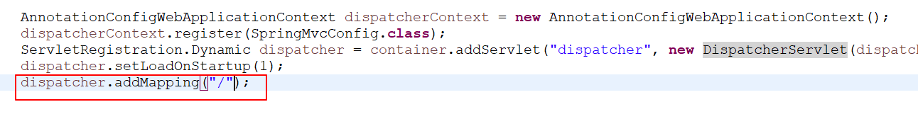

精确匹配
<a href="${pageContext.request.contextPath}/Anno_PathVariable/one/admin/123456">PathVariable注解</a>
@RequestMapping(method = RequestMethod.GET, value = "/one/{username}/{password}")
@ResponseBody
public void one(@PathVariable(name = "username") String user_name, @PathVariable(name = "password") String pwd) throws Exception {

System.out.println("user_name = " + user_name);
System.out.println("pwd = " + pwd);
}

模糊匹配
单层匹配：使用一个*，一个*表示一层路径。
<a href="${pageContext.request.contextPath}/Anno_PathVariable/two/xxxx/edit">模糊的通配符匹配_单层</a>
<a href="${pageContext.request.contextPath}/Anno_PathVariable/two/yyyy/edit">模糊的通配符匹配_单层</a>
@RequestMapping(method = RequestMethod.GET, value = "/two/*/edit")
@ResponseBody
public void two() throws Exception {
System.out.println("通过模糊匹配，执行了two这个方法");
}

多层匹配：使用两个*，两个**表示多层路径。
@RequestMapping(method = RequestMethod.GET, value = "/three/**/{userid}/del")
@ResponseBody
public void three(@PathVariable(name = "userid") String userid) throws Exception {
System.out.println("通过模糊匹配，执行了three这个方法");

System.out.println("userid = " + userid);
}

<a href="${pageContext.request.contextPath}/Anno_PathVariable/three/xxxx/10/del">模糊的通配符匹配_多层</a>

<a href="${pageContext.request.contextPath}/Anno_PathVariable/three/yyyy/aaa/bbb/ccc/ddd/20/del">模糊的通配符匹配_多层</a>

综合使用
使用地址栏参数
<a href="${pageContext.request.contextPath}/Anno_Total/param_list">列表</a>
<a href="${pageContext.request.contextPath}/Anno_Total/param_save">保存</a>
<a href="${pageContext.request.contextPath}/Anno_Total/param_edit?userid=10">修改</a>
<a href="${pageContext.request.contextPath}/Anno_Total/param_del?userid=20">删除</a>
使用地址栏变量
<a href="${pageContext.request.contextPath}/Anno_Total/path_list">列表</a>
<a href="${pageContext.request.contextPath}/Anno_Total/path_save">保存</a>
<a href="${pageContext.request.contextPath}/Anno_Total/path_edit/30">修改</a>
<a href="${pageContext.request.contextPath}/Anno_Total/40/path_del">删除</a>

获取Servlet对象

自动注入的方式
//1、使用注入的方式
@Autowired
private HttpServletRequest request;
@Autowired
private HttpServletResponse response;
@Autowired
private HttpSession session;
@Autowired
private ServletContext context;

使用形参的方式
形参的方式中，ServletContext是不能注入的。只能在代码中获取。
@RequestMapping(method = RequestMethod.GET, value = "/two")
@ResponseBody
public void two(HttpServletRequest req_2, HttpServletResponse res_2, HttpSession session_2) throws Exception {
System.out.println("使用形参的方式获取Servlet的对象");
String contextPath = req_2.getContextPath();

实现接口的方式
只能完成ServletContext对象的获取，其他的对象获取不到。
public class ServletObjController implements ServletContextAware, ServletConfigAware {}

获取请求对象(Request)中的值
- 使用Request来获取
- 使用形参来获取： 形参的名称要与请求参数一致，如果不一致，配合@RquestParam注解来完成请求参数的获取。
- 使用JavaBean对象来获取，原则：Bean的属性名称要与请求参数的名称一致。
@Controller
@RequestMapping(value = "requestObjController")
public class RequestObjController extends BaseController {

@RequestMapping(value = "/one")
@ResponseBody
public void one() throws Exception {
String username = request.getParameter("username");
String password = request.getParameter("password");
String truename = request.getParameter("truename");

System.out.println("username = " + username);
System.out.println("password = " + password);
System.out.println("truename = " + truename);
}

@RequestMapping(value = "/two")
@ResponseBody
public void two(String username, String password, @RequestParam(name = "truename") String realname) throws Exception {
System.out.println("username = " + username);
System.out.println("password = " + password);
System.out.println("truename = " + realname);
}

@RequestMapping(value = "/three")
@ResponseBody
public void three(UserBean userBean) throws Exception {
System.out.println("username = " + userBean.getUsername());
System.out.println("password = " + userBean.getPassword());
System.out.println("truename = " + userBean.getTruename());
}
}

响应Response中值

使用ModelAndView来存储
@RequestMapping(value = "/one")
public ModelAndView one() throws Exception {
ModelAndView mv = new ModelAndView();
mv.addObject("str_1", "使用MoelAndView存放的对象");
mv.setViewName("responseObj");
return mv;

}

使用ModelMap/Model/Map来存储
@RequestMapping(value = "/three")
public String three(ModelMap modelMap, Model model, Map<String, Object> map) throws Exception {
modelMap.put("str_3", "这是ModelMap中的值");
model.addAttribute("str_4", "这是Model中的值");
map.put("str_5", "这是Map中的值");
return "responseObj";
}

使用Request作用域来存储
@RequestMapping(value = "/two")
public String two(HttpServletRequest request) throws Exception {
request.setAttribute("str_2", "使用Request作用域存放的值");
return "responseObj";
}

优先级取值顺序
ModelAndView>ModelMap、Model、Map>Request作用域。ModelMap、Model、Map,3个对象中的值的存在覆盖的操作。
@RequestMapping(value = "/four")
public String four(ModelMap modelMap, Model model, Map<String, Object> map) throws Exception {
//ModelAndView mv = new ModelAndView();
//mv.addObject("str_total", "使用MoelAndView存放的对象");

map.put("str_total", "这是Map中的值");
model.addAttribute("str_total", "这是Model中的值");
modelMap.put("str_total", "这是ModelMap中的值");
request.setAttribute("str_total", "使用Request作用域存放的值");
//mv.setViewName("responseObj");
//return mv;
return "responseObj";
}

静态资源的显示
静态资源不显示的原因：由于SpringMVC的DispatchServlet的配置为”/”，因此所有的静态资源都经过了该Servlet,认为是一个Cotroller请求。但是在Controller中没有找到对应的请求地址。所有无法显示。

排除静态资源的过滤

配置文件中配置
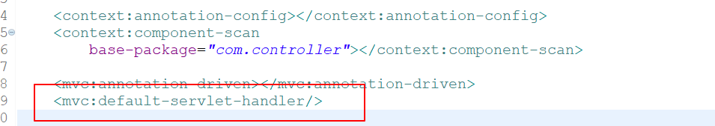

配置类中配置
- 配置类继承WebMvcConfigurerAdapter
- 重写方法
@Override
public void configureDefaultServletHandling(DefaultServletHandlerConfigurer configurer) {
super.configureDefaultServletHandling(configurer);
configurer.enable();
}

WEB-INF目录下的静态资源访问
9.1中的方式只能解决静态资源在非WEB-INF目录下的显示，如果静态资源放在WEB-INF目录下，还需要加入静态资源映射的配置。
配置文件
<mvc:resources mapping="/inf_images/**" location="/WEB-INF/inf_images/"></mvc:resources>
<mvc:resources mapping="/inf_css/**" location="/WEB-INF/inf_css/"></mvc:resources>
<mvc:resources mapping="/inf_js/**" location="/WEB-INF/inf_js/"></mvc:resources>

配置类
@Override
public void addResourceHandlers(ResourceHandlerRegistry registry) {
super.addResourceHandlers(registry);
registry.addResourceHandler("/inf_images/**").addResourceLocations("/WEB-INF/inf_images/");
registry.addResourceHandler("/inf_css/**").addResourceLocations("/WEB-INF/inf_css/");
registry.addResourceHandler("/inf_js/**").addResourceLocations("/WEB-INF/inf_js/");
}
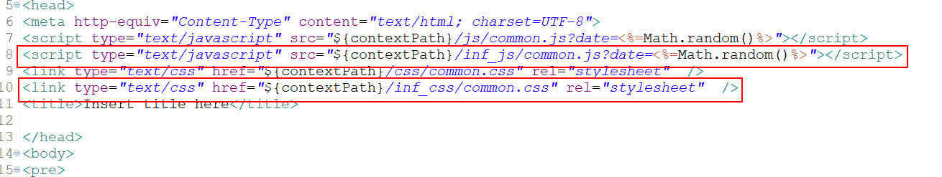

JSON数据处理

JSON的请求

GET请求
function sendGET() {
var formData = jQuery("#form1").serializeArray();
var url = "${contextPath}/jsonController/one_get";
jQuery.get(url, formData, function(jsonData) {

}, "json");
}

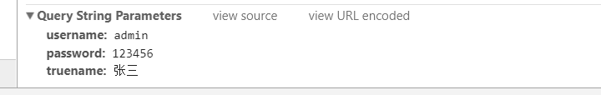
服务端接收
@RequestMapping(value = "/one_get")
@ResponseBody
public void one_get() throws Exception {
System.out.println("获取GET的数据");
String username = request.getParameter("username");
String password = request.getParameter("password");
String truename = request.getParameter("truename");

System.out.println("username = " + username);
System.out.println("password = " + password);
System.out.println("truename = " + truename);

}

POST请求的数据
function sendPOST() {
var formData = jQuery("#form1").serializeArray();
var url = "${contextPath}/jsonController/one_post";
jQuery.post(url, formData, function(jsonData) {

}, "json");
}

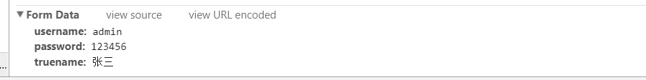
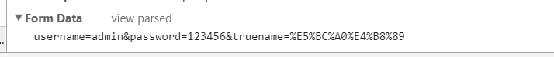
服务端接收
@RequestMapping(value = "/one_post")
@ResponseBody
public void one_post() throws Exception {
System.out.println("获取POST的数据");
String username = request.getParameter("username");
String password = request.getParameter("password");
String truename = request.getParameter("truename");

System.out.println("username = " + username);
System.out.println("password = " + password);
System.out.println("truename = " + truename);

}

SpringMVC中接收JSON数据
导入相应的依赖包
<dependency>
<groupId>com.fasterxml.jackson.core</groupId>
<artifactId>jackson-core</artifactId>
<version>2.5.1</version>
</dependency>
<dependency>
<groupId>com.fasterxml.jackson.core</groupId>
<artifactId>jackson-databind</artifactId>
<version>2.5.1</version>
</dependency>
<dependency>
<groupId>com.fasterxml.jackson.core</groupId>
<artifactId>jackson-annotations</artifactId>
<version>2.5.1</version>
</dependency>
客户端发送
function convertArray(o) { //主要是推荐这个函数。它将jquery系列化后的值转为name:value的形式。
var v = {};
for ( var i in o) {
if (typeof (v[o[i].name]) == 'undefined')
v[o[i].name] = o[i].value;
else
v[o[i].name] += "," + o[i].value;
}
return v;
}
function sendJSON() {
var jsonObj = {
"username" : "用户名",
"password" : "123"
};
var formData = jQuery("#form1").serializeArray();
//formData是一组数组结构的数据类型，不是json类型。
//将数组类型，转为json类型。

var formDataObj = convertArray(formData);
console.log(jsonObj);
console.log(formData);
console.log(formDataObj);

var jsonStr = JSON.stringify(formDataObj);

jQuery.ajax({
type : "POST",
url : "${contextPath}/jsonController/one_json?date=" + Math.random() + "",
contentType : "application/json;charset=utf-8",
//ajax中发送json，是发送json的字符串，不是json对象。
data : jsonStr,
//返回的数据，jQuery会自动转为json的对象。。
dataType : "json",
success : function(data) {
window.alert("data = " + data);
}
});
}
function sendJSONBean() {
var jsonObj = {
"username" : "用户名",
"password" : "123"
};
var formData = jQuery("#form1").serializeArray();
//formData是一组数组结构的数据类型，不是json类型。
//将数组类型，转为json类型。

var formDataObj = convertArray(formData);
console.log(jsonObj);
console.log(formData);
console.log(formDataObj);

var jsonStr = JSON.stringify(formDataObj);

jQuery.ajax({
type : "POST",
url : "${contextPath}/jsonController/one_jsonBean?date=" + Math.random() + "",
contentType : "application/json;charset=utf-8",
//ajax中发送json，是发送json的字符串，不是json对象。
data : jsonStr,
//返回的数据，jQuery会自动转为json的对象。。
dataType : "json",
success : function(data) {
window.alert("data = " + data);
}
});
}

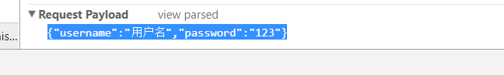
服务端接收
@RequestMapping(value = "/one_json")
@ResponseBody
public void one_json(@RequestBody String jsonStr) throws Exception {
//接收到的是一个json的字符串。
System.out.println(jsonStr);
//将json的字符串转为Bean，可以使用Gson或者jackson
ObjectMapper objectMapper = new ObjectMapper();
UserBean userBean = objectMapper.readValue(jsonStr, UserBean.class);
System.out.println("转为userBean = " + userBean);
}

@RequestMapping(value = "/one_jsonBean")
@ResponseBody
public void one_jsonBean(@RequestBody UserBean userBean) throws Exception {
//接收到的是一个json的字符串，然后SpringMVC自动转为一个Bean
System.out.println(userBean);
}

Json数据的返回

原始方式
将返回的对象转为json的字符串，然后使用out的方式输出。客户端接收返回的jsono数据进行处理。
@RequestMapping(value = "/one_get")
@ResponseBody
public void one_get() throws Exception {
System.out.println("获取GET的数据");
String username = request.getParameter("username");
String password = request.getParameter("password");
String truename = request.getParameter("truename");

System.out.println("username = " + username);
System.out.println("password = " + password);
System.out.println("truename = " + truename);

java.util.List<Map<String, Object>> dataList = new ArrayList<>();
for (int i = 1; i <= 3; i++) {
Map<String, Object> rowMap = new HashMap<String, Object>();
rowMap.put("dog_id", i);
rowMap.put("dog_name", "狗名_" + i);
dataList.add(rowMap);
}
ObjectMapper objectMapper = new ObjectMapper();
String jsonStr = objectMapper.writeValueAsString(dataList);

PrintWriter out = response.getWriter();
out.print(jsonStr);
out.flush();
out.close();
}

SpringMVC中返回JSON数据
使用注解：@ResponseBody,SpringMVC会自动将对象转为json的字符串，返回到客户端。
@RequestMapping(value = "/one_post")
@ResponseBody
public java.util.List<Map<String, Object>> one_post() throws Exception {
System.out.println("获取POST的数据");
String username = request.getParameter("username");
String password = request.getParameter("password");
String truename = request.getParameter("truename");

System.out.println("username = " + username);
System.out.println("password = " + password);
System.out.println("truename = " + truename);

java.util.List<Map<String, Object>> dataList = new ArrayList<>();
for (int i = 1; i <= 3; i++) {
Map<String, Object> rowMap = new HashMap<String, Object>();
rowMap.put("dog_id", i);
rowMap.put("dog_name", "狗名_" + i);
dataList.add(rowMap);
}
return dataList;
}

综合
两种方式进行结合使用：发送不要使用SpringMVC的方式，使用GET或者POST的方式。返回使用SpringMVC的JSON数据返回。

文件上传与下载

文件上传

前提配置
- 加入Commons-fileupload的依赖
- 上传表单必须配置enctype="multipart/form-data"
- 配置类或者配置文件中必须定义文件的渲染器初始化对象
// <bean id="multipartResolver"
// class="org.springframework.web.multipart.commons.CommonsMultipartResolver">
// <property name="defaultEncoding" value="UTF-8"></property>
// <property name="maxUploadSize" value="10485760000"></property>
// <property name="maxInMemorySize" value="40960"></property>
// </bean>

@Bean(name = "multipartResolver")
public CommonsMultipartResolver getCommonsMultipartResolver() {
CommonsMultipartResolver resolver = new CommonsMultipartResolver();
resolver.setDefaultEncoding("UTF-8");
resolver.setMaxUploadSize(10485760000L);
resolver.setMaxInMemorySize(40960);
return resolver;
}

上传到文件夹
@RequestMapping(value = "/save_folder")
@ResponseBody
public void save_folder(HttpServletRequest request, MultipartFile userface) throws Exception {
/**
* 注意点：Request只能使用形参中的Request才可以获取到请求中的参数，不能使用成员变量的Request对象来获取。
*
*/
String username = request.getParameter("username");
//上传控件的名称
String name = userface.getName();
//上传的文件名称
String orgFileName = userface.getOriginalFilename();
String filepath = "";
System.out.println("username = " + username);
System.out.println("orgFileName = " + orgFileName);
System.out.println("name = " + name);
if (orgFileName != null && orgFileName.equals("") == false) {
//表示有文件上传。
String uploadPath = context.getRealPath("/uploadfiles");
filepath = DateUtil.getSystemTimeStamp() + "_" + orgFileName;
File destFile = new File(uploadPath + "/" + filepath);
userface.transferTo(destFile);
} else {
orgFileName = "";
filepath = "";
}

//将username与filename,filepath写到表中
Connection conn = JdbcUtil.getConn();
Statement stmt = conn.createStatement();
StringBuffer insertSQL = new StringBuffer();
insertSQL.append("Insert Into T_TestLob(");
insertSQL.append(" testname,filename,filepath");
insertSQL.append(") values(");
insertSQL.append(" '" + username + "',");
insertSQL.append(" '" + orgFileName + "',");
insertSQL.append("'" + filepath + "'");
insertSQL.append(")");
stmt.executeUpdate(insertSQL.toString());

}

上传到数据库
@RequestMapping(value = "/save_table")
@ResponseBody
public void save_table(HttpServletRequest request, MultipartFile userface) throws Exception {
/**
* 注意点：Request只能使用形参中的Request才可以获取到请求中的参数，不能使用成员变量的Request对象来获取。
*
*/
String username = request.getParameter("username");
//上传控件的名称
String name = userface.getName();
//上传的文件名称
String orgFileName = userface.getOriginalFilename();
InputStream inputStream = null;
System.out.println("username = " + username);
System.out.println("orgFileName = " + orgFileName);
System.out.println("name = " + name);
if (orgFileName != null && orgFileName.equals("") == false) {
//表示有文件上传。
inputStream = userface.getInputStream();
} else {
orgFileName = "";
}
Connection conn = JdbcUtil.getConn();
PreparedStatement pstmt = null;
StringBuffer insertSQL = new StringBuffer();
insertSQL.append("Insert Into T_TestLob(");
insertSQL.append(" testname,filename,filedata");
insertSQL.append(") values(");
insertSQL.append(" ?,?,?");
insertSQL.append(")");
pstmt = conn.prepareStatement(insertSQL.toString());
pstmt.setString(1, username);
pstmt.setString(2, orgFileName);
pstmt.setBlob(3, inputStream);
pstmt.executeUpdate();

}

文件下载
SpringMVC中对于文件的下载，没有做额外的封装处理。沿用原先Servlet的下载方式

文件夹下载
@RequestMapping(value = "/download_folder/{id}")
@ResponseBody
public void download_folder(@PathVariable(name = "id", required = true) String fileid) throws Exception {
response.setContentType("text/html");
PrintWriter out = response.getWriter();
//根据id，取出filename,filepath这两个字段。
StringBuffer querySQL = new StringBuffer();
querySQL.append("Select filename,filepath");
querySQL.append(" From T_TestLob where id = '" + fileid + "'");
Connection conn = null;
try {
conn = JdbcUtil.getConn();
QueryRunner queryRunner = new QueryRunner();
Map<String, Object> dataMap = queryRunner.query(conn, querySQL.toString(), new MapHandler());
String filename = String.valueOf(dataMap.get("filename"));
String filepath = String.valueOf(dataMap.get("filepath"));
if (filepath != null && filepath.equals("") == false) {
//通过文件路径，找到对应的文件。
String downloadDir = context.getRealPath("/uploadfiles");
File file = new File(downloadDir + "/" + filepath);
if (file.exists() == true) {
InputStream inputStream = new FileInputStream(file);
//下载就是流写入到客户端。
response.reset();
//Content-Type的类型：在tomcat的web.xml中。
response.setHeader("Content-type", "application/x-msdownload");
//流是不认中文的，所以文件名中有包含中文字符，要进行转码。
String encode_filename = new String(filename.getBytes("GBK"), "ISO-8859-1");
response.setHeader("Content-disposition", "attachment;filename=\"" + encode_filename + "\"");

OutputStream outputStream = response.getOutputStream();
IOUtils.copy(inputStream, outputStream);

//关闭流
IOUtils.closeQuietly(inputStream);
IOUtils.closeQuietly(outputStream);
} else {
throw new FileNotFoundException("下载的文件不存在");
}
}
} catch (Exception e) {
e.printStackTrace();
} finally {
DbUtils.closeQuietly(conn);
}
out.flush();
out.close();
}

数据库下载
@RequestMapping(value = "/download_table/{id}")
@ResponseBody
public void download_table(@PathVariable(name = "id", required = true) String fileid) throws Exception {
System.out.println(fileid);
response.setContentType("text/html");
PrintWriter out = response.getWriter();
//根据id，取出filename,filepath这两个字段。
StringBuffer querySQL = new StringBuffer();
querySQL.append("Select filename,filedata");
querySQL.append(" From T_TestLob where id = '" + fileid + "'");
Connection conn = null;
Statement stmt = null;
ResultSet rs = null;
try {
conn = JdbcUtil.getConn();
stmt = conn.createStatement();
rs = stmt.executeQuery(querySQL.toString());
if (rs.next()) {
String filename = rs.getString("filename");
InputStream inputStream = rs.getBinaryStream("filedata");

if (inputStream != null) {
//下载就是流写入到客户端。
response.reset();
response.setHeader("Content-type", "application/x-msdownload");
//流是不认中文的，所以文件名中有包含中文字符，要进行转码。
String encode_filename = new String(filename.getBytes("GBK"), "ISO-8859-1");
response.setHeader("Content-disposition", "attachment;filename=\"" + encode_filename + "\"");

OutputStream outputStream = response.getOutputStream();
IOUtils.copy(inputStream, outputStream);

//关闭流
IOUtils.closeQuietly(inputStream);
IOUtils.closeQuietly(outputStream);
}
}
} catch (Exception e) {
e.printStackTrace();
} finally {
DbUtils.closeQuietly(rs);
DbUtils.closeQuietly(stmt);
DbUtils.closeQuietly(conn);
}
out.flush();
out.close();
}

SpringMVC表单标签
在Servlet中学习JSTL的标签(Core,Format)标签。
通过Spring的表单标签，能够完成表单元素与模型对象的绑定。完成值的回填。

使用SpringMVC表单标签的注意点
- 导入Spring标签
- 使用标签,表单标签必须要绑定一个模型对象。modelAttribute = "模型对象的名称"
- 使用path属性从modelAttribute中取出相应的属性以及值进行组件的渲染。
- path相当于在调用对象的getXXX的方法，所以Map对象不能与表单标签绑定。只能使用Bean对象，而且属性要生成GET方法。
- 表单标签提交后，Controller中可以直接使用Bean来接收值。

使用示例
<form:form method="post" id="form2" name="form2" autocomplete="off"
modelAttribute="registerBean" action="${contextPath}/tagController/tag_save">
<table>
<tr>
<td align="right">文本框标签：</td>
<td><form:input path="username" cssStyle="width:200px;" /></td>
</tr>
<tr>
<td align="right">密码框标签：</td>
<td><form:password path="password" cssStyle="width:200px;"/></td>
</tr>
<tr>
<td align="right">文本域标签：</td>
<td><form:textarea path="remark" rows="7" cols="60" /></td>
</tr>
<tr>
<td align="right">单选框：</td>
<td><form:radiobutton path="usersex_1" value="1" />男 <form:radiobutton path="usersex_1" value="0" />女</td>
</tr>
<tr>
<td align="right">单选框组(集合取数)：</td>
<td><form:radiobuttons path="usersex_2" items="${classList}" itemLabel="classname" itemValue="classid" /></td>
</tr>
<tr>
<td align="right">单选框组(Map取数)：</td>
<td><form:radiobuttons path="usersex_3" items="${classMap}" /></td>
</tr>
<tr>
<td align="right">下拉框：</td>
<td><form:select path="select_1" cssStyle="width:250px;">
<form:option value=""></form:option>

<form:option value="1">下拉框值1</form:option>
<form:option value="2">下拉框值2</form:option>
<form:option value="3">下拉框值3</form:option>
<form:option value="4">下拉框值4</form:option>
<form:option value="5">下拉框值5</form:option>
</form:select></td>
</tr>
<tr>
<td align="right">下拉框(集合取数)：</td>
<td><form:select path="select_2" cssStyle="width:250px;">
<form:option value=""></form:option>
<form:options items="${classList}" itemLabel="classname" itemValue="classid" />
</form:select></td>
</tr>
<tr>
<td align="right">下拉框(Map取数)：</td>
<td><form:select path="select_3" cssStyle="width:250px;">
<form:option value=""></form:option>
<form:options items="${classMap}" />
</form:select></td>
</tr>
<tr>
<td align="right">复选框：</td>
<td><form:checkbox path="check_1" value="1" />复选框1 <form:checkbox path="check_1" value="2" />复选框2 <form:checkbox path="check_1" value="3" />复选框3
<form:checkbox path="check_1" value="4" />复选框4 <form:checkbox path="check_1" value="5" />复选框5</td>
</tr>
<tr>
<td align="right">复选框(集合取数)：</td>
<td><form:checkboxes items="${classList}" itemLabel="classname" itemValue="classid" path="check_2" /></td>
</tr>
<tr>
<td align="right">复选框(Map取数)：</td>
<td><form:checkboxes items="${classMap}" path="check_3" /></td>
</tr>
<tr>
<td align="right">隐藏域：</td>
<td><form:hidden path="userid"/></td>
</tr>
<tr>
<td align="right">按纽：</td>
<td>
<input type="button" value="普通按纽"/>
<input type="submit" value="提交按纽"/>
</td>
</tr>
</table>
</form:form>

拦截器
SpringMVC中的拦截器与过滤器的原理类似
过滤器：对请求的数据进行过滤，将过滤后的数据再传递给Servlet或者jsp组件。
拦截器：对请求的数据进行拦截，将处理后的数据再传递给Controll方法处理。

拦截器的方法
- preHandle：Controller方法执行之前的拦截操作，根据返回值来决定是否将请求继续传递到Controller中。
- postHandle:Controller方法执行之后的操作
- afterCompletion：视图页面渲染完成之后的操作

拦截器的实现
- 实现HandlerInterceptor接口
- 继承HandlerInterceptorAdapter类

拦截器的配置

拦截所有的请求
配置文件
<mvc:interceptors>
<bean class="com.interceptor.Interceptor_One"></bean>
</mvc:interceptors>
配置类
@Override
public void addInterceptors(InterceptorRegistry registry) {
super.addInterceptors(registry);
Interceptor_One interceptor_One = new Interceptor_One();
registry.addInterceptor(interceptor_One);
}

拦截具体的请求
配置文件
<mvc:interceptors>
<mvc:interceptor>
<mvc:mapping path="/**/*" />
<mvc:mapping path="/**/easyui/**" />
<mvc:exclude-mapping path="/**/fonts/*" />
<mvc:exclude-mapping path="/**/*.css" />
<mvc:exclude-mapping path="/**/*.js" />
<mvc:exclude-mapping path="/**/*.png" />
<mvc:exclude-mapping path="/**/*.gif" />
<mvc:exclude-mapping path="/**/*.jpg" />
<mvc:exclude-mapping path="/**/*.jpeg" />
<mvc:exclude-mapping path="/**/*login*" />
<mvc:exclude-mapping path="/**/*Login*" />
<bean class="com.interceptor.Interceptor_Two"></bean>
</mvc:interceptor>
</mvc:interceptors>
配置类
@Override
public void addInterceptors(InterceptorRegistry registry) {
super.addInterceptors(registry);
Interceptor_One interceptor_One = new Interceptor_One();
Interceptor_Two interceptor_Two = new Interceptor_Two();
registry.addInterceptor(interceptor_One);
registry.addInterceptor(interceptor_Two).addPathPatterns("/responseObjController/**").excludePathPatterns("/**/*.css");
}

拦截器执行的顺序
拦截器的执行顺序：是根据拦截器中添加的顺序来决定的。
registry.addInterceptor(interceptor_Two).addPathPatterns("/responseObjController/**").excludePathPatterns("/**/*.css");
registry.addInterceptor(interceptor_One);
上述的代码就表是表示：interceptor_Two由于先加到拦截器栈中，所以先执行interceptor_Two，再执行interceptor_One。

方法执行的顺序
preHandler/PostHandler的执行顺序。
多个拦截器，在SpringMVC的容器中，是以栈的方式来管理拦截。栈的特点：先进后出。
preHandler：先进入栈的拦截器，这个方法先执行。
PostHandler：先出栈的拦截器，这个方法先执行。
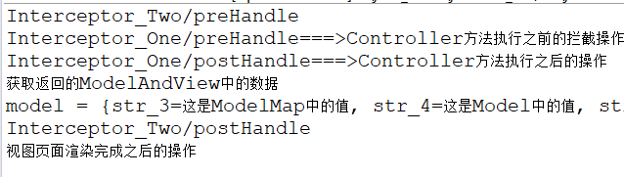
preHandle(A) --> preHandle(B) --> 控制器方法 --> postHandle(B) --> postHanle(A) --> JSP --> afterCompletion(B) --> afterCompletion(A)
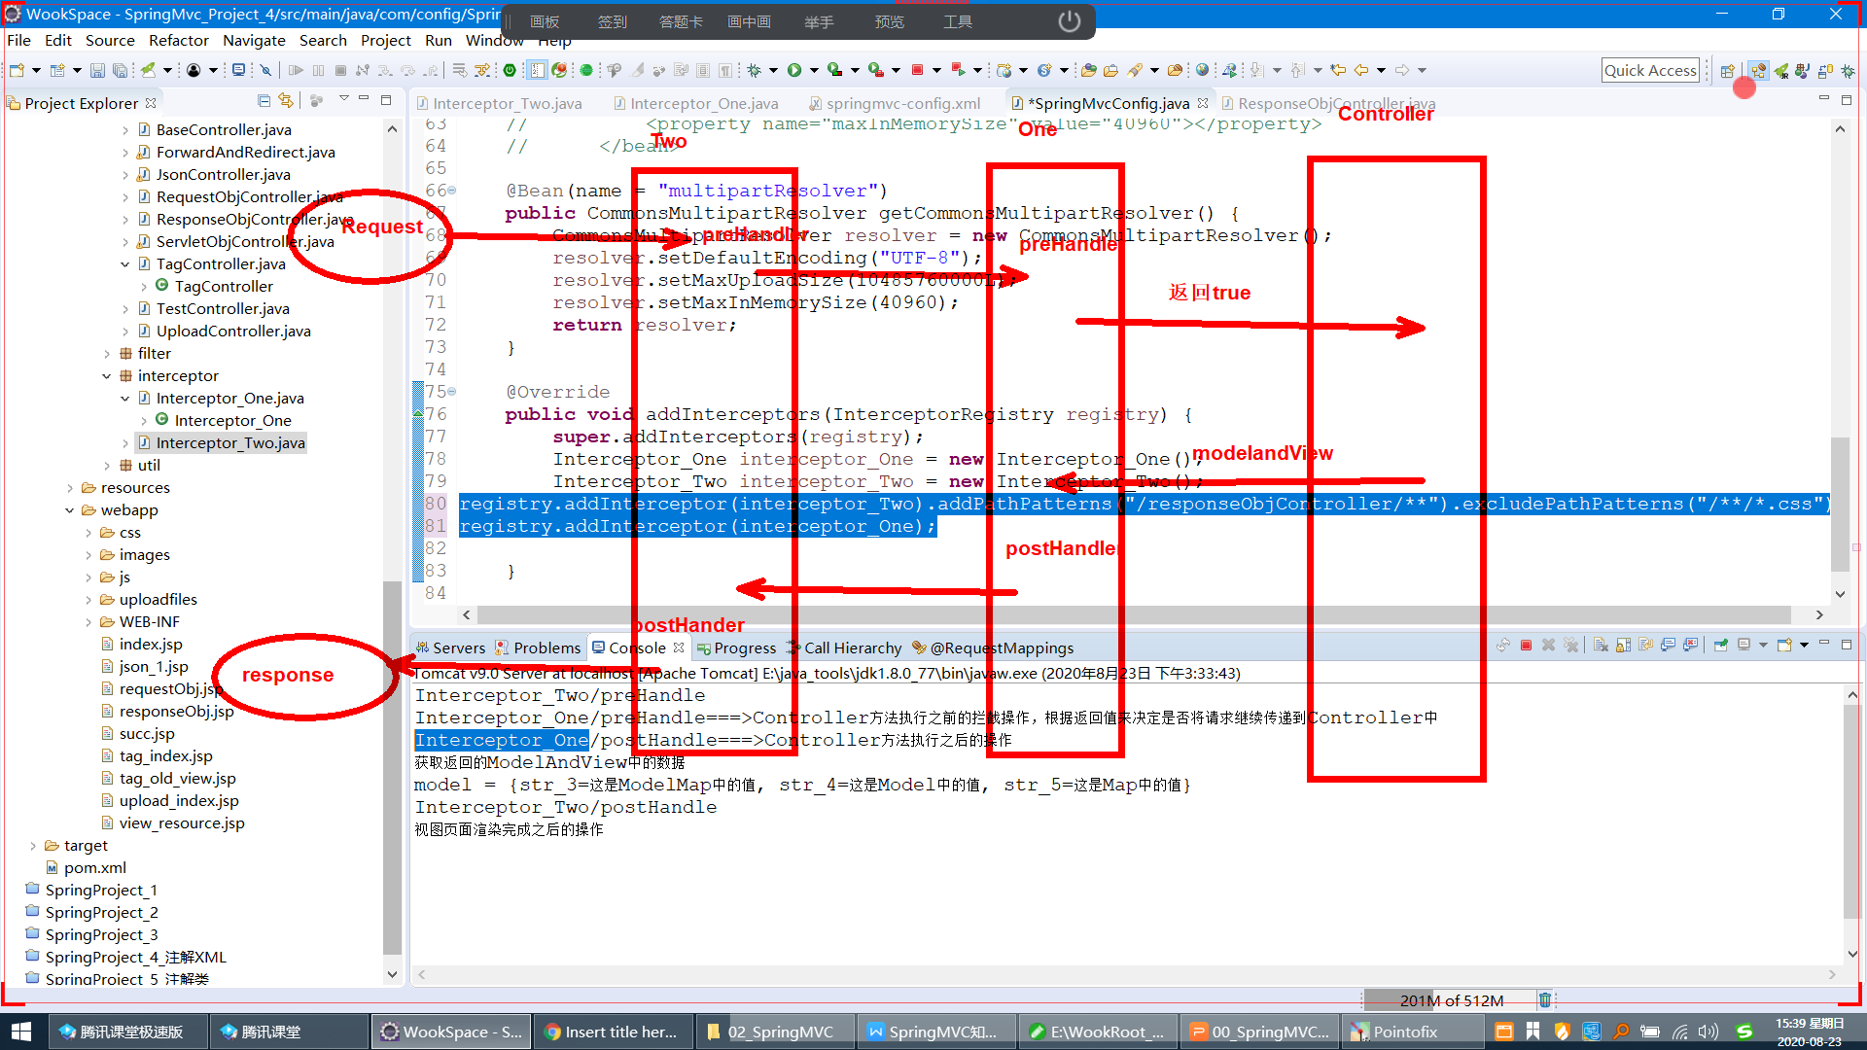

拦截器与过滤器的顺序
优先级：过滤器>拦截器
原因： 拦截器是由SpringMVC框架来管理。而SpringMVC的初始化是通过DispathServlet来实现的。在WEB的规范中，Filter的优先级的执行顺序优先于Servlet。

异常处理
在Controller执行过程中，如果有异常发生，服务端会报500的异常信息，同时会将异常的堆栈信息抛出。错误页面不太友好。

SpringMVC允许Controller中的异常在视图层进行处理。视图层进行统一的错误控制。异常处理包含2种方式。

局部异常处理
@ExceptionHandler
public ModelAndView exceptionHandler(Exception ex) {
//参数中的Exception是用来接收Controller方法中出错的异常信息
//@ExceptionHandler表示这个方法是专门用于处理Controller中的异常出错
ModelAndView mv = new ModelAndView();
mv.setViewName("exception_error");
mv.addObject("errorMsg", ex);

String requestURI = request.getRequestURI();
String contextPath = request.getContextPath();
requestURI = requestURI.replaceAll(contextPath, "");
mv.addObject("requestURI", requestURI);
return mv;
}

全局异常处理
局部异常处理，需要在每个Controller中都要添加ExceptionHandler的处理。所以可以定义全局的异常处理。
- 将局部的异常定义到BaseController中，所有Controller继承BaseController。
package com.controller;

import javax.servlet.ServletContext;
import javax.servlet.http.HttpServletRequest;
import javax.servlet.http.HttpServletResponse;
import javax.servlet.http.HttpSession;

import org.springframework.beans.factory.annotation.Autowired;
import org.springframework.web.bind.annotation.ExceptionHandler;
import org.springframework.web.servlet.ModelAndView;

public class BaseController {

//1、使用注入的方式
@Autowired
protected HttpServletRequest request;
@Autowired
protected HttpServletResponse response;
@Autowired
protected HttpSession session;
@Autowired
protected ServletContext context;

@ExceptionHandler
public ModelAndView exceptionHandler(Exception ex) {
//参数中的Exception是用来接收Controller方法中出错的异常信息
//@ExceptionHandler表示这个方法是专门用于处理Controller中的异常出错
ModelAndView mv = new ModelAndView();
mv.setViewName("exception_error");
mv.addObject("errorMsg", ex);

String requestURI = request.getRequestURI();
String contextPath = request.getContextPath();
requestURI = requestURI.replaceAll(contextPath, "");
mv.addObject("requestURI", requestURI);
return mv;
}
}

- 使用ControlerAdvice注解来完成全局异常的声明。
package com.controller;

import javax.servlet.http.HttpServletRequest;

import org.springframework.web.bind.annotation.ControllerAdvice;
import org.springframework.web.bind.annotation.ExceptionHandler;
import org.springframework.web.servlet.ModelAndView;

@ControllerAdvice
public class GlobalExceptionAdvice {
@ExceptionHandler
public ModelAndView exceptionHandler(HttpServletRequest request, Exception ex) {
System.out.println("全局异常...");
//参数中的Exception是用来接收Controller方法中出错的异常信息
//@ExceptionHandler表示这个方法是专门用于处理Controller中的异常出错
ModelAndView mv = new ModelAndView();
mv.setViewName("exception_error");
mv.addObject("errorMsg", ex);
String requestURI = request.getRequestURI();
String contextPath = request.getContextPath();
requestURI = requestURI.replaceAll(contextPath, "");
mv.addObject("requestURI", requestURI);
return mv;
}
}

注意点：全局与局部异常同时存在时，最终起作用的是局部异常。

SpringMVC与Spring的整合

配置文件的方式

Pom.xml
<project xmlns="http://maven.apache.org/POM/4.0.0"
xmlns:xsi="http://www.w3.org/2001/XMLSchema-instance"
xsi:schemaLocation="http://maven.apache.org/POM/4.0.0 http://maven.apache.org/xsd/maven-4.0.0.xsd">
<modelVersion>4.0.0</modelVersion>
<groupId>com.java1909</groupId>
<artifactId>SpringMvc_Project_5</artifactId>
<packaging>war</packaging>
<version>0.0.1-SNAPSHOT</version>
<name>SpringMvc_Project_5</name>
<url>http://maven.apache.org</url>
<properties>
<project.build.sourceEncoding>
UTF-8
</project.build.sourceEncoding>
<maven.compiler.source>1.7</maven.compiler.source>
<maven.compiler.target>1.7</maven.compiler.target>
</properties>
<dependencies>
<!--
<dependency>
<groupId>javax.servlet</groupId>
<artifactId>servlet-api</artifactId>
<version>2.5</version>
<scope>provided</scope>
</dependency>
<dependency>
<groupId>javax.servlet.jsp</groupId>
<artifactId>jsp-api</artifactId>
<version>2.1</version>
<scope>provided</scope>
</dependency>
-->
<dependency>
<groupId>javax.servlet</groupId>
<artifactId>javax.servlet-api</artifactId>
<version>3.1.0</version>
<scope>provided</scope>
</dependency>

<dependency>
<groupId>javax.servlet.jsp</groupId>
<artifactId>javax.servlet.jsp-api</artifactId>
<version>2.3.1</version>
<scope>provided</scope>
</dependency>

<dependency>
<groupId>javax.servlet</groupId>
<artifactId>jstl</artifactId>
<version>1.2</version>
</dependency>
<dependency>
<groupId>commons-beanutils</groupId>
<artifactId>commons-beanutils</artifactId>
<version>1.8.3</version>
</dependency>
<dependency>
<groupId>commons-codec</groupId>
<artifactId>commons-codec</artifactId>
<version>1.9</version>
</dependency>
<dependency>
<groupId>commons-collections</groupId>
<artifactId>commons-collections</artifactId>
<version>3.2</version>
</dependency>
<dependency>
<groupId>commons-dbcp</groupId>
<artifactId>commons-dbcp</artifactId>
<version>1.4</version>
</dependency>
<dependency>
<groupId>commons-dbutils</groupId>
<artifactId>commons-dbutils</artifactId>
<version>1.3</version>
</dependency>
<dependency>
<groupId>commons-pool</groupId>
<artifactId>commons-pool</artifactId>
<version>1.5.6</version>
</dependency>
<dependency>
<groupId>commons-io</groupId>
<artifactId>commons-io</artifactId>
<version>2.4</version>
</dependency>
<dependency>
<groupId>commons-fileupload</groupId>
<artifactId>commons-fileupload</artifactId>
<version>1.3.1</version>
</dependency>
<dependency>
<groupId>commons-lang</groupId>
<artifactId>commons-lang</artifactId>
<version>2.5</version>
</dependency>
<dependency>
<groupId>org.apache.commons</groupId>
<artifactId>commons-lang3</artifactId>
<version>3.6</version>
</dependency>

<dependency>
<groupId>org.springframework</groupId>
<artifactId>spring-aop</artifactId>
<version>4.3.22.RELEASE</version>
</dependency>
<dependency>
<groupId>org.springframework</groupId>
<artifactId>spring-aspects</artifactId>
<version>4.3.22.RELEASE</version>
</dependency>
<dependency>
<groupId>org.springframework</groupId>
<artifactId>spring-beans</artifactId>
<version>4.3.22.RELEASE</version>
</dependency>
<dependency>
<groupId>org.springframework</groupId>
<artifactId>spring-context</artifactId>
<version>4.3.22.RELEASE</version>
</dependency>
<dependency>
<groupId>org.springframework</groupId>
<artifactId>spring-context-support</artifactId>
<version>4.3.22.RELEASE</version>
</dependency>
<dependency>
<groupId>org.springframework</groupId>
<artifactId>spring-core</artifactId>
<version>4.3.22.RELEASE</version>
</dependency>
<dependency>
<groupId>org.springframework</groupId>
<artifactId>spring-expression</artifactId>
<version>4.3.22.RELEASE</version>
</dependency>
<dependency>
<groupId>org.springframework</groupId>
<artifactId>spring-jdbc</artifactId>
<version>4.3.22.RELEASE</version>
</dependency>
<dependency>
<groupId>org.springframework</groupId>
<artifactId>spring-orm</artifactId>
<version>4.3.22.RELEASE</version>
</dependency>
<dependency>
<groupId>org.springframework</groupId>
<artifactId>spring-tx</artifactId>
<version>4.3.22.RELEASE</version>
</dependency>
<dependency>
<groupId>org.springframework</groupId>
<artifactId>spring-web</artifactId>
<version>4.3.22.RELEASE</version>
</dependency>

<dependency>
<groupId>org.springframework</groupId>
<artifactId>spring-webmvc</artifactId>
<version>4.3.22.RELEASE</version>
</dependency>

<dependency>
<groupId>mysql</groupId>
<artifactId>mysql-connector-java</artifactId>
<version>5.1.47</version>
<scope>runtime</scope>
</dependency>

<dependency>
<groupId>com.fasterxml.jackson.core</groupId>
<artifactId>jackson-core</artifactId>
<version>2.5.1</version>
</dependency>
<dependency>
<groupId>com.fasterxml.jackson.core</groupId>
<artifactId>jackson-databind</artifactId>
<version>2.5.1</version>
</dependency>
<dependency>
<groupId>com.fasterxml.jackson.core</groupId>
<artifactId>jackson-annotations</artifactId>
<version>2.5.1</version>
</dependency>
</dependencies>
<build>
<finalName>SpringMvc_Project_5</finalName>
<plugins>
<plugin>
<artifactId>maven-clean-plugin</artifactId>
<version>3.1.0</version>
</plugin>
<plugin>
<artifactId>maven-resources-plugin</artifactId>
<version>3.0.2</version>
</plugin>
<plugin>
<artifactId>maven-compiler-plugin</artifactId>
<version>3.7.0</version>
<configuration>
<source>1.7</source>
<target>1.7</target>
<encoding>UTF-8</encoding>
</configuration>
</plugin>
<plugin>
<artifactId>maven-jar-plugin</artifactId>
<version>3.0.2</version>
</plugin>
<plugin>
<artifactId>maven-surefire-plugin</artifactId>
<version>2.22.1</version>
</plugin>
<plugin>
<artifactId>maven-install-plugin</artifactId>
<version>2.5.2</version>
</plugin>

<plugin>
<artifactId>maven-deploy-plugin</artifactId>
<version>2.8.2</version>
</plugin>

<plugin>
<artifactId>maven-site-plugin</artifactId>
<version>3.7.1</version>
</plugin>
<plugin>
<artifactId>
maven-project-info-reports-plugin
</artifactId>
<version>3.0.0</version>
</plugin>
<plugin>
<artifactId>maven-war-plugin</artifactId>
<version>2.4</version>
<configuration>
<version>2.5</version>
</configuration>
</plugin>
</plugins>
</build>
</project>

Web.xml
<?xml version="1.0" encoding="UTF-8"?>
<web-app xmlns:xsi="http://www.w3.org/2001/XMLSchema-instance"
xmlns="http://xmlns.jcp.org/xml/ns/javaee"
xsi:schemaLocation="http://xmlns.jcp.org/xml/ns/javaee http://xmlns.jcp.org/xml/ns/javaee/web-app_3_1.xsd"
id="WebApp_ID" version="3.1">
<!-- 加载springcontext配置 -->
<context-param>
<param-name>contextConfigLocation</param-name>
<param-value>classpath:spring-context.xml</param-value>
</context-param>
<listener>
<listener-class>org.springframework.web.context.ContextLoaderListener</listener-class>
</listener>
<!-- 加载springmvc的配置 -->
<servlet>
<servlet-name>DispatcherServlet</servlet-name>
<servlet-class>org.springframework.web.servlet.DispatcherServlet</servlet-class>
<init-param>
<param-name>contextConfigLocation</param-name>
<param-value>classpath:spring-mvc.xml</param-value>
</init-param>
<load-on-startup>1</load-on-startup>
</servlet>
<servlet-mapping>
<servlet-name>DispatcherServlet</servlet-name>
<url-pattern>/</url-pattern>
</servlet-mapping>
<welcome-file-list>
<welcome-file>/index.jsp</welcome-file>
</welcome-file-list>
</web-app>
load-on-startup的值必须为1，表示Controller的初始化进行延迟。必须保证SpringContext中对象先初始化。

spring-mvc.xml
<?xml version="1.0" encoding="UTF-8"?>
<beans xmlns="http://www.springframework.org/schema/beans"
xmlns:xsi="http://www.w3.org/2001/XMLSchema-instance"
xmlns:mvc="http://www.springframework.org/schema/mvc"
xmlns:context="http://www.springframework.org/schema/context"
xsi:schemaLocation="http://www.springframework.org/schema/mvc http://www.springframework.org/schema/mvc/spring-mvc.xsd
http://www.springframework.org/schema/beans http://www.springframework.org/schema/beans/spring-beans.xsd
http://www.springframework.org/schema/context http://www.springframework.org/schema/context/spring-context.xsd">
<bean
class="org.springframework.web.servlet.mvc.method.annotation.RequestMappingHandlerMapping"></bean>
<bean
class="org.springframework.web.servlet.mvc.method.annotation.RequestMappingHandlerAdapter"></bean>

<context:annotation-config></context:annotation-config>
<context:component-scan
base-package="com.controller">
<context:include-filter type="annotation"
expression="org.springframework.stereotype.Controller" />
<context:include-filter type="annotation"
expression="org.springframework.web.bind.annotation.ControllerAdvice" />
</context:component-scan>

<mvc:annotation-driven></mvc:annotation-driven>
<!-- 静态资源的配置 -->
<mvc:default-servlet-handler />
<mvc:resources mapping="/inf_images/**"
location="/WEB-INF/inf_images/"></mvc:resources>
<mvc:resources mapping="/inf_css/**"
location="/WEB-INF/inf_css/"></mvc:resources>
<mvc:resources mapping="/inf_js/**"
location="/WEB-INF/inf_js/"></mvc:resources>
<!-- 文件的上传与下载 -->
<bean id="multipartResolver"
class="org.springframework.web.multipart.commons.CommonsMultipartResolver">
<property name="defaultEncoding" value="UTF-8"></property>
<property name="maxUploadSize" value="10485760000"></property>
<property name="maxInMemorySize" value="40960"></property>
</bean>
<!-- 拦截器 -->
<mvc:interceptors>
<bean class="com.interceptor.Interceptor_One"></bean>
<mvc:interceptor>
<mvc:mapping path="/testController/**" />
<bean class="com.interceptor.Interceptor_Two"></bean>
</mvc:interceptor>
</mvc:interceptors>

<bean name="viewResolver"
class="org.springframework.web.servlet.view.InternalResourceViewResolver">
<property name="prefix" value="/"></property>
<property name="suffix" value=".jsp"></property>
<property name="viewClass"
value="org.springframework.web.servlet.view.JstlView" />
</bean>
</beans>

spring-context.xml
<?xml version="1.0" encoding="UTF-8"?>
<beans xmlns="http://www.springframework.org/schema/beans"
xmlns:xsi="http://www.w3.org/2001/XMLSchema-instance"
xmlns:context="http://www.springframework.org/schema/context"
xmlns:tx="http://www.springframework.org/schema/tx"
xsi:schemaLocation="http://www.springframework.org/schema/beans http://www.springframework.org/schema/beans/spring-beans-4.3.xsd
http://www.springframework.org/schema/context http://www.springframework.org/schema/context/spring-context-4.3.xsd
http://www.springframework.org/schema/tx http://www.springframework.org/schema/tx/spring-tx-4.3.xsd">
<context:annotation-config></context:annotation-config>
<context:component-scan
base-package="com.service,com.dao">
<context:exclude-filter type="annotation"
expression="org.springframework.stereotype.Controller" />
<context:exclude-filter type="annotation"
expression="org.springframework.web.bind.annotation.ControllerAdvice" />
</context:component-scan>
<!-- 配置数据源对象 -->
<bean id="dataSource"
class="org.springframework.jdbc.datasource.DriverManagerDataSource">
<property name="driverClassName"
value="com.mysql.jdbc.Driver"></property>
<property name="url"
value="jdbc:mysql://127.0.0.1:3306/java1909?useUnicode=true&amp;characterEncoding=UTF-8"></property>
<property name="username" value="root"></property>
<property name="password" value="root"></property>
</bean>
<bean id="transactionManager"
class="org.springframework.jdbc.datasource.DataSourceTransactionManager">
<property name="dataSource" ref="dataSource"></property>
</bean>
<tx:annotation-driven
transaction-manager="transactionManager" proxy-target-class="true" />
</beans>

Controller/Service/Dao
@Controller
@RequestMapping(value = "/userController")
public class UserController extends BaseController {
@Autowired
private UserService userService;
@Service
@Transactional(rollbackFor = java.lang.Exception.class)
public class UserService {
@Autowired
private UserDao userDao;
@Repository
public class UserDao {
@Autowired
private DataSource dataSource;

页面访问Controller进行数据的显示。

配置类的方式

Pom.xml
与上述的配置一致。

Web.xml
<?xml version="1.0" encoding="UTF-8"?>
<web-app xmlns:xsi="http://www.w3.org/2001/XMLSchema-instance"
xmlns="http://xmlns.jcp.org/xml/ns/javaee"
xsi:schemaLocation="http://xmlns.jcp.org/xml/ns/javaee http://xmlns.jcp.org/xml/ns/javaee/web-app_3_1.xsd"
id="WebApp_ID" version="3.1">
<welcome-file-list>
<welcome-file>/index.jsp</welcome-file>
</welcome-file-list>
</web-app>

Web加载Spring对象上下文的类
package com.config;

import javax.servlet.ServletContext;
import javax.servlet.ServletException;
import javax.servlet.ServletRegistration;

import org.springframework.web.WebApplicationInitializer;
import org.springframework.web.context.ContextLoaderListener;
import org.springframework.web.context.support.AnnotationConfigWebApplicationContext;
import org.springframework.web.servlet.DispatcherServlet;

public class WebInitConfig implements WebApplicationInitializer {

@Override
public void onStartup(ServletContext container) throws ServletException {
//加载SpringContextConfig对象的配置
// <context-param>
// <param-name>contextConfigLocation</param-name>
// <param-value>classpath:spring-context.xml</param-value>
// </context-param>
// <listener>
// <listener-class>org.springframework.web.context.ContextLoaderListener</listener-class>
// </listener>
AnnotationConfigWebApplicationContext configContext = new AnnotationConfigWebApplicationContext();
configContext.register(SpringContextConfig.class);
container.addListener(new ContextLoaderListener(configContext));

//加载SpringMvcConfig对象的配置
// <servlet>
// <servlet-name>DispatcherServlet</servlet-name>
// <servlet-class>org.springframework.web.servlet.DispatcherServlet</servlet-class>
// <init-param>
// <param-name>contextConfigLocation</param-name>
// <param-value>classpath:spring-mvc.xml</param-value>
// </init-param>
// <load-on-startup>1</load-on-startup>
// </servlet>
// <servlet-mapping>
// <servlet-name>DispatcherServlet</servlet-name>
// <url-pattern>/</url-pattern>
// </servlet-mapping>
AnnotationConfigWebApplicationContext mvcContext = new AnnotationConfigWebApplicationContext();
mvcContext.register(SpringMvcConfig.class);

ServletRegistration.Dynamic dispatcher = container.addServlet("springmvcServlet", new DispatcherServlet(mvcContext));
dispatcher.setLoadOnStartup(1);
dispatcher.addMapping("/");
}

}

SpringMvcConfig.java
package com.config;

import org.springframework.context.annotation.Bean;
import org.springframework.context.annotation.ComponentScan;
import org.springframework.context.annotation.Configuration;
import org.springframework.context.annotation.FilterType;
import org.springframework.context.annotation.ComponentScan.Filter;
import org.springframework.web.multipart.commons.CommonsMultipartResolver;
import org.springframework.web.servlet.ViewResolver;
import org.springframework.web.servlet.config.annotation.DefaultServletHandlerConfigurer;
import org.springframework.web.servlet.config.annotation.EnableWebMvc;
import org.springframework.web.servlet.config.annotation.InterceptorRegistry;
import org.springframework.web.servlet.config.annotation.ResourceHandlerRegistry;
import org.springframework.web.servlet.config.annotation.WebMvcConfigurerAdapter;
import org.springframework.web.servlet.view.InternalResourceViewResolver;
import org.springframework.web.servlet.view.JstlView;

import com.interceptor.Interceptor_One;
import com.interceptor.Interceptor_Two;

// <context:annotation-config></context:annotation-config>
@Configuration
//<context:component-scan base-package="com.controller">
// <context:include-filter type="annotation"
// expression="org.springframework.stereotype.Controller" />
// <context:include-filter type="annotation"
// expression="org.springframework.web.bind.annotation.ControllerAdvice" />
//</context:component-scan>

@ComponentScan(basePackages = "com.controller", includeFilters = {

@Filter(type = FilterType.ANNOTATION, classes = org.springframework.stereotype.Controller.class),

@Filter(type = FilterType.ANNOTATION, classes = org.springframework.web.bind.annotation.ControllerAdvice.class)

})
//<mvc:annotation-driven></mvc:annotation-driven>
@EnableWebMvc
public class SpringMvcConfig extends WebMvcConfigurerAdapter {

//<mvc:default-servlet-handler />
@Override
public void configureDefaultServletHandling(DefaultServletHandlerConfigurer configurer) {
super.configureDefaultServletHandling(configurer);
configurer.enable();
}

// <!-- 静态资源的配置 -->
// <mvc:resources mapping="/inf_images/**" location="/WEB-INF/inf_images/"></mvc:resources>
// <mvc:resources mapping="/inf_css/**" location="/WEB-INF/inf_css/"></mvc:resources>
// <mvc:resources mapping="/inf_js/**" location="/WEB-INF/inf_js/"></mvc:resources>
@Override
public void addResourceHandlers(ResourceHandlerRegistry registry) {
super.addResourceHandlers(registry);
registry.addResourceHandler("/inf_images/**").addResourceLocations("/WEB-INF/inf_images/");
registry.addResourceHandler("/inf_css/**").addResourceLocations("/WEB-INF/inf_css/");
registry.addResourceHandler("/inf_js/**").addResourceLocations("/WEB-INF/inf_js/");
}

// <bean id="multipartResolver"
// class="org.springframework.web.multipart.commons.CommonsMultipartResolver">
// <property name="defaultEncoding" value="UTF-8"></property>
// <property name="maxUploadSize" value="10485760000"></property>
// <property name="maxInMemorySize" value="40960"></property>
// </bean>

@Bean(name = "multipartResolver")
public CommonsMultipartResolver getCommonsMultipartResolver() {
CommonsMultipartResolver resolver = new CommonsMultipartResolver();
resolver.setDefaultEncoding("UTF-8");
resolver.setMaxUploadSize(10485760000L);
resolver.setMaxInMemorySize(40960);
return resolver;
}

// <!-- 拦截器 -->
// <mvc:interceptors>
// <bean class="com.interceptor.Interceptor_One"></bean>
// <mvc:interceptor>
// <mvc:mapping path="/testController/**" />
// <bean class="com.interceptor.Interceptor_Two"></bean>
// </mvc:interceptor>
// </mvc:interceptors>
@Override
public void addInterceptors(InterceptorRegistry registry) {
super.addInterceptors(registry);
Interceptor_One interceptor_One = new Interceptor_One();
Interceptor_Two interceptor_Two = new Interceptor_Two();
registry.addInterceptor(interceptor_One);
registry.addInterceptor(interceptor_Two).addPathPatterns("/testController/**").excludePathPatterns("/**/*.css");

}

// <bean name="viewResolver"
// class="org.springframework.web.servlet.view.InternalResourceViewResolver">
// <property name="prefix" value="/"></property>
// <property name="suffix" value=".jsp"></property>
// <property name="viewClass"
// value="org.springframework.web.servlet.view.JstlView" />
// </bean>

@Bean(name = "viewResolver")
public ViewResolver getViewResolver() {
InternalResourceViewResolver viewResolver = new InternalResourceViewResolver();
viewResolver.setPrefix("/");
viewResolver.setSuffix(".jsp");
viewResolver.setViewClass(JstlView.class);
return viewResolver;
}
}

SpringContextConfig.java
package com.config;

import javax.sql.DataSource;

import org.springframework.context.annotation.Bean;
import org.springframework.context.annotation.ComponentScan;
import org.springframework.context.annotation.ComponentScan.Filter;
import org.springframework.context.annotation.Configuration;
import org.springframework.context.annotation.FilterType;
import org.springframework.jdbc.datasource.DataSourceTransactionManager;
import org.springframework.jdbc.datasource.DriverManagerDataSource;
import org.springframework.transaction.PlatformTransactionManager;
import org.springframework.transaction.annotation.EnableTransactionManagement;

// <context:annotation-config></context:annotation-config>

@Configuration

//<context:component-scan base-package="com.service,com.dao">
// <context:exclude-filter type="annotation" expression="org.springframework.stereotype.Controller" />
// <context:exclude-filter type="annotation" expression="org.springframework.web.bind.annotation.ControllerAdvice" />
//</context:component-scan>

@ComponentScan(basePackages = "com.service,com.dao", excludeFilters = {

@Filter(type = FilterType.ANNOTATION, classes = org.springframework.stereotype.Controller.class),

@Filter(type = FilterType.ANNOTATION, classes = org.springframework.web.bind.annotation.ControllerAdvice.class)

})
//<tx:annotation-driven transaction-manager="transactionManager" proxy-target-class="true" />
@EnableTransactionManagement(proxyTargetClass = true)
public class SpringContextConfig {

// <bean id="dataSource"
// class="org.springframework.jdbc.datasource.DriverManagerDataSource">
// <property name="driverClassName"
// value="com.mysql.jdbc.Driver"></property>
// <property name="url"
// value="jdbc:mysql://127.0.0.1:3306/java1909?useUnicode=true&amp;characterEncoding=UTF-8"></property>
// <property name="username" value="root"></property>
// <property name="password" value="root"></property>
// </bean>

@Bean(name = "dataSource")
public DataSource getDataSource() {
DriverManagerDataSource dataSource = new DriverManagerDataSource();
dataSource.setDriverClassName("com.mysql.jdbc.Driver");
dataSource.setUrl("jdbc:mysql://127.0.0.1:3306/java1909?useUnicode=true&amp;characterEncoding=UTF-8");
dataSource.setUsername("root");
dataSource.setPassword("root");
return dataSource;
}

// <bean id="transactionManager"
// class="org.springframework.jdbc.datasource.DataSourceTransactionManager">
// <property name="dataSource" ref="dataSource"></property>
// </bean>
@Bean(name = "transactionManager")
public PlatformTransactionManager getTransactionManager() {
DataSourceTransactionManager transactionManager = new DataSourceTransactionManager(this.getDataSource());
return transactionManager;
}
}

Controller/Service/Dao
@Controller
@RequestMapping(value = "/userController")
public class UserController extends BaseController {
@Autowired
private UserService userService;
@Service
@Transactional(rollbackFor = java.lang.Exception.class)
public class UserService {
@Autowired
private UserDao userDao;
@Repository
public class UserDao {
@Autowired
private DataSource dataSource;

