A. Mass flow inventory data for marine fuels (Tables S1-S15)
Table S1 | Mass flow inventory data for 1kg MDO
Input/output | Project | Value
Input | Crude oil mix | 2.69 kg
 | Natural gas mix | 0.073 kg
 | Water (desalinated; deionized)-Pre-processing stage | 9.24 kg
 | Electricity-Pre-processing stage | 4.78 MJ
 | Diesel | 0.00192 kg
 | Water (desalinated; deionized) | 2.03 kg
 | Electricity | 3.49 MJ
Output | MDO | 1 kg

Table S2 | Mass flow inventory data for 1kg Coal-MeOH
Input/output | Project | Value
Input | Hard coal | 8.04 kg
 | Natural gas | 0.522 kg
 | Electricity-Pre-processing stage | 1.39 MJ
 | Diesel | 1.916 kg
 | Water (desalinated; deionized)-Pre-processing stage | 3.07 kg
 | Coal | 1.57 kg
 | Electricity | 0.692 MJ
 | Water (desalinated; deionized) | 9.03 kg
Output | MeOH | 1 kg
 | Ammonium sulphate | 0.002 kg

Table S3 | Mass flow inventory data for 1kg NG-MeOH
Input/output | Project | Value
Input | Hard coal | 0.047 kg
 | Crude oil | 0.000811 kg
 | Electricity-Pre-processing stage | 5.8 MJ
 | Natural gas | 0.498 kg
 | Electricity | 2.09 MJ
 | Water (desalinated; deionized) | 3.63 kg
Output | MeOH | 1 kg

Table S4 | Mass flow inventory data for 1kg e-MeOH
Input/output | Project | Value
Input | CO₂ | 1.59 kg
 | H₂ from electrolysis | 0.22 kg
 | Electricity-Pre-processing stage | 44.2 MJ
 | Steel | 1.53×10⁻⁴ kg
 | Water (desalinated; deionized)-Pre-processing stage | 2.319 kg
 | Steam | 0.4397 MJ
 | Electricity | 0.033 MJ
Output | CO₂ | 0.0770 kg
 | MeOH | 1 kg
 | NO₂ | 1.78×10⁻⁶ kg
 | Wastewater | 5.71×10⁻⁴ kg

Table S5 | Mass flow inventory data for 1kg bio-MeOH
Input/output | Project | Value
Input | Diesel | 0.00662 kg
 | Electricity-Pre-processing stage | 0.076 MJ
 | Oxygen | 0.8 kg
 | Crude oil | 0.0201 kg
 | Gasoline | 0.00376 kg
 | Biomass | 1.07 kg
 | CO₂ | 0.0343 kg
 | CO | 0.875 kg
 | Water (desalinated; deionized) | 10.8 kg
 | Electricity | 0.783 MJ
Output | MeOH | 1 kg

Table S6 | Mass flow inventory data for 1kg Conv-LNG
Input/output | Project | Value
Input | Crude oil mix | 0.000811 kg
 | Natural gas mix | 1.33 kg
 | Electricity | 12.7 MJ
 | Electricity-liquefaction stage | 1.22 MJ
Output | LNG | 1 kg

Table S7 | Mass flow inventory data for 1kg e-LNG
Input/output | Project | Value
Input | Water (desalinated; deionized) | 6.2 kg
 | Electricity-Pre-processing stage | 89.4 MJ
 | CO₂ from DAC | 2.99 kg
 | H₂ from electrolysis | 0.547 kg
 | Electricity | 4.61 MJ
 | Methane | 1.09 kg
 | Nitrogen | 0.033 kg
 | Butane | 0.0128 kg
 | Ethane | 0.115 kg
 | Propane | 0.0384 kg
Output | LNG | 1 kg

Table S8 | Mass flow inventory data for 1kg bio-LNG
Input/output | Project | Value
Input | Diesel | 0.135 kg
 | Electricity-Pre-processing stage | 0.0072 MJ
 | Biogas | 23.3 MJ
 | Methane | 1.09 kg
 | Nitrogen | 0.028 kg
 | Butane | 0.0109 kg
 | Ethane | 0.0981 kg
 | Propane | 0.0237 kg
 | Electricity | 0.957 MJ
Output | LNG | 1 kg

Table S9 | Mass flow inventory data for 1kg Conv-LH₂
Input/output | Project | Value
Input | Hard coal | 0.34 kg
 | Electricity-Pre-processing stage | 41.9 MJ
 | Natural gas | 3.6 kg
 | Water (desalinated; deionized) | 9 kg
 | Electricity | 43.2 MJ
Output | LH₂ | 1 kg

Table S10 | Mass flow inventory data for 1kg e-LH₂
Input/output | Project | Value
Input | Electricity-Pre-processing stage | 201 MJ
 | Water (desalinated; deionized) | 10 kg
 | H₂ from electrolysis | 1 kg
 | Electricity | 36 MJ
Output | LH₂ | 1 kg

Table S11 | Mass flow inventory data for 1kg bio-LH₂
Input/output | Project | Value
Input | Electricity | 35.72 MJ
 | Biomass | 24 kg
 | Nitrogen | 0.43 kg
 | Electricity-liquefaction stage | 21.5 MJ
 | Pyrolysis gas | 14.4 kg
 | Water (desalinated; deionized) | 5.4 kg
Output | LH₂ | 1 kg

Table S12 | Mass flow inventory data for 1kg Conv-LNH₃
Input/output | Project | Value
Input | Natural gas | 1.03 kg
 | Water (desalinated; deionized)- Pre-processing stage | 2.2 kg
 | Electricity-Pre-processing stage | 0.995 MJ
 | Diesel | 5.76 kg
 | Coal | 9.89 kg
 | H₂ from coke-oven gas | 0.179 kg
 | Nitrogen | 0.808 kg
 | Electricity | 36.03 MJ
 | Water (desalinated; deionized) | 0.6 kg
Output | LNH₃ | 1 kg

Table S13 | Mass flow inventory data for 1kg e-LNH₃
Input/output | Project | Value
Input | Electricity-Pre-processing stage | 36.492 MJ
 | Water (desalinated; deionized) | 1.79 kg
 | H₂ from electrolysis | 0.179 kg
 | N₂ from air separator | 0.808 kg
 | Electricity | 36 MJ
 | Water (desalinated; deionized) | 0.6 kg
Output | LNH₃ | 1 kg

Table S14 | Mass flow inventory data for 1kg Biodiesel
Input/output | Project | Value
Input | Soybean | 2.193 kg
 | Electricity-Pre-processing stage | 6.48 MJ
 | Hexane | 8.772 g
 | Sulphuric acid | 0.021 g
 | Methanol | 0.316 kg
 | Electricity | 0.61 MJ
 | Sodium Hydroxide | 0.011 kg
 | Steam | 5.6 MJ
 | Phosphoric acid for glycerine | 3.5 kg
 | Water | 1.719 kg
Output | Biodiesel* | 1 kg
Note*: Biodiesel in this study refers to fatty acid methyl ester produced by transesterification of soybean oil (soybean-FAME).

Table S15 | Mass flow inventory data for 1kg HFO
Input/output | Project | Value
Input | Crude Oil | 3.4 kg
 | Natural Gas | 0.25 kg
 | Electricity | 7.5 MJ
 | Diesel/Fuel Gas | 0.03 kg
 | Water | 6 kg
Output | HFO | 1 kg

B. 1,300 discrete scenarios of parameter combinations across the life cycle
The 1,300 scenarios represent comprehensive combinations of all discrete input parameters across the life cycle (see Fig. S1).
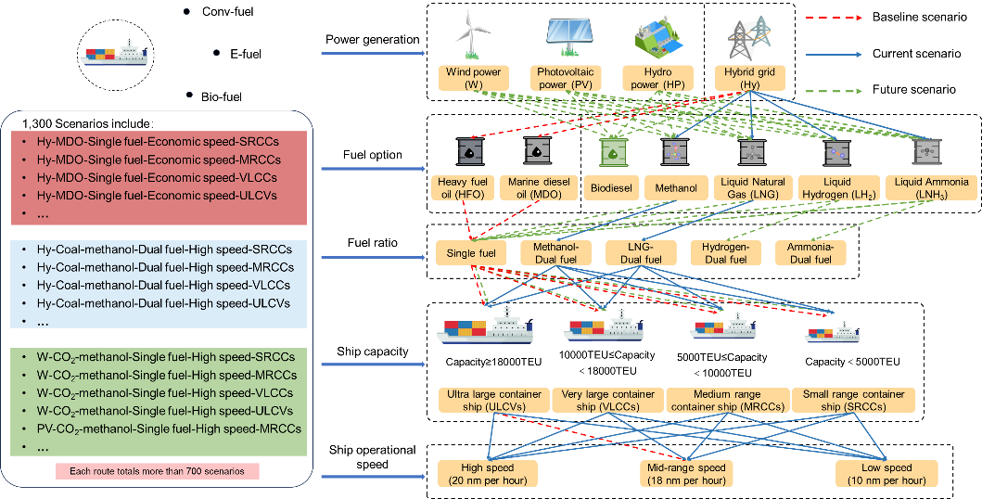
Fig. S1 | Composition of the 1,300 assessment scenarios, defined by combinations of power source, fuel production pathway, ship engine type, operational speed, and ship capacity.

