System dynamics
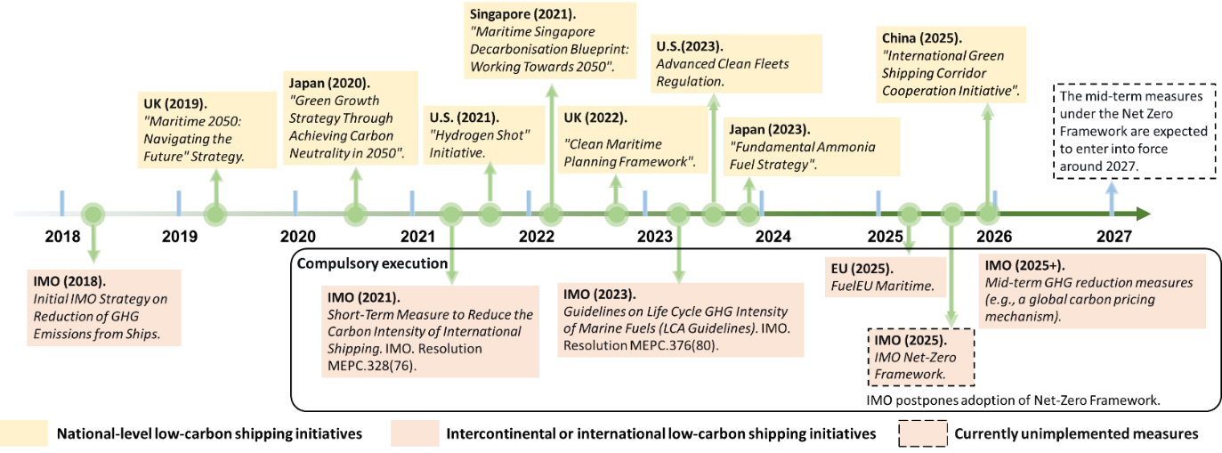
Fig. S4 outlines the international and regional decarbonisation policies included in this study. The corresponding regulatory parameters, derived from the IMO Net-Zero Framework and the FuelEU Maritime regulation, are detailed in Table S1.
Fig. S1 | A timeline of key global policy developments. International and regional policies are listed below the timeline, while national policies from various countries are listed above.

Table S1 | Summary of key regulations simulated in the model
Feature | The EU’s FuelEU Maritime | The IMO Net-Zero Framework
GHG reduction targets (year, g CO₂-eq/MJ) | (2024,89.34), (2030,85.69), (2035,77.94), (2040,77.94), (2041,62.9), (2045,34.64), (2050,18.23) | Direct Compliance Targets:  (2024,93.3), (2025,93.3), (2028,77.4), (2029,75.6), (2030,73.7), (2031,69.6), (2032,65.6), (2033,61.4), (2034,57.3), (2035,53.2), (2040,25.8), (2045,20.0)*, (2050,18.2)*  Base Targets:  (2024,93.3), (2025,93.3), (2028,89.6), (2029,87.7), (2030,85.8), (2031,81.7), (2032,77.6), (2033,73.5), (2034,69.4), (2035,65.3), (2040,32.7), (2045,23.8)*, (2050,18.2)*
Flexibility mechanism | Positive compliance balance can be:  banked, sold, pooled with other vessels, or cancelled. | Surplus Units can be: banked for two years, pooled with other vessels, or cancelled.
Penalties | $730/tonne of excess CO₂-eq | $100/tonne of excess CO₂-eq for Tier 1 Remedial Units; $380/tonne of excess CO₂-eq for Tier 2 Remedial Units
Note*: The IMO 2023 Strategy defines its checkpoints only until 2040. Therefore, the post-2040 trajectory is not yet formally established. Values for the IMO “Base Target” and “Direct compliance Target” beyond 2040 are based on the analysis and projections from King & Spalding (2025), which offers a reasoned professional forecast of the framework’s long-term implementation.
Within the system dynamics framework, these policy mechanisms are formalized as dynamic variables based on official IMO and EU policy documents. They are then systematically represented through a feedback loop diagram (Fig. S2) and a stock-flow diagram (Fig. S3).
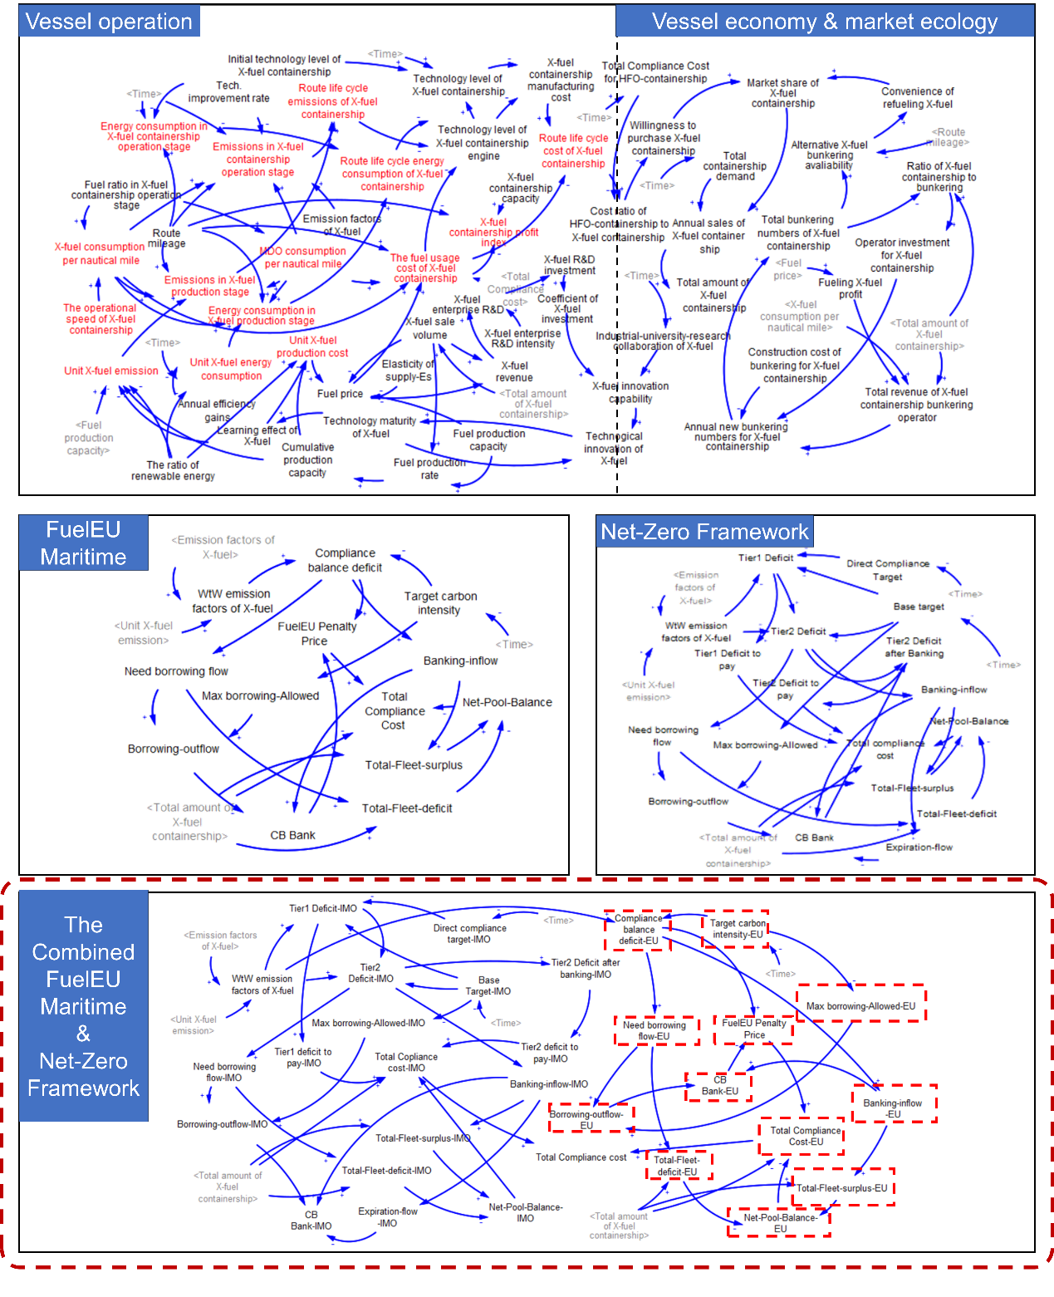
Fig. S2 | System causal loop diagram (developed in Vensim).
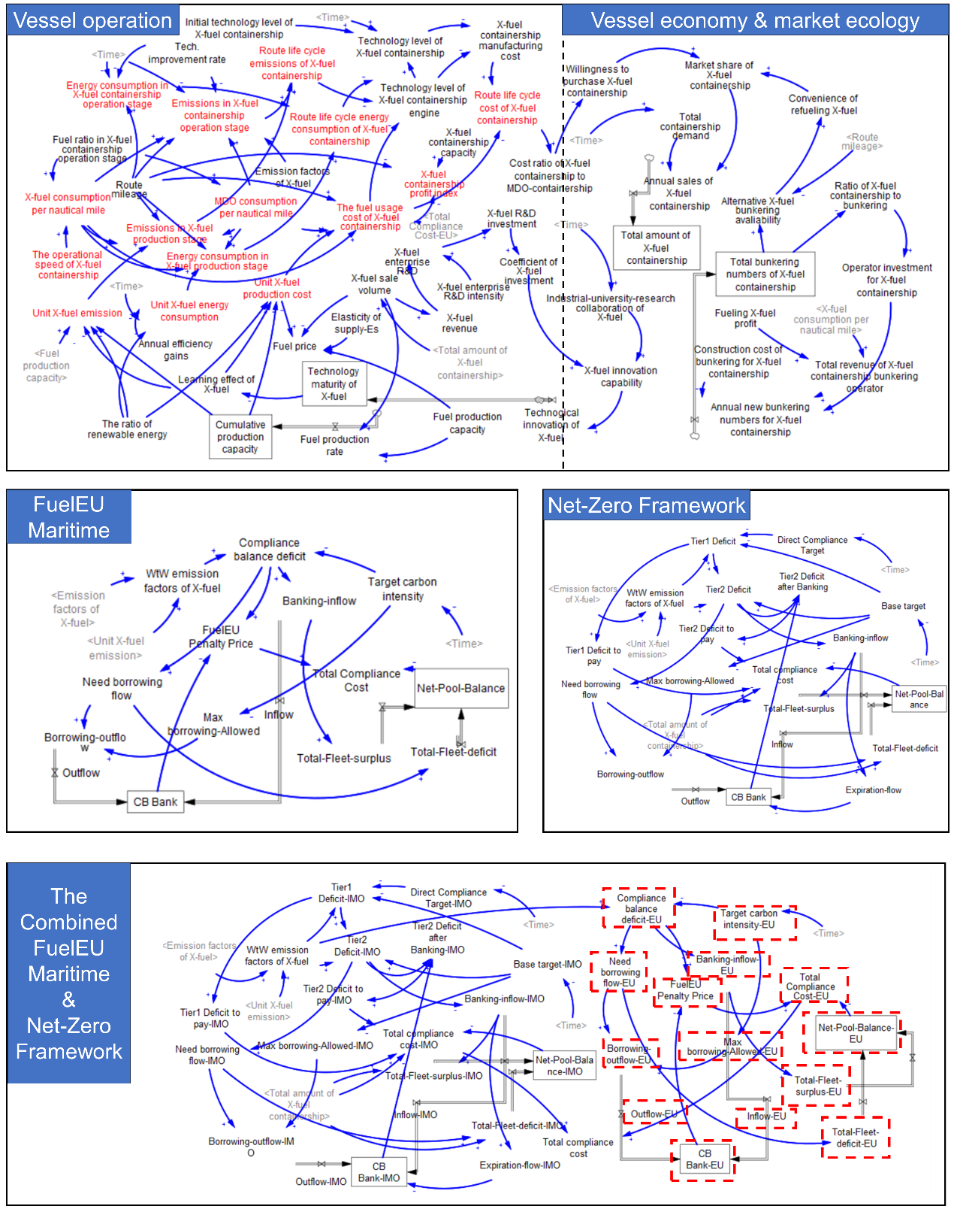
Fig. S3 | System dynamics stock-flow diagram (developed in Vensim).

A complete listing of the SD model’s variables (Table S2), their definitions (Table S3), and governing equations (Table S4) is provided.
Table S2 | Variable specification and data sources
Parameters | Category | Value (Unit)
Initial technology level of X-fuel containership | MeOH | 0.8 (-)
 | LNG | 0.8 (-)
 | LH₂ | 0.2 (-)
 | LNH₃ | 0.3 (-)
 | Biodiesel | 0.9 (-)
Technology level of X-fuel containership engine | MeOH | 0.8 (-)
 | LNG | 0.8 (-)
 | LH₂ | 0.9 (-)
 | LNH₃ | 0.8 (-)
 | Biodiesel | 0.9 (-)
Emission factors of X-fuel | MeOH | 1.375 (g CO₂-eq/g fuel)
 | LNG | 2.78 (g CO₂-eq/g fuel)
 | LH₂ | 0 (g CO₂-eq/g fuel)
 | LNH₃ | 0 (g CO₂-eq/g fuel)
 | Biodiesel | 3.2 (g CO₂-eq/g fuel)
X-fuel enterprise R&D intensity | Normal | 1 (-)
 | Weak | 0.8 (-)
Total containership demand on Asia-Europe corridor | Containership demand | ([(2025,9) - (2050,206)], (2025,9), (2026,15),  (2027,20), (2028,26),  (2029,31), (2030,38),  (2035,78), (2040,121),  (2045,165), (2050,206)) (million TEU)
Elasticity of supply-Es | Biodiesel | 0.615 (-)
 | Bio-MeOH | 0.416 (-)
 | Bio-LNG | 0.686 (-)
 | Bio-LH₂ | 0.416 (-)
Fuel production capacity | Biodiesel | 57,131,793,525 kg/year
 | Bio-MeOH | 1,712,709,406 kg/year
 | Bio-LNG | 14,229,994,820 kg/year
 | Bio-LH₂ | 7,635,829,437 kg/year
Initial refuelling ports for X-fuel containership on the corridor | MeOH | 10 (ports/year)
 | LNG | 40 (ports/year)
 | LH₂ | 0 (ports/year)
 | LNH₃ | 0 (ports/year)
FuelEU penalty | Price | 730 ($/tonne excess CO₂-eq)
Tier1 remedial units | Price | 100 ($/tonne excess CO₂-eq)
Tier2 remedial units | Price | 380 ($/tonne excess CO₂-eq)
Target carbon intensity-FuelEU | Carbon intensity | ([(2024,89.34) - (2050,18.23)], (2024,89.34), (2025,89.34), (2026,89.34), (2027,89.34), (2028,89.34), (2029,89.34), (2030,85.69), (2031,85.69), (2032,85.69), (2033,85.69), (2034,85.69), (2035,77.94), (2036,77.94), (2037,77.94), (2038,77.94), (2039,77.94), (2040,77.94), (2041,62.9), (2042,62.9), (2043,62.9), (2044,62.9), (2045,34.64), (2046,34.64), (2047,34.64), (2048,34.64), (2049,34.64), (2050,18.23)) (g CO₂-eq/MJ)
Direct compliance target | Carbon intensity | ([(2024,93.3) - (2050,18.2)], (2024,93.3), (2025,93.3), (2028,77.4), (2029,75.6), (2030,73.7), (2031,69.6), (2032,65.6), (2033,61.4), (2034,57.3), (2035,53.2), (2040,25.8), (2045,20.0), (2050,18.2))  (g CO₂-eq/MJ)
Base target | Carbon intensity | ([(2024,93.3) - (2050,18.2)], (2024,93.3), (2025,93.3), (2028,89.6), (2029,87.7), (2030,85.8), (2031,81.7), (2032,77.6), (2033,73.5), (2034,69.4), (2035,65.3), (2040,32.7), (2045,23.8), (2050,18.2))  (g CO₂-eq/MJ)
Data Sources: IMO: Study on the readiness and availability of low- and zero-carbon ship technology and marine fuels (2023); 2024 Guidelines on life cycle GHG intensity of marine fuels (2024); Energy Transitions Commission: The Next Wave: Green Corridors (2021); DNV: FuelEU Maritime-Requirements, compliance strategies, and commercial impacts (2025); King & Spalding: the IMO’s Net-Zero Framework and the Global Carbon Price on Shipping (2025); Transport & Environment: Impact of the IMO’s draft Net-Zero Framework (2025); International Energy Agency (IEA): Outlook for Biogas and Biomethane (2025); World Bioenergy Association: Global bioenergy statistics (2024); European Commission: Implementation of bioenergy in the European Union – 2024 update; USDA Foreign Agricultural Service: China: Biofuels Annual.

Major system dynamics equations
Table S3 | Nomenclature of key variables in the system dynamics model
Name | Description | Unit | Type
Technology maturity of X-fuel | A state variable representing the progression of a fuel’s technology from inception (0) to full maturity (1). | Dimensionless | Stock
X-fuel innovation capability | The rate of generating new knowledge and technical improvements for the fuel. | Dimensionless | Converter
X-fuel enterprise R&D | The annual expenditure on research and development by private enterprises for X-fuel technology. | $/year | Converter
X-fuel enterprise R&D intensity | The fraction of revenue that enterprises reinvest in R&D for X-fuel technology. | Dimensionless | Converter
X-fuel revenue | The total annual sales revenue generated from the sale of X-fuel. | $/year | Converter
Technological innovation of X-fuel | The rate of improvement in X-fuel technology, driven by innovation capability and the remaining room for improvement. | Each year | Converter
Industrial-university-research collaboration of X-fuel | An indicator of the effectiveness of the collaborative innovation ecosystem. | Dimensionless | Converter
Coefficient of X-fuel Investment | A lookup function mapping R&D investment to innovation efficiency, representing diminishing returns. | Dimensionless | Converter
X-fuel R&D investment | The total annual investment in research and development for the fuel. | $/year | Converter
Learning effect of X-fuel | The cost/emission reduction factor derived from cumulative experience and technology maturity. | Dimensionless | Converter
The ratio of renewable energy | The percentage of renewable energy in the electricity mix used for X-fuel production. | Dimensionless | Converter
Fuel production capacity | The maximum amount of fuel that can be produced per year. | tonne/year or MJ | Converter
Fuel production rate | The amount of fuel produced per year. | tonne/year or MJ | Flow
Elasticity of supply-Es | A measure of how responsive fuel production changes in its market price. | Dimensionless | Converter
Fuel price | The cost per unit of fuel. | $/kg | Converter
Cumulative production capacity | The total historical sum of all production capacity ever built. | tonne/year or MJ | Stock
Initial production capacity | The production capacity at the start of the simulation. | tonne/year or MJ | Constant
Annual efficiency gains | The yearly percentage improvement in the production efficiency (e.g., energy input per unit output). | Each year (e.g., 0.02 for 2%) | Constant
The operational speed of X-containership | The average sailing speed of a containership powered by X-fuel. | Nautical miles per hour (nm/h) | Converter
Fuel ratio in X-fuel containership operation stage | The proportion of X-fuel used in the total fuel mix during the operation. | Dimensionless (0-1) | Converter
Route mileage | The total length of the Asia-Europe green corridor. | Nautical miles (nm) | Converter
Emission factors of X-fuel | The number of specific pollutants emitted per unit of X-fuel combusted. | kg CO₂-eq/kg-fuel | Converter
Initial technology level of X-fuel containership | The starting level of integration and efficiency of X-fuel technology in the ship’s design at the model’s start time. | Dimensionless (0-1) | Constant
Technology level of X-fuel containership | A state variable representing the current overall technological sophistication and integration of X-fuel systems. | Dimensionless (0-1) | Stock
Technology level of X-fuel containership engine | The maturity and efficiency of the specific engine technology designed to use X-fuel. | Dimensionless (0-1) | Stock
X-fuel containership  manufacturing cost | The capital cost to build a new X-fuel containership. | $/ship | Converter
Cost ratio of X-fuel containership to HFO-containership | The ratio of the building and operating cost of an X-fuel ship compared to a conventional HFO ship. | Dimensionless | Converter
Annual sales of X-fuel containership | The number of new X-fuel containerships sold each year. | Ships/year | Flow
Market share of X-fuel containership | The fraction of all new ship orders that are for X-fuel containerships. | Dimensionless (0-1) | Converter
Ratio of X-fuel containership to bunkering | The number of X-fuel ships per available bunkering facility. | Ships/bunkering facility | Converter
Operator investment for X-fuel containership | The annual capital invested by shipping operators in purchasing X-fuel ships. | $/year | Flow
Total containership demand | The total annual demand for new containerships. | million TEU | Converter
Convenience of refuelling X-fuel | A factor representing how easy it is for ships to find and use X-fuel bunkering facilities. | Dimensionless (0-1) | Converter
Willingness to purchase X-fuel containership | The probability that a shipowner chooses a newbuild X-fuel ship over a conventional one. | Dimensionless (0-1) | Converter
Total bunkering numbers of X-fuel | The stock of bunkering facilities available for X-fuel at ports along the Asia-Europe green corridor. | Number of facilities | Stock
Total amount of X-fuel containership | The global fleet size of containerships powered by X-fuel. | Number of ships | Stock
Alternative X-fuel bunkering availability | The average distance between bunkering facilities, influencing refuelling convenience. | km/facility | Converter
Fuelling X-fuel profit | The profit a bunkering operator makes per ship per refuelling event. | $/ship/refuel | Converter
Construction cost of bunkering for X-fuel containership | The capital cost to build one X-fuel bunkering facility. | $/facility | Converter
The numbers of refuelling port | The stock of ports equipped with X-fuel bunkering infrastructure. | Number of ports | Stock
Annual new refuelling ports for X-fuel containership | The flow of new ports becoming equipped with X-fuel bunkering each year. | Ports/year | Flow
Total revenue of X-fuel containership bunkering operator | The total annual revenue generated from selling X-fuel to ships. | $/year | Converter
Unit X-fuel Production Cost | The production cost per unit of fuel. Decreases over time due to the learning effect and may increase due to demand-supply elasticity (biofuels). | $/kg | Converter
Unit X-fuel energy consumption | The energy consumed during the production of one unit of fuel. Decreases with technological learning. | MJ/kg | Converter
Unit X-fuel emissions | The GHG emissions from producing one unit of fuel. Decreases with technological learning. | kg CO₂-eq/kg | Converter
X-fuel consumption per nautical mile | The mass of X-fuel consumed by a containership to travel one nautical mile. | kg/nm/ship | Converter
Emissions in X-fuel production stage | Life cycle emissions from the production of the fuel consumed for a journey. | kg CO₂-eq | Converter
Energy consumption in X-fuel production stage | Life cycle energy consumption from the production of the fuel consumed for a journey. | MJ | Converter
MDO consumption per nautical mile | The mass of Marine Diesel Oil consumed per nautical mile as pilot fuel in a dual-fuel engine. | kg/nm/ship | Converter
The fuel usage cost of X-fuel containership | The total cost of fuel (X-fuel + MDO + compliance cost) for a journey. | $ | Converter
X-fuel containership profit index | The operational profitability relative to fuel cost, calculated as capacity divided by fuel cost per km. | Dimensionless | Converter
Emissions in X-fuel containership operation stage | Combustion emission during the vessel’s operation. Calculated from fuel consumption and emission factors. | kg CO₂-eq | Converter
Energy consumption in X-fuel containership operation stage | The energy released from fuel combustion during operation. | MJ | Converter
Route life cycle energy consumption of X-fuel containership | The total energy consumed over the life cycle for the route. | MJ | Converter
Route life cycle emissions of X-fuel containership | The total emissions over the life cycle for the route. | kg CO₂-eq | Converter
Route life cycle cost of X-fuel containership | The total cost incurred over the life cycle for the route. | $ | Converter
Compliance balance deficit | The shortfall in a ship’s/annual GHG intensity target compliance. | tonne CO₂-eq | Converter
Target carbon intensity | The mandated GHG intensity limit. | g CO₂-eq/MJ | Converter
Banking-inflow | The rate at which compliance surpluses are added to the bank. | tonne CO₂-eq/year | Flow
Net-pool-balance | The net revenue (or cost) from participating in a compliance pool. | $/year | Stock
FuelEU penalty price | The financial penalty per unit of compliance deficit. | $/tonne CO₂-eq | Constant
Max borrowing-allowed | The maximum amount that can be borrowed against future compliance. | tonne CO₂-eq | Converter
Need borrowing flow | The calculated requirement for borrowing to avoid penalties. | tonne CO₂-eq | Flow
CB Bank | The stock of banked compliance surpluses available for use. | tonne CO₂-eq | Stock
Total compliance cost | The total cost incurred due to GHG compliance mechanisms. | $/year | Converter
Total-fleet-surplus | The aggregate compliance surplus of the entire fleet. | tonne CO₂-eq | Converter
Total-fleet-deficit | The aggregate compliance deficit of the entire fleet. | tonne CO₂-eq | Converter
Direct compliance target | The stricter IMO target line that determines surplus generation. | g CO₂-eq/MJ | Converter
Base target | The IMO baseline target line that triggers Tier 2 penalties. | g CO₂-eq/MJ | Converter
Tier1 deficit | The compliance deficit calculated against the Direct Compliance target. | tonne CO₂-eq | Converter
Tier1 deficit to pay | The remaining Tier 1 deficit after any available bank mechanisms are applied. | tonne CO₂-eq | Converter
Tier2 deficit | The compliance deficit calculated against the Base target. | tonne CO₂-eq | Converter
Tier2 deficit to pay | The remaining Tier 2 deficit after any available bank mechanisms are applied. | tonne CO₂-eq | Converter
Tier2 deficit after banking | The Tier 2 deficit remaining after using banked surplus units. | tonne CO₂-eq | Converter
Expiration-flow | The rate at which banked surpluses expire after their validity period  (2 years for IMO). | tonne CO₂-eq | Flow
Notes: Gray shallow background values are sourced from LCA; green shallow values are defined by the EU’s FuelEU Maritime and the IMO Net-Zero Framework; blue shallow values are normal.

Table S4 | Justification and formulation of key model equations
Eq. | Justification | Calibration & Parameter Source (with citations)
Eq.1 | Represents the sub-linear growth of collaborative network efficiency. Power-law functions are common in knowledge production models. The exponent < 1 captures diminishing returns due to increasing coordination costs as networks grow. | Parameters (0.3, 0.15, 2024 base year) were calibrated to mirror the early-stage growth patterns observed in historical analogies (e.g., hydrogen fuel cell truck penetration) [6, 7].
Eq.2 | Model innovation as the product of R&D investment efficiency and collaborative knowledge input. This multiplicative form is standard in knowledge production functions. | The relationship is conceptual. The calibration of the Coefficient (via Eq.3) drives the scaling [6], [8].
Eq.3 | A non-linear lookup function models the diminishing marginal returns of R&D investment. This is a standard approach in SD to represent complex, non-analytic relationships without assuming a specific functional form. | The curve was calibrated based on related literature in the transportation sector. The specific data points define an initial high-return region that flattens significantly at high investment levels [9].
Eq.4 | The rate of technological innovation is highest when the technology is immature (1-Maturity is large) and is driven by current innovation capability. This captures the “low-hanging fruit” phenomenon. | The functional form is standard in technology diffusion models. The scaling is determined by the output of Eq.2. [6].
Eq.5 | Enterprise R&D spending is assumed to be a fixed proportion of revenue generated from the product, a common heuristic for R&D intensity in industry. | The R&D intensity parameter would be calibrated from financial reports of firms in analogous sectors [9].
Eq.6 | A standard accounting identity for revenue. | Price and sale volumes are key market variables [10].
Eq.7 | This equation dynamically calculates the market price of X-fuel by integrating production costs with a supply elasticity mechanism. It captures the fundamental economic principle that prices rise non-linearly as demand approaches production capacity limits, reflecting resource scarcity and supply chain constraints. The 1.1 multiplier represents a 10% profit margin over the production cost, ensuring model realism by incorporating a baseline internal rate of return for producers when supply is highly elastic or when demand exceeds sustainable capacity. | The supply elasticity values (Es) were calibrated based on the supply responsiveness of agricultural and energy commodities, particularly relevant for biofuel pathways. The 1.1 multiplier (10% IRR) is a conservative estimate aligned with financial benchmarks for energy infrastructure projects [11].
Eq.8 | Total fuel demand is driven by the size of the fleet and its average consumption rate. This is a fundamental physical driver of the fuel market. | Annual average consumption would be sourced from marine engineering specifications for a given ship design and operational profile.
Eq.9 | The standard system dynamics formulation for a stock (accumulation) process. Technology maturity accumulates innovations over time. | The Initial technology maturity is a critical calibration point, set based on the assessed Technology Readiness Level of the fuel at the model start time [6].
Eq.10 | A logistic-based function maps technology maturity (S-curve) to a learning effect. The steepness factor controls how rapidly cost/performance improvements occur around the point of maturity. This formalizes the experience curve concept. | The logistic shape is grounded in empirical observations of technology learning. The steepness factor was tuned to generate learning rates observed for energy technologies. The initial maturity value anchors the curve [12, 13].
Eq.11 | Assumes emissions per unit of fuel produced decrease as the technology matures, following the learning effect. This captures process optimisations and cleaner production. | The initial emission factor is sourced from LCA of the fuel production pathway at its early stage [6].
Eq.12 | Analogous to Eq.10, energy efficiency in the production process improves with technological learning. | Initial energy consumption is calibrated from process engineering models or LCA studies of the initial production technology.
Eq.13 | The core experience curve effect: unit cost decreases as cumulative knowledge increases. This is a foundational concept in energy technology modelling. | Initial production cost is a key economic parameter, calibrated from LCA [14].
Eq.14 | Calculates Well-to-Tank emissions by summing emissions from conventional fuel and X-fuel used in the production and transportation process. The constants (1.22) are emission factors for MDO production. | The MDO emission factor (1.22 kg CO₂-eq/kg fuel) is derived from LCA.
Eq.15 | Calculates the energy cost of fuel production and delivery, following the same logic as Eq.14. The constant (615.26 kJ/kg) is the energy content of MDO. | The energy content value is standard from LCA.
Eq.16 | Calculates the direct fuel cost for a voyage based on consumption and unit costs. The constant (1.32) is the assumed price of MDO. | The MDO price is standard from LCA. The structure is a straightforward cost accounting.
Eq.17 | Calculates Tank-to-Wake emissions during ship operation. The constant (3.206 kg/kg fuel) is the emission factor for combusting MDO. The X-fuel factor is a key variable. | MDO combustion emission factors are standard from IMO guidelines. The Emission factors of X-fuel is a critical parameter sourced from the IMO Net-Zero Framework or scientific literature on its combustion properties.
Eq.18 | Represents the total energy required to propel the ship over the route. This is a simplified calculation, based on a typical energy intensity per km for a containership. | The constant (2242.31 MJ/km) is derived from LCA.
Eq.19 | An index relating a ship’s revenue-generating capacity to its variable fuel cost per km. A higher index implies better profitability. | The comparator value is calibrated to represent the profitability of a standard X-fuelled vessel.
Eq.20 | Standard stock accumulation equation for infrastructure build-out. | Initial bunkering numbers are calibrated based on the number of ports with pilot or planned X-fuel bunkering facilities at the model start time.
Eq.21 | Models the growth of bunkering infrastructure as a function of the economic incentive for operators (Total revenue) and the capital required (Construction cost). The Operator investment fraction is determined elsewhere. | The Construction cost is a key parameter calibrated from infrastructure project cost estimates for alternative fuel bunkering [15].
Eq.22 | The revenue for bunkering operators is a function of the fleet size and the profit margin per refuelling event. | Fuelling X-fuel profit ($/ship) is calibrated based on margin expectations for new fuel infrastructure, low initially and increasing with scale [10].
Eq.23 | A key performance indicator for infrastructure adequacy. A high ratio indicates infrastructure strain, which triggers further investment. | The equation defines the interpretation of the related infrastructure of X-fuel containership [16].
Eq.24 | This is a logistic function, commonly used to model diffusion, adoption, and investment thresholds. This represents a common heuristic decision rule where investment increases step-wise as infrastructure scarcity becomes a critical barrier. | The investment fractions were set based on case studies of electric vehicles refuelling infrastructure rollout [6], [16, 17].
Eq.25 | An if-then-else chain models shipowner choice behaviour as a function of relative capital cost and relative operational profitability. A lookup table captures non-linear, threshold-based decision-making observed, including risk aversion. | The curve was constructed based on historical adoption patterns of vehicles and hydrogen buses. It captures risk aversion (low adoption even at parity) and accelerating adoption after a tipping point [9], [18, 19].
Eq.26 | Market share is the product of purchase willingness and refuelling convenience. This multiplicative form implies both are necessary conditions for adoption. | This is a common formulation in adoption models, where the overall utility is a product of different attributes [20].
Eq.27 | Defines infrastructure availability as the average distance between bunkering facilities. This is a direct measure of accessibility. | A straightforward calculation. The resulting value is interpreted by the lookup function in Eq.28.
Eq.28 | A lookup function maps the average distance between bunkering ports (Availability) to a convenience score. Greater distance reduces convenience, discouraging adoption. | The specific values in the lookup table were calibrated to reflect shipowner interviews and logistics models showing how the voyage becomes more complex and costly as bunkering options become sparser [21-23].
Eq.29 | The annual sales of new ships are the product of total market demand and the captured market share. This is a standard market share equation. | Total containership demand (ships/year) is an exogenous input, calibrated from shipping market forecast.
Eq.30 | Standard stock accumulation equation for the fleet size of X-fuelled ships. | Initial amount is calibrated based on the number of pilot or ordered ships at the model start time.
Eq.31 | Calculates the annual compliance position. A positive value indicates a surplus (emissions below target); a negative value indicates a deficit (emissions above target). | Target carbon intensity is sourced from the EU’s FuelEU Maritime. WtW emission factors of X-fuel are from our LCA study.
Eq.32 | Determines the amount of surplus compliance balance that can be banked for future years. Deficits result in zero banking inflow. | Logic is directly derived from the banking rules outlined in the EU’s FuelEU Maritime.
Eq.33 | Represents the net balance of a compliance pool, summing the total deficits and surpluses of all ships in the fleet. | The logic is based on the EU’s FuelEU Maritime on pooling.
Eq.34 | Calculates the penalty under FuelEU. It is triggered if a deficit exists and cannot be covered by the banked credits (CB Bank). The penalty is proportional to the uncovered deficit and annual fuel consumption. | The structure and logic are derived from the EU’s FuelEU Maritime on penalties.
Eq.35 | Defines the maximum amount that can be borrowed in a given year, set as 2% of the target carbon intensity. | The 2% factor is specified in the EU’s FuelEU Maritime.
Eq.36 | Represents the borrowing requirement for the year. It is equal to the deficit (if any); otherwise, it is zero. | Logic is derived from the borrowing rules outlined in the EU’s FuelEU Maritime and the IMO Net-Zero Framework.
Eq.37 | Calculates the current balance of the compliance bank under the FuelEU Maritime, netting new banking inflows and borrowing outflows. | The IF-THEN-ELSE structure is a standard system dynamics method to prevent negative stock values. The core parameters are defined by FuelEU.
Eq.38 | Calculates the total compliance cost under FuelEU Maritime. If no penalty is due, the cost is based on the net pool balance. If a penalty is due, the cost is a function of the penalty price and the net pool balance. | The structure is a model-specific formulation to aggregate costs. The multiplier of 0.5 applied to the regulatory cost calculations for the Eurasia Green Corridor is from the FuelEU Maritime.
Eq.39 | Aggregates the banking inflow across the entire fleet of X-fuel ships. | The “Total amount of X-fuel containership” is an output of the fleet dynamics sub-model (Eq. 29).
Eq.40 | Aggregates the borrowing need across the entire fleet of X-fuel ships. | The “Total amount of X-fuel containership” is an output of the fleet dynamics sub-model (Eq. 29).
Eq.41 | Calculates the Tier 1 deficit. It is zero if emissions are below the direct target. If emissions are between the direct and base targets, the deficit is the difference from the direct target. If emissions exceed the base target, the deficit is fixed between the direct and base targets. | The “Direct Compliance Target” and “Base Target” are model parameters set based on the IMO Net-Zero Framework.
Eq.42 | Monetary value of the Tier 1 deficit, calculated by multiplying the deficit by remedial units and annual fuel consumption. | The “Tier1 Remedial Units” (a monetary value per g CO₂-eq/MJ) is calibrated from policy document.
Eq.43 | Calculates the Tier 2 deficit. If emissions are below the base target, it equals the Tier 1 deficit. If emissions are above the base target, it is different from the base target. | The “Base Target” is a model parameter set based on the IMO Net-Zero Framework.
Eq.44 | Monetary value of the Tier 2 deficit (after banking), calculated by multiplying the deficit by remedial units and annual fuel consumption. | The “Tier2 Remedial Units” (a monetary value per g CO₂-eq/MJ) is calibrated from the policy document.
Eq.45 | Determines the Tier 2 deficit that remains after banking is considered. The logic suggests that only a non-positive Tier2 Deficit is processed for banking. | This is a model-specific logical rule to integrate the banking mechanism with the tiered penalty system.
Eq.46 | Models the expiration of banked credits after 2 years. The credits banked in a given year become unavailable two years later (Just for the IMO Net-Zero Framework). | The 2-year delay is based on the IMO Net-Zero Framework, which states banked credits are valid for two compliance periods.
Eq.47 | Calculates the current balance of the compliance bank under the IMO Net-Zero Framework, which includes an expiration mechanism for banked credits. | The structure incorporates the IMO’s banking logic [24, 25].
Eq.48 | Calculates the total compliance cost under IMO Net-Zero Framework. | The structure is a model-specific formulation to aggregate costs.
Eq.49 | Calculates the total compliance cost under the combined FuelEU Maritime and IMO Net-Zero Framework. | The structure is a model-specific formulation to aggregate costs.

The number of equations below corresponds to the numbers in Table S27:
Eq.1. Industrial-university-research collaboration of X-fuel = 0.3×(Time-2024) ^0.15
Eq.2. X-fuel innovation capability = "Coefficient of X-fuel investment" × "Industrial-university-research collaboration of X-fuel"
Eq.3. Coefficient of X-fuel investment = WITH LOOKUP ("X-fuel R&D investment", ([(1e+08,0.2) - (1e+09,0.68)], (1e+08,0.2), (1.3e+08,0.23), (1.8133e+08,0.26), (2.3266e+08,0.29), (2.9893e+08,0.327941), (3.50267e+08,0.354412), (4.01604e+08,0.380882), (5e+08,0.429412), (5.49198e+08,0.451471), (5.98396e+08,0.484559), (6.47594e+08,0.506618), (7.01069e+08,0.541912), (7.56684e+08,0.568382), (7.99465e+08,0.597059), (8.48663e+08,0.625735), (9e+08,0.65), (1e+09,0.68)))
Eq.4. Technological innovation of X-fuel = "X-fuel innovation capability" × (1 - "Technology maturity of X-fuel")
Eq.5. X-fuel enterprise R&D = "X-fuel enterprise R&D intensity" × "X-fuel revenue"
Eq.6. X-fuel revenue = "X-fuel price" × "X-fuel sale volumes"
Eq.7. X-fuel price = IF THEN ELSE ("Elasticity of supply-Es" >= 1, "Unit X-fuel production cost" × 1.1, IF THEN ELSE ("X-fuel sale volume" < Fuel production capacity, ("X-fuel sale volume" / "Fuel production capacity") ^ ("Elasticity of supply-Es") × "Unit X-fuel production cost", "Unit X-fuel production cost" × 1.1))
Eq.8. Fuel sale volumes = "Total amount of X-containership" × "Annual average X-fuel consumption per containership"
Eq.9. Technology maturity of X-fuel = INTEG ("Technological innovation of X-fuel", "Initial technology maturity of X-fuel")
Eq.10. Learning effect of X-fuel = (1 / (1 + EXP (-10 × ("Technology maturity of X-fuel" - "Initial technology maturity of X-fuel"))) - (1 / (1 + EXP (-10 × "Initial technology maturity of X-fuel")))
Eq.11. Unit X-fuel emission = "Initial X-fuel emission" × (Cumulative production capacity / (Initial production capacity)) ^ (-"Learning effect of X-fuel")
Eq.12. Unit X-fuel energy consumption = "Initial X-fuel energy consumption" × (1 - Annual efficiency gains) ^ (Time-2024)
Eq.13. Unit X-fuel production cost = "Initial X-fuel production cost" × (Cumulative production capacity / Initial production capacity) ^ (-"Learning effect of X-fuel")
Eq.14. Emissions in X-fuel production stage = "MDO consumption per nautical mile" × "Route mileage" × 1.22 + "X-fuel consumption per nautical mile" × "Route mileage" × "Unit X-fuel emission"
Eq.15. Energy consumption in X-fuel production stage = "MDO consumption per nautical mile" × "Route mileage" × 615.26 + "Unit X-fuel energy consumption" × "X-fuel consumption per nautical mile" × "Route mileage"
Eq.16. The fuel usage cost of X-fuel containership = "MDO consumption per nautical mile" × 1.32 × "Route mileage" + "Unit X-fuel production cost" × "X-fuel consumption per nautical mile" × "Route mileage" + "Total Compliance Cost"
Eq.17. Emissions in X-fuel containership operation stage = "MDO consumption per nautical mile" × "Route mileage" × 3.206 + "Emission factors of X-fuel" × "X-fuel consumption per nautical mile" × "Route mileage"
Eq.18. Energy consumption in X-fuel containership operation stage = 2242.31 × "Route mileage"
Eq.19. X-fuel containership profit index = "X-fuel containership capacity" / ("The fuel usage cost of X-containership" / "Route mileage")
Eq.20. Total bunkering numbers of X-fuel containership = INTEG ("Annual new bunkering numbers for X-fuel containership", "Initial bunkering numbers of X-fuel containership")
Eq.21. Annual new bunkering numbers for X-fuel containership = ("Operator investment for X-fuel containership" × "Total revenue of X-fuel containership bunkering operator") / ("Construction cost for X-fuel containership")
Eq.22. Total revenue of X-fuel containership bunkering operator = "Total amount of X-containership" × "Fuelling X-fuel profit"
Eq.23. Ratio of X-fuel containership to bunkering = "Total amount of X-containership" / "Total bunkering numbers of X-fuel containership"
Eq.24. Operator investment for X-fuel containership bunkering = 0.1 + 0.6 / (1 + EXP (-1.2 × ("Ratio of X-fuel containership to bunkering" - 5)))
Eq.25. Willingness to purchase X-fuel containership = IF THEN ELSE ("Cost ratio of HFO-containership to X-fuel containership" < 0.5, 0.5, IF THEN ELSE ("Cost ratio of HFO-containership to X-fuel containership" > 3, 3, "Cost ratio of HFO-containership to X-fuel containership")), WITH LOOKUP ("Cost ratio of HFO-containership to X-fuel containership", ([(0.5,0.05) - (3,0.98)], (0.5,0.05), (0.8,0.15), (1,0.35), (1.2,0.65), (1.5,0.85), (2,0.95), (3,0.98)))
Eq.26. Market share of X-fuel containership = "Willingness to purchase X-containership" × "Convenience of refuelling X-fuel"
Eq.27. Alternative X-fuel bunkering availability = "Route mileage" / "Total bunkering numbers of X-fuel containership"
Eq.28. Convenience of refuelling X-fuel = IF THEN ELSE ("Alternative X-fuel bunkering availability">1200, 1200, "Alternative X-fuel bunkering availability"), WITH LOOKUP ("Alternative X-fuel bunkering availability", ([(0,1) - (1200,0.1)], (0,1), (200,0.95), (400,0.85), (600,0.7), (800,0.45), (1000,0.25), (1200,0.1))
Eq.29. Annual sales of X-fuel containership = "Total containership demand" × "Market share of X-containership"
Eq.30. Total amount of X-fuel containership = INTEG ("Annual sales of X-ship", "Initial amount of X-fuel containership")
Eq.31. Compliance balance deficit = "Target carbon intensity" - "WtW emission factors of X-fuel"
Eq.32. Banking-inflow = IF THEN ELSE (Compliance balance deficit>=0, Compliance balance deficit, 0)
Eq.33. Net-pool-Balance = "Total-Fleet-deficit" + "Total-Fleet-surplus"
Eq.34. FuelEU Penalty Price = IF THEN ELSE (Compliance balance deficit>=0, 0, IF THEN ELSE (Compliance balance deficit > (-CB Bank):AND: Compliance balance deficit<0, ((-Compliance balance deficit) - CB Bank) × " FuelEU Penalty Price" × "Annual average X-fuel consumption per containership", 0))
Eq.35. Max borrowing-Allowed = 0.02 × Target carbon intensity
Eq.36. Need borrowing flow = IF THEN ELSE (Compliance balance deficit<0, Compliance balance deficit, 0)
Eq.37. CB Bank-EU = IF THEN ELSE ("Banking-inflow" + "Borrowing-outflow" >= 0, "Banking-inflow" + "Borrowing-outflow", 0)
Eq.38. Total Compliance Cost-EU = IF THEN ELSE (FuelEU Penalty Price=0, "Net-Pool-Balance" / "Total amount of X-fuel containership" × "Annual average X-fuel consumption per containership", (FuelEU Penalty Price - ("Net-Pool-Balance" / "Total amount of X-fuel containership" × "Annual average X-fuel consumption per containership")) × 0.5)
Eq.39. Total-Fleet-surplus = "Banking-inflow" × "Total amount of X-fuel containership"
Eq.40. Total-Fleet-deficit = "Need borrowing flow" × "Total amount of X-fuel containership"
Eq.41. Tier1 Deficit = IF THEN ELSE ("WtW emission factors of X-fuel" < "Direct compliance target", 0, IF THEN ELSE ("WtW emission factors of X-fuel" >= "Direct compliance target": AND: "WtW emission factors of X-fuel" < "Base Target", ("Direct compliance target" - "WtW emission factors of X-fuel"), ("Direct compliance target" - "Base Target")))
Eq.42. Tier1 Deficit to pay = "Tier1 Deficit" × "Tier1 Remedial Units" × "Annual average X-fuel consumption per containership"
Eq.43. Tier2 Deficit = IF THEN ELSE ("WtW emission factors of X-fuel" < "Base Target", "Tier1 Deficit", ("Base Target" - "WtW emission factors of X-fuel"))
Eq.44. Tier2 Deficit to pay = "Tier 2 Deficit after banking" × "Tier2 Remedial Units" × "Annual average X-fuel consumption per containership"
Eq.45. Tier2 Deficit after Banking = IF THEN ELSE ("Tier2 Deficit" <= 0, "Tier2 Deficit", 0)
Eq.46. Expiration-flow = DELAY FIXED ("Banking-inflow", 2, 0)
Eq.47. CB Bank-IMO = IF THEN ELSE ("Banking-inflow" + "Borrowing-outflow" - "Expiration-flow" >= 0, "Banking-inflow" + "Borrowing-outflow" - "Expiration-flow", 0)
Eq.48. Total Compliance Cost-IMO = Tier2 deficit to pay + Tier1 deficit to pay - ("Net-Pool-Balance-IMO" / "Total amount of X-fuel containership")
Eq.49. Total Compliance Cost = "Total Compliance Cost-IMO" + " Total Compliance Cost-EU"

