**老男孩linux运维实战培训**

**老男孩教育教学核心思想6重：重目标、重思路、重方法、重实践、重习惯、重总结**

**学无止境，老男孩教育成就你人生的起点！**

**版权声明：**

本文作者为《老男孩linux运维实战培训》学生—**你的名字**

本文的所有内容均来自老男孩培训**命令总结**，未经本人及老男孩培训许可，禁止私自转发及使用。

QQ: **你的**XXXX

E-mail: **你的**XXXX

**联系方式:**

|  |  |  |  |
| --- | --- | --- | --- |
| 网站运维交流群： | | | |
| **Linux QQ交流群 385168604** | | **架构师 QQ交流群 390642196** | |
| **Python QQ交流群 29215534** | | **大数据 QQ交流群 421358633** | |
| =================================================================================== | | | |
| **老男孩linux实训联系方式** |  | |  |
| **咨询QQ** | **41117397（丹丹）** | | **70271111（歪歪）** |
|  | **80042789（飞雪）** | | **390320151（小雨）** |
|  | **41117483（冰冰）** | |  |
| **电话：** | **158-1059-0206（丹丹）** | | **189-1171-8229（歪歪）** |
|  | **135-5261-2571（飞雪）** | | **186-0046-2391（小雨）** |
| **网站:** | <http://www.etiantian.org> | | <http://www.oldboyedu.com> |
| **博客:** | http://oldboy.blog.51cto.com | | <http://blog.oldboyedu.com> |

**快捷方式说明:**

**ctrl + 1 一级标题**

**ctrl + 2 二级标题**

**ctrl + 3 三级标题**

**ctrl + 5 程序代码**

**ctrl + 6 正文**

**格式约定：**

蓝色字体：内容注释

目 录

XXX课程总结 2

第1章 一级标题示例 2

1.1 二级标题示例 2

1.1.1 三级示例 2

mysql部署记录

# mysql-blibc部署

## 环境

[root@ELK_node1 ~]# cat /etc/redhat-release && uname -r

CentOS Linux release 7.1.1503 (Core)

3.10.0-229.el7.x86_64

## mysql-glibc版本

mysql-5.7.22-linux-glibc2.12-x86_64.tar

## 目录定义

mkdir –p /application/ #程序存放目录

mkdir -p /server/scripts/ #脚本目录

mkdir -p /tools/ #工具目录

## 创建mysql用户及组

groupadd mysql

useradd -g mysql -s /sbin/noligin mysql -M

## 上传包并解压

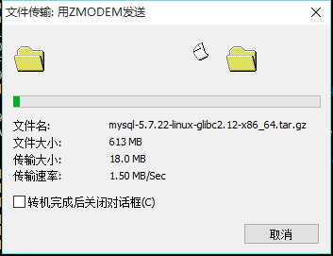

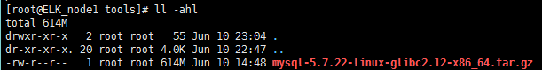

tar xf mysql-5.7.22-linux-glibc2.12-x86_64.tar.gz



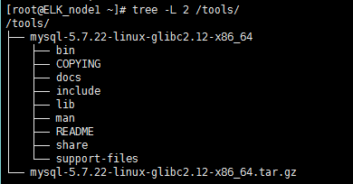

mv mysql-5.7.22-linux-glibc2.12-x86_64 /application/ #移动到指定的application目录

cd /application/

mv mysql-5.7.22-linux-glibc2.12-x86_64 mysql-5.7.22 #修改名称

ll

drwxr-xr-x 9 root root 120 Jun 10 23:13 mysql-5.7.22



## 在mysql目中创建一个data目录

mkdir -p /application/mysql-5.7.22/data

chmod 770 /application/mysql-5.7.22/data && ll /application/mysql-5.7.22/

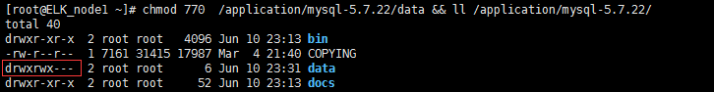

## 设置目录用户以及组为mysql

chown -R mysql:mysql /application/mysql-5.7.22 && ll /application/

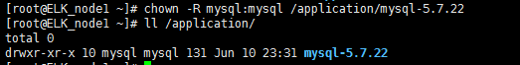

## 初始化并指定用户,mysql目录以及数据目录

bin/mysqld --initialize --user=mysql --basedir=/application/mysql-5.7.22 --datadir=/application/mysql-5.7.22/data

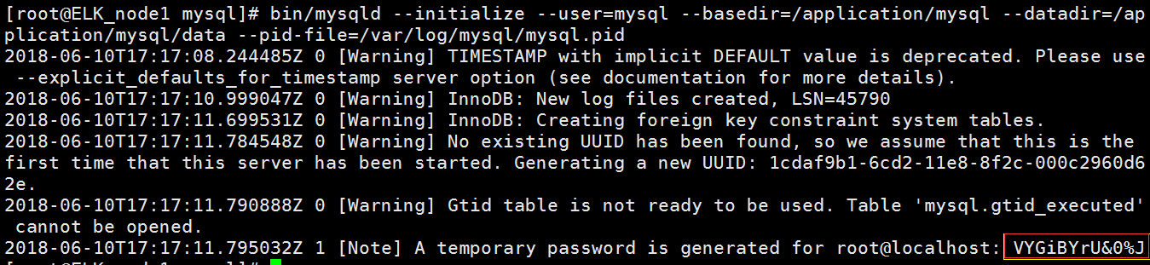

2018-06-10T17:17:08.244485Z 0 [Warning] TIMESTAMP with implicit DEFAULT value is deprecated. Please use --explicit_defaults_for_timestamp server option (see documentation for more details).

2018-06-10T17:17:10.999047Z 0 [Warning] InnoDB: New log files created, LSN=45790

2018-06-10T17:17:11.699531Z 0 [Warning] InnoDB: Creating foreign key constraint system tables.

2018-06-10T17:17:11.784548Z 0 [Warning] No existing UUID has been found, so we assume that this is the first time that this server has been started. Generating a new UUID: 1cdaf9b1-6cd2-11e8-8f2c-000c2960d62e.

2018-06-10T17:17:11.790888Z 0 [Warning] Gtid table is not ready to be used. Table 'mysql.gtid_executed' cannot be opened.

2018-06-10T17:17:11.795032Z 1 [Note] A temporary password is generated for root@localhost: VYGiBYrU&0%🡨-----默认密码

## 设置SS兰州连接mysql （RSA加密）

bin/mysql_ssl_rsa_setup --basedir=/application/mysql-5.7.22 --datadir=/application/ mysql-5.7.22/data

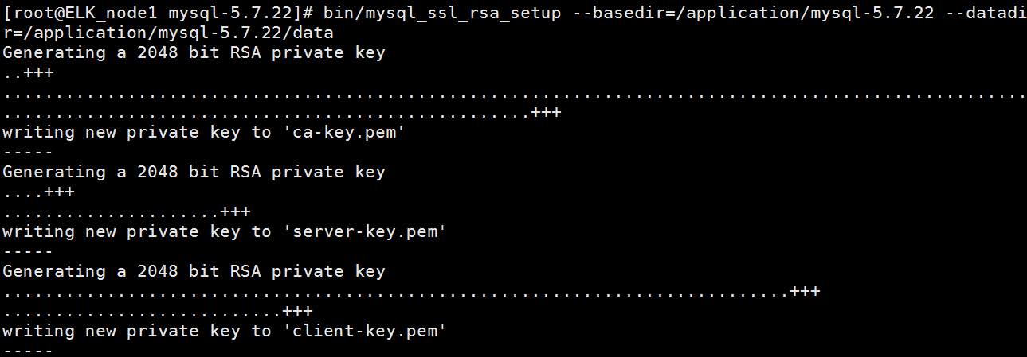

## 创建日志目录

mkdir -p /var/log/mysql

chown -R mysql:mysql /var/log/mysql #不赋权的话启动会报一下错误



## 使其在后台运行

bin/mysqld_safe --user=mysql --basedir=/application/mysql-5.7.22/ --datadir=/application/mysql-5.7.22/data &

正确：



### 错误：

mysqld_safe error: log-error set to '/var/log/mariadb/mariadb.log', however file don't exists. Create writable for user 'mysql'.

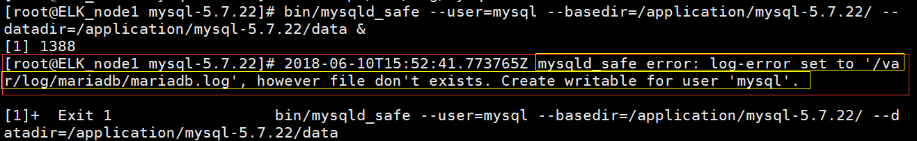

以上报错解决方法：

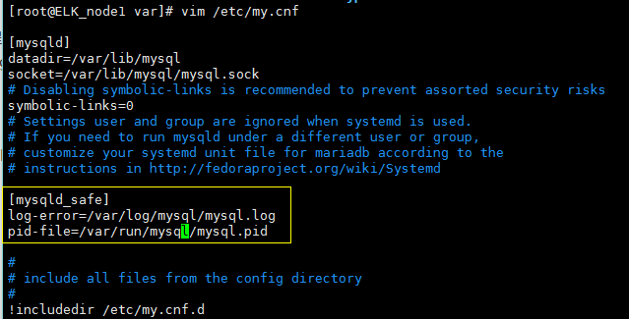

## 修改启动配置文件

cd /application/mysql/bin

/bin/sed -i 's#/usr/local/#/application/#g' mysqld_safe

sed -i 's#/usr/local/#/application/#g' mysqld_safe

cd ..

/bin/sed -i 's#/usr/local/#/application/#g' support-files/mysql.server

## 将mysql加入到/etc/init.d启动引导

cp support-files/mysql.server /etc/init.d/mysqld

chmod +x /etc/init.d/mysqld #赋执行权限

## 修改my.conf配置文件

egrep -v "^$|^#" /etc/my.cnf

[mysqld]

basedir = /application/mysql

datadir = /application/mysql/data

socket = /tmp/mysql.sock

user = mysql

symbolic-links=0

[mysqld_safe]

log-error = /var/log/mysql/mysql_error.log

pid-file = /var/log/mysql/mysql.pid

!includedir /etc/my.cnf.d

## 配置环境变量

vim /etc/profile

export MYSQL_HOME="/application/mysql"  
export PATH="$PATH:$MYSQL_HOME/bin"



source /etc/profile #使其变量生效

## 创建软连接（符号链接）

ln -s /application/mysql-5.7.22 /application/mysql

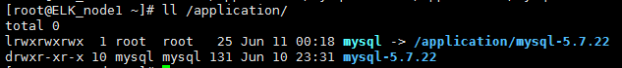

# 启动数据库

/etc/init.d/mysqld start



## 查看日志

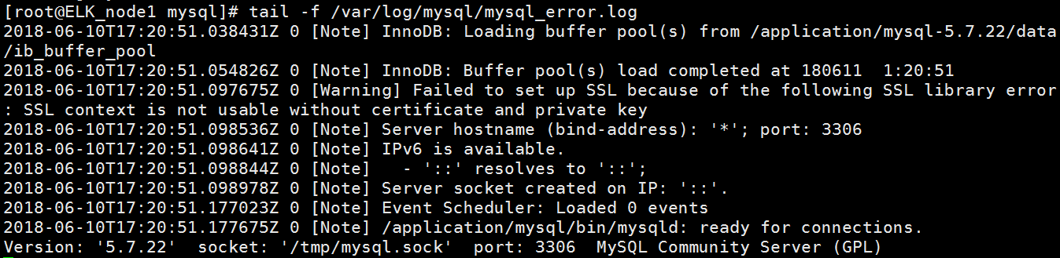

## 进入数据库并设置新的密码

mysql -uroot -pVYGiBYrU&0%J

mysql>

mysql> SET PASSWORD=PASSWORD('123456'); #方法1

mysql> flush privileges;

mysqladmin -uroot -p123456 password oldboy123 #方法2







# 部署完成