**老男孩linux运维实战培训**

**老男孩教育教学核心思想6重：重目标、重思路、重方法、重实践、重习惯、重总结**

**学无止境，老男孩教育成就你人生的起点！**

**版权声明：**

本文作者为《老男孩linux运维实战培训》学生—**你的名字**

本文的所有内容均来自老男孩培训**命令总结**，未经本人及老男孩培训许可，禁止私自转发及使用。

QQ: **你的**XXXX

E-mail: **你的**XXXX

**联系方式:**

|  |  |  |  |
| --- | --- | --- | --- |
| 网站运维交流群： | | | |
| **Linux QQ交流群 385168604** | | **架构师 QQ交流群 390642196** | |
| **Python QQ交流群 29215534** | | **大数据 QQ交流群 421358633** | |
| =================================================================================== | | | |
| **老男孩linux实训联系方式** |  | |  |
| **咨询QQ** | **41117397（丹丹）** | | **70271111（歪歪）** |
|  | **80042789（飞雪）** | | **390320151（小雨）** |
|  | **41117483（冰冰）** | |  |
| **电话：** | **158-1059-0206（丹丹）** | | **189-1171-8229（歪歪）** |
|  | **135-5261-2571（飞雪）** | | **186-0046-2391（小雨）** |
| **网站:** | <http://www.etiantian.org> | | <http://www.oldboyedu.com> |
| **博客:** | http://oldboy.blog.51cto.com | | <http://blog.oldboyedu.com> |

**快捷方式说明:**

**ctrl + 1 一级标题**

**ctrl + 2 二级标题**

**ctrl + 3 三级标题**

**ctrl + 5 程序代码**

**ctrl + 6 正文**

**格式约定：**

蓝色字体：内容注释

目 录

LAMP课程总结 1

第1章 Apache实战 1

1.1 Apache部署 1

1.2 Apache目录结构 1

1.3 配置文件 2

第2章 Php部署 4

2.1.1 配置apache实现PHP整合 5

2.1.2 Php测试 5

2.2 wordpress博客搭建 6

2.3 Apache两种工作模式介绍及配置优化 8

LAMP课程总结

集群架构

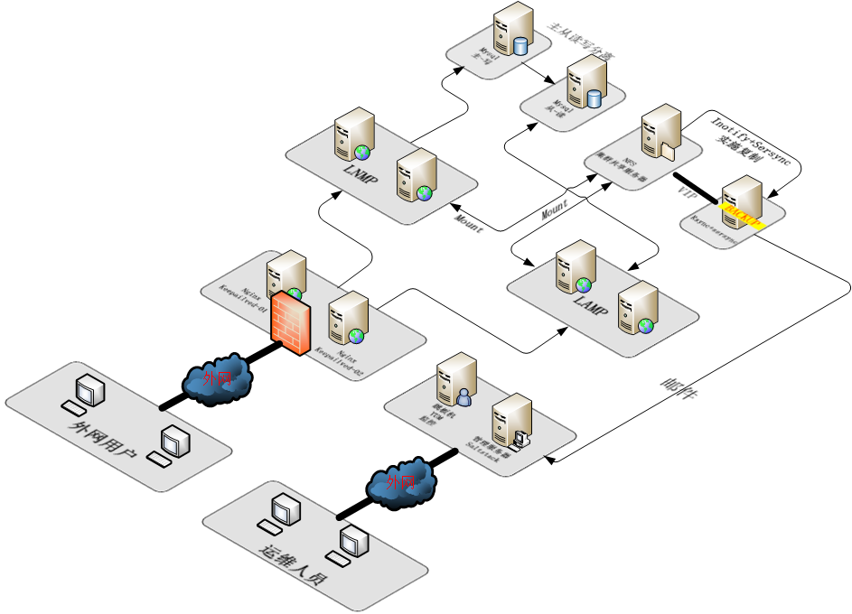

版本安排

|  |  |
| --- | --- |
| Apache | httpd-2.2.31.tar.gz |
| Php | 5.3.27 |
| mysql | 5.5.49 |

脚本清单

|  |  |  |
| --- | --- | --- |
| 脚本名称 | 作用区域 | 备注 |
| 01_one_rsync_Server.sh | Backup服务器部署配置 | /srv/salt/scripts |
| 02_two_rsync_client.sh | Nfs服务器部署配置 | /srv/salt/scripts |
| 03_Inotify+SersynCrsync.sh | Inotify+sersync数据同步配置 | /srv/salt/scripts |
| mysql_db.sh | 数据库服务器部署 | /srv/salt/scripts |
| yum-one_lnmp.sh | LNMP | /srv/salt/scripts |
| yum-one_lamp.sh | LAMP | /srv/salt/scripts |
| nginx_lb01.sh | 负载均衡node1 | /srv/salt/scripts |
| nginx_lb02.sh | 负载均衡node2 | /srv/salt/scripts |
| yumRepository | YUM仓库部署 | /server/scripts |
| saltstack | Saltstack-master-minion部署 | * |
| 04_expect_fenfa_m01 | M01管理分发机器-YUM仓库 |  |

# Apache实战

## Apache部署

http://archive.apache.org/dist/httpd/

[root@web02 scripts]# mkdir -p /home/oldboy/tools

[root@web02 scripts]# cd/home/oldboy/tools

Wget <http://archive.apache.org/dist/httpd/httpd-2.2.31.tar.gz>

[root@web02 tools]# tar zxf httpd-2.2.31.tar.gz

[root@web02 tools]# cd httpd-2.2.31

[root@web02 httpd-2.2.31]# yum install zlib zlib-devlel gcc -y

[root@web02 httpd-2.2.31]# ./configure --prefix=/application/apache2.2.31 --enable-deflate --enable-expires --enable-headers --enable-modules=most --enable-so --with-mpm=worker --enable-rewrite

[root@web02 httpd-2.2.31]# make

[root@web02 httpd-2.2.31]# make install

[root@web02 application]# ln -s /application/apache2.2.31/ /application/apache



## Apache目录结构

[root@web02 application]# tree -L 1 apache

apache

├── bin

├── build

├── cgi-bin

├── conf 配置文件目录

├── error

├── htdocs 相当于nginx中的html文件目录

├── icons

├── include

├── lib

├── logs

├── man

├── manual

└── modules

## 配置文件

[root@web02 application]# cd apache/htdocs/

[root@web02 htdocs]# mkdir bbs www blog

[root@web02 conf]# pwd

/application/apache/conf

[root@web02 conf]# vim httpd.conf

69 User www

70 Group www

98 ServerName 127.0.0.1:80

145 Options -Indexes FollowSymLinks

170 DirectoryIndex index.php index.html

313 AddHandler php5-script php

314 AddType application/x-httpd-php .php. phtml

315 AddType application/x-httpd-php-source .phps

396 Include conf/extra/httpd-vhosts.conf

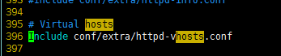

打开虚拟主机（去掉前面注释）

[root@web02 extra]# vim httpd-vhosts.conf

<VirtualHost *:80>

ServerAdmin 278028843@qq.com

DocumentRoot "/application/apache2.2.31/htdocs/www"

ServerName www.51cto.com

ServerAlias 51cto.com

ErrorLog "logs/www-error_log"

CustomLog "logs/www-access_log" common

</VirtualHost>

<VirtualHost *:80>

ServerAdmin 278028843@qq.com

DocumentRoot "/application/apache2.2.31/htdocs/blog"

ServerName blog.51cto.com

ErrorLog "logs/www-error_log"

CustomLog "logs/www-access_log" common

</VirtualHost>

<VirtualHost *:80>

ServerAdmin 278028843@qq.com

DocumentRoot "/application/apache2.2.31/htdocs/bbs"

ServerName bbs.51cto.com

ErrorLog "logs/www-error_log"

CustomLog "logs/www-access_log" common

</VirtualHost>

[root@web02 conf]# ../bin/apachectl -t 检查语法

Syntax OK

[root@web02 conf]# ../bin/apachectl start 启动

[root@web02 conf]# ../bin/apachectl graceful 优雅重启 相当于nginx的reload

添加测试页：

[root@web02 htdocs]# cd blog/

[root@web02 blog]# echo 'apache blog' >index.html

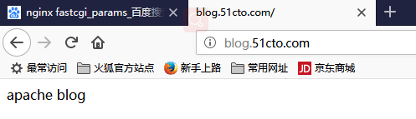

记得hosts文件做解析

# Php部署

##yum安装php依赖库

#更新bash源

wget -O /etc/yum.repos.d/CentOS-Base.repo http://mirrors.aliyun.com/repo/Centos-6.repo

#更新epel源

wget -O /etc/yum.repos.d/epel.repo http://mirrors.aliyun.com/repo/epel-6.repo

yum install -y zlib-devel libxml2-devel libjpeg-devel libjpeg-turbo-devel libiconv-devel freetype-devel libpng-devel gd-devel libcurl-devel libxslt-devel libmcrypt-devel mcrypt mhash

cd /home/oldboy/tools/

wget http://ftp.gnu.org/pub/gnu/libiconv/libiconv-1.14.tar.gz

cd libiconv-1.14

./configure --prefix=/usr/local/libiconv

make &&make install

yum install -y openssl openssl-devel

[root@web02 tools]# tar zxf php-5.3.27.tar.gz

[root@web02 tools]# cd php-5.3.27

./configure \

--prefix=/application/php5.3.27 \

--with-mysql=mysqlnd \

--with-pdo-mysql=mysqlnd \

--with-apxs2=/application/apache/bin/apxs \

--with-openssl \

--with-zlib \

--with-freetype-dir \

--with-jpeg-dir \

--with-png-dir \

--with-libxml-dir=/usr \

--enable-xml \

--disable-rpath \

--enable-bcmath \

--enable-shmop \

--enable-sysvsem \

--enable-inline-optimization \

--with-curl \

--enable-mbregex \

--enable-mbstring \

--with-mcrypt \

--with-gd \

--enable-gd-native-ttf \

--with-openssl \

--enable-pcntl \

--enable-sockets \

--with-xmlrpc \

--enable-soap \

--enable-short-tags \

--enable-zend-multibyte \

--enable-static \

--with-xsl \

--enable-ftp

make &&make install

ln -s /application/php5.5.32/ /application/php

### 配置apache实现PHP整合

[root@web02 php-5.5.32]# vim /application/apache/conf/httpd.conf

312 AddHandler php5-script php

313 AddType application/x-httpd-php .php. phtml

314 AddType application/x-httpd-php-source .phps

[root@web02 php-5.5.32]# useradd -u 501 -s /sbin/nologin -M www

### Php测试

[root@web02 blog]# pwd

/application/apache/htdocs/blog

[root@web02 blog]# cat phpinfo.php

<?php

phpinfo():

?>

[root@web02 blog]# vim mysql.php

<?php

$link_id=mysql_connect('db01.51cto.com','wordpress','123456') or mysql_error();

if($link_id) {

echo "mysql successful by cj wordpress!";

}

else{

echo mysql_error();

}

?>

## wordpress博客搭建

直接将web01blog目录打包，到apache/htdoc/目录下解压

[root@web02 blog]# tar xf blog.tar.gz

[root@web02 blog]# ll

总用量 11160

drwxr-xr-x 5 www www 4096 4月 13 13:49 blog

-rw-r--r-- 1 root root 11407713 4月 15 15:47 blog.tar.gz

-rw-r--r-- 1 root root 12 4月 15 12:48 index.html

-rw-r--r-- 1 root root 225 4月 15 21:12 mysql.php

-rw-r--r-- 1 root root 20 4月 15 20:35 phpinfo.php

[root@web02 blog]# \mv blog/* .

[root@web02 blog]# rm -rf blog

[root@web02 blog]# ll

总用量 11356

-rw-r--r-- 1 root root 11407713 4月 15 15:47 blog.tar.gz

-rw-r--r-- 1 www www 5 4月 10 11:02 index.html

-rw-r--r-- 1 www www 418 9月 25 2013 index.php

-rw-r--r-- 1 www www 19935 1月 7 03:32 license.txt

-rw-r--r-- 1 root root 225 4月 15 21:12 mysql.php

-rw-r--r-- 1 root root 20 4月 15 20:35 phpinfo.php

-rw-r--r-- 1 www www 7001 2月 8 12:53 readme.html

-rw-r--r-- 1 www www 20 4月 12 17:05 test_info.php

-rw-r--r-- 1 www www 240 4月 12 20:54 test_mysql.php

-rw-r--r-- 1 www www 5434 9月 23 2017 wp-activate.php

drwxr-xr-x 9 www www 4096 2月 8 12:52 wp-admin

-rw-r--r-- 1 www www 364 12月 19 2015 wp-blog-header.php

-rw-r--r-- 1 www www 1627 8月 29 2016 wp-comments-post.php

-rw-rw-rw- 1 www www 3212 4月 13 13:49 wp-config.php

-rw-r--r-- 1 www www 2930 2月 8 12:53 wp-config-sample.php

drwxr-xr-x 6 www www 4096 4月 13 10:58 wp-content

-rw-r--r-- 1 www www 3669 8月 20 2017 wp-cron.php

drwxr-xr-x 18 www www 12288 2月 8 12:52 wp-includes

-rw-r--r-- 1 www www 2422 11月 21 2016 wp-links-opml.php

-rw-r--r-- 1 www www 3306 8月 22 2017 wp-load.php

-rw-r--r-- 1 www www 36583 10月 13 2017 wp-login.php

-rw-r--r-- 1 www www 8048 1月 11 2017 wp-mail.php

-rw-r--r-- 1 www www 16246 10月 4 2017 wp-settings.php

-rw-r--r-- 1 www www 30071 10月 19 01:36 wp-signup.php

-rw-r--r-- 1 www www 4620 10月 24 06:12 wp-trackback.php

-rw-r--r-- 1 www www 3065 9月 1 2016 xmlrpc.php

[root@web02 blog]# /application/apache/bin/apachectl restart

页面访问测试

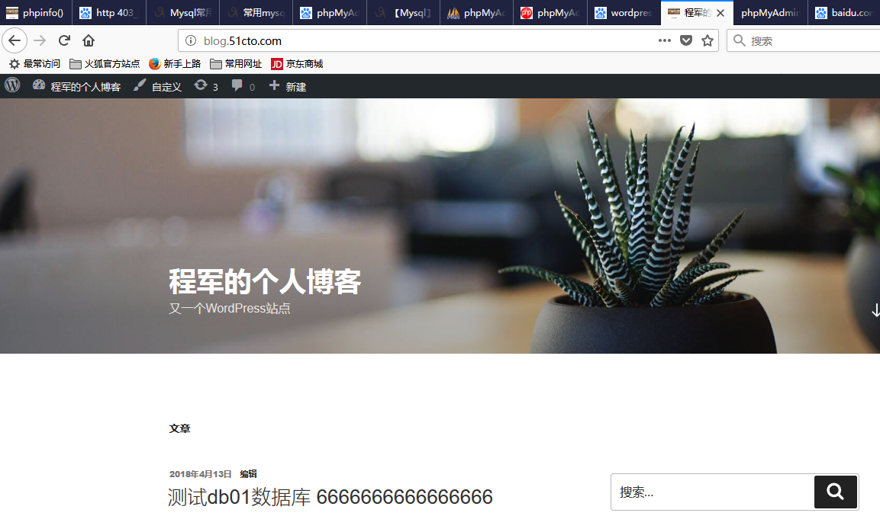

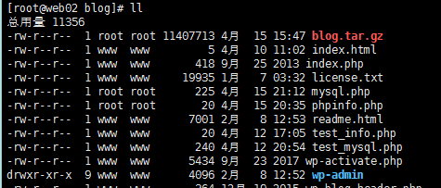

NFS存储数据分离

[root@web02 blog]# mount -t nfs 172.16.1.31:/data/nfs-blog /application/apache/htdocs/blog/wp-content/uploads/

[root@web02 ~]# df -HP

Filesystem Size Used Avail Use% Mounted on

172.16.1.31:/data/nfs-blog 8.7G 1.7G 6.6G 20% /application/apache2.2.31/htdocs/blog/wp-content/uploads

[root@web02 ~]# echo "mount -t nfs 172.16.1.31:/data/nfs-blog /application/apache/htdocs/blog/wp-content/uploads/" >>/etc/rc.local

## Apache两种工作模式介绍及配置优化

模式比较

|  |  |
| --- | --- |
| 模式 | 特性 |
| Worker | 线程模式；占用资源少；稳定性略差；并发大 |
| Perfork | 进程模式；占用资源多；稳定；开发一般 |

在程序编译时进行选择，默认是perfork模式

优化配置文件：

/application/apache/conf/extra httpd-mpm.conf

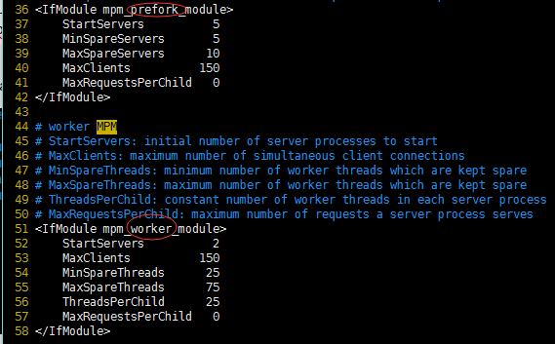

#### Php部署错误记录

1、configure: error: Cannot find OpenSSL's <evp.h>

yum install openssl-devel -y

## 脚本汇总

#!/bin/bash  
#create LNMP scripts  
#zuozhe cj  
#time 20180418  
hostname web02  
/bin/sed -i 's#backup#web02#' /etc/sysconfig/network  
/bin/sed -i 's#IPADDR=10.0.0.100#IPADDR=10.0.0.7#g' /etc/sysconfig/network-scripts/ifcfg-eth0  
/bin/sed -i 's#IPADDR=172.16.1.100#IPADDR=172.16.1.7#g' /etc/sysconfig/network-scripts/ifcfg-eth1  
##########################################################################################  
#配置使用内部YUM仓库172.16.1.61 conf/etc/yum.repos.d/yum.repo####  
#/bin/echo -e "[yum]\n  
#name=Server\n  
#baseurl=http://10.0.0.61\n  
#enable=1\n  
#gpgcheck=0"|egrep -v "^$" >/etc/yum.repos.d/yum.repo  
#/bin/sed -i '18a enabled=0' /etc/yum.repos.d/CentOS-Base.repo  
#/bin/sed -i '26a enabled=0' /etc/yum.repos.d/CentOS-Base.repo  
#/bin/sed -i '34a enabled=0' /etc/yum.repos.d/CentOS-Base.repo  
yum --enablerepo=yum --disablerepo=base,extras,updates,epel list  
##########################################################################################  
yum install zlib zlib-devlel gcc openssl-devel -y  
yum install gcc nfs-utils rpcbind -y  
yum install -y zlib-devel libxml2-devel libjpeg-devel libjpeg-turbo-devel libiconv-devel freetype-devel libpng-devel gd-devel libxslt-devel libmcrypt-devel  
yum install -y mcrypt mhash  
####################################################################  
useradd -s /sbin/noligin mysql -M  
useradd -u 502 -s /sbin/nologin -M www  
mkdir -p /home/oldboy/tools  
mkdir -p /application/  
mkdir -p /data/nfs-blog  
mkdir -p /server/scripts/  
cd /home/oldboy/tools/  
wget http://10.0.0.61/mysql-5.5.49-linux2.6-x86_64.tar.gz  
tar zxf mysql-5.5.49-linux2.6-x86_64.tar.gz  
mv mysql-5.5.49-linux2.6-x86_64 /application/mysql-5.5.49  
cd /application/mysql-5.5.49/  
ln -s /application/mysql-5.5.49/ /application/mysql  
chown -R mysql.mysql /application/mysql/  
./scripts/mysql_install_db --basedir=/application/mysql/ --datadir=/application/mysql/data/ --user=mysql  
cd /application/mysql/bin  
sed -i 's#/usr/local/#/application/#g' mysqld_safe  
cd ..  
sed -i 's#/usr/local/#/application/#g' support-files/mysql.server  
cp support-files/mysql.server /etc/init.d/mysqld  
chmod +x /etc/init.d/mysqld  
\cp support-files/my-small.cnf /etc/my.cnf  
/application/mysql/bin/mysqld_safe --user=mysql &  
PATH="/application/mysql/bin:$PATH"  
echo "PATH="/application/mysql/bin:$PATH"" >>/etc/profile  
. /etc/profile  
lsof -i :3306  
/etc/init.d/mysqld stop  
chkconfig mysqld on  
###########################################################  
##部署apache###############################################  
###########################################################  
cd /home/oldboy/tools  
wget http://10.0.0.61/httpd-2.2.31.tar.gz  
tar zxf httpd-2.2.31.tar.gz  
cd httpd-2.2.31  
./configure --prefix=/application/apache2.2.31 --enable-deflate --enable-expires --enable-headers --enable-modules=most --enable-so --with-mpm=worker --enable-rewrite  
make && make install  
####  
###  
ln -s /application/apache2.2.31/ /application/apache  
#  
cd /application/apache/htdocs/  
mkdir www blog bbs  
###修改配置文件，让其支持PHP解析  
cd /application/apache/conf/  
/bin/sed -i 's#\#User daemon#User www#g' /application/apache/conf/httpd.conf  
/bin/sed -i 's#\#Group daemon#User www#g' /application/apache/conf/httpd.conf  
/bin/sed -i 's#\#Include conf/extra/httpd-vhosts.conf#Include conf/extra/httpd-vhosts.conf#g' /application/apache/conf/httpd.conf  
/bin/sed -i 's#ServerName locahost:80#ServerName 127.0.0.1:80#' /application/apache/conf/httpd.conf  
/bin/sed -i 's#Options Indexes FollowSymLinks#Options -Indexes FollowSymLinks#g' /application/apache/conf/httpd.conf  
/bin/sed -i '312a AddHandler php5-script php' /application/apache/conf/httpd.conf  
/bin/sed -i '313a AddType application/x-httpd-php .php. phtml' /application/apache/conf/httpd.conf  
/bin/sed -i '314a AddType application/x-httpd-php-source .phps' /application/apache/conf/httpd.conf  
##############  
cd /application/apache/conf/extra/  
echo -e "NameVirtualHost *:80\n  
<VirtualHost *:80>\n  
 ServerAdmin 278028843@qq.com\n  
 DocumentRoot \"/application/apache2.2.31/htdocs/www\"\n  
 ServerName www.51cto.com\n  
 ServerAlias 51cto.com\n  
 ErrorLog \"logs/www-error_log\"\n  
 CustomLog \"logs/www-access_log\" common\n  
</VirtualHost>\n  
<VirtualHost *:80>\n  
 CustomLog \"logs/blog-access_log\" common\n  
</VirtualHost>\n  
<VirtualHost *:80>\n  
 ServerAdmin 278028843@qq.com\n  
 DocumentRoot \"/application/apache2.2.31/htdocs/bbs\"\n  
 ServerName bbs.51cto.com\n  
 ErrorLog \"logs/bbs-error_log\"\n  
 CustomLog \"logs/bbs-access_log\" common\n  
</VirtualHost>"|egrep -v "^$" >httpd-vhosts.conf  
########################################################  
/application/apache/bin/apachectl -t  
/application/apache/bin/apachectl graceful  
########################################################  
###########PHP部署#####################################  
#wget -O /etc/yum.repos.d/epel.repo http://mirrors.aliyun.com/repo/epel-6.repo  
#安装基础库及程序  
cd /etc/yum.repos.d/  
mkdir tmp -p  
mv CentOS-Base.repo CentOS-Debuginfo.repo CentOS-fasttrack.repo CentOS-Media.repo CentOS-Vault.repo yum.repo tmp/  
wget -O /etc/yum.repos.d/CentOS-Base.repo http://mirrors.aliyun.com/repo/Centos-6.repo  
wget -O /etc/yum.repos.d/epel.repo http://mirrors.aliyun.com/repo/epel-6.repo  
yum install libcurl-devel -y  
rm -rf CentOS-Base.repo epel.repo  
mv tmp/* .  
#####安装基础库-编译安装  
cd /home/oldboy/tools/  
wget http://10.0.0.61/libiconv-1.14.tar.gz  
tar xf libiconv-1.14.tar.gz  
cd libiconv-1.14  
./configure --prefix=/usr/local/libiconv  
make && make install  
#######################  
#####安装编译PHP#######  
#######################  
cd /home/oldboy/tools/  
wget http://10.0.0.61/php-5.3.27.tar.xz  
tar xf php-5.3.27.tar.xz  
cd php-5.3.27  
make && make install  
ln -s /application/php5.3.27/ /application/php  
###################################################  
#php测试文件  
cd /application/apache/htdocs/blog/  
echo -e "<?php\n  
phpinfo():\n  
?>"|egrep -v "^$" >test_info.php  
#数据库连接测试文件  
echo -e "<?php\n  
 \$link_id=mysql_connect('db01.51cto.com','wordpress','123456') or mysql_error();\n  
 if(\$link_id) {\n  
 echo \"mysql successful by cj wordpress\";\n  
 }\n  
 else{\n  
 echo mysql_error();\n  
 }\n  
?>"|egrep -v "^$" >test_mysql.php  
#####################################################  
##Wordpress 博客#####数据恢复####  
#cd /home/oldboy/tools  
#/bin/tar xf blog.tar.gz  
#\mv blog/* /application/apache/htdocs/blog/  
#chown -R www.www /application/apache/htdocs/blog  
########################################################  
/application/apache/bin/apachectl -t  
/application/apache/bin/apachectl graceful  
########################################################  
#配置挂载NFS空间##  
#/etc/init.d/rpcbind start  
#/bin/echo "/etc/init.d/rpcbind start" >> /etc/rc.local  
#/bin/mount -t nfs 172.16.1.31:/data/nfs-blog /application/apache/htdocs/blog/wp-content/uploads  
#/bin/echo "/bin/mount -t nfs 172.16.1.31:/data/nfs-blog /application/apache/htdocs/blog/wp-content/uploads/" >>/etc/rc.local  
###检查挂载效果  
df -HP  
######################  
/bin/uname -n  
cd -