**老男孩linux运维实战培训**

**老男孩教育教学核心思想6重：重目标、重思路、重方法、重实践、重习惯、重总结**

**学无止境，老男孩教育成就你人生的起点！**

**版权声明：**

本文作者为《老男孩linux运维实战培训》学生—**你的名字**

本文的所有内容均来自老男孩培训**命令总结**，未经本人及老男孩培训许可，禁止私自转发及使用。

QQ: **你的**XXXX

E-mail: **你的**XXXX

**联系方式:**

|  |  |  |  |
| --- | --- | --- | --- |
| 网站运维交流群： | | | |
| **Linux QQ交流群 385168604** | | **架构师 QQ交流群 390642196** | |
| **Python QQ交流群 29215534** | | **大数据 QQ交流群 421358633** | |
| =================================================================================== | | | |
| **老男孩linux实训联系方式** |  | |  |
| **咨询QQ** | **41117397（丹丹）** | | **70271111（歪歪）** |
|  | **80042789（飞雪）** | | **390320151（小雨）** |
|  | **41117483（冰冰）** | |  |
| **电话：** | **158-1059-0206（丹丹）** | | **189-1171-8229（歪歪）** |
|  | **135-5261-2571（飞雪）** | | **186-0046-2391（小雨）** |
| **网站:** | <http://www.etiantian.org> | | <http://www.oldboyedu.com> |
| **博客:** | http://oldboy.blog.51cto.com | | <http://blog.oldboyedu.com> |

**快捷方式说明:**

**ctrl + 1 一级标题**

**ctrl + 2 二级标题**

**ctrl + 3 三级标题**

**ctrl + 5 程序代码**

**ctrl + 6 正文**

**格式约定：**

蓝色字体：内容注释

目 录

自动化运维工具课程总结 1

第1章 自动化运维-saltstack 1

1.1 Saltstack功能 1

第2章 Saltstack实战 1

2.1 添加阿里eple源以及安装saltstack 1

2.1.1 配置Master端-/etc/salt/master 2

2.1.2 批量管理实战 4

2.1.3 Saltstack管理crontd计划任务 6

自动化运维工具课程总结

# 自动化运维-saltstack

saltstack 一种全新的基础设施管理方式,部署轻松,在几分钟内可运行起来,扩展性好,很容易管理上万台服务器,速度够快,服务器之间秒级通讯.

***模式类型：***

1、local

2、Master、Minion(仆从)

3、salt SSH

## Saltstack功能

* saltstack 远程执行
* saltstack配置管理
* saltstack 云管理

***支持OS：***

CentOS、Redhat、Fedora、Gentoo、Debian、MAC、ubuntu、suse….

# Saltstack实战

<https://opsx.alibaba.com/mirror>

<https://blog.csdn.net/jiedao_liyk/article/details/78470458>

#yum repolist ###查询系统现在使用的软件列表 yum源

## 添加阿里eple源以及安装saltstack

安装eple源

Master端-服务端

[root@m01 ~]# wget -O /etc/yum.repos.d/epel.repo <http://mirrors.aliyun.com/repo/epel-6.repo>

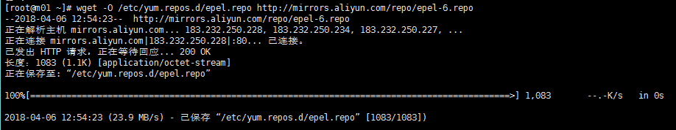

[root@m01 ~]# yum install salt-master -y

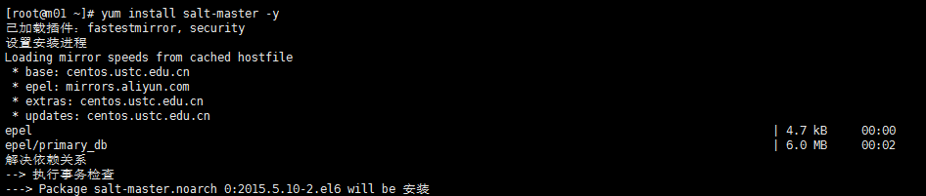

[root@m01 ~]# rpm -qa salt-master

salt-master-2015.5.10-2.el6.noarch

[root@m01 ~]# chkconfig salt-master on 设置开机启动

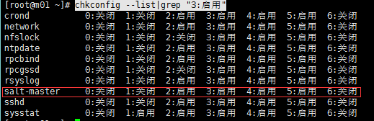

### 配置Master端-/etc/salt/master

[root@m01 ~]# vim /etc/salt/master

找到416和529行 ：file_roots 和 pillar_roots去掉注释 后保存退出

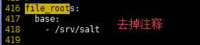

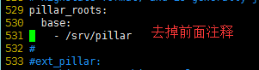

**启动-salt-master**

[root@m01 ~]# /etc/init.d/salt-master start

Starting salt-master daemon:

***Master端***

[root@m01 ~]# salt-key

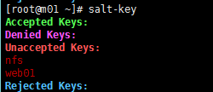

[root@m01 salt]# salt-key -d nfs01 🡨删除指定ID

[root@m01 ~]# salt-key -A 🡨--添加所有被管理端

The following keys are going to be accepted:

Unaccepted Keys:

backup

nfs

nfs01

web01

Proceed? [n/Y] y

Key for minion backup accepted.

Key for minion nfs accepted.

Key for minion nfs01 accepted.

Key for minion web01 accepted.

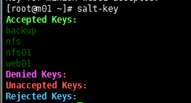

[root@m01 ~]# salt '*' test.ping 🡨测试主机是否存活 也可以测试某台主机’ID’

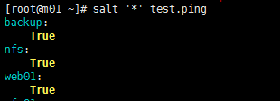

[root@m01 salt]# salt 'web-test' cmd.run '/bin/sh /opt/scripts/yum-one_lamp.sh' 远程执行脚本

[root@m01 salt]# salt 'web-test' cmd.run '/bin/sh /opt/scripts/yum-one_lamp.sh' & 后台运行

[root@m01 ~]# salt '*' cmd.run 'df -h' 🡨检查所有主机的磁盘 示例

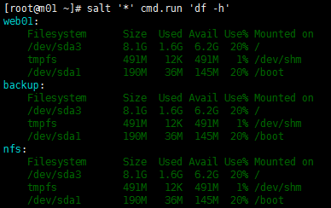

### 批量管理实战

[root@m01 ~]# mkdir /srv/{salt,pillar}

[root@m01 ~]# cd /srv/salt/

[root@m01 salt]# vim host_file.sls 配置示例-hosts文件分发

/etc/hosts:

file.managed:

- soures: salt://files/hosts

- user: root

- group: root

- mode: 644

[root@m01 salt]# mkdir files 创建同级目录

[root@m01 salt]# cd files/

[root@m01 files]# cp /etc/hosts . 将hosts文件拷贝到该目录下

[root@m01 files]# ll

总用量 4

-rw-r--r-- 1 root root 306 4月 7 15:23 hosts

[root@m01 salt]# salt '*' state.sls host_file

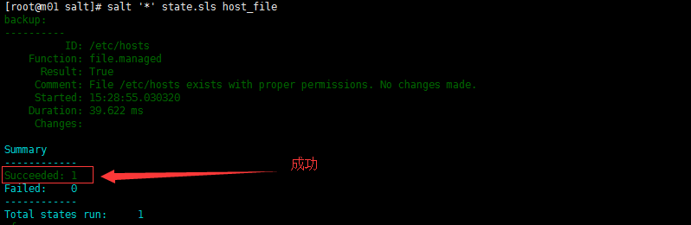

***示例：推送hosts***

[root@m01 salt]# salt-cp '*' /etc/hosts /etc/

{'backup': {'/etc/hosts': True},

'nfs': {'/etc/hosts': True},

'web01': {'/etc/hosts': True}}

***示例：批量安装nginx***

[root@m01 salt]# vim nginx_install.sls

nginx-install:

pkg.installed:

- names:

- nginx

/etc/hosts:

file.managed:

- source: salt://files/hosts

- user: root

- group: root

- mode: 644

- require:

- pkg: nginx-install

service.running:

- names:

- nginx

[root@m01 salt]# curl -I 172.16.1.8 🡨-测试Nginx是否安全且启动成功

HTTP/1.1 200 OK

Server: nginx/1.10.2

Date: Sat, 07 Apr 2018 07:59:36 GMT

Content-Type: text/html

Content-Length: 3698

Last-Modified: Mon, 31 Oct 2016 12:37:31 GMT

Connection: keep-alive

ETag: "58173b0b-e72"

Accept-Ranges: bytes

***网页测试：***

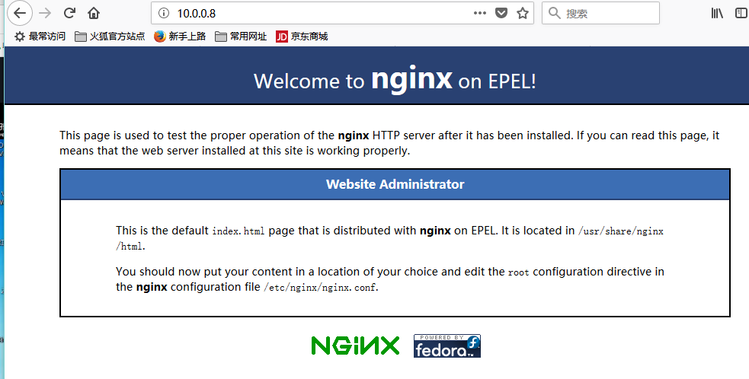

**将脚本推送指定机器的目录下https://blog.csdn.net/jxm_csdn/article/details/53608784**

[root@m01 salt]# salt 'web-test' cp.get_file salt://yum-one_lamp.sh /opt/scripts/yum-one_lamp.sh





### Saltstack管理crontd计划任务

方法一：

[root@m01 salt]# salt '*' cron.list_tab root

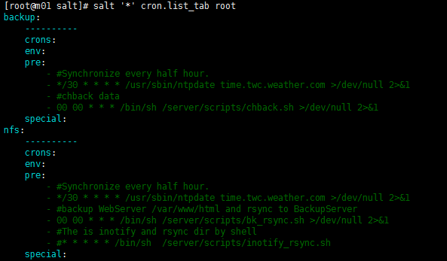

方法二：

[root@m01 salt]# vim crontab.sls

/usr/sbin/ntpdate time.twc.weather.com >>/dev/null:

cron.present:

- user: root

- minute: '*/5'

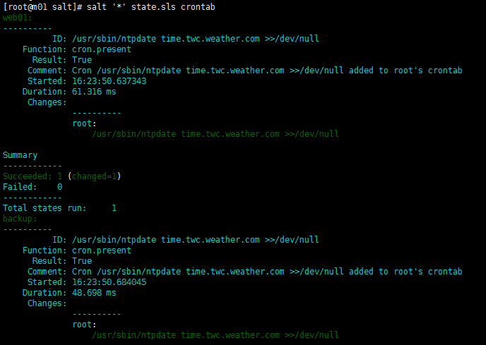

***修改计划任务 直接修改模块中的时间***

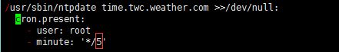

***删除计划任务***

[root@m01 salt]# vim del_cron.sls

/usr/sbin/ntpdate time.twc.weather.com >>/dev/null:

cron.absent:

- name: /usr/sbin/ntpdate time.twc.weather.com >>/dev/null

[root@m01 salt]# salt '*' state.sls 'del_cron'

***Nfs部署模板：***

vim nfs.sls

nfs-install:

pkg.installed:

- names:

- nfs-utils

- rpcbind

nfs-service:

service.running:

- names:

- rpcbind

- nfs

- enable: True

- reload: True

Minion(仆从)端

[root@nfs01 ~]# wget -O /etc/yum.repos.d/epel.repo <http://mirrors.aliyun.com/repo/epel-6.repo>

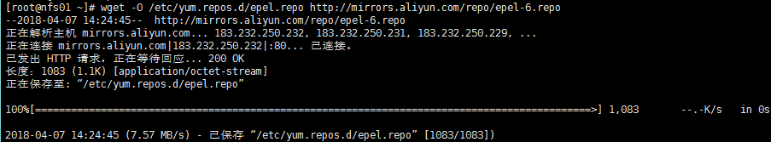

[root@nfs01 ~]# yum install salt-minion -y

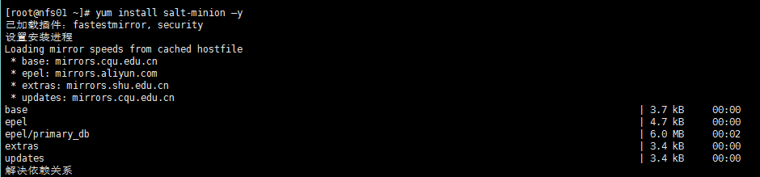

[root@nfs01 ~]# rpm -qa salt-minion

salt-minion-2015.5.10-2.el6.noarch

[root@nfs01 ~]# chkconfig salt-minion on 设置开机启动

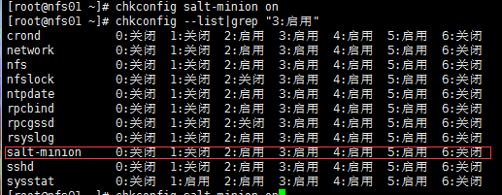

***修改配置***

[root@nfs01 ~]# vim /etc/salt/minion

修改如下

master: 172.16.1.61





启动 monion

[root@nfs01 ~]# /etc/init.d/salt-minion start

## 脚本汇总

satstack脚本汇总

wget -O /etc/yum.repos.d/epel.repo http://mirrors.aliyun.com/repo/epel-6.repo

yum install salt-master -y

从端安装salt-minion

wget -O /etc/yum.repos.d/epel.repo http://mirrors.aliyun.com/repo/epel-6.repo

yum install salt-minion -y

将脚本推送指定机器的目录下https://blog.csdn.net/jxm_csdn/article/details/53608784

salt 'web-test' cp.get_file salt://yum-one_lamp.sh /opt/scripts/yum-one_lamp.sh

#将负载均衡lb01的脚本拷贝到初始集群node

salt 'lb01' cp.get_file salt://files/nginx_lb01.sh /home/oldboy/nginx_lb01.sh

#从管理机后台执行该脚本

salt 'lb01' cmd.run '/bin/sh /home/oldboy/nginx_lb01.sh' &

批量测试脚本

salt 'backup' cp.get_file salt://scripts/01_one_rsync_Server.sh /home/oldboy/01_one_rsync_Server.sh

salt 'backup' cmd.run '/bin/sh /home/oldboy/01_one_rsync_Server.sh' &

salt 'nfs01' cp.get_file salt://scripts/02_two_rsync_client.sh /home/oldboy/02_two_rsync_client.sh

salt 'nfs01' cmd.run '/bin/sh /home/oldboy/02_two_rsync_client.sh' &

salt 'db01' cp.get_file salt://scripts/mysql_db.sh /home/oldboy/mysql_db.sh

salt 'db01' cmd.run '/bin/sh /home/oldboy/mysql_db.sh' &

salt 'web01' cp.get_file salt://scripts/yum-one_lnmp.sh /home/oldboy/yum-one_lnmp.sh

salt 'web01' cmd.run '/bin/sh /home/oldboy/yum-one_lnmp.sh' &

salt 'web01' cp.get_file salt://scripts/03_Inotify+SersynCrsync.sh /home/oldboy/03_Inotify+SersynCrsync.sh

salt 'web01' cmd.run '/bin/sh /home/oldboy/03_Inotify+SersynCrsync.sh' &

salt 'web02' cp.get_file salt://scripts/yum-one_lamp.sh /home/oldboy/yum-one_lamp.sh

salt 'web02' cmd.run '/bin/sh /home/oldboy/yum-one_lamp.sh' &

salt 'web02' cp.get_file salt://scripts/03_Inotify+SersynCrsync.sh /home/oldboy/03_Inotify+SersynCrsync.sh

salt 'web02' cmd.run '/bin/sh /home/oldboy/03_Inotify+SersynCrsync.sh' &

salt 'lb01' cp.get_file salt://scripts/nginx_lb01.sh /home/oldboy/nginx_lb01.sh

salt 'lb01' cmd.run '/bin/sh /home/oldboy/nginx_lb01.sh' &

salt 'lb02' cp.get_file salt://scripts/nginx_lb02.sh /home/oldboy/nginx_lb02.sh

salt 'lb02' cmd.run '/bin/sh /home/oldboy/nginx_lb02.sh' &

minion端修改

sed -i 's#\#master: salt#master: 172.16.1.61#' /etc/salt/minion

sed -i 's#\#id:#id: backup#' /etc/salt/minion

sed -i 's#\#id:#id: nfs01#' /etc/salt/minion

sed -i 's#\#id:#id: web01#' /etc/salt/minion

sed -i 's#\#id:#id: web02#' /etc/salt/minion

sed -i 's#\#id:#id: db01#' /etc/salt/minion

sed -i 's#\#id:#id: lb01#' /etc/salt/minion

sed -i 's#\#id:#id: lb02#' /etc/salt/minion