源码安装Zabbix

# 安装Zabbix-Server

## 安装依赖包

|  |
| --- |
| yum -y install gcc gcc-c++ autoconf httpd php php-mysql httpd-manual mod_ssl mod_perl mod_auth_mysql php-gd php-xml php-mbstring php-ldap php-pear php-xmlrpc php-bcmath mysql-connector-odbc mysql-devel libdbi-dbd-mysql net-snmp-devel curl-devel unixODBC-devel OpenIPMI-devel java-devel php-pecl-ssh2.x86_64 libssh2-devel.x86_64 openldap openldap-devel |

## MySQL的安装

|  |
| --- |
| #!/bin/bash  yum install gcc make cmake ncurses-devel libxml2-devel libtool-ltdl-devel gcc-c++ autoconf automake bison zlib-devel -y  #创建mysql组和用户  groupadd mysql  useradd -g mysql mysql  #创建安装目录  mkdir -p /opt/mysql #MySQL安装目录  chown -R mysql:mysql /opt/mysql  mkdir -p /data/mysql/data #存放数据  mkdir -p /data/mysql/log #存放日志  mkdir -p /data/mysql/tmp #存放临时文件  chown -R mysql:mysql /data/mysql  #编译安装mysql  tar -zxvf /usr/local/src/mysql-5.6.25.tar.gz -C /usr/local/src  cd /usr/local/src/mysql-5.6.25  cmake . -DCMAKE_INSTALL_PREFIX=/opt/mysql -DMYSQL_DATADIR=/data/mysql -DSYSCONFDIR=/opt/mysql -DDEFAULT_CHARSET=utf8 -DDEFAULT_COLLATION=utf8_general_ci -DEXTRA_CHARSETS=all -DENABLED_LOCAL_INFILE=1  make && make install  #初始化mysql(用户表和权限表)  /opt/mysql/scripts/mysql_install_db --user=mysql --basedir=/opt/mysql --datadir=/data/mysql/data  #修改配置文件my.cnf  cat > /opt/mysql/my.cnf <<EOF  [mysqld]  #GENERAL  basedir =/opt/mysql  datadir=/data/mysql/data  tmpdir =/data/mysql/tmp  socket=/opt/mysql/run/mysql.sock  pid_file=/opt/mysql/run/mysql.pid  user=mysql  port=3306  default_storage_engine=InnoDB  #INNODB  innodb_buffer_pool_size=2G  innodb_log_file_size=128M  innodb_file_per_table=1  #innodb_flush_method=O_DIRECT  #MyISAM  key_buffer_size=32M  #LOGGING  log_error = /data/mysql/log/alert.log  slow_query_log = 1  slow_query_log_file = /data/mysql/log/slow.log  long_query_time =0.5  #OTHER  tmp_table_size=64M  max_heap_table_size=64M  query_cache_type=0  query_cache_size=0  max_connections=500  thread_cache_size=150  table_open_cache = 1024  open_files_limit=65535  skip-name-resolve  lower_case_table_names=1  sql_mode=NO_ENGINE_SUBSTITUTION,STRICT_TRANS_TABLES  [client]  socket=/opt/mysql/run/mysql.sock  port=3306    EOF  /bin/cp /opt/mysql/my.cnf /etc/my.cnf  #设置mysql开机自动启动  cat >> /etc/profile <<EOF  export PATH=\$PATH:/opt/mysql/bin  EOF  source /etc/profile  cp /opt/mysql/support-files/mysql.server /etc/rc.d/init.d/mysqld  chmod 755 /etc/init.d/mysqld #增加执行权限  chkconfig mysqld on #加入开机启动  service mysqld start &>/dev/null #启动mysql  #关闭防火墙  service iptables stop  #设置mysql用户/密码  mysql -e "GRANT ALL ON *.* to root@'%' IDENTIFIED BY '123' WITH GRANT OPTION"  mysqladmin -u root password '123' |

## 安装Zabbix-Server

|  |
| --- |
| cd /usr/local/src  wget <http://jaist.dl.sourceforge.net/project/zabbix/ZABBIX%20Latest%20Stable/2.2.11/zabbix-2.2.11.tar.gz>  groupadd zabbix -g 201  useradd -g zabbix -u 201 -m zabbix  tar -zxvf zabbix-2.2.11.tar.gz  cd zabbix-2.2.11  #缺少的依赖包，configure过程会给出提示  ./configure --prefix=/usr/local/zabbix --sysconfdir=/etc/zabbix --enable-server --enable-proxy --enable-agent --enable-ipv6 --with-mysql=/opt/mysql/bin/mysql_config --with-net-snmp --with-libcurl --with-openipmi --with-unixodbc --with-ldap --with-ssh2 --enable-java  make && make install |

## 配置php所需的环境

vim /etc/php.ini

|  |
| --- |
| #修改如下  date.timezone = Asia/Shanghai  max_execution_time = 300  post_max_size = 16M  max_input_time = 300  memory_limit = 128M  mbstring.func_overload = 2 |

## 导入数据库

|  |
| --- |
| cd /usr/local/src/zabbix-2.2.11  mysql -uroot -p123 -e "create database zabbix"  mysql -uroot -p123 -e "grant all privileges on zabbix.* to zabbix@localhost identified by 'zabbix';"  mysql -uroot -p123 -e "flush privileges;"  #导入数据，安装Proxy只要导入schema.sql  mysql -uzabbix -pzabbix zabbix < database/mysql/schema.sql  mysql -uzabbix -pzabbix zabbix < database/mysql/images.sql  mysql -uzabbix -pzabbix zabbix < database/mysql/data.sql  ln -s /opt/mysql/lib/libmysqlclient.so.18 /usr/lib64/  mkdir /var/log/zabbix  chown zabbix.zabbix /var/log/zabbix/ |

## 复制service启动脚本

|  |
| --- |
| cp misc/init.d/fedora/core/zabbix_* /etc/init.d  chmod 755 /etc/init.d/zabbix_* |

vi /etc/init.d/zabbix_server

|  |
| --- |
| BASEDIR=/usr/local/zabbix |

vi /etc/init.d/zabbix_agentd

|  |
| --- |
| BASEDIR=/usr/local/zabbix |

## 配置zabbix_server.conf服务端文件

vi /etc/zabbix/zabbix_server.conf

|  |
| --- |
| DBHost=localhost  DBName=zabbix  DBUser=zabbix  DBPassword=zabbix  DBSocket=/opt/mysql/run/mysql.sock  StartPollers=5  CacheSize=256M |

## 复制网页文件到Apache目录

|  |
| --- |
| cp -r frontends/php/ /var/www/html/zabbix  chown -R apache.apache /var/www/html/zabbix  chkconfig zabbix_server on  chkconfig httpd on  service zabbix_server start  service httpd start |

## 设置防火墙，SELinux

|  |
| --- |
| #iptables的设置 -A INPUT -m state --state NEW -m tcp -p tcp --dport 22 -j ACCEPT  -A INPUT -m state --state NEW -m tcp -p tcp --dport 80 -j ACCEPT  -A INPUT -m state --state NEW -m tcp -p tcp --dport 10051 -j ACCEPT  -A INPUT -m state --state NEW -m tcp -p tcp --dport 10050 -j ACCEPT  -A INPUT -m state --state NEW -m tcp -p tcp --sport 10050 -j ACCEPT  service iptables restart  #设置SELinux，需要重启  vim /etc/selinux/config  SELINUX=disabled |

## 配置Zabbix-Server前端UI

第一步：输入网址http://172.16.130.65/zabbix

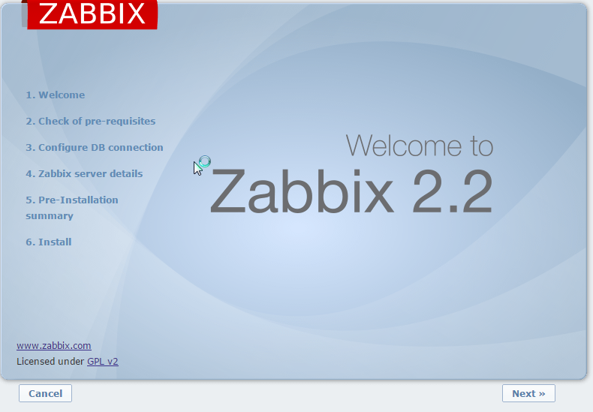

第二步：各个参数都满足条件的时候，点击next

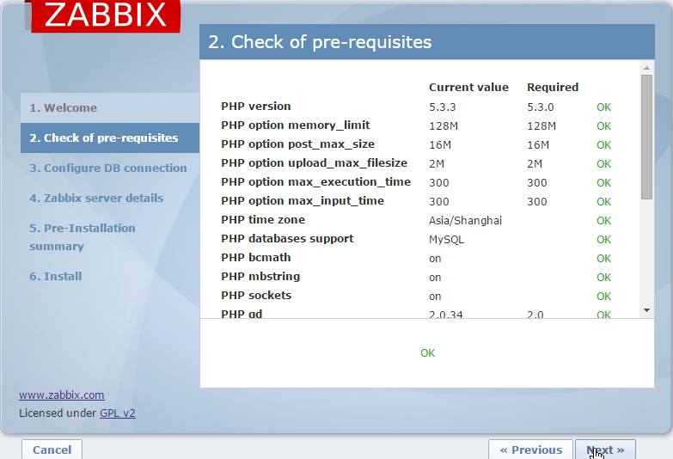

第三步配置数据库

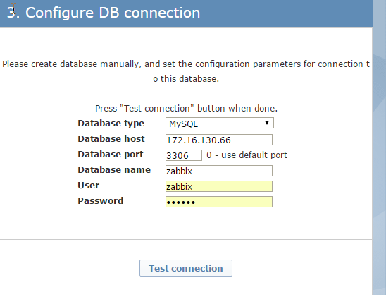

第四步：配置zabbix信息，会写入${PATH}/zabbix/conf/zabbix.conf.php

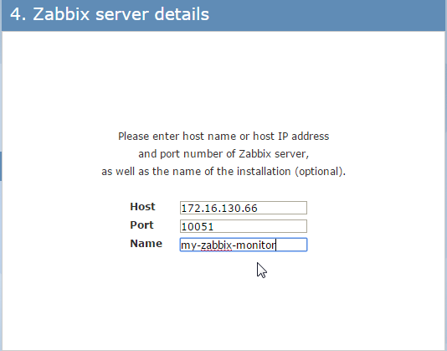

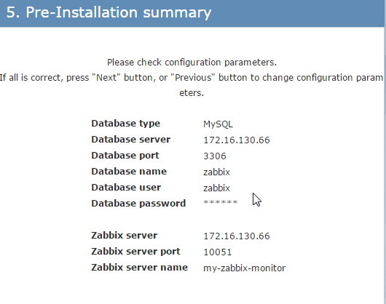

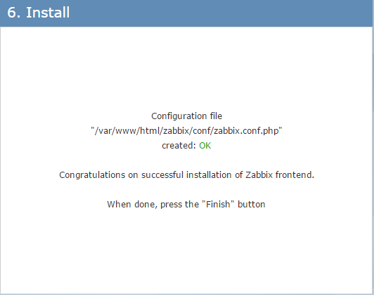

第五步：进入登录界面

用户名/密码：admin/zabbix

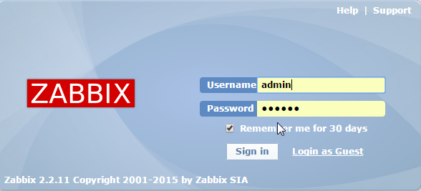

## 更改zabbix默认语言为简体中文

#修改系统配置文件，让web页面支持简体中文显示

#vi /var/www/html/zabbix/include/locales.inc.php

|  |
| --- |
| #也就是把false改为true  'zh_CN' => ['name' => _('Chinese (zh_CN)'), 'display' => true], |

#替换监控图像上系统默认的字体

在Windows系统中的C:\Windows\Fonts目录中复制出一个中文字体文件，例如msyh.ttf把字体文件msyh.ttf上传到zabbix站点根目录下fonts文件夹中/var/www/html/zabbix/fonts

# 安装Zabbix-Agent

## Linux中安装

|  |
| --- |
| yum install tree gcc gcc-c++ -y  cd /usr/local/src  wget <http://jaist.dl.sourceforge.net/project/zabbix/ZABBIX%20Latest%20Stable/2.2.11/zabbix-2.2.11.tar.gz>  groupadd zabbix -g 201  useradd -g zabbix -u 201 -m zabbix  tar -zxvf zabbix-2.2.11.tar.gz  cd zabbix-2.2.11  ./configure --prefix=/usr/local/zabbix --sysconfdir=/etc/zabbix --enable-agent  make && make install  mkdir /var/log/zabbix  chown zabbix.zabbix /var/log/zabbix  cp misc/init.d/fedora/core/zabbix_agentd /etc/init.d/  chmod 755 /etc/init.d/zabbix_agentd  #防火墙开放端口  -A INPUT -p tcp -m multiport --dports 10050:10051 -j ACCEPT  sed -i "s@BASEDIR=/usr/local@BASEDIR=/usr/local/zabbix@g" /etc/init.d/zabbix_agentd  cat >>/etc/services <<eof  zabbix-agent 10050/tcp # Zabbix Agent  zabbix-agent 10050/udp # Zabbix Agent  zabbix-trapper 10051/tcp # Zabbix Trapper  zabbix-trapper 10051/udp # Zabbix Trapper  eof  #配置zabbix_agentd.conf  #Server：被动模式，允许那台服务器连接Agent  #ServerActive：主动模式，向哪台服务器传送数据  egrep -v "(#|^$)" /etc/zabbix/zabbix_agent.conf  vi /etc/zabbix/zabbix_agent.conf  #修改  ServerActive=172.16.130.53  chkconfig zabbix_agentd on  service zabbix_agentd start |

## Windows中安装Zabbix-Agent

|  |
| --- |
| #第一步：安装配置Zabbix-Agent  下载zabbix_agents_2.2.11.win.zip到本地，然后解压到C:\Program Files  配置zabbix_agentd.conf  #第二步：注册服务  cd "C:\Program Files\bin\win64\"  .\zabbix_agentd.exe --install -c "C:\Program Files\conf\zabbix_agentd.win.conf"  #第三步：启动服务  net start "zabbix Agent"  net stop "zabbix Agent" |