**虚拟机环境架构图：**

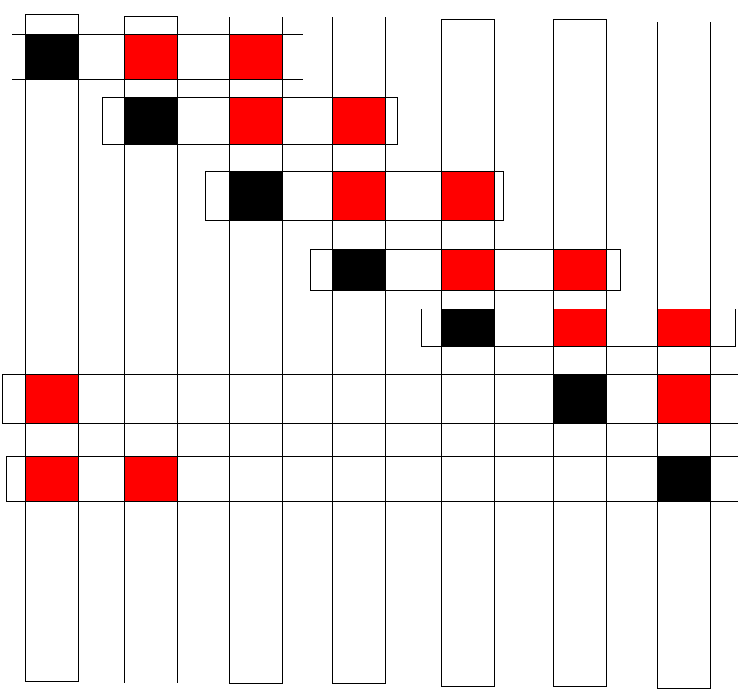

**1 2 3 4 5 6 7**

**注：mongoDB集群最好是奇数数个服务器**

linux下载mongoDB：# wget http://www.mongodb.org/dr/fastdl.mongodb.org/linux/mongodb-linux-x86_64-2.4.6.tgz/download

linux下解压mongoDB：tar zxvf mongo_xxx.tgz

mongo启动执行配置文件：/mongo/bin/mongod --config /etc/mongodb.cnf

将mongo.exe文件放在/usr/bin下可以直接运行mongo，就不必再进到具体目录下

执行db.getMongo().setSlaveOk()，从库可以读

db.runCommand({ enablesharding:"nfspring" })

db.runCommand({ shardcollection: "nfspring.photo", key: { _id:1 }})

1. 分别在3台机器上运行一个mongod实例（称为mongod shard11,mongod shard12,mongod shard13）组成replica set1 ,作为cluster的shard1
2. 分别在7台机器运行一个mongod实例，作为7个config server
3. 分别在每台机器运行一个mongos进程，用于客户连接

|  |  |  |  |
| --- | --- | --- | --- |
| 主机 | | IP | 端口信息 |
| Server1  logs  data:   * config * Shard1_1 * Shard6_3 * Shard7_2 | 节点 | 192.168.1.101 | mongod shard11:27017  mongod shard63:27012  mongod shard72:27013 |
| 服务config | mongod shard1:30000 |
| 路由分配 | mongos:50000 |
| Server2  logs  data:   * Shard1_2 * Shard2_1 * Shard7_3 | 节点 | 192.168.1.102 | mongod shard12:27017  mongod shard21:27018  mongod shard73:27013 |
| 服务config | mongod shard2:30000 |
| 路由分配 | mongos:50000 |
| Server3  logs  data:   * Shard1_3 * Shard2_2 * Shard3_1 | 节点 | 192.168.1.103 | mongod shard13:27017  mongod shard22:27018  mongod shard31:27019 |
| 服务config | mongod shard3:30000 |
| 路由分配 | mongos:50000 |
| Server4  logs  data:   * Shard2_3 * Shard3_2 * Shard4_1 | 节点 | 192.168.1.104 | mongod shard23:27018  mongod shard32:27019  mongod shard41:27010 |
| 服务config | mongod shard4:30000 |
| 路由分配 | mongos:50000 |
| Server5  logs  data:   * Shard3_3 * Shard4_2 * Shard5_1 | 节点 | 192.168.1.105 | mongod shard33:27019  mongod shard42:27010  mongod shard51:27011 |
| 服务config | mongod shard5:30000 |
| 路由分配 | mongos:50000 |
| Server6  logs  data:   * Shard4_3 * Shard5_2 * Shard6_1 | 节点 | 192.168.1.106 | mongod shard43:27010  mongod shard52:27011  mongod shard61:27012 |
| 服务config | mongod shard6:30000 |
| 路由分配 | mongos:50000 |
| Server7  logs  data:   * Shard5_3 * Shard6_2 * Shard7_1 | 节点 | 192.168.1.107 | mongod shard53:27011  mongod shard62:27012  mongod shard71:27013 |
| 服务config | mongod shard7:30000 |
| 路由分配 | mongos:50000 |

Shard port:(27017~27013)

Shard1：

./mongod --shardsvr --replSet shard1 --port 27017 --dbpath /mongo/data/shard1_1 --logpath /mongo/data/shard1_1/shard1_1.log --logappend --rest --oplogSize 512 --maxConns 2000 --fork

./mongod --shardsvr --replSet shard1 --port 27017 --dbpath /mongo/data/shard1_2 --logpath /mongo/data/shard1_2/shard1_2.log --logappend --rest --oplogSize 512 --maxConns 2000 --fork

./mongod --shardsvr --replSet shard1 --port 27017 --dbpath /mongo/data/shard1_3 --logpath /mongo/data/shard1_3/shard1_3.log --logappend --rest --oplogSize 512 --maxConns 2000 --fork

初始化分片：

分片一：

config={_id:'shard1',members:[{_id: 0,host:'192.168.0.101:27017'},{_id:1,host:'192.168.0.102:27017'},{_id:2,host:'192.168.0.103:27017'}]}

rs.initiate(config)

配置分片config服务

./mongod --configsvr --dbpath /mongo/data/config --port 30000 --logpath /mongo/logs/config.log --logappend --fork

./mongod --configsvr --dbpath /mongo/data/config --port 30000 --logpath /mongo/logs/config.log --logappend --fork

./mongod --configsvr --dbpath /mongo/data/config --port 30000 --logpath /mongo/logs/config.log --logappend --fork

配置分片路由：

./mongos --configdb 172.16.15.78:30000,172.16.15.82:30000,172.16.15.136:30000 --port 50000 --logpath /mongo/logs/mongos.log --logappend --fork

./mongos --configdb 172.16.4.222:30000,172.16.4.228:30000,172.16.4.229:30000 --port 50000 --logpath /mongo/logs/mongos.log --logappend --maxConns 10000 --fork

./mongos --configdb 172.16.4.222:30000,172.16.4.229:30000,172.16.4.229:30000 --port 50000 --logpath /mongo/logs/r2/mongos.log --logappend --fork

./mongos –port 50000

use admin

db.runCommand({addshard:"shard1/192.168.0.101:27017,192.168.0.102:27017,192.168.0.103:27017"})

……

db.runCommand({addshard:"shard7/192.168.0.107:27013,192.168.0.101:27013,192.168.0.102:27013"})