Name: __Chengkun Yang

EID: __cy7496

Semester: Fall 2024

Course: ECE445L

A) ***Objectives*:**

1. In a few sentences, describe the purpose of the lab and the features of your alarm clock.

The purpose of this lab is to create a schematic for the alarm clock from lab 4, then converting it to a PCB and layout traces all within KiCAD. It features the tm4c chip instead of the full board and has reset / mode change switches. There are also plenty of bypass capacitors to prevent sudden changes in voltage along with routing to make the wire capacitance lower in critical subsystems.

B) ***Hardware Design Deliverables:***

1. Deliverable 1: Using **KiCad**, create a schematic for your design. Include a screenshot in the space below.

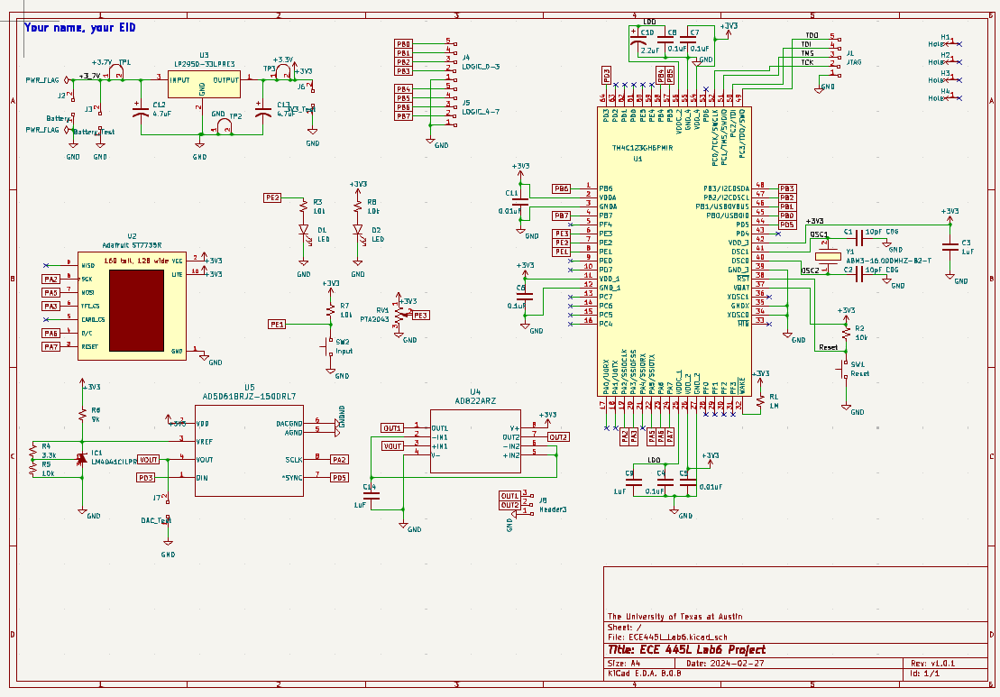

1. Deliverable 2: Using **KiCad**, create a Layout for your design. Include a screenshot in the space below.

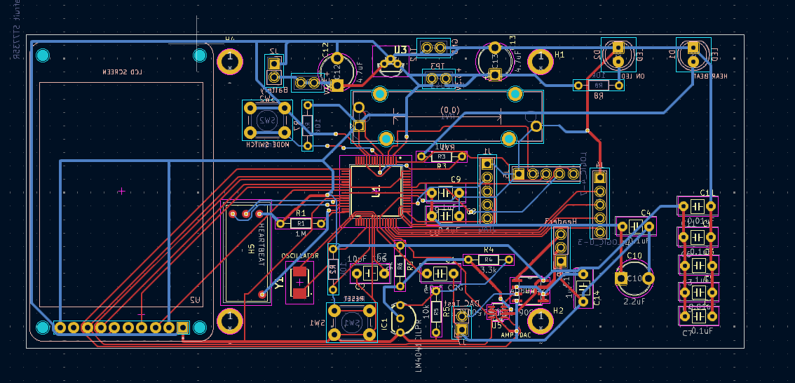

C) ***Software Design Deliverables:***

1. I have pushed my project to GitHub for grading (Check box if true).

D) ***Measurement Data:***

1. Deliverable 3: Cardboard mockup of the PCB
2. Deliverable 4: I have updated the bill of materials (Check box if true).
3. Deliverable 5: Estimated current usage

142.9 mA

1. Deliverable 6: JLC PCB Quote

$80.69

1. Deliverable 7 (4 or 8pt EC): Custom Symbol and Footprint

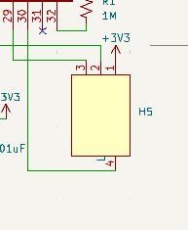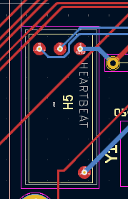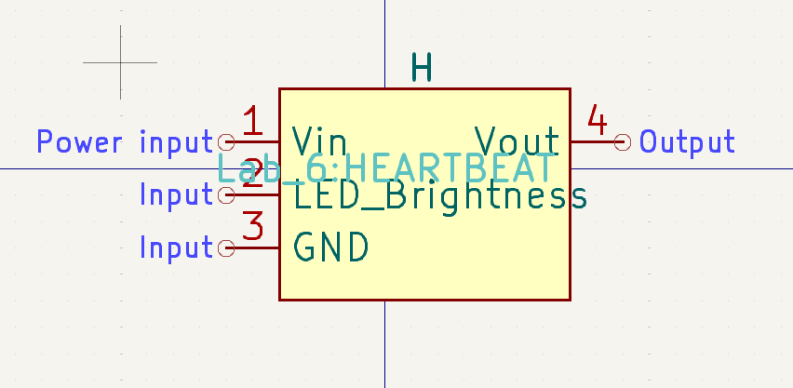



I did not show off my custom symbol during checkout, I just used the symbol editor and footprint editor in KiCAD and copied the footprint of other parts. For symbol I added 4 pins and labeled them as input/output/powerinput and for the footprint I added 3 layers of outline along with the silkscreen text and pins corresponding to the ones on the symbol.

E) ***Analysis and Discussion Questions:***

1. Estimate how long the system you created would run on the 2600mA battery.

You do capacity/current to get around 18.2 hours.

1. Estimate the power dissipated through the LDO regulator knowing the current draw from downstream components and voltage drop across the regulator.

Since the voltage drop is 0.4V and the current draw is 142.9 mAh, the power dissipation is 0.0572W.

1. Examine the following excerpt from the datasheet for the MX1500 which has a nominal capacity of 2500mAh. Assuming you placed enough of these batteries in series to power your system, how long would the lifetime be? What happens to the lifetime of the battery when you double the current?

Since we need at least 3 in series to get >3.7V, the capacity would be 7500mAh which would be around 52.7 hours of lifetime. If the current is doubled, the lifetime halves.

1. Discuss the advantages and disadvantages of using an LDO versus a switching regulator.

LDOs are smaller in area and have low noise/output ripple. They are also cheaper and work with almost all power supplies with output variation. Unfortunately, they are less efficient, can only work with one predefined input voltage, can only output a single Vout lower than Vin, and work better with smaller current.