课程设计报告
 | 设计题目： | 水电气管理系统
 | 学生姓名： | 白忠魏
 | 专 业： | 计算机科学与技术
 | 班 级： | 三班
 | 学 号： | 200805030326
 | 指导教师：
 | 完成日期： | 2009/3/9
成都理工大学信息工程学院
（一） 需求和规格说明
问题描述
设计一个水电管理信息系统，能够对高校的水电费用进行管理,包括了登记费用，查询费用，以及住户信息管理等。在设计时要考虑到学生和教工在用水电时的不同，学生可以免费使用一定额度的水电，超过这个额度的随便以后必须自费使用，且自费部分水电费的价格标准要高于教工的收费标准（主要是节约资源）。
  - 实现对用户信息的录入
  - 实现水电煤气数据的录入
  - 计算并查询用户应缴费用
  - 查询未缴纳费用名单

（二） 设计
Base::使用GUI设计界面
- 用户登陆:
设定一个唯一的管理员用于管理数据
密码使用md5加混合方式
保存于databse/ PWD.mdb
- 用户的录入和查询
所有用户的信息放置于数据库databse/ data.mdb
数据库密码zxcasdqwe
应缴费用等详细显示在主界面
默认的配置config.ini
后台服务设置都可以再这里实现
历史信息以文件的形式放入userdata
3.考虑到用户可能需要远程查询数据.加入网络模块
网络模块::考虑到可以让用户用浏览器浏览..所以协议使用tcp/ip
实际使用方面抛弃了原vb的activeX控件
使用.net库中的Tcpclienter和Tcplistener
4.设计语言采用c#(有类的概念.类C语言系)
5.用户信息数据库采用access,oledb方式连接
保存于databse/ data.mdb
6.附加程序
在不使用主程序的时候可使用此程序建立后台服务.供远程用户查询数据
简略说明
类名 | 属性/方法 | 访问级别 | 说明
sck |  | public | 网络通信模块
 | listen(int ThreadNum,int port) | public | 使用多线程.监听本地端口
 | ls() | private | 由线程控制的函数  用于处理连接的quest并返回数据
server |  | public | 结构体
 | text | public | 用于在启动窗口和后台线程间传递服务器状态消息
ReadFile |  | public | 读取和设置文件
 | Existen (string path) | public | 判断文件是否存在
 | GetConfig(string path,string name) | public | 读取配置文件  返回设定的值
 | SetPwd (string path,string username,string userpwd) | public | 设置管理员密码
 | AddDetail(string path, string detail) | public | 添加历史记录
 | SetPwd(string path,string username,string userpwd) | public | 设置用户密码
Launcher |  |  | 启动窗体
 | string GetMd6STR(string ConvertString) | public | 给字符编码(md5+混合…)
Mainform |  |  | 主窗体
 | LoadData() | public | 载入数据
 | setdefault() | public | 默认值的载入
 | updatemoney() | public | 更新应缴金额
AboutBox |  |  | 版权声明窗体

系统类图(简化版)

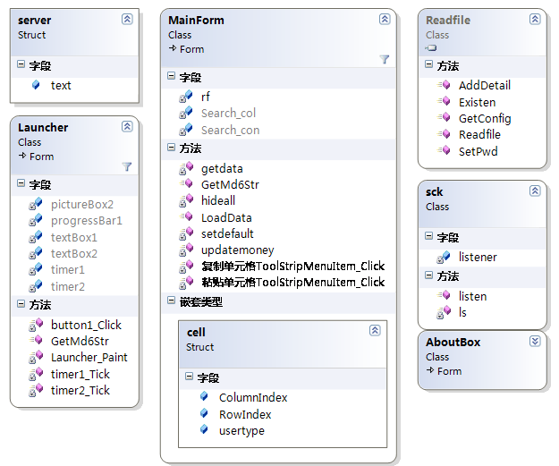

（三） 用户手册
水电气管理系统
by 白忠魏(princehaku)
安装完成请双击桌面图标或主程序进入程序

注意:
1 .如果无法启动,请先安装.NET framework 2.0
2 .默认账户admin.密码icyfire.请妥善保管您的密码
3 .您可以自由发布此程序,但请注明作者白忠魏(princehaku)
4 .在未获得作者本人同意下请不要尝试破解,修改此软件

配置文件在config.ini
默认端口为80 线程数为10

BackgroundServise使用说明
此附加程序为后台服务程序,主程序已带有此功能.

在不使用主程序的时候可使用此程序建立后台服务.供远程用户查询数据

程序接口p 端口 t线程数
例 BackgroundServise.exe /p 80 /t 10
->将在本地开启10个线程监听80端口
超过此线程用户将无法连接

访问方式
浏览器输入服务器ip:服务器端口
例
服务器::
cmd{
c:/>ipconfig
+---------------------------------------------+
IP Address. . . . . . . . . . . . : 125.70.161.182
+---------------------------------------------+
c:/>BackgroundServise.exe /p 80 /t 10
远程用户::
打开浏览器.
输入地址
http://125.70.161.182:80
回车即可
ps:服务器自己可使用http://localhost:80

（四） 调试及测试

本地测试
登陆系统
1错误登陆
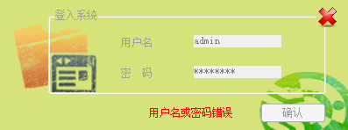
Passed
2成功登陆
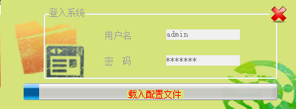
Passed
主程序
1 新添
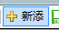
Passed
2 保存
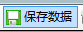
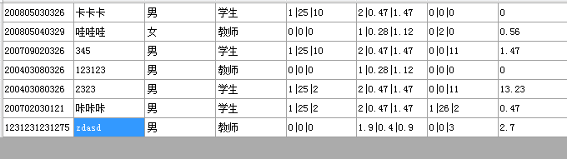
成功保存并显示
Passed
3删除
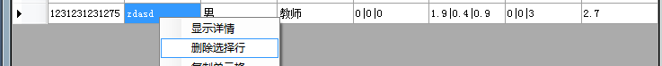
保存后
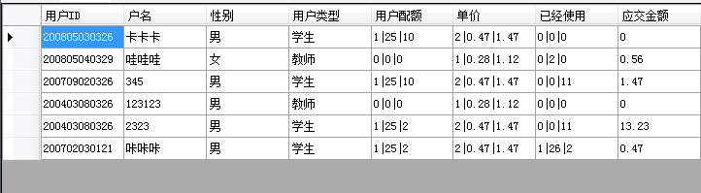
正常
Passed
4详细记录
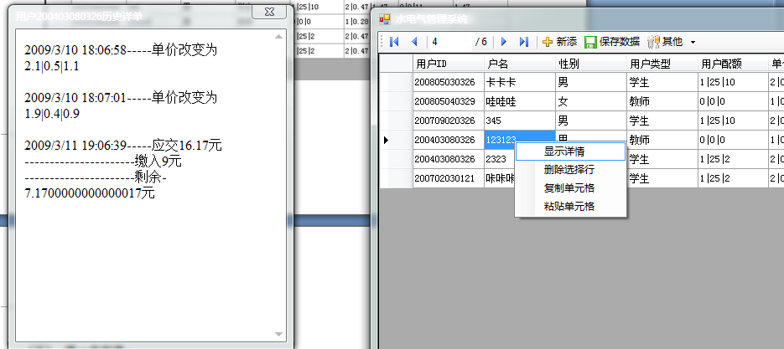
正常
Passed
@@@@@@@@@改变单价为1|0.23|1.12和改变使用2度电测试详细记录@@@@@@@@@@@
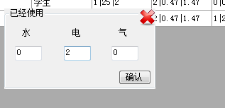

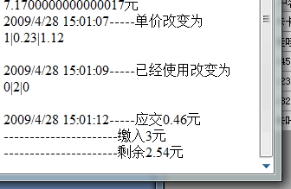
正常
Passed
5.查询
1未缴费用户
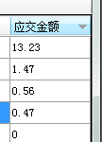
点击应交金额..按降序排列
正常
2. 定位查询
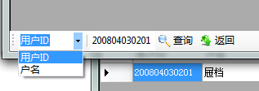
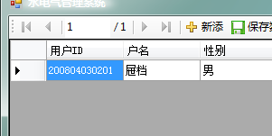
正常
Passed
网络模块测试
1启动服务器
1端口被占用
命令行 “BackgroundServise.exe" /p 80 /t 20
输出
水电管理系统后台服务器
版权所有:白忠魏
线程数20
端口80
Socket错误，启动失败
正常
Passed
2 正常开启
命令行 “BackgroundServise.exe" /p 80 /t 20
输出
水电管理系统后台服务器
版权所有:白忠魏
线程数20
端口80
开始监听
正常
Passed
2浏览器查看
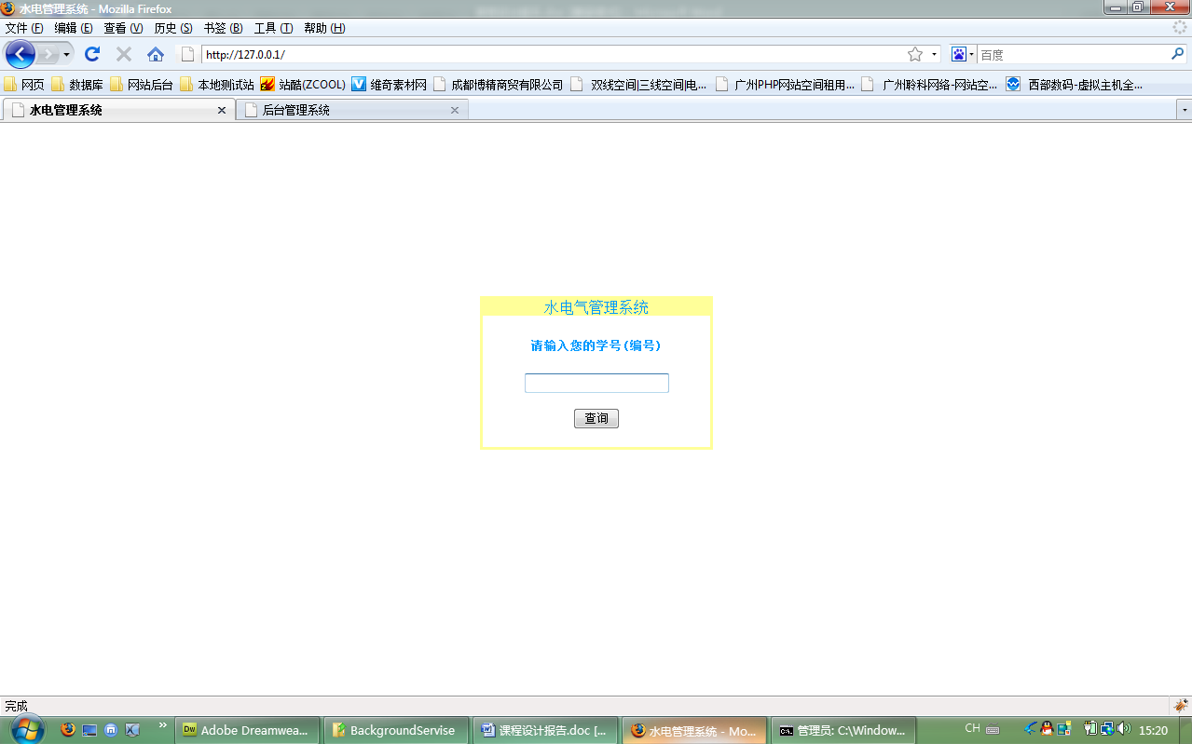
正常显示
测试id为123123的用户(不存在此用户)
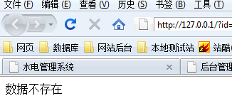
命令行结果
GET /?id=123&button=%E6%9F%A5%E8%AF%A2 HTTP/1.1
./UserData/wegDbfile-123.rdb123无此数据
测试id为200403080326的用户(存在此用户)
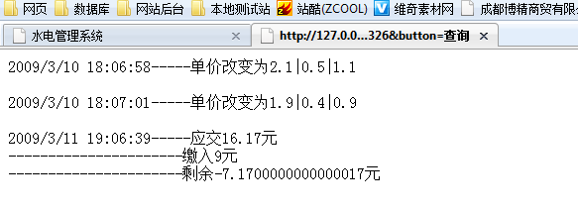
命令行结果
GET /?id=200403080326&button=%E6%9F%A5%E8%AF%A2 HTTP/1.1
200403080326数据发送成功
Passed
附录:源代码(not latest vision)

主界面源码

using System;
using System.Collections.Generic;
using System.ComponentModel;
using System.Data;
using System.Drawing;
using System.Text;
using System.Windows.Forms;
using System.Security.Cryptography;
using Readfile;

namespace My_project
{

public partial class MainForm : Form
{
private bool Edit;
Readfile.Readfile rf = new Readfile.Readfile();
public MainForm()

{
InitializeComponent();
}
public struct cell
{
public static int ColumnIndex;
public static int RowIndex;
public static string usertype;
}
private void userBindingNavigatorSaveItem_Click(object sender, EventArgs e)
{
//保存并重置数据单元
this.Validate();
this.userBindingSource.EndEdit();
this.tableAdapterManager.UpdateAll(this.dataDataSet);
this.LoadData();
this.Edit = false;
}
//数据加密
public static string GetMd6Str(string ConvertString)
{
MD5CryptoServiceProvider md5 = new MD5CryptoServiceProvider();
string t2 = BitConverter.ToString(md5.ComputeHash(UTF8Encoding.Default.GetBytes(ConvertString)), 4, 8).Replace("-", "B");
t2 += BitConverter.ToString(md5.ComputeHash(UTF8Encoding.Default.GetBytes(ConvertString)), 4, 8).Replace("-", "Z");
t2 += BitConverter.ToString(md5.ComputeHash(UTF8Encoding.Default.GetBytes(ConvertString)), 4, 8).Replace("-", "W");
return t2;
}

//填充数据库
public void LoadData()
{
this.userTableAdapter.Fill (this.dataDataSet.user);
}

private void 删除ToolStripMenuItem_Click(object sender, EventArgs e)
{

foreach (DataGridViewCell c in userDataGridView.SelectedCells)
{
if (c.RowIndex>=0) { this.userDataGridView.Rows.RemoveAt(c.RowIndex); }
}

}
//设定当前单元格
private void userDataGridView_CellMouseDown(object sender, DataGridViewCellMouseEventArgs e)
{
if (userDataGridView.SelectedCells.Count == 1 & e.ColumnIndex >= 0 & e.RowIndex >= 0 & e.Button==MouseButtons .Right)
{
userDataGridView.CurrentCell = userDataGridView[e.ColumnIndex, e.RowIndex];

}
}

private void 关于本程序ToolStripMenuItem_Click(object sender, EventArgs e)
{
AboutBox newabout= new AboutBox ();
newabout.Show();
}

private void fwToolStripMenuItem_Click(object sender, EventArgs e)
{
groupBox3.Visible = true;
}

private void MainForm_FormClosed(object sender, FormClosedEventArgs e)
{
if(this.Edit == true)
{

switch (MessageBox.Show("是否保存您作的修改?", "关闭程序", MessageBoxButtons.YesNo))
{
case DialogResult.Yes:
this.Validate();
this.userBindingSource.EndEdit();
this.tableAdapterManager.UpdateAll(this.dataDataSet);
break;

}
}
//else
{
//终止所有线程并结束程序
Application.Exit();
}
}
private void hideall()
{
//隐藏所有可能出现的窗体

groupBox2.Visible = false;

button1.Visible = false;

groupBox1.Visible = false;

}
private void userDataGridView_CellDoubleClick(object sender, DataGridViewCellEventArgs e)
{
string[] data=new string[0];
hideall();
this.Edit = true;
if (e.RowIndex >= 0)
{
try
{
switch (e.ColumnIndex)
{
//配额
case 5:
groupBox1.Text = "用户配额";
//读取数据
data = userDataGridView.CurrentCell.Value.ToString().Split('|');
if (data[0] != "")
{
water.Text = data[0];
elec.Text = data[1];
gas.Text = data[2];
}
else
{
water.Text = "0";
elec.Text = "0";
gas.Text = "0";
}
cell.ColumnIndex = e.ColumnIndex;
cell.RowIndex = e.RowIndex;
groupBox1.Visible = true;
button1.Visible = true;
//用户类型
cell.usertype = userDataGridView[e.ColumnIndex - 1, e.RowIndex].Value.ToString();
break;
//单价
case 6:
groupBox1.Text = "单价";
//读取数据
data = userDataGridView.CurrentCell.Value.ToString().Split('|');
if (data[0] != "")
{
water.Text = data[0];
elec.Text = data[1];
gas.Text = data[2];
}
else
{
water.Text = "0";
elec.Text = "0";
gas.Text = "0";
}
cell.ColumnIndex = e.ColumnIndex;
cell.RowIndex = e.RowIndex;
groupBox1.Visible = true;
button1.Visible = true;
//用户类型
cell.usertype = userDataGridView[e.ColumnIndex - 2, e.RowIndex].Value.ToString();
break;
//使用
case 7:
groupBox1.Text = "已经使用";
//读取数据
data = userDataGridView.CurrentCell.Value.ToString().Split('|');
if (data[0] != "")
{
water.Text = data[0];
elec.Text = data[1];
gas.Text = data[2];
}
else
{
water.Text = "0";
elec.Text = "0";
gas.Text = "0";
}
cell.ColumnIndex = e.ColumnIndex;
cell.RowIndex = e.RowIndex;
groupBox1.Visible = true;
//用户类型
cell.usertype = userDataGridView[e.ColumnIndex - 3, e.RowIndex].Value.ToString();
; break;

//缴费
case 8:
recent.Text = userDataGridView[9, e.RowIndex].Value.ToString();
updatemoney();
button1.Visible = true;
groupBox2.Visible = true;
//应交费的信息
textBox4.Text = userDataGridView[e.ColumnIndex, e.RowIndex].Value.ToString();
; break;

default: this.userDataGridView.BeginEdit(true);break;

}
handin.Text = "";
}
catch
{
groupBox1.Text = "";
}
}

}

private void 详情ToolStripMenuItem_Click(object sender, EventArgs e)
{
//详情载入
//string type = userDataGridView.CurrentCellAddress.X();
string userid = "wegDbfile-" + userDataGridView[1, userDataGridView.CurrentCell.RowIndex].Value.ToString();
string path=Application.StartupPath + "/UserData/" + userid + ".rdb";
detail de = new detail(path,userDataGridView[1, userDataGridView.CurrentCell.RowIndex].Value.ToString());
de.Show();

}

private void 数据库导出ToolStripMenuItem_Click(object sender, EventArgs e)
{
saveFileDialog1.ShowDialog();
if (saveFileDialog1.FileName.ToString() != "")
{
this.dataDataSet.WriteXml(saveFileDialog1.FileName.ToString());
}
}

private void toolStripSplitButton1_ButtonClick(object sender, EventArgs e)
{
toolStripSplitButton1.ShowDropDown();
}

private void toolStripButton1_Click(object sender, EventArgs e)
{
//this.Search_col.Text.Trim;
//this.Search_con.Text.Trim;
if (this.Search_col.Text.ToString() != "" & this.Search_con.Text.ToString() != "")
{
userTableAdapter.Adapter.SelectCommand.CommandText = "SELECT [user].* FROM [user] WHERE [" + this.Search_col.Text.Trim() + "] like '%" + this.Search_con.Text.Trim() + "%'";

this.userTableAdapter.Fill(this.dataDataSet.user);
}
}

private void toolStripButton2_Click(object sender, EventArgs e)
{
userTableAdapter.Adapter.SelectCommand.CommandText = "SELECT [user].* FROM [user]";

this.userTableAdapter.Fill(this.dataDataSet.user);
}

private void MainForm_Load(object sender, EventArgs e)
{

}
//限制输入数字
private void water_KeyPress(object sender, KeyPressEventArgs e)
{
if (e.KeyChar != 8 && !Char.IsDigit(e.KeyChar)&& !(e.KeyChar == '.'))
{
e.Handled = true;
}
}

private void elec_KeyPress(object sender, KeyPressEventArgs e)
{
if (e.KeyChar != 8 && !Char.IsDigit(e.KeyChar) && !(e.KeyChar == '.'))
{
e.Handled = true;
}
}

private void handin_KeyPress(object sender, KeyPressEventArgs e)
{
if (e.KeyChar != 8 && !Char.IsDigit(e.KeyChar) && !(e.KeyChar == '.'))
{
e.Handled = true;
}
}

private void gas_KeyPress(object sender, KeyPressEventArgs e)
{
if (e.KeyChar != 8 && !Char.IsDigit(e.KeyChar) && !(e.KeyChar == '.'))
{
e.Handled = true;
}
}

private void accept_Click(object sender, EventArgs e)
{
userDataGridView[cell.ColumnIndex, cell.RowIndex].Value = water.Text + '|' + elec.Text + "|" + gas.Text;
if(groupBox1.Text=="已经使用")
{
//更新应交金额
updatemoney();
}

//加入历史
string userid = "wegDbfile-" + userDataGridView[1, userDataGridView.CurrentCell.RowIndex].Value.ToString();
string detail = DateTime.Now.ToString() + "-----" + groupBox1.Text + "改变为" +getdata() +"<br />";
rf.AddDetail(Application.StartupPath + "/UserData/" + userid + ".rdb", detail);

groupBox1.Visible = false;
}
//得到详细改变的内容
private string getdata()
{
switch (groupBox1.Text.ToString())
{
case "已经使用":
return userDataGridView.CurrentCell.Value.ToString();

case "用户配额":
return userDataGridView.CurrentCell.Value.ToString();

case "单价":
return userDataGridView.CurrentCell.Value.ToString();

}

return "未知";
}

private void button1_Click(object sender, EventArgs e)
{
setdefault();
}

private void pictureBox1_Click(object sender, EventArgs e)
{
groupBox1.Visible = false;
}
//+++++++++++++++++++++

private void setdefault()
{
//默认值的取得
Readfile.Readfile rf = new Readfile.Readfile();
if (groupBox1.Text == "用户配额")
{
if (cell.usertype == "教师")
{
water.Text = "0";
elec.Text = "0";
gas.Text = "0";
}
else
{
water.Text = rf.GetConfig(Application.StartupPath + "/config.ini", "waterlimit");
elec.Text = rf.GetConfig(Application.StartupPath + "/config.ini", "eleclimit");
gas.Text = rf.GetConfig(Application.StartupPath + "/config.ini", "gaslimit");
}

}
if (groupBox1.Text == "单价")
{

if (cell.usertype == "教师")
{
water.Text = rf.GetConfig(Application.StartupPath + "/config.ini", "watertc");
elec.Text = rf.GetConfig(Application.StartupPath + "/config.ini", "electc");
gas.Text = rf.GetConfig(Application.StartupPath + "/config.ini", "gastc");

}
else
{
water.Text = rf.GetConfig(Application.StartupPath + "/config.ini", "waterst");
elec.Text = rf.GetConfig(Application.StartupPath + "/config.ini", "elecst");
gas.Text = rf.GetConfig(Application.StartupPath + "/config.ini", "gasst");
}

}
//rf.GetConfig();
/*water.Text = data[0];
elec.Text = data[1];
gas.Text = data[2];
* */

}

private void pictureBox2_Click(object sender, EventArgs e)
{
groupBox2.Visible = false;
}

private void button2_Click(object sender, EventArgs e)
{

if (handin.Text != "")
{
//修改余额
userDataGridView[9, userDataGridView.CurrentCell.RowIndex].Value = double.Parse(recent.Text.ToString()) + double.Parse(handin.Text.ToString()) - double.Parse(textBox4.Text.ToString());
recent.Text=userDataGridView[9, userDataGridView.CurrentCell.RowIndex].Value.ToString();
//加入历史
string userid = "wegDbfile-" + userDataGridView[1, userDataGridView.CurrentCell.RowIndex].Value.ToString();
string detail = DateTime.Now.ToString() + "-----应交" + textBox4.Text.ToString() + "元" +
"<br />" + "----------------------缴入" + handin.Text.ToString() + "元" +
"<br />" + "----------------------剩余" + recent.Text.ToString() + "元"
;
rf.AddDetail(Application.StartupPath + "/UserData/" + userid + ".rdb", detail);
//清空已经使用
userDataGridView[userDataGridView.CurrentCell.ColumnIndex - 1, userDataGridView.CurrentCell.RowIndex].Value = "0|0|0";
updatemoney();
groupBox2.Visible = false;
textBox4.Text = "0";

}

}

private void updatemoney()
{
string[] used;
string[] limit;
string[] per;
double money=0.0;
double me = 0.0;
//已经使用
used=userDataGridView[7, userDataGridView.CurrentCell.RowIndex].Value.ToString().Split('|');
//单价
per = userDataGridView[6, userDataGridView.CurrentCell.RowIndex].Value.ToString().Split('|');
//配额
limit = userDataGridView[5, userDataGridView.CurrentCell.RowIndex].Value.ToString().Split('|');
//用户类型
try
{
if (cell.usertype == "教师")
for (int i = 0; i < 3; i++)
{
money += double.Parse(used[i]) * double.Parse(per[i]);
}
else
{
for (int i = 0; i < 3; i++)
{
//如果没超过使用限额算0元
if (double.Parse(limit[i]) - double.Parse(used[i]) >= 0)
{
me = 0; }
else {
me=(double.Parse(used[i]) - double.Parse(limit[i])) * double.Parse(per[i]);
}
money += me;
}
}

if (recent.Text=="") {
recent.Text = "0";
}
//money = money - double.Parse(recent.Text.ToString());
userDataGridView[8, userDataGridView.CurrentCell.RowIndex].Value = money.ToString();

}
catch
{
userDataGridView[8, userDataGridView.CurrentCell.RowIndex].Value = "数据格式有误..请检查";
}

}

private void pictureBox3_Click(object sender, EventArgs e)
{
groupBox3.Visible = false;
}

private void button3_Click(object sender, EventArgs e)
{
string user = rf.GetConfig(Application.StartupPath + "/Database/PWD.mdb", "username");
string pwd = rf.GetConfig(Application.StartupPath + "/Database/PWD.mdb", "userpassword");
if (curpwd.Text == "" || newpwd.Text == "" || newpwd2.Text == "") { MessageBox.Show("密码不能为空"); return; }
if (newpwd.Text != newpwd2.Text) { MessageBox.Show("两次输入不同"); return; }
if (GetMd6Str(curpwd.Text) == pwd)
{
//写入密码
rf.SetPwd(Application.StartupPath + "/Database/PWD.mdb", GetMd6Str("admin"), GetMd6Str(newpwd.Text));
MessageBox.Show("设置成功");
}
else
{ MessageBox.Show("原密码错误"); }
//隐藏并清空
groupBox3.Visible = false;
curpwd.Text = ""; newpwd.Text = ""; newpwd2.Text = "";
}

private void 复制单元格ToolStripMenuItem_Click(object sender, EventArgs e)
{
Clipboard.SetText(userDataGridView.CurrentCell.Value.ToString());
}

private void 粘贴单元格ToolStripMenuItem_Click(object sender, EventArgs e)
{
userDataGridView.CurrentCell.Value = Clipboard.GetText();
}

private void dToolStripMenuItem_Click(object sender, EventArgs e)
{

}
}

}

网络模块源码
using System;
using System.Collections.Generic;
using System.Text;
using System.Windows.Forms;
using System.Net;
using System.Net.Sockets;
using System.Threading;
using System.IO;
using Readfile;

namespace My_project
{

class sck
{
//创建新tcplistenr监听端口
TcpListener listener = new TcpListener(IPAddress.Any, 8080);

public void listen(int ThreadNum,int port)
{
//改变端口
listener = new TcpListener(IPAddress.Any, port);
try
{
listener.Start();

server.text = "后台服务器启动成功";

//MessageBox.Show (listener.LocalEndpoint.ToString());
//创建线程
for (int i = 1; i <= ThreadNum; i++)
{
Thread thrd = new Thread(new ThreadStart(this.ls));
thrd.IsBackground = true;
thrd.Start();
}
}
catch
{
server.text = "socket错误，未能启动";
}

}

private void ls()
{
string GET,data;
string[] result;

TcpClient client = listener.AcceptTcpClient();
//创建网络流
NetworkStream netStream = client.GetStream();

StreamReader sr = new StreamReader(client.GetStream());

//读取第一行的东西然后关闭sr
GET=sr.ReadLine().ToString();

StreamWriter sw = new StreamWriter(client.GetStream());

Readfile.Readfile rf = new Readfile.Readfile();

result=GET.Split(' ');
//sw.Write("HTTP/1.1 200 OK\r\n");
if (result[1] == "") { ; }
if (result[1] == "/"|result[1] == "/index.html")
{
//显示首页
//
StreamReader fsr = new StreamReader(Application.StartupPath + "/UserData/default.dba");
while (fsr.EndOfStream == false)
{
sw.Write(fsr.ReadLine().ToString());
}
fsr.Close();
sw.Close();
sr.Close();
netStream.Close();
}
else
{
try
{//分离&
string[] fs = result[1].Split('&');
//分离=
string[] fr = fs[0].Split('=');

if (fr[1].ToString() != "")
{
if (rf.Existen(Application.StartupPath + "/UserData/wegDbfile-"
+ fr[1].ToString() + ".rdb"))
{
StreamReader fsr = new StreamReader(Application.StartupPath + "/UserData/wegDbfile-"
+ fr[1].ToString() + ".rdb");
while (fsr.EndOfStream == false)
{
sw.Write(fsr.ReadLine().ToString());
}
fsr.Close();
sw.Close();
sr.Close();
netStream.Close();
}
else
{
data = "<html><head><meta http-equiv=content-type content=\"text/html; charset=UTF-8\">数据不存在";
sw.Write(data);
sw.Close();
sr.Close();
netStream.Close();
}

}
else
{
data = "<html><head><meta http-equiv=content-type content=\"text/html; charset=UTF-8\">数据不存在";
sw.Write(data);
sw.Close();
sr.Close();
netStream.Close();
}

}
catch
{
data = "<html><head><meta http-equiv=content-type content=\"text/html; charset=UTF-8\">数据不存在";

sw.Write(data);
sw.Close();
sr.Close();
netStream.Close();
}
//MessageBox.Show(data);

}

//此线程退出时创建新线程
Thread thrd = new Thread(new ThreadStart(this.ls));
thrd.IsBackground = true;
thrd.Start();
}
}
}

启动窗体源码
using System;
using System.Collections.Generic;
using System.ComponentModel;
using System.Data;
using System.Drawing;
using System.Text;
using System.Windows.Forms;
using System.Security.Cryptography;
using Readfile;

namespace My_project
{
//公共结构..用于传递后台服务器状况
public struct server {
public static string text;
}
public partial class Launcher : Form
{
//public int i;
MainForm mainform = new MainForm();

public Launcher()
{
InitializeComponent();
}

private void timer1_Tick(object sender, EventArgs e)
{
if (progressBar1.Value == 100)
{
progressBar1.Value = 0;
}
progressBar1.Value += 1;
//如果线程结束则清空资源进入主窗口
switch (progressBar1.Value)
{
case 1: label3.Text = "载入配置文件"; break;
case 20: label3.Text = "载入数据库"; break;
case 40: label3.Text = "设置后台线程"; break;
case 60: label3.Text = server.text; break;
case 80: label3.Text = "载入界面"; break;
}
if (!backgroundWorker1.IsBusy & progressBar1.Value >= 90)
{
//释放线程资源
backgroundWorker1.CancelAsync();
backgroundWorker1.Dispose();
this.Hide();
this.ShowInTaskbar = false;
mainform.Show();
timer1.Enabled = false;
}

}

private void Launcher_Load(object sender, EventArgs e)
{

}
public static string GetMd6Str(string ConvertString)
{
MD5CryptoServiceProvider md5 = new MD5CryptoServiceProvider();
string t2 = BitConverter.ToString(md5.ComputeHash(UTF8Encoding.Default.GetBytes(ConvertString)), 4, 8).Replace("-", "B");
t2 += BitConverter.ToString(md5.ComputeHash(UTF8Encoding.Default.GetBytes(ConvertString)), 4, 8).Replace("-","Z");
t2 += BitConverter.ToString(md5.ComputeHash(UTF8Encoding.Default.GetBytes(ConvertString)), 4, 8).Replace("-", "W");
return t2;
}

private void backgroundWorker1_DoWork(object sender, DoWorkEventArgs e)
{
//在此载入数据库
mainform.LoadData();
}

private void button1_Click(object sender, EventArgs e)
{
groupBox1.Enabled =false ;
//配置文件读取类
Readfile.Readfile cfg = new Readfile.Readfile();

button1.Enabled = false;
//检验用户名和密码
string user=cfg.GetConfig(Application.StartupPath + "/Database/PWD.mdb", "username");
string pwd = cfg.GetConfig(Application.StartupPath + "/Database/PWD.mdb", "userpassword");

if (GetMd6Str(textBox1.Text) == user && GetMd6Str(textBox2.Text) == pwd)
{
this.Focus();
//改变鼠标形状
this.Cursor = System.Windows.Forms.Cursors.WaitCursor;
progressBar1.Visible = true;
button1.Visible = false;
timer1.Enabled = true;
backgroundWorker1.RunWorkerAsync();
//启用socket
if(cfg.GetConfig(Application.StartupPath + "/config.ini", "enable")=="true")
{
sck sock = new sck();
//读取线程数量
sock.listen(int.Parse(cfg.GetConfig(Application.StartupPath + "/config.ini", "ThreadNum")),
int.Parse(cfg.GetConfig(Application.StartupPath + "/config.ini", "port")));
}
else
{
server.text="未开启后台服务";}
}
else
{
label3.Text = "用户名或密码错误";
timer2.Enabled = true;
}
}

private void timer2_Tick(object sender, EventArgs e)
{
groupBox1.Enabled = true;
button1.Enabled = true;
label3.Text = "";
timer2.Enabled = false;
}

private void pictureBox2_Click(object sender, EventArgs e)
{
Application.Exit();
}

private void Launcher_Paint(object sender, PaintEventArgs e)
{
//设定交点
if (textBox1.Text=="") { textBox1.Focus(); }
}

}
}

Readfile源码

using System;
using System.Collections.Generic;
using System.Text;
using System.IO;

namespace Readfile
{
public class Readfile
{
public string GetConfig(string path,string name)
{
StreamReader sr = new StreamReader(path);
//初始化数组
string[] config = "1=1".ToString().Split('=');
//循环读取所需设置
while (config[0] != name & sr.EndOfStream==false )
{
config = sr.ReadLine().ToString().Split('=');
}
sr.Close();
try
{
return config[1];
}

catch
{
return "error";

}
}

public bool SetPwd(string path,string username,string userpwd)
{
FileStream sm = new FileStream(path, FileMode.Create);
StreamWriter sw = new StreamWriter(sm);
sw.Write("[管理员信息]");
sw.Write("\r\n");
sw.Write("\r\n");
sw.Write("-------请勿改动以下内容------");
sw.Write("\r\n");
sw.Write("username="+username);
sw.Write("\r\n");
sw.Write("userpassword="+userpwd);
sw.Write("\r\n");
sw.Write("-------请勿改动以上内容------");
sw.Close();
sm.Close();
return true;

}

//历史记录加入
public void AddDetail(string path, string detail)
{
//如果文件不存在则新建

FileStream File = new FileStream(path, FileMode.OpenOrCreate);
//如果是新建的文件。。。则写入meta属性
if (File.Length == 0)
{

StreamWriter sw1 = new StreamWriter(File);

sw1.Write("<html><head><meta http-equiv=content-type content=\"text/html; charset=UTF-8\"></head><body>");

sw1.Close();
}

File.Close();

FileStream append = new FileStream(path, FileMode.Append);

StreamWriter sw = new StreamWriter(append);

sw.Write(detail);
//写入换行符
sw.Write("<br />");

sw.Close();

}
public bool Existen(string path)
{
try
{
FileStream File = new FileStream(path, FileMode.Open);
File.Close();
return true;
}
catch
{
return false;
}
}

}
}

BackgroundServise源码

using System;
using System.Collections.Generic;
using System.Text;
using System.Net;
using System.Net.Sockets;
using System.Threading;
using System.IO;
using Readfile;

namespace BackgroundServise
{
class Program
{
//创建新tcplistenr监听端口
static TcpListener listener = new TcpListener(IPAddress.Any,0);

static void Main(string[] args)
{
Console.Clear();
int ThreadNum; int port;
//初始值
ThreadNum = -1;
port = -1;
try
{
//改变端口和线程数
for (int i = 0; i < args.Length; i++)
{
string[] result = args[i].Split('=');
if (result[0] == "p") { port = int.Parse(result[1]); }
if (result[0] == "t") { ThreadNum = int.Parse(result[1]); }
}
if (ThreadNum == -1 || port == -1)
{
Console.Beep();
Console.Write("用法错误 \r\n程序接口p 端口 t线程数\r\n例 BackgroundServise.exe p=8080 t=10" +
"\r\n将在本地开启10个线程监听8080端口\r\n超过此线程用户将无法连接\r\n");
return;
}
}
catch
{
//错误捕获
Console.Beep();
Console.Write("用法错误 \r\n程序接口p 端口 t线程数\r\n例 BackgroundServise.exe p=8080 t=10" +
"\r\n将在本地开启10个线程监听8080端口\r\n超过此线程用户将无法连接\r\n");
return;
}
Console.Write("水电管理系统后台服务器\r\n版权所有:白忠魏\r\n");
Console.Write("线程数" + ThreadNum.ToString());
Console.Write("\r\n");
Console.Write("端口" + port.ToString()+"\r\n");
//改变端口
listener = new TcpListener(IPAddress.Any, port);
try
{
listener.Start();

Console.Write("开始监听");

//MessageBox.Show (listener.LocalEndpoint.ToString());
//创建线程
for (int i = 1; i <= ThreadNum; i++)
{
Thread thrd = new Thread(new ThreadStart(ls));
thrd.IsBackground = false;
thrd.Start();
}
}
catch
{
Console.Beep();
Console.Write("socket错误，启动失败");
return;
}

}

static private void ls()
{
string GET,data;
string[] result;

TcpClient client = listener.AcceptTcpClient();
//创建网络流
NetworkStream netStream = client.GetStream();

StreamReader sr = new StreamReader(client.GetStream());

//读取第一行的东西然后关闭sr
GET=sr.ReadLine().ToString();
Console.Write("\r\n");
Console.Write(GET);
StreamWriter sw = new StreamWriter(client.GetStream());

Readfile.Readfile rf = new Readfile.Readfile();

result=GET.Split(' ');
//sw.Write("HTTP/1.1 200 OK\r\n");
if (result[1] == "") { ; }
if (result[1] == "/"|result[1] == "/index.html")
{
//显示首页
//

StreamReader fsr = new StreamReader("./UserData/default.dba");
while (fsr.EndOfStream == false)
{
sw.Write(fsr.ReadLine().ToString());
}
fsr.Close();
sw.Close();
sr.Close();
netStream.Close();
}
else
{
try
{//分离&
string[] fs = result[1].Split('&');
//分离=
string[] fr = fs[0].Split('=');

if (fr[1].ToString() != "")
{
if (rf.Existen("/UserData/wegDbfile-"
+ fr[1].ToString() + ".rdb"))
{
StreamReader fsr = new StreamReader("./UserData/wegDbfile-"
+ fr[1].ToString() + ".rdb");
while (fsr.EndOfStream == false)
{
sw.Write(fsr.ReadLine().ToString());
}
Console.Write("\r\n");
Console.Write(fr[1].ToString()+"数据发送成功");
fsr.Close();
sw.Close();
sr.Close();
netStream.Close();
}
else
{
data = "<html><head><meta http-equiv=content-type content=\"text/html; charset=UTF-8\">数据不存在";
sw.Write(data);
Console.Write("\r\n");
Console.Write(fr[1].ToString() + "无此数据");
sw.Close();
sr.Close();
netStream.Close();
}

}
else
{
data = "<html><head><meta http-equiv=content-type content=\"text/html; charset=UTF-8\">数据不存在";
sw.Write(data);
Console.Write("\r\n");
Console.Write(fr[1].ToString() + "数据发送失败");
sw.Close();
sr.Close();
netStream.Close();
}

}
catch
{
data = "<html><head><meta http-equiv=content-type content=\"text/html; charset=UTF-8\">数据不存在";
sw.Write(data);
sw.Close();
sr.Close();
netStream.Close();
}
//MessageBox.Show(data);

}

//此线程退出时创建新线程
Thread thrd = new Thread(new ThreadStart(ls));
thrd.IsBackground = false;
thrd.Start();
}

}
}

