# 传统控制器

## Omega=3

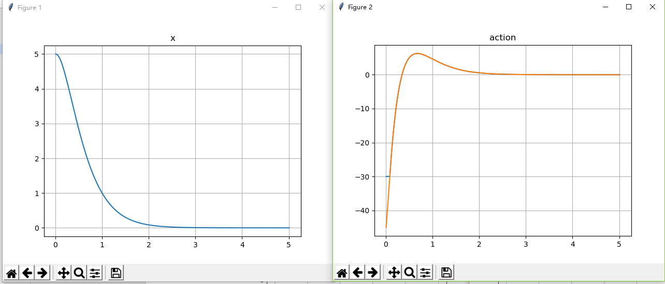

Total_reward = 2.67

## Omega=5

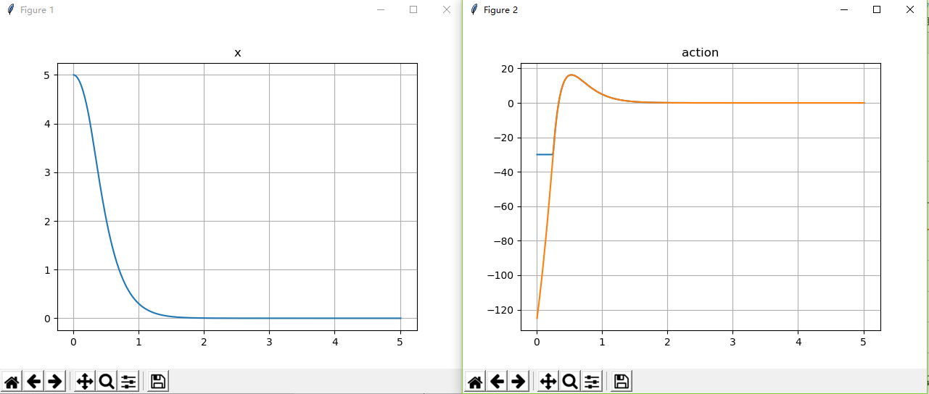

Total_reward = 1.2474188772869084

## Omega = 8

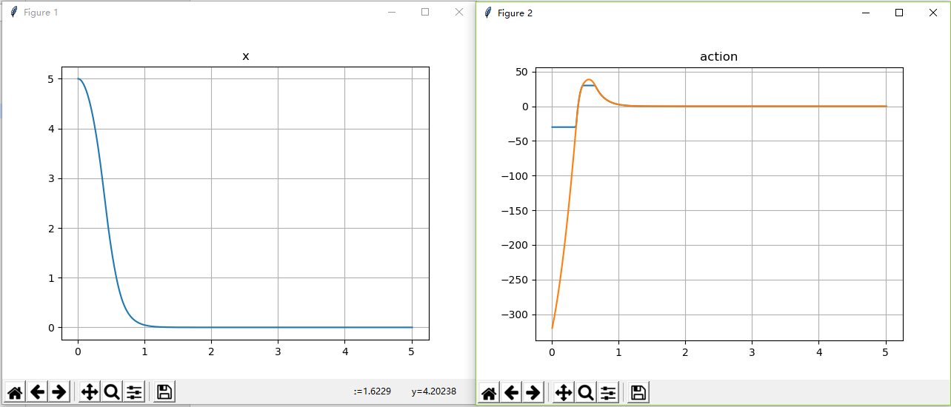

Total_reward = -3.4072429012582592

## Omega = 10

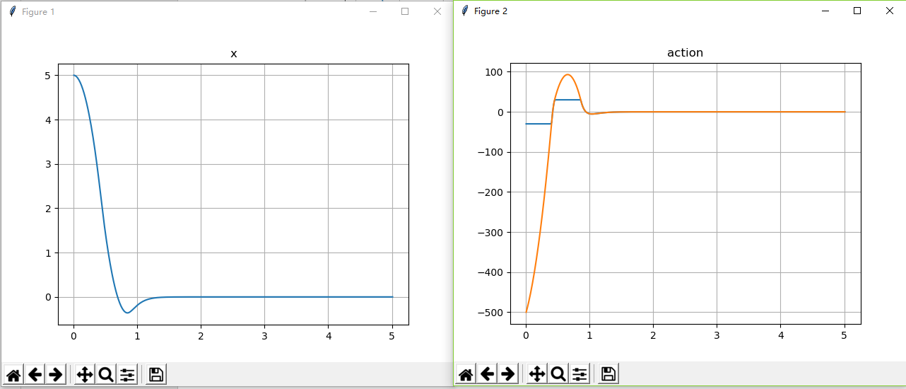

Total_reward = -7.928182669069031

# A3C

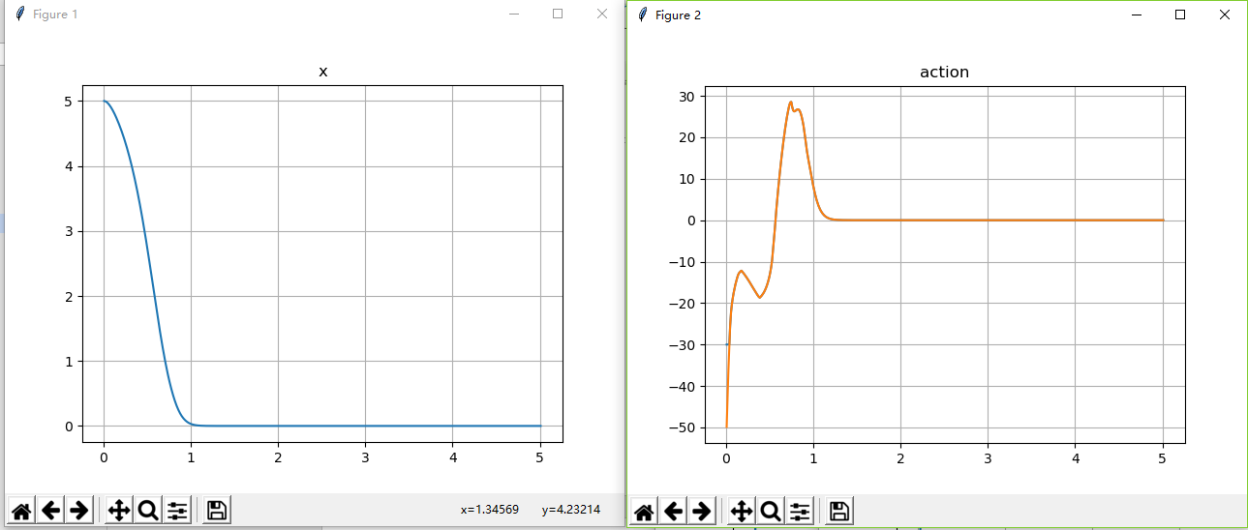

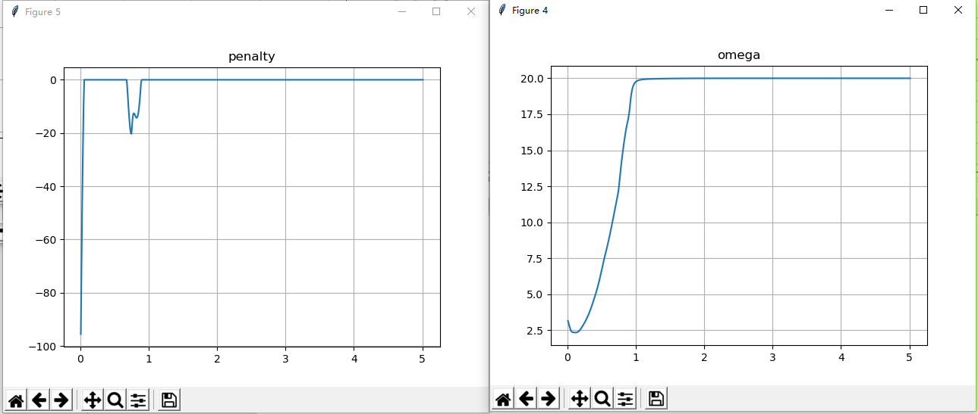

Total_reward = 17.368853043967064