第一节 入门 1
第二节 数据列表显示 12
第三节 数据详细显示 23
第四节 数据增加 29
第五节 数据修改 36
第六节 数据删除 45

第一节 入门
- 创建项目框架
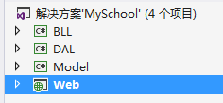
Model实体模型层 DAL数据访问层 BLL业务逻辑成 Web表示层
- 添加项目之间引用
Dal 引用 model ；bll引用model 、dal；web引用model、bll
准备数据访问类DbHelperSQL 弹出框类MessageBox
- 编写model层
以admin为例。创建Admin类
using System;
namespace Model
{
/// <summary>
/// Admin:实体类(属性说明自动提取数据库字段的描述信息)
/// </summary>
[Serializable]
public partial class Admin
{
public Admin()
{}
#region Model
private int _adminid;
private string _loginid;
private string _loginpwd;
private string _adminname;
private bool _sex;
/// <summary>
///
/// </summary>
public int adminID
{
set{ _adminid=value;}
get{return _adminid;}
}
/// <summary>
///
/// </summary>
public string LoginID
{
set{ _loginid=value;}
get{return _loginid;}
}
/// <summary>
///
/// </summary>
public string LoginPWD
{
set{ _loginpwd=value;}
get{return _loginpwd;}
}
/// <summary>
///
/// </summary>
public string AdminName
{
set{ _adminname=value;}
get{return _adminname;}
}
/// <summary>
///
/// </summary>
public bool sex
{
set{ _sex=value;}
get{return _sex;}
}
#endregion Model

}
}
- 编写数据访问层 DAL
创建AdminDAL类, 编写数据库访问代码。准备好 DbHelperSQL
using System;
using System.Data;
using System.Text;
using System.Data.SqlClient;
using Model;

namespace DAL
{
/// <summary>
/// 数据访问类:Admin
/// </summary>
public class AdminDAL
{
public AdminDAL()
{}

/// <summary>
/// 查询一个对象实体
/// </summary>
public Admin GetModel(string name, string pwd)
{
StringBuilder strSql=new StringBuilder();
strSql.Append("select top 1 ");
strSql.Append(" adminID,LoginID,LoginPWD,AdminName,sex ");
strSql.Append(" from Admin ");
strSql.Append(" where LoginID='" + name + "' and LoginPWD='" + pwd + "'");
Admin model=new Admin();
DataSet ds=DbHelperSQL.Query(strSql.ToString());
if(ds.Tables[0].Rows.Count>0)
{
return DataRowToModel(ds.Tables[0].Rows[0]);
}
else
{
return null;
}
}
/// <summary>
/// 得到一个对象实体
/// </summary>
public Admin DataRowToModel(DataRow row)
{
Admin model = new Admin();
if (row != null)
{
if (row["adminID"] != null && row["adminID"].ToString() != "")
{
model.adminID = int.Parse(row["adminID"].ToString());
}
if (row["LoginID"] != null)
{
model.LoginID = row["LoginID"].ToString();
}
if (row["LoginPWD"] != null)
{
model.LoginPWD = row["LoginPWD"].ToString();
}
if (row["AdminName"] != null)
{
model.AdminName = row["AdminName"].ToString();
}
if (row["sex"] != null && row["sex"].ToString() != "")
{
if ((row["sex"].ToString() == "1") || (row["sex"].ToString().ToLower() == "true"))
{
model.sex = true;
}
else
{
model.sex = false;
}
}
}
return model;
}
}
}

- 编写业务逻辑层 BLL
创建 AdminBLL类
using System;
using System.Data;
using System.Collections.Generic;
using DAL;
using Model;
namespace BLL
{
/// <summary>
/// Admin
/// </summary>
public class AdminBLL
{
private readonly AdminDAL dal=new AdminDAL();
public AdminBLL()
{}
/// <summary>
/// 得到一个对象实体
/// </summary>
public Admin GetModel(string name, string pwd)
{

return dal.GetModel(name, pwd);
}
}
}
- 编写表示层WEB
创建login.aspx页面.进行登录验证
（0）web.config 添加连接字符串
<connectionStrings>
<add name="DefaultConnection" connectionString="Data Source=(LocalDb)\v11.0;AttachDbFilename=|DataDirectory|\aspnet-MySchool-20160228042251.mdf;Initial Catalog=aspnet-MySchool-20160228042251;Integrated Security=True"
providerName="System.Data.SqlClient" />
<add name="sqlservercon" connectionString="user id=sa;password=sasa;initial catalog=school;data source=.\SQLexpress"
providerName="System.Data.SqlClient" />
</connectionStrings>
- 创建页面。
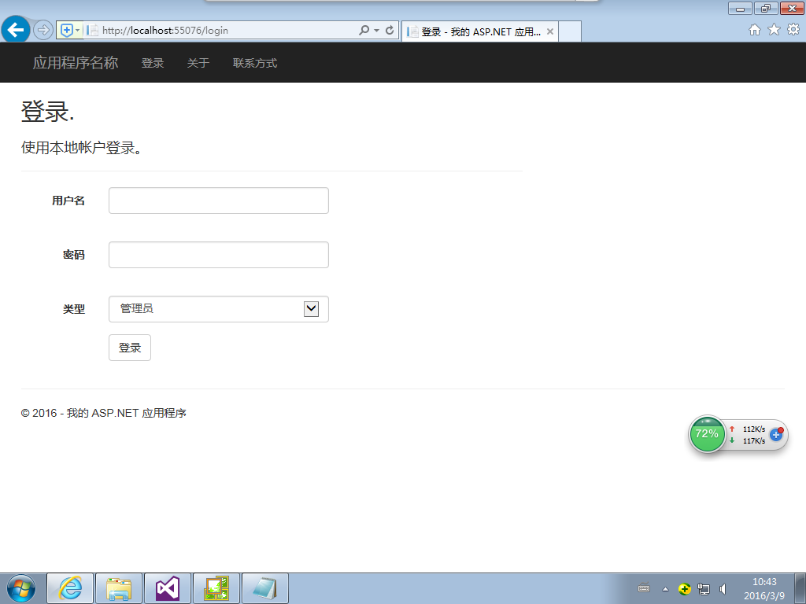
<%@ Page Title="登录" Language="C#" MasterPageFile="~/Site.Master" AutoEventWireup="true" CodeBehind="Login.aspx.cs" Inherits="Web.Login" Async="true" %>
<asp:Content runat="server" ID="BodyContent" ContentPlaceHolderID="MainContent">
<h2><%: Title %>.</h2>
<div class="row">
<div class="col-md-8">
<section id="loginForm">
<div class="form-horizontal">
<h4>使用本地帐户登录。</h4>
<hr />
<asp:PlaceHolder runat="server" ID="ErrorMessage" Visible="false">
<p class="text-danger">
<asp:Literal runat="server" ID="FailureText" />
</p>
</asp:PlaceHolder>
<div class="form-group">
<asp:Label runat="server" AssociatedControlID="UserName" CssClass="col-md-2 control-label">用户名</asp:Label>
<div class="col-md-10">
<asp:TextBox runat="server" ID="UserName" CssClass="form-control" />
<asp:RequiredFieldValidator runat="server" ControlToValidate="UserName"
CssClass="text-danger" ErrorMessage="“用户名”字段是必填字段。" />
</div>
</div>
<div class="form-group">
<asp:Label runat="server" AssociatedControlID="Password" CssClass="col-md-2 control-label">密码</asp:Label>
<div class="col-md-10">
<asp:TextBox runat="server" ID="Password" TextMode="Password" CssClass="form-control" />
<asp:RequiredFieldValidator runat="server" ControlToValidate="Password" CssClass="text-danger" ErrorMessage="“密码”字段是必填字段。" />
</div>
</div>
<div class="form-group">
<asp:Label runat="server" AssociatedControlID="DropDownList1" CssClass="col-md-2 control-label">类型</asp:Label>
<div class=" col-md-10">
<asp:DropDownList ID="DropDownList1" runat="server" CssClass="form-control" >
<asp:ListItem Value="1">管理员</asp:ListItem>
<asp:ListItem Value="2">学生</asp:ListItem>
</asp:DropDownList>
</div>
</div>
<div class="form-group">
<div class="col-md-offset-2 col-md-10">
<asp:Button runat="server" id="submit" Text="登录" CssClass="btn btn-default" OnClick="submit_Click" />
</div>
</div>
</div>
<p>

</p>
</section>
</div>

<div class="col-md-4">
</div>
</div>
</asp:Content>
- 编写代码
using System;
using System.Collections.Generic;
using System.Linq;
using System.Web;
using System.Web.UI;
using System.Web.UI.WebControls;
using BLL;
using Model;
namespace Web
{
public partial class Login : System.Web.UI.Page
{
protected void Page_Load(object sender, EventArgs e)
{

}

protected void submit_Click(object sender, EventArgs e)
{
string usertype = DropDownList1.SelectedValue;
string name = UserName.Text.Trim();
string pwd = Password.Text.Trim();
if (usertype == "1")//管理员
{
AdminBLL bll=new AdminBLL();
Admin model = bll.GetModel(name,pwd);
if (model != null)
{
Response.Redirect("welcome.aspx");
}
else
{
FailureText.Text = "Invalid username or password.";
ErrorMessage.Visible = true;
}
}
else if (usertype == "2")//学生
{
/*
studentBLL bll = new studentBLL();
student model = bll.GetModel(name, pwd);
if (model != null)
{
Response.Redirect("welcome.aspx");
}
else
{ FailureText.Text = "Invalid username or password.";
ErrorMessage.Visible = true;
}
*/
}
}
}
}

第二节 数据列表显示

- dal层
/// <summary>
/// 获得数据列表
/// </summary>
public DataSet GetList(string strWhere)
{
StringBuilder strSql = new StringBuilder();
strSql.Append("select adminID,LoginID,LoginPWD,AdminName,sex ");
strSql.Append(" FROM Admin ");
if (strWhere.Trim() != "")
{
strSql.Append(" where " + strWhere);
}
return DbHelperSQL.Query(strSql.ToString());
}

/// <summary>
/// 获得前几行数据
/// </summary>
public DataSet GetList(int Top, string strWhere, string filedOrder)
{
StringBuilder strSql = new StringBuilder();
strSql.Append("select ");
if (Top > 0)
{
strSql.Append(" top " + Top.ToString());
}
strSql.Append(" adminID,LoginID,LoginPWD,AdminName,sex ");
strSql.Append(" FROM Admin ");
if (strWhere.Trim() != "")
{
strSql.Append(" where " + strWhere);
}
strSql.Append(" order by " + filedOrder);
return DbHelperSQL.Query(strSql.ToString());
}
/// <summary>
/// 批量删除数据
/// </summary>
public bool DeleteList(string adminIDlist)
{
StringBuilder strSql = new StringBuilder();
strSql.Append("delete from Admin ");
strSql.Append(" where adminID in (" + adminIDlist + ") ");
int rows = DbHelperSQL.ExecuteSql(strSql.ToString());
if (rows > 0)
{
return true;
}
else
{
return false;
}
}

- bll层
/// <summary>
/// 获得数据列表
/// </summary>
public DataSet GetList(string strWhere)
{
return dal.GetList(strWhere);
}
/// <summary>
/// 获得前几行数据
/// </summary>
public DataSet GetList(int Top, string strWhere, string filedOrder)
{
return dal.GetList(Top, strWhere, filedOrder);
}
/// <summary>
/// 删除一条数据
/// </summary>
public bool DeleteList(string adminIDlist)
{
return dal.DeleteList(adminIDlist);
}
3.web层
- 页面
新建页面 List.aspx
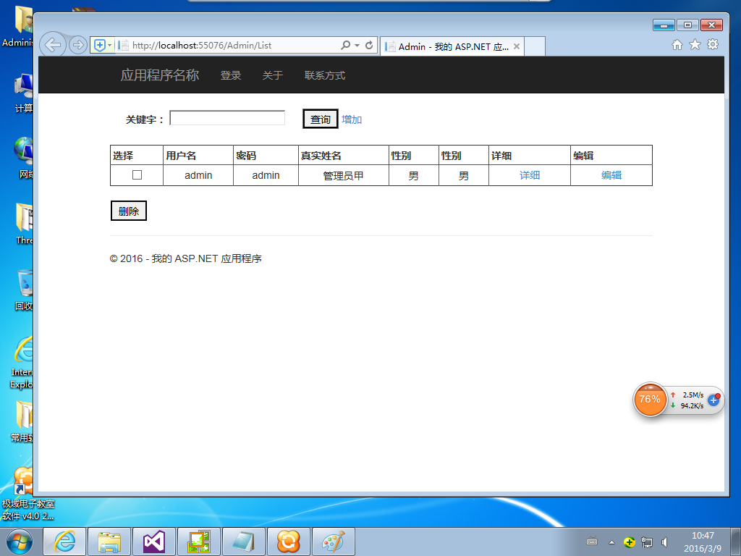
<%@ Page Title="Admin" Language="C#" MasterPageFile="~/site.master" AutoEventWireup="true" CodeBehind="List.aspx.cs" Inherits="Web.List" %>

<asp:Content ID="Content2" ContentPlaceHolderID="MainContent" runat="server">

<!--Search -->
<br />
<table style="width: 100%;" cellpadding="2" cellspacing="1" class="border">
<tr>
<td style="width: 80px" align="right" class="tdbg">
<b>关键字：</b>
</td>
<td class="tdbg">
<asp:TextBox ID="txtKeyword" runat="server"></asp:TextBox>
&nbsp;&nbsp;&nbsp;&nbsp;
<asp:Button ID="btnSearch" runat="server" Text="查询" OnClick="btnSearch_Click" >
</asp:Button>
<a href="Add.aspx">增加</a>
</td>
<td class="tdbg">

</td>
</tr>
</table>
<!--Search end-->
<br />
<asp:GridView ID="gridView" runat="server" AllowPaging="True" Width="100%" CellPadding="3" OnPageIndexChanging ="gridView_PageIndexChanging"
BorderWidth="1px" DataKeyNames="adminID" OnRowDataBound="gridView_RowDataBound"
AutoGenerateColumns="false" PageSize="10" RowStyle-HorizontalAlign="Center" OnRowCreated="gridView_OnRowCreated">
<Columns>
<asp:TemplateField ControlStyle-Width="30" HeaderText="选择" >
<ItemTemplate>
<asp:CheckBox ID="DeleteThis" runat="server" />
</ItemTemplate>
</asp:TemplateField>

<asp:BoundField DataField="LoginID" HeaderText="用户名" SortExpression="LoginID" ItemStyle-HorizontalAlign="Center" />
<asp:BoundField DataField="LoginPWD" HeaderText="密码" SortExpression="LoginPWD" ItemStyle-HorizontalAlign="Center" />
<asp:BoundField DataField="AdminName" HeaderText="真实姓名" SortExpression="AdminName" ItemStyle-HorizontalAlign="Center" />
<asp:BoundField DataField="sex" HeaderText="性别" SortExpression="sex" ItemStyle-HorizontalAlign="Center" />
<asp:TemplateField HeaderText="性别">
<ItemTemplate>
<%#Eval("Sex").ToString()=="True"?"男":(Eval("Sex").ToString()=="False"?"女":"不详")%>
</ItemTemplate>
</asp:TemplateField>
<asp:HyperLinkField HeaderText="详细" ControlStyle-Width="50" DataNavigateUrlFields="adminID" DataNavigateUrlFormatString="Show.aspx?id={0}"
Text="详细" />
<asp:HyperLinkField HeaderText="编辑" ControlStyle-Width="50" DataNavigateUrlFields="adminID" DataNavigateUrlFormatString="Modify.aspx?id={0}"
Text="编辑" />
<asp:TemplateField ControlStyle-Width="50" HeaderText="删除" Visible="false" >
<ItemTemplate>
<asp:LinkButton ID="LinkButton1" runat="server" CausesValidation="False" CommandName="Delete"
Text="删除"></asp:LinkButton>
</ItemTemplate>
</asp:TemplateField>
</Columns>
</asp:GridView>
<br />
<table border="0" cellpadding="0" cellspacing="1" style="width: 100%;">
<tr>
<td style="width: 1px;">
</td>
<td align="left">
<asp:Button ID="btnDelete" runat="server" Text="删除" OnClick="btnDelete_Click"/>
</td>
</tr>
</table>
</asp:Content>
<%--<asp:Content ID="Content3" ContentPlaceHolderID="ContentPlaceCheckright" runat="server">
</asp:Content>--%>

- 代码
using System;
using System.Collections.Generic;
using System.Web;
using System.Web.UI;
using System.Web.UI.WebControls;
using System.Text;
using System.Data;
using System.Drawing;
using BLL;
namespace Web
{
public partial class List : Page
{

AdminBLL bll = new AdminBLL();

protected void Page_Load(object sender, EventArgs e)
{
if (!Page.IsPostBack)
{
btnDelete.Attributes.Add("onclick", "return confirm(\"你确认要删除吗？\")");
BindData();
}
}

protected void btnSearch_Click(object sender, EventArgs e)
{
BindData();
}

protected void btnDelete_Click(object sender, EventArgs e)
{
string idlist = GetSelIDlist();
if (idlist.Trim().Length == 0)
return;
bll.DeleteList(idlist);
BindData();
}

#region gridView

public void BindData()
{
#region
//if (!Context.User.Identity.IsAuthenticated)
//{
// return;
//}
//AccountsPrincipal user = new AccountsPrincipal(Context.User.Identity.Name);
//if (user.HasPermissionID(PermId_Modify))
//{
// gridView.Columns[6].Visible = true;
//}
//if (user.HasPermissionID(PermId_Delete))
//{
// gridView.Columns[7].Visible = true;
//}
#endregion

DataSet ds = new DataSet();
StringBuilder strWhere = new StringBuilder();
if (txtKeyword.Text.Trim() != "")
{

strWhere.AppendFormat("loginid like '%{0}%'", txtKeyword.Text.Trim());
}
ds = bll.GetList(strWhere.ToString());
gridView.DataSource = ds;
gridView.DataBind();
}

protected void gridView_PageIndexChanging(object sender, GridViewPageEventArgs e)
{
gridView.PageIndex = e.NewPageIndex;
BindData();
}
protected void gridView_OnRowCreated(object sender, GridViewRowEventArgs e)
{
if (e.Row.RowType == DataControlRowType.Header)
{
//e.Row.Cells[0].Text = "<input id='Checkbox2' type='checkbox' onclick='CheckAll()'/><label></label>";
}
}
protected void gridView_RowDataBound(object sender, GridViewRowEventArgs e)
{
e.Row.Attributes.Add("style", "background:#FFF");
if (e.Row.RowType == DataControlRowType.DataRow)
{
LinkButton linkbtnDel = (LinkButton)e.Row.FindControl("LinkButton1");
linkbtnDel.Attributes.Add("onclick", "return confirm(\"你确认要删除吗\")");

if (e.Row.Cells[4].Text == "True")
{
e.Row.Cells[4].Text = "男";
}
else
{
e.Row.Cells[4].Text = "女";
}
}
}

protected void gridView_RowDeleting(object sender, GridViewDeleteEventArgs e)
{
//#warning 代码生成警告：请检查确认真实主键的名称和类型是否正确
//int ID = (int)gridView.DataKeys[e.RowIndex].Value;
//bll.Delete(ID);
//gridView.OnBind();
}

private string GetSelIDlist()
{
string idlist = "";
bool BxsChkd = false;
for (int i = 0; i < gridView.Rows.Count; i++)
{
CheckBox ChkBxItem = (CheckBox)gridView.Rows[i].FindControl("DeleteThis");
if (ChkBxItem != null && ChkBxItem.Checked)
{
BxsChkd = true;
//#warning 代码生成警告：请检查确认Cells的列索引是否正确
if (gridView.DataKeys[i].Value != null)
{
idlist += gridView.DataKeys[i].Value.ToString() + ",";
}
}
}
if (BxsChkd)
{
idlist = idlist.Substring(0, idlist.LastIndexOf(","));
}
return idlist;
}

#endregion

}
}

第三节 数据详细显示

- dal层
注意：DataRowToModel方法在第一节已定义
/// <summary>
/// 得到一个对象实体
/// </summary>
public Admin GetModel(int adminID)
{
StringBuilder strSql = new StringBuilder();
strSql.Append("select top 1 ");
strSql.Append(" adminID,LoginID,LoginPWD,AdminName,sex ");
strSql.Append(" from Admin ");
strSql.Append(" where adminID=" + adminID + "");
Admin model = new Admin();
DataSet ds = DbHelperSQL.Query(strSql.ToString());
if (ds.Tables[0].Rows.Count > 0)
{
return DataRowToModel(ds.Tables[0].Rows[0]);
}
else
{
return null;
}
}
2.bll层
/// <summary>
/// 得到一个对象实体
/// </summary>
public Admin GetModel(int adminID)
{

return dal.GetModel(adminID);
}
3.web层
（1）页面
新建页面Show.aspx
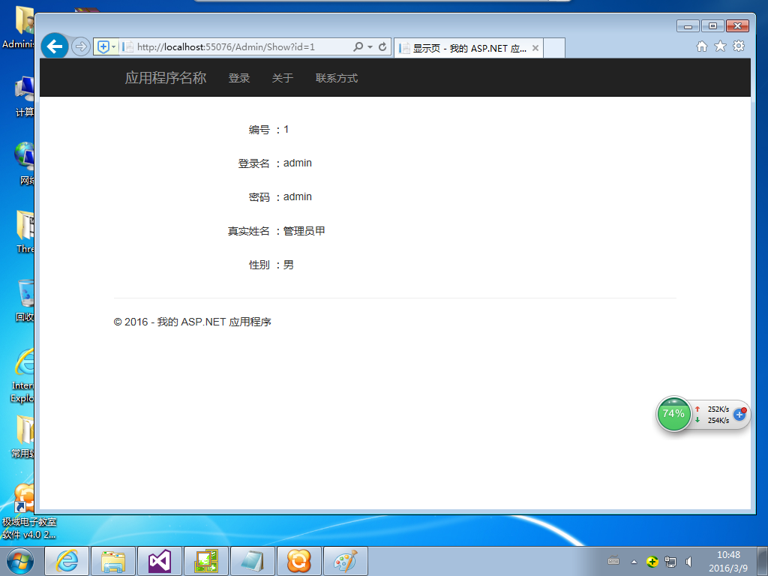
<%@ Page Language="C#" MasterPageFile="~/site.master" AutoEventWireup="true" CodeBehind="Show.aspx.cs" Inherits="Web.Show" Title="显示页" %>

<asp:Content ID="Content2" ContentPlaceHolderID="MainContent" runat="server">
<br />
<table style="width: 100%;" cellpadding="2" cellspacing="1" class="border">
<tr>
<td class="tdbg">

<table cellSpacing="0" cellPadding="0" width="100%" border="0">
<tr>
<td height="45" width="30%" align="right">
编号
：</td>
<td height="45" width="*" align="left">
<asp:Label id="lbladminID" runat="server"></asp:Label>
</td></tr>
<tr>
<td height="45" width="30%" align="right">
登录名
：</td>
<td height="45" width="*" align="left">
<asp:Label id="lblLoginID" runat="server"></asp:Label>
</td></tr>
<tr>
<td height="45" width="30%" align="right">
密码
：</td>
<td height="45" width="*" align="left">
<asp:Label id="lblLoginPWD" runat="server"></asp:Label>
</td></tr>
<tr>
<td height="45" width="30%" align="right">
真实姓名
：</td>
<td height="45" width="*" align="left">
<asp:Label id="lblAdminName" runat="server"></asp:Label>
</td></tr>
<tr>
<td height="45" width="30%" align="right">
性别
：</td>
<td height="45" width="*" align="left">
<asp:Label id="lblsex" runat="server"></asp:Label>
</td></tr>
</table>

</td>
</tr>
</table>
</asp:Content>
<%--<asp:Content ID="Content3" ContentPlaceHolderID="ContentPlaceCheckright" runat="server">
</asp:Content>--%>

（2）代码
using System;
using System.Data;
using System.Configuration;
using System.Collections;
using System.Web;
using System.Web.Security;
using System.Web.UI;
using System.Web.UI.WebControls;
using System.Web.UI.WebControls.WebParts;
using System.Web.UI.HtmlControls;
using System.Text;
using BLL;
using Model;
namespace Web
{
public partial class Show : Page
{
public string strid="";
protected void Page_Load(object sender, EventArgs e)
{
if (!Page.IsPostBack)
{
if (Request.Params["id"] != null && Request.Params["id"].Trim() != "")
{
strid = Request.Params["id"];
int adminID=(Convert.ToInt32(strid));
ShowInfo(adminID);
}
}
}

private void ShowInfo(int adminID)
{
AdminBLL bll = new AdminBLL();
Admin model=bll.GetModel(adminID);
this.lbladminID.Text=model.adminID.ToString();
this.lblLoginID.Text=model.LoginID;
this.lblLoginPWD.Text=model.LoginPWD;
this.lblAdminName.Text=model.AdminName;
this.lblsex.Text=model.sex?"男":"女";

}

}
}

第四节 数据增加

1.dal层
/// <summary>
/// 增加一条数据
/// </summary>
public int Add(Admin model)
{
StringBuilder strSql = new StringBuilder();
StringBuilder strSql1 = new StringBuilder();
StringBuilder strSql2 = new StringBuilder();
if (model.LoginID != null)
{
strSql1.Append("LoginID,");
strSql2.Append("'" + model.LoginID + "',");
}
if (model.LoginPWD != null)
{
strSql1.Append("LoginPWD,");
strSql2.Append("'" + model.LoginPWD + "',");
}
if (model.AdminName != null)
{
strSql1.Append("AdminName,");
strSql2.Append("'" + model.AdminName + "',");
}

strSql1.Append("sex,");
strSql2.Append("" + (model.sex ? 1 : 0) + ",");

strSql.Append("insert into Admin(");
strSql.Append(strSql1.ToString().Remove(strSql1.Length - 1));
strSql.Append(")");
strSql.Append(" values (");
strSql.Append(strSql2.ToString().Remove(strSql2.Length - 1));
strSql.Append(")");
strSql.Append(";select @@IDENTITY");
object obj = DbHelperSQL.GetSingle(strSql.ToString());
if (obj == null)
{
return 0;
}
else
{
return Convert.ToInt32(obj);
}
}
2.bll层
/// <summary>
/// 增加一条数据
/// </summary>
public int Add(Admin model)
{
return dal.Add(model);
}
3.web层
（1）页面
新建增加页面Add.aspx
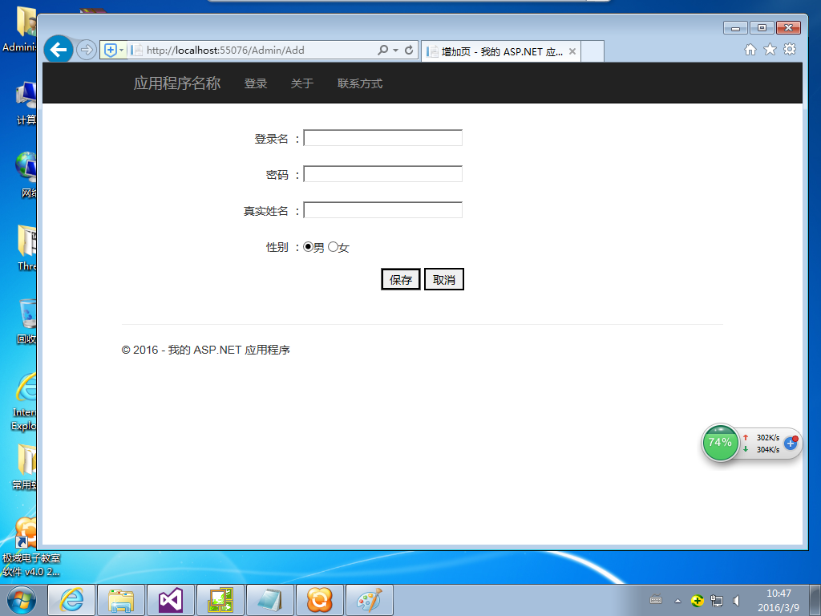
<%@ Page Language="C#" MasterPageFile="~/site.master" AutoEventWireup="true"
CodeBehind="Add.aspx.cs" Inherits="Web.Add" Title="增加页" %>

<asp:Content ID="Content2" ContentPlaceHolderID="MainContent" runat="server">
<br />
<table style="width: 100%;" cellpadding="2" cellspacing="1" class="border">
<tr>
<td class="tdbg">

<table cellSpacing="0" cellPadding="0" width="100%" border="0">
<tr>
<td height="45" width="30%" align="right">
登录名
：</td>
<td height="45" width="*" align="left">
<asp:TextBox id="txtLoginID" runat="server" Width="200px"></asp:TextBox>
</td></tr>
<tr>
<td height="45" width="30%" align="right">
密码
：</td>
<td height="45" width="*" align="left">
<asp:TextBox id="txtLoginPWD" runat="server" Width="200px" TextMode="Password"></asp:TextBox>
</td></tr>
<tr>
<td height="45" width="30%" align="right">
真实姓名
：</td>
<td height="45" width="*" align="left">
<asp:TextBox id="txtAdminName" runat="server" Width="200px"></asp:TextBox>
</td></tr>
<tr>
<td height="45" width="30%" align="right">
性别
：</td>
<td height="45" width="*" align="left">

<asp:RadioButton ID="sexm" Checked="true" runat="server" GroupName="sex" />男
<asp:RadioButton ID="sexf" runat="server" GroupName="sex" />女
</td></tr>

</table>

</td>
</tr>
<tr>
<td class="tdbg" align="center" valign="bottom">
<asp:Button ID="btnSave" runat="server" Text="保存"
OnClick="btnSave_Click" class="inputbutton" onmouseover="this.className='inputbutton_hover'"
onmouseout="this.className='inputbutton'"></asp:Button>
<asp:Button ID="btnCancle" runat="server" Text="取消"
OnClick="btnCancle_Click" class="inputbutton" onmouseover="this.className='inputbutton_hover'"
onmouseout="this.className='inputbutton'"></asp:Button>
</td>
</tr>
</table>
<br />
</asp:Content>
<%--<asp:Content ID="Content3" ContentPlaceHolderID="ContentPlaceCheckright" runat="server">
</asp:Content>--%>

（2）代码
using System;
using System.Data;
using System.Configuration;
using System.Collections;
using System.Web;
using System.Web.Security;
using System.Web.UI;
using System.Web.UI.WebControls;
using System.Web.UI.WebControls.WebParts;
using System.Web.UI.HtmlControls;
using System.Text;
using Model;
using BLL;
namespace Web
{
public partial class Add : Page
{
protected void Page_Load(object sender, EventArgs e)
{

}

protected void btnSave_Click(object sender, EventArgs e)
{

string strErr="";
if(this.txtLoginID.Text.Trim().Length==0)
{
strErr+="LoginID不能为空！\\n";
}
if(this.txtLoginPWD.Text.Trim().Length==0)
{
strErr+="LoginPWD不能为空！\\n";
}
if(this.txtAdminName.Text.Trim().Length==0)
{
strErr+="AdminName不能为空！\\n";
}

if(strErr!="")
{

return;
}
string LoginID=this.txtLoginID.Text;
string LoginPWD=this.txtLoginPWD.Text;
string AdminName=this.txtAdminName.Text;
bool sex=true;
if (sexm.Checked) { sex = true; }
if (sexf.Checked) { sex = false; }

Admin model=new Admin();
model.LoginID=LoginID;
model.LoginPWD=LoginPWD;
model.AdminName=AdminName;
model.sex=sex;

AdminBLL bll=new AdminBLL();
bll.Add(model);
MessageBox.ShowAndRedirect(this,"保存成功！","add.aspx");

}

public void btnCancle_Click(object sender, EventArgs e)
{
Response.Redirect("list.aspx");
}
}
}

第五节 数据修改

1.dal层
/// <summary>
/// 更新一条数据
/// </summary>
public bool Update(Admin model)
{
StringBuilder strSql = new StringBuilder();
strSql.Append("update Admin set ");
if (model.LoginID != null)
{
strSql.Append("LoginID='" + model.LoginID + "',");
}
else
{
strSql.Append("LoginID= null ,");
}
if (model.LoginPWD != null)
{
strSql.Append("LoginPWD='" + model.LoginPWD + "',");
}
else
{
strSql.Append("LoginPWD= null ,");
}
if (model.AdminName != null)
{
strSql.Append("AdminName='" + model.AdminName + "',");
}
else
{
strSql.Append("AdminName= null ,");
}

strSql.Append("sex=" + (model.sex ? 1 : 0) + ",");

int n = strSql.ToString().LastIndexOf(",");
strSql.Remove(n, 1);
strSql.Append(" where adminID=" + model.adminID + "");
int rowsAffected = DbHelperSQL.ExecuteSql(strSql.ToString());
if (rowsAffected > 0)
{
return true;
}
else
{
return false;
}
}
2.bll层
/// <summary>
/// 更新一条数据
/// </summary>
public bool Update(Admin model)
{
return dal.Update(model);
}
3.web层
（1）页面
新建 Modify .aspx
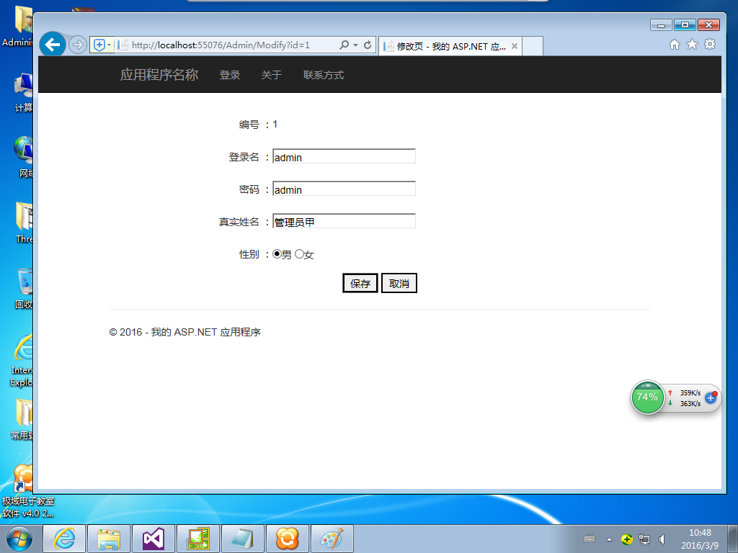
<%@ Page Language="C#" MasterPageFile="~/site.master" AutoEventWireup="true" CodeBehind="Modify.aspx.cs" Inherits="Web.Modify" Title="修改页" %>

<asp:Content ID="Content2" ContentPlaceHolderID="MainContent" runat="server">
<br />
<table style="width: 100%;" cellpadding="2" cellspacing="1" class="border">
<tr>
<td class="tdbg">

<table cellSpacing="0" cellPadding="0" width="100%" border="0">
<tr>
<td height="45" width="30%" align="right">
编号
：</td>
<td height="45" width="*" align="left">
<asp:label id="lbladminID" runat="server"></asp:label>
</td></tr>
<tr>
<td height="45" width="30%" align="right">
登录名
：</td>
<td height="45" width="*" align="left">
<asp:TextBox id="txtLoginID" runat="server" Width="200px"></asp:TextBox>
</td></tr>
<tr>
<td height="45" width="30%" align="right">
密码
：</td>
<td height="45" width="*" align="left">
<asp:TextBox id="txtLoginPWD" runat="server" Width="200px"></asp:TextBox>
</td></tr>
<tr>
<td height="45" width="30%" align="right">
真实姓名
：</td>
<td height="45" width="*" align="left">
<asp:TextBox id="txtAdminName" runat="server" Width="200px"></asp:TextBox>
</td></tr>
<tr>
<td height="45" width="30%" align="right">
性别
：</td>
<td height="45" width="*" align="left">

<asp:RadioButton ID="sexm" runat="server" GroupName="sex" />男
<asp:RadioButton ID="sexf" runat="server" GroupName="sex" />女
</td></tr>

</table>

</td>
</tr>
<tr>
<td class="tdbg" align="center" valign="bottom">
<asp:Button ID="btnSave" runat="server" Text="保存"
OnClick="btnSave_Click" class="inputbutton" onmouseover="this.className='inputbutton_hover'"
onmouseout="this.className='inputbutton'"></asp:Button>
<asp:Button ID="btnCancle" runat="server" Text="取消"
OnClick="btnCancle_Click" class="inputbutton" onmouseover="this.className='inputbutton_hover'"
onmouseout="this.className='inputbutton'"></asp:Button>
</td>
</tr>
</table>
</asp:Content>
<%--<asp:Content ID="Content3" ContentPlaceHolderID="ContentPlaceCheckright" runat="server">
</asp:Content>--%>

- 代码
using System;
using System.Data;
using System.Configuration;
using System.Collections;
using System.Web;
using System.Web.Security;
using System.Web.UI;
using System.Web.UI.WebControls;
using System.Web.UI.WebControls.WebParts;
using System.Web.UI.HtmlControls;
using System.Text;
using BLL;
using Model;
namespace Web
{
public partial class Modify : Page
{

protected void Page_Load(object sender, EventArgs e)
{
if (!Page.IsPostBack)
{
if (Request.Params["id"] != null && Request.Params["id"].Trim() != "")
{
int adminID=(Convert.ToInt32(Request.Params["id"]));
ShowInfo(adminID);
}
}
}

private void ShowInfo(int adminID)
{
AdminBLL bll=new AdminBLL();
Admin model=bll.GetModel(adminID);
this.lbladminID.Text=model.adminID.ToString();
this.txtLoginID.Text=model.LoginID;
this.txtLoginPWD.Text=model.LoginPWD;
this.txtAdminName.Text=model.AdminName;

if (model.sex)
{
sexm.Checked = true;
sexf.Checked = false;
}
else
{
sexm.Checked =false;
sexf.Checked =true;
}

}

public void btnSave_Click(object sender, EventArgs e)
{

string strErr="";
if(this.txtLoginID.Text.Trim().Length==0)
{
strErr+="LoginID不能为空！\\n";
}
if(this.txtLoginPWD.Text.Trim().Length==0)
{
strErr+="LoginPWD不能为空！\\n";
}
if(this.txtAdminName.Text.Trim().Length==0)
{
strErr+="AdminName不能为空！\\n";
}

if(strErr!="")
{
MessageBox.Show(this,strErr);
return;
}
int adminID=int.Parse(this.lbladminID.Text);
string LoginID=this.txtLoginID.Text;
string LoginPWD=this.txtLoginPWD.Text;
string AdminName=this.txtAdminName.Text;

bool sex = true;
if (sexm.Checked) { sex = true; }
if (sexf.Checked) { sex = false; }

Admin model=new Admin();
model.adminID=adminID;
model.LoginID=LoginID;
model.LoginPWD=LoginPWD;
model.AdminName=AdminName;
model.sex=sex;

AdminBLL bll = new AdminBLL();
bll.Update(model);
MessageBox.ShowAndRedirect(this,"保存成功！","list.aspx");

}

public void btnCancle_Click(object sender, EventArgs e)
{
Response.Redirect("list.aspx");
}
}
}

第六节 数据删除

1.dal层
/// <summary>
/// 删除一条数据
/// </summary>
public bool Delete(int adminID)
{
StringBuilder strSql = new StringBuilder();
strSql.Append("delete from Admin ");
strSql.Append(" where adminID=" + adminID + "");
int rowsAffected = DbHelperSQL.ExecuteSql(strSql.ToString());
if (rowsAffected > 0)
{
return true;
}
else
{
return false;
}
}
2.bll层
/// <summary>
/// 删除一条数据
/// </summary>
public bool Delete(int adminID)
{

return dal.Delete(adminID);
}
3.web层
（1）页面

（2）代码

