IOM3D-HBM: System-Hardware Co-design with IGZO Orthogonal Monolithic 3D HBM for Long-Context LLM Inference

Abstract—We present IOM3D-HBM, an IGZO-based orthogonal monolithic 3D memory architecture with FEOL near-memory processing (NMP) for long-context LLM inference. IOM3D-HBM integrates 318 thin M3D memory dies around the GPU, providing 1.49 TB of local capacity while avoiding the extended thermal path of conventional vertical stacking. Reducing the M3D die thickness from 300 to 100 μm triples capacity with only a 1.2% reduction in thermally sustainable bandwidth. We further propose Distributed NMP Scheduling (DNS) to process memory-intensive Decode operations close to resident weights and KV caches, and Critical-Path-Aware Placement (CPA) to optimize their physical mapping. Across 18 Llama-3.1 workloads spanning 8B, 70B, and 405B models, DNS+CPA achieves 7.28× geometric-mean end-to-end throughput and 4.75× energy efficiency over an optimistic conventional HBM-on-GPU (HoG) baseline, while all NMP workloads reach at most 81.41°C under an 85°C thermal limit. Further FEOL frequency scaling provides an additional 12.6% geometric-mean throughput improvement, demonstrating substantial performance headroom within the same architecture.
Keywords—monolithic 3D memory, orthogonal integration, IGZO, near-memory processing, long-context inference

Introduction
Large language models (LLMs) are rapidly extending toward longer context windows and higher concurrency, substantially increasing the memory footprint of model weights and key-value (KV) caches. During autoregressive Decode, these data must be repeatedly accessed for every generated token, making long-context inference increasingly constrained by both memory capacity and data movement. When the working set exceeds local HBM capacity, external-memory accesses further degrade throughput.
To alleviate the memory wall, recent studies have explored 3D HBM-on-GPU (HoG) integration, which shortens the memory–GPU path and improves bandwidth density. However, conventional vertical stacking also increases local power density and vertical thermal resistance, making further memory stacking increasingly difficult. Orthogonal memory integration provides a promising alternative by aligning the high-thermal-conductivity Si substrates with the dominant heat-flow direction. Recent MOSAIC demonstrations show that such an organization can substantially increase memory capacity while maintaining comparable bandwidth and peak temperature. Nevertheless, orthogonal stacking primarily addresses thermally scalable capacity; the enlarged resident data still need to traverse the die-to-GPU interface for computation, leaving the data-movement bottleneck of long-context Decode largely unresolved.
IGZO 2T0C memory combines low leakage with low-temperature sequential integration, enabling dense BEOL storage above Si logic [1]. This physical separation leaves the underlying FEOL available for local MAC, SRAM, and control. Orthogonal integration can therefore scale resident capacity while the short BEOL–FEOL path supplies computation beneath the stored weights and KV cache.
We present IOM3D-HBM, an architecture integrating orthogonal packaging, monolithic-3D IGZO memory, and underlying Si FEOL near-memory processing (NMP). Its contributions are threefold.
First, the integrated physical hierarchy couples thermally scalable orthogonal capacity with dense BEOL storage and local Si MAC execution. Large resident weights and KV data reach FEOL computation through the local BEOL–FEOL path instead of repeatedly traversing the GPU-facing interface.
Second, architecture-aware execution and placement exploit this locality. Distributed NMP Scheduling (DNS) keeps Prefill and irregular/global Decode operators on the GPU and maps partitionable MAC operators near resident operands. Critical-Path-Aware Placement (CPA) refines uniform DNS ownership using modeled resource bottlenecks and communication contention.
Third, evaluation under physical and thermal constraints demonstrates 1.49 TB capacity, approximately 3.40 TB/s thermally sustainable external bandwidth, and 7.28× E2E throughput and 4.75× energy efficiency over conventional HBM-GPU, with NMP temperatures at most 81.41°C. A fine-grained physical execution model resolves memory service, shared communication resources, NMP execution, energy, and workload-dependent steady-state temperature.

Background

Long-Context LLM Inference Challenge
The inference working set comprises model weights plus a KV cache that grows with context length and batch size. For example, Llama-3.1-8B at 128K tokens requires approximately 16 GiB of FP16 KV storage per request. Larger models, longer histories, and greater concurrency progressively exceed local HBM capacity; the evaluated workload matrix includes both HBM-resident and overflowing cases.
Second, long contexts further amplify the imbalance in resource demands across LLM operators. KV-cache-based attention becomes increasingly bandwidth-bound during decoding, whereas feed-forward network (FFN) computation and the prefill phase exhibit much higher arithmetic intensity. This growing mismatch between memory demand and compute demand makes efficient long-context inference increasingly dependent on both large resident memory capacity and high-bandwidth local data access.
Fig. 1. Long-context inference demands: (a) model and KV-cache capacity; (b) modeled memory traffic and arithmetic intensity during Decode and Prefill.

Monolithic 3D IGZO Memory
Monolithic 3D (M3D) integration provides a promising approach to increasing memory capacity density by vertically stacking multiple active device layers within the same footprint. IGZO is particularly attractive for M3D memory because its low-temperature fabrication enables sequential integration over underlying circuitry, while its low leakage current supports long retention in capacitorless memory cells. Recent CAA-IGZO 4F² 2T0C DRAM designs achieve a storage density of approximately 30 Mb/mm² per layer, providing a scalable building block for high-capacity multilayer memory.
Fig. 2(a) illustrates the vertically stacked M3D IGZO memory structure considered in this work. The key device- and cell-level parameters are adopted from [1], while MAT-level read-energy parameters are obtained through SPICE simulation using the corresponding device characteristics. The representative technology parameters used throughout our architecture evaluation are summarized in Fig. 2(b).
Fig 2. (a) M3D IGZO 4F² array. (b) Key device- and cell-level parameters of IGZO M3D.

Orthogonal Memory Integration

Orthogonal memory integration provides a thermally scalable alternative to conventional vertical HBM stacking by orienting multiple memory dies orthogonally to the base die. In this configuration, heat is primarily conducted through the high-thermal-conductivity silicon body rather than across an increasing number of bonding interfaces, so the dominant thermal path does not degrade significantly as more dies are integrated. This makes orthogonal integration suitable for large-scale memory stacking. Without through-silicon vias (TSVs), power can be delivered through sidewall metallization, while data communication is provided through wireless interfaces [2]. The reported wireless link achieves 8 Gb/s with 0.5 pJ/bit I/O energy per channel, and up to 50 channels can be accommodated along a 22 mm-wide die.

IOM3D-HBM Architecture

Architecture Overview
Fig. 3(a) presents the overall architecture of IOM3D-HBM. Instead of vertically stacking memory dies along the heat-flow direction, IOM3D-HBM arranges thin memory dies orthogonally around the GPU. A total of 318 100 µm thick memory dies are integrated within the package, providing approximately 1.49 TB of local memory capacity.
Each memory die integrates multilayer IGZO memory in the BEOL with distributed near-memory processing logic in the FEOL, and communicates with the GPU through contactless die-to-die interfaces. The high-capacity M3D memory enables model weights and KV caches to remain locally resident, while the FEOL processing units provide an additional execution path for memory-intensive Decode operations. The orthogonal organization distributes memory and NMP activity across the package to support thermal scalability.
Fig 3. Overview of IOM3D-HBM. (a) Package-level orthogonal memory integration. (b) Key architecture specifications. (c) BEOL IGZO memory and FEOL NMP organization within each M3D die. (d) Cluster-level 8×8 MAT organization and peripheral circuitry.

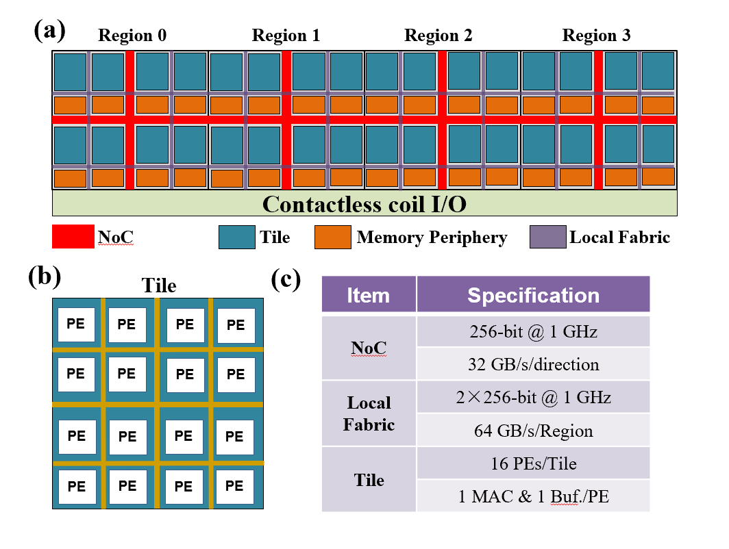
Fig. 4. FEOL NMP organization of an IOM3D memory die: (a) four-region architecture with distributed memory peripherals, NMP tiles, local fabrics, inter-region NoC, and contactless I/O; (b) 16-PE NMP tile; and (c) key FEOL specifications.

BEOL Memory and FEOL NMP Organization
Each IOM3D memory die integrates eight monolithically stacked IGZO memory layers in the BEOL with distributed near-memory processing logic in the FEOL, as illustrated in Fig. 3(c). Each memory layer contains 280 clusters, where each cluster consists of an 8×8 MAT array with local selection circuitry, as shown in Fig. 3(d). The clusters are organized into 70 independent 256-bit service groups per die. The service groups are partitioned into four physical regions, providing distributed access points from the stacked memory layers to the underlying FEOL circuitry. Data from each M3D layer are transferred vertically through monolithic inter-layer vias (MIVs) and sensed by the corresponding FEOL memory peripherals.
The FEOL follows the same four-region organization. Each region contains eight NMP tiles arranged in a 4×2 grid, and each tile integrates 16 processing elements (PEs). Each PE contains one FP16 MAC unit and 1-KiB local SRAM, resulting in 512 FP16 MAC units and 512 KiB SRAM per die. Two 256-bit local-fabric channels provide 64 GB/s nominal bandwidth per region at 1 GHz, while adjacent regions are connected through a 256-bit inter-region NoC providing 32 GB/s per direction. Fifty contactless GPU-facing ports are distributed along one 22-mm edge of each die for GPU communication.
The 50 ports per die are finite physical interface resources. GPU reads use nearest-port group routing with port-balanced resident ownership; NMP transfers stripe across regional ports or enter once before an intra-die broadcast. Shared-port payloads accumulate, and boundary service is the larger of aggregate payload divided by the global ceiling and the slowest port’s serialization plus route startup; nominal port rates are not summed into unconstrained GPU bandwidth.

Physical M3D Execution Modeling
The physical execution model maps each LLM operator to resident row/KV partitions, M3D layers, cluster service groups, and regions. Array/MIV service feeds FEOL routes, MAC tiles and SRAM, local fabrics, inter-region NoC, and GPU-facing ports. The fixed operator dependency sequence determines GPU/NMP handoff; concurrent batch requests merge demand on shared groups, tiles, links, and ports before completion times are evaluated.
Eight memory layers serialize within each service-group lane; independent groups operate concurrently. An NMP operator takes boundary service plus NoC/reduction service plus the maximum of array, fabric, and MAC service. A GPU-side physical operator takes the maximum of array, boundary, and GPU service. Thus changing placement changes resource loads and completion time. Achieved boundary bandwidth is completed payload divided by summed boundary-active service time, excluding GPU gaps; it is distinct from nominal interface and thermal ceilings.
Traffic and energy use the same operator activity: array/peripheral accesses, MIV and FEOL wire movement, boundary bits, MACs, SRAM accesses, and reduction events. Device/cell parameters follow published IGZO measurements [1] and the corresponding MAT SPICE extraction; interconnects use distributed RC with documented literature parameters. HBM retains its configured DreamRAM-derived physical parameters [3]; GPU service and energy retain specification-based ceilings and frozen modeling coefficients. Numerical and traffic/energy-conservation checks verify model consistency. GPU service is modeled at operator level; handoff follows dependencies and boundary transfers, without an independently calibrated software synchronization term.

System–Hardware Co-Optimization

Scaling Beyond the Thermal Wall
Fig. 5. Thermal scalability of IOM3D-HBM. (a) Thermal paths of conventional vertical HBM stacking and orthogonal IOM3D integration. (b) Peak temperature versus effective memory bandwidth under different stacking configurations. (c) Thermally sustainable bandwidth B_{thermal}, defined at T_{crit}=85℃, and the corresponding memory capacity.

Increasing memory capacity through conventional vertical stacking inevitably extends the serial heat-flow path and increases the effective thermal resistance, making thermal constraints increasingly severe as more memory dies are integrated. In contrast, the orthogonal organization of IOM3D-HBM decouples capacity scaling from the vertical thermal depth: additional thin M3D dies increase the available memory capacity without proportionally extending the dominant heat-flow path.
To quantify this thermal scalability, we define the thermal bandwidth, B_{thermal}, as the maximum sustainable memory bandwidth under a peak-temperature constraint:
where Tcrit=85°C. A three-dimensional steady-state conductance model resolves material and interface thermal paths under the same package boundary conditions. Workload events determine memory, interconnect, and NMP power, grouped by die and distributed uniformly within each die’s BEOL; GPU power is mapped to its FEOL. FP64 matrix-free PCG solves the spatial temperature field. The bandwidth sweep identifies the sustainable external ceiling.
Fig. 5 compares thermal scalability. Doubling conventional HBM from 12-Hi to 24-Hi reduces sustainable bandwidth from 3.09 to 1.96 TB/s (36.5%). The 300-µm and 100-µm IOM3D configurations sustain 3.44 and 3.40 TB/s, respectively: thinning triples capacity with only a 1.2% bandwidth reduction.
The extracted B_{thermal} defines the thermally sustainable upper bound of each memory architecture. HBM-GPU is evaluated at this closed bandwidth, whereas IOM3D execution uses workload-dependent operating points determined by the physical execution model.

Distributed NMP Scheduling (DNS)
Fig. 6. Comparison of conventional GPU-side Decode and Distributed NMP Scheduling (DNS) in IOM3D-HBM. DNS executes major Decode operators close to resident weights and KV caches, reducing bulk data transfers across the GPU-facing interface.

DNS exploits resident weight and KV locality through a fixed heterogeneous execution policy (Fig. 6).
DNS adopts a heterogeneous GPU–NMP execution policy that deliberately keeps the FEOL datapath simple and MAC-centric. The compute-intensive Prefill phase remains on the GPU, while Decode operations dominated by matrix-vector multiplication and locally partitionable MAC computation are mapped to the distributed FEOL NMP units. Complex non-MAC operators, such as normalization, Softmax, and residual operations, as well as global coordination across memory dies, continue to reuse the existing GPU execution path. This avoids introducing complex general-purpose logic or direct inter-die synchronization into the NMP datapath. The resulting dataflow also matches the communication hierarchy: bulk operands transferred from BEOL to FEOL include weight matrices on the order of d×d or d×d_{ff,} and KV tensors scaling with B×H_{kv}×L×d_{h}, whereas the GPU-facing interface primarily carries much smaller intermediate tensors, such as activations of size B×d and attention scores or probabilities of size B×H_{q}×L. Therefore, DNS keeps the large weight and KV traffic on the high-bandwidth local BEOL–FEOL path while reserving the GPU-facing interface for substantially smaller intermediate data.
Uniform DNS establishes initial data and compute ownership. CPA then refines legal NMP placements to account for topology-dependent contention and communication; it does not change operator assignment between GPU and NMP.

Critical-Path-Aware Placement (CPA)
CPA refines uniform DNS placement because communication and shared-resource contention depend on physical topology. Its objective minimizes modeled Decode latency over legal resident-data and tile mappings:
subject to per-region memory capacity and tile-resource limits,
CPA identifies the dominant physical component, proposes legal coarse-grained resident or tile remappings, and re-evaluates candidates with the same complete contention-aware physical stage model rather than a placement-cost surrogate. Concurrent request demand is included; paired KV ownership and endpoint/append checks are preserved. Only latency-improving moves are accepted. Search stops when no qualifying move remains or the bounded refinement budget is exhausted; the implementation uses one resident pass and at most two tile-refinement rounds per operator.

Implementation and Evaluation

Experiment Setup
We evaluate IOM3D-HBM using Llama-3.1-8B, 70B, and 405B models with FP16 inference. Three representative long-context workloads are considered: LC20K with (H, P, G) = (20K, 128, 32) , LC64K with (64K, 128, 32), and LC126K with (126K, 128, 32), where H, P, and G denote the cached history, Prefill length, and number of generated Decode tokens, respectively. Batch sizes of B=1 and B=8 are evaluated, resulting in 18 workload configurations.
We compare four configurations: conventional HBM-on-GPU (HoG), M3D-GPU, DNS, and DNS+CPA. To provide a conservative comparison against IOM3D-HBM, HoG is evaluated assuming that its local HBM continuously reaches the maximum bandwidth allowed by both the GPU memory interface and the thermal envelope,
HBM-GPU uses the closed local bandwidth. On overflow, it accesses sufficiently provisioned Grace LPDDR5X through the frozen 416.34-GB/s NVLink-C2C path with 5.3-pJ/bit transfer energy. M3D-GPU retains GPU execution with port-balanced physical memory service; DNS uses uniform NMP placement and DNS+CPA refines that placement. These M3D paths retain their canonical Prefill and Decode accounting. E2E throughput includes the incremental Prefill and all 32 growing-context Decode steps; temperatures use Decode steady-state power.

E2E Evaluation and Ablation
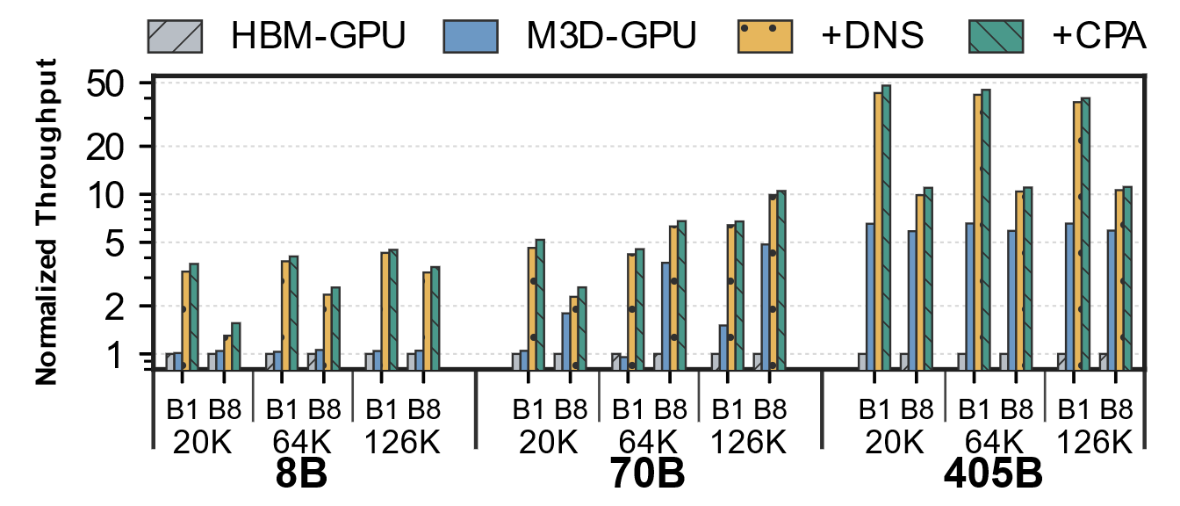
Fig. 7. Normalized end-to-end throughput of M3D-GPU, DNS, and DNS+CPA relative to HBM-GPU across the evaluated workloads.

Performance. Fig. 7 reports per-case HBM-normalized E2E throughput. Geometric-mean improvements are 2.31× for M3D-GPU, 6.68× for DNS, and 7.28× for DNS+CPA (maximum 47.98×); CPA adds 1.09× over DNS. The capacity audit identifies five HBM-resident cases, all 8B configurations except LC126K/B8. Within this subset, DNS and CPA achieve 2.77× and 3.07× over HBM-GPU, and 2.67× and 2.96× over M3D-GPU. The corresponding M3D-GPU/HBM-GPU ratio is 1.04×, separating NMP locality from capacity spill avoidance. The 13 overflow cases yield 10.15× CPA/HBM-GPU and 3.23× CPA/M3D-GPU.
At LC20K, HBM-GPU/M3D-GPU/CPA throughput (tokens/s) is 169.28/171.38/619.96 for 8B/B1, 65.77/118.06/171.76 for 70B/B8, and 0.600/3.920/28.785 for 405B/B1. CPA mean TPOT is 1.441/37.914/27.075 ms, respectively; one Decode step emits B tokens.
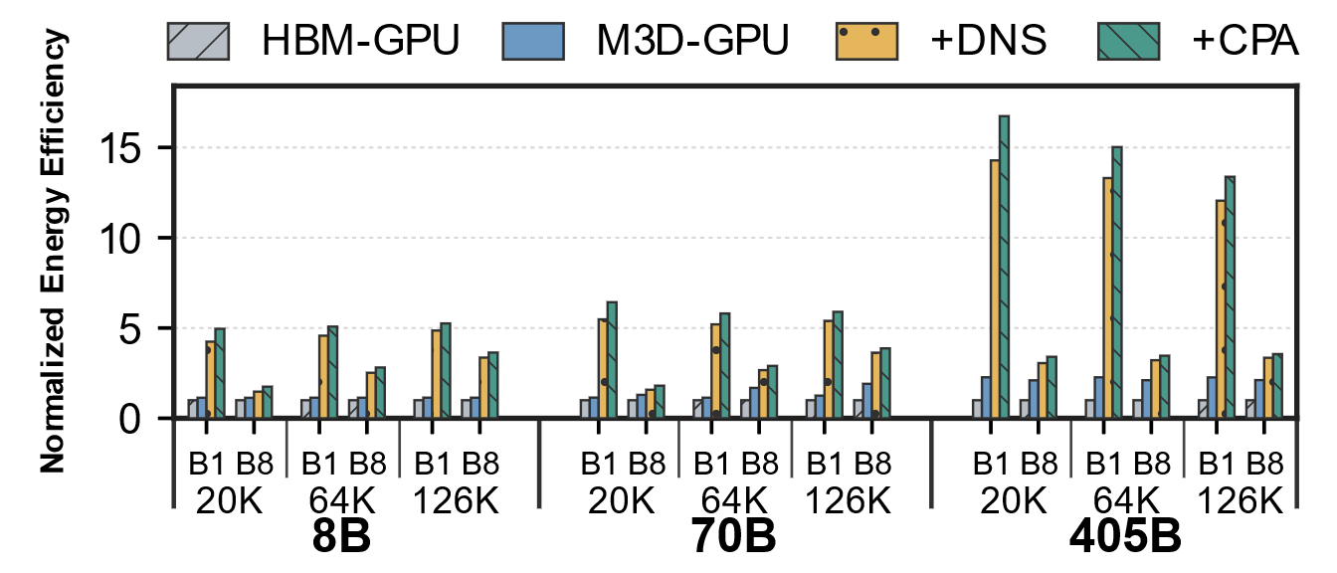
Fig. 8. Normalized end-to-end energy efficiency of M3D-GPU, DNS, and DNS+CPA relative to HBM-GPU across the evaluated workloads.

Energy efficiency. As shown in Fig. 8, the reduction in off-chip and GPU-facing data movement also translates into substantial energy-efficiency gains. M3D-GPU improves the geometric-mean energy efficiency by 1.51× over HBM-GPU, while DNS increases the improvement to 4.26×. With CPA, IOM3D-HBM achieves a geometric-mean improvement of 4.75× and up to 16.73×. CPA alone provides an additional 1.12× energy-efficiency improvement over uniform DNS, primarily by reducing unnecessary data movement and communication along the execution critical path.
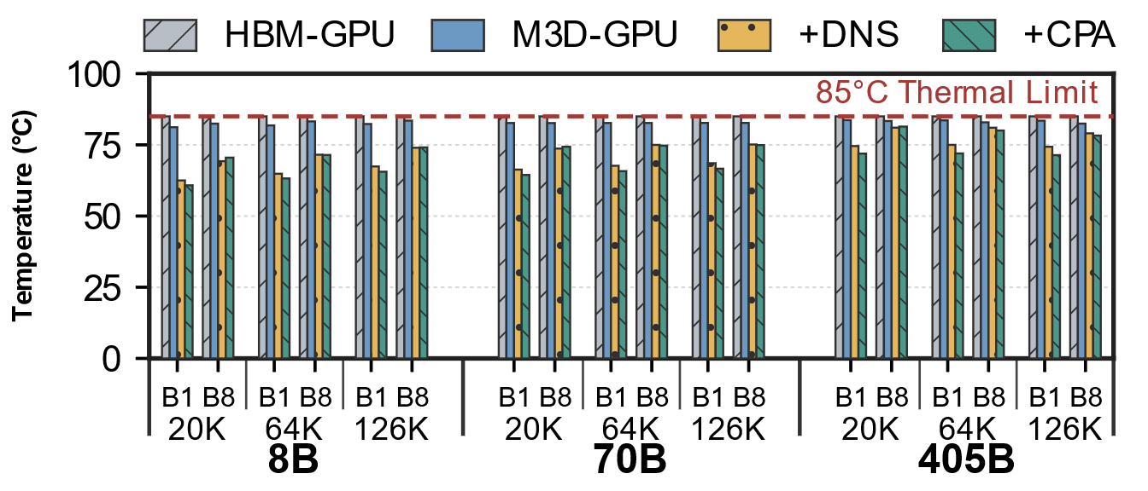
Fig. 9. Peak temperature of the evaluated execution configurations under the 85℃ thermal constraint.

Thermal behavior. Fig. 9 compares the thermal behavior of the evaluated execution paths. HBM-GPU is operated at its thermally closed bandwidth and therefore reaches the 85℃ design limit. In contrast, M3D-GPU, DNS, and DNS+CPA use workload-specific operating points obtained from their actual execution behavior. M3D-GPU remains within 81.19-83.68℃, while DNS and DNS+CPA remain within 62.50-81.03℃ and 60.79-81.41℃, respectively. Across all workloads, CPA reduces the average NMP peak temperature from 72.27℃ to 71.19℃. These results show that the end-to-end performance and energy-efficiency gains remain within the 85℃ package thermal constraint.

Thermal-Constrained Performance Headroom
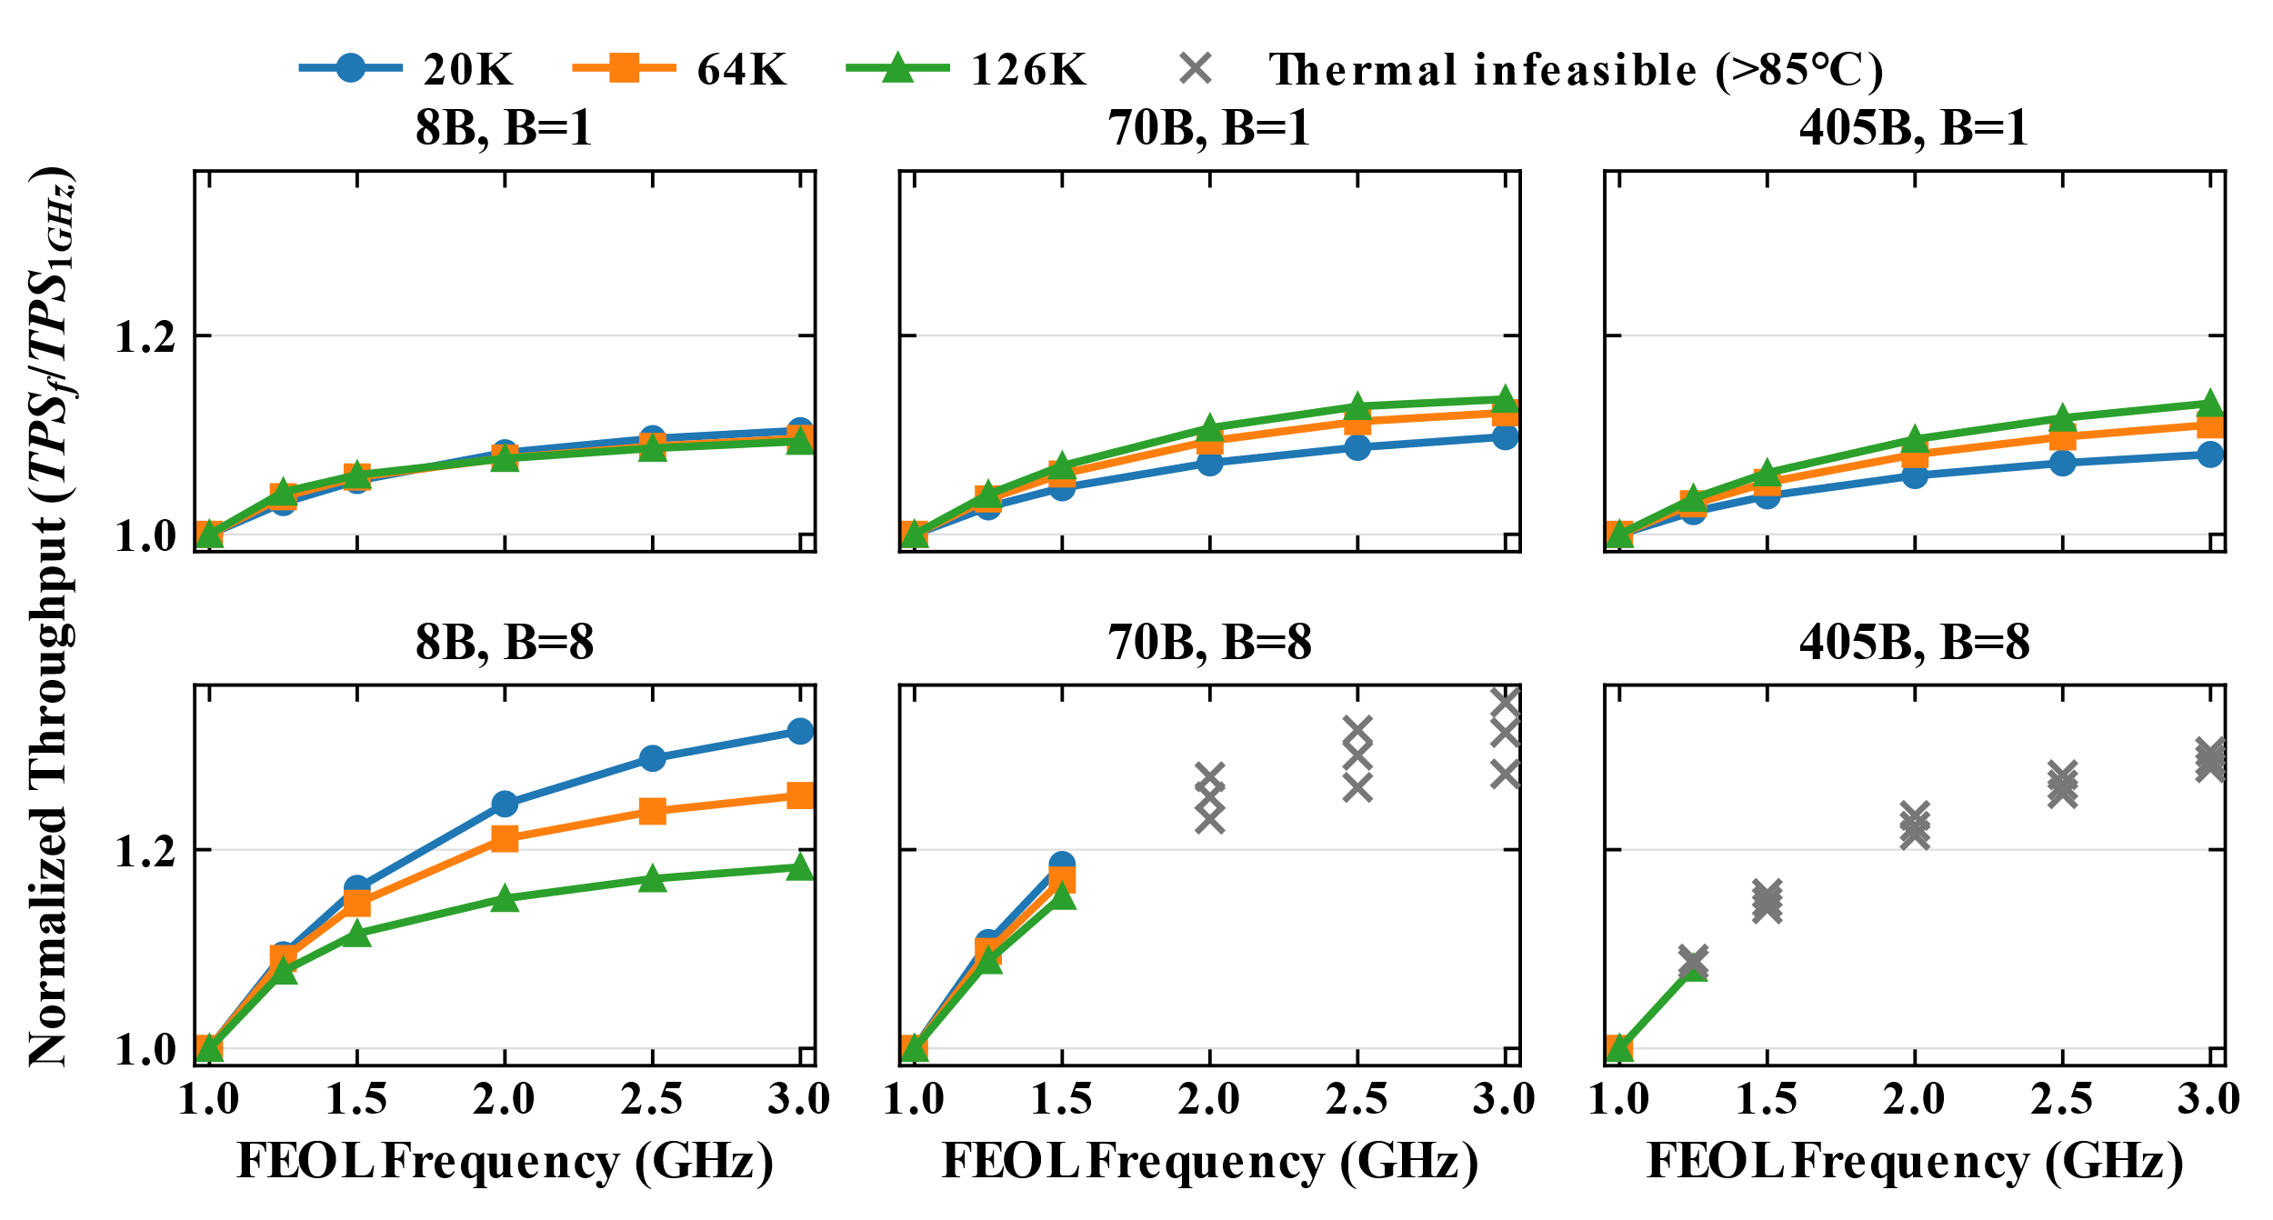
Fig. 10. Normalized end-to-end throughput under FEOL frequency scaling, with thermally infeasible configurations Tmax>85°C marked by crosses.

We further explore the performance headroom of IOM3D-HBM by scaling the FEOL frequency beyond the nominal 1-GHz operating point. As shown in Fig. 10, selecting the highest thermally feasible frequency for each workload provides an additional 12.6% geometric-mean throughput improvement, with a maximum gain of 31.9%, while requiring no change to the proposed architecture. The corresponding energy efficiency also improves by 3.0% on geometric average. These results demonstrate that the nominal design retains meaningful performance headroom that can be exploited according to workload characteristics.
The achievable gain is determined jointly by resource utilization and thermal headroom. For B=1, all workloads remain feasible up to 3 GHz and obtain 8.0–13.6% higher throughput; however, the memory array remains the dominant bottleneck, causing the benefit of further FEOL acceleration to gradually saturate. At B=8, higher parallelism increases FEOL utilization and exposes substantially greater scaling opportunities. The 8B workloads remain feasible at 3 GHz and achieve 18.2–31.9% additional throughput, with the critical path eventually shifting toward the GPU-facing boundary. The 70B workloads achieve 15.3–18.5% improvement at 1.5 GHz before approaching the 85℃ thermal limit, while the more intensive 405B workloads have considerably less frequency headroom. Thus, FEOL scaling can provide substantial additional performance when FEOL resources lie on the critical path, until either the bottleneck migrates to another physical resource or the thermal envelope is reached.

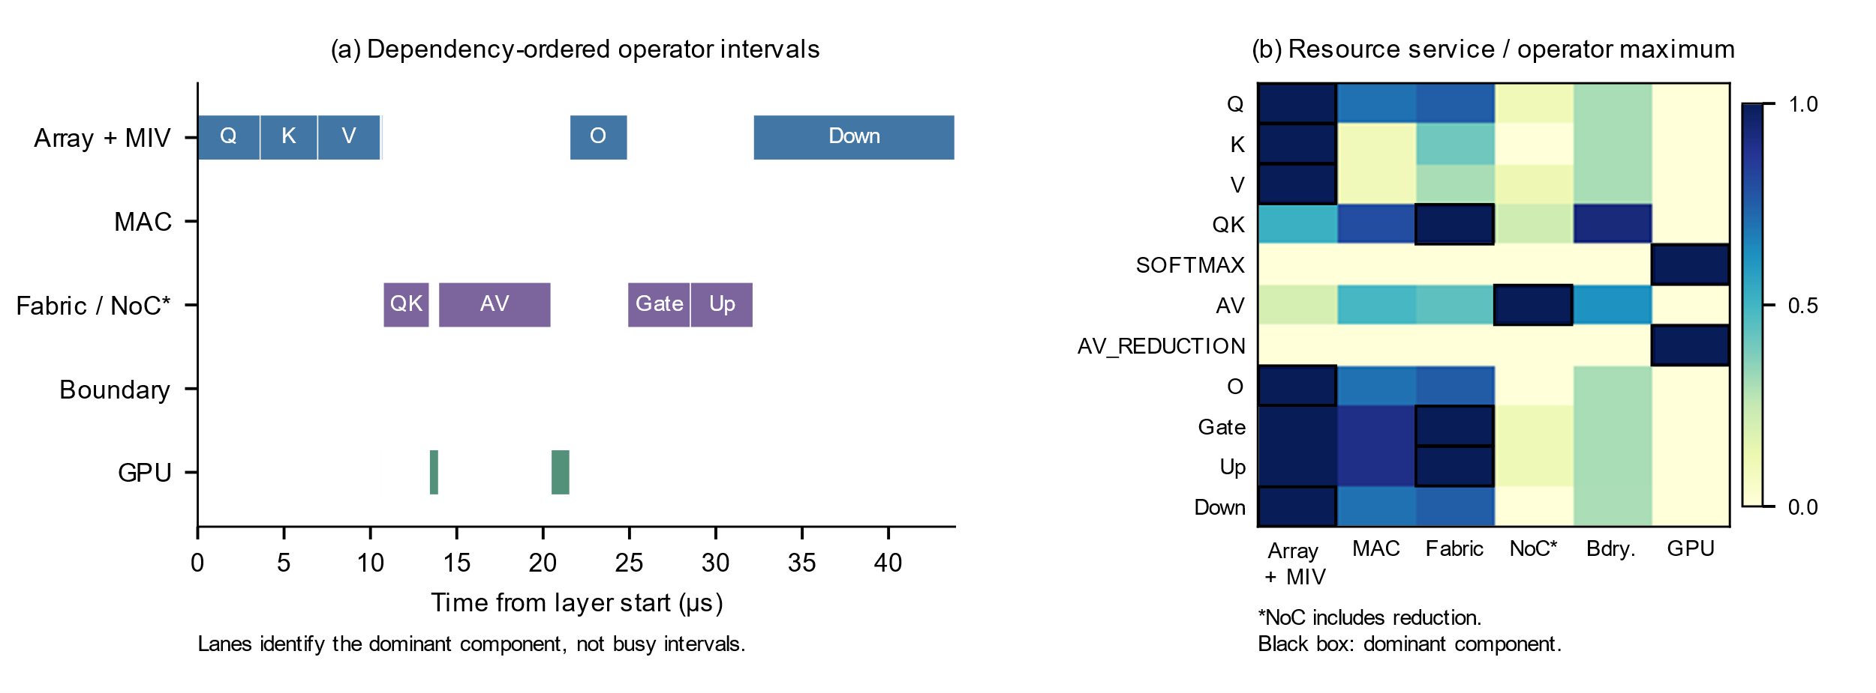
Fig. 11. Physical Decode Execution Anatomy: Llama-3.1-8B, LC20K, B=1, M3D_NMP_CPA, Decode step 1 (context 20,128), layer 0. (a) Reconstructed dependency-ordered operator intervals, placed in the lane of their dominant service component; these are not individual resource occupancy intervals. (b) Resource service divided by the maximum resource service of each operator; black boxes mark maxima. NoC includes reduction and GPU denotes its modeled local service. Sub-0.1-µs operators are retained in (a) and omitted from (b).
The single-step replay in Fig. 11 matches the canonical 1.441094-ms checkpoint; layer 0 occupies 43.844 µs. Q/K/V and FFN Down are array-dominated, QK and FFN Gate/Up are fabric-dominated, while AV is dominated by NoC/reduction. GPU Softmax and cross-die AV reduction separate NMP stages. The service balance changes across operators even within one layer.

Conclusion
We present IOM3D-HBM, an IGZO-based orthogonal monolithic 3D memory architecture with FEOL NMP for long-context LLM inference. By combining high-density M3D memory with orthogonal integration, IOM3D-HBM provides 1.49 TB of local capacity while maintaining scalable thermal behavior as memory capacity increases. We further introduce Distributed NMP Scheduling (DNS) to exploit data locality and Critical-Path-Aware Placement (CPA) to improve physical resource utilization. Across 18 long-context Llama-3.1 workloads, DNS+CPA achieves 7.28× geometric-mean end-to-end throughput and 4.75× energy-efficiency improvements over an optimistic conventional HBM-on-GPU baseline, while remaining within the 85℃ thermal limit. Beyond the nominal 1-GHz design, workload-aware FEOL frequency scaling provides an additional 12.6% geometric-mean throughput improvement, reaching up to 31.9%, demonstrating further performance headroom within the same architecture. Overall, IOM3D-HBM enables scalable memory capacity, high-locality execution, and substantial thermally sustainable acceleration for long-context LLM inference.

REFERENCES
[1]W. Tang et al., "30 Mb/mm²/layer 3D eDRAM Computing-in-Memory with Embedded BEOL Peripherals and Local Layer-wise Calibration based on First-Demonstrated Vertically-stacked CAA-IGZO 4F² 2T0C Cell," 2023: IEEE, doi: 10.1109/iedm45741.2023.10413756.
[2]Y. Mitarai et al., "3D Orthogonal Die Stacking Technology for DRAM-on-GPU Integration Using Contactless Die-to-Die Interface," 2026: IEEE, pp. 1-3, doi: 10.1109/vlsitechnologyandcir65830.2026.11577466.
[3]V. Cai, J. Zhou, D. Brooks, and G. Y. Wei, "DreamRAM: A Fine-Grained Configurable Design Space Modeling Tool for Custom 3D Die-Stacked DRAM," in 2026 Design, Automation & Test in Europe Conference (DATE), 20-22 April 2026 2026, pp. 1-7, doi: 10.23919/DATE69613.2026.11539402.

