A management strategy evaluation for Northern Southeast Inside (NSEI) Sablefish (Anoplopoma fimbria)

Authors
Matthew LH. Cheng^{1,2*}, Aaron W. Lambert³, Curry J. Cunningham²
¹National Oceanic and Atmospheric Administration, National Marine Fisheries Service, Alaska Fisheries Science Center, Auke Bay Laboratories, 17109 Point Lena Loop Road, Juneau AK, 99801, United States
²Department of Fisheries at Lena Point, College of Fisheries and Ocean Sciences, University of Alaska Fairbanks, 17101 Point Lena Loop Road, Juneau,
Fairbanks, AK 99801, United States
³Alaska Department of Fish and Game, Division of Commercial Fisheries, Juneau, 1255 W. 8th Street Juneau, AK, 99801, United States
* Corresponding author (matt.cheng@noaa.gov)

Abstract

Fisheries management commonly seeks to reconcile competing objectives, requiring harvest strategies that sustain populations while prescribing catches stable enough for harvesters, processors, and markets to plan around. Harvest control rules (HCRs) are the primary tool for balancing these objectives, specifying how catch or fishing mortality should change as a population fluctuates. Threshold rules, which reduce fishing mortality as biomass declines, better limit the probability of low biomass than rules holding fishing mortality constant, yet the latter still remain commonly applied given the greater catch stability conferred. The magnitude of that trade-off for any given fishery remains less clear, as it depends on the target fishing mortality, the biomass reference points, and the productivity the population subsequently experiences. The Northern Southeast Inside (NSEI) sablefish (Anoplopoma fimbria) fishery is an exemplary case-study, being managed at a constant $F_{50\%}$ with a 15% cap on year-over-year increases in catch and no biomass threshold, while recruitment is characterized as highly episodic. Using closed-loop simulations, we evaluate candidate HCRs for this fishery, spanning a range of spawning potential ratio targets, closure thresholds, and stability constraints, under stable, regime-like, and crashed recruitment. The status-quo rule resulted in the highest and most stable catches under stable and regime-like recruitment, but proved least robust to a collapse, resulting in high probability of depletion. Defining intermediate biomass thresholds substantially reduced the probability of depletion while forgoing only small amounts of catch under favorable conditions and rarely invoking fishery closures. Catch stability depended primarily on the target fishing mortality rather than on the stability constraint imposed. In the case of NSEI sablefish, a moderate biomass reference point would therefore afford considerable protection during a decline while preserving much of the catch and stability the fishery presently enjoys. More broadly, rules that appear adequate while a population is productive may prove the least robust when it is not, underscoring the value of adopting moderate precautions before adverse conditions emerge.

Keywords: closed-loop simulation, sablefish, harvest control rules (HCR), non-stationarity, management strategy evaluation (MSE)

Introduction

Understanding the effects of harvest on fish populations has been an interest to fisheries managers since the early 20th century, when declining catches in the North Sea led scientists to ask whether fishing itself could reduce a population’s productivity (Russell, 1931). Much has been learned since then, and the question has largely shifted from whether harvest of the population itself matters, to which harvest strategies can achieve conservation and socioeconomic goals for a given fishery when population dynamics vary unpredictably (Bessell-Browne et al., 2024; Quinn et al., 1990). In particular, non-stationary dynamics, where a population’s average growth, survival, or reproduction shifts over time, have become increasingly common across a variety of fisheries, due in part to changing environmental conditions. These shifts are often abrupt, unpredictable, and difficult to detect until after they have occurred, and are therefore challenging to manage for (Walters, 1987). Consequently, managers are increasingly tasked with developing harvest strategies that perform well across a range of possible future conditions.

In contemporary fisheries management harvest control rules (HCRs) are commonly employed to manage fisheries, which represent a pre-determined set of rules that specify how catches (or fishing mortality rates) should be prescribed as the population fluctuates (Deroba and Bence, 2008). HCRs are increasingly selected using management strategy evaluation (MSE), in which simulations are used to test candidate management strategies under a range of uncertainties in population and harvest dynamics, and to identify trade-offs among achieving management goals (Punt et al., 2016). By far, threshold rules are among the most widely used HCRs for populations with formal stock assessments, in which fishing mortality is held constant when the population remains above an upper reference level, reduced linearly as the population falls below that level, and set to zero (or near zero) at a lower reference level (Free et al., 2022). Given the pervasive use of threshold rules, their performance has been tested in many settings, with most studies finding that they are able to limit declines in population size and promote faster recovery times when compared to alternative HCRs (e.g., Punt et al., 2008). For instance, Kritzer et al. (2019) found that, under gradual climate-driven declines in population productivity and systematic overestimates of population size, an HCR that reduced fishing mortality as the population declined generally maintained larger populations than one that held fishing mortality fixed. Nevertheless, HCRs that hold fishing mortality constant remain a common alternative to threshold rules, in part because they tend to produce more stable catches, particularly in the short-term (Deroba and Bence, 2008; Free et al., 2022; Mildenberger et al., 2022).

Beyond maintaining biomass at sustainable levels, managers are increasingly interested in harvest strategies that keep catches stable from year to year. Stable catches are particularly valued by harvesters and processors because they allow markets, processing capacity, and cold storage to be planned in advance. By contrast, large and rapid changes in catch can disrupt markets, where increases can outpace market demand, while decreases can leave buyers without a reliable supply. For instance, non-stationary environmental conditions likely led to periods of high recruitment for Alaska sablefish (Anoplopoma fimbria) and substantial increases in quota, though much of the additional catch consisted of small, low-value fish, and prices reduced to historic lows (Goethel et al., 2025). In a similar vein, record sockeye salmon (Oncorhynchus nerka) returns to Bristol Bay have been accompanied by sharp declines in prices, due in part to limitations in processing capacity (Donnellan and Nemeth, 2024). A common way to promote stability is to incorporate a stability constraint to an HCR, which limits how much catch advice can increase or decrease from one year to the next. However, because they slow how quickly catches can respond to changes in the population, they may also delay reductions in catch when a population declines (Zahner et al., 2025). Yet, stability rules have typically been evaluated as additions to a single HCR, such that their contribution to catch stability has rarely been separated from that of the target fishing mortality and biomass reference point to which they are applied to.

The Northern Southeast Inside (NSEI) sablefish fishery in Alaska state waters provides a well-suited case study for evaluating the trade-offs between ensuring sustainable population sizes and maintain stable catch levels. Notably, the fishery is managed using a constant fishing mortality rule with no biomass reference point, combined with a stability constraint that prevents catches from increasing by more than 15% from one year to the next. At the same time, sablefish recruitment is highly non-stationary, with long periods of low recruitment punctuated by occasional exceptionally strong year classes, such that the population fluctuates between extended periods of growth and decline (Goethel et al., 2025). Taken together, these features allow the effects of incorporating a biomass reference point, and of how catches are constrained to change, to be evaluated under conditions in which both are likely to matter. Using closed-loop simulations, we compare the performance of the existing NSEI harvest strategy with alternative threshold rules that differ in their target fishing mortality, biomass reference point, and stability constraint, under scenarios with stable recruitment, a shift in average recruitment, and a recruitment collapse.

Methods

We used closed-loop simulations to evaluate candidate harvest control rules and biomass reference points for NSEI sablefish. In general, closed-loop simulations follow the same structure as MSE, but without a strict formal stakeholder process used to define management objectives and candidate strategies. Each simulation consists of three components. First, operating models (OM) are developed to represent the “true” population and fishery, and generate simulated data. Second, an estimation model (EM), representing the stock assessment, is fitted to these simulated data to estimate biomass and reference points. These estimates are then passed to an HCR, which determines the catch advice through a formal rule. The prescribed catch is then removed from the population in the OM, which is projected forward one year and generates new data, thus completing the loop. Repeating this loop over many years and simulation replicates then demonstrates how each HCR performs under alternative demographic scenarios, and when management decisions rely on imperfect estimates of the population. All OMs and EMs were implemented in the SPoRC stock assessment package (Cheng et al., 2026), which provides a generalized age- and sex-structured model along with a generalized closed-loop simulation framework used in this study. Below, we describe the staged process through which the simulation was developed with managers and stakeholders, followed by the structure of the OM, the EM, the candidate HCRs, and the metrics used to compare them. For a description of the full specifications, equations, and parameter values, see Supplementary Material 1. All code used for this study can be found at https://github.com/chengmatt/nsei_sablefish_mse.

Study Species and System
Sablefish are a long-lived (> 90 years old), deep dwelling species, capable of exhibiting high movement rates, and are considered genetically panmictic across their observed North Pacific range (Timm et al., 2024). Females generally grow to larger sizes than males (i.e., asymptotic sizes are ~20% larger; Cheng et al., 2024), maturing at around 6-7 years of age. Moreover, sablefish recruitment dynamics are characterized by highly episodic patterns, wherein exceptionally strong year classes are separated by periods of low recruitment levels (Goethel et al., 2025). Within Alaskan waters, sablefish support one of the most valuable groundfish fisheries and are managed under two management systems. In the federal fishery, catch advice is set by a threshold HCR in which fishing mortality is held at a target rate ($F_{40\%}$) when spawning stock biomass ($SSB$) is at or above a target level ($B_{40\%}$) and is reduced linearly below it (NPFMC, 2024). Here, $F_{40\%}$ is the fishing mortality rate that reduces spawning biomass per recruit to 40% of its unfished level, and $B_{40\%}$ is the $SSB$ expected at $F_{40\%}$ given average recruitment. By contrast, the catch advice in the state-managed NSEI fishery is set at a constant $F_{50\%}$with a 15% cap on year-over-year increases in catch and no biomass threshold.

Simulation Design

In general, the simulation was designed in collaboration with Alaska Department of Fish and Game (ADF&G) managers and analysts and builds on the stakeholder engagement process undertaken for the recent federal sablefish MSE (Zahner et al., 2025). Because many NSEI participants also take part in the federal fishery, both the OM scenarios and the threshold form of HCR developed for the federal MSE were already familiar to many NSEI stakeholders. Therefore, for this study, we adopted the federal scenario structure rather than developing new scenarios, and extended the threshold rule family evaluated federally by varying the spawning potential ratio ($SPR$) target, the closure threshold (i.e., $α$; the steepness of the ramp), and different stability constraints imposed on catch (given the interest in catch stability among stakeholders) across a grid of candidate rules.

A total of two closed-loop simulation sets were conducted: 1) simulations assuming perfect information, and 2) simulations assuming imperfect information, wherein an estimation model was employed to estimate biomass levels and catch advice. We refer to them hereafter as the perfect information and with assessment simulation set. For the perfect information simulation set, we initially conducted a broad screening of the 298 candidate, in which each HCR was applied directly to the true OM values rather than to estimates from an assessment (i.e., a shortcut simulation; Punt et al., 2016). This was done because shortcut simulations are computationally inexpensive and isolate the properties of the rules themselves, which allowed the full trade-off surface among yield, catch stability, and depletion risk to be evaluated across the rule space. However, we acknowledge that shortcut simulations do not encapsulate the full range of uncertainties, and omitting the estimation model can change the relative ranking of alternative strategies (Punt et al., 2016). Results from the screening were then presented during a virtual meeting to ADF&G staff, who hold management authority for the NSEI fishery and were therefore the primary audience for this decision, and a candidate set of seven rules was identified and carried forward for investigation in the with assessment simulation set. A separate stakeholder consultation was not held at this step because the scenarios and rule types were already familiar to NSEI participants from the federal process. In the with assessment simulation set, a stock assessment was fit in every year and the HCR responded to the resulting estimates rather than on the true state, such that the consequences of assessment error were incorporated for the rules under active consideration. All simulations comprised 150 replicates over a 60-year projection period (2026–2085).

Operating Models

The OM was a single-area, age-structured, two-sex population model (ages 2- 31, with age 31 as the plus group), conditioned on the 2026 ADF&G statistical catch-at-age assessment model estimates (1975 – 2025) (Lambert and Ehresmann, 2026). Because simulations were conditioned on the best-known estimates for NSEI sablefish, OMs were able to recreate historical trajectories of $SSB$ and abundance trends (Fig. S1). Biological processes in the OM (i.e., weight-at-age, maturity-at-age, and natural mortality; Fig. S2) were specified from the assessment inputs and were held constant across both the conditioning and projection periods. Moreover, fishery processes governing retention and discarding dynamics followed the 2026 stock assessment model. Specifically, OMs incorporated sex-specific selectivity, retention, and discard mortality, with all three processes held constant over time (Fig. S3). In each projection year, the OM generated observations used by an EM, including: landed catch, a fishery CPUE index, a longline survey abundance index, and fishery and survey age compositions subject to ageing error, where observation error levels were specified based on historical estimates (Table S2).

For both simulation sets, a total of three OM scenarios were developed following Zahner et al (2025). In particular, recruitment during the projection period followed one of three scenarios, which were designed to bracket the primary axes of uncertainty for NSEI sablefish population dynamics, rather than to attribute specific hypotheses regarding its drivers. In the Baseline OM, recruitment was randomly resampled from the historical time-series from 1975 – 2025, thereby representing the historical mean and variability, and did not impose a stock-recruitment relationship. Two additional scenarios were also designed. A regime-like recruitment (Regime) scenario was designed, wherein the OM assumed a Beverton-Holt stock-recruitment function (steepness = 0.8) with lognormal recruitment deviations, and unfished recruitment alternated between 15-year periods at the historical mean and 5-year periods at five times the historical mean, effectively mimicking existing sablefish recruitment dynamics. The next scenario induced a recruitment crash (Crash), wherein the unfished recruitment was reduced to 10% of the historical mean for an 11-year period (2040-2050), which then subsequently recovered towards historical levels (see Figure 1 for a summary of simulated recruitment dynamics and Table S1 for scenario specifications).

Estimation Models

Under the perfect information simulation sets, EMs were effectively the true OM values. By contrast, under the with assessment simulation set, the EM used was an age-structured SCAA model configured to generally mirror the operational ADF&G assessment (Table S3). In particular, the EM shared the age and sex structure of the OM, where it fixed natural mortality at 0.1, estimated mean recruitment with annual lognormal deviations ($σ_{R}$ fixed at 1.2) without a stock–recruitment relationship, and estimated sex-specific logistic selectivity for the fishery (three time blocks reflecting historical changes in fleet structure) and the survey (a single block), along with time-blocked fishery catchability and time-invariant survey catchability. Additionally, the EM was fit to the simulated catch, fishery CPUE, survey abundance index, and age compositions, with data availability truncated to reflect the historical record. Unlike the operational assessment, length compositions were excluded, because age compositions largely provided the same information on population structure. Retention and discard mortality were fixed at their OM values, consistent with the operational assessment. Models were fit by penalized maximum likelihood in RTMB and SPoRC, and convergence diagnostics (i.e., a positive-definite Hessian and the maximum absolute gradient component $≤{10}^{-3}$) were recorded for every assessment. Following the current management process for NSEI sablefish, we conducted an annual stock assessment in each year of the projection. Reference points for each year were recomputed from the terminal-year estimates in each assessment year (see Harvest Control Rules section), and catch advice was obtained by projecting the estimated population forward under the fishing mortality prescribed by the HCR (see Supplementary Material 1). Consistent with the real-world fishery dynamics, we assumed that 100% of the catch prescribed was utilized.

Harvest Control Rules

A range of HCRs were evaluated, all primarily following the form of threshold rules (i.e., hockey-stick shapes), with SPR-based targets ($F_{x\%}$ and $B_{x\%}$) as well as a closure threshold ($α$). SPR-based targets were always varied in tandem, such that specifying an SPR rate of 50% meant that $F_{50\%}$ and $B_{50\%}$ were the targets. HCRs considering alternative stability constraints were also evaluated in combination with SPR rates and closure thresholds, given the interest in catch stability among sablefish stakeholders. Here, threshold rules determined fishing mortality rates at $F_{x\%}$ when $SSB≥B_{x\%}$, decreased it linearly toward zero as $SSB$ fell from $B_{x\%}$ to $αB_{x\%}$, and closed the fishery below $αB_{x\%}$ (see Fig. 2 for a visualization). Where a stability constraint was applied, the catch prescribed by the threshold rule was adjusted to satisfy the constraint relative to the preceding year’s catch. Moreover, constraints were not applied when the rule prescribed a closure, nor in the year following a closure, such that closure and reopening were governed by the threshold rule alone.

Under the perfect information simulation set, $SPR$ values of 30% to 70% (in increments of 5%) and $α$ from 0 to 0.5 (in increments of 0.05) were considered, each combined with one of three catch stability constraints applied to the resulting catch advice. Specifically, these were: no constraint applied; a symmetric constraint limiting year-over-year changes in catch to $±15\%$; and an asymmetric constraint that limited increases to 15% but allowed unconstrained decreases. A constant fishing mortality rule set at $F_{50\%}$ with the asymmetric constraint, intended as an analogue of the current management approach, was also included as a reference rule, thereby yielding a total of 298 candidate rules evaluated (Table S4). Following the initial screening of candidate rules, the with assessment simulation set then carried forward seven rules for further evaluation. These rules included the constant $F_{50\%}$ reference rule and the threshold rules with $F_{40\%}$ and $F_{50\%}$ targets and $α$ values of 0, 0.25, and 0.5, all with an asymmetric constraint imposed. These rules were chosen for further evaluation given that they include the current $F_{50\%}$target and span the range of closure thresholds considered in the screening. Moreover, the asymmetric constraint was retained because it is the constraint currently applied by ADF&G and because catch stability is a priority for the fishery.

Performance Evaluation
Performance of candidate rules were summarized across simulation replicates and the projection period using metrics focused on conservation, yield, and stability. These metrics included: 1) median $SSB$, median catch, average annual variability (AAV) in catch, the probability that $SSB$ fell below 10% of its historical (1975 - 2025) maximum (i.e., probability of depletion; $P\left(depletion\right)$), and the probability of fishery closure (Table S5). For the perfect information simulation sets, metrics were visualized across the full $F_{x\%}$ and $α$ grid for each stability constraint rule and OM scenario to understand trade-offs among candidate rules under perfect information. Under the with assessment setting, the seven candidate rules were evaluated using the same metrics. To evaluate how assessment error affected performance, we compared each metric for these seven rules between the perfect-information and assessment-based simulations, and examined whether the relative ranking of these candidate rules changed.

Results

Under perfect information, the SPR target primarily determined the overall levels of catch, biomass and catch variability, and largely determined conservation risk (Fig. 3). As expected, more conservative targets (i.e., lower fishing mortality rates) resulted in lower catch and higher SSB, with $F_{60\%}$and $F_{70\%}$ forgoing a substantial proportion of the catch, relative to targets like $F_{50\%}$. Moreover, conservative targets also resulted in lower catch AAV, because catch is approximately proportional to exploitable biomass and lightly fished populations retain a broader age structure that buffers biomass against individual recruitment events. However, these simulations also indicated a slight increase in AAV at $F_{70\%},$which likely arose because SSB fell below the correspondingly high $B_{70\%}$threshold in most years, such that fishing mortality was adjusted along the ramp more frequently. Unsurprisingly, conservation risk was confined almost entirely to the Crash scenario, where $F_{30\%}$had the potential to strongly deplete the stock, while targets of $F_{70\%}$and above resulted in little or no depletion.
In contrast to SPR targets, the closure threshold had a negligible effect on catch and SSB under the Baseline scenario and instead governed how the rules responded to declines. Under the Regime and Crash scenarios, higher closure thresholds converted catch into biomass during periods of low productivity and reduced the probability of depletion at any given target, but at the cost of inducing higher catch AAV, because a higher threshold steepens the ramp of the rule. Moreover, under the Crash scenario, increases in the probability of fishery closures tended to occur at closure thresholds of 0.3 and above and most often at conservative targets, whose higher biomass thresholds were reached more readily during a decline. Thus, no single threshold level dominated the performance of HCRs, with lower thresholds yielding the most and most stable catches, an intermediate threshold providing meaningful protection with essentially no closures, and high thresholds providing the strongest protection at the greatest cost.
Lastly, the alternative stability constraints tested did not appear to alter the aforementioned trade-offs but determined how quickly catch levels tracked biomass levels. In particular, the asymmetric constraint reduced the variability of aggressive SPR targets but had a fairly negligible effect at $F_{50\%}$and above. While the symmetric constraint performed in a similar fashion to an asymmetric constraint across most scenarios, we found that catch reductions were delayed under declines (i.e., the Crash scenario), resulting in larger decreases in SSB, which then manifested into increasing probability of depletion and closure. By contrast, imposing zero stability constraints under the Crash scenario allowed catches to increase rapidly after the crash had occurred, but at the cost of lower SSB and more variable catches.
Based on these results and discussions with managers, six candidate threshold rules combining SPR targets of $F_{40\%}$and $F_{50\%}$with closure thresholds of 0, 0.25 and 0.5 under an asymmetric constraint were evaluated alongside the current constant $F_{50\%}$rule in the with assessment simulation set (Figs. 4, 5). In general, most with assessment simulation runs achieved adequate model convergence (i.e., fewer than 10 simulations remained unconverged). Assessment error did not alter the patterns observed under perfect information or the ranking of the rules, but degraded performance across metrics (Figs. S8 - S11). Most notably, incorporating assessment error increased catch AAV for every rule under the Baseline scenario (Fig. 4). Median catch and SSB changed comparatively little, whereas under the Crash scenario, the probability of depletion increased for all rules, likely because the assessment overestimated biomass during the decline (Figs. S4, S5). The time-series trajectories make these differences most apparent (Fig. 5). Under the Baseline scenario the performance of rules differed only by SPR target (i.e., higher SPR targets led to lower catches and higher SSB). Under the Regime scenario, candidate rules separated only in the troughs between large recruitment events, wherein the constant $F_{50\%}$rule maintained the highest catch and catch stability, while higher thresholds held more biomass at the cost of catch and stability. Lastly, under the Crash scenario, the constant $F_{50\%}$rule held catches stable but drove median SSB below the depletion threshold for two decades, whereas a closure threshold of 0.5 protected biomass by closing the fishery for more than a decade. Intermediate thresholds paired with either $F_{40\%}$or $F_{50\%}$therefore offered a reasonable compromise, giving up little catch under the Baseline and Regime scenarios while keeping median SSB near or above the depletion threshold through the crash without closures.

Discussion
Managing fisheries is often described as managing people, with managers needing to consider both conservation and socioeconomic objectives when making decisions (Hilborn, 2007). Results from this study illustrate this challenge, revealing key trade-offs between catch, catch stability, and biomass levels among alternative harvest strategies and across demographic scenarios. Under stable recruitment dynamics (i.e., the Baseline scenario), incorporating a biomass threshold into the existing constant fishing mortality rule made little difference to yield or biomass, due in part to the lack of contrast in population dynamics (Figs. 3 and 5). The trade-offs associated with a biomass threshold only became apparent under cyclic or crash recruitment dynamics, where threshold-based rules reduced catches during periods of low recruitment, and at high closure thresholds closed the fishery, in exchange for a lower probability of depletion and higher biomass towards the end of the projection period. In general, trade-offs between catch and biomass levels depended on the SPR target and closure threshold, whereas the stability constraints did not alter the relative performance of strategies and instead determined how quickly catches tracked changes in the stock, with consequences that depended on the rule to which they were combined with.

Findings from this study are broadly consistent with previous evaluations of threshold-based harvest strategies and stability constraints. In particular, studies spanning a continuum of life-histories have concluded that rules which reduced fishing mortality as biomass declines lower the probability of low biomass relative to constant fishing mortality rules, though at the cost of increased catch variability, with the placement of the threshold largely governing the size of the trade-off (Kritzer et al., 2019; Mildenberger et al., 2022; Punt et al., 2008). We likewise found similarities with Zahner et al (2025), who demonstrated that stability constraints for a long-lived species (i.e., sablefish) were rarely invoked and had negligible effects on average catch or biomass, but that imposing symmetric constraints increased risk during periods of decline by delaying catch reductions. However, we also found that how often the constraint was invoked, and its effect, depended on the SPR target. In particular, invoking a stability constraint had the largest effect on stabilizing catches for aggressive SPR targets, which prescribe the largest year-over-year increases, while such constraints were rarely triggered for moderate targets (i.e., $F_{40\%}$ and $F_{50\%})$. Catch stability instead depended primarily on the target fishing mortality itself (Fig. 3), likely because lightly fished populations maintain a broader age structure that buffers biomass, and hence catch, against individual recruitment events, while heavily fished populations become more dependent on incoming year classes (Barnett et al., 2017; Brunel and Piet, 2013). Thus, much of the stability of the existing ADF&G harvest strategy arises from its moderate $F_{50\%}$ target, rather than from the constraint imposed.

Comparing the status-quo ADF&G constant $F_{50\%}$rule with the asymmetric stability constraint to the alternative strategies evaluated, we found that the current rule performed well under stable and regime-like recruitment, where it produced the highest and most stable catches among the $F_{50\%}$ rules, but was the least robust to a recruitment crash (Figs. 3 - 5). This is unsurprising, given that constant fishing mortality rules have no formal mechanism for reducing fishing mortality at low biomass (Deroba and Bence, 2008; Free et al., 2022). Here, the constant $F_{50\%}$rule continued to remove relatively large catches as the population declined, holding median SSB below the depletion threshold for two decades and recovering the least by the end of the projection period. Retaining the current strategy but incorporating a biomass threshold addressed this shortcoming at a fairly small cost. In particular, closure thresholds of 0 or 0.25 forwent little catch under stable recruitment, approximately a sixth of catch in exchange for higher biomass under regime-like recruitment, and greatly reducing the probability of depletion under the crash scenario, with a threshold of 0.25 doing so with essentially no closures (Figs. 4 and 5). By contrast, while closure thresholds of 0.5 provided the strongest protection, imposing high thresholds closed the fishery for more than a decade during a crash scenario, and such rules were also the most sensitive to assessment error (Fig. 4). Consequently, if the priority is to maintain current catch levels and stability under favorable conditions, while limiting risk during a crash, an $F_{50\%}$ threshold rule with an intermediate closure threshold under the existing asymmetric constraint represents the smallest change to the current strategy that achieves both, with the choice between a threshold of 0 and 0.25 depending on the relative tolerance for depletion risk versus forgone catch during a decline.

Conducting MSEs and closed-loop simulations are a time-consuming process, and it is generally recommended that harvest strategies be revisited at a regular schedule as new information accumulates (de Moor et al., 2022; Punt et al., 2016). The results of this study therefore represent a first step towards developing robust harvest strategies for NSEI sablefish, and several extensions remain to be explored. Perhaps most importantly, the OM represented NSEI sablefish as a single closed population, whereas sablefish are highly mobile and genetically panmictic across the North Pacific, such that dynamics of the NSEI population are likely influenced by exchange with adjacent areas (Cheng et al., 2025; Kapur, 2025; Kapur et al., 2024; Timm et al., 2024). While resampling historical recruitment implicitly captures the net effect of such exchange during the conditioning period, it is unable to represent how movement would respond to changes in abundance inside or outside NSEI, and a spatially-explicit OM that links the NSEI to the broader population, coupled with the federal management process would be a natural next step. The OM also considered growth, maturity, selectivity, and discarding dynamics to remain constant over the projection period, whereas large year classes are known to depress growth and increasing discarding of small fish (Cheng et al., 2024; Goethel et al., 2025), processes that are relevant under the regime-like scenario, and would likely impact harvest strategy performance under recruitment pulses. Moreover, to facilitate a wide suite of harvest strategies to be evaluated within the constraints of computing time and memory, recruitment dynamics were the primary axis of uncertainty considered. Results from this study are therefore limited to this axis, and implementation error, estimation-model misspecification, and other sources of assessment error were not evaluated. Lastly, the performance of alternative strategies was evaluated against a small set of metrics rather than formally defined management objectives. This was deliberate, as a small set of interpretable metrics aids communication with managers and stakeholders with limited prior exposure to MSE, but it also meant that neither the closure threshold nor the stability cap was tuned to an agreed level of acceptable risk. A more formal and continued process with stakeholders would allow these parameters to be tuned, and would also allow socio-economic metrics that account for the lower prices of small fish from large year classes to be evaluated alongside the metrics considered here.

For populations whose productivity shifts are unpredictable, the question that matters is not what the population will do, but rather, what the agreed upon harvest strategy will do when the population experiences unexpected change. Unfortunately, that question is ultimately answered by people, rather than by models (Hilborn, 2007). Closed-loop simulations such as those presented here are one step towards achieving that end, but a formal MSE process is needed to complete it, and such a process requires time and resources to convene managers, stakeholders, and analysts, and to repeat the exercise as conditions change (de Moor et al., 2022). If fisheries management is to become more participatory and more ecosystem-based, as is widely called for, then funding mechanisms that support this form of engagement must be established. Ultimately, the harvest strategies most likely to withstand unexpected changes in a stock are those that managers and stakeholders have agreed upon before such changes occur.

Acknowledgements

We thank the xxx anonymous reviewers for providing feedback on earlier versions of this manuscript. Additionally, we gratefully acknowledge the contributions of participants in previous federal sablefish MSE processes, whose insights helped inform this work. We also thank ADF&G staff Rhea Ehresmann for their input on candidate harvest control rules for further evaluation. The work of Zahner et al (2025) provided much of the inspiration for this study. We thank Kasper Kristensen for developing TMB and RTMB, which made this work possible. This work was funded by the Marine Stewardship Council and the Alaska Department of Fish and Game.

References
Barnett, L.A.K., Branch, T.A., Ranasinghe, R.A., Essington, T.E., 2017. Old-Growth Fishes Become Scarce under Fishing. Current Biology 27, 2843-2848.e2. https://doi.org/10.1016/j.cub.2017.07.069
Bessell-Browne, P., Punt, A.E., Tuck, G.N., Burch, P., Penney, A., 2024. Management strategy evaluation of static and dynamic harvest control rules under long-term changes in stock productivity: A case study from the SESSF. Fisheries Research 273, 106972. https://doi.org/10.1016/j.fishres.2024.106972
Brunel, T., Piet, G.J., 2013. Is age structure a relevant criterion for the health of fish stocks? ICES Journal of Marine Science 70, 270–283. https://doi.org/10.1093/icesjms/fss184
Cheng, M.LH., Goethel, D.R., Cunningham, C.J., Hulson, P.F., Ianelli, J.N., Omori, K.L., 2026. The SPoRC Stock Assessment Package: A Generalized Next‐Generation Platform to Assess Spatial, Age and Sex‐Structured Populations. Fish and Fisheries faf.70082. https://doi.org/10.1111/faf.70082
Cheng, M.L.H., Goethel, D.R., Hulson, P.-J.F., Echave, K.B., Cunningham, C.J., 2024. ‘Slim pickings?’: Extreme large recruitment events may induce density-dependent reductions in growth for Alaska sablefish (Anoplopoma fimbria) with implications for stock assessment. Can. J. Fish. Aquat. Sci. cjfas-2024-0228. https://doi.org/10.1139/cjfas-2024-0228
Cheng, M.L.H., Marsh, C.A., Goethel, D.R., Hulson, P.F., Echave, K., Williams, B.C., Berger, A.M., Cunningham, C.J., 2025. Panmictic Panacea? Demonstrating Good Practices for Developing Spatial Stock Assessments Through Application to Alaska Sablefish ( Anoplopoma fimbria ). Fish and Fisheries faf.70002. https://doi.org/10.1111/faf.70002
de Moor, C.L., Butterworth, D.S., Johnston, S., 2022. Learning from three decades of Management Strategy Evaluation in South Africa. ICES Journal of Marine Science 79, 1843–1852. https://doi.org/10.1093/icesjms/fsac114
Deroba, J.J., Bence, J.R., 2008. A review of harvest policies: Understanding relative performance of control rules. Fisheries Research 94, 210–223. https://doi.org/10.1016/j.fishres.2008.01.003
Donnellan, S.J., Nemeth, M.J., 2024. 2024 Bristol Bay sockeye salmon processing capacity survey summary. Alaska Department of Fish and Game Divisions of Sport Fish and Commercial Fisheries Special Publication No. 24-12.
Free, C.M., Mangin, T., Wiedenmann, J., Smith, C., McVeigh, H., Gaines, S.D., 2022. Harvest control rules used in US federal fisheries management and implications for climate resilience. Fish and Fisheries faf.12724. https://doi.org/10.1111/faf.12724
Goethel, D.R., Williams, B.C., Cleaver, S.M., Lunsford, C.R., 2025. Getting back in the black: an interactive decision-support tool to aid timely management decisions associated with Alaska black cod (sablefish) discarding. Can. J. Fish. Aquat. Sci. 82, 1–11. https://doi.org/10.1139/cjfas-2024-0298
Hilborn, R., 2007. Managing fisheries is managing people: what has been learned? Fish and Fisheries 8, 285–296. https://doi.org/10.1111/j.1467-2979.2007.00263_2.x
Kapur, M., 2025. Hidden markov mark-recapture modeling highlights transboundary exchange for northeast pacific sablefish. Fisheries Research.
Kapur, M.S., Haltuch, M.A., Connors, B., Berger, A., Holt, K., Marshall, K., Punt, A.E., 2024. Range-wide contrast in management outcomes for transboundary Northeast Pacific sablefish. Can. J. Fish. Aquat. Sci. 81, 810–827. https://doi.org/10.1139/cjfas-2024-0008
Kritzer, J.P., Costello, C., Mangin, T., Smith, S.L., 2019. Responsive harvest control rules provide inherent resilience to adverse effects of climate change and scientific uncertainty. ICES Journal of Marine Science 76, 1424–1435. https://doi.org/10.1093/icesjms/fsz038
Lambert, A.W., Ehresmann, R.K., 2026. 2026 Northern Southeast Inside Subdistrict sablefish management plan and stock assessment. Alaska Department of Fish and Game Division of Commercial Fisheries.
Mildenberger, T.K., Berg, C.W., Kokkalis, A., Hordyk, A.R., Wetzel, C., Jacobsen, N.S., Punt, A.E., Nielsen, J.R., 2022. Implementing the precautionary approach into fisheries management: Biomass reference points and uncertainty buffers. Fish and Fisheries 23, 73–92. https://doi.org/10.1111/faf.12599
NPFMC, 2024. STOCK ASSESSMENT AND FISHERY EVALUATION REPORT FOR THE GROUNDFISH RESOURCES OF THE BERING SEA/ALEUTIAN ISLANDS REGIONS.
Punt, A.E., Butterworth, D.S., de Moor, C.L., De Oliveira, J.A.A., Haddon, M., 2016. Management strategy evaluation: best practices. Fish Fish 17, 303–334. https://doi.org/10.1111/faf.12104
Punt, A.E., Dorn, M.W., Haltuch, M.A., 2008. Evaluation of threshold management strategies for groundfish off the U.S. West Coast. Fisheries Research 94, 251–266. https://doi.org/10.1016/j.fishres.2007.12.008
Quinn, T.J., Fagen, R., Zheng, J., 1990. Threshold Management Policies for Exploited Populations. Can. J. Fish. Aquat. Sci. 47, 2016–2029. https://doi.org/10.1139/f90-226
Russell, E.S., 1931. Some theoretical Considerations on the “Overfishing” Problem. ICES Journal of Marine Science 6, 3–20. https://doi.org/10.1093/icesjms/6.1.3
Timm, L.E., Larson, W.A., Jasonowicz, A.J., Nichols, K.M., 2024. Whole genome resequencing of sablefish at the northern end of their range reveals genetic panmixia and large putative inversions. ICES Journal of Marine Science fsae070. https://doi.org/10.1093/icesjms/fsae070
Walters, C.J., 1987. Nonstationarity of Production Relationships in Exploited Populations. Can. J. Fish. Aquat. Sci. 44, s156–s165. https://doi.org/10.1139/f87-319
Zahner, J.A., Goethel, D.R., Cunningham, C.J., Cheng, M.L.H., Williams, B.C., Kapur, M.S., Lunsford, C., 2025. Comparing alternative harvest strategies to address robustness to recruitment variability and uncertainty: implications for Alaska sablefish tested with management strategy evaluation. Can. J. Fish. Aquat. Sci. 82, 1–17. https://doi.org/10.1139/cjfas-2025-0115

Figures

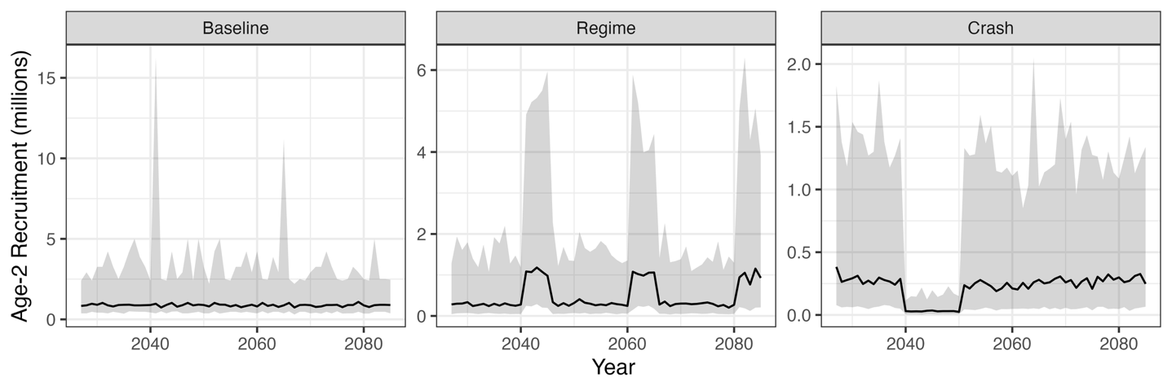Figure 1. Visual depiction of simulated age-2 recruitment over the projection period (2026–2085) under the Baseline, Regime, and Crash operating models. Lines are the median and shading the 90% interval (5th to 95th percentiles) across 150 replicates. Note that baseline recruitment is resampled from the 1975–2025 assessment estimates and does not depend on the harvest control rule. By contrast, under the Regime and Crash scenarios depicted here, recruitment follows a Beverton–Holt relationship and therefore depends on spawning stock biomass, and the series shown are those realized under the constant $F_{50\%}$ rule with perfect information.

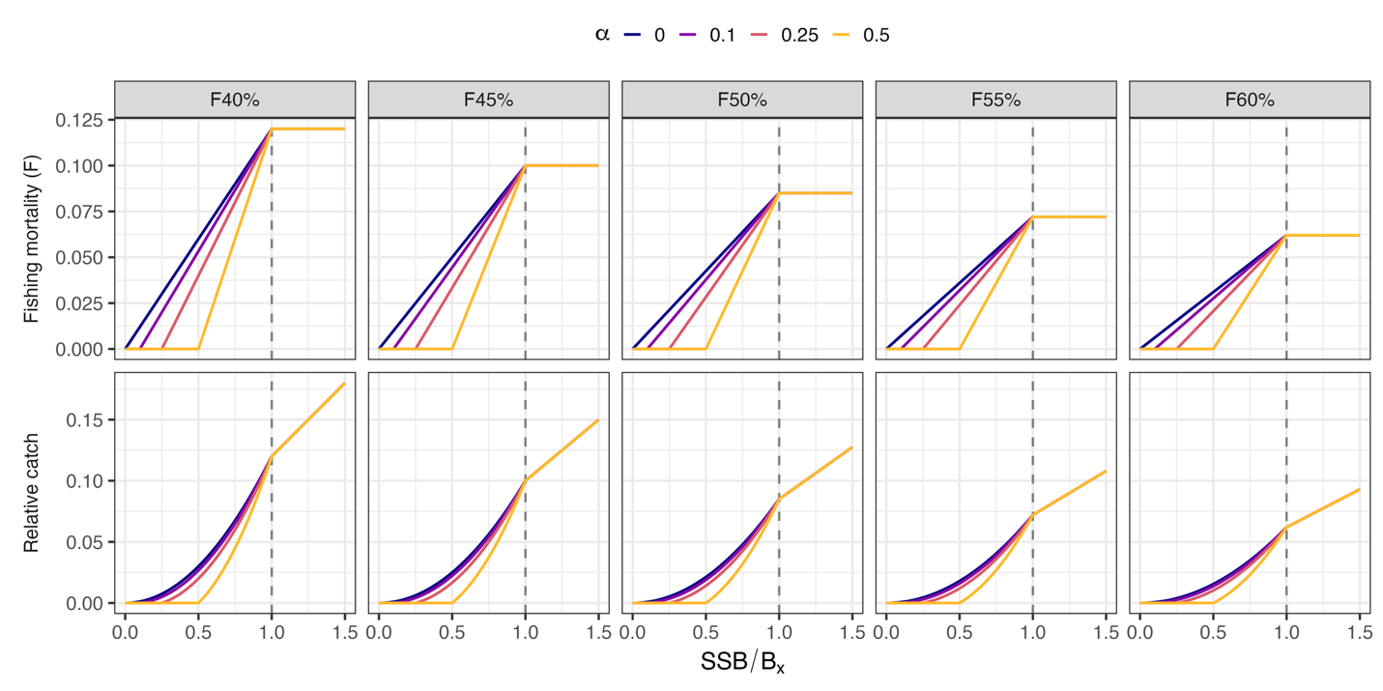Figure 2. Illustration of the shapes of the threshold harvest control rules (HCRs) evaluated, shown for a subset of the $SPR$ targets ($F_{40\%}$ to $F_{60\%}$; columns) and closure thresholds ($α$ = 0, 0.1, 0.25, and 0.5; colours). Each rule applies the target fishing mortality $F_{x\%}$ when spawning stock biomass ($SSB$) is at or above the paired biomass target $B_{x\%}$ (dashed vertical line), reduces fishing mortality linearly as $SSB$ falls from $B_{x\%}$ to $αB_{x\%}$, and closes the fishery below $αB_{x\%}$,. The top row shows the prescribed fishing mortality and the bottom row the resulting catch relative to $B_{x\%}$. Note that fishing mortality values are illustrative and higher $SPR$ targets correspond to lower fishing mortality.

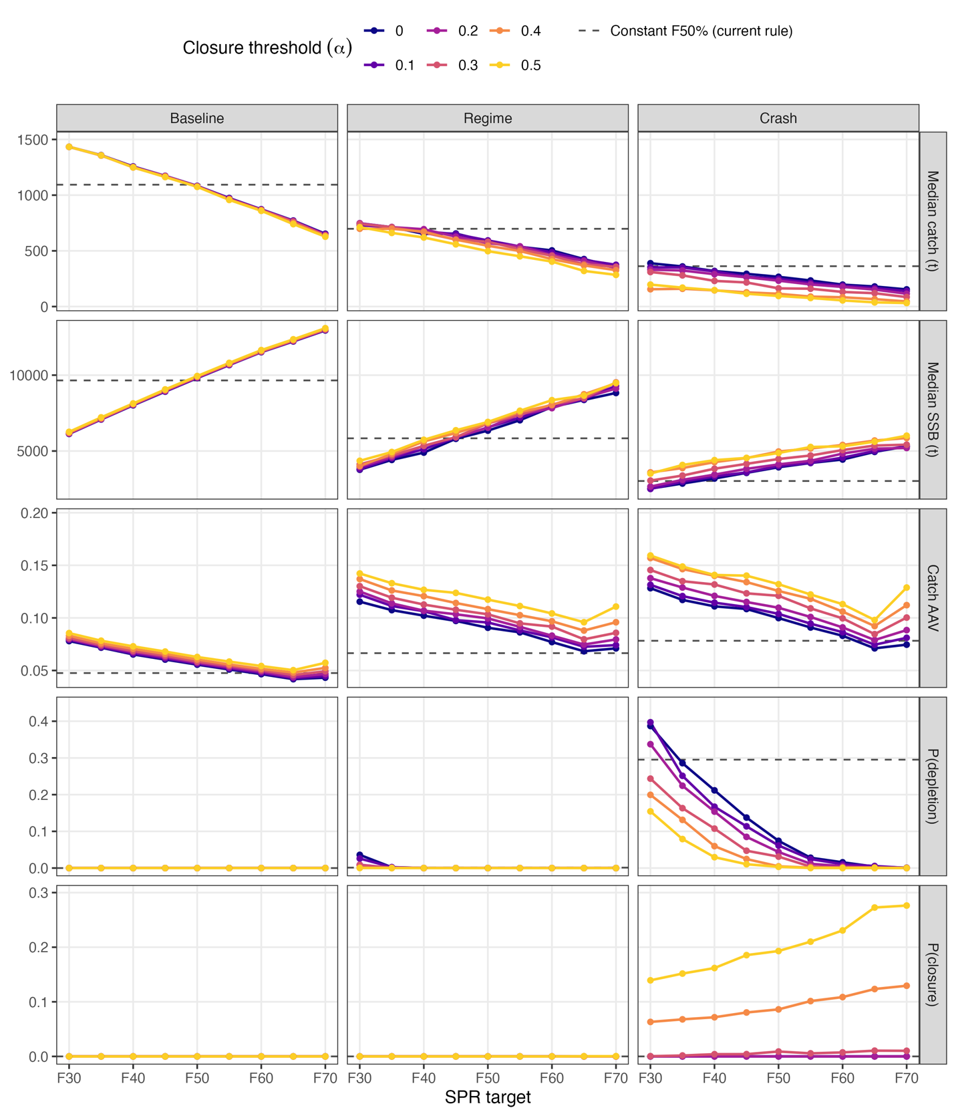
Figure 3. Performance of the threshold harvest control rules evaluated in the perfect information simulation setting, by $SPR$ target (x-axis) and closure threshold ($α$; colours, six of the eleven values evaluated), for the Baseline, Regime, and Crash operating models. Rows show median catch, median spawning stock biomass ($SSB$), catch AAV, the probability that $SSB$ fell below 10% of its 1975–2025 maximum, and the probability of fishery closure, each summarized over 2025–2085 and 150 replicates. Dashed horizontal lines give the value for the status-quo constant $F_{50\%}$ rule. All rules shown apply the asymmetric stability constraint (a 15% cap on year-over-year increases in catch). In general, results for the symmetric and unconstrained cases are shown in Figures S6 and S7 on the same axes and generally follow the same patterns, though with slightly different scaling.
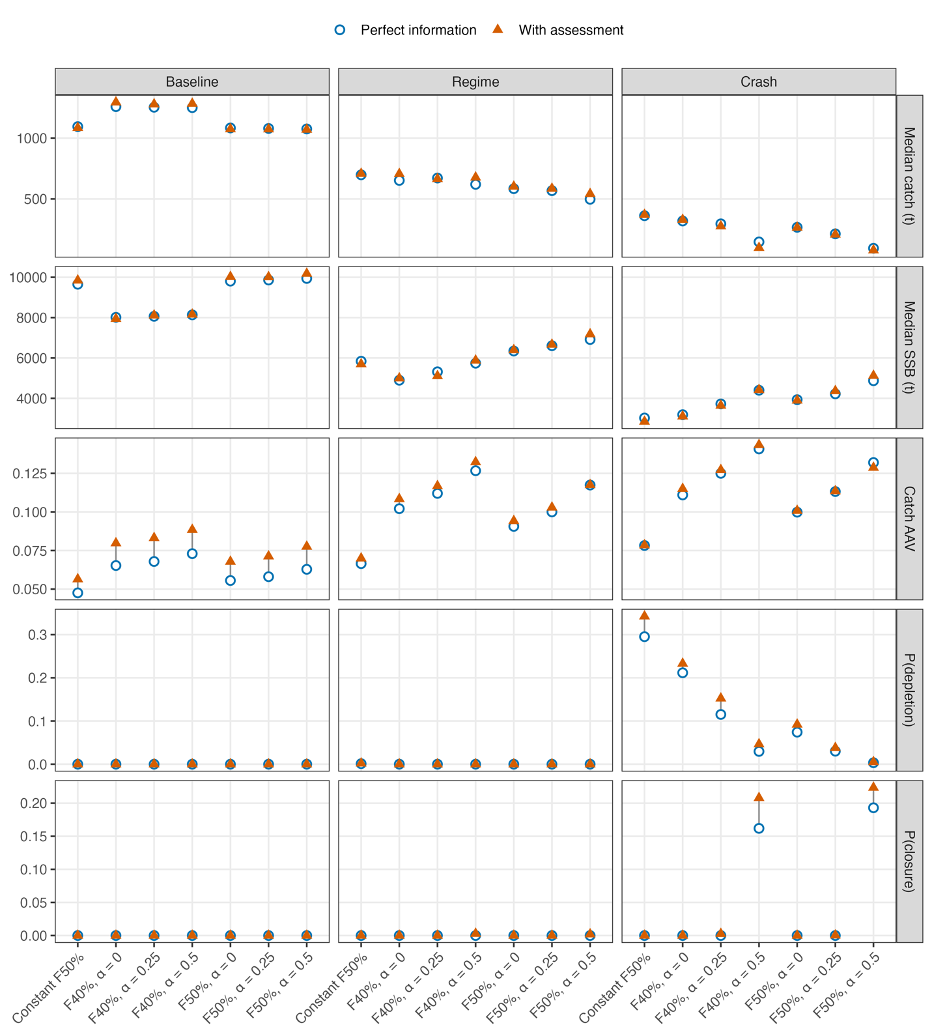Figure 4. Performance of the seven candidate harvest control rules (x-axis) under perfect information (blue circles) and with assessment (orange triangles) for the Baseline, Regime, and Crash operating models (columns). Rows show median catch, median spawning stock biomass ($SSB$), catch AAV, the probability that SSB fell below 10% of its 1975–2025 maximum, and the probability of fishery closure, each summarized over 2025–2085 and 150 replicates; the grey segment joining each pair is the change attributable to assessment error. All rules apply the asymmetric stability constraint (a 15% cap on year-over-year increases in catch).

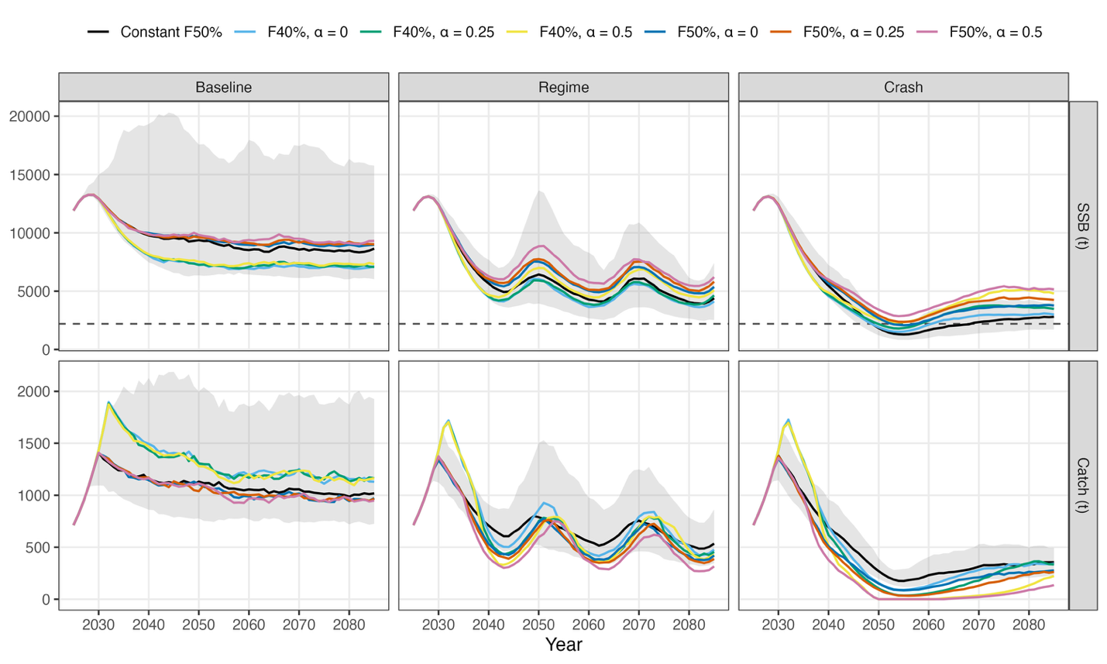
Figure 5. Time-series of realized median spawning stock biomass (SSB) and catch (row panels) for the Baseline, Regime, and Crash operating models (columns) under the with assessment simulation setting. Colors depict the seven candidate harvest control rules (HCRs) tested, lines indicate the median of the time-series, and shading denotes the 90% interval (5th to 95th percentiles) across simulation replicates for the constant $F_{50\%}$ rule. The dashed-line in the SSB panel shows the 10% of the SSB historical (1975 - 2025) maximum and is used to indicate the probability of depletion.

