Supplementary Material 1

Operating model
The operating model (OM) was implemented in the SPoRC stock assessment package (Cheng et al., 2026), which provides a generalized age-, sex-, and spatially-structured population model together with the simulation functions used here for data generation, closed-loop assessment, reference point calculation, and projection. For NSEI sablefish, the OM was configured as a single area and single season with two sexes, 30 age classes (ages 2-31, where age 31 is a plus group), 30 length bins (41-99 cm in 2-cm increments), one fishery fleet (the longline fishery), and one survey fleet (the ADF&G longline survey).

Conditioning
The OM was conditioned on the 2026 ADF&G statistical catch-at-age assessment (hereafter ADF&G SCAA) for NSEI sablefish, which spans model years 1975–2025 (Lambert and Ehresmann, 2026). Note that conditioning did not involve refitting a model to the data. Instead, annual fishing mortality, sex-specific fishery selectivity, fishery and survey catchability, annual recruitment, and the initial (1975) age structure estimated by the ADF&G SCAA were supplied directly to the OM, and the OM was projected forward deterministically from 1975 to 2025. Because the OM and the ADF&G SCAA share similar population dynamics and biological inputs, this procedure reproduced the spawning stock biomass (SSB) and recruitment time series estimated by the assessment closely (Figure S1). The conditioning period was therefore identical across OM scenarios, replicates, harvest control rules (HCRs), thereby allowing differences among simulations to be generally attributed solely to the projection-period processes being compared.

Population dynamics
Population dynamics followed the standard age-structured formulation implemented in SPoRC (Cheng et al., 2026), and only the components relevant to interpreting the simulations are summarized here. Numbers-at-age ($N$) for age $a$, sex $s$, and year $y$ were projected as:
$$N_{a+1,s,y+1}=N_{a,s,y} e^{-Z_{a,s,y}}, \\ N_{A,s,y+1}=N_{A-1,s,y} e^{-Z_{A-1,s,y}}+N_{A,s,y} e^{-Z_{A,s,y}},$$
where $A$ denotes the plus group and total mortality $Z$ combined natural mortality ($M$) with fishing mortality on retained and discarded fish:
$$Z_{a,s,y}=M+F_{y} S_{a,s,y}\left[ρ_{a,s}+\left(1-ρ_{a,s}\right)d\right],$$
where $F_{y}$ is the fully-selected fishing mortality rate, $S_{a,s,y}$ is fishery selectivity, $ρ_{a,s}$ is the probability of retention, and $d=0.16$ is the discard mortality rate. Landed catch in biomass was obtained from the Baranov catch equation applied to the retained component:
Cy=a​s​Na,s,y Fy Sa,s,y ρa,sZa,s,y1-e-Za,s,ywa,sfish,
where $w_{a,s}^{fish}$ is fishery weight-at-age. Spawning stock biomass was defined as female spawning biomass at the time of spawning ($t_{sp}$ = 0.17 of the year):
SSBy=a​Na,f,y e-tsp Za,f,y ma wa,f,
where $m_{a}$ is female maturity-at-age and $w_{a,f}$ is female population weight-at-age. Recruitment entered the population at age 2 and was apportioned equally between sexes.

Biological inputs
Biological inputs were taken directly from the ADF&G assessment and held constant across all years (Figure S2). Natural mortality was fixed at 0.1 for both sexes and all ages, consistent with the ADF&G SCAA. Sex-specific weight-at-age from the survey was used to compute SSB and the survey index, whereas sex-specific fishery weight-at-age was used to convert catch-at-age to catch biomass. Maturity-at-age was specified for females only, such that males did not contribute to SSB, and the sex ratio at recruitment was fixed at 0.5. The ageing error matrix used in the assessment was applied when generating age composition data.

Fishery and survey processes
During the conditioning period, fishing mortality was specified at the ADF&G SCAA estimates. By contrast, during the projection period, fishing mortality in each year was determined based on the HCR and specified biomass levels. Sex-specific fishery selectivity followed the ADF&G SCAA estimates, which were estimated in three time-blocks corresponding to historical changes in the fishery; the terminal-year (2025) selectivity was assumed for all projection years (Figure S3). Likewise, sex-specific retention-at-age followed the ADF&G SCAA and was held constant throughout. Fishery catchability followed the three ADF&G SCAA block estimates, with the final block carried through the projection, and the fishery CPUE index was generated in biomass units from the retained component of the population. Survey selectivity was fixed at the sex-specific logistic curve estimated by the ADF&G SCAA for 2004, and survey catchability was fixed at the ADF&G SCAA estimate for the second catchability block for all years. The survey index was generated in abundance units (numbers).

Recruitment scenarios
Three recruitment scenarios were specified for the projection period (Table S1; main-text Figure 1). These scenarios were designed to bracket plausible futures for NSEI sablefish productivity, which represents the dominant uncertainty for this population, rather than to represent specific mechanistic hypotheses (e.g., Zahner et al., 2025). In the Baseline OM, recruitment in each projection year was resampled with replacement from the recruitment estimates of the conditioning period, such that the historical mean and variability of recruitment were retained and recruitment was independent of SSB. In the Regime and Crash OMs, recruitment instead followed a Beverton–Holt stock–recruitment relationship parameterized in terms of steepness ($h$),
$$R_{y}=\frac{4hR_{0} {SSB}_{y}}{{SSB}_{0}\left(1-h\right)+\left(5h-1\right){SSB}_{y}} exp\left(ε_{y}\right), \\ ε_{y}∼N\left(0,σ_{R}^{2}\right),$$
with $h=0.8$, $σ_{R}=1.0$, ${SSB}_{0}$ the unfished SSB implied by $R_{0}$ and unfished spawning biomass per recruit, and $R_{0}$ set to the ADF&G SCAA estimate of mean (log-scale) recruitment (Table S1). The two scenarios differed only in how $R_{0}$ varied over the projection period. In the Regime OM, $R_{0}$ alternated between 15-year periods at its base value and 5-year periods at five times its base value (i.e., elevated recruitment during 2041–2045, 2061–2065, and 2081–2085), representing episodic productivity regimes. In the Crash OM, $R_{0}$ was reduced to 10% of its base value for 11 years (2040–2050) and then returned to its base value, representing a prolonged recruitment failure followed by subsequent recovery. Recruitment deviations (and, for the Baseline OM, resampling draws) were generated once per replicate and stored with the OM, such that every HCR and both information conditions experienced the same recruitment sequence within a given replicate.

Data generation
In each simulated year, the OM generated the observations required by the EM (Table S2). Landed catch was observed with lognormal error (CV = 0.05). Likewise, the fishery CPUE index (biomass) and the survey abundance index (numbers) were observed with lognormal error. Fishery and survey age compositions were generated as multinomial samples, jointly across sexes, with input sample sizes equal to the mean historical input sample sizes used in the assessment, and the assessment ageing error matrix was applied to the sampled ages.

Estimation model

Configuration
The EM was an age-structured model implemented in SPoRC and configured to mirror the operational ADF&G assessment as closely as possible (Table S3). The EM tracked the same age and sex structure as the OM. Natural mortality was fixed at 0.1 for both sexes. Recruitment was modeled as a mean with annual lognormal deviations, with $σ_{R}$ fixed and deviations penalized accordingly, and no stock–recruitment relationship was assumed. Fishery selectivity was sex-specific and logistic, estimated in three time-blocks that match those of the ADF&G SCAA, and survey selectivity was sex-specific and logistic in a single block. Fishery catchability was estimated in three time-blocks matching the selectivity blocks, and survey catchability was estimated as a single time-invariant parameter. Annual fishing mortality was estimated as a mean with annual deviations subject to a penalty, and catch was fit with a fixed lognormal standard deviation of 0.05, such that catch was fit nearly exactly. Similarly, fishery and survey indices were fit with a fixed lognormal standard deviation, specified at the uncertainty set for the OM. Retention-at-age and the discard mortality rate (0.16) were fixed at their OM values.

Data availability and likelihood
The joint negative log-likelihood comprised lognormal components for catch and the two indices, multinomial components for the fishery and survey age compositions, the recruitment deviation penalty, and the fishing mortality penalty. Data availability in the EM was specified to reflect the historical record: fishery CPUE was used from 1979, fishery age compositions from 2001, and the survey index and age compositions from 1996, with catch available in all years.

Fitting and diagnostics
In every year $y$ from 2025 (the terminal conditioning year) through 2085, the EM was fit to all data available through year $y$ by penalized maximum likelihood using RTMB (Kristensen et al., 2016). The Hessian was computed for every fit, and whether it was positive definite, together with the maximum absolute gradient component, was recorded as a convergence diagnostic. Across all assessments conducted, the Hessian was positive definite in all but a handful of instances ($<10$ simulations), and maximum gradients were generally small (i.e., $≤{10}^{-3}$).

Reference points and catch advice

Reference points
Reference points were computed from the terminal-year estimates in each assessment year (or from the true population dynamics under perfect information) following the spawning potential ratio (SPR) approach as is currently used by ADF&G (Clark, 1991). Spawning biomass per recruit as a function of fishing mortality ($SBPR\left(F\right)$) was computed from terminal-year weight-at-age, maturity-at-age, fishery selectivity, and retention, and the fishing mortality reference point $F_{x\%}$ was defined as the value of $F$ satisfying the following condition:
$$\frac{SBPR\left(F_{x\%}\right)}{SBPR\left(0\right)}=x.$$
The corresponding biomass reference point was defined as the equilibrium SSB expected at $F_{x\%}$ given mean recruitment:
$$B_{x\%}=\overset{‾}{R} SBPR\left(F_{x\%}\right), \\ \overset{‾}{R}=\frac{1}{y-2-1975+1}\sum_{t=1975}^{y-2}{R_{t}},$$
where the two most recent recruitment estimates were excluded from the mean because age-2 recruitment is poorly determined in the terminal years. Because $\overset{‾}{R}$ was recomputed in each assessment year, $B_{x\%}$ was updated annually as the recruitment time series length increased. Note that under perfect information, $\overset{‾}{R}$ was the mean of the true recruitment series. Moreover, under this definition, $B_{x\%}$ is equivalent to $x×B_{0}$ where $B_{0}=\overset{‾}{R} SBPR\left(0\right)$.

Projection and catch advice
Catch advice for year $y+1$ was obtained by projecting the population forward for two years from the terminal-year numbers-at-age (estimated or true). In the first projection year (year $y$), the terminal-year fishing mortality was applied to obtain end-of-year abundance and ${SSB}_{y}$. The HCR was then evaluated using the ratio ${SSB}_{y}/B_{x\%}$ to determine $F_{y+1}$ (see Harvest control rules), and the population was projected through year $y+1$ under $F_{y+1}$, with recruitment set to mean recruitment and biological and selectivity inputs fixed at their terminal-year values. The projected landed catch in year $y+1$ constituted the catch advice, to which the catch stability constraint was then applied (see Harvest control rules). The resulting catch was removed from the OM in year $y+1$ by solving for the fully-selected fishing mortality that produced exactly that landed catch given the OM’s selectivity, retention, and discard mortality (i.e., no implementation error was assumed).

Closures
When the HCR prescribed $F_{y+1}=0$, the catch advice was zero and fishing mortality in the OM was set to zero for year $y+1$. The stability constraint was not applied to closures, such that the fishery closed immediately. Following a closed year, the stability constraint was also not applied to the subsequent year’s advice (because the previous year’s catch was zero), such that reopening was governed by the HCR alone.

Harvest control rules

Threshold rule
Threshold HCRs were defined by an SPR-based target ($F_{x\%}$, $B_{x\%}$) and a closure threshold $α$ expressed as a fraction of $B_{x\%}$ (Deroba and Bence, 2008). Letting $θ_{y}={SSB}_{y}/B_{x\%}$ denote stock status, the prescribed fishing mortality was determined as:
$$F_{y+1}=\left\{\begin{matrix}F_{x\%} & θ_{y}≥1 \\ F_{x\%} \frac{θ_{y}-α}{1-α} & α<θ_{y}<1 \\ 0 & θ_{y}≤α,\end{matrix}\right.$$
such that fishing mortality declined linearly from $F_{x\%}$ at $B_{x\%}$ to zero at $αB_{x\%}$, below which the fishery was closed (main-text Figure 2). When $α=0$, fishing mortality declined linearly toward zero at $SSB=0$ and no closure threshold was imposed. The constant-F reference rule applied $F_{50\%}$ regardless of stock status.

Catch stability constraints
Stability constraints were applied to the catch advice $C_{y+1}^{adv}$ relative to the realized catch in the preceding year, $C_{y}$. Under the asymmetric constraint, increases were limited to 15% while decreases were unconstrained,
$$C_{y+1}=min\left(C_{y+1}^{adv}, 1.15 C_{y}\right);$$
under the symmetric constraint, both increases and decreases were limited to 15%,
$$C_{y+1}=min\left(max\left(C_{y+1}^{adv}, 0.85 C_{y}\right), 1.15 C_{y}\right);$$
and under no constraint, $C_{y+1}=C_{y+1}^{adv}$. As described above, constraints were bypassed when the HCR prescribed a closure and in the year following a closure.

Candidate rules
The candidate set comprised the full factorial combination of nine SPR targets ($x$ = 30%, 35%, …, 70%), eleven closure thresholds ($α$ = 0, 0.05, …, 0.5), and three stability constraints (none, symmetric, asymmetric), for 297 threshold rules, plus the constant $F_{50\%}$ reference rule with the asymmetric constraint, for 298 rules in total (Table S4). All 298 rules were evaluated under perfect information. Under the with assessment simulation setting, evaluation was restricted to seven rules: the constant-$F_{50\%}$ reference rule and the threshold rules with $x∈\{40\%,50\%\}$ and $α∈\{0,0.25,0.5\}$, all with the asymmetric constraint. This candidate set was selected following review of the perfect-information screening results with ADF&G and included the current $F_{50\%}$ target, as well as the federal $F_{40\%}$ target, spanning the range of closure thresholds considered in the screening, and retained the asymmetric stability constraint currently applied by ADF&G. All comparisons between information conditions (i.e., perfect information and with assessment) are restricted to these rules.

Performance metrics and diagnostics

Performance metrics
Performance was summarized over model years 51-111 (2025-2085) using the metrics in Table S5; this window comprises the 60 HCR-controlled years together with the terminal conditioning year (2025), which is identical across rules and information conditions and allows the first year-over-year change in catch under each rule to enter the variability calculation. For replicate $j$ with summary years $t=1,…,T$, average annual variability (AAV) in catch was computed as
$${AAV}_{j}=\frac{\sum_{t=1}^{T-1}{\left|C_{j,t+1}-C_{j,t}\right|}}{\sum_{t=1}^{T-1}{C_{j,t}}},$$
and the median across replicates was reported. The probability of depletion was defined as the proportion of replicate-years in which SSB fell below 10% of the maximum SSB of the conditioning period, and the probability of closure as the proportion of replicate-years with zero catch. Median SSB and median catch were computed across all projection years and replicates, and terminal status was the median across replicates of ${SSB}_{T}/B_{x\%}$ in the final projection year, where $B_{x\%}$ was the value used by the HCR in that year. For the perfect-information runs, each metric was summarized for every rule and mapped across the SPR and closure threshold grid for each stability constraint and OM.

Comparison between information conditions
For the seven rules evaluated under both information conditions, the effect of assessment error was quantified as the change in each metric between conditions, expressed as a percentage of the perfect-information value for median SSB, median catch, catch AAV, and terminal status, and as a difference in percentage points for the two probabilities (because the perfect information probabilities were often zero; Figure S11).

Assessment diagnostics
Assessment performance was characterized using two diagnostics (Figures S4 and S5). The first was the relative error of the terminal SSB estimate in assessment year $y$, $\left({\hat{SSB}}_{y|y}-{SSB}_{y}\right)/{SSB}_{y}$, which measures the bias in the quantity on which the HCR acted. The second compared the perceived stock status, ${\hat{SSB}}_{y|y}/{\hat{B}}_{x\%}$, with the true status, ${SSB}_{y}/B_{x\%}$, to show how assessment error translated into the HCR.

References
Cheng, M.LH., Goethel, D.R., Cunningham, C.J., Hulson, P.F., Ianelli, J.N., Omori, K.L., 2026. The SPoRC Stock Assessment Package: A Generalized Next‐Generation Platform to Assess Spatial, Age and Sex‐Structured Populations. Fish Fish. faf.70082. https://doi.org/10.1111/faf.70082
Clark, W.G., 1991. Groundfish Exploitation Rates Based on Life History Parameters. Can. J. Fish. Aquat. Sci. 48, 734–750. https://doi.org/10.1139/f91-088
Deroba, J.J., Bence, J.R., 2008. A review of harvest policies: Understanding relative performance of control rules. Fish. Res. 94, 210–223. https://doi.org/10.1016/j.fishres.2008.01.003
Kristensen, K., Nielsen, A., Berg, C.W., Skaug, H., Bell, B., 2016. TMB: Automatic Differentiation and Laplace Approximation. J. Stat. Softw. 70. https://doi.org/10.18637/jss.v070.i05
Lambert, A.W., Ehresmann, R.K., 2026. 2026 Northern Southeast Inside Subdistrict sablefish management plan and stock assessment. Alsk. Dep. Fish Game Div. Commer. Fish.
Zahner, J.A., Goethel, D.R., Cunningham, C.J., Cheng, M.L.H., Williams, B.C., Kapur, M.S., Lunsford, C., 2025. Comparing alternative harvest strategies to address robustness to recruitment variability and uncertainty: implications for Alaska sablefish tested with management strategy evaluation. Can. J. Fish. Aquat. Sci. 82, 1–17. https://doi.org/10.1139/cjfas-2025-0115

Supplementary tables
Table S1. Projection-period recruitment scenarios.
Scenario | Recruitment model | Parameters | Projection-period schedule
Baseline | Empirical resampling | Resampled with replacement from 1975–2025 estimates | Stationary; mean 1.41 million age-2 recruits
Regime | Beverton–Holt, lognormal deviations | $h$ = 0.8, $σ_{R}$ = 1.0, $R_{0}$ = 4.7 × 105 | $R_{0}$ at base value, except 5 × base during 2041–2045, 2061–2065, 2081–2085
Crash | Beverton–Holt, lognormal deviations | $h$ = 0.8, $σ_{R}$ = 1.0, $R_{0}$ = 4.7 × 105 | $R_{0}$ at 0.1 × base during 2040–2050, base value otherwise

Table S2. Observation model settings used to generate simulated data.
Data type | Units | Error distribution | Uncertainty
Landed catch | Biomass (t) | Lognormal | CV = 0.05
Fishery CPUE index | Biomass | Lognormal | SE = 0.35
Survey abundance index | Numbers | Lognormal | SE = 0.23
Fishery age composition | Proportions by age and sex | Multinomial, with ageing error | Input sample size = 81 (historical mean)
Survey age composition | Proportions by age and sex | Multinomial, with ageing error | Input sample size = 66 (historical mean)

Table S3. Estimation model configuration.
Component | Specification
Structure | Single area, two sexes, ages 2-31 (31 = plus group), years 1975 to the current assessment year
Natural mortality | Fixed at 0.1 (both sexes, all ages)
Recruitment | Mean recruitment with annual lognormal deviations; no stock–recruitment relationship
Initial age structure | Geometric series with estimated age-specific deviations
Fishery selectivity | Sex-specific logistic; three time-blocks (1975-1994, 1995-2021, 2022 onward)
Survey selectivity | Sex-specific logistic; single time block
Fishery catchability | Estimated in three time-blocks matching selectivity
Survey catchability | Estimated, time-invariant
Fishing mortality | Mean with annual deviations
Catch likelihood | Lognormal, with input standard errors fixed
Index likelihoods | Lognormal, with input standard errors fixed
Composition likelihoods | Multinomial, with input sample sizes fixed
Retention and discard mortality | Fixed at OM values (discard mortality rate = 0.16)

Table S4. Candidate harvest control rules evaluated in the study.
Factor | Screening stage (perfect information) | Candidate set (with assessment)
SPR target ($x$) | 30%, 35%, 40%, 45%, 50%, 55%, 60%, 65%, 70% | 40%, 50%
Closure threshold ($α$) | 0, 0.05, 0.10, …, 0.50 | 0, 0.25, 0.50
Stability constraint | None, symmetric (±15%), asymmetric (+15%, unconstrained decrease) | Asymmetric
Reference rule | Constant $F_{50\%}$, asymmetric constraint | Constant $F_{50\%}$, asymmetric constraint
Total rules | 298 | 7

Table S5. Performance metrics.
Metric | Definition | Objective
Median SSB | Median of SSB across projection years and replicates (t) | Conservation
Median catch | Median of landed catch across projection years and replicates (t) | Yield
Catch AAV | Median across replicates of within-replicate average annual variability in catch | Stability
P(depletion) | Proportion of replicate-years with SSB < 10% of the 1975–2025 maximum | Conservation
P(closure) | Proportion of replicate-years with zero catch | Stability and yield
Terminal status | Median across replicates of SSB/$B_{x\%}$ in 2085 | Conservation

Supplementary figures
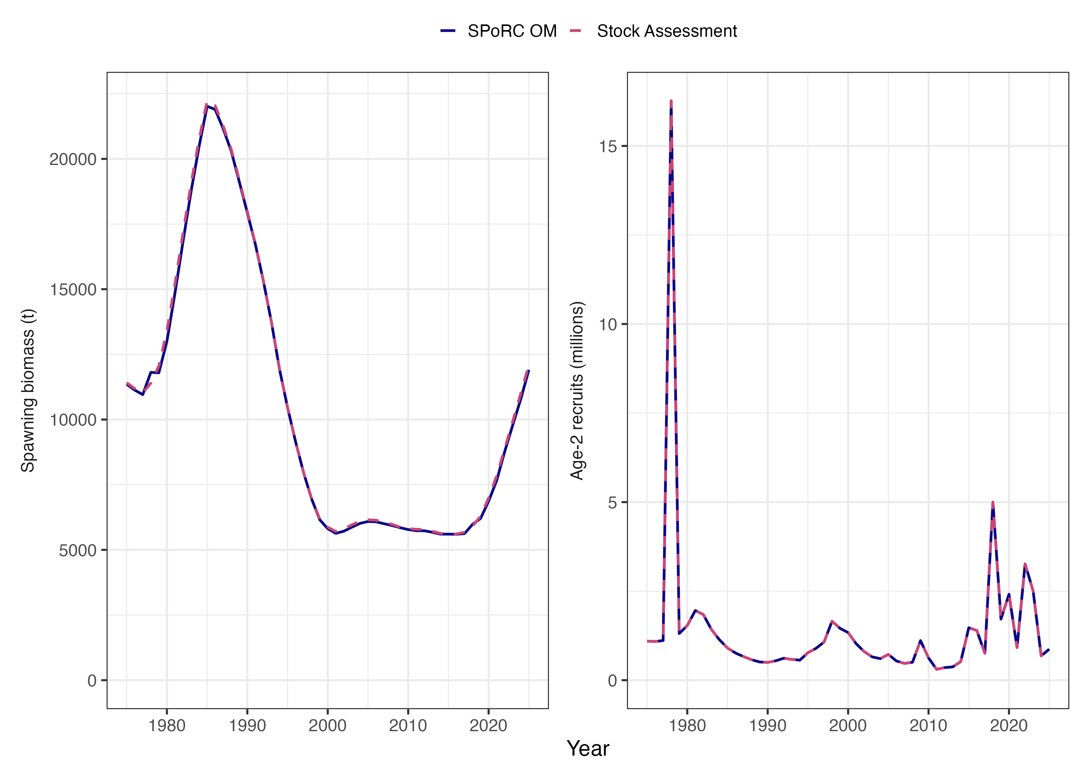
Figure S1. Operating model conditioning. Spawning stock biomass (left) and age-2 recruitment (right) from the SPoRC operating model (solid line) and the 2026 ADF&G statistical catch-at-age assessment (dashed line) over the conditioning period (1975–2025). The operating model was projected forward from the assessment’s estimated fishing mortality, selectivity, catchability, recruitment, and initial age structure, and reproduces the assessment trajectories.

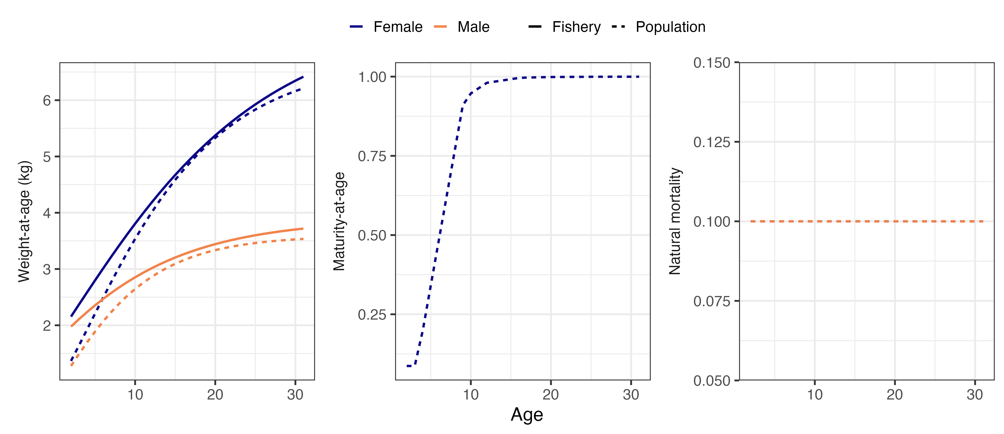
Figure S2. Biological inputs to the operating model, held constant over the conditioning and projection periods: sex-specific weight-at-age for the fishery (solid lines) and the population (dashed lines), female maturity-at-age, and natural mortality (0.1 for both sexes and all ages).

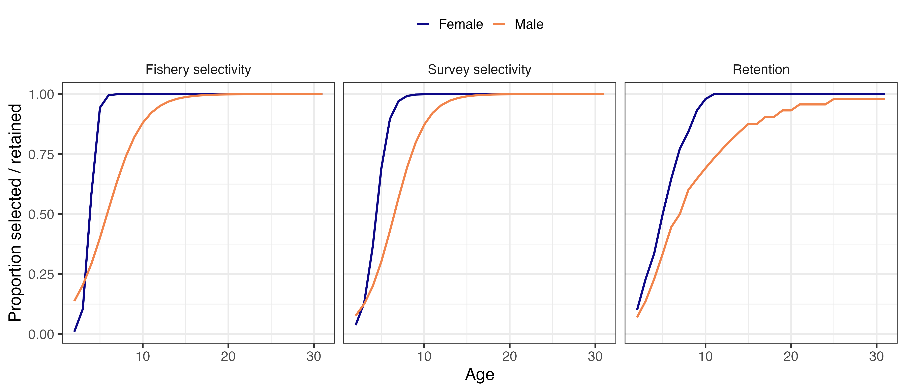
Figure S3. Sex-specific fishery selectivity, survey selectivity, and retention-at-age applied in the projection period, taken from the terminal (2025) block of the ADF&G assessment and held constant.

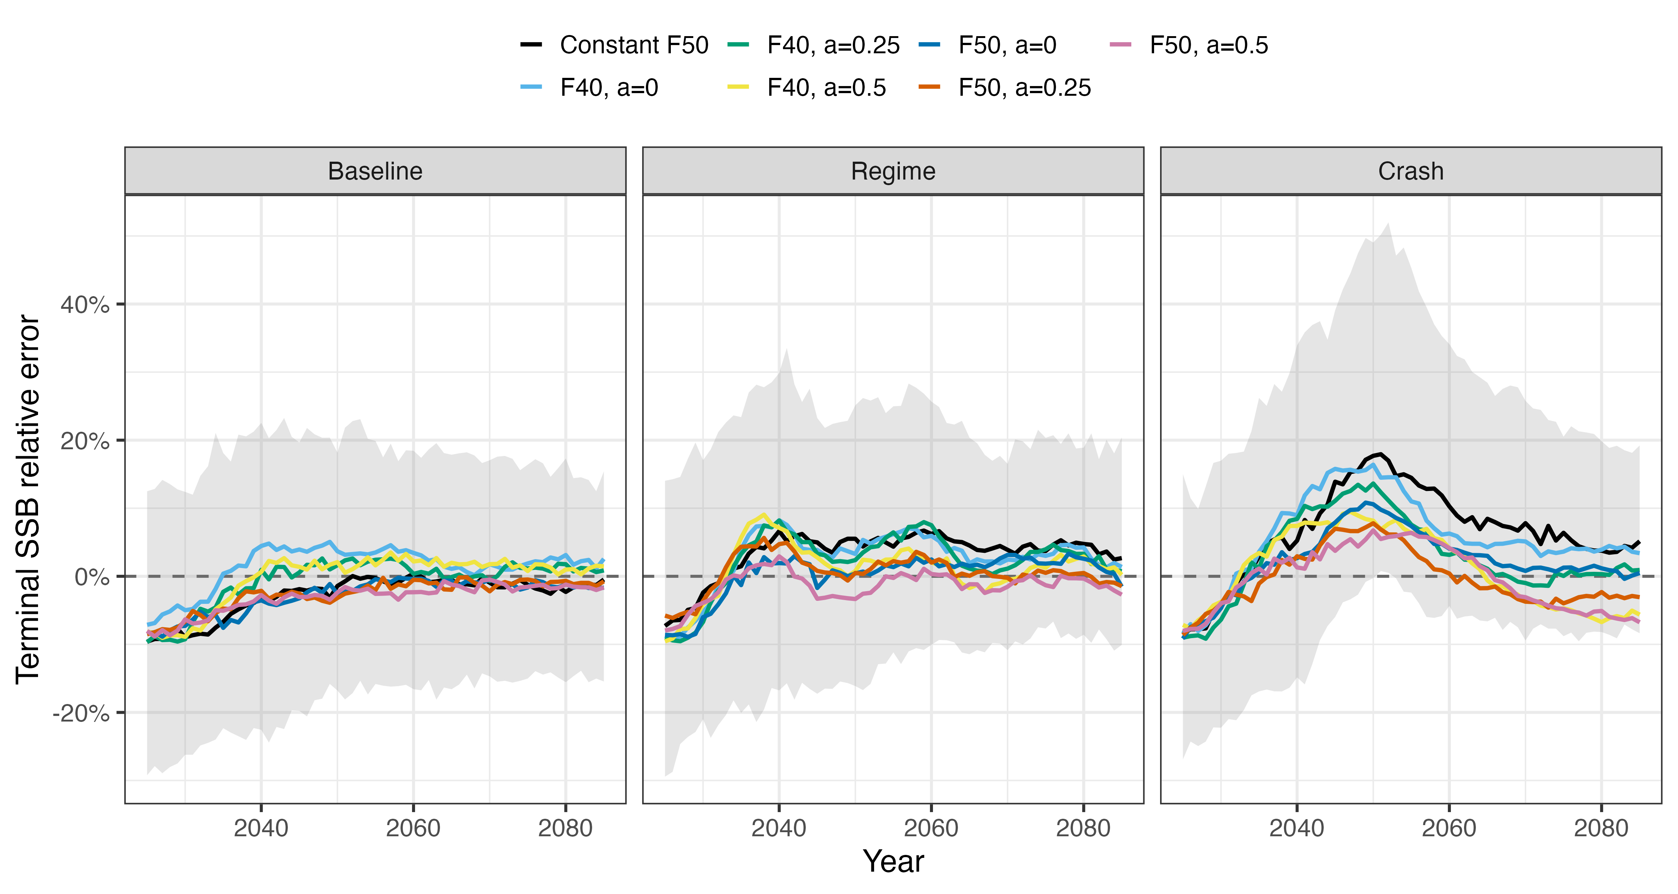
Figure S4. Relative error of the assessment’s terminal-year SSB estimate, (estimated − true) / true, by year, operating model (columns), and candidate harvest control rule (colours) in the with-assessment simulations. Lines are medians across 150 replicates; the grey ribbon is the 90% interval (5th to 95th percentiles) for the constant F50% rule. Positive values indicate that the assessment overestimated SSB.

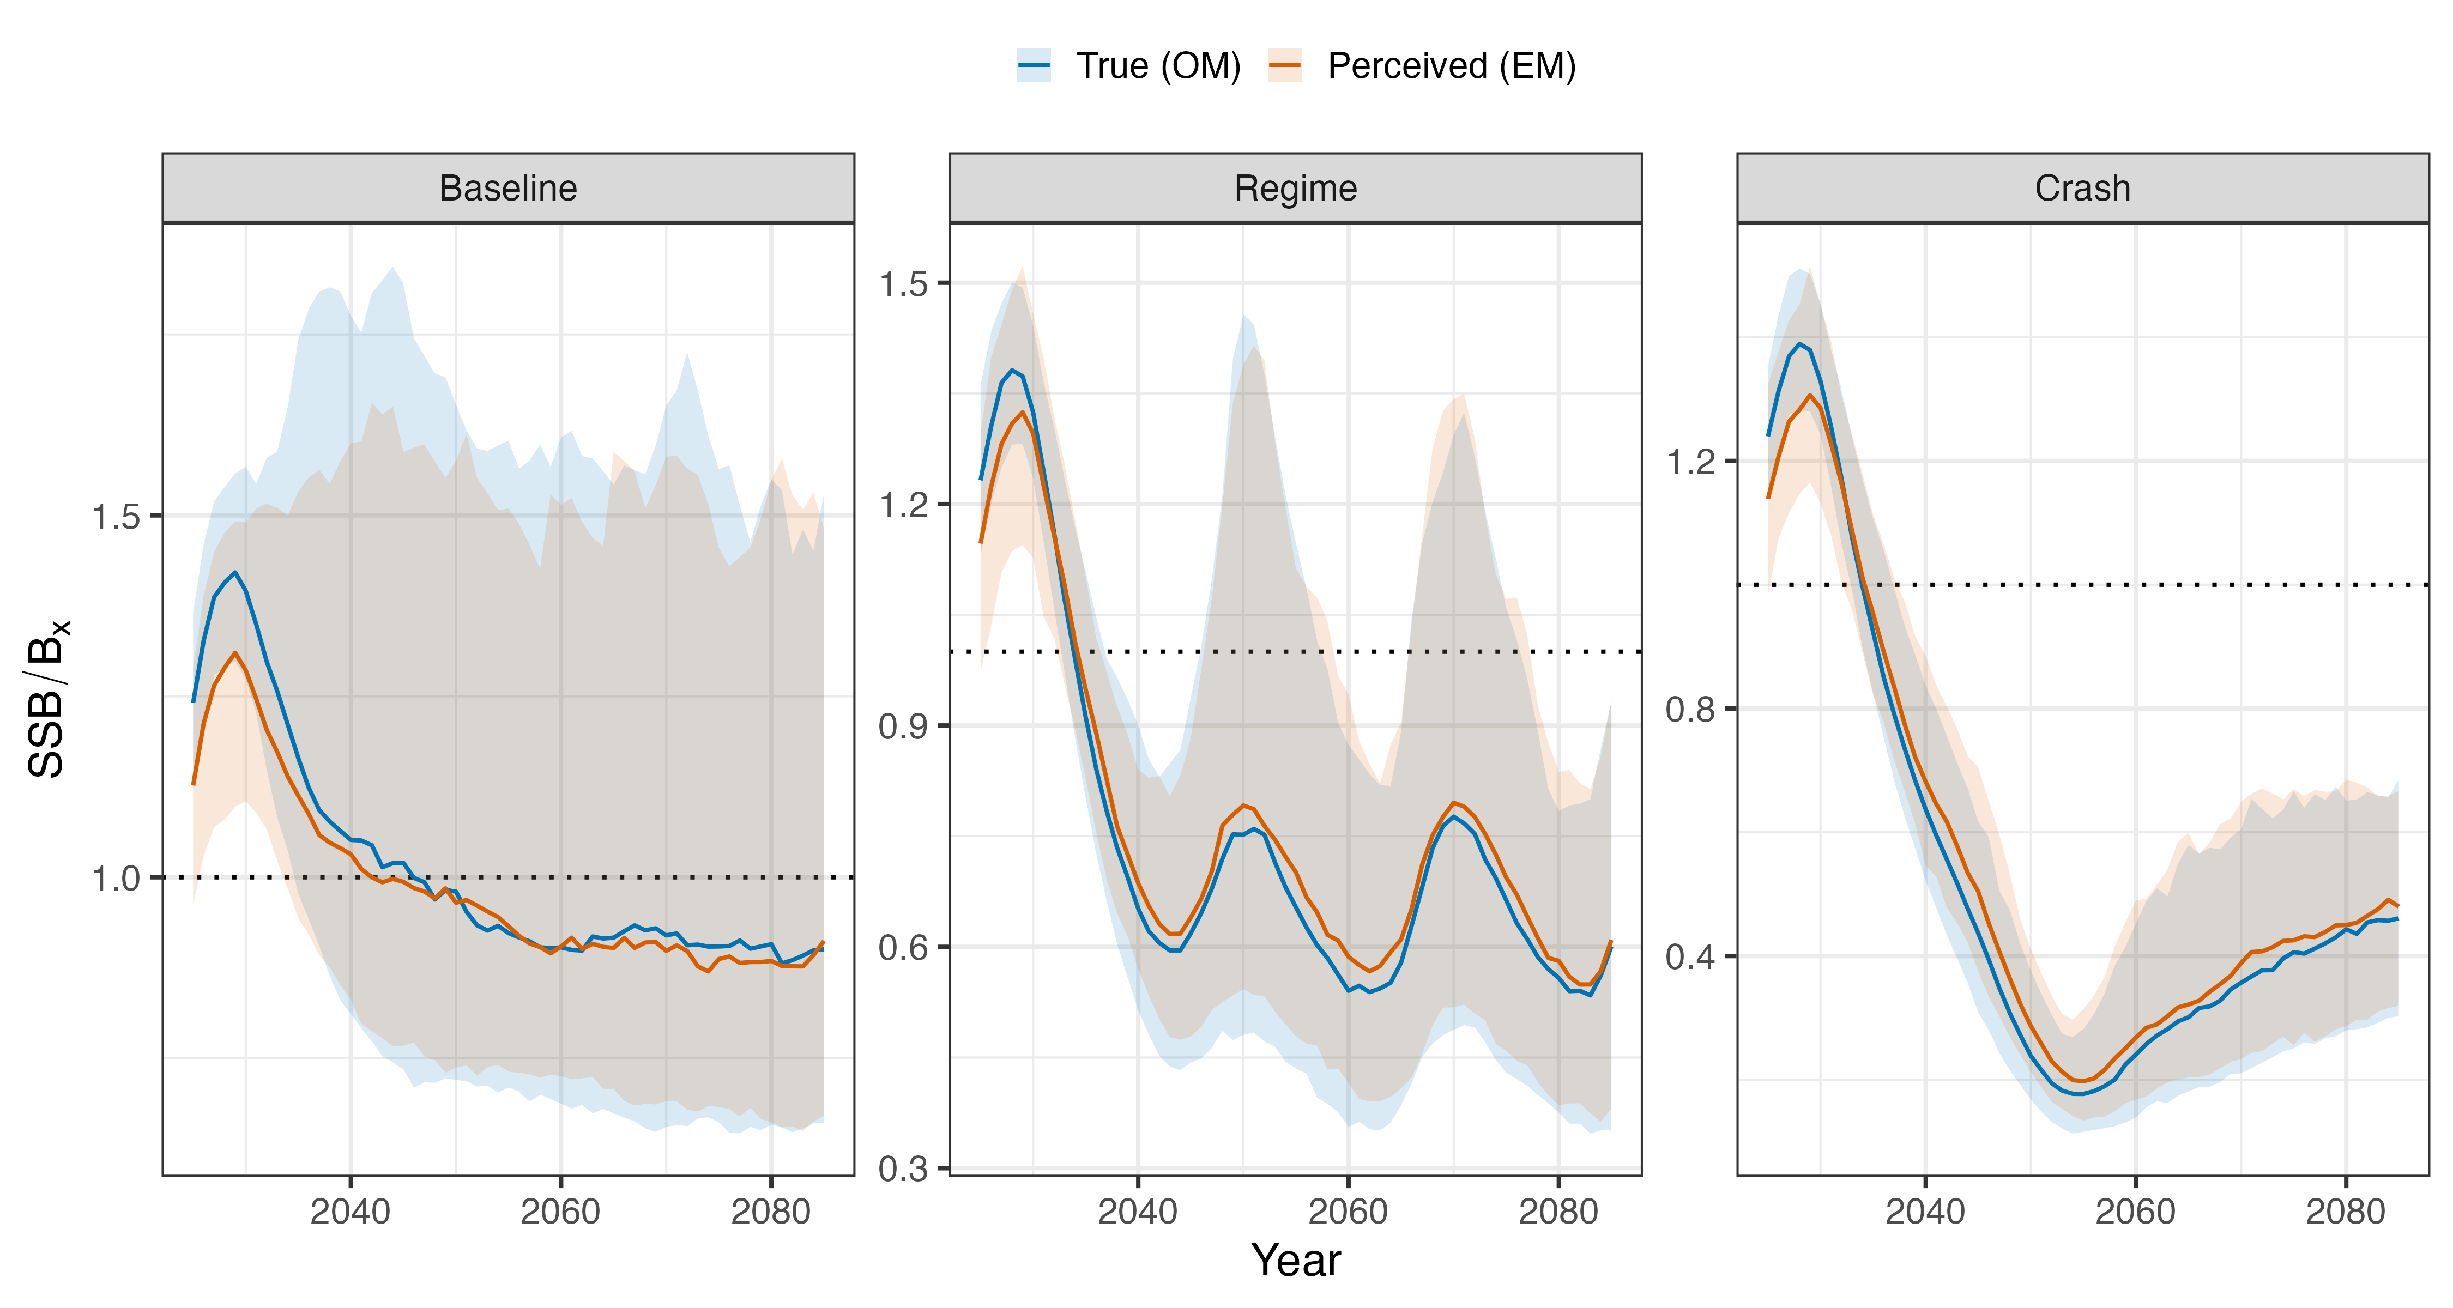
Figure S5. Perceived versus true stock status under the constant F50% rule with assessment, by operating model. Perceived status is the assessment’s terminal-year SSB estimate divided by the B50% it computed in that year; true status is the operating model SSB divided by the same B50%. Lines are medians and ribbons 90% intervals across 150 replicates; the dotted line marks SSB = B50%.
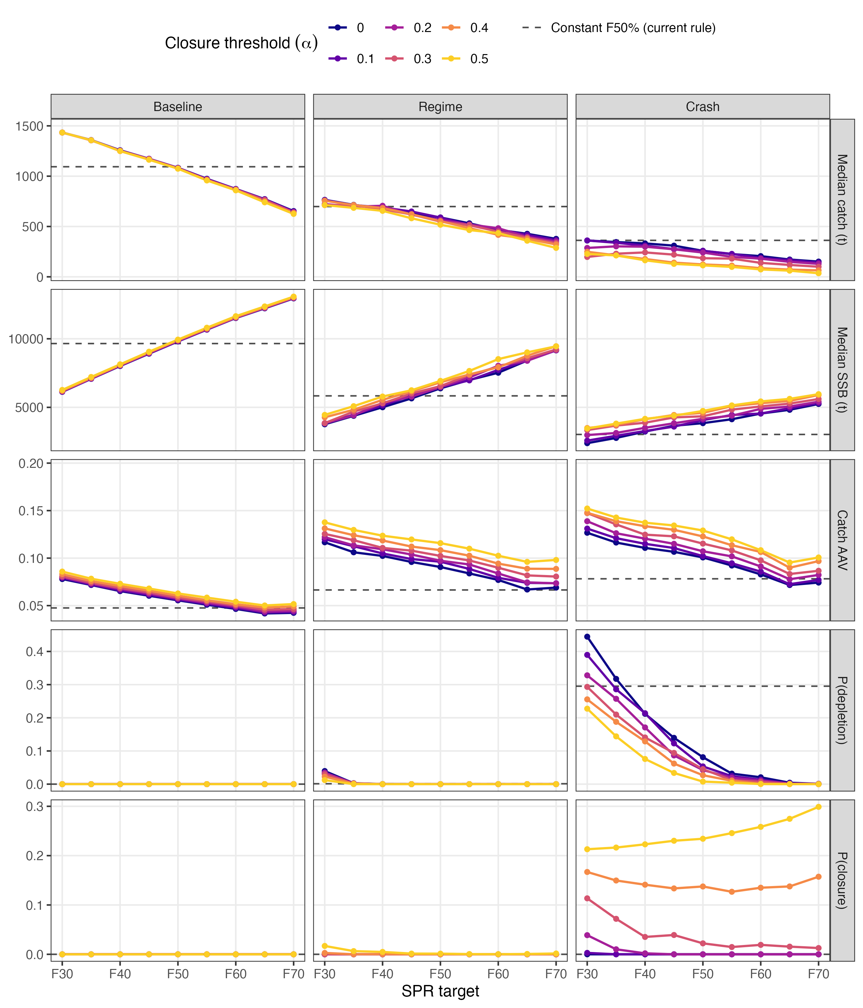
Figure S6. As Figure 3 of the main text, for the threshold rules with the symmetric stability constraint (±15% cap on year-over-year changes in catch). Rows show median catch, median SSB, catch AAV, the probability that SSB fell below 10% of its 1975–2025 maximum, and the probability of fishery closure, by SPR target (x-axis) and closure threshold (α; colours, six of the eleven values evaluated), for the Baseline, Regime, and Crash operating models (columns), each summarized over 2025–2085 and 150 replicates. Dashed horizontal lines give the value for the constant F50% rule with the asymmetric constraint. Axes are identical to Figure 3 and Figure S7.
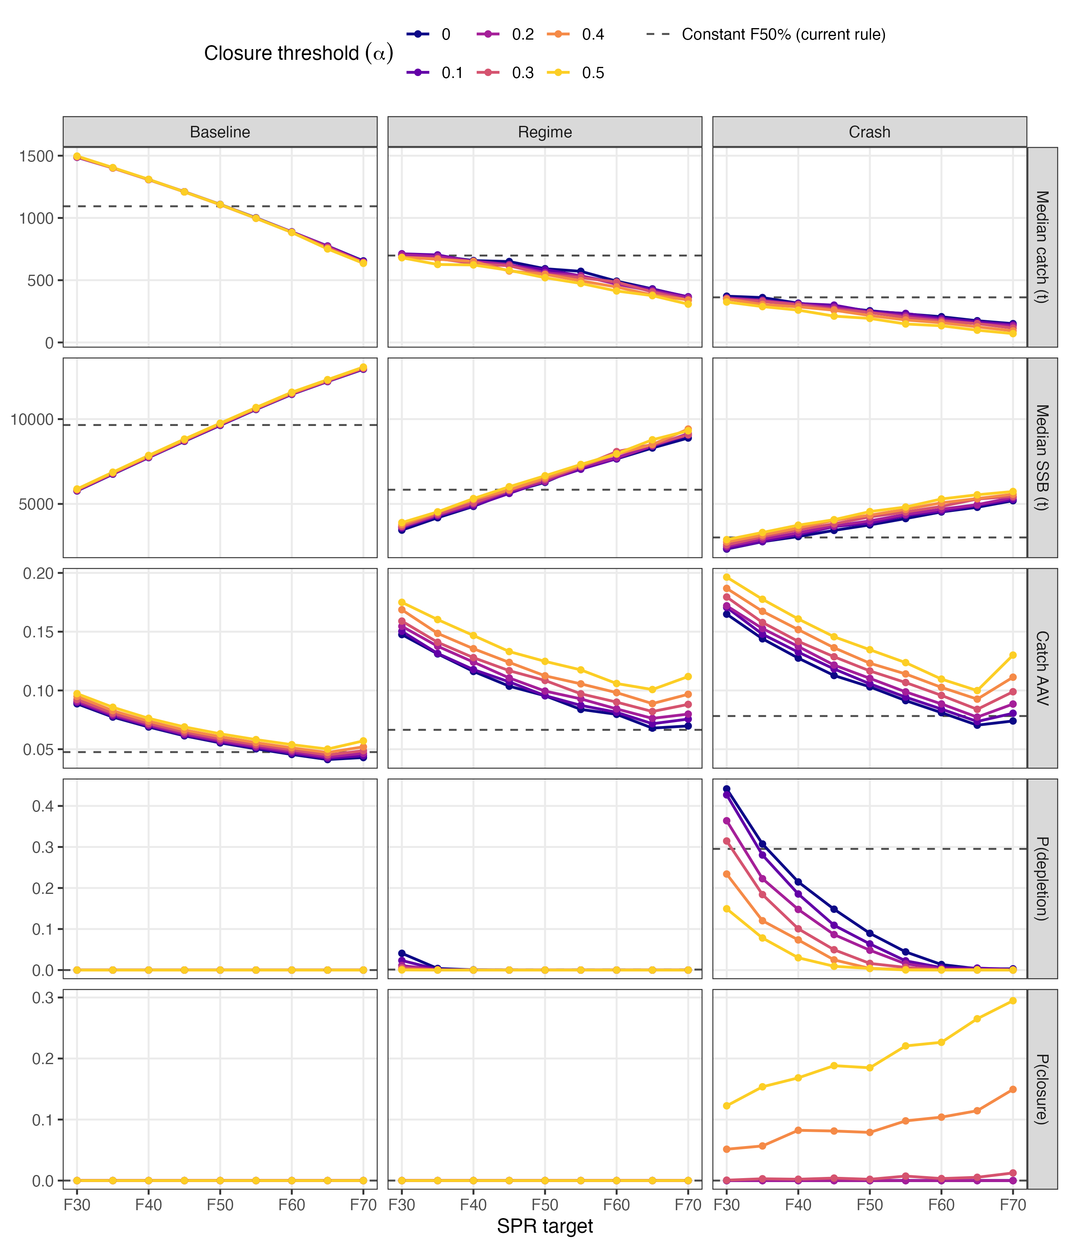
Figure S7. As Figure 3 of the main text, for the threshold rules with no stability constraint. Layout, metrics, and axes as in Figure S6; dashed horizontal lines give the value for the constant F50% rule with the asymmetric constraint.
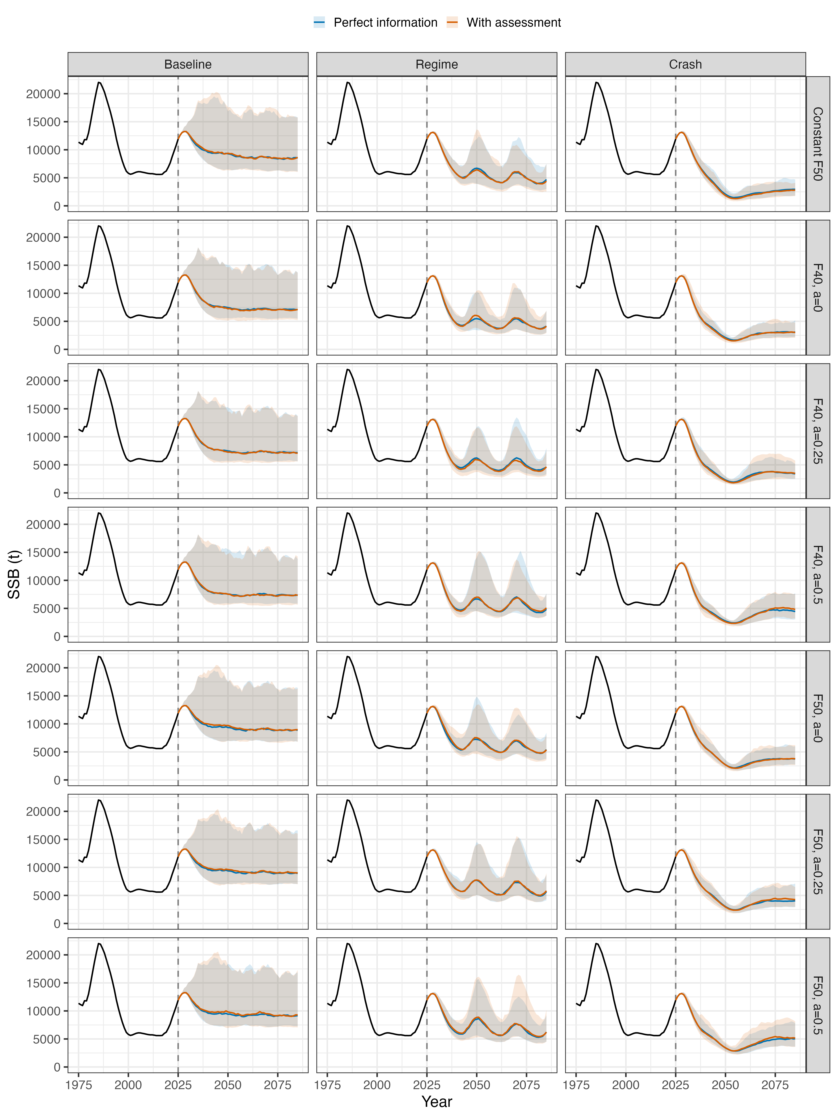
Figure S8. Spawning stock biomass over the conditioning and projection periods for the seven candidate harvest control rules (rows) and the Baseline, Regime, and Crash operating models (columns), under perfect information (blue) and with assessment (orange). Lines are medians and ribbons 90% intervals (5th to 95th percentiles) across 150 replicates. The black line is the conditioning trajectory (1975–2025), which is shared by all replicates and rules, and the dashed vertical line marks the terminal conditioning year (2025).
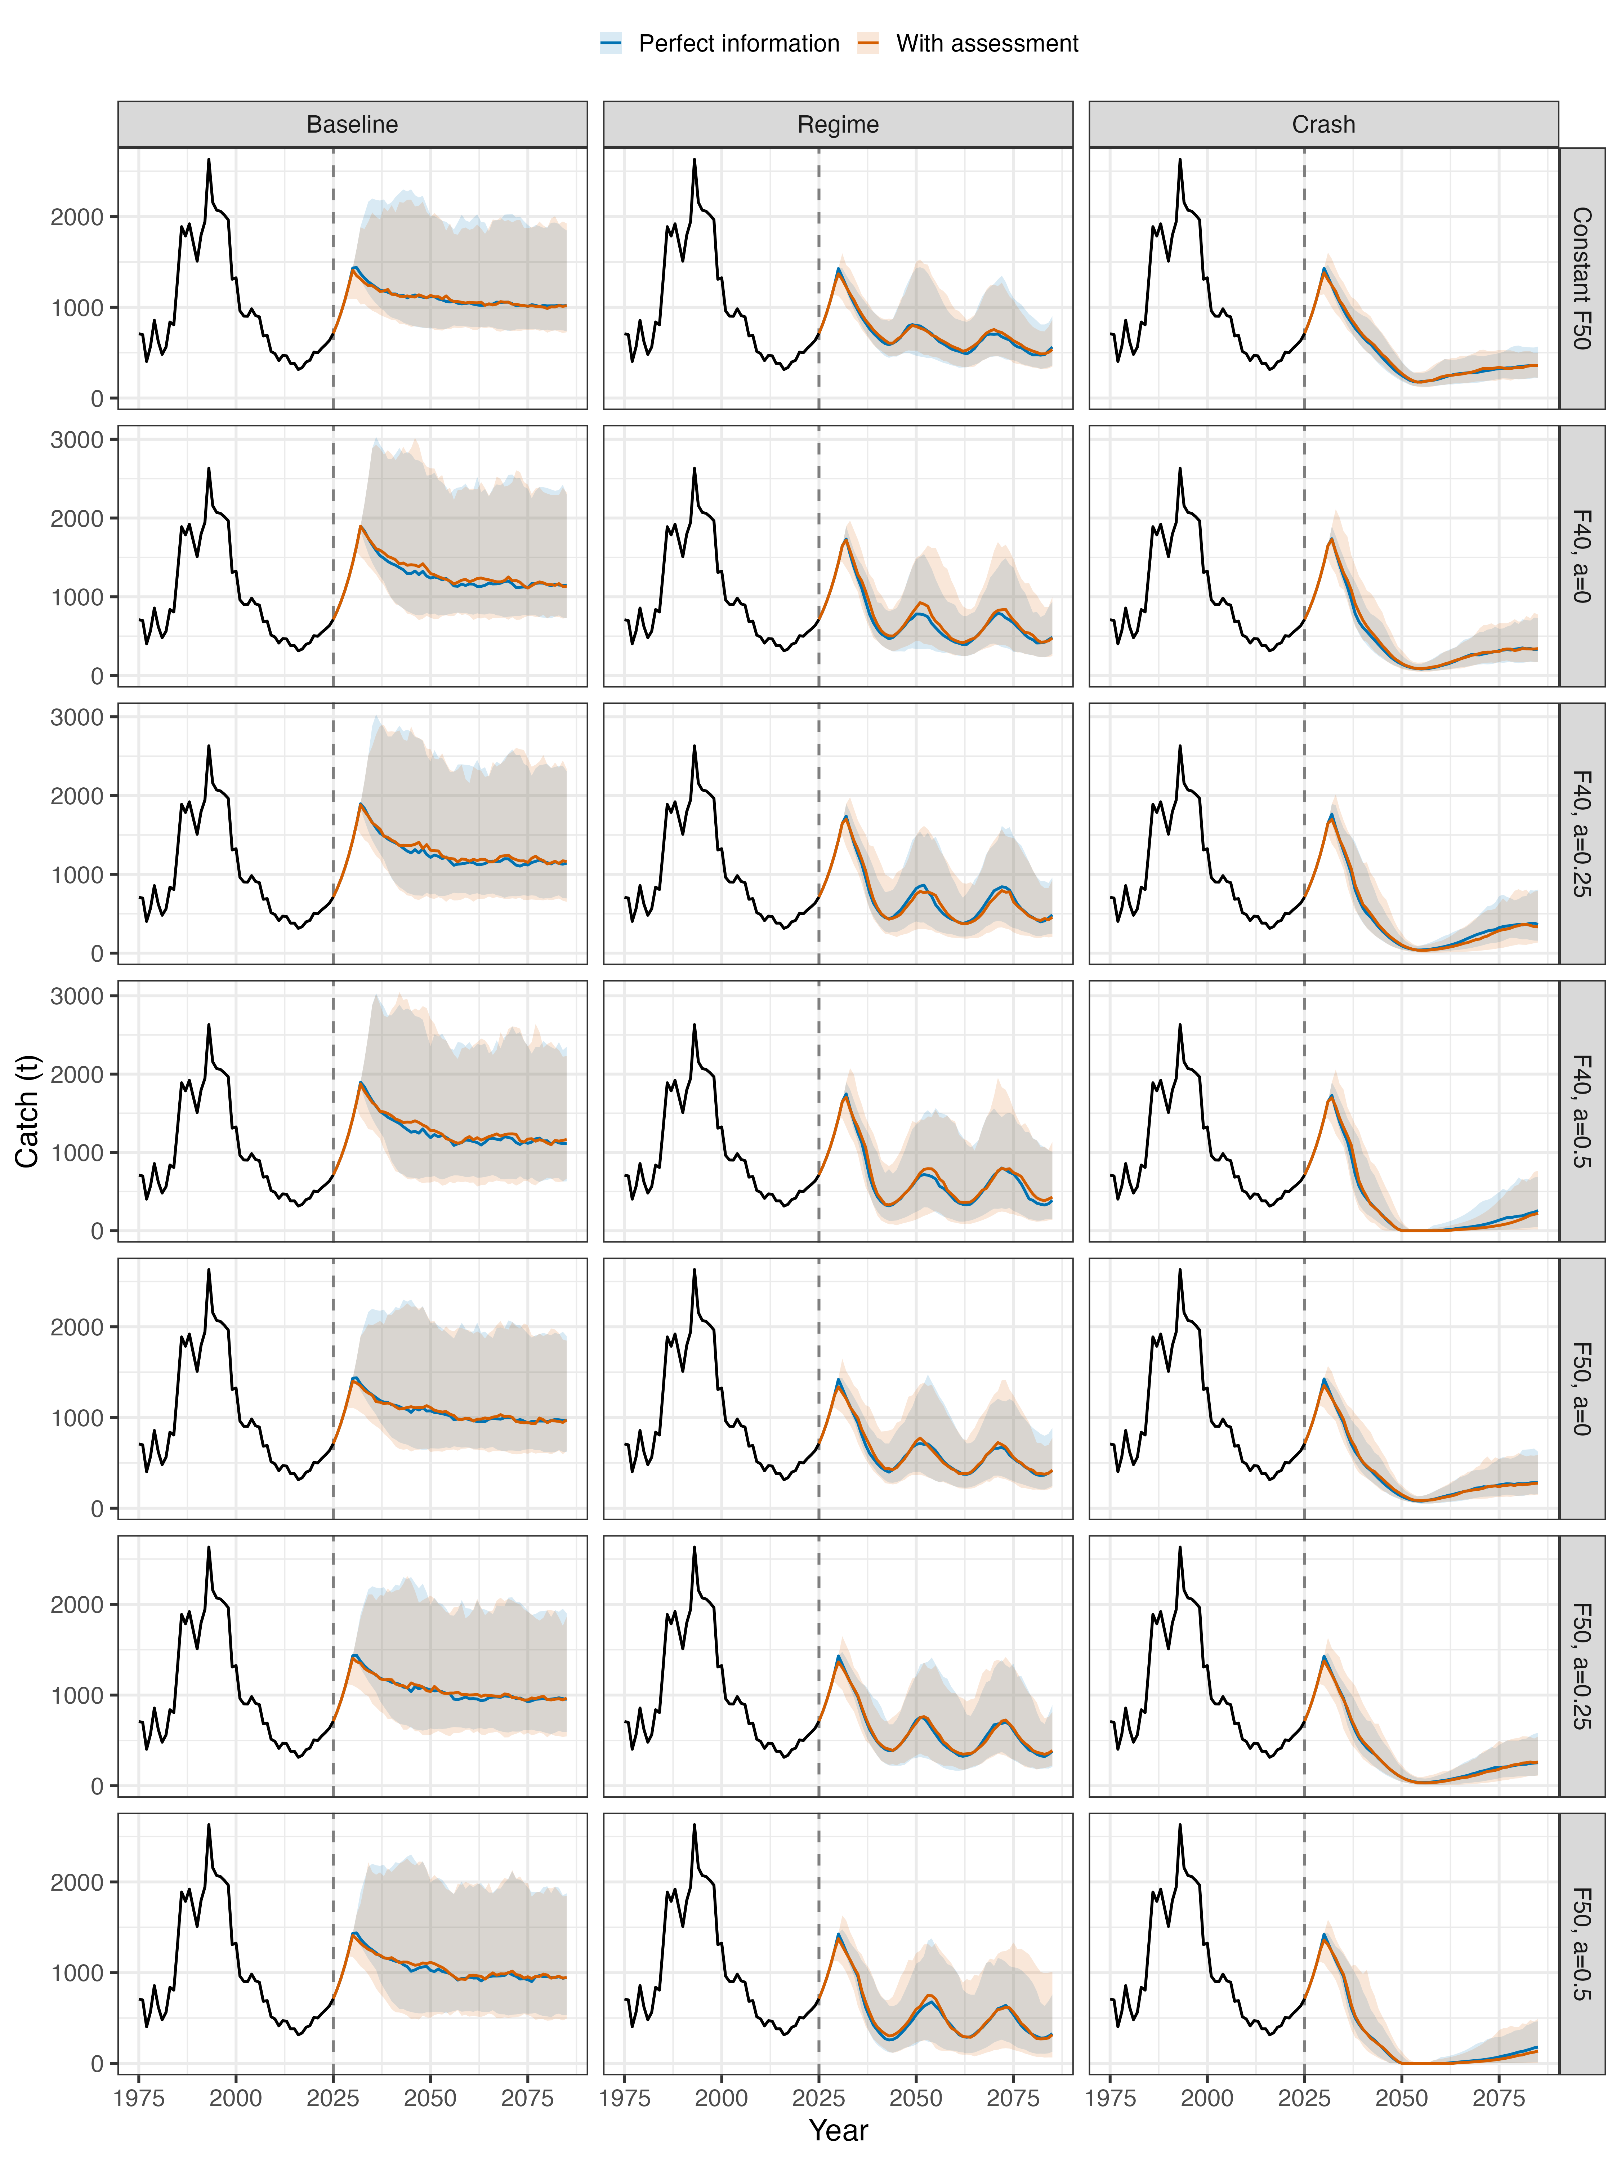
Figure S9. As Figure S8, for catch.
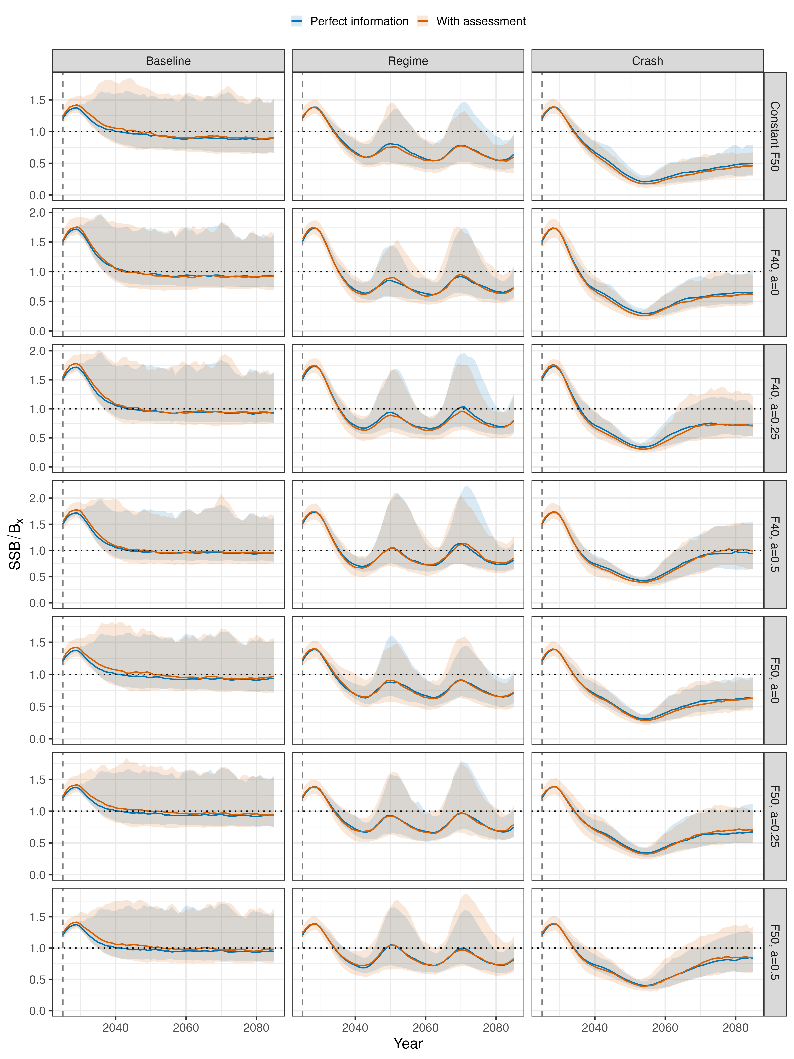
Figure S10. Stock status (SSB / Bₓ) over the projection period for the seven candidate harvest control rules (rows) and three operating models (columns), under perfect information (blue) and with assessment (orange), where Bₓ is the biomass reference point the rule used in that year (B40% or B50%, and B50% for the constant F50% rule). Lines are medians and ribbons 90% intervals across 150 replicates; the dotted line marks SSB = Bₓ and the dashed vertical line the terminal conditioning year (2025).

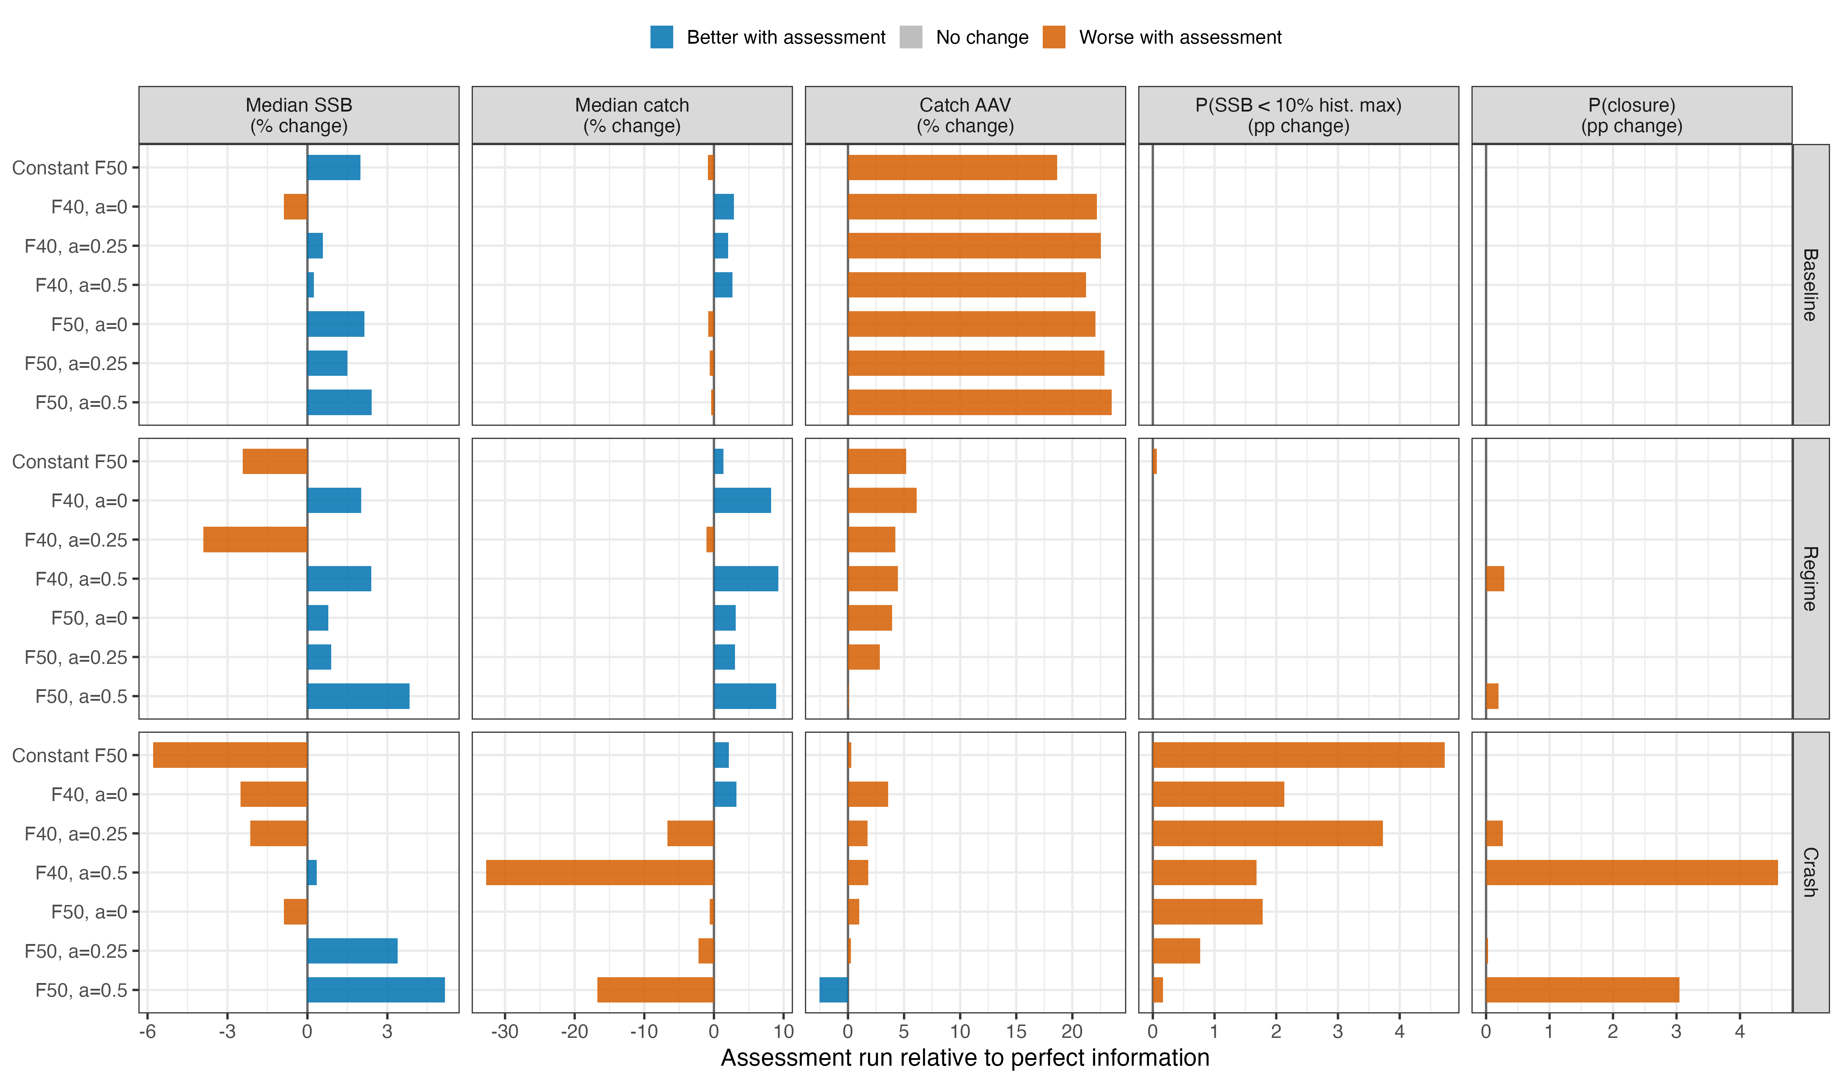
Figure S11. Change in each performance metric for the seven candidate harvest control rules when the assessment is incorporated, relative to perfect information, by operating model (rows). Median SSB, median catch, and catch AAV are shown as percent changes; the probability that SSB fell below 10% of its 1975–2025 maximum and the probability of closure as percentage-point changes. Blue bars indicate better performance with assessment and orange bars worse performance; metrics with no change are omitted.

