CEG5206 CPU Experiment Comparison
  - Group 6 Exact kNN Search Report date 23 October 2026
This report compares three records: the original experiment by Member 1, a local run of the original executable, and a local rebuild from the same source. All three use identical inputs and measurement rules. Their hardware, operating systems, virtualisation and binary provenance differ.
The results cover eight parameter configurations and two methods, giving 16 matched comparisons. Both local runs are faster at baseline, although the local rebuild is slightly slower than the original experiment in two AVX2 configurations. All three main experiments pass the required correctness checks, with zero FP64 neighbour ID-position differences. Timing variability and environment differences limit the conclusions; the gaps cannot be attributed entirely to the CPU model.

1 Experimental environments
Attribute | A Original run | B Original binary locally | C Local rebuild
Processor | Core Ultra 5 125H | Core i7-12700H | Core i7-12700H
Operating system | openEuler 24.03 | Ubuntu 26.04 | Ubuntu 26.04
Virtualisation | VMware | WSL2 | WSL2
Visible logical CPUs | 2 | 20 | 20
Measured executable | Release binary built by Member 1 | Same retained binary as A  No local rebuild | Built locally from the original source  New Release binary
Build compiler | GCC 12.3.1 | GCC 12.3.1  Original binary build | GCC 12.5.0
Compute threads | 1 | 1 | 1
CPU affinity | Logical CPU 1 in each environment | Logical CPU 1 in each environment | Logical CPU 1 in each environment

Experiment B keeps the original executable to reduce differences introduced by recompilation. Experiment C checks the build, correctness and performance of the same source on the local machine. The same logical CPU number does not guarantee the same type of physical core.

2 Shared settings and parameter grid
All three records use source revision 063769a4d6b04f6f572aa01d119c3092e4e5577d. Each contains one complete main experiment; results are not selected or pooled across multiple complete experiments. The comparisons consistently use the first timing group, group 0, as in the original report.
Setting | Common procedure
Input generation | Row-major FP32 arrays; synthetic v1; MT19937 seed 5206 reset for each configuration; generate X then Q; labels are ID modulo 10.
Warm-up and timing | 10 warm-ups and 20 complete-search timings per method and group; alternate the order of the two methods each round.
Timing boundary | Include state reset, distance computation, selection, final ordering and label gathering.  Exclude input generation, file I/O, full validation, the FP64 oracle and initial reusable allocation.
Floating-point controls | Disable fast math and FMA contraction; disable scalar auto-vectorisation; round to nearest; disable FTZ and DAZ.
Statistics and extra groups | Linearly interpolate quartiles and median at position 19p. If either method has IQR/median above 10%, add at most one group for both methods and retain every record.

R0 combines scalar distance computation with full sorting. R1 combines AVX2 distance computation with a Top-k max-heap. These are complete search methods: the R1/R0 difference includes changes to both distance arithmetic and candidate selection.
Table 1 Eight configurations with database rows N, dimension d, query count q and output size k
Case | Parameter change | N | d | q | k
0 | Baseline | 100000 | 64 | 16 | 10
1 | Smaller database | 10000 | 64 | 16 | 10
2 | Lower dimension | 100000 | 32 | 16 | 10
3 | Higher dimension | 100000 | 128 | 16 | 10
4 | Single query | 100000 | 64 | 1 | 10
5 | Larger batch | 100000 | 64 | 64 | 10
6 | Smaller k | 100000 | 64 | 16 | 5
7 | Larger k | 100000 | 64 | 16 | 32

3 All 16 latency comparisons
Table 2 lists all eight configurations and both methods. Times are in milliseconds; lower is faster. Each value is the median of 20 calls in group 0. An A/B or A/C ratio above one means that the corresponding local run is faster.
Table 2 Complete results for the three experiments using the parameters in Table 1
Case | Method | A  ms | B  ms | C  ms | A / B  ratio | A / C  ratio
0 | R0 | 215.247 | 129.874 | 137.031 | 1.657 | 1.571
0 | R1 | 45.207* | 20.766* | 27.189* | 2.177 | 1.663
1 | R0 | 18.345* | 10.940 | 11.329 | 1.677 | 1.619
1 | R1 | 2.571* | 1.217 | 1.280* | 2.113 | 2.008
2 | R0 | 186.177 | 114.044 | 121.362 | 1.633 | 1.534
2 | R1 | 24.624* | 9.802* | 11.565* | 2.512 | 2.129
3 | R0 | 294.843 | 189.116 | 193.697 | 1.559 | 1.522
3 | R1 | 68.524* | 49.974* | 58.207* | 1.371 | 1.177
4 | R0 | 13.816* | 8.487 | 8.468 | 1.628 | 1.631
4 | R1 | 3.044* | 1.679 | 1.884 | 1.814 | 1.616
5 | R0 | 885.862 | 544.341 | 600.751* | 1.627 | 1.475
5 | R1 | 163.747 | 92.523 | 122.000 | 1.770 | 1.342
6 | R0 | 219.832 | 134.578 | 212.966* | 1.633 | 1.032
6 | R1 | 35.487* | 22.514 | 37.787* | 1.576 | 0.939
7 | R0 | 214.022 | 134.721 | 195.904 | 1.589 | 1.092
7 | R1 | 34.476* | 22.462 | 34.681 | 1.535 | 0.994

An asterisk marks an IQR/median ratio above 10%, indicating substantial variability within that timing group. Additional groups do not replace group 0 in this table; they are retained with all raw samples. Section 5 gives the corresponding variability figures.
R0 is scalar full sort; R1 is AVX2 with a Top-k heap. Ratios are calculated from unrounded measurements. Only the displayed values are rounded, so ratios recomputed from this table may differ slightly.

4 Baseline results and interpretation
The baseline is N=100000, d=64, q=16 and k=10, corresponding to case 0 in Table 1. Figure 1 compares complete batch latency for the three experiments.
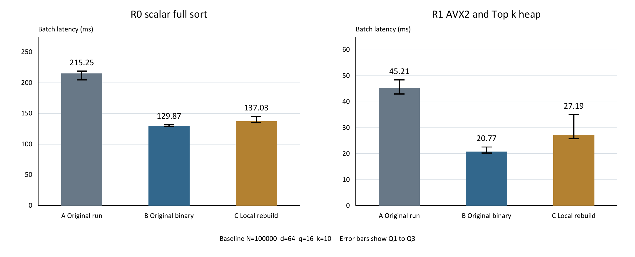
Figure 1 Baseline medians and Q1 to Q3 ranges with different vertical scales and no confidence intervals
Experiment | R0 ms | R1 ms | R0 / R1
A Original run | 215.247 | 45.207 | 4.76
B Original binary locally | 129.874 | 20.766 | 6.25
C Local rebuild | 137.031 | 27.189 | 5.04

At baseline, B is about 1.66 times faster than A for scalar full sort and 2.18 times faster for AVX2 with a heap. C is about 1.57 and 1.66 times faster, respectively. These ratios describe measured batch latency in the recorded environments.
Across all 16 comparisons, B is faster than A in every case. C is faster in 14 cases; its R1 results for cases 6 and 7 are slightly slower than A, with A/C ratios of 0.939 and 0.994. The baseline advantage therefore does not extend to every parameter setting.
B and C were not simultaneous paired experiments, and their compiler and runtime conditions differ. C being slower than B here does not establish that local recompilation reduces performance. R0/R1 measures the speedup between complete methods, rather than the isolated benefit of SIMD instructions.

5 Timing variability and additional groups
IQR is the third quartile minus the first quartile. Table 3 reports group 0 IQR/median percentages for the same 16 comparisons as Table 2. Values above 10% are marked as variable under the original rule.
Table 3 Group 0 IQR to median percentages for all 16 comparisons
Case | Method | A | B | C
0 | R0 | 6.6% | 2.0% | 7.3%
0 | R1 | 12.0%* | 11.3%* | 34.0%*
1 | R0 | 18.9%* | 6.1% | 5.3%
1 | R1 | 21.8%* | 8.5% | 11.9%*
2 | R0 | 7.9% | 3.5% | 6.5%
2 | R1 | 35.1%* | 10.5%* | 28.1%*
3 | R0 | 6.5% | 8.3% | 5.7%
3 | R1 | 14.7%* | 20.7%* | 11.8%*
4 | R0 | 16.5%* | 5.2% | 4.8%
4 | R1 | 25.6%* | 5.3% | 7.8%
5 | R0 | 4.8% | 2.3% | 22.0%*
5 | R1 | 5.7% | 7.9% | 8.7%
6 | R0 | 7.6% | 1.4% | 15.8%*
6 | R1 | 38.5%* | 6.9% | 14.6%*
7 | R0 | 5.9% | 0.9% | 7.8%
7 | R1 | 30.7%* | 4.1% | 8.5%

Baseline R1 variability is about 12.0%, 11.3% and 34.0% for A, B and C. C is particularly variable here, so 27.19 ms should not be interpreted as a stable, invariant latency. If an additional group is still variable, the experiment does not keep repeating until a better result appears.
A, B and C trigger additional groups for seven, three and six parameter configurations, yielding 600, 440 and 560 raw timing samples. These counts follow the same conditional rule; they are not extra repetitions of the entire experiment. Each method and timing group still contains exactly 20 calls.

6 Correctness and limits of the conclusions
Check | A | B | C
Main correctness records | 16 | 16 | 16
Structure, labels, order and selection | PASS | PASS | PASS
Distance tolerance and determinism | PASS | PASS | PASS
Main FP64 ID-position differences | 0 | 0 | 0
SHA256 of 24 input files | Identical across A, B and C | Identical across A, B and C | Identical across A, B and C

Distance checks require absolute error <= 0.00001 + 0.0001 times the absolute reference distance. FP64 neighbour ID agreement in the main experiment does not guarantee strict agreement for every floating-point input. Local unit tests include numerical boundaries such as near ties and separately record 16 FP32/FP64 ID-position differences. These are reported independently of the zero differences in the main experiment.
For C, the Release, independent clean Release and Debug memory-checking builds each pass 111 cases and 1145 checks. Only the Release build is used for performance timing; memory-checking builds are excluded from the latency comparison.
The source records below retain the raw timing groups, correctness checks, input hashes, build provenance and execution notes for these comparisons.
A Original experiment records
B Original executable run locally
C Local rebuild and build provenance

