PAPR and Error Performance of DFT Spread OFDM for 5G Uplink Transmission
Abstract—This paper comparatively analyzes CP-OFDM and locally-mapped DFT-s-OFDM in the 5G uplink. Using MATLAB, I investigated whether reducing the signal peak could also, to a certain extent, lower the bit error rate. After quadruple oversampling of 30,000 data blocks, the DFT expansion reduced the 99th percentile PAPR of QPSK and 16-QAM by 2.92 dB and 2.09 dB respectively. The BER curves of the two waveforms in AWGN are almost identical; in the Rayleigh fading test, the zero-forcing receiver spreads the noise on the weak subcarrier to the entire data block, causing the BER of DFT-s-OFDM to increase instead. After adding power amplifier limiting, its advantages begin to manifest: with an input attenuation of 2 dB, the BER of 16-QAM drops from 0.00512 to 0.00121. Therefore, when we select the uplink channel waveform, we not only need to compare the peak-to-average power ratio, but also need to take into account the influence of the receiver and the power amplifier.
Keywords—5G uplink; digital modulation; DFT-s-OFDM; PAPR; zero-forcing equalization; clipping.

I. INTRODUCTION

A. Background and Motivation
The signals sent from the mobile terminal need to pass through a power amplifier first, and then enter the wireless channel. The larger signal peaks can cause certain difficulties for the power amplifier circuit, because even if the average power is within the allowable range of the channel, some of the sampled values may still exceed the amplitude limit and be clipped. Parkvall et al. [1] and Shafi et al. [2] have already provided a comprehensive introduction to the overall background of the 5G system. This paper will narrow the scope to the changes brought about by DFT expansion, and compare the two waveforms under the same conditions of bandwidth, modulation method and average input energy.
Orthogonal Frequency Division Multiplexing (OFDM) is a technique that transmits data simultaneously over multiple subcarriers. The signals of each subcarrier sometimes superimpose in the same direction, resulting in large instantaneous peaks. If the sampling values at the end of the data block are copied to the beginning, a cyclic prefix (CP) is formed, and thereby the CP-OFDM signal used as the benchmark in this paper is obtained. DFT extended OFDM involves adding one DFT step before the symbols are mapped to subcarriers. In this paper, a local mapping method is adopted, where the allocated subcarriers are adjacent in frequency. This structure can be implemented based on the CP-OFDM transmitter.

B. Literature Survey
The transformation processing shared by these two waveforms has a long research history. Weinstein and Ebert [12] introduced the frequency division multiplexing method based on DFT, while Bingham [13] presented the principles and applications of multi-carrier modulation. The principles described in these papers form the basis for the implementation in this article: The transmitting end generates data blocks through IFFT, and the receiving end restores the values of subcarriers through FFT. DFT-s-OFDM retains this processing procedure, adding DFT before subcarrier mapping and inverse DFT after equalization. Furthermore, the two waveforms can be placed in the same MATLAB model for comparison.
For SC-FDMA, the allocation method of subcarriers and the receiver both have an impact on its performance. Myung et al. [4] investigated the effects of different mapping methods and pulse shaping on the peak-to-average power ratio (PAPR). Pancaldi et al. [5] investigated the problem of frequency-domain equalization in single-carrier transmission. Priyanto et al. [14] conducted tests on DFT-extended OFDM in the uplink of LTE. Berardinelli et al. [16] conducted a study on OFDMA and SC-FDMA in the IMT-Advanced scenario. These studies indicate that waveform performance needs to be analyzed in conjunction with specific working conditions. Therefore, in this paper, when comparing CP-OFDM and DFT-s-OFDM in the simplified 5G uplink, the settings of subcarrier mapping and equalizer are clearly presented.
DFT expansion is a method for handling some large signal peaks. Han and Lee [6] as well as Jiang and Wu [7] have conducted reviews discussing methods such as clipping, encoding, selective mapping, and pitch reservation. When comparing peak values, it is also necessary to pay attention to the frequency at which the larger peaks occur. Ochiai and Imai [9] conducted a statistical study on the PAPR of OFDM. Therefore, this paper has collected a large amount of data blocks instead of merely presenting a simple time-domain waveform. Li and Cimini [8] analyzed the changes in limiting and filtering based on bit error rate and spectrum. Ochiai and Imai [17] studied the OFDM signal after limiting.
Spectrum comparison also requires a clear understanding of the shape of the pulses. Sahin et al. [10] studied the organization of multi-carrier filters and signals. Farhang-Boroujeny [11] compared OFDM with group-based multi-carrier filtering. Levanen et al. [15] conducted research on the waveform processing at the transmitting and receiving ends of 5G NR. The two waveforms in this article both use rectangular pulses and no additional filters are added. Therefore, the spectrum test compares the effects of DFT expansion and limiting under the same pulse conditions.

C. Project Question and Contributions
A lower PAPR is beneficial for the performance at the transmitting end, but it does not directly determine how many bit errors will occur at the receiving end. A lower PAPR is beneficial for the performance at the transmitting end, but it does not directly determine how many bit errors will occur at the receiving end. First, I compared CP-OFDM and DFT-s-OFDM in linear transmission, and then added power amplifier clipping; I made the simulation settings for the two links consistent so that they could share the same resources. Since DFT-s-OFDM is already a mature method, I did not propose any new modulation techniques. Instead, I focused on observing under which conditions its performance is the best. And when will the channels and equalizers weaken or even reverse the advantages brought about by the low peaks?
This article compares the above situations. By keeping the definitions of bandwidth and energy consistent, the six generated graphs represent PAPR, BER, error vector magnitude (EVM), and power spectrum respectively. These graphs compare the peak of the transmitted signal, distortion, and the error at the receiving end. They also include the situation where the waveform with lower PAPR results in a higher BER in a fading channel.

II. SYSTEM MODEL AND PROBLEM FORMULATION

A. Transmitter and Subcarrier Mapping
Suppose that data block d contains K complex symbols, and the average energy of each symbol is one. When using Gray mapping, each symbol of QPSK carries b = 2 bits, and each symbol of 16-QAM carries b = 4 bits. F_K and F_N represent the DFT matrices after energy normalization. The mapping matrix P places the K values on adjacent subcarriers near the center of the rest with zeros. Based on this, the valid transmission data block can be written as
$$x_{CP}=F_{N}^{H}P d,x_{DFT}=F_{N}^{H}PF_{K}d. (1)$$
The superscript H represents the conjugate transpose; for the normalized DFT, it's the inverse transformation. The expected energy of both waveforms is E{||x||²} = K. The average sampling power is K/N. At the base sampling rate, N_base is 256 and K is set to 72. The subcarrier spacing is 15 kHz and the occupied bandwidth is 1.08 MHz. The waveform measurement employs a four-fold oversampling method, which increases the FFT length to N = 1024 and the sampling rate to 15.36 MHz, while maintaining the subcarrier spacing and the occupied bandwidth.

B. Channel, Noise, and Receiver
In this article, I employed two channel models to distinguish the effects of noise and multipath fading. Only introduce AWGN noise without altering the channel frequency response. The Rayleigh model contains four paths. The delay at the base sampling rate is [0, 1, 3, 5], and the average power is proportional to [1, 10⁻⁰·³, 10⁻⁰·⁶, 10⁻⁰·⁹] . Each data block independently generates a set of channel coefficients that remain constant within the block. The channels generated in a single instance will no longer be normalized separately, to avoid excluding some weak channel situations. After removing the cyclic prefix and performing FFT, the received data block returns to the frequency domain. Selecting the effective subcarriers will result in
$$Y =diag(H) S d + n, S ∈ \{I_{K},F_{K}\}. (2)$$
If it is assumed that the receiver has the exact channel response known, and the timing is correct. Definition γ_b = 10^(E_b/N_0[dB]/10), Then the noise variance on the effective subcarrier is σ_n² = c/(bγ_b). Therefore, in this text, E_b/N_0 includes the pre-circuit prefix energy and is based on the signal before it reaches the power amplifier. To control the running time of the linear channel test, the program directly calculates the BER in the frequency domain. Under these assumptions, the zero-forcing (ZF) equalization is expressed as
$$d̂ =S^{H}diag(1/H) Y. (3)$$
The ZF receiver will divide the received value of each valid subcarrier by the corresponding channel response. The subsequent steps will be determined by the waveform: CP-OFDM can be directly detected, while DFT-s-OFDM requires first performing K-point IDFT to restore to the data symbol domain. Then, the nearest constellation point was selected for the hard-bit decision. Both links employed ZF and DFT as the main comparison factors.

C. How Fading Affects the Receiver
Only in the AWGN case, H = 1, and there is no attenuation difference between subcarriers. The DFT and IDFT preserve the signal energy and noise distribution, so the theoretical BER of the two waveforms is the same. The noise variance after equalization on subcarrier k in CP-OFDM is σ_n²/|H_k|². For DFT-s-OFDM, the noise variance of each recovered symbol after IDFT is
$$σ_{DFT}^{2}=\frac{σ_{n}^{2}}{K}Σ_{k}{|H_{k}|}^{−2}. (4)$$
When certain |H_k| values are very small, the corresponding terms will account for a large proportion in the average value. ZF amplifies the noise on the weaker subcarriers, and the inverse DFT then spreads these noise components throughout the entire data block. (4) The noise variance under a specific channel is provided. Moreover, there may be some correlation between the noise experienced by different symbols. Therefore, reducing the peak value of the transmission cannot prevent the errors caused by the enhancement of noise at the receiving end.

D. Metrics and Evaluation Question
$$PAPR=\frac{\max_{n}{|x[n]|}^{2}}{{mean}_{n}{|x[n]|}^{2}}. (5)$$
The effective data block before adding the cyclic prefix for PAPR measurement is equal to the ratio of the maximum sampling power to the average sampling power. Its complementary cumulative distribution function (CCDF) indicates what the probability is that the PAPR could exceed a given threshold. The BER at the receiving end is the ratio of the number of erroneous bits to the total number of tested bits. The EVM measures the root mean square deviation between the received symbols and the ideal symbols. The lower the BER and EVM values are, the better the received performance is.

III. PROPOSED TRANSMISSION SCHEME AND SIMULATION

A. Localized DFT-s-OFDM Processing
In DFT-s-OFDM, the data blocks are first subjected to DFT and then mapped onto adjacent subcarriers, [3], [4],[14]. The remaining steps at the transmitting end are the same as those in CP-OFDM. At the receiving end, an 72-point IDFT is added. However, this change will not increase the data transmission rate. Each data block contains 72 bits and the duration remains constant. The unencoded data rates of QPSK and 16-QAM are approximately 2.018 Mbit/s and 4.036 Mbit/s respectively.

B. Amplifier Clipping Model
The power amplifier can be represented by a hard limiter with an amplitude of A. The sampling values lower than A remain unchanged. Values that exceed A are regarded as A. Maintain the phase simultaneously:
$$g(x) = xmin(1, A/|x|). (6)$$
$$A =\sqrt{\frac{K}{N}}{10}^{\frac{IBO}{20}}. (7)$$
Input Backoff (IBO) indicates the extent to which the average input power is below the power amplifier's limit threshold. The larger the IBO, the greater the available peak margin and the less the amplitude limitation. In AWGN, 16-QAM is adopted, and the E_b/N_0 value before the power amplifier is 14 dB.

C. Simulation Settings
Parameter | Value
Random seed / MATLAB | 20261027 / R2024a Update 9
Modulations | QPSK and 16-QAM
FFT / active bins / CP | 256 / 72 / 18 (base rate)
Waveform oversampling | 4×
PAPR sample size | 30,000 blocks per curve
Linear BER stopping | ≥2,048 blocks; target 1,000 errors for both waveforms; cap ≈2×10⁶ bits
PA sample size | 8,000 blocks; 2,304,000 bits per waveform and IBO
PSD sample size | 600 blocks; CP included

Each point provides the same data, channel samples, and noise to the two waveform test inputs. The simulation runs continuously until both waveforms reach the target error count or the total bit count limit is reached. At higher SNR levels, the simulation error rate for a finite length may be quite small. If there are no errors, the CSV file will be recorded as zero（not plotted on the logarithmic BER graph). All the bits in the same block undergo the same fading channel, so these errors are not independent. The sample size also affects the tail estimation of the PAPR distribution.
The power spectral density (PSD) is estimated using 600 data blocks. The length of the Hann window is 4096 sampling points. The adjacent windows will overlap by half. All the curves are based on the maximum PSD of linear CP-OFDM as the reference value, and the display range is ±3 MHz.

IV. SIMULATION RESULTS AND DISCUSSION

A. Peak-to-Average Power Ratio
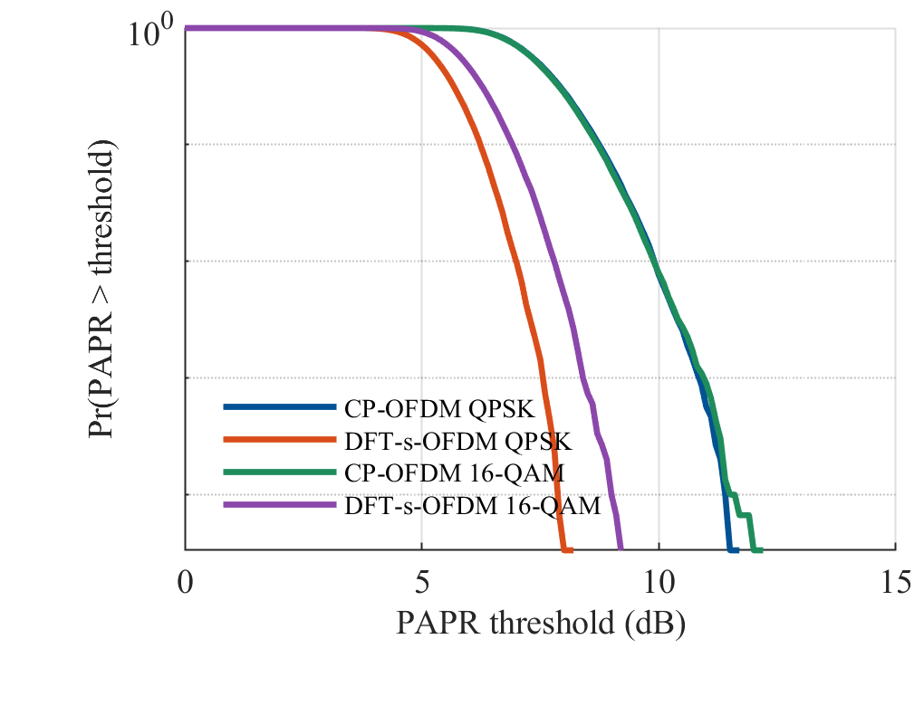
Figure 1. Each curve is obtained by statistically analyzing 30,000 valid data blocks, with a fourfold oversampling rate. CP represents CP-OFDM, and DFT-s represents locally mapped DFT-s-OFDM.
Figure 1 shows that DFT reduces PAPR, and the improvement of QPSK is greater than that of 16-QAM. The PAPR of QPSK has decreased from 9.9014 dB to 6.9846 dB, a reduction of 2.9168 dB. The 16-QAM signal level decreased from 9.8912 dB to 7.7970 dB, a reduction of 2.0941 dB. The two CP-OFDM curves almost overlap each other, while there is a distinct gap between the two DFT-s-OFDM curves. This indicates that under the current subcarrier allocation, the modulation order after DFT has a more significant impact on the peak performance.
Modulation | CP q99 | DFT-s q99 | Reduction
QPSK | 9.9014 | 6.9846 | 2.9168
16-QAM | 9.8912 | 7.7970 | 2.0941

The table shows that approximately 99% of the simulated data blocks are below the corresponding values. At the tail of the distribution, the relationship between the amplitudes of the two waveforms has not changed. The values for CP-OFDM and DFT-s-OFDM in QPSK are 10.8147 dB and 7.5629 dB respectively. For 16-QAM, the values are 10.9292 dB and 8.3986 dB. Therefore, it can be concluded that the DFT expansion will alleviate the limiting effect.

B. Error Rates in AWGN
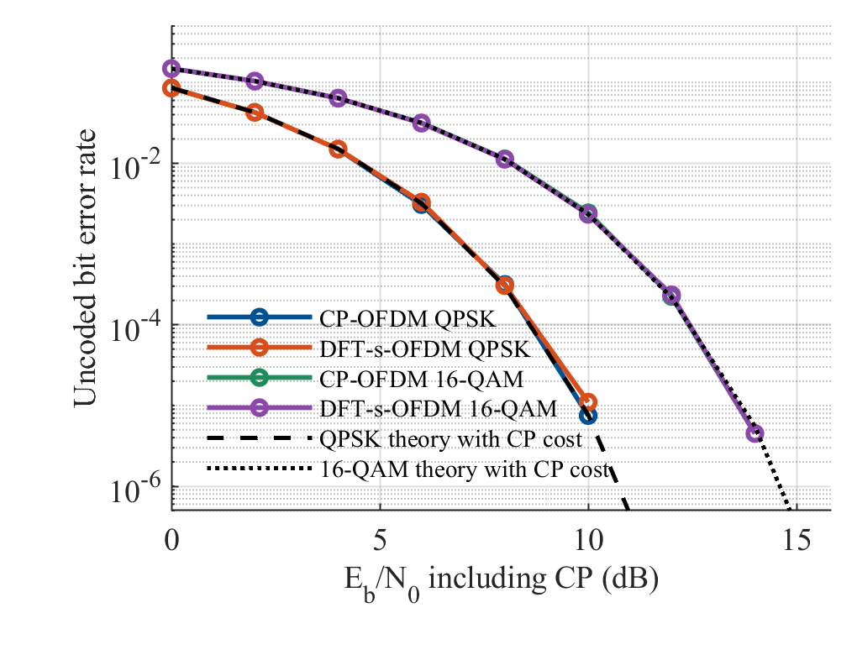
Figure 2. Curve of BER simulation values versus theoretical values in a linear AWGN channel. The reference formula for QPSK is Q(√(2γ_b/c)). The reference formula for 16-QAM is (3/4)Q(a) + (1/2)Q(3a) − (1/4)Q(5a), here a =√(0.8γ_b/c). Q represents the upper tail probability of the standard Gaussian variable, and c is used to incorporate the energy of the cyclic prefix.
In AWGN, the difference between the two waveforms is very small. For 16-QAM, the bit error rates (BER) of CP-OFDM and DFT-s-OFDM at 10 dB are 0.002433 and 0.002328 respectively. At 12 dB, the values are 0.0002240 and 0.0002345 respectively. The conclusion is consistent with the theoretical BER of both.

C. Frequency-Selective Rayleigh Channel with ZF
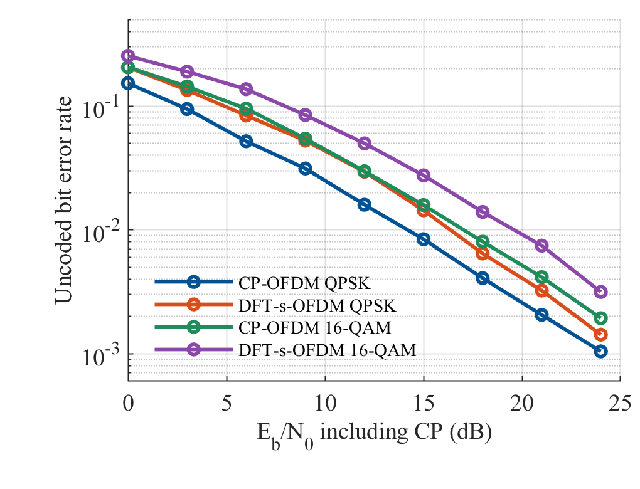Figure 3. Unencoded BER in the four-diameter Rayleigh channel, Use ZF balance.
The Rayleigh channel results in Figure 3 are different from those of PAPR. When using the ZF receiver, the BER of DFT-s-OFDM is higher. At 12 dB, the BER of CP-OFDM is 0.02977, while that of DFT-s-OFDM is 0.04993 for 16-QAM. At 18 dB, the bit error rates (BER) are 0.008024 and 0.01395 respectively. QPSK also exhibited the same trend within the range of SNR tested. Therefore, even if the peak value of the transmitted signal is relatively small, how the receiver handles the fading will still affect the final bit error rate.
Equation (4) can explain this result. For CP-OFDM, the stronger noise on the weak sub-carrier mainly affects the data carried by that sub-carrier. In DFT-s-OFDM, the inverse DFT will incorporate this noise into other symbols. The smaller transmission peak cannot counteract this effect, so under the same fading conditions, the BER may be higher.

D. BER under Amplifier Saturation
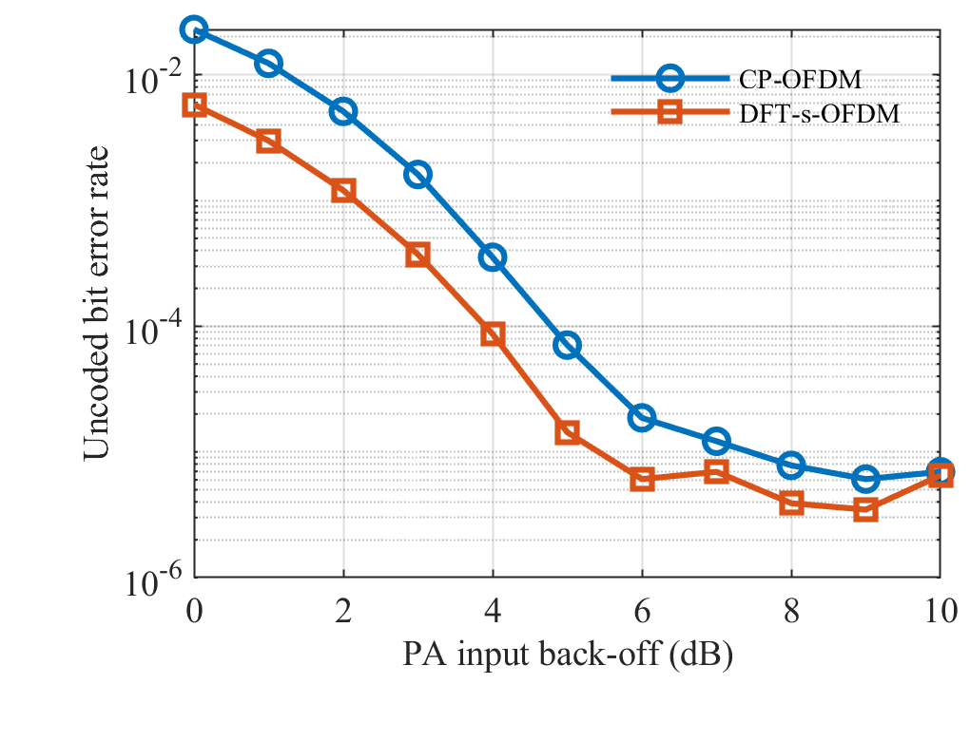
Figure 4. BER of 16-QAM under hard limiter and AWGN conditions, varying with IBO.
After adding power amplifier limiting, the advantages of DFT-s-OFDM begin to manifest. At 2 dB IBO, CP-OFDM had 11,798 errors. DFT-s-OFDM had 2,778 errors. The corresponding BER values are 0.005121 and 0.001206 respectively. Under the same amplitude threshold, the smaller peak value of DFT-s-OFDM results in less damage to the transmitted signal.
This advantage persists at 3 dB IBO. At this point, the BER values for CP-OFDM and DFT-s-OFDM are 0.001613 and 0.0003733 respectively. Among the integer backoff values tested, the point where DFT-s-OFDM first fell below 10⁻³ was 3 dB, while for CP-OFDM it was 4 dB.

E. EVM and Output Power
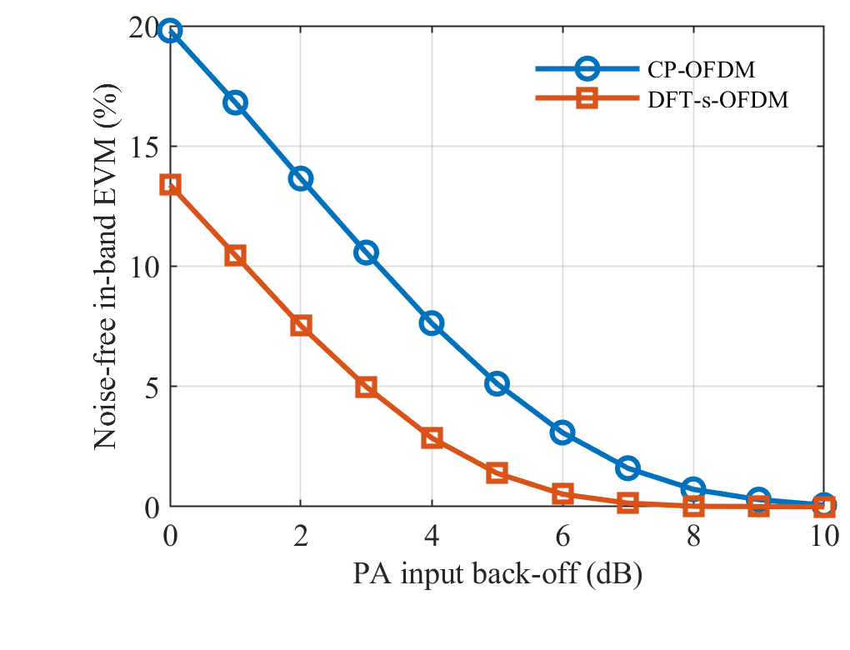
Figure 5. In-band root mean square EVM solely caused by distortion
Figure 5 isolates the limiting distortion by shutting off the receiver noise. At 2 dB IBO, the EVM of CP-OFDM is 13.65%, and that of DFT-s-OFDM is 7.53%. At 3 dB, they are 10.57% and 4.98% respectively. The deviation of DFT-s-OFDM is relatively small, which is consistent with its lower BER shown in Figure 4.
At 2 dB IBO, the output-to-input power ratio of CP-OFDM is -0.9864 dB, while that of DFT-s-OFDM is -0.5206 dB. Both will lose signal power due to the limit, but DFT-s-OFDM suffers less loss.

F. Power Spectrum
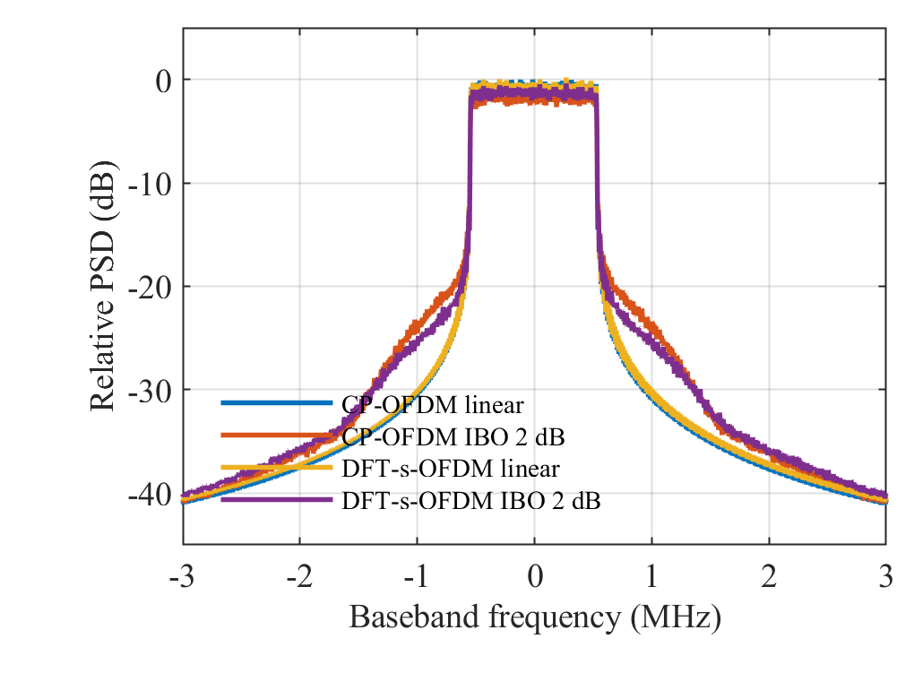
Figure 6. 16-QAM Welch PSD using rectangular pulses.
When not limited in amplitude, the spectra of the two waveforms almost overlap. The limiting effect causes the power outside the allocated frequency band to increase. In the frequency range near the edge, the curve of DFT-s-OFDM is lower, but it is not lower than that of CP-OFDM at all frequencies.

G. What the Results Mean and Model Limitations
Taking all these tests into consideration, it can be seen that merely choosing a waveform based on PAPR can lead to rather limited conclusions. In the limiting scenario with a smaller input backoff amount, the lower peak of DFT-s-OFDM results in less distortion and errors. In linear AWGN, the theoretical BER of the two links is the same.
Next, we can first compare ZF with MMSE, and then incorporate channel coding. These two changes may both alter the results of the degradation test and also bring the model closer to the actual link. If further research on energy efficiency is to be conducted, it will be necessary to use a measured power amplifier model.

V. CONCLUSION
The MATLAB results indicate that in the simplified 5G uplink, the DFT expansion needs to be determined based on specific conditions. It reduces the 99th percentile PAPR of QPSK and 16-QAM by 2.92 dB and 2.09 dB respectively. When the power amplifier operates at 2 dB IBO and reaches the limit, the BER of CP-OFDM is approximately 4.25 times that of DFT-s-OFDM, and the EVM decreases from 13.65% to 7.53%. The theoretical BER in AWGN remains unchanged, while in the Rayleigh channel using ZF, the BER of DFT-s-OFDM is higher. Therefore, a lower PAPR helps alleviate the limiting problems that occur during testing.

REFERENCES
[1] S. Parkvall, E. Dahlman, A. Furuskar, and M. Frenne, "NR: The New 5G Radio Access Technology," IEEE Communications Standards Magazine, vol. 1, no. 4, pp. 24-30, 2017, doi: 10.1109/mcomstd.2017.1700042.
[2] M. Shafi et al., "5G: A Tutorial Overview of Standards, Trials, Challenges, Deployment, and Practice," IEEE Journal on Selected Areas in Communications, vol. 35, no. 6, pp. 1201-1221, 2017, doi: 10.1109/jsac.2017.2692307.
[3] H. Myung, J. Lim, and D. Goodman, "Single carrier FDMA for uplink wireless transmission," IEEE Vehicular Technology Magazine, vol. 1, no. 3, pp. 30-38, 2006, doi: 10.1109/mvt.2006.307304.
[4] H. Myung, J. Lim, and D. Goodman, "Peak-To-Average Power Ratio of Single Carrier FDMA Signals with Pulse Shaping," in 2006 IEEE 17th International Symposium on Personal, Indoor and Mobile Radio Communications, pp. 1-5, 2006, doi: 10.1109/pimrc.2006.254407.
[5] F. Pancaldi, G. Vitetta, R. Kalbasi, N. Al-Dhahir, M. Uysal, and H. Mheidat, "Single-carrier frequency domain equalization," IEEE Signal Processing Magazine, vol. 25, no. 5, pp. 37-56, 2008, doi: 10.1109/msp.2008.926657.
[6] S. H. Han and J. H. Lee, "An overview of peak-to-average power ratio reduction techniques for multicarrier transmission," IEEE Wireless Communications, vol. 12, no. 2, pp. 56-65, 2005, doi: 10.1109/mwc.2005.1421929.
[7] T. Jiang and Y. Wu, "An Overview: Peak-to-Average Power Ratio Reduction Techniques for OFDM Signals," IEEE Transactions on Broadcasting, vol. 54, no. 2, pp. 257-268, 2008, doi: 10.1109/tbc.2008.915770.
[8] X. Li and L. J. Cimini, "Effects of clipping and filtering on the performance of OFDM," IEEE Communications Letters, vol. 2, no. 5, pp. 131-133, 1998, doi: 10.1109/4234.673657.
[9] H. Ochiai and H. Imai, "On the distribution of the peak-to-average power ratio in OFDM signals," IEEE Transactions on Communications, vol. 49, no. 2, pp. 282-289, 2001, doi: 10.1109/26.905885.
[10] A. Sahin, I. Guvenc, and H. Arslan, "A Survey on Multicarrier Communications: Prototype Filters, Lattice Structures, and Implementation Aspects," IEEE Communications Surveys & Tutorials, vol. 16, no. 3, pp. 1312-1338, 2014, doi: 10.1109/surv.2013.121213.00263.
[11] B. Farhang-Boroujeny, "OFDM Versus Filter Bank Multicarrier," IEEE Signal Processing Magazine, vol. 28, no. 3, pp. 92-112, 2011, doi: 10.1109/msp.2011.940267.
[12] S. Weinstein and P. Ebert, "Data Transmission by Frequency-Division Multiplexing Using the Discrete Fourier Transform," IEEE Transactions on Communication Technology, vol. 19, no. 5, pp. 628-634, 1971, doi: 10.1109/tcom.1971.1090705.
[13] J. A. C. Bingham, "Multicarrier modulation for data transmission: an idea whose time has come," IEEE Communications Magazine, vol. 28, no. 5, pp. 5-14, 1990, doi: 10.1109/35.54342.
[14] B. E. Priyanto, H. Codina, S. Rene, T. B. Sorensen, and P. Mogensen, "Initial erformance Evaluation of DFT-Spread OFDM Based SC-FDMA for UTRA LTE Uplink," in 2007 IEEE 65th Vehicular Technology Conference - VTC2007-Spring, pp. 3175-3179, 2007, doi: 10.1109/vetecs.2007.650.
[15] T. Levanen, J. Pirskanen, K. Pajukoski, M. Renfors, and M. Valkama, "Transparent Tx and Rx Waveform Processing for 5G New Radio Mobile Communications," IEEE Wireless Communications, vol. 26, no. 1, pp. 128-136, 2019, doi: 10.1109/mwc.2018.1800015.
[16] G. Berardinelli, L. A. Ruiz de Temino, S. Frattasi, M. Rahman, and P. Mogensen, "OFDMA vs. SC-FDMA: performance comparison in local area imt-a scenarios," IEEE Wireless Communications, vol. 15, no. 5, pp. 64-72, 2008, doi: 10.1109/mwc.2008.4653134.
[17] H. Ochiai and H. Imai, "Performance analysis of deliberately clipped OFDM signals," IEEE Transactions on Communications, vol. 50, no. 1, pp. 89-101, 2002, doi: 10.1109/26.975762.

APPENDIX A. COMPLETE MATLAB IMPLEMENTATION
function outDir = run_5g_uplink(mode)
if nargin < 1, mode = 'quick'; end
assert(any(strcmp(mode, {'quick','full','test'})), 'Use quick, full, or test.');
cfg.Nfft = 256; cfg.K = 72; cfg.Ncp = 18; cfg.L = 4;
cfg.deltaF = 15e3; cfg.seed = 20261027; cfg.batch = 128;
cfg.delays = [0 1 3 5]; cfg.pdpDB = [0 -3 -6 -9];
cfg.modOrders = [4 16]; cfg.awgnDB = 0:2:16; cfg.fadingDB = 0:3:24;
cfg.iboDB = 0:1:10; cfg.paEbN0DB = 14;
cfg.paprBlocks = 3000; cfg.maxBits = 150000; cfg.minBlocks = 256;
cfg.targetErrors = 200; cfg.paBlocks = 1000; cfg.spectrumBlocks = 100;
if strcmp(mode, 'full')
cfg.paprBlocks = 30000; cfg.maxBits = 2000000; cfg.minBlocks = 2048;
cfg.targetErrors = 1000; cfg.paBlocks = 8000; cfg.spectrumBlocks = 600;
end
cfg.N = cfg.Nfft*cfg.L; cfg.cp = cfg.Ncp*cfg.L;
cfg.idx = (cfg.N/2-cfg.K/2+1):(cfg.N/2+cfg.K/2);
cfg.bin = (-cfg.K/2:cfg.K/2-1).';
cfg.overhead = (cfg.Nfft+cfg.Ncp)/cfg.Nfft;
cfg.mode = mode; cfg.matlabVersion = version;
rng(cfg.seed, 'twister');
selftest(cfg);
if strcmp(mode, 'test'), outDir = ''; return; end

root = fileparts(mfilename('fullpath'));
outDir = fullfile(root, 'results', [mode '_' datestr(now,'yyyymmdd_HHMMSS')]);
if exist(outDir,'dir'), outDir = [outDir '_new']; end
mkdir(outDir);
diary(fullfile(outDir, 'run_log.txt')); cleanup = onCleanup(@() diary('off')); %#ok<NASGU>
fprintf('Mode %s, seed %d, MATLAB %s\n',mode,cfg.seed,version);
fprintf('Output %s\n', outDir);
set(groot,'defaultAxesFontName','Times New Roman','defaultAxesFontSize',11);
set(groot,'defaultTextFontName','Times New Roman');
colors = [0.00 0.32 0.58; 0.85 0.30 0.10; 0.12 0.55 0.36; 0.55 0.28 0.67];
labels = {'CP-OFDM QPSK','DFT-s-OFDM QPSK','CP-OFDM 16-QAM','DFT-s-OFDM 16-QAM'};

%% 1. Oversampled PAPR statistics. CP excluded from measurement interval.
fprintf('1/6 PAPR statistics\n');
papr = zeros(cfg.paprBlocks,4);
for m = 1:2
for first = 1:cfg.batch:cfg.paprBlocks
n = min(cfg.batch,cfg.paprBlocks-first+1);
[~,d] = source(cfg.modOrders(m),cfg.K,n);
for w = 1:2
x = transmit(d,w,cfg);
v = 10*log10(max(abs(x).^2,[],1)./mean(abs(x).^2,1));
papr(first:first+n-1,2*(m-1)+w) = v.';
end
end
end
threshold = (0:0.1:15).'; ccdf = zeros(length(threshold),4);
fig = newfig; hold on;
for c = 1:4
ccdf(:,c) = mean(bsxfun(@gt,papr(:,c).',threshold),2);
semilogy(threshold,positive(ccdf(:,c)),'LineWidth',1.6,'Color',colors(c,:));
end
set(gca,'YScale','log'); grid(gca,'on'); ylim([1/cfg.paprBlocks 1]);
xlabel('PAPR threshold (dB)'); ylabel('Pr(PAPR > threshold)');
title(sprintf('PAPR CCDF, %d blocks, %dx oversampling',cfg.paprBlocks,cfg.L));
legend(labels,'Location','southwest');
savefigs(fig,outDir,'fig01_papr_ccdf');
writecsv(fullfile(outDir,'papr_ccdf.csv'),{'threshold_dB','CP_QPSK','DFTs_QPSK','CP_16QAM','DFTs_16QAM'},[threshold ccdf]);
pq = zeros(4,2);
for c=1:4
v=sort(papr(:,c)); pq(c,:)=[v(ceil(0.99*numel(v))) v(ceil(0.999*numel(v)))];
end
writecsv(fullfile(outDir,'papr_quantiles.csv'),{'curve_id','q99_dB','q999_dB'},[(1:4).' pq]);

berResults = struct;
for channel = {'AWGN','Rayleigh'}
cname = channel{1};
if strcmp(cname,'AWGN'), axisDB=cfg.awgnDB; num=2; else, axisDB=cfg.fadingDB; num=3; end
fprintf('%d/6 BER in %s\n',num,cname);
matrix=zeros(numel(axisDB),4); rows=[];
for m=1:2
M=cfg.modOrders(m);
for s=1:numel(axisDB)
st=linearPoint(M,axisDB(s),cname,cfg);
matrix(s,2*m-1:2*m)=st.ber;
for w=1:2
rows(end+1,:)=[M w axisDB(s) st.errors(w) st.bits st.blocks st.ber(w) st.blockSE(w)]; %#ok<AGROW>
end
fprintf(' M=%d, Eb/N0=%g dB, BER=[%.3g %.3g], bits=%d\n',M,axisDB(s),st.ber,st.bits);
end
end
fig=newfig; hold on;
for c=1:4
semilogy(axisDB,positive(matrix(:,c)),'-o','LineWidth',1.4,'Color',colors(c,:),'MarkerSize',4);
end
leg=labels;
if strcmp(cname,'AWGN')
g=10.^(axisDB/10)/cfg.overhead;
qpsk=0.5*erfc(sqrt(g));
a=sqrt(0.8*g); Q=@(x) 0.5*erfc(x/sqrt(2));
qam16=0.75*Q(a)+0.5*Q(3*a)-0.25*Q(5*a);
semilogy(axisDB,positive(qpsk),'k--','LineWidth',1.2);
semilogy(axisDB,positive(qam16),'k:','LineWidth',1.2);
leg=[labels {'QPSK theory with CP cost','16-QAM theory with CP cost'}];
end
set(gca,'YScale','log'); grid(gca,'on'); ylim([1/cfg.maxBits 0.5]);
xlabel('Pre-PA E_b/N_0 including CP energy (dB)'); ylabel('Uncoded bit error rate');
title([cname ' channel, perfect CSI, ZF equalization']);
legend(leg,'Location','southwest');
savefigs(fig,outDir,sprintf('fig%02d_ber_%s',num,lower(cname)));
writecsv(fullfile(outDir,['ber_' lower(cname) '.csv']), ...
{'M','waveform_id','EbN0_dB','error_bits','total_bits','blocks','BER','block_standard_error'},rows);
berResults.(cname).curves=matrix; berResults.(cname).raw=rows;
end

fprintf('4/6 and 5/6 PA back-off experiment\n');
paRows=[]; paBER=zeros(numel(cfg.iboDB),2); paEVM=paBER;
for s=1:numel(cfg.iboDB)
ibo=cfg.iboDB(s); A=sqrt(cfg.K/cfg.N)*10^(ibo/20);
gain=ones(1,2); pin=zeros(1,2); pout=pin;
[~,dcal]=source(16,cfg.K,512);
for w=1:2
x=transmit(dcal,w,cfg); z=limiter(x,A);
gain(w)=real(sum(conj(x(:)).*z(:))/sum(abs(x(:)).^2));
end
errors=zeros(1,2); evmNumer=errors; evmDenom=0;
for first=1:cfg.batch:cfg.paBlocks
n=min(cfg.batch,cfg.paBlocks-first+1);
[b,d]=source(16,cfg.K,n);
nv=cfg.overhead/(4*10^(cfg.paEbN0DB/10));
noise=sqrt(nv/2)*(randn(cfg.K,n)+1i*randn(cfg.K,n));
evmDenom=evmDenom+sum(abs(d(:)).^2);
for w=1:2
x=transmit(d,w,cfg); z=limiter(x,A);
rxGrid=fftshift(fft(z,[],1)/sqrt(cfg.N),1); v=rxGrid(cfg.idx,:);
dhat=despread((v+noise)/gain(w),w);
dec=qamDemap(dhat,16); errors(w)=errors(w)+sum(dec(:)~=b(:));
clean=despread(v/gain(w),w);
evmNumer(w)=evmNumer(w)+sum(abs(clean(:)-d(:)).^2);
pin(w)=pin(w)+sum(abs(x(:)).^2); pout(w)=pout(w)+sum(abs(z(:)).^2);
end
end
bits=cfg.paBlocks*cfg.K*4;
paBER(s,:)=errors/bits; paEVM(s,:)=100*sqrt(evmNumer/evmDenom);
for w=1:2
paRows(end+1,:)=[ibo w cfg.paEbN0DB errors(w) bits paBER(s,w) paEVM(s,w) gain(w) 10*log10(pout(w)/pin(w))]; %#ok<AGROW>
end
fprintf(' IBO=%g dB, BER=[%.3g %.3g], EVM=[%.2f %.2f] %%\n',ibo,paBER(s,:),paEVM(s,:));
end
fig=newfig;
semilogy(cfg.iboDB,positive(paBER(:,1)),'-o',cfg.iboDB,positive(paBER(:,2)),'-s','LineWidth',1.5);
grid(gca,'on'); xlabel('PA input back-off (dB)'); ylabel('Uncoded bit error rate');
title(sprintf('16-QAM with hard limiting, pre-PA E_b/N_0 = %g dB',cfg.paEbN0DB));
legend({'CP-OFDM','DFT-s-OFDM'},'Location','northeast');
savefigs(fig,outDir,'fig04_ber_pa_backoff');
fig=newfig;
plot(cfg.iboDB,paEVM(:,1),'-o',cfg.iboDB,paEVM(:,2),'-s','LineWidth',1.5);
grid(gca,'on'); xlabel('PA input back-off (dB)'); ylabel('RMS in-band EVM after gain compensation (%)');
title('16-QAM distortion without receiver noise');
legend({'CP-OFDM','DFT-s-OFDM'},'Location','northeast');
savefigs(fig,outDir,'fig05_evm_pa_backoff');
writecsv(fullfile(outDir,'pa_backoff.csv'), ...
{'IBO_dB','waveform_id','EbN0_dB','error_bits','total_bits','BER','EVM_percent','gain','output_input_power_dB'},paRows);

fprintf('6/6 Power spectral density\n');
[~,d]=source(16,cfg.K,cfg.spectrumBlocks);
psdAll=[]; fs=cfg.N*cfg.deltaF;
for w=1:2
x=transmit(d,w,cfg); frame=[x(end-cfg.cp+1:end,:);x]; stream=frame(:);
for state=1:2
sig=stream;
if state==2, sig=limiter(sig,sqrt(cfg.K/cfg.N)*10^(2/20)); end
[f,p]=welchLocal(sig,fs,4*cfg.N);
psdAll(:,2*(w-1)+state)=p; %#ok<AGROW>
end
end
referenceLevel=max(psdAll(:,1)); psdDB=10*log10(max(psdAll/referenceLevel,1e-14));
fig=newfig; plot(f/1e6,psdDB,'LineWidth',1.3); grid(gca,'on');
xlim([-3 3]); ylim([-80 5]); xlabel('Baseband frequency (MHz)');
ylabel('PSD relative to linear CP-OFDM peak (dB)');
title('16-QAM spectrum, rectangular pulses, common normalization');
legend({'CP-OFDM linear','CP-OFDM IBO 2 dB','DFT-s-OFDM linear','DFT-s-OFDM IBO 2 dB'},'Location','southwest');
savefigs(fig,outDir,'fig06_psd');
writecsv(fullfile(outDir,'psd.csv'),{'frequency_Hz','CP_linear_dB','CP_clipped_dB','DFTs_linear_dB','DFTs_clipped_dB'},[f psdDB]);

save(fullfile(outDir,'results.mat'),'cfg','papr','threshold','ccdf','pq','berResults','paRows','paBER','paEVM','f','psdAll');
fid=fopen(fullfile(outDir,'summary.txt'),'w');
fprintf(fid,'Mode: %s\nSeed: %d\nMATLAB: %s\n',mode,cfg.seed,version);
fprintf(fid,'Curve order: CP QPSK, DFTs QPSK, CP 16QAM, DFTs 16QAM.\n');
fprintf(fid,'PAPR q99 / q999 in dB:\n');
for c=1:4, fprintf(fid,'%s: %.4f / %.4f\n',labels{c},pq(c,:)); end
fprintf(fid,'No zero-error point has been replaced by a fabricated positive BER.\n');
fprintf(fid,'Zero-error BER/CCDF points are omitted on logarithmic plots; raw counts are in CSV.\n');
fprintf(fid,'Rayleigh uncertainty: block-level standard error, not an iid-bit interval.\n');
fprintf(fid,'PA results use pre-PA energy. Output power loss is saved; no battery-efficiency claim.\n');
fprintf(fid,'Full mode is recommended for the report. Quick mode is for debugging.\n');
fclose(fid);
fprintf('Complete. Return this entire results folder for report and slides.\n');
fprintf('Keep raw CSV and MAT files, not just screenshots.\n');
end

function [b,d]=source(M,K,n)
b=randi([0 1],log2(M),K*n); d=reshape(qamMap(b,M),K,n);
end

function d=qamMap(b,M)
p=log2(M)/2;
if M==4, levels=[-1 1]; elseif M==16, levels=[-3 -1 3 1]; else, error('Only QPSK and 16-QAM'); end
weights=2.^(p-1:-1:0);
ii=weights*b(1:p,:); qq=weights*b(p+1:end,:);
d=(levels(ii+1)+1i*levels(qq+1))/sqrt(2*(M-1)/3);
end

function b=qamDemap(d,M)
p=log2(M)/2;
if M==4, levels=[-1 1]; else, levels=[-3 -1 3 1]; end
v=d(:)*sqrt(2*(M-1)/3);
[~,ii]=min(abs(bsxfun(@minus,real(v),levels)),[],2);
[~,qq]=min(abs(bsxfun(@minus,imag(v),levels)),[],2);
b=zeros(2*p,numel(v));
for j=1:p
b(j,:)=bitget(uint32(ii-1),p-j+1).';
b(p+j,:)=bitget(uint32(qq-1),p-j+1).';
end
end

function z=spread(d,w)
if w==2, z=fft(d,[],1)/sqrt(size(d,1)); else, z=d; end
end

function d=despread(z,w)
if w==2, d=ifft(z,[],1)*sqrt(size(z,1)); else, d=z; end
end

function x=transmit(d,w,cfg)
txGrid=zeros(cfg.N,size(d,2)); txGrid(cfg.idx,:)=spread(d,w);
x=ifft(ifftshift(txGrid,1),[],1)*sqrt(cfg.N);
end

function z=limiter(x,A)
z=x.*min(1,A./max(abs(x),eps));
end

function st=linearPoint(M,ebDB,cname,cfg)
bitsPerBlock=cfg.K*log2(M);
maxBlocks=max(cfg.minBlocks,floor(cfg.maxBits/bitsPerBlock));
e=zeros(1,2); sums2=e; blocks=0;
pdp=10.^(cfg.pdpDB/10); pdp=pdp/sum(pdp);
response=exp(-1i*2*pi*cfg.bin*cfg.delays/cfg.Nfft);
nv=cfg.overhead/(log2(M)*10^(ebDB/10));
while blocks<maxBlocks && (blocks<cfg.minBlocks || any(e<cfg.targetErrors))
n=min(cfg.batch,maxBlocks-blocks); [b,d]=source(M,cfg.K,n);
if strcmp(cname,'Rayleigh')
taps=bsxfun(@times,sqrt(pdp(:)/2),randn(numel(pdp),n)+1i*randn(numel(pdp),n));
H=response*taps; % E[|H|^2]=1; do NOT normalize each realization.
else
H=ones(cfg.K,n);
end
noise=sqrt(nv/2)*(randn(cfg.K,n)+1i*randn(cfg.K,n));
for w=1:2
z=H.*spread(d,w)+noise;
dhat=despread(z./H,w); % exact ZF; deep fades legitimately amplify noise.
dec=qamDemap(dhat,M); err=reshape(dec~=b,bitsPerBlock,n);
eb=sum(err,1); e(w)=e(w)+sum(eb);
sums2(w)=sums2(w)+sum((eb/bitsPerBlock).^2);
end
blocks=blocks+n;
end
st.bits=blocks*bitsPerBlock; st.blocks=blocks; st.errors=e; st.ber=e/st.bits;
samplevar=max(0,(sums2-blocks*st.ber.^2)/(blocks-1));
st.blockSE=sqrt(samplevar/blocks);
end

function selftest(cfg)
fprintf('Running deterministic modem and CP tests...\n');
for M=[4 16]
b=zeros(log2(M),M);
for j=1:log2(M), b(j,:)=bitget(uint32(0:M-1),log2(M)-j+1); end
assert(isequal(b,qamDemap(qamMap(b,M),M)),'QAM round trip failed.');
assert(abs(mean(abs(qamMap(b,M)).^2)-1)<1e-12,'Constellation energy failed.');
end
[b,d]=source(16,cfg.K,3);
h=zeros(1,max(cfg.delays)*cfg.L+1); h(cfg.delays*cfg.L+1)=[1 0.3+0.2i -0.1i 0.1];
H=fftshift(fft(h,cfg.N)).';
for w=1:2
x=transmit(d,w,cfg);
assert(max(abs(sum(abs(x).^2,1)-sum(abs(d).^2,1)))<1e-9,'Energy preservation failed.');
xc=[x(end-cfg.cp+1:end,:);x]; y=filter(h,1,xc,[],1);
g=fftshift(fft(y(cfg.cp+(1:cfg.N),:),[],1)/sqrt(cfg.N),1);
dhat=despread(bsxfun(@rdivide,g(cfg.idx,:),H(cfg.idx)),w);
assert(max(abs(dhat(:)-d(:)))<1e-9,'CP convolution / FFT equivalence failed.');
assert(isequal(b,qamDemap(dhat,16)),'Noiseless link failed.');
c1=cfg; c1.N=cfg.Nfft; c1.idx=(c1.N/2-c1.K/2+1):(c1.N/2+c1.K/2);
xb=transmit(d,w,c1); xs=x(1:cfg.L:end,:)*sqrt(cfg.L);
assert(max(abs(xs(:)-xb(:)))<1e-9,'Oversampling consistency failed.');
end
one=ones(cfg.K,1); a=transmit(one,1,cfg); s=transmit(one,2,cfg);
assert(abs(max(abs(a).^2)/mean(abs(a).^2)-cfg.K)<1e-9,'OFDM peak test failed.');
assert(abs(max(abs(s).^2)/mean(abs(s).^2)-1)<1e-9,'DFT tone test failed.');
assert(cfg.Ncp>max(cfg.delays),'CP does not cover channel.');
fprintf('PASS: Gray mapping, unit energy, CP channel, zero BER, oversampling, known PAPR.\n');
end

function [f,p]=welchLocal(x,fs,nfft)
len=nfft; hop=floor(len/2); window=0.5-0.5*cos(2*pi*(0:len-1)'/(len-1));
p=zeros(nfft,1); count=0;
for a=1:hop:(numel(x)-len+1)
s=x(a:a+len-1).*window;
p=p+abs(fft(s,nfft)).^2/(fs*sum(window.^2)); count=count+1;
end
assert(count>0,'Not enough samples for PSD.');
p=fftshift(p/count); f=(-nfft/2:nfft/2-1)'*fs/nfft;
end

function y=positive(x)
y=x; y(y<=0)=NaN;
end

function fig=newfig
fig=figure('Color','w','Position',[100 100 900 600]);
end

function savefigs(fig,path,name)
savefig(fig,fullfile(path,[name '.fig']));
print(fig,fullfile(path,[name '.png']),'-dpng','-r300');
set(fig,'PaperPositionMode','auto');
print(fig,fullfile(path,[name '.pdf']),'-dpdf','-bestfit');
end

function writecsv(path,header,data)
fid=fopen(path,'w'); assert(fid>=0,'Cannot create CSV.');
fprintf(fid,'%s',header{1});
for k=2:numel(header), fprintf(fid,',%s',header{k}); end
fprintf(fid,'\n'); fclose(fid);
dlmwrite(path,data,'-append','delimiter',',','precision','%.12g');
end

