PAPR and Error Performance of DFT Spread OFDM for 5G Uplink Transmission
Abstract—This report compares CP-OFDM and localized DFT-s-OFDM for a simplified 5G uplink. We use MATLAB to examine whether a reduction in signal peaks also improves bit error rate. For 30,000 blocks with fourfold oversampling, the 99th-percentile PAPR falls by 2.92 dB with QPSK and 2.09 dB with 16-QAM. The BER curves are almost identical in AWGN. In the Rayleigh fading test, however, DFT spreading increases BER because the zero-forcing receiver spreads the noise from weak subcarriers across the data block. The advantage appears when amplifier clipping is included: at 2 dB input back-off, 16-QAM BER falls from 0.00512 to 0.00121. These results illustrate why PAPR alone is insufficient for choosing an uplink waveform. The receiver and amplifier must be considered as well.
Keywords—5G uplink; digital modulation; DFT-s-OFDM; PAPR; zero-forcing equalization; clipping.

I. INTRODUCTION

A. Background and Motivation
A mobile transmitter must send its data through a power amplifier before the signal reaches the wireless channel. Large peaks are a difficulty at this stage: even when average power is within the amplifier's range, some samples may exceed its limit and be clipped. This is the uplink issue considered in this report. The wider 5G setting is described by Parkvall et al. [1] and Shafi et al. [2]. We focus on the change introduced by DFT spreading and compare waveforms with the same bandwidth, modulation, and average input energy. Keeping these quantities fixed lets us relate the observed differences to waveform processing.
In orthogonal frequency division multiplexing (OFDM), several subcarriers carry data at the same time. Their contributions sometimes add to a large peak. A cyclic prefix (CP) is added by copying the end of the transmitted block to its beginning, giving the CP-OFDM signal used as our reference. DFT spread OFDM adds a discrete Fourier transform before the symbols are mapped to subcarriers. Here we use localized mapping, so all allocated subcarriers are adjacent. This is the SC-FDMA arrangement described by Myung et al. [3], and it can be implemented by modifying the CP-OFDM transmitter rather than constructing a completely different link.

B. Literature Survey
The transform operations shared by these waveforms have a long history. Weinstein and Ebert [12] described frequency-division multiplexing using the DFT, and Bingham [13] reviewed the principles and applications of multicarrier modulation. This provides the starting point for our implementation: an IFFT forms the transmitted block, and an FFT recovers its subcarrier values. DFT-s-OFDM keeps this processing. It adds a DFT before subcarrier mapping and an inverse DFT after equalization, which makes the comparison convenient to implement within the same MATLAB model.
For SC-FDMA, the allocated subcarriers and the receiver both matter. Myung et al. [4] studied peak-to-average power ratio (PAPR) for different mapping and pulse-shaping choices, while Pancaldi et al. [5] discussed frequency-domain equalization for single-carrier transmission. Priyanto et al. [14] evaluated DFT-spread OFDM for the LTE uplink; Berardinelli et al. [16] compared OFDMA and SC-FDMA in IMT-Advanced scenarios. These earlier studies connect the waveform to its operating conditions. In our model, we therefore specify the mapping and equalizer explicitly when comparing CP-OFDM with DFT-s-OFDM in the simplified 5G uplink.
DFT spreading is one way to address large peaks. The surveys by Han and Lee [6] and Jiang and Wu [7] also discuss clipping, coding, selected mapping, and tone reservation, with different costs in complexity, bandwidth, and error performance. A useful comparison must account for how often peaks occur. Ochiai and Imai [9] treated OFDM PAPR statistically, which is why we collect many blocks instead of displaying a single time waveform. The other issue is what happens when a peak is removed. Li and Cimini [8] examined clipping and filtering through error rates and spectra, and Ochiai and Imai [17] analyzed clipped OFDM signals. We use both distortion and bit error measurements to follow that effect.
The spectral comparison needs a separate assumption about pulse shape. Sahin et al. [10] reviewed multicarrier filters and signal arrangements, and Farhang-Boroujeny [11] compared OFDM with filter-bank multicarrier. Levanen et al. [15] examined transmitter and receiver waveform processing for 5G NR. These papers concern processing choices beyond the spreading transform itself. We retain rectangular pulses in both links and add no filter, so the spectrum test measures the effect of DFT spreading and clipping under that common choice. A filtering improvement is not expected from the DFT alone.

C. Project Question and Contributions
A low PAPR is useful at the transmitter, but it does not determine how many bits the receiver gets wrong. The link between these quantities is the question we examine. We compare CP-OFDM and DFT-s-OFDM first with linear transmission and then with amplifier clipping, using the same simulation settings wherever the two links can share them. Since DFT-s-OFDM is already established, this course project does not introduce a new modulation method. It instead asks where the method helps and where the channel and equalizer remove, or reverse, the apparent advantage of smaller peaks.
The contribution of the project is to examine those cases within a common MATLAB implementation. We keep the bandwidth and energy definition consistent and use six figures to compare PAPR, BER, error vector magnitude (EVM), and the power spectrum. Output power loss is recorded as a separate quantity. The measurements make it possible to follow the change from transmitted peaks to distortion and then to detection errors, including a fading case in which the lower-PAPR waveform has the higher BER. The study is limited to this simulated link; it does not estimate phone battery life, network capacity, or coverage distance.

II. SYSTEM MODEL AND PROBLEM FORMULATION

A. Transmitter and Subcarrier Mapping
Consider a data block d containing K complex symbols with unit average energy. Gray QPSK carries b = 2 bits per symbol, and Gray 16-QAM carries b = 4. We write the transforms as F_K and F_N, using energy-preserving scaling. The mapping matrix P places the K values on adjacent subcarriers near the band centre; all remaining positions are zero. With this notation, the useful transmitted blocks are
$x_{CP} = F_{N}^{H}P d, x_{DFT} = F_{N}^{H}P F_{K} d. (1)$
The superscript H means the Hermitian transpose, which gives the inverse transform for these scaled DFT matrices. The expected block energy is E{||x||²} = K for either waveform, and the average sample power is K/N. We use N_base = 256 and K = 72 at the base rate. With 15 kHz subcarrier spacing, the nominal occupied bandwidth is 1.08 MHz. Waveform measurements use fourfold oversampling, which increases the FFT size to N = 1024 and the sampling rate to 15.36 MHz while keeping the subcarrier spacing and occupied band unchanged.
The CP consists of the last 18 base-rate samples of a block, or 72 samples after oversampling. It provides separation between consecutive blocks as long as the channel delay remains within its length. The useful part lasts 66.67 microseconds and the CP adds 4.69 microseconds. We include this extra transmitted energy through c = 274/256 = 1.0703125 when defining energy per bit. Pilots and transport-channel processing are omitted, so these parameters describe the waveform comparison rather than a complete NR slot.

B. Channel, Noise, and Receiver
We use two channel models to separate the effect of noise from that of multipath fading. Additive white Gaussian noise (AWGN) introduces noise without changing the frequency response. The Rayleigh model has four taps with base-rate delays [0, 1, 3, 5] and average powers proportional to [1, 10⁻⁰·³, 10⁻⁰·⁶, 10⁻⁰·⁹]. These average powers are normalized to sum to one. A new channel is drawn independently for each block and held constant within it. We do not normalize each channel sample, since doing so would remove some weak-channel cases. The maximum tap delay is shorter than the CP, as required by the receiver model.
Removing the CP and applying an FFT returns the received block to the frequency domain. Selecting the active subcarriers gives
$Y = diag(H) S d + n, S ∈ \{I_{K}, F_{K}\}. (2)$
For the receiver, we assume exact channel knowledge and correct timing. Defining γ_b = 10^(E_b/N_0[dB]/10), we set the active-subcarrier noise variance to σ_n² = c/(bγ_b). The stated E_b/N_0 therefore includes CP energy and refers to the signal before the amplifier. To keep the linear-channel simulations practical, the program calculates BER directly in the frequency domain. Its separate self-test compares this calculation with time-domain convolution and CP removal. Under these assumptions, zero-forcing (ZF) equalization is written as
$d̂ = S^{H}diag(1/H) Y. (3)$
The ZF receiver divides each active-subcarrier value by its channel response. The next step depends on the waveform. CP-OFDM can be detected immediately, whereas DFT-s-OFDM requires the inverse K-point DFT to return to the data symbols. We then select the nearest constellation point and make hard bit decisions. Using ZF in both cases leaves spreading as the change under study. The model does not include coding, interleaving, channel-estimation errors, multiple antennas, or interference.

C. How Fading Affects the Receiver
With AWGN alone, H = 1 and there is no unequal attenuation across subcarriers. The DFT pair preserves both signal energy and the noise distribution, giving the same theoretical BER for the two waveforms. This reasoning changes in a fading channel because ZF divides by different values of H_k. Its output noise variance on CP-OFDM subcarrier k is σ_n²/|H_k|². For DFT-s-OFDM, applying the inverse DFT gives the following noise variance for each recovered data symbol:
$σ_{DFT}^{2} = \frac{σ_{n}^{2}}{K} Σ_{k} {|H_{k}|}^{−2}. (4)$
The terms with small |H_k| dominate this average. ZF increases the noise on a weak subcarrier, and the inverse DFT then distributes that contribution across the recovered data block. Equation (4) describes the resulting variance for a given channel; the noise affecting different symbols can also be correlated. Thus, reducing transmitted peaks does not prevent errors caused by receiver noise enhancement. This is a consequence of the chosen receiver. An MMSE equalizer, channel coding, or another resource allocation could give a different comparison.

D. Metrics and Evaluation Question
$PAPR = \frac{\max_{n} {|x[n]|}^{2}}{{mean}_{n} {|x[n]|}^{2}}. (5)$
We measure PAPR over the useful block, before adding the CP, as the ratio of its largest sample power to its average sample power. The complementary cumulative distribution function (CCDF) then reports how often PAPR exceeds a selected threshold. At the receiver, BER is calculated from the number of incorrect bits divided by the number tested. EVM gives the root-mean-square distance from the ideal symbols, normalized by reference symbol energy and expressed as a percentage. Smaller BER and EVM mean better reception. For each waveform pair, K, modulation, input power, and receiver settings are held fixed.

III. PROPOSED TRANSMISSION SCHEME AND SIMULATION

A. Localized DFT-s-OFDM Processing
The proposed transmission scheme is our implementation of localized DFT-s-OFDM following [3], [4], and [14]. A scaled 72-point DFT acts on the data block before adjacent-subcarrier mapping. The remaining transmitter steps are the same IFFT and CP insertion used for CP-OFDM. At reception, the additional inverse 72-point DFT is placed after equalization. This shared structure is useful for the experiment: the two links use the same surrounding processing, making it easier to trace a performance difference to the spreading operation.
There is no data-rate increase from this change. The block contains 72b bits with or without spreading, and its duration is unchanged. Under the fixed bandwidth and modulation settings, the uncoded rates are about 2.018 Mbit/s for QPSK and 4.036 Mbit/s for 16-QAM, before pilots and coding are allowed for. What changes is the processing cost. The added DFT and inverse DFT require roughly O(K log K) operations per block when implemented with FFT algorithms. Their purpose here is to change the transmitted waveform, not to carry extra information.

B. Amplifier Clipping Model
To study clipping, we represent the amplifier by a hard limiter with amplitude limit A. It passes smaller samples unchanged and reduces larger ones to A without changing their phase:
$g(x) = x min(1, A/|x|). (6)$
$A = \sqrt{\frac{K}{N}} {10}^{\frac{IBO}{20}}. (7)$
Input back-off (IBO) specifies how far the average input power is below the amplifier limit. We hold that input power fixed and vary the limit, using the same setting for both waveforms. Larger IBO gives the peaks more room and reduces clipping. This test uses 16-QAM in AWGN at pre-amplifier E_b/N_0 = 14 dB. It models the signal effect of the amplifier; electrical power consumption is not part of the calculation.
Clipping also changes the average gain. We estimate α = Re{Σx* g(x)}/Σ|x|² from an independent set of 512 blocks and divide the received active-subcarrier values by α before detection. This compensates the scalar gain but cannot undo clipping distortion; it also changes the noise level at the detector. We leave the transmitter output power as it is after clipping and record the output-to-input power ratio. Rescaling that output would otherwise hide the signal power lost at the limiter.
For the EVM test, receiver noise is turned off. Any remaining distance from an ideal symbol then comes from clipping and the subsequent receiver processing, including gain correction and the inverse DFT for DFT-s-OFDM. This helps separate distortion from the combined noise-and-distortion effect measured by BER. The calculation is a simplified EVM measurement. It does not implement the full reference-signal, filtering, and normalization procedures of a standards test.

C. Simulation Settings
Parameter | Value
Random seed / MATLAB | 20261027 / R2024a Update 9
Modulations | QPSK and 16-QAM
FFT / active bins / CP | 256 / 72 / 18 (base rate)
Waveform oversampling | 4×
PAPR sample size | 30,000 blocks per curve
Linear BER stopping | ≥2,048 blocks; target 1,000 errors for both waveforms; cap ≈2×10⁶ bits
PA sample size | 8,000 blocks; 2,304,000 bits per waveform and IBO
PSD sample size | 600 blocks; CP included

At each operating point we pass the same data, channel samples, and noise to the two waveform tests. Both continue until the target error count is reached or the bit limit is met, with the limit rounded to complete blocks. A finite run can still produce very few errors at high signal-to-noise ratio (SNR). If it produces none, the saved CSV records zero. That point is left out of the logarithmic BER plot because zero has no logarithm; no positive replacement value is inserted.
The fading channel is shared by all bits in a block, so their errors are not independent. We estimate standard error from the variation between blocks. Sample size also affects the PAPR tail: the 99.9th percentile has only about 30 blocks above it, compared with the larger sample supporting the 99th percentile. It is therefore the less stable estimate. The fixed random seed allows this run to be repeated, although more independent seeds would be needed to measure variation between runs.
All six figures use the completed MATLAB run. Resizing the plots does not change their underlying data. We estimate power spectral density (PSD) from 600 blocks with a Hann window of 4096 oversampled samples and half-window overlap. PSD describes how signal power is distributed over frequency. For comparison, all curves use the maximum linear CP-OFDM PSD as a common reference and cover ±3 MHz. We do not apply an emission limit or define an adjacent-channel measurement band.

IV. SIMULATION RESULTS AND DISCUSSION

A. Peak-to-Average Power Ratio
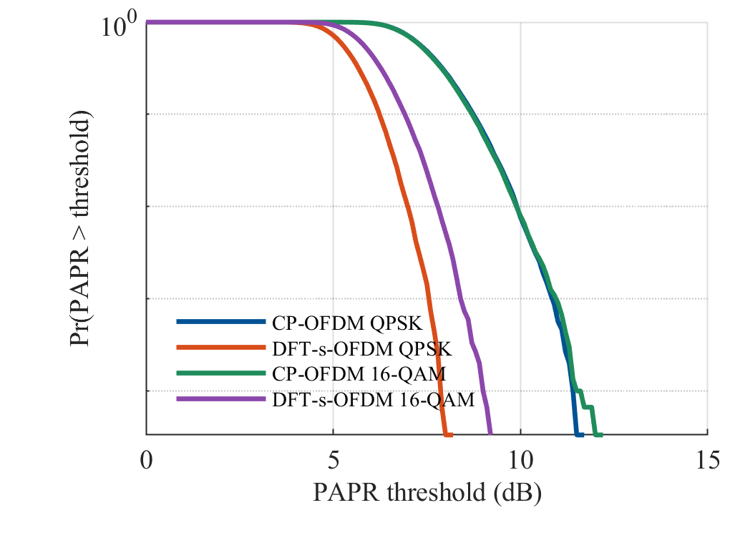
Fig. 1. PAPR CCDF from 30,000 useful blocks per curve and fourfold oversampling. CP denotes CP-OFDM; DFT-s denotes localized DFT-s-OFDM.
DFT spreading gives a clear PAPR reduction in Fig. 1, with a larger change for QPSK than for 16-QAM. At the 99th percentile, the QPSK value falls from 9.9014 to 6.9846 dB, a reduction of 2.9168 dB. For 16-QAM it falls from 9.8912 to 7.7970 dB, or by 2.0941 dB. The CP-OFDM curves are almost on top of each other, while the DFT-s-OFDM curves are separated. In this allocation, modulation order therefore makes a more visible difference once the data are spread.
Modulation | CP q99 | DFT-s q99 | Reduction
QPSK | 9.9014 | 6.9846 | 2.9168
16-QAM | 9.8912 | 7.7970 | 2.0941

The table gives the 99th-percentile values in dB: about 99% of the simulated blocks lie below each value. The same ordering remains farther into the tail. At the 99.9th percentile, CP-OFDM and DFT-s-OFDM give 10.8147 and 7.5629 dB for QPSK, and 10.9292 and 8.3986 dB for 16-QAM. These are sample percentiles, so larger peaks can still occur. The result gives us a reason to expect less clipping with DFT spreading. Whether that becomes a useful energy saving requires more information than the PAPR distribution provides.

B. Error Rates in AWGN
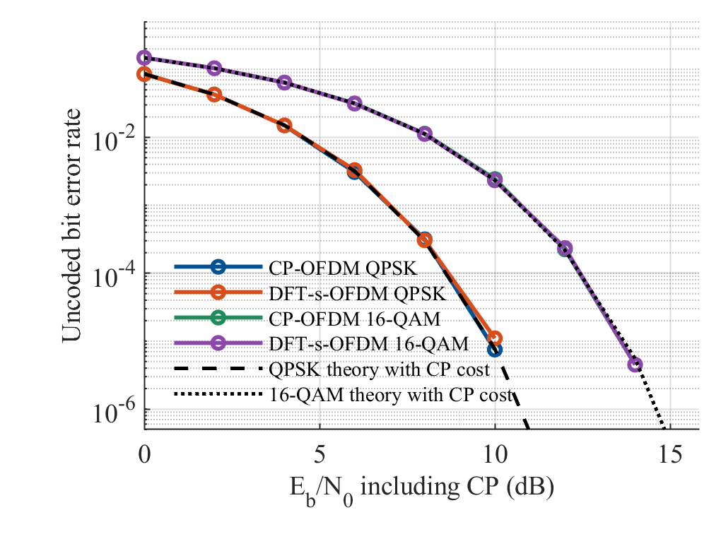
Fig. 2. Linear AWGN BER and analytical references with the same CP energy cost. Zero-error points are omitted from the logarithmic plot.
The AWGN test in Figure 2 checks the link against known BER expressions. For QPSK we use Q(√(2γ_b/c)); for Gray 16-QAM we use (3/4)Q(a) + (1/2)Q(3a) − (1/4)Q(5a), with a = √(0.8γ_b/c). Here Q is the upper-tail probability of a standard Gaussian variable, and c accounts for CP energy. Agreement with these references checks the combined effect of modulation, signal scaling, noise generation, and detection before the channel or amplifier is made more complicated.
There is little to choose between the waveforms in AWGN. At 10 dB with 16-QAM, the measured BER is 0.002433 for CP-OFDM and 0.002328 for DFT-s-OFDM. At 12 dB the ordering switches: the values are 0.0002240 and 0.0002345. This switching, together with the close curves, is consistent with the common theoretical BER. At 14 dB each waveform gives only nine errors in 1,999,872 bits. We cannot use such small counts to argue that one is the better waveform.
This agreement is also useful for interpreting the later tests. If the links already had a persistent BER separation in linear AWGN, we would first need to check signal scaling, noise power, subcarrier mapping, and detection. Here the energy-preserving transforms give the expected result. We can therefore carry the same settings into the fading and clipping tests and examine the additional effects there.

C. Frequency-Selective Rayleigh Channel with ZF
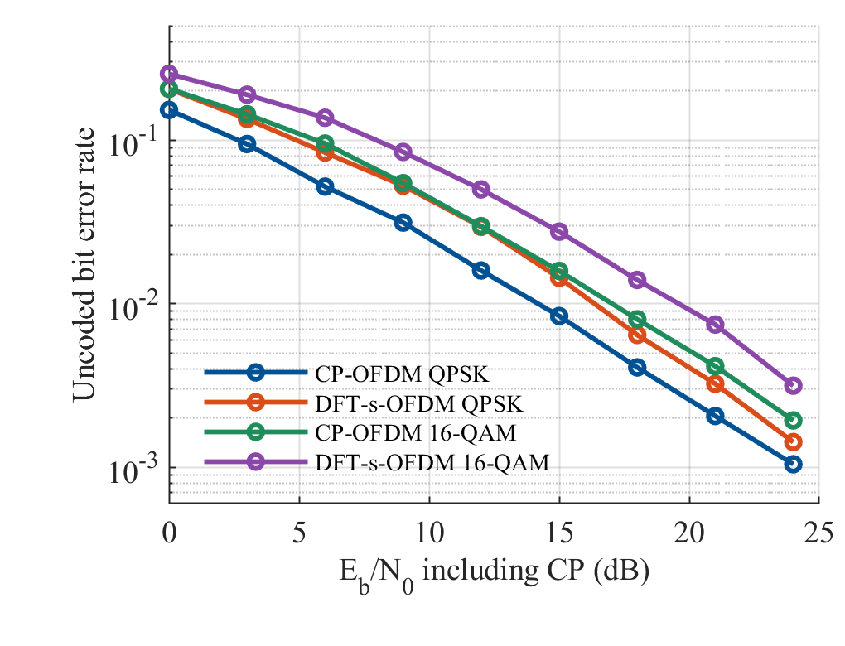
Fig. 3. Uncoded BER in the four-tap Rayleigh channel with perfect CSI and ZF equalization. The comparison is conditional on this receiver and channel model.
The Rayleigh result in Figure 3 does not follow the PAPR ranking. DFT-s-OFDM has the higher BER with the ZF receiver. For example, at 12 dB with 16-QAM, CP-OFDM gives 0.02977 and DFT-s-OFDM gives 0.04993; their block-based standard errors are 0.000869 and 0.001855. At 18 dB the respective BER values are 0.008024 and 0.01395. QPSK shows the same ordering over the tested SNR range. The receiver's response to fading therefore matters even though the transmitted signal has smaller peaks.
Equation (4) helps explain this result. For CP-OFDM, the strong noise enhancement on a weak subcarrier mainly affects that subcarrier's data. In DFT-s-OFDM, the inverse DFT mixes this noise with the other recovered symbols. Smaller transmitted peaks do not compensate for that step, so the BER can increase under the same fading conditions. We used ZF without channel coding in this test. The result should be read with that receiver assumption in mind, since neither MMSE equalization nor a coded 5G link was evaluated.

D. BER under Amplifier Saturation
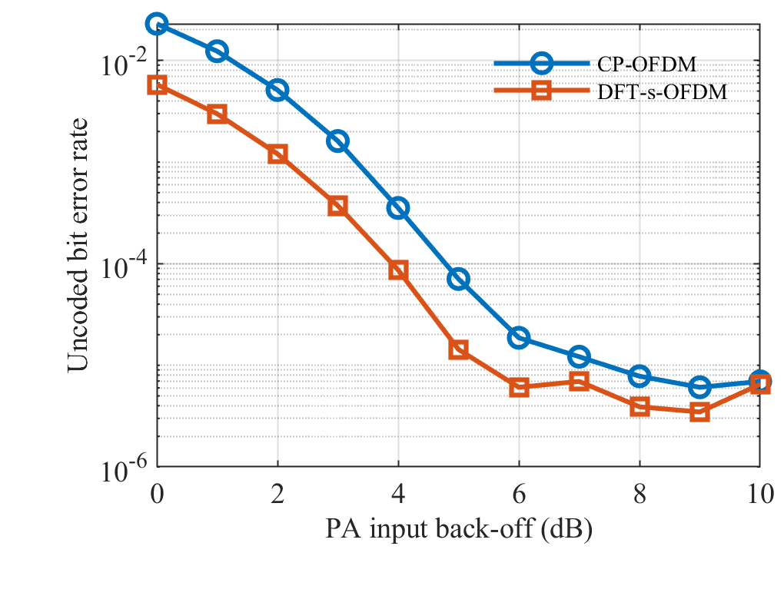
Fig. 4. 16-QAM BER versus IBO with a hard limiter and AWGN at pre-amplifier E_b/N_0 = 14 dB. There is no post-amplifier power renormalization.
Once the amplifier clips, DFT-s-OFDM gains an advantage. At 2 dB IBO, we count 11,798 errors for CP-OFDM and 2,778 for DFT-s-OFDM in the same 2,304,000 transmitted bits. These counts give BER values of 0.005121 and 0.001206, respectively, so CP-OFDM has about 4.25 times as many bit errors. This comparison is based on many more errors than the few-error points at large back-off. Under the common amplitude limit, the smaller peaks of DFT-s-OFDM lead to less damage to the transmitted signal.
The advantage remains at 3 dB IBO, where BER is 0.001613 for CP-OFDM and 0.0003733 for DFT-s-OFDM. Among the integer settings tested, DFT-s-OFDM is first below 10⁻³ at 3 dB, whereas CP-OFDM reaches that level at 4 dB. We swept IBO in 1 dB steps, so these points do not locate the exact threshold crossings. They also depend on the hard-limiter model. As the back-off becomes large enough to avoid most clipping, both curves approach the low AWGN BER.

E. EVM and Output Power
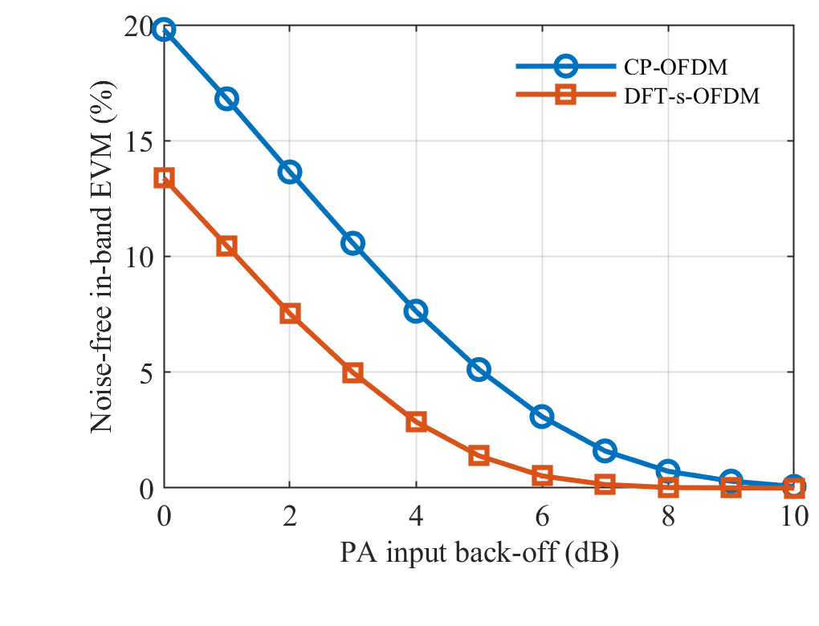
Fig. 5. RMS in-band EVM from distortion alone, after independent scalar gain calibration. Receiver noise is excluded from this metric.
Figure 5 isolates the clipping distortion by removing receiver noise. At 2 dB IBO, EVM is 13.65% for CP-OFDM and 7.53% for DFT-s-OFDM; at 3 dB the corresponding values are 10.57% and 4.98%. These measurements are taken after gain correction, so they show the residual displacement of the symbols from their ideal positions. The smaller displacement for DFT-s-OFDM gives a consistent explanation for its lower BER in Fig. 4. The difference is therefore visible in both symbol distortion and bit decisions.
The power records show another part of the clipping effect. At 2 dB IBO, the output-to-input power ratio is −0.9864 dB for CP-OFDM and −0.5206 dB for DFT-s-OFDM. Clipping removes signal power from both, with the smaller loss occurring for DFT-s-OFDM. These values describe power in the signal, not the electrical power drawn by a transmitter. Our limiter has no model for DC consumption, heating, phase distortion, or memory. A phone battery saving cannot be calculated from these ratios.

F. Power Spectrum
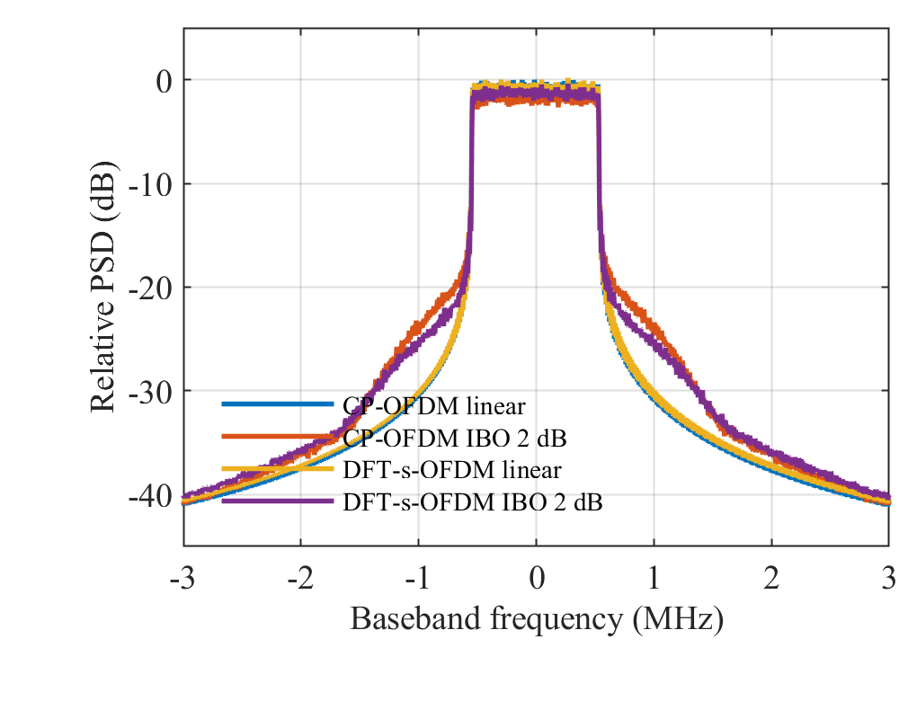
Fig. 6. Welch PSD for 16-QAM with rectangular pulses. All curves use the linear CP-OFDM peak as their common reference. Clipped curves use 2 dB IBO.
Without clipping, the two spectra in Fig. 6 almost coincide. This is consistent with the common subcarrier allocation and rectangular pulse shape: adding the DFT has not added a filter. Clipping changes the picture by raising power outside the allocated band. Near part of the band edge, the DFT-s-OFDM curve is lower, but it does not stay below CP-OFDM at every frequency. The plot therefore supports a local spectral comparison, rather than a claim of lower emissions everywhere.
To turn this plot into an adjacent-channel leakage ratio (ACLR), we would need to define the adjacent band and integrate its power. That calculation is outside the present test, as is comparison with a specific emission mask. A next step would be to add filtering or windowing and repeat the PAPR, EVM, and out-of-band power measurements. This would connect the simple rectangular-pulse model more closely to the waveform processing considered in [10], [11], and [15].

G. What the Results Mean and Model Limitations
Taken together, the tests explain why choosing a waveform from PAPR alone can be misleading. DFT-s-OFDM is useful in the low-back-off clipping case: the lower peaks are accompanied by less distortion and fewer errors. That benefit is absent in linear AWGN, where both links have the same theoretical BER. In the Rayleigh test, ZF noise enhancement gives the opposite BER ordering. The useful choice consequently depends on which part of the link is limiting reception.
The next receiver comparison to make is ZF versus MMSE, followed by channel coding. Both could change the fading result and would bring the model closer to a working link. More channel tap powers, delays, and subcarrier allocations should also be tested, since the present conclusions use only one of each. Coding, pilots, mobility, phase noise, carrier-frequency offsets, interference, multiple antennas, amplifier memory, and receiver adaptation are all omitted here. Those choices keep the simulation manageable, but limit what it says about a network. An energy-efficiency study would additionally need a measured amplifier model.

V. CONCLUSION
The MATLAB results show a useful but conditional benefit from DFT spreading in the simplified 5G uplink. It reduces the 99th-percentile PAPR by 2.92 dB with QPSK and 2.09 dB with 16-QAM. When the amplifier clips at 2 dB IBO, the CP-OFDM BER is about 4.25 times the DFT-s-OFDM BER, and EVM falls from 13.65% to 7.53%. The linear-channel tests set the limit on that conclusion: theoretical BER is unchanged in AWGN, and the tested Rayleigh channel gives a higher BER for DFT-s-OFDM with ZF. Lower PAPR is therefore helpful for this clipping problem, but the channel and receiver still determine whether it improves reception.

REFERENCES
[1] S. Parkvall, E. Dahlman, A. Furuskar, and M. Frenne, "NR: The New 5G Radio Access Technology," IEEE Communications Standards Magazine, vol. 1, no. 4, pp. 24-30, 2017, doi: 10.1109/mcomstd.2017.1700042.
[2] M. Shafi et al., "5G: A Tutorial Overview of Standards, Trials, Challenges, Deployment, and Practice," IEEE Journal on Selected Areas in Communications, vol. 35, no. 6, pp. 1201-1221, 2017, doi: 10.1109/jsac.2017.2692307.
[3] H. Myung, J. Lim, and D. Goodman, "Single carrier FDMA for uplink wireless transmission," IEEE Vehicular Technology Magazine, vol. 1, no. 3, pp. 30-38, 2006, doi: 10.1109/mvt.2006.307304.
[4] H. Myung, J. Lim, and D. Goodman, "Peak-To-Average Power Ratio of Single Carrier FDMA Signals with Pulse Shaping," in 2006 IEEE 17th International Symposium on Personal, Indoor and Mobile Radio Communications, pp. 1-5, 2006, doi: 10.1109/pimrc.2006.254407.
[5] F. Pancaldi, G. Vitetta, R. Kalbasi, N. Al-Dhahir, M. Uysal, and H. Mheidat, "Single-carrier frequency domain equalization," IEEE Signal Processing Magazine, vol. 25, no. 5, pp. 37-56, 2008, doi: 10.1109/msp.2008.926657.
[6] S. H. Han and J. H. Lee, "An overview of peak-to-average power ratio reduction techniques for multicarrier transmission," IEEE Wireless Communications, vol. 12, no. 2, pp. 56-65, 2005, doi: 10.1109/mwc.2005.1421929.
[7] T. Jiang and Y. Wu, "An Overview: Peak-to-Average Power Ratio Reduction Techniques for OFDM Signals," IEEE Transactions on Broadcasting, vol. 54, no. 2, pp. 257-268, 2008, doi: 10.1109/tbc.2008.915770.
[8] X. Li and L. J. Cimini, "Effects of clipping and filtering on the performance of OFDM," IEEE Communications Letters, vol. 2, no. 5, pp. 131-133, 1998, doi: 10.1109/4234.673657.
[9] H. Ochiai and H. Imai, "On the distribution of the peak-to-average power ratio in OFDM signals," IEEE Transactions on Communications, vol. 49, no. 2, pp. 282-289, 2001, doi: 10.1109/26.905885.
[10] A. Sahin, I. Guvenc, and H. Arslan, "A Survey on Multicarrier Communications: Prototype Filters, Lattice Structures, and Implementation Aspects," IEEE Communications Surveys & Tutorials, vol. 16, no. 3, pp. 1312-1338, 2014, doi: 10.1109/surv.2013.121213.00263.
[11] B. Farhang-Boroujeny, "OFDM Versus Filter Bank Multicarrier," IEEE Signal Processing Magazine, vol. 28, no. 3, pp. 92-112, 2011, doi: 10.1109/msp.2011.940267.
[12] S. Weinstein and P. Ebert, "Data Transmission by Frequency-Division Multiplexing Using the Discrete Fourier Transform," IEEE Transactions on Communication Technology, vol. 19, no. 5, pp. 628-634, 1971, doi: 10.1109/tcom.1971.1090705.
[13] J. A. C. Bingham, "Multicarrier modulation for data transmission: an idea whose time has come," IEEE Communications Magazine, vol. 28, no. 5, pp. 5-14, 1990, doi: 10.1109/35.54342.
[14] B. E. Priyanto, H. Codina, S. Rene, T. B. Sorensen, and P. Mogensen, "Initial Performance Evaluation of DFT-Spread OFDM Based SC-FDMA for UTRA LTE Uplink," in 2007 IEEE 65th Vehicular Technology Conference - VTC2007-Spring, pp. 3175-3179, 2007, doi: 10.1109/vetecs.2007.650.
[15] T. Levanen, J. Pirskanen, K. Pajukoski, M. Renfors, and M. Valkama, "Transparent Tx and Rx Waveform Processing for 5G New Radio Mobile Communications," IEEE Wireless Communications, vol. 26, no. 1, pp. 128-136, 2019, doi: 10.1109/mwc.2018.1800015.
[16] G. Berardinelli, L. A. Ruiz de Temino, S. Frattasi, M. Rahman, and P. Mogensen, "OFDMA vs. SC-FDMA: performance comparison in local area imt-a scenarios," IEEE Wireless Communications, vol. 15, no. 5, pp. 64-72, 2008, doi: 10.1109/mwc.2008.4653134.
[17] H. Ochiai and H. Imai, "Performance analysis of deliberately clipped OFDM signals," IEEE Transactions on Communications, vol. 50, no. 1, pp. 89-101, 2002, doi: 10.1109/26.975762.

APPENDIX A. COMPLETE MATLAB IMPLEMENTATION
The complete MATLAB program is listed below. In the MATLAB code folder, run run_5g_uplink('test') to check the model or run_5g_uplink('full') to repeat all six experiments. The results in this report come from the completed full_20261027_132725 run. The separate run_5g_uplink.m file is the runnable version.
function outDir = run_5g_uplink(mode)
% RUN_5G_UPLINK Reproducible CP-OFDM / localized DFT-s-OFDM study.
% Usage: run_5g_uplink('quick'), run_5g_uplink('full'), run_5g_uplink('test').
% Base MATLAB only. Intended for MATLAB R2016b or later.
% Simplified SISO 5G-uplink-inspired link, not a complete NR implementation.
% Eb/N0 includes CP energy and is measured BEFORE the PA. No FEC or pilots.
% All transforms are unitary. A memoryless hard limiter is a PA surrogate.
% See README_CN.txt and experiment_design.txt before interpreting results.

if nargin < 1, mode = 'quick'; end
assert(any(strcmp(mode, {'quick','full','test'})), 'Use quick, full, or test.');
cfg.Nfft = 256; cfg.K = 72; cfg.Ncp = 18; cfg.L = 4;
cfg.deltaF = 15e3; cfg.seed = 20261027; cfg.batch = 128;
cfg.delays = [0 1 3 5]; cfg.pdpDB = [0 -3 -6 -9];
cfg.modOrders = [4 16]; cfg.awgnDB = 0:2:16; cfg.fadingDB = 0:3:24;
cfg.iboDB = 0:1:10; cfg.paEbN0DB = 14;
cfg.paprBlocks = 3000; cfg.maxBits = 150000; cfg.minBlocks = 256;
cfg.targetErrors = 200; cfg.paBlocks = 1000; cfg.spectrumBlocks = 100;
if strcmp(mode, 'full')
cfg.paprBlocks = 30000; cfg.maxBits = 2000000; cfg.minBlocks = 2048;
cfg.targetErrors = 1000; cfg.paBlocks = 8000; cfg.spectrumBlocks = 600;
end
cfg.N = cfg.Nfft*cfg.L; cfg.cp = cfg.Ncp*cfg.L;
cfg.idx = (cfg.N/2-cfg.K/2+1):(cfg.N/2+cfg.K/2);
cfg.bin = (-cfg.K/2:cfg.K/2-1).';
cfg.overhead = (cfg.Nfft+cfg.Ncp)/cfg.Nfft;
cfg.mode = mode; cfg.matlabVersion = version;
rng(cfg.seed, 'twister');
selftest(cfg);
if strcmp(mode, 'test'), outDir = ''; return; end

root = fileparts(mfilename('fullpath'));
outDir = fullfile(root, 'results', [mode '_' datestr(now,'yyyymmdd_HHMMSS')]);
if exist(outDir,'dir'), outDir = [outDir '_new']; end
mkdir(outDir);
diary(fullfile(outDir, 'run_log.txt')); cleanup = onCleanup(@() diary('off')); %#ok<NASGU>
fprintf('Mode %s, seed %d, MATLAB %s\n',mode,cfg.seed,version);
fprintf('Output %s\n', outDir);
set(groot,'defaultAxesFontName','Times New Roman','defaultAxesFontSize',11);
set(groot,'defaultTextFontName','Times New Roman');
colors = [0.00 0.32 0.58; 0.85 0.30 0.10; 0.12 0.55 0.36; 0.55 0.28 0.67];
labels = {'CP-OFDM QPSK','DFT-s-OFDM QPSK','CP-OFDM 16-QAM','DFT-s-OFDM 16-QAM'};

%% 1. Oversampled PAPR statistics. CP excluded from measurement interval.
fprintf('1/6 PAPR statistics\n');
papr = zeros(cfg.paprBlocks,4);
for m = 1:2
for first = 1:cfg.batch:cfg.paprBlocks
n = min(cfg.batch,cfg.paprBlocks-first+1);
[~,d] = source(cfg.modOrders(m),cfg.K,n);
for w = 1:2
x = transmit(d,w,cfg);
v = 10*log10(max(abs(x).^2,[],1)./mean(abs(x).^2,1));
papr(first:first+n-1,2*(m-1)+w) = v.';
end
end
end
threshold = (0:0.1:15).'; ccdf = zeros(length(threshold),4);
fig = newfig; hold on;
for c = 1:4
ccdf(:,c) = mean(bsxfun(@gt,papr(:,c).',threshold),2);
semilogy(threshold,positive(ccdf(:,c)),'LineWidth',1.6,'Color',colors(c,:));
end
set(gca,'YScale','log'); grid(gca,'on'); ylim([1/cfg.paprBlocks 1]);
xlabel('PAPR threshold (dB)'); ylabel('Pr(PAPR > threshold)');
title(sprintf('PAPR CCDF, %d blocks, %dx oversampling',cfg.paprBlocks,cfg.L));
legend(labels,'Location','southwest');
savefigs(fig,outDir,'fig01_papr_ccdf');
writecsv(fullfile(outDir,'papr_ccdf.csv'),{'threshold_dB','CP_QPSK','DFTs_QPSK','CP_16QAM','DFTs_16QAM'},[threshold ccdf]);
pq = zeros(4,2);
for c=1:4
v=sort(papr(:,c)); pq(c,:)=[v(ceil(0.99*numel(v))) v(ceil(0.999*numel(v)))];
end
writecsv(fullfile(outDir,'papr_quantiles.csv'),{'curve_id','q99_dB','q999_dB'},[(1:4).' pq]);

%% 2 and 3. Linear AWGN and block Rayleigh channels.
% FFT-domain simulation is exactly equivalent to CP removal / FFT under
% a CP longer than the channel and perfect timing. selftest verifies this.
berResults = struct;
for channel = {'AWGN','Rayleigh'}
cname = channel{1};
if strcmp(cname,'AWGN'), axisDB=cfg.awgnDB; num=2; else, axisDB=cfg.fadingDB; num=3; end
fprintf('%d/6 BER in %s\n',num,cname);
matrix=zeros(numel(axisDB),4); rows=[];
for m=1:2
M=cfg.modOrders(m);
for s=1:numel(axisDB)
st=linearPoint(M,axisDB(s),cname,cfg);
matrix(s,2*m-1:2*m)=st.ber;
for w=1:2
rows(end+1,:)=[M w axisDB(s) st.errors(w) st.bits st.blocks st.ber(w) st.blockSE(w)]; %#ok<AGROW>
end
fprintf(' M=%d, Eb/N0=%g dB, BER=[%.3g %.3g], bits=%d\n',M,axisDB(s),st.ber,st.bits);
end
end
fig=newfig; hold on;
for c=1:4
semilogy(axisDB,positive(matrix(:,c)),'-o','LineWidth',1.4,'Color',colors(c,:),'MarkerSize',4);
end
leg=labels;
if strcmp(cname,'AWGN')
g=10.^(axisDB/10)/cfg.overhead;
qpsk=0.5*erfc(sqrt(g));
a=sqrt(0.8*g); Q=@(x) 0.5*erfc(x/sqrt(2));
qam16=0.75*Q(a)+0.5*Q(3*a)-0.25*Q(5*a);
semilogy(axisDB,positive(qpsk),'k--','LineWidth',1.2);
semilogy(axisDB,positive(qam16),'k:','LineWidth',1.2);
leg=[labels {'QPSK theory with CP cost','16-QAM theory with CP cost'}];
end
set(gca,'YScale','log'); grid(gca,'on'); ylim([1/cfg.maxBits 0.5]);
xlabel('Pre-PA E_b/N_0 including CP energy (dB)'); ylabel('Uncoded bit error rate');
title([cname ' channel, perfect CSI, ZF equalization']);
legend(leg,'Location','southwest');
savefigs(fig,outDir,sprintf('fig%02d_ber_%s',num,lower(cname)));
writecsv(fullfile(outDir,['ber_' lower(cname) '.csv']), ...
{'M','waveform_id','EbN0_dB','error_bits','total_bits','blocks','BER','block_standard_error'},rows);
berResults.(cname).curves=matrix; berResults.(cname).raw=rows;
end

%% 4 and 5. PA limiter: BER and noiseless in-band EVM, 16-QAM.
% Both waveforms have the same ensemble mean input power and threshold.
% There is NO post-PA power renormalization. Gain estimated on a separate
% independent calibration sequence is compensated at the receiver.
fprintf('4/6 and 5/6 PA back-off experiment\n');
paRows=[]; paBER=zeros(numel(cfg.iboDB),2); paEVM=paBER;
for s=1:numel(cfg.iboDB)
ibo=cfg.iboDB(s); A=sqrt(cfg.K/cfg.N)*10^(ibo/20);
gain=ones(1,2); pin=zeros(1,2); pout=pin;
[~,dcal]=source(16,cfg.K,512);
for w=1:2
x=transmit(dcal,w,cfg); z=limiter(x,A);
gain(w)=real(sum(conj(x(:)).*z(:))/sum(abs(x(:)).^2));
end
errors=zeros(1,2); evmNumer=errors; evmDenom=0;
for first=1:cfg.batch:cfg.paBlocks
n=min(cfg.batch,cfg.paBlocks-first+1);
[b,d]=source(16,cfg.K,n);
nv=cfg.overhead/(4*10^(cfg.paEbN0DB/10));
noise=sqrt(nv/2)*(randn(cfg.K,n)+1i*randn(cfg.K,n));
evmDenom=evmDenom+sum(abs(d(:)).^2);
for w=1:2
x=transmit(d,w,cfg); z=limiter(x,A);
rxGrid=fftshift(fft(z,[],1)/sqrt(cfg.N),1); v=rxGrid(cfg.idx,:);
dhat=despread((v+noise)/gain(w),w);
dec=qamDemap(dhat,16); errors(w)=errors(w)+sum(dec(:)~=b(:));
clean=despread(v/gain(w),w);
evmNumer(w)=evmNumer(w)+sum(abs(clean(:)-d(:)).^2);
pin(w)=pin(w)+sum(abs(x(:)).^2); pout(w)=pout(w)+sum(abs(z(:)).^2);
end
end
bits=cfg.paBlocks*cfg.K*4;
paBER(s,:)=errors/bits; paEVM(s,:)=100*sqrt(evmNumer/evmDenom);
for w=1:2
paRows(end+1,:)=[ibo w cfg.paEbN0DB errors(w) bits paBER(s,w) paEVM(s,w) gain(w) 10*log10(pout(w)/pin(w))]; %#ok<AGROW>
end
fprintf(' IBO=%g dB, BER=[%.3g %.3g], EVM=[%.2f %.2f] %%\n',ibo,paBER(s,:),paEVM(s,:));
end
fig=newfig;
semilogy(cfg.iboDB,positive(paBER(:,1)),'-o',cfg.iboDB,positive(paBER(:,2)),'-s','LineWidth',1.5);
grid(gca,'on'); xlabel('PA input back-off (dB)'); ylabel('Uncoded bit error rate');
title(sprintf('16-QAM with hard limiting, pre-PA E_b/N_0 = %g dB',cfg.paEbN0DB));
legend({'CP-OFDM','DFT-s-OFDM'},'Location','northeast');
savefigs(fig,outDir,'fig04_ber_pa_backoff');
fig=newfig;
plot(cfg.iboDB,paEVM(:,1),'-o',cfg.iboDB,paEVM(:,2),'-s','LineWidth',1.5);
grid(gca,'on'); xlabel('PA input back-off (dB)'); ylabel('RMS in-band EVM after gain compensation (%)');
title('16-QAM distortion without receiver noise');
legend({'CP-OFDM','DFT-s-OFDM'},'Location','northeast');
savefigs(fig,outDir,'fig05_evm_pa_backoff');
writecsv(fullfile(outDir,'pa_backoff.csv'), ...
{'IBO_dB','waveform_id','EbN0_dB','error_bits','total_bits','BER','EVM_percent','gain','output_input_power_dB'},paRows);

%% 6. Welch PSD implemented here, including CP and symbol boundaries.
fprintf('6/6 Power spectral density\n');
[~,d]=source(16,cfg.K,cfg.spectrumBlocks);
psdAll=[]; fs=cfg.N*cfg.deltaF;
for w=1:2
x=transmit(d,w,cfg); frame=[x(end-cfg.cp+1:end,:);x]; stream=frame(:);
for state=1:2
sig=stream;
if state==2, sig=limiter(sig,sqrt(cfg.K/cfg.N)*10^(2/20)); end
[f,p]=welchLocal(sig,fs,4*cfg.N);
psdAll(:,2*(w-1)+state)=p; %#ok<AGROW>
end
end
referenceLevel=max(psdAll(:,1)); psdDB=10*log10(max(psdAll/referenceLevel,1e-14));
fig=newfig; plot(f/1e6,psdDB,'LineWidth',1.3); grid(gca,'on');
xlim([-3 3]); ylim([-80 5]); xlabel('Baseband frequency (MHz)');
ylabel('PSD relative to linear CP-OFDM peak (dB)');
title('16-QAM spectrum, rectangular pulses, common normalization');
legend({'CP-OFDM linear','CP-OFDM IBO 2 dB','DFT-s-OFDM linear','DFT-s-OFDM IBO 2 dB'},'Location','southwest');
savefigs(fig,outDir,'fig06_psd');
writecsv(fullfile(outDir,'psd.csv'),{'frequency_Hz','CP_linear_dB','CP_clipped_dB','DFTs_linear_dB','DFTs_clipped_dB'},[f psdDB]);

save(fullfile(outDir,'results.mat'),'cfg','papr','threshold','ccdf','pq','berResults','paRows','paBER','paEVM','f','psdAll');
fid=fopen(fullfile(outDir,'summary.txt'),'w');
fprintf(fid,'Mode: %s\nSeed: %d\nMATLAB: %s\n',mode,cfg.seed,version);
fprintf(fid,'Curve order: CP QPSK, DFTs QPSK, CP 16QAM, DFTs 16QAM.\n');
fprintf(fid,'PAPR q99 / q999 in dB:\n');
for c=1:4, fprintf(fid,'%s: %.4f / %.4f\n',labels{c},pq(c,:)); end
fprintf(fid,'No zero-error point has been replaced by a fabricated positive BER.\n');
fprintf(fid,'Zero-error BER/CCDF points are omitted on logarithmic plots; raw counts are in CSV.\n');
fprintf(fid,'Rayleigh uncertainty: block-level standard error, not an iid-bit interval.\n');
fprintf(fid,'PA results use pre-PA energy. Output power loss is saved; no battery-efficiency claim.\n');
fprintf(fid,'Full mode is recommended for the report. Quick mode is for debugging.\n');
fclose(fid);
fprintf('Complete. Return this entire results folder for report and slides.\n');
fprintf('Keep raw CSV and MAT files, not just screenshots.\n');
end

function [b,d]=source(M,K,n)
b=randi([0 1],log2(M),K*n); d=reshape(qamMap(b,M),K,n);
end

function d=qamMap(b,M)
p=log2(M)/2;
if M==4, levels=[-1 1]; elseif M==16, levels=[-3 -1 3 1]; else, error('Only QPSK and 16-QAM'); end
weights=2.^(p-1:-1:0);
ii=weights*b(1:p,:); qq=weights*b(p+1:end,:);
d=(levels(ii+1)+1i*levels(qq+1))/sqrt(2*(M-1)/3);
end

function b=qamDemap(d,M)
p=log2(M)/2;
if M==4, levels=[-1 1]; else, levels=[-3 -1 3 1]; end
v=d(:)*sqrt(2*(M-1)/3);
[~,ii]=min(abs(bsxfun(@minus,real(v),levels)),[],2);
[~,qq]=min(abs(bsxfun(@minus,imag(v),levels)),[],2);
b=zeros(2*p,numel(v));
for j=1:p
b(j,:)=bitget(uint32(ii-1),p-j+1).';
b(p+j,:)=bitget(uint32(qq-1),p-j+1).';
end
end

function z=spread(d,w)
if w==2, z=fft(d,[],1)/sqrt(size(d,1)); else, z=d; end
end

function d=despread(z,w)
if w==2, d=ifft(z,[],1)*sqrt(size(z,1)); else, d=z; end
end

function x=transmit(d,w,cfg)
txGrid=zeros(cfg.N,size(d,2)); txGrid(cfg.idx,:)=spread(d,w);
x=ifft(ifftshift(txGrid,1),[],1)*sqrt(cfg.N);
end

function z=limiter(x,A)
z=x.*min(1,A./max(abs(x),eps));
end

function st=linearPoint(M,ebDB,cname,cfg)
bitsPerBlock=cfg.K*log2(M);
maxBlocks=max(cfg.minBlocks,floor(cfg.maxBits/bitsPerBlock));
e=zeros(1,2); sums2=e; blocks=0;
pdp=10.^(cfg.pdpDB/10); pdp=pdp/sum(pdp);
response=exp(-1i*2*pi*cfg.bin*cfg.delays/cfg.Nfft);
nv=cfg.overhead/(log2(M)*10^(ebDB/10));
while blocks<maxBlocks && (blocks<cfg.minBlocks || any(e<cfg.targetErrors))
n=min(cfg.batch,maxBlocks-blocks); [b,d]=source(M,cfg.K,n);
if strcmp(cname,'Rayleigh')
taps=bsxfun(@times,sqrt(pdp(:)/2),randn(numel(pdp),n)+1i*randn(numel(pdp),n));
H=response*taps; % E[|H|^2]=1; do NOT normalize each realization.
else
H=ones(cfg.K,n);
end
noise=sqrt(nv/2)*(randn(cfg.K,n)+1i*randn(cfg.K,n));
for w=1:2
z=H.*spread(d,w)+noise;
dhat=despread(z./H,w); % exact ZF; deep fades legitimately amplify noise.
dec=qamDemap(dhat,M); err=reshape(dec~=b,bitsPerBlock,n);
eb=sum(err,1); e(w)=e(w)+sum(eb);
sums2(w)=sums2(w)+sum((eb/bitsPerBlock).^2);
end
blocks=blocks+n;
end
st.bits=blocks*bitsPerBlock; st.blocks=blocks; st.errors=e; st.ber=e/st.bits;
samplevar=max(0,(sums2-blocks*st.ber.^2)/(blocks-1));
st.blockSE=sqrt(samplevar/blocks);
end

function selftest(cfg)
fprintf('Running deterministic modem and CP tests...\n');
for M=[4 16]
b=zeros(log2(M),M);
for j=1:log2(M), b(j,:)=bitget(uint32(0:M-1),log2(M)-j+1); end
assert(isequal(b,qamDemap(qamMap(b,M),M)),'QAM round trip failed.');
assert(abs(mean(abs(qamMap(b,M)).^2)-1)<1e-12,'Constellation energy failed.');
end
[b,d]=source(16,cfg.K,3);
h=zeros(1,max(cfg.delays)*cfg.L+1); h(cfg.delays*cfg.L+1)=[1 0.3+0.2i -0.1i 0.1];
H=fftshift(fft(h,cfg.N)).';
for w=1:2
x=transmit(d,w,cfg);
assert(max(abs(sum(abs(x).^2,1)-sum(abs(d).^2,1)))<1e-9,'Energy preservation failed.');
xc=[x(end-cfg.cp+1:end,:);x]; y=filter(h,1,xc,[],1);
g=fftshift(fft(y(cfg.cp+(1:cfg.N),:),[],1)/sqrt(cfg.N),1);
dhat=despread(bsxfun(@rdivide,g(cfg.idx,:),H(cfg.idx)),w);
assert(max(abs(dhat(:)-d(:)))<1e-9,'CP convolution / FFT equivalence failed.');
assert(isequal(b,qamDemap(dhat,16)),'Noiseless link failed.');
c1=cfg; c1.N=cfg.Nfft; c1.idx=(c1.N/2-c1.K/2+1):(c1.N/2+c1.K/2);
xb=transmit(d,w,c1); xs=x(1:cfg.L:end,:)*sqrt(cfg.L);
assert(max(abs(xs(:)-xb(:)))<1e-9,'Oversampling consistency failed.');
end
one=ones(cfg.K,1); a=transmit(one,1,cfg); s=transmit(one,2,cfg);
assert(abs(max(abs(a).^2)/mean(abs(a).^2)-cfg.K)<1e-9,'OFDM peak test failed.');
assert(abs(max(abs(s).^2)/mean(abs(s).^2)-1)<1e-9,'DFT tone test failed.');
assert(cfg.Ncp>max(cfg.delays),'CP does not cover channel.');
fprintf('PASS: Gray mapping, unit energy, CP channel, zero BER, oversampling, known PAPR.\n');
end

function [f,p]=welchLocal(x,fs,nfft)
len=nfft; hop=floor(len/2); window=0.5-0.5*cos(2*pi*(0:len-1)'/(len-1));
p=zeros(nfft,1); count=0;
for a=1:hop:(numel(x)-len+1)
s=x(a:a+len-1).*window;
p=p+abs(fft(s,nfft)).^2/(fs*sum(window.^2)); count=count+1;
end
assert(count>0,'Not enough samples for PSD.');
p=fftshift(p/count); f=(-nfft/2:nfft/2-1)'*fs/nfft;
end

function y=positive(x)
y=x; y(y<=0)=NaN;
end

function fig=newfig
fig=figure('Color','w','Position',[100 100 900 600]);
end

function savefigs(fig,path,name)
savefig(fig,fullfile(path,[name '.fig']));
print(fig,fullfile(path,[name '.png']),'-dpng','-r300');
set(fig,'PaperPositionMode','auto');
print(fig,fullfile(path,[name '.pdf']),'-dpdf','-bestfit');
end

function writecsv(path,header,data)
fid=fopen(path,'w'); assert(fid>=0,'Cannot create CSV.');
fprintf(fid,'%s',header{1});
for k=2:numel(header), fprintf(fid,',%s',header{k}); end
fprintf(fid,'\n'); fclose(fid);
dlmwrite(path,data,'-append','delimiter',',','precision','%.12g');
end

