ECS TE Claim — Pre-Trip & TMC Integration
Analysis and screen mockups · 12 November 2026 · reference claim TE00080614
Now that Pre-Trip lives in ECS, the TE claim should shift from PNR-anchored (the claimant picks a TMC booking) to Travel-Authorisation-anchored (the approved Pre-Trip travel request seeds the claim and the TMC data arrives under one TA). Most of this is already specified in the Pre-Trip TE-sync contract; what remains is four ECS-side gaps plus a TMC-transition plan. Part A is the written analysis; Part B is the six affected screens mocked up field by field.

Part A — Analysis

1. The anchor shift: PNR to the Travel Authorisation
The claim should be created from the approved Pre-Trip travel request, not assembled on the claim side around a PNR. Today the only automated travel data is a Travel Booking Reference lookup where the claimant picks a TMC PNR; everything else is re-keyed. The approved request already carries the whole trip under one TA, and the TA groups every PNR, segment and CTA charge. This matters most for group travel: one TA fans out to many PNRs (one per traveller).
- Already in the contract. createClaimFromRequest + resolveClaimTraveller create the claim from the approved request, scoped per traveller (GRP-7). The TA and TR number are Locked; the PNR is demoted to Reference.
- ECS change. Flip the Travel Booking Reference entry from PNR-first to TA-first (the TA is the anchor; its PNRs show as children) and add a travel-request link as the creation path.

2. Travel Booking Details: locked from the request
The claim travel header should be pre-filled and read-only from the approved request, not re-selected. The contract assigns a treatment to each field:
Claim header field | Source (from the request) | Treatment
Traveller / Entity / Department | employee record | Locked
Travel Request no / Travel Authorisation no | requestNumber / authorisationNo | Locked
Travel purpose | purposeId | Locked
Description | description | Locked
Main destination | destCity / destCountry | Locked
Official travel dates | startDate / endDate | Editable
Travel class (approved) | travelClassId | Reference
Charging & allocation | allocations[] (CC/WBS) | Locked
Booking reference (PNR / ticket) | booking.pnr / ticketNo | Reference
"Booking not made on TRS" becomes derived from the request booking arrangement, not a manual tick.

3. Expense lines & CTA: reference-only, excluded from claim posting
Lines split by who already paid, and that split decides what the claim reimburses. Settlement (DD-19) is the single source of truth: an employee-settled line is Editable (claimable); a centrally-billed line (TMC/CTA airfare, or a CTA hotel) is Reference-only — shown for comparison, not reimbursed.
CTA charges post once, at booking, and are excluded from the claim posting. The Pre-Trip module posts CTA charges when the TMC charge lands (ON_RECEIPT), not at claim. In the claim they are carried only as Reference: they let the traveller and approver see the total trip cost, but are excluded from the claim accounting entries, reimbursable total and posting — no double-posting.
- Airfare: CTA-billed = Reference (feeds the Less NTU Corporate Card line); self-booked = Editable.
- Accommodation: CTA-billed = Reference; traveller-paid = Editable with the city/nights scaffold pre-filled.
- ODA: pre-populated from the approved per-city ODA, personal days already excluded.
- Out-of-pocket (taxis, trains, meals): unchanged — claimant-entered with receipts.

4. Charging inherited, and M6 extended to the reimbursable claim path
Charging. The claim defaults charging and accounting from the approved request allocation (Locked). Accounting entries / posting cover only the reimbursable lines; CTA lines inherit charging for display, flagged non-posting (already posted at booking).
M6 (travel-class upgrade differential) — extend to claim, but only on one path:
- CTA-billed (TMC-booked) upgrade: no re-derivation at claim — the M6 split was applied at booking on the actual fare; the claim only references it.
- Traveller-reimbursed upgrade (self-booked/offline): extend M6 to claim — reimburse the entitled-class equivalent to normal charging, route the uplift to the M6 account (if NTU-funded) or treat it as self-funded.
- Gap today: prepopulateClaim applies only the self-funded cap; the M6-funded differential split for a reimbursed self-booked upgrade is not re-derived. Extending it reuses the Pre-Trip M6 derivation + account masters.

5. Personal extension days: how and where they are reflected
Reflected first as an exclusion baked into the amounts. Pre-Trip removes personal days/nights before the claim sees a number: ODA funded days = stay days − personal days; accommodation funded nights = stay nights − personal nights. The claim pre-fills from those funded amounts, so the traveller cannot claim ODA/hotel for personal days. For a group this is per traveller.
But it must also be made visible, in three places:
- Claim header — a personal-travel indicator plus the declared personal dates, showing the official-vs-personal split.
- ODA line — personal days visibly reduce the funded Duration per city.
- Accommodation line — funded nights shown as stay nights minus personal nights.
Contract gap. personalIndicator is a TMC-side field only; there is no claim-side personal field. Update its source to the declared personal periods (per traveller for a group), carry the period list, add a claim-side reflection, and validate the claimed days against the funded figures (an actual-vs-declared difference is a ReviewAtClaim deviation).

6. Reconciliation at claim: approved vs booked vs claimed
Pre-Trip froze an approved cost breakdown at approval, so the claim can show approved (request reference), booked (TMC actuals) and claimed (out-of-pocket actuals) per category. The contract carries the pieces: costCeiling / costCeilingBreakdown (Reference), teBookedAmounts, feedBookedClass / feedBookedDates, and BookingDeviation (ReviewAtClaim).
- Deviations: the Policy violation / Limit / % Exceeded / Justification columns should be driven by this comparison plus the Pre-Trip deviations, not generic caps.
- Offline-approval evidence: the te.evidence gate blocks claim submission until evidence is attached or waived (per traveller).
- Netting: prepopulateClaim already nets each line by prior claims (CLM-8), dropping fully-claimed lines.

7. TMC transition handling
Go-live does not retire legacy travel: trips booked under the existing TMC before go-live keep being claimed for months after. So the claim must run both origination paths concurrently through the transition.
- Two paths, routed by request existence. An approved request → the TA path (legacy picker hidden); none → the legacy PNR dropdown, unchanged.
- Unify PNR consumption (the key fix). Replace the per-path dropdown list with a single claimed-PNR ledger: a PNR attached to any claim (legacy or TA) is marked consumed and filtered from the legacy dropdown, so it cannot be claimed twice. Deleting/recalling a claim releases it.
- Two TMC feeds in parallel. Tag each PNR with its TMC source so retrieval, reference format and CTA reconciliation go to the right feed. Neither path re-posts CTA.
- Cutover + sunset. State the boundary plainly; monitor unclaimed legacy PNRs and retire the legacy dropdown once the tail clears (typically 6–12 months).

8. Mapping to the contract, and the ECS gaps
Area | Already in the contract | ECS-side gap
Anchor (PNR → TA/TR) | Claim built from the request; TA/TR Locked, PNR Reference | Flip booking-ref to TA-first; add request link
Travel Booking Details | Locked header, dates Editable, class/PNR Reference | Honour the treatments; derive the TRS flag
CTA vs reimbursable | DD-19 settlement; CTA feed Reference; CTA posts at booking | Wire Less Corporate Card to CTA postings; keep CTA out of posting
Charging | Charging Locked from allocations (+ per-line) | Post accounting entries for reimbursable lines only
M6 upgrade | Self-funded cap at claim | Extend M6 split to the reimbursable airfare path
Personal days | Excluded from funded ODA/hotel; personalIndicator TMC-only | Add a claim-side personal reflection + funded-vs-stay breakdown
Reconciliation | Approved/booked refs, deviations, evidence gate, netting | Drive the policy-violation columns from this
TMC transition | Per-traveller scoping; multi-TMC master | Dual path + unified PNR ledger + legacy fallback
The build list (genuinely new on the ECS side):
- Flip the claim booking-reference entry from PNR-first to TA-first; add the request link (keep a legacy PNR fallback).
- Wire CTA postings to the claim CTA / Less-corporate-card reference without re-posting.
- Extend M6 derivation to the reimbursable-airfare claim path (self-booked / offline upgrades).
- Add a claim-side personal-days reflection (carry the declared periods, show them, validate against the funded reference).
- TMC transition: dual claim paths with a unified claimed-PNR ledger, TMC-source tagging and a sunset plan.

9. Build update — ECS-side changes now implemented in Pre-Trip
Since this analysis, several of the ECS-side gaps above have been built in the Pre-Trip prototype, and one path the analysis did not cover — a claim raised with no Travel Request — was added. The reference claim and names used in Part B remain illustrative.
Pre-populate & CTA posting (§3). A reimbursable (non-CTA) line now pre-populates with its actual amount at zero, for the claimant to enter against the approved estimate; a CTA / Reference line keeps its central-billed amount. A budgeted line left at zero (nothing claimed) is excluded from the claim posting and the Accounting Entries, so only actual reimbursable amounts post.
Budget-line integrity. A line pre-populated from the approved request cannot be deleted — only edited, or set to zero if nothing was spent. Only a manually-added line is removable while the claim is in Draft.
Policy-violation reconciliation (§6). A policy exception already approved at the Travel Request (travel class above entitlement, hotel over cap) now flows onto the claim line read-only: its justification, policy limit and overage are copied from the approved request and marked “Pre-approved · TR”, and it is not re-routed to the verifier. A violation that surfaces only at claim time keeps an editable justification.
Expense-items parity & actions. The claim expense table now carries the full ECS column set (Policy violation shown as Yes/No, Policy limit, Total exceeded, % Exceeded, Justification, verifier status, attachment, duplicate check, send-back history), with per-line View / Edit / Remove actions and an approved-estimate total. The key columns fill the card width and the verifier/attachment columns scroll.
Exception claim — no Travel Request (new path). The analysis assumes every claim is TA-anchored; ECS still needs a claim-side path for travel that never had a pre-trip request (emergency or short-notice). A claimant can now raise a TE claim directly, with no Travel Request: every header field and every expense line is entered manually, the travel booking reference is optional, and a reason for the missing TR is mandatory. Because it bypasses pre-trip approval, it routes for full approval — Verifier → Exception Approver → RO → DOA, nothing auto-granted — and its expense table shows the same ECS columns with the TR-derived fields greyed.

Part B — Screen mockups
Each affected screen is shown field by field. Rows shaded below are new or changed once Pre-Trip is the source; the number keys them to the notes beneath each screen. Colour = source:
Pre-Trip request | TMC / CTA feed | Derived in ECS | Transition / legacy

Screen 1 — Expense Detail header
# | Field | Value / source
1 | Booking channel | TMC online — derived (not a manual "not on TRS" tick)
2 | Travel Authorisation / Travel Request | TA-2026-000481 · TR-2026-000207 (Locked — the anchor)
3 | Linked booking refs (PNR / ticket) | SQ-7KD2P1, SQ-9ML4R2 (shown under the TA)
 | Main country / region | China (Locked from request)
4 | Travel purpose | Training/Conference — Research Staff (Locked)
 | Travel class | Economy (Reference)
 | Trip description | Academic visit — Wuhan & Shanghai
 | Travel start / end | 15 Jul 2026 → 23 Jul 2026 (Editable — trim to actual)
5 | Personal extension (excluded) | 20–21 Jul · 2 personal days
What's new & where it comes from
- 1 "Booking on TRS" is derived from the request booking arrangement (bookingMethod).
- 2 Anchor is the TA/TR, replacing the PNR-first lookup; the claim is created from the approved request.
- 3 PNRs are listed under the TA (one TA → many PNRs for a group).
- 4 Purpose, class, country, description, dates are locked/derived from the request.
- 5 Personal-extension indicator + dates — new; shows the official-vs-personal split (personalPeriodsJson, per traveller).

Screen 2 — Expense items
Txn date | Expense type | Payment | Expense amt | Approved | Booked
12 Jul | Airfare | CTA · reference | — ref — | 1,780.00 | 1,815.40
15 Jul | Overseas Daily Allowance | Staff | 920.00 | 920.00 | —
12 Jul | Hotel — Wuhan | Staff | 211.84 | 210.00 | —
23 Jul | Hotel — Shanghai (review at claim) | Staff | 1,255.05 | 1,050.00 | —
15 Jul | Airport transfer | Staff | 19.97 | — | —
Total expenses 4,641.31 · Less NTU Corporate Card (CTA) 1,815.40 · Total reimbursable to staff 2,825.91
What's new & where it comes from
- 1 Payment column (CTA vs staff) drives reimbursable-vs-reference; a CTA line is shown but not reimbursed (DD-19).
- 2 Approved (request) and Booked (TMC feed) columns appear beside the claimed amount; a material gap → Review at claim.
- 3 "Less NTU Corporate Card" is populated automatically from the TA CTA postings — already posted at booking, excluded from claim posting.

Screen 3 — ODA (View Expense)
City | Arrival | Departure | Stay days | Personal | Funded days | Amount (SGD)
Wuhan | 15 Jul | 17 Jul | 3 | 0 | 3 | 345.00
Shanghai | 18 Jul | 22 Jul | 5 | 0 | 5 | 575.00
Total |  |  | 8 | 0 | 8 | 920.00
What's new & where it comes from
- 6 Amount pre-fills from the approved ODA (reference); the claimant edits the actual.
- 7 Personal & Funded-days columns are new: funded days = stay days − personal days; the amount is already net of personal days (eligibleDays).

Screen 4 — Hotel / Accommodation (View Expense)
City | Check-in | Check-out | Nights | Personal | Funded nights | Avg/night | Amount (SGD)
Wuhan | 15 Jul | 17 Jul | 2 | 0 | 2 | 105.92 | 211.84
Shanghai | 17 Jul | 23 Jul | 6 | 0 | 6 | 209.18 | 1,255.05
What's new & where it comes from
- 8 Personal & Funded-nights columns are new: funded nights = stay nights − personal nights (chargeableNights). A CTA-billed hotel would instead show as a Reference line (not reimbursed).

Screen 5 — Charging & accounting entries
# | Field | Value / source
1 | Company / Business area | NTU · (C150) Sch of Materials Science & Eng (Locked from request)
 | CC / WBS charging account | 04OIP000389C150OST01 (from request allocation)
3 | M6 upgrade differential | → BA M6 account (reimbursed upgrades only)

Expense type | CC / WBS | GL account | Amount | Posts at claim?
Airfare (CTA) | 04OIP…OST01 | 75100330 | 1,815.40 | No — posted at booking
Overseas Daily Allowance | 04OIP…OST01 | 72000181 | 920.00 | Yes
Hotel — Shanghai | 04OIP…OST01 | 72000181 | 1,255.05 | Yes
Airfare upgrade differential (M6) | BA M6 account | — | upgrades only | Yes
What's new & where it comes from
- 1 Charging is inherited from the approved request allocation (+ per-line split in LINE mode), Locked — not re-selected.
- 2 CTA lines are flagged non-posting at claim (already posted at booking); only reimbursable lines generate claim accounting entries.
- 3 M6 differential extends to the claim for a reimbursed (self-booked) upgrade; CTA-billed upgrades keep their booking-time split (reference).

Screen 6 — Booking reference (TMC transition)
# | Field | Value / source
1 | New path — anchor on the approved request | TA-2026-000481 · TR-2026-000207 (PNRs as children)
2 | Legacy fallback — no Pre-Trip request | Select a TMC booking (PNR) — consumed PNRs hidden
 | DTMAGS-10006291 | available
 | DTMAGS-10006284 | claimed on TE00080614 — hidden
What's new & where it comes from
- 1 A trip with an approved request uses the TA path; the legacy PNR picker is hidden. Both paths run concurrently through the transition.
- 2 Legacy PNR path stays for pre-go-live bookings, with a unified claimed-PNR ledger: a PNR consumed by any claim (TA or legacy) is hidden from the dropdown, so it cannot be claimed twice; released on recall/delete. Retire the legacy picker once the tail clears.
Full-fidelity review mockups; field layout is indicative, figures illustrative (TE00080614).

Part C — Rendered screen mockups
Full-fidelity renderings of each affected claim screen. Highlighted fields mark the new or changed datapoints; the colour key below each follows the legend — green = Pre-Trip travel request (approved), blue = TMC / CTA feed under the TA, amber = derived / computed in ECS, grey = transition / legacy fallback. The in-image “What’s new & where it comes from” panel repeats each field’s source.

1. Claim header — Travel Booking Details
The claim is anchored on the approved TA / TR (green, locked) instead of a PNR-first lookup; the linked PNRs are listed under that TA (blue, TMC/CTA feed); “booking on TRS” is derived from the request, not a manual tick (amber); and a new personal-extension indicator (green) shows the official-vs-personal split. Numbered callouts 1–5 give each field’s source.
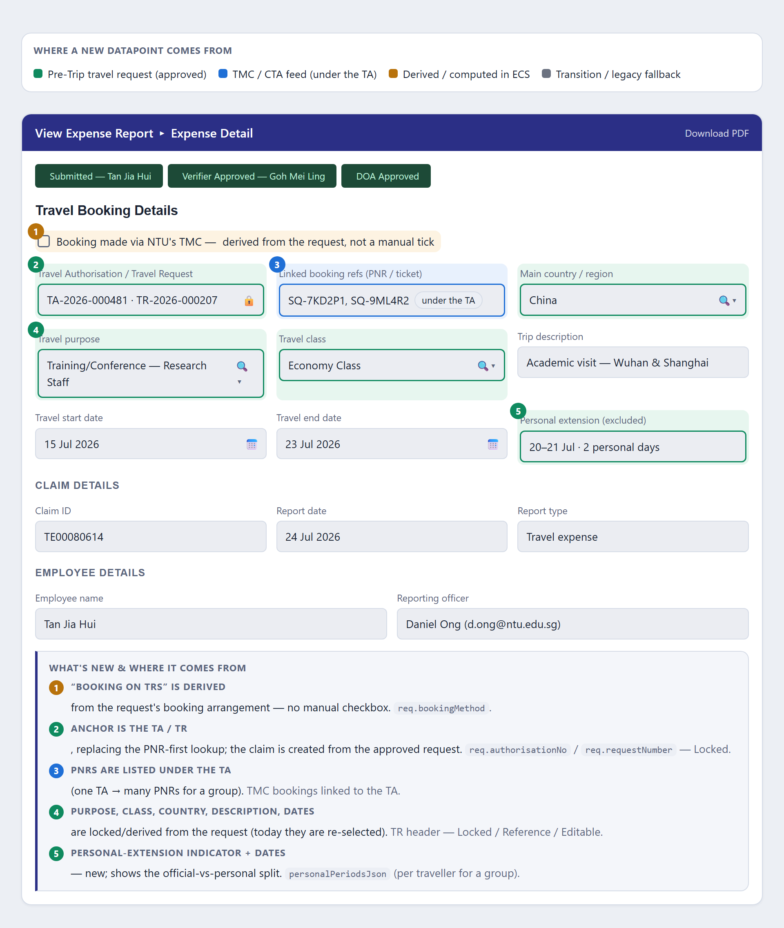

2. Overseas Daily Allowance (ODA) expense
The amount pre-fills from the approved ODA (green, reference — the claimant edits the actual), and the new Personal / Funded-days columns (amber, eligibleDays) make the personal-day exclusion visible: funded days = stay days − personal days, and the ODA is already net of personal days. Callouts 6–7.
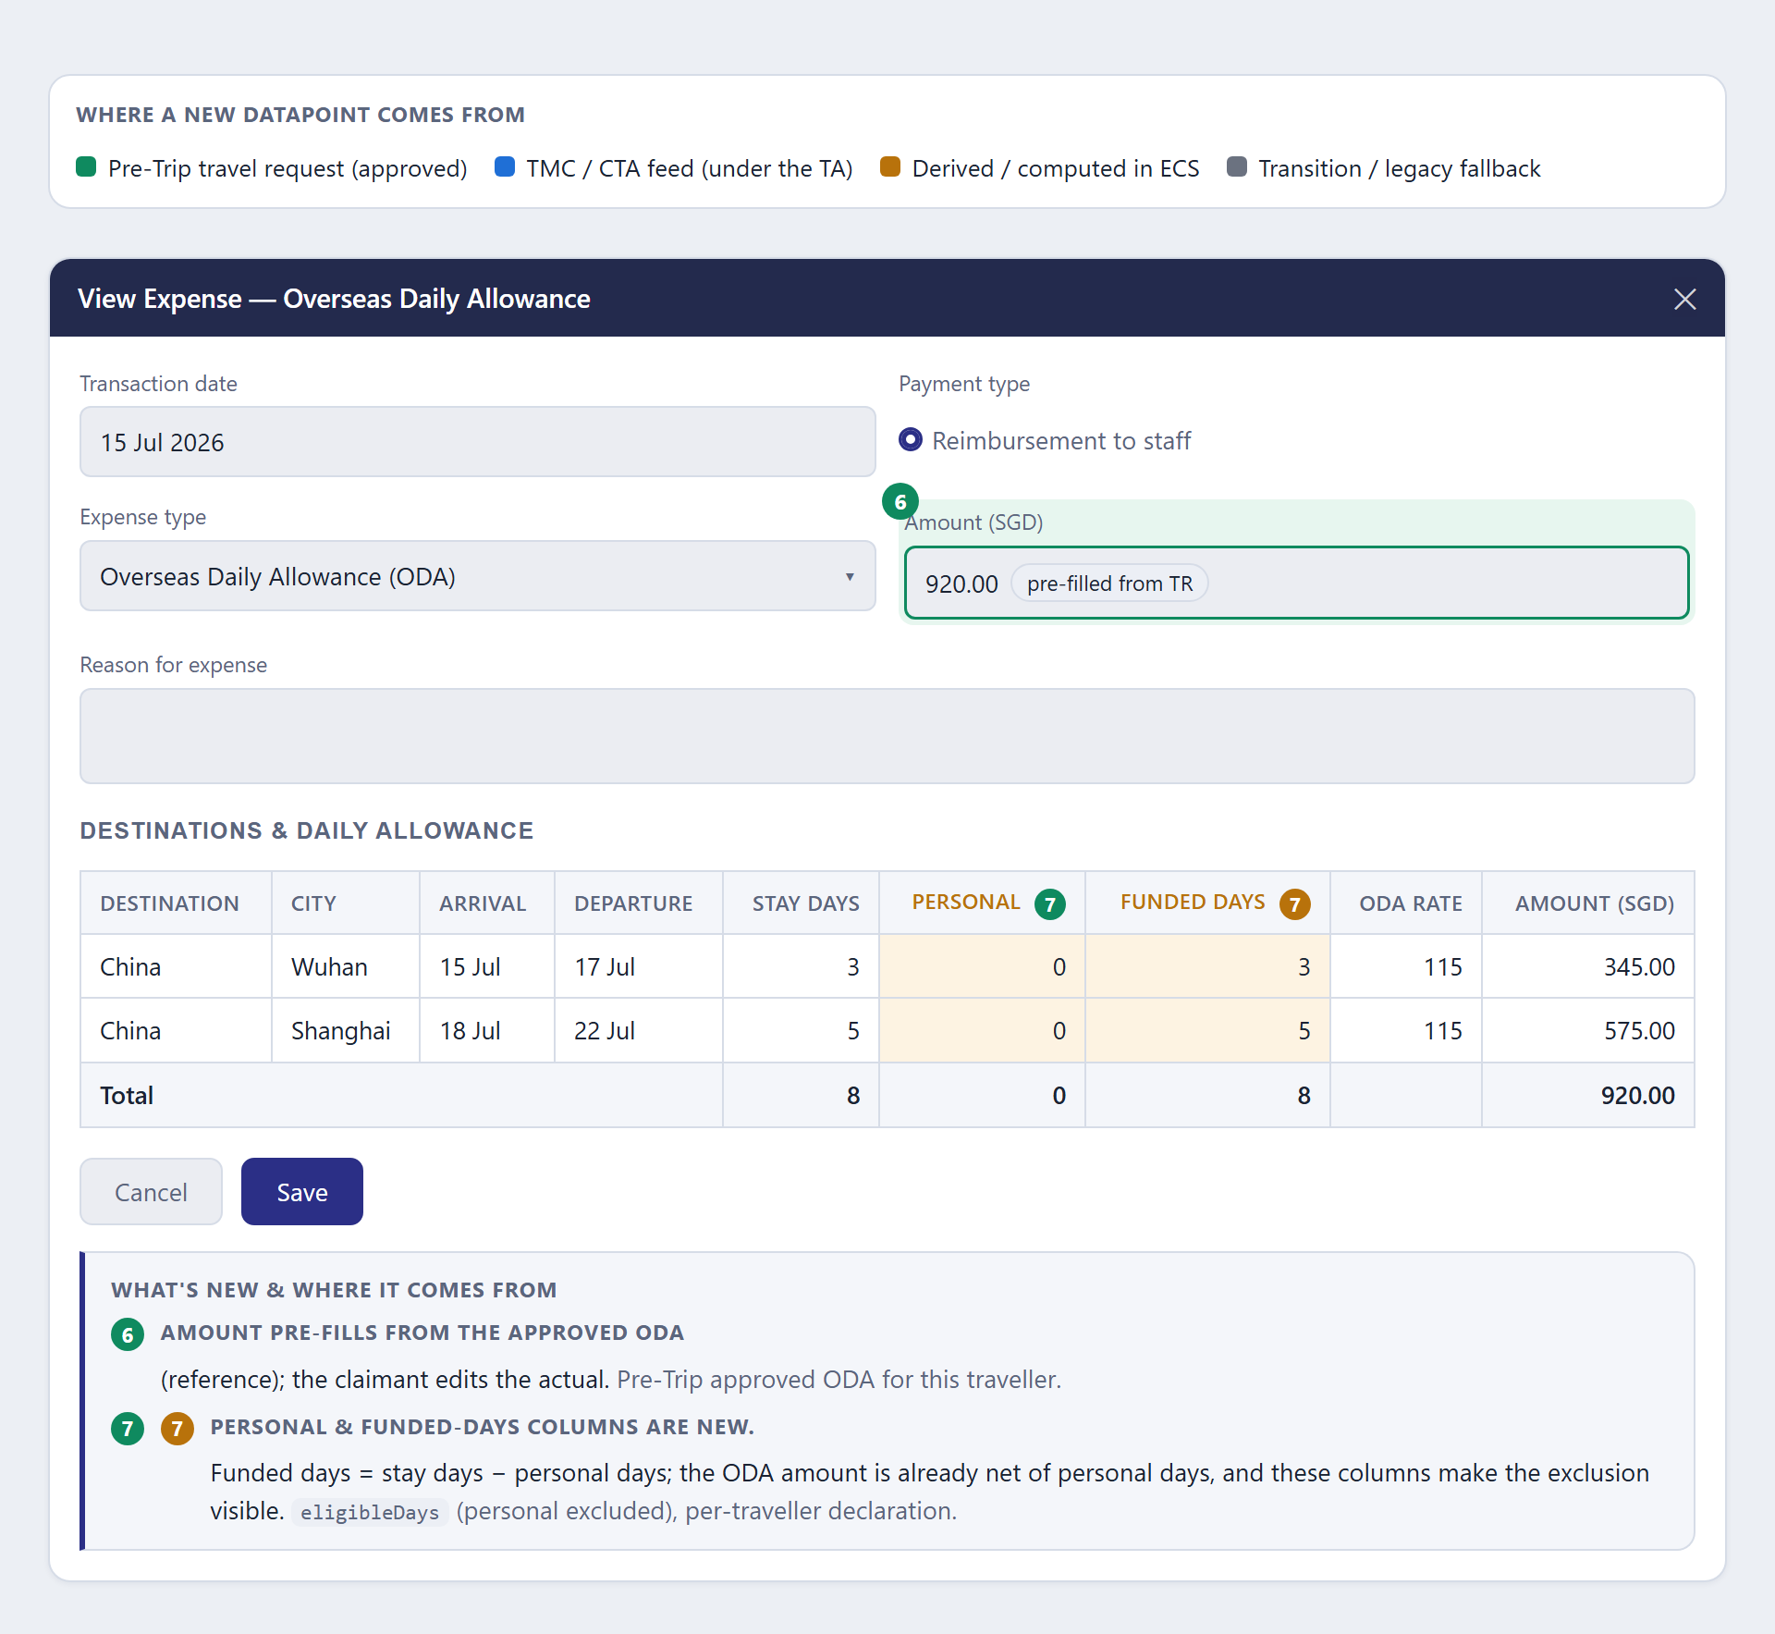

3. Hotel / Accommodation expense
Chargeable nights are net of the traveller’s declared personal nights (amber, computed in ECS); the approved room estimate pre-fills from the request as a reference figure (green). Personal nights come from the per-traveller personal-extension declaration on the Pre-Trip request.
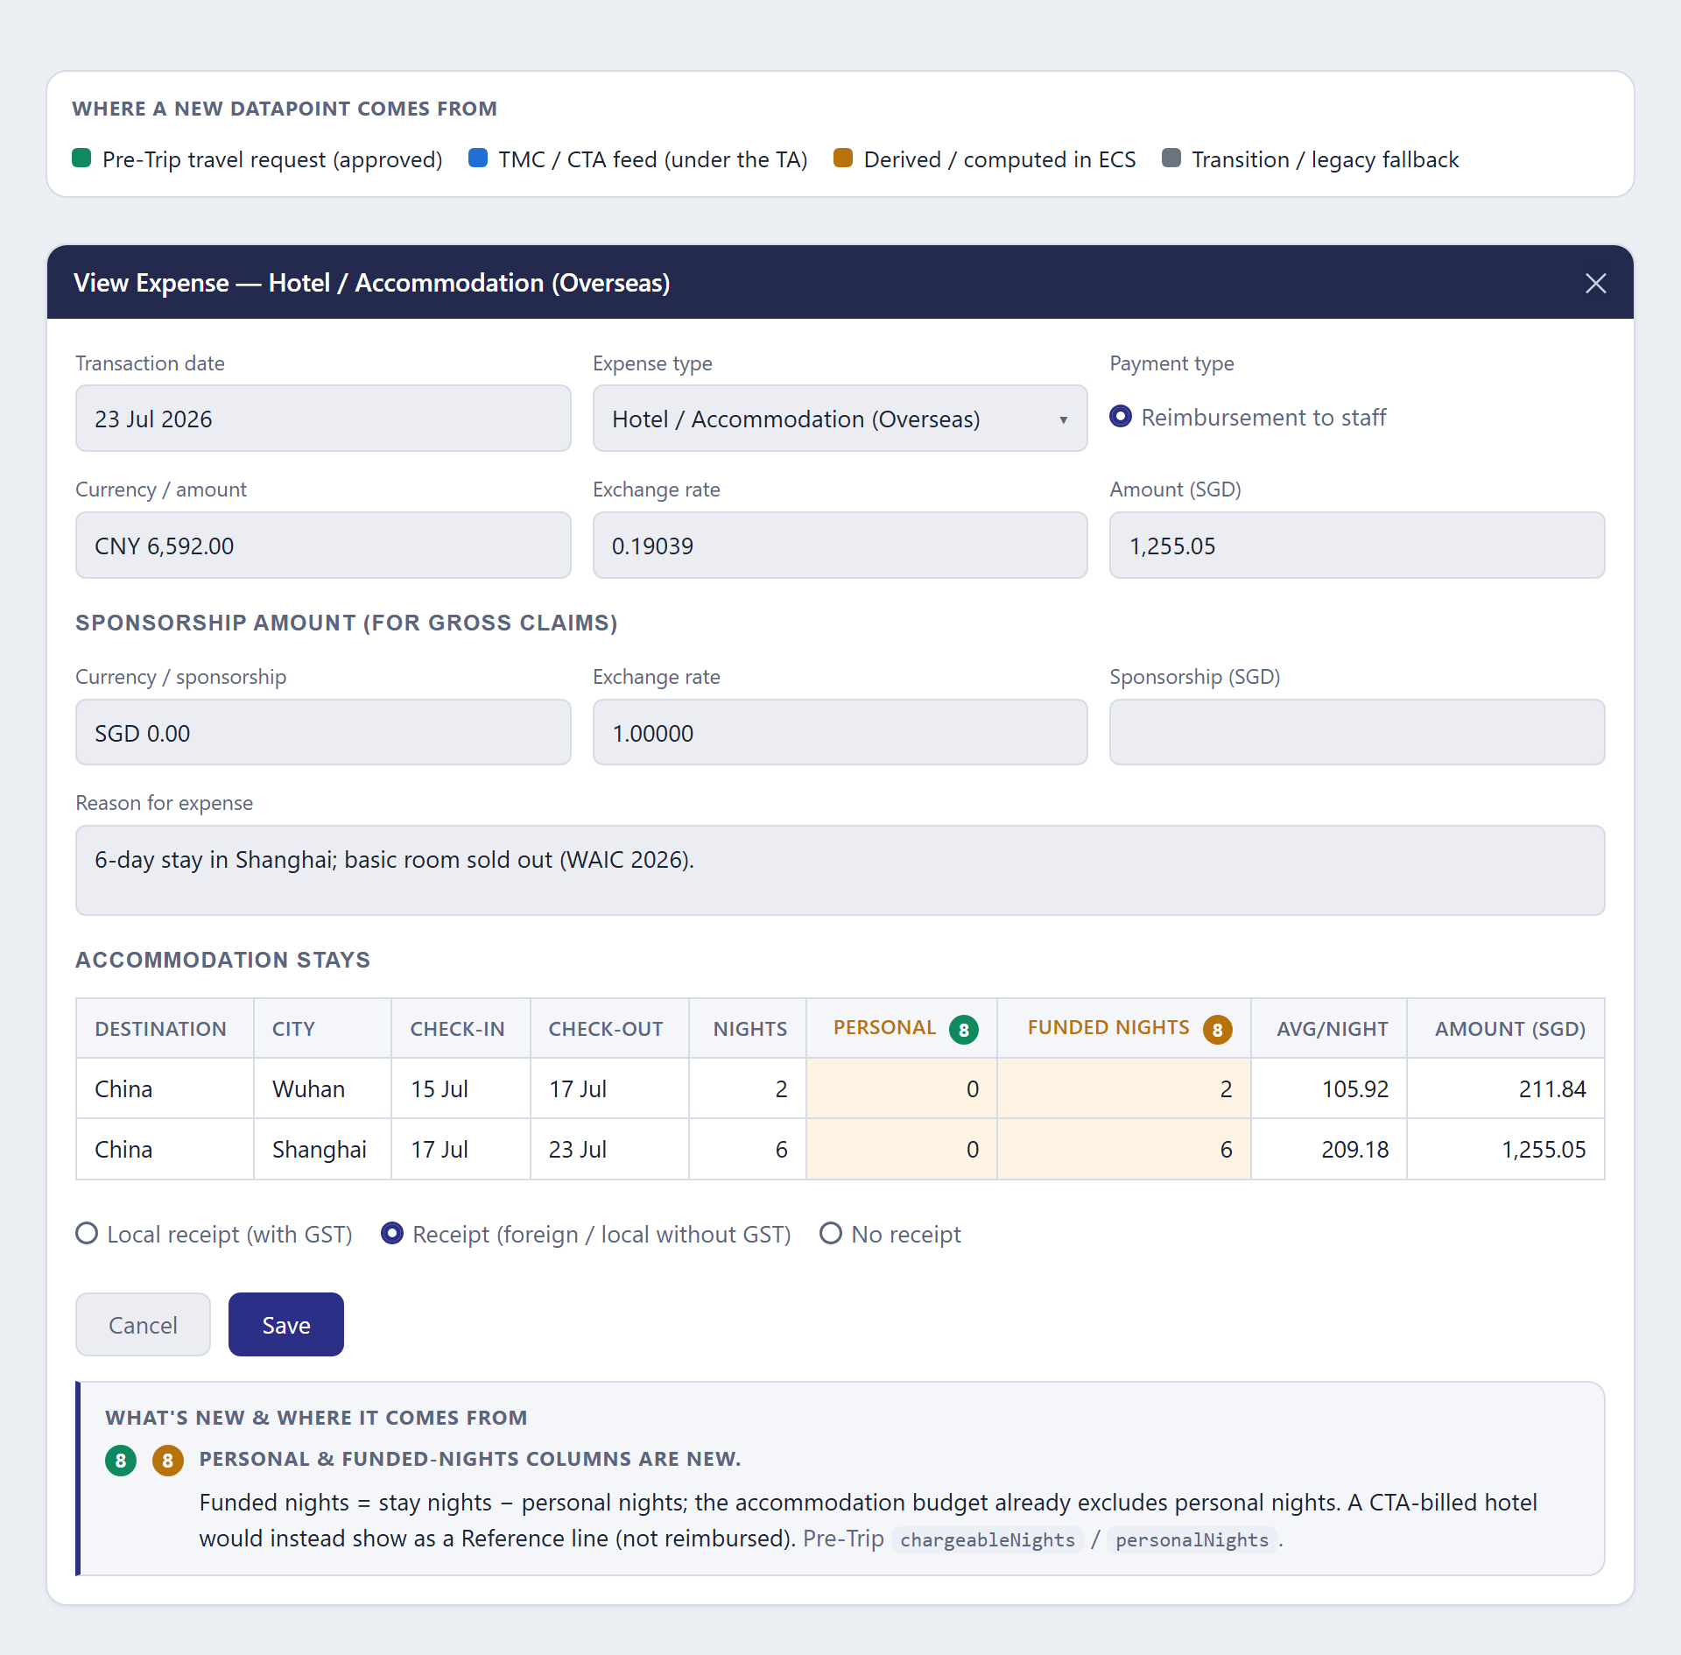

4. Expense items (reimbursable vs reference)
Each line’s reimbursable-vs-reference treatment follows the Pre-Trip TE-sync contract. CTA-posted lines (e.g. the air ticket) are shown so the total cost is visible but are excluded from claim posting, because the CTA amount is posted at booking, not on the claim. The M6 upgrade differential is carried through to the claim.
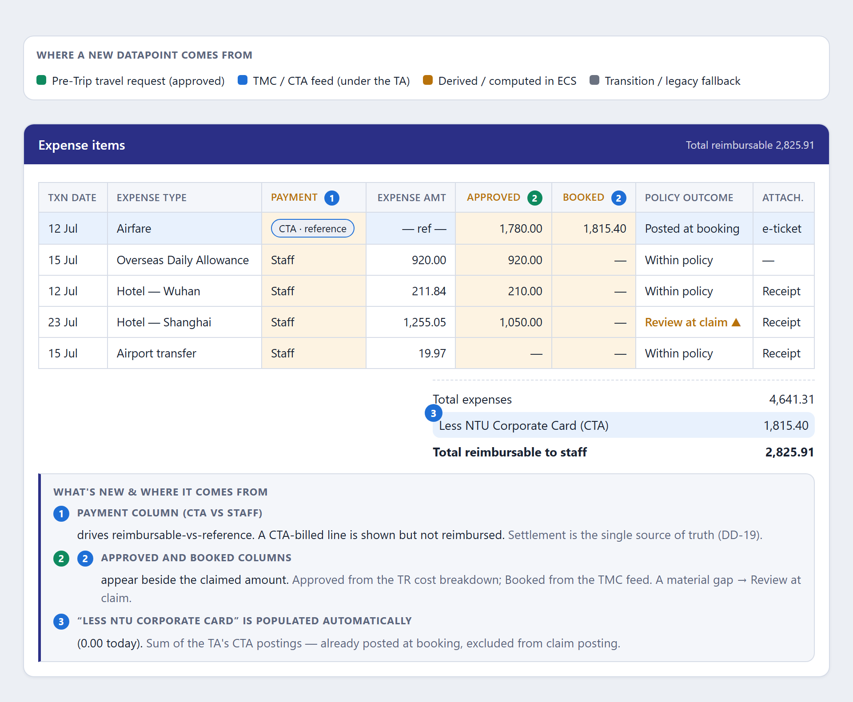

5. Charging account & accounting entries
The charging account is inherited from the approved request (green, locked) rather than re-keyed on the claim; per-line splits follow the approved allocation. Transition / legacy bookings fall back to the manually-keyed account (grey).
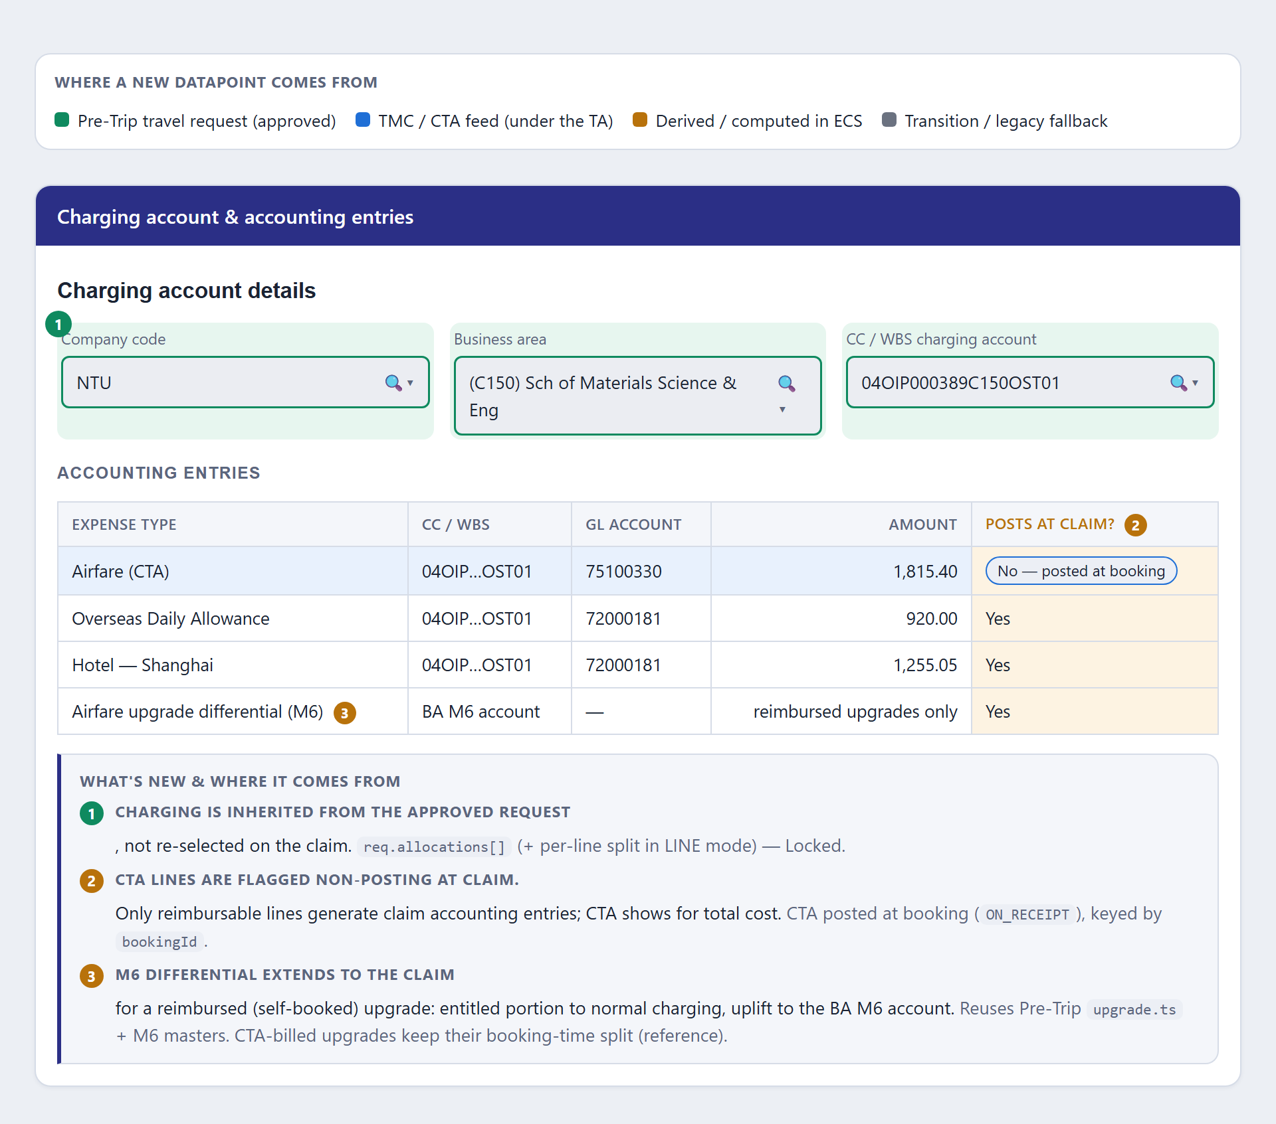

6. Select travel booking — TMC transition
For travel booked under the existing TMC the PNR picker stays available (blue); a PNR consumed by any claim (TA-anchored or legacy) is hidden from the dropdown so it cannot be claimed twice, and is released on recall or delete. The TA-anchored path and the legacy-PNR path run concurrently through the transition.


