日历集成文档

一. 将Calendar第三方库导入您的工程中，见下图（详细CalendarDemo）

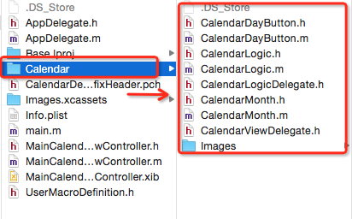

注意：请务必在上述步骤中选择“copy items if needed”单选按钮组。

二. 主要实现代码

1. 初始化日历视图

NSDate *aDate = self.selectedDate;
if (aDate == nil) {
aDate = [CalendarLogic dateForToday];
}
NSDateComponents *components = [[[NSDateComponents alloc] init] autorelease];
aDate = [[[NSCalendar currentCalendar] dateByAddingComponents:components toDate:aDate options:0] retain];

// 初始化代理类
CalendarLogic *calendarLogic = [[CalendarLogic alloc] initWithDelegate:self referenceDate:aDate];
self.calendarLogic = calendarLogic;

// 初始化日历
CalendarMonth *aCalendarView = [[CalendarMonth alloc] initWithFrame:CGRectMake(2, 0, 0,0)
logic:calendarLogic
dayButtonWidth:(CGRectGetWidth(self.scrollView.frame)-2)/7
dayButtonHeight:CGRectGetWidth(self.scrollView.frame)/8
font:[UIFont fontWithName:@"ArialHebrew-Bold" size:11.f]];

[aCalendarView selectButtonForDate:self.selectedDate];
self.calendarView = aCalendarView;
[aCalendarView release];
[calendarLogic release];

// 显示日历标记按钮
[self.calendarView showCalendarAndMarkDownButton];

// 添加左右手势进行滑动，切换日历视图
UISwipeGestureRecognizer *swipeLeftGesture=[[UISwipeGestureRecognizer alloc] initWithTarget:self action:@selector(updateCalendar:)];
swipeLeftGesture.direction=UISwipeGestureRecognizerDirectionLeft;
[self.calendarView addGestureRecognizer:swipeLeftGesture];
UISwipeGestureRecognizer *swipeRightGesture=[[UISwipeGestureRecognizer alloc] initWithTarget:self action:@selector(updateCalendar:)];
swipeRightGesture.direction=UISwipeGestureRecognizerDirectionRight;
[self.calendarView addGestureRecognizer:swipeRightGesture];
[swipeLeftGesture release];
[swipeRightGesture release];

2.delegate代理方法
(1).#pragma mark - UIGestureRecognizer delegate
- (void)updateCalendar:(UIGestureRecognizer *)recognizer;

(2).#pragma mark - CalendarLogic delegate
@optional
- (void)calendarLogic:(CalendarLogic *)aLogic dateSelected:(NSDate *)aDate distance:(NSInteger)distance;

@optional
- (void)calendarLogic:(CalendarLogic *)aLogic monthChangeDirection:(Direction)aDirection;

// - (void)animationMonthSlideComplete 系统方法

(3).#pragma mark – CalendarViewDelegate delegate
- (void)updateCalendar;

- (void)showScheduleWithArray:(NSArray *)array;

3.数据加载和按钮响应事件方法
(1). #import "CalendarMonth.h"

//******* 刷新加载按钮响应事件 ******* //
- (void)refreshButton
{
dispatch_queue_t getlistQueue = dispatch_get_global_queue(DISPATCH_QUEUE_PRIORITY_DEFAULT, 0);
dispatch_async(getlistQueue, ^{

[self getDayButtonTodoList]; // 异步加载请求数据

dispatch_async(dispatch_get_main_queue(), ^{

[self updateButton]; // 刷新按钮事件
});
});
}

//*******响应单击按钮事件 ******* //
- (void)dayButtonPressed:(id)sender
{
CalendarDayButton * button = sender;
NSDate * date = [datesIndex objectAtIndex:[button tag]];

//计算是否本月，可设置是否响应该button
NSInteger distance = [calendarLogic distanceOfDateFromCurrentMonth:date];
if (distance != 0)
{
// return; // 不是本月日期，不响应按钮事件发生
}

// CalendarViewDelegate
if (self.delegate && [self.delegate respondsToSelector:@selector(showScheduleWithArray:)]) {

[self.delegate showScheduleWithArray:button.dayTodoList];
}

// 响应按钮事件1
[self changeButtonState:sender];

// 响应按钮事件2
[calendarLogic setReferenceDate:date];
}

(2). #import "CalendarLogic.h"
（此3个方法可以不用改写）
/**
* 前一个月
*/
- (void)selectPreviousMonth;

/**
* 后一个月
*/
- (void)selectNextMonth;

/**
* 回到今天
*/
- (void)turnBackToday;

三. 注意事项：
(1). Calendar支持非ARC，添加依赖库
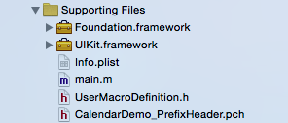

(2). 待续

