左右滑动集成文档

一. 将SliderViewController第三方库导入您的工程中，见下图（详细SliderViewControllerDemo）

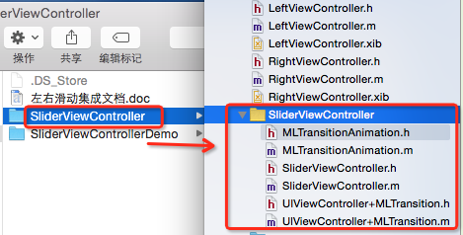

注意：请务必在上述步骤中选择“copy items if needed”单选按钮组。

二. 主要实现代码（数据参数根据需要情况而定）

// 初始化主视图
ViewController *mainCtrl = [[ViewController alloc] init];
[SliderViewController sharedSliderController].MainVC = mainCtrl;

// 初始化左视图
LeftViewController *leftCtrl = [[LeftViewController alloc] initWithNibName:@"LeftViewController" bundle:nil];
[SliderViewController sharedSliderController].LeftVC = leftCtrl;

[SliderViewController sharedSliderController].LeftSContentOffset=275;
[SliderViewController sharedSliderController].LeftContentViewSContentOffset = 90;
[SliderViewController sharedSliderController].LeftSContentScale=0.77;
[SliderViewController sharedSliderController].LeftSJudgeOffset=160;
[SliderViewController sharedSliderController].changeLeftView = ^(CGFloat sca, CGFloat transX)
{
// leftCtrl.view.layer.anchorPoint = CGPointMake(1, 1);
CGAffineTransform ltransS = CGAffineTransformMakeScale(sca, sca);
CGAffineTransform ltransT = CGAffineTransformMakeTranslation(transX, 0);
CGAffineTransform lconT = CGAffineTransformConcat(ltransT, ltransS);
leftCtrl.view.transform = lconT;
};

// 初始化右视图
RightViewController *rightCtrl= [[RightViewController alloc] initWithNibName:@"RightViewController" bundle:nil];
[SliderViewController sharedSliderController].RightVC = rightCtrl;

[SliderViewController sharedSliderController].RightSContentOffset=275;
[SliderViewController sharedSliderController].RightSContentScale=0.77;
[SliderViewController sharedSliderController].RightSJudgeOffset=160;

// 设置手势
[UIViewController validatePanPackWithMLTransitionGestureRecognizerType:MLTransitionGestureRecognizerTypePan];

三. 注意事项：
(1). SliderViewController支持ARC。如要支持非ARC，要
加-fobjc-arc 。如下图

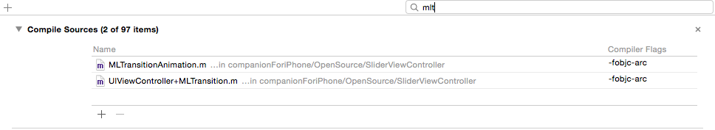

(2). 添加依赖库
UIKit.framework #import <UIKit/UIKit.h>

(3). SliderViewController兼容ios6以下版本，需要注意这段代码。
#ifdef __IPHONE_7_0

if (kSystemVersion >= 7.0) {
if (!vc.navigationController||
[vc.navigationController.transitionCoordinator isAnimated]||
vc.navigationController.viewControllers.count < 2) {
return NO;
}
}
else if(!vc.navigationController||
vc.navigationController.viewControllers.count < 2) {
return NO;
}

#else
if (!vc.navigationController||
vc.navigationController.viewControllers.count < 2) {
return NO;
}
#endif

(4). SliderViewController静止右滑动返回手势，需要添加这段代码。

#pragma mark - 直接在这处理的话对性能有好处。
-(BOOL)gestureRecognizerShouldBegin:(UIPanGestureRecognizer *)gestureRecognizer
{
UIViewController *vc = gestureRecognizer.__MLTransition_ViewController;

// 在这里进行拦截
if ([vc isKindOfClass:[ClassViewController class]]) {
return NO;
}

if (!vc) {
return NO;
}
。。。。。
}

