Sample Test Case Table

Test ID | Requirement | Test Case (Description) | Input | Expected Output | Actual Result | Pass/Fail | V&V Evidence
TC-01 | RQ-01: Successful Login | Verify login with valid credentials | user: admin1, pw: admin | Dashboard page loads | Dashboard loaded successfully | Pass | Screenshot of dashboard
TC-02 | RQ-02: Fail Login | Verify login with invalid password | user: admin1, pw: amin | “Invalid username/email or password.” error | Error displayed | Pass | Screenshot of login page
TC-03 | RQ-03: Add New Asset | Verify adding new asset | Fill out asset create form | Display message “Asset created successfully.” | Success message displayed | Pass | Screenshot of message
TC-04 | RQ-04: Rental Request | Verify requesting a rental | Fill out rental request form | Display success message and redirects user to dashboard | User is redirected to dashboard | Pass | Screenshot of message
TC-05 | RQ-05: Logout | Verify logout | Click logout button | User is logged out of account and is redirected to login page | User is redirect to login page. | Pass | Screenshot of login page
TC-06 | RQ-06: Approve rental request | Verify approving a rental request | Click approve button | Request is approved and moved to the “Approve” tab | Request is approved. | Pass | Screenshot of approved message
TC-07 | RQ-07: Deny rental request | Verify denying a rental request | Click deny button | Request is denied and moved to the “Denied” tab | Request is denied. | Pass | Screenshot of denied message
TC-08 | RQ-08: Create New User | Verify creating a new user | Fill out user create form | User is successfully created and shown in “Manage Users” page | New user is listed in users list | Pass | Screenshot of “Manage Users” page
TC-09 | RQ-08: Delete User | Verify deleting a user | Click delete in “Manage Users” page | User is removed from “Manage Users” page | User is removed from “Manage Users” page | Pass | Screenshot of “Manage Users” page

Screenshots
TC-01: Screenshot of dashboard
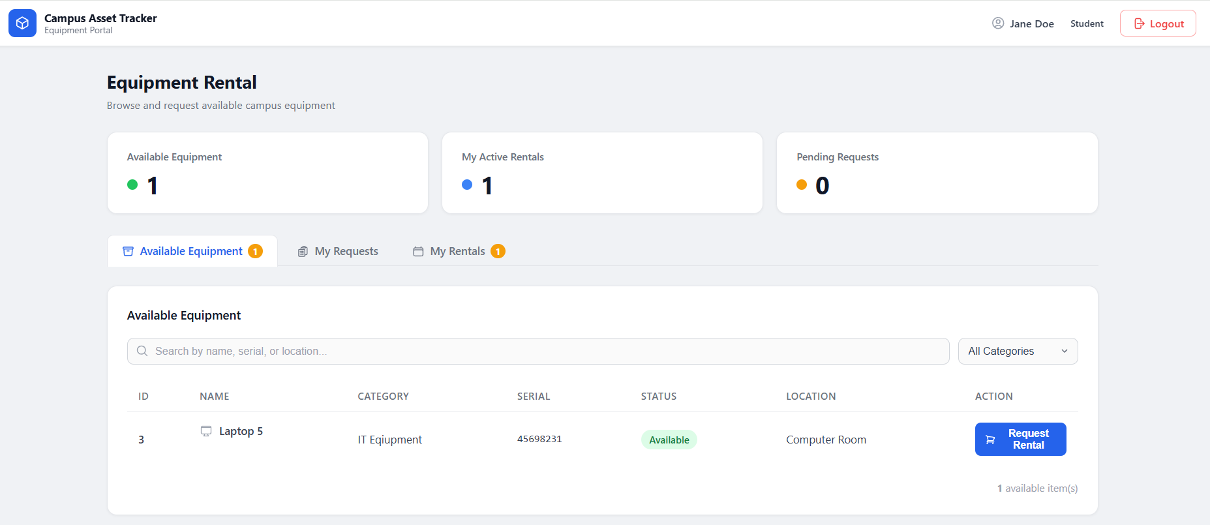

TC-02: Screenshot of login page
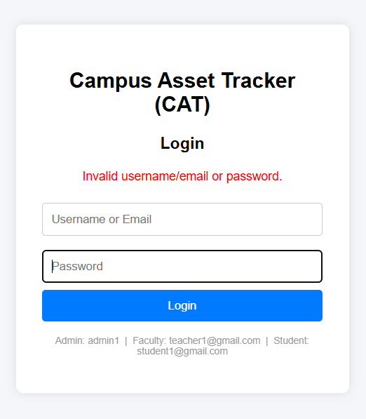
TC-03: Screenshot of message
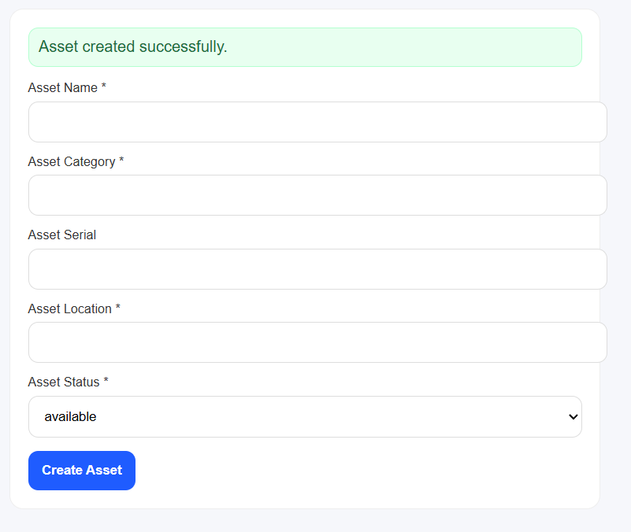

TC-04: Screenshot of message
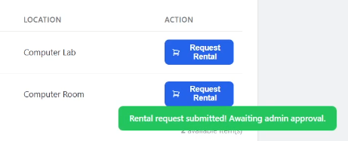

TC-05: Screenshot of login page
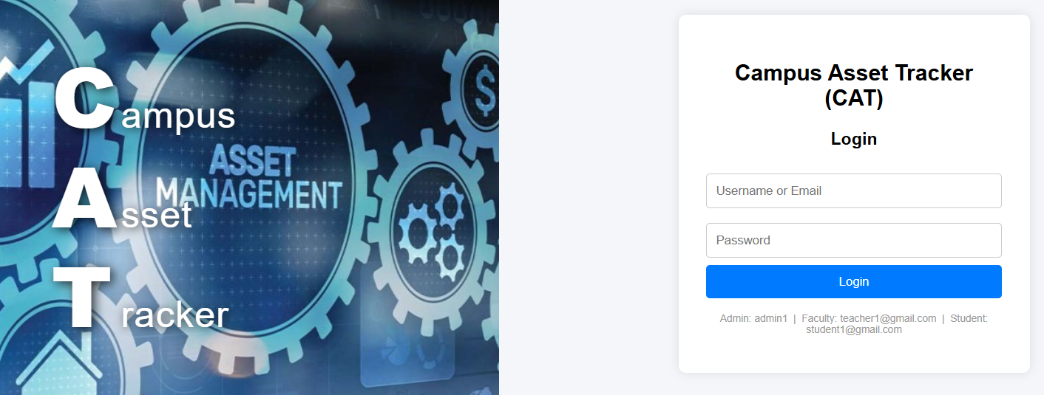

TC-06: Screenshot of approved message
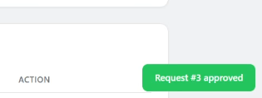

TC-07: Screenshot of denied message
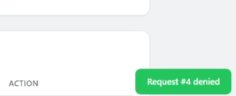
TC-08: Screenshot of “Manage Users” page
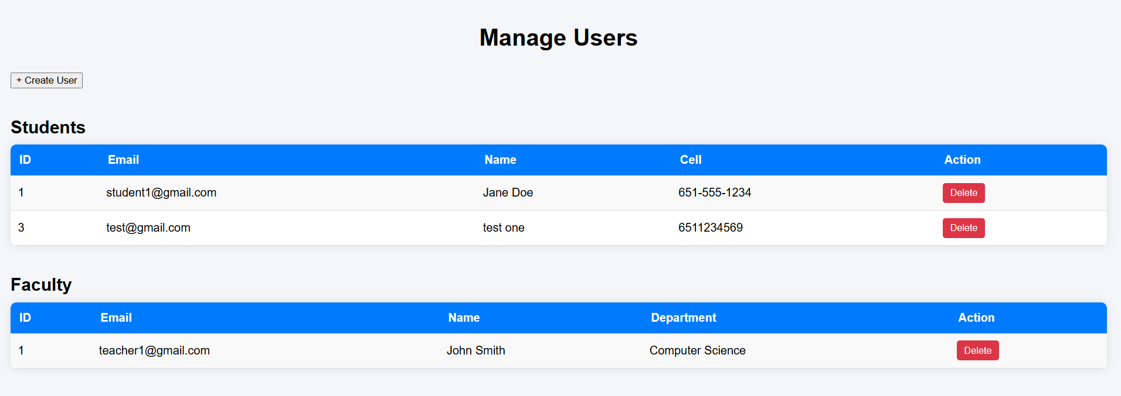
TC-09: Screenshot of “Manage Users” page
