1.

SSE = 0.2213179

2.

Order:2

SSE = 0.00131611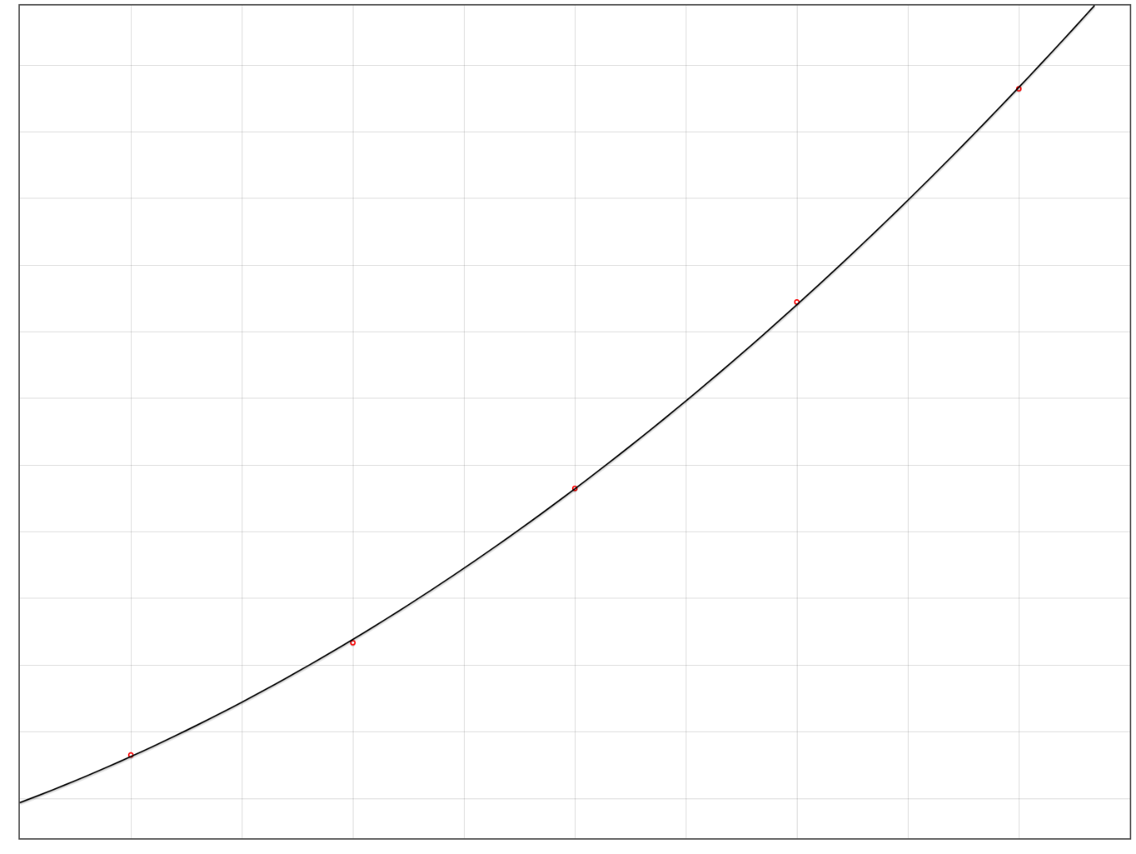

Order:3

SSE = 0.0000165143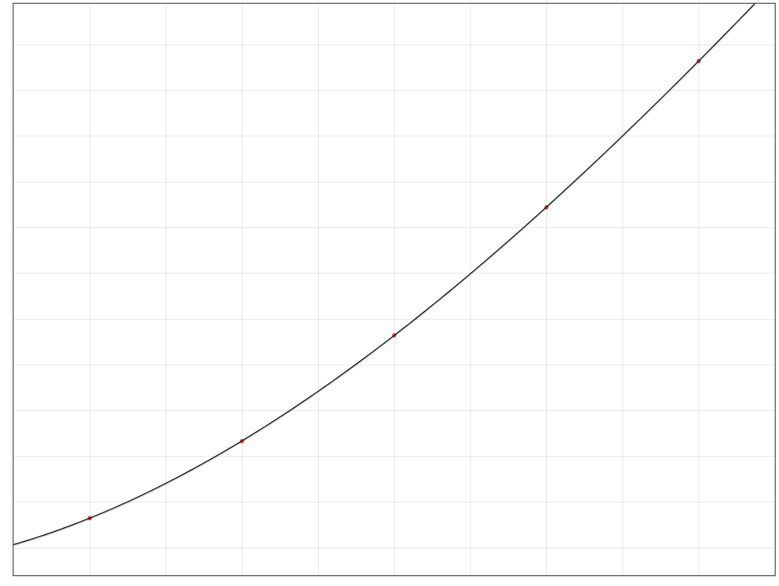

Order: 4

SSE = 1.94203036 e-20

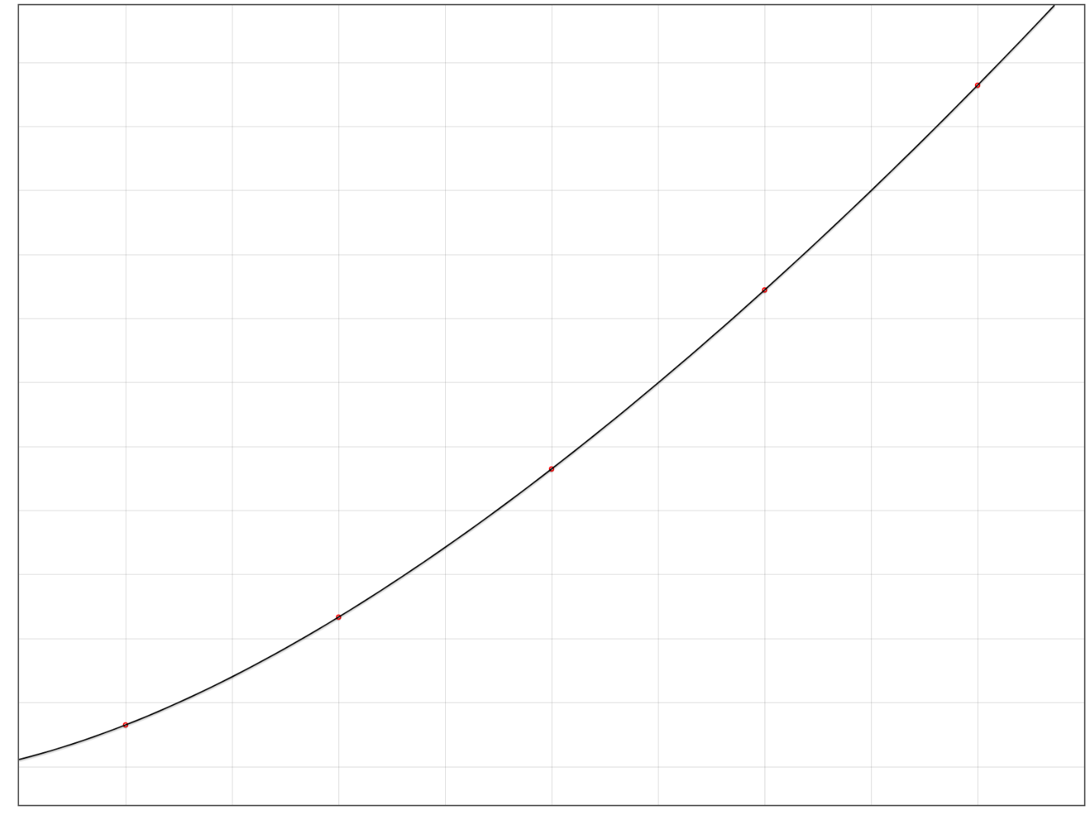

I think the model with the polynomial of order 4 fits the data the best, because the sum of squares error is the smallest out of all of the models for order 4. Which means that this model is the closest to the data upon all of the models.

3.

4.

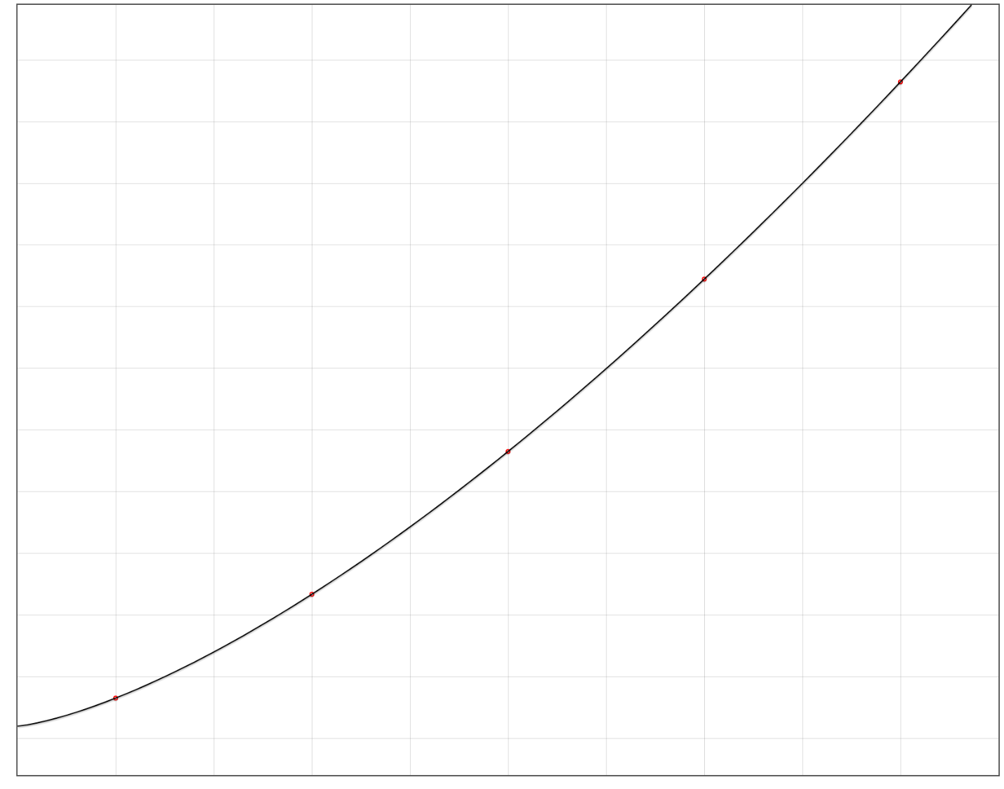

This model is not better than the previous ones because the sse of the last iteration is still larger than the sse in the previous question.

5.

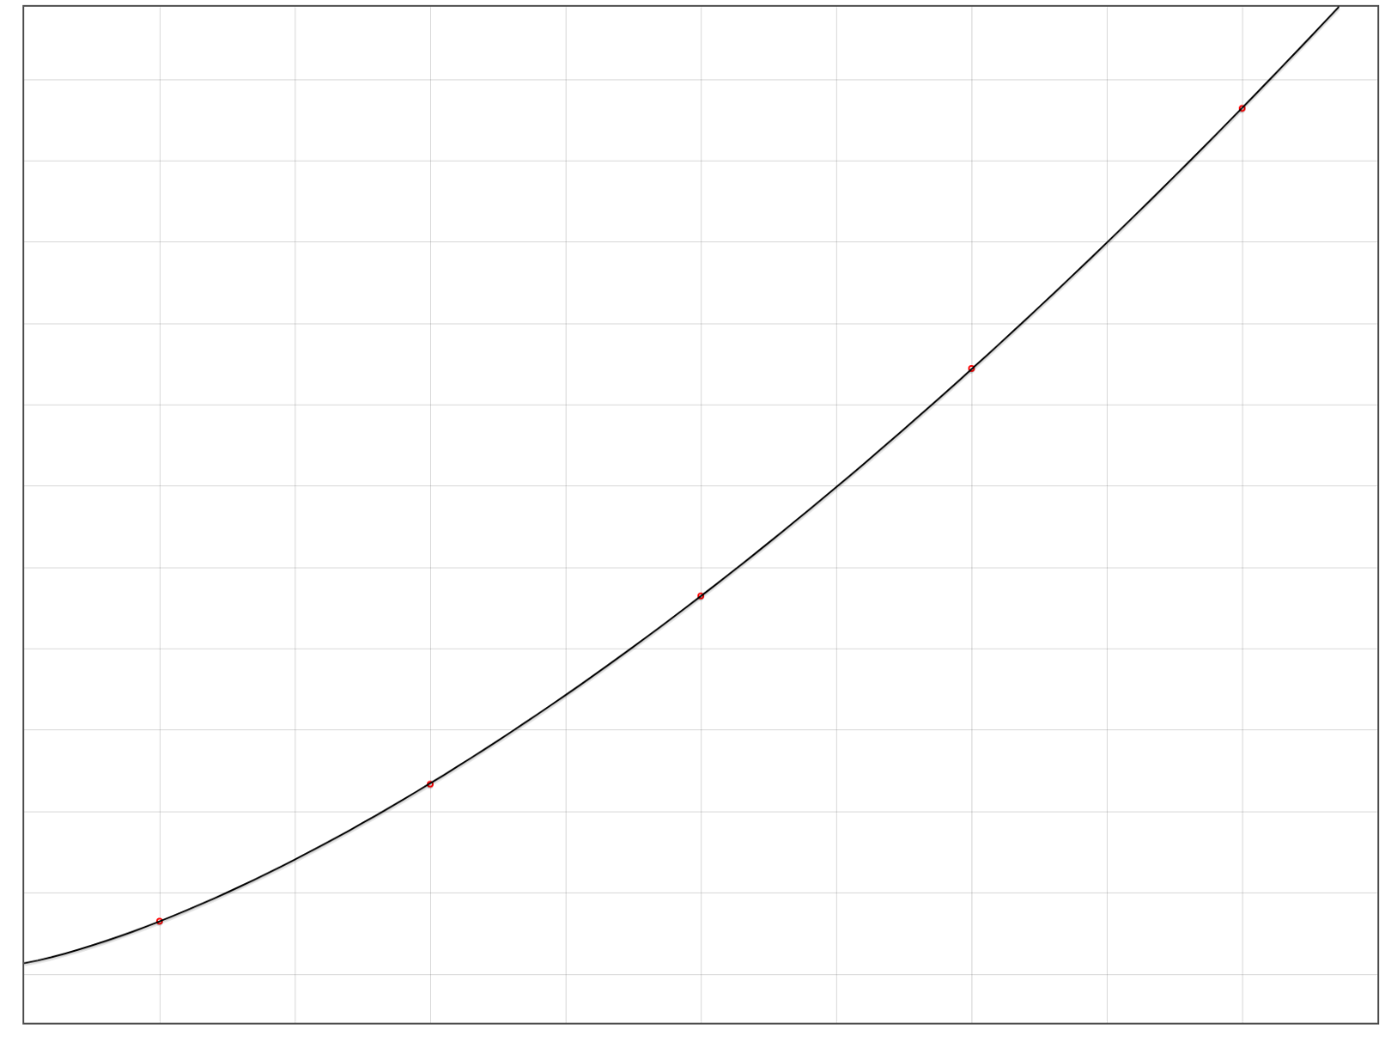

The algorithm is close to (4) but slightly worse than (4).

With the different values for learning rate, the higher the learning rate, the better the convergence rate. The lower the learning rate, the more iterations it take for the algorithm to get to the same error.