School of Computing (SoC)

ST0524

Fundamental of Programming 2

ASSIGNMENT 1

Endpoints Documents (DataSet)

Endpoint 1:
 | /retailData5
  GET
 | Get the first 5 rows of data from dataset
Parameters
Name | Type | Description
N.A.
Responses | Content Type: application.json
Code | Description
200 | Example call: /retailData5  Example Value:
  [
  {
  "no": "1",
  "customerID": "109318",
  "productID": "C",
  "quantity": "7",
  "price": 80.07984415,
  "transactionDate": "12/26/2023 12:32",
  "paymentMethod": "Cash",
  "storeLocation": "176 Andrew Cliffs\nBaileyfort, HI 93354",
  "productCategory": "Books",
  "discountAppliedInPercentage": 18.6770995,
  "totalAmount": 455.8627638
  }, ………
  ………
  ]

Endpoint 2:
 | /byPaymentMethod/:paymentMethod
  GET
 | Return data for the payment method
Parameters
Name | Type | Description
category | path | filter by payment method (cash, credit-card, debit-card, paypal)
Responses | Content Type: application.json
Code | Description
200 | Example call: /byPaymentMethod/cash  Example Value:
  [
  {
  "no": "1",
  "customerID": "109318",
  "productID": "C",
  "quantity": "7",
  "price": 80.07984415,
  "transactionDate": "12/26/2023 12:32",
  "paymentMethod": "Cash",
  "storeLocation": "176 Andrew Cliffs\nBaileyfort, HI 93354",
  "productCategory": "Books",
  "discountAppliedInPercentage": 18.6770995,
  "totalAmount": 455.8627638
  }, ……..
  ……..
  [

Endpoint 3:
 | /byProductCategory/:productCategory
  GET
 | Return data by product category (clothing, books, electronic, home-decor)
Parameters
Name | Type | Description
sellonline | Path | filter by product category (clothing, books, electronics, home-decor)
Responses | Content Type: application.json
Code | Description
200 | Example call: /byProductCategory/books  Example Value:  No record found:
  [
  {
  "no": "1",
  "customerID": "109318",
  "productID": "C",
  "quantity": "7",
  "price": 80.07984415,
  "transactionDate": "12/26/2023 12:32",
  "paymentMethod": "Cash",
  "storeLocation": "176 Andrew Cliffs\nBaileyfort, HI 93354",
  "productCategory": "Books",
  "discountAppliedInPercentage": 18.6770995,
  "totalAmount": 455.8627638
  }, ……..
  ……..
  ]
  []

Endpoint 4:
 | /productCategory
  GET
 | Return the unique product category
Parameters
Name | Type | Description
designer | path | Unique product category
Responses | Content Type: application.json
Code | Description
200 | Example call: /productCategory  Example Value:  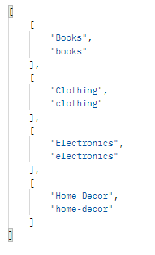  No record found:
  []

Endpoint 5:
 | /paymentMethod
  GET
 | Return unique payment method
Parameters
Name | Type | Description
designer | path | Unique payment method
Responses | Content Type: application.json
Code | Description
200 | Example call: /paymentMethod  Example Value:  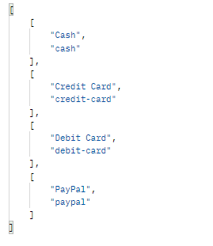  No record found:
  []

- END -

