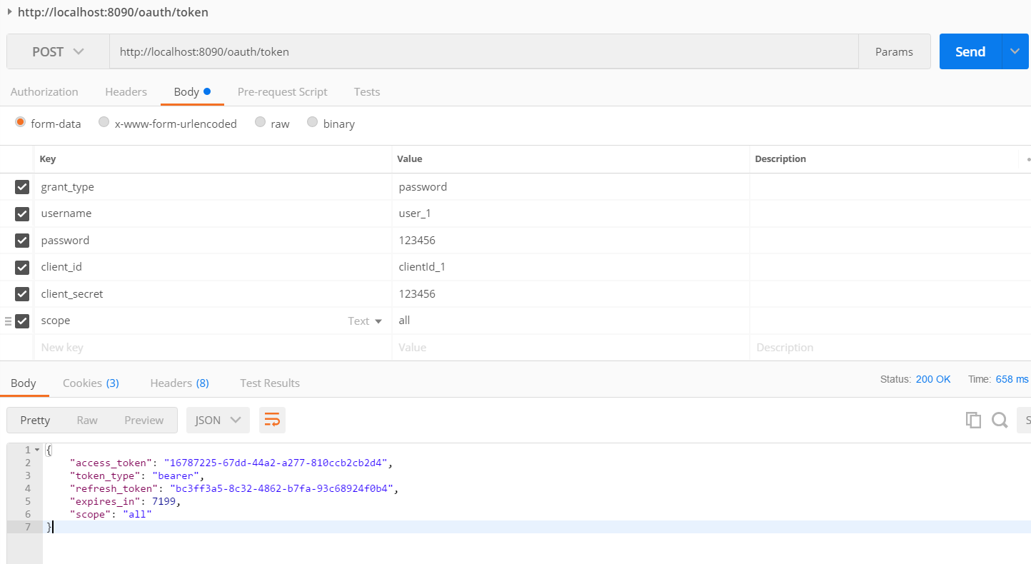

<http://localhost:8090/oauth/token>

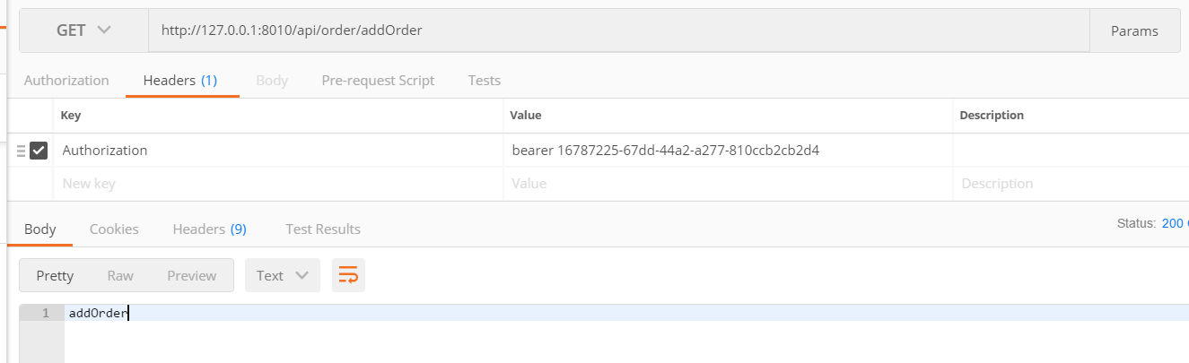

数据库:

<https://github.com/spring-projects/spring-security-oauth/blob/master/spring-security-oauth2/src/test/resources/schema.sql>

|  |  |  |  |  |  |  |  |  |  |  |  |  |  |  |  |  |  |  |  |  |  |  |  |  |  |  |  |  |  |  |  |  |  |  |  |  |  |  |  |  |  |  |  |  |  |  |  |  |  |  |  |  |  |  |  |  |  |  |  |  |  |  |  |  |  |  |  |  |  |  |  |  |  |  |  |  |  |  |  |  |  |  |  |  |  |  |  |  |  |  |  |  |  |  |  |  |  |  |  |  |  |  |  |  |  |  |  |  |  |  |  |  |  |  |  |  |  |  |  |  |  |  |  |  |  |  |  |  |  |  |  |  |
| --- | --- | --- | --- | --- | --- | --- | --- | --- | --- | --- | --- | --- | --- | --- | --- | --- | --- | --- | --- | --- | --- | --- | --- | --- | --- | --- | --- | --- | --- | --- | --- | --- | --- | --- | --- | --- | --- | --- | --- | --- | --- | --- | --- | --- | --- | --- | --- | --- | --- | --- | --- | --- | --- | --- | --- | --- | --- | --- | --- | --- | --- | --- | --- | --- | --- | --- | --- | --- | --- | --- | --- | --- | --- | --- | --- | --- | --- | --- | --- | --- | --- | --- | --- | --- | --- | --- | --- | --- | --- | --- | --- | --- | --- | --- | --- | --- | --- | --- | --- | --- | --- | --- | --- | --- | --- | --- | --- | --- | --- | --- | --- | --- | --- | --- | --- | --- | --- | --- | --- | --- | --- | --- | --- | --- | --- | --- | --- | --- | --- | --- | --- | --- |
| |  |  | | --- | --- | |  | create table oauth_client_details ( | |  | client_id VARCHAR(256) PRIMARY KEY, | |  | resource_ids VARCHAR(256), | |  | client_secret VARCHAR(256), | |  | scope VARCHAR(256), | |  | authorized_grant_types VARCHAR(256), | |  | web_server_redirect_uri VARCHAR(256), | |  | authorities VARCHAR(256), | |  | access_token_validity INTEGER, | |  | refresh_token_validity INTEGER, | |  | additional_information VARCHAR(4096), | |  | autoapprove VARCHAR(256) | |  | ); | |  |  | |  | create table oauth_client_token ( | |  | token_id VARCHAR(256), | |  | token LONGVARBINARY, | |  | authentication_id VARCHAR(256) PRIMARY KEY, | |  | user_name VARCHAR(256), | |  | client_id VARCHAR(256) | |  | ); | |  |  | |  | create table oauth_access_token ( | |  | token_id VARCHAR(256), | |  | token LONGVARBINARY, | |  | authentication_id VARCHAR(256) PRIMARY KEY, | |  | user_name VARCHAR(256), | |  | client_id VARCHAR(256), | |  | authentication LONGVARBINARY, | |  | refresh_token VARCHAR(256) | |  | ); | |  |  | |  | create table oauth_refresh_token ( | |  | token_id VARCHAR(256), | |  | token LONGVARBINARY, | |  | authentication LONGVARBINARY | |  | ); | |  |  | |  | create table oauth_code ( | |  | code VARCHAR(256), authentication LONGVARBINARY | |  | ); | |  |  | |  | create table oauth_approvals ( | |  | userId VARCHAR(256), | |  | clientId VARCHAR(256), | |  | scope VARCHAR(256), | |  | status VARCHAR(10), | |  | expiresAt TIMESTAMP, | |  | lastModifiedAt TIMESTAMP | |  | ); | |  |  | |  |  | |  | -- customized oauth_client_details table | |  | create table ClientDetails ( | |  | appId VARCHAR(256) PRIMARY KEY, | |  | resourceIds VARCHAR(256), | |  | appSecret VARCHAR(256), | |  | scope VARCHAR(256), | |  | grantTypes VARCHAR(256), | |  | redirectUrl VARCHAR(256), | |  | authorities VARCHAR(256), | |  | access_token_validity INTEGER, | |  | refresh_token_validity INTEGER, | |  | additionalInformation VARCHAR(4096), | |  | autoApproveScopes VARCHAR(256) | |  | ); | |