5

1

2

4

3

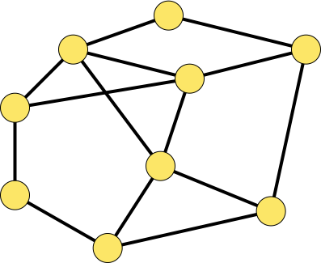

2

1

1

12

8

5

3

9

4

3

2

5

1

6

*1*

*2*

*3*

*4*

*5*

*6*

*7*

*9*

*8*

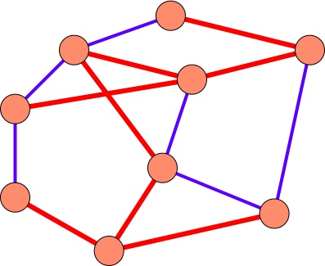

*1*

2

1

1

12

8

5

3

9

4

3

2

5

1

6

*2*

*3*

*5*

*6*

*7*

*9*

*8*

4

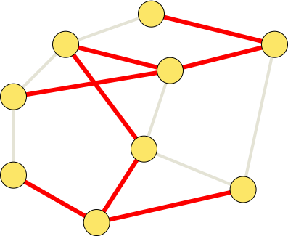

2

1

1

12

8

5

3

9

4

3

2

5

1

6

*1*

*2*

*3*

*4*

5

*6*

*7*

*9*

*8*

