Supplementary Material
  - LLM aesthetic assessment and reward model evaluation for bridge pylons

S1 Evaluation design
This material documents a supplementary comparison of five accessible multimodal LLM versions on 15 bridge pylon forms from Ref. [32]. Only pylon images were submitted as visual inputs, without human vote counts or quality-group labels. Images from the different quality groups were presented in a shuffled order. Human evaluations were retained separately as the reference for assessing agreement with model scores. The samples, scores, evaluation procedures, and reproducibility limitations are reported below. Section S5 additionally reports classification performance and probability calibration of the aesthetic reward model.
The original comparison was conducted through web interfaces in 2025 using two highly rated and two poorly rated samples. Qwen-VL-Max was adopted for subsequent labeling. During revision, the original versions were no longer accessible through those interfaces. The present comparison therefore uses accessible later versions from the corresponding model families wherever possible. These supplementary versions do not replace the original model used to generate the training labels.
Five samples were selected from each of the high-, intermediate-, and low-rated groups in Ref. [32]. For each sample, the human reference is the number of participants assigning a high-aesthetic-quality rating divided by 50. These are existing evaluations from Ref. [32], distinct from the supplementary survey of RL-refined designs reported in the main manuscript.
Table S1. Access platforms and model identifiers used in the supplementary comparison.
Code | Access platform | Model identifier
M1 | ERNIE Bot | DeepSeek-V4.1-Flash-1017
M2 | Kimi | K2.8
M3 | ChatGPT | GPT-4o
M4 | Qwen | Qwen3.6-Flash
M5 | Doubao | Doubao2.1 pro

Access platforms and model identifiers are listed separately. A platform name does not identify the developer of every model available through that platform.
All models used the aesthetic-assessment prompt specified in the main manuscript, requesting a 0–100 score based on the two-dimensional pylon silhouette. The statistical analysis below compares the recorded scores in Table S2 with the separately retained human evaluations.

S2 Pylon samples
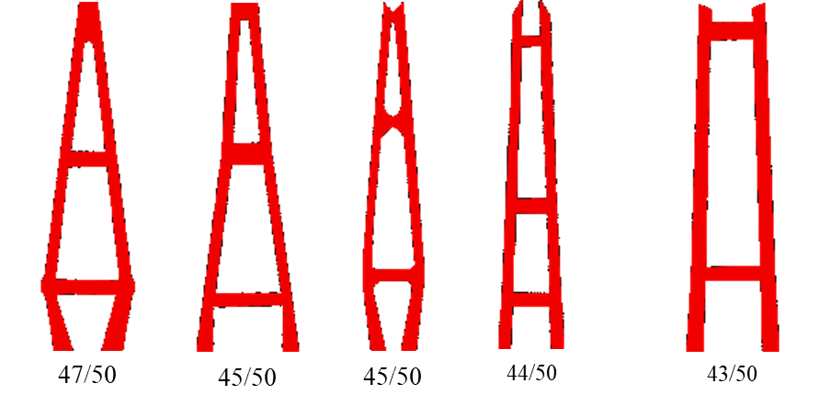
(a) High-rated group Samples 1–5
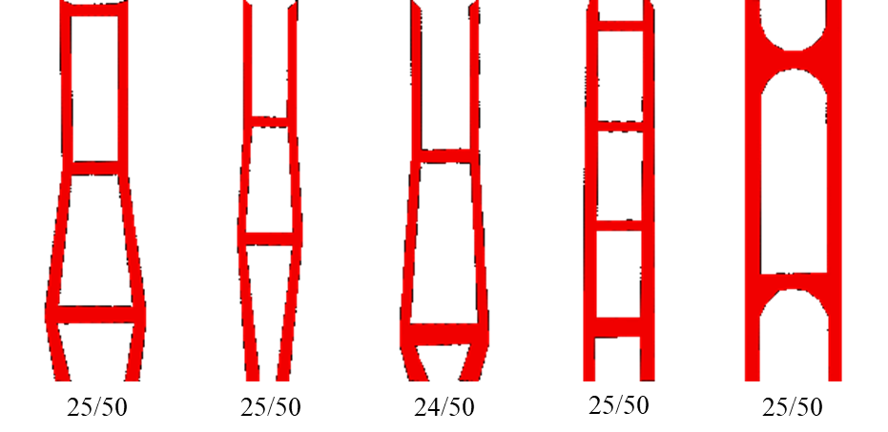
(b) Intermediate-rated group Samples 6–10
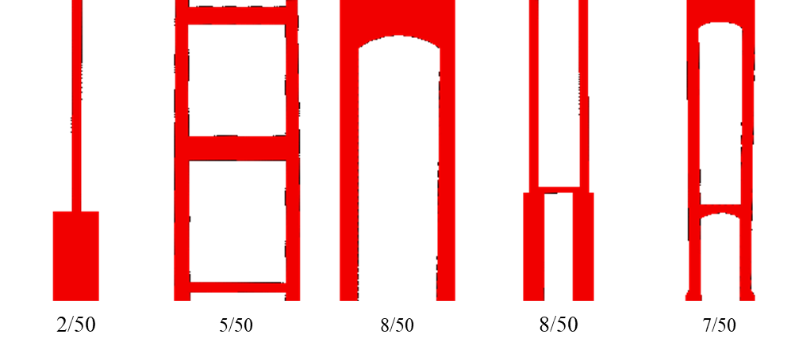
(c) Low-rated group Samples 11–15
Figure S1. Fifteen pylon samples from Ref. [32], ordered from left to right within each group to match Table S2. Vote counts and group labels are shown here for reference only. Neither was included in the model inputs; the images were presented in a shuffled order across quality groups.

S3 Recorded scores and agreement measures
Table S2. LLM aesthetic scores and human evaluations for the 15 pylon samples from Ref. [32].
ID | Group | M1 | M2 | M3 | M4 | M5 | Human  ratings
1 | High | 82 | 85 | 90 | 90 | 72 | 47/50
2 | High | 71 | 85 | 70 | 92 | 76 | 45/50
3 | High | 82 | 75 | 85 | 90 | 78 | 45/50
4 | High | 85 | 75 | 85 | 88 | 74 | 44/50
5 | High | 68 | 75 | 80 | 79 | 75 | 43/50
6 | Intermediate | 82 | 80 | 70 | 93 | 65 | 25/50
7 | Intermediate | 82 | 80 | 70 | 87 | 70 | 25/50
8 | Intermediate | 82 | 80 | 80 | 85 | 71 | 24/50
9 | Intermediate | 72 | 80 | 85 | 78 | 60 | 25/50
10 | Intermediate | 82 | 70 | 95 | 85 | 70 | 25/50
11 | Low | 55 | 65 | 70 | 60 | 48 | 2/50
12 | Low | 75 | 70 | 90 | 65 | 62 | 5/50
13 | Low | 75 | 65 | 80 | 80 | 66 | 8/50
14 | Low | 82 | 65 | 95 | 82 | 63 | 8/50
15 | Low | 82 | 75 | 85 | 76 | 72 | 7/50

M1–M5 are defined in Table S1. Human ratings are high-quality vote counts, not mean scores. Group labels describe the selected strata and do not imply that every participant assigned the same category.
Agreement between model scores and human evaluations is assessed using pairwise ranking consistency and Spearman’s rank correlation, following the use of preference consistency and rank-based metrics in LLM evaluation [S1]. Both measures compare ordering, avoiding direct comparison of numerical score ranges across models.
For pairwise agreement, every unordered pair of samples is considered once. The 15 samples yield 105 pairs. Eight pairs have equal human proportions and are excluded, leaving 97 comparable pairs. A pair is counted as concordant when the model score and human proportion have the same ordering. Opposite orderings are discordant; equal model scores on a human-nontied pair are counted as not correctly distinguishing the alternatives. Pairwise agreement is the concordant count divided by 97.
Spearman’s correlation is calculated across the 15 samples as the Pearson correlation between the ranks of the model scores and the ranks of the human proportions. Average ranks are assigned to tied values. The 97 sample pairs share the same 15 samples and are not treated as independent observations; the results are descriptive comparisons, without a claim of statistically significant superiority between models.

S4 Results and reproducibility
Table S3. Agreement between model scores and human evaluations across the 15 samples.
Model identifier | Concordant  pairs | Agreement  (%) | Spearman’s  ρ
DeepSeek-V4.1-Flash-1017 | 44/97 | 45.4 | 0.243
K2.8 | 66/97 | 68.0 | 0.662
GPT-4o | 41/97 | 42.3 | 0.001
Qwen3.6-Flash | 81/97 | 83.5 | 0.776
Doubao2.1 pro | 76/97 | 78.4 | 0.725

Agreement follows the tie rules in Section S3. Bold entries identify the highest observed pairwise agreement and Spearman correlation in this comparison.
Table S4. Mean model scores within the three human-rated groups.
Model identifier | High | Intermediate | Low
DeepSeek-V4.1-Flash-1017 | 77.6 | 80.0 | 73.8
K2.8 | 79.0 | 78.0 | 68.0
GPT-4o | 82.0 | 80.0 | 84.0
Qwen3.6-Flash | 87.8 | 85.6 | 72.6
Doubao2.1 pro | 75.0 | 67.2 | 62.2

Qwen3.6-Flash achieves the highest observed pairwise agreement (81/97, 83.5%) and Spearman correlation (ρ = 0.776), followed by Doubao2.1 pro (78.4%, ρ = 0.725). Kimi K2.8 also shows positive ranking agreement. GPT-4o has an approximately zero correlation (ρ = 0.001), with average scores of 82.0, 80.0, and 84.0 for the high-, intermediate-, and low-rated groups, respectively. DeepSeek-V4.1-Flash-1017 likewise assigns a higher mean score to the intermediate group than to the high group.
Qwen, Kimi, and Doubao reproduce the high-to-low ordering of the group means. Qwen’s high and intermediate means remain close, whereas Doubao separates those means more clearly. Thus, Qwen has the highest overall ranking agreement on these samples without being superior on every descriptive aspect. These findings provide task-specific support for a Qwen-based aesthetic-assessment approach.
The complete sample scores and both agreement measures are retained to make the comparison transparent and checkable. Group means in Table S4 provide descriptive summaries and are not used as the sole basis for assessing agreement with human evaluations.
The sample is limited to 15 selected pylons. Later model versions cannot be assumed equivalent to the unavailable original web versions. Future studies should archive model identifiers, access dates, prompts, inputs, and complete outputs. Fixed API snapshots or locally deployed checkpoints can improve version control and repeatability where available, although larger models may require substantial hardware resources.

S5 Reward model classification and probability calibration
The reward model was evaluated on an independent test set of 134 samples, comprising 78 high-quality and 56 low-quality samples. Classification performance was assessed using a confusion matrix, classwise precision, recall and F1 scores, together with overall accuracy and macro-averaged F1.
Table S5. Confusion matrix of the aesthetic reward model on the independent test set.
Reference / Predicted class | High quality | Low quality | Total
High quality | 71 | 7 | 78
Low quality | 16 | 40 | 56
Total | 87 | 47 | 134

Rows indicate reference labels, and columns indicate predicted classes.
Table S6. Classwise classification performance of the aesthetic reward model.
Class | Precision (%) | Recall (%) | F1 (%)
High quality | 81.61 | 91.03 | 86.06
Low quality | 85.11 | 71.43 | 77.67

Overall accuracy was 82.84% (111/134), and the macro-averaged F1 score was 81.87%.
Probability calibration was assessed using ten equal-width bins over [0,1]. The expected calibration error (ECE) was calculated as the sample-weighted average absolute difference between the mean predicted high-quality probability and the observed high-quality proportion within each bin.
The ECE for the high-quality probability was 0.0855, corresponding to a weighted average calibration discrepancy of approximately 8.55 percentage points under this binning scheme. This measures probability calibration and is not a classification error rate. These results quantify classification performance and the remaining probability-calibration error.

References
[S1] Chen J, Li H, Chu Z, Liu Y, Ai Q. Overview of the NTCIR-18 Automatic Evaluation of LLMs (AEOLLM) Task. Proceedings of the 18th NTCIR Conference on Evaluation of Information Access Technologies. 2025:12–15. doi:10.20736/0002002024.
[32] Xiang C, Chen A, Wang D, Ning Y. Deep-learning-based aesthetic evaluation network for bridge pylon and aesthetics-oriented bridge design. Structures. 2025;71:108167. Reference [32] follows the numbering in the main manuscript.

