**HIT Title:** Select the best out of two answers to a question.

**HIT Description:** In this HIT you will be shown a question and two alternative answers.

Your goal is to:

1. Click on the answer that answers the question better.
2. If both answers are similar, select the one with the least extraneous information.
3. If both answers are similar, select the one with the best formatting (typos, punctuation, etc.)

Here is an example of question and a pair of answers:

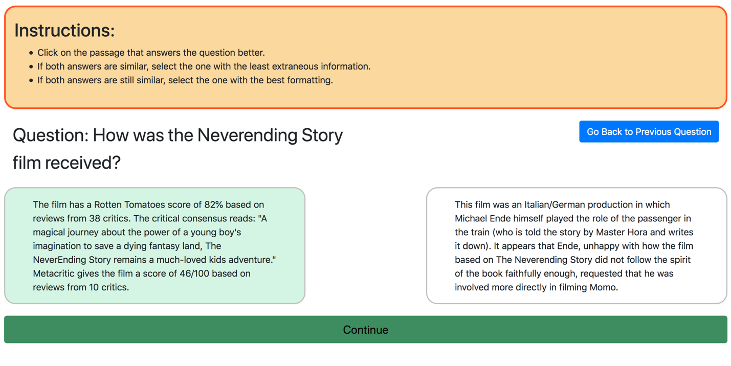

If you made a mistake and need to return to the previous question, click the blue “Go Back to Previous Question” button. Do not use the back button in your browser.

One HIT contains 13 questions.

Expected duration: **5 minutes.**

Payment: **$1.50**.

If you have any questions or concerns, contact Charles L.A. Clarke (claclark@gmail.com) or Sasha Vtyurina (sasha.vtyurina@uwaterloo.ca) from the University of Waterloo, Canada.

This study has been reviewed and received ethics clearance through a University of Waterloo Research Ethics Committee.