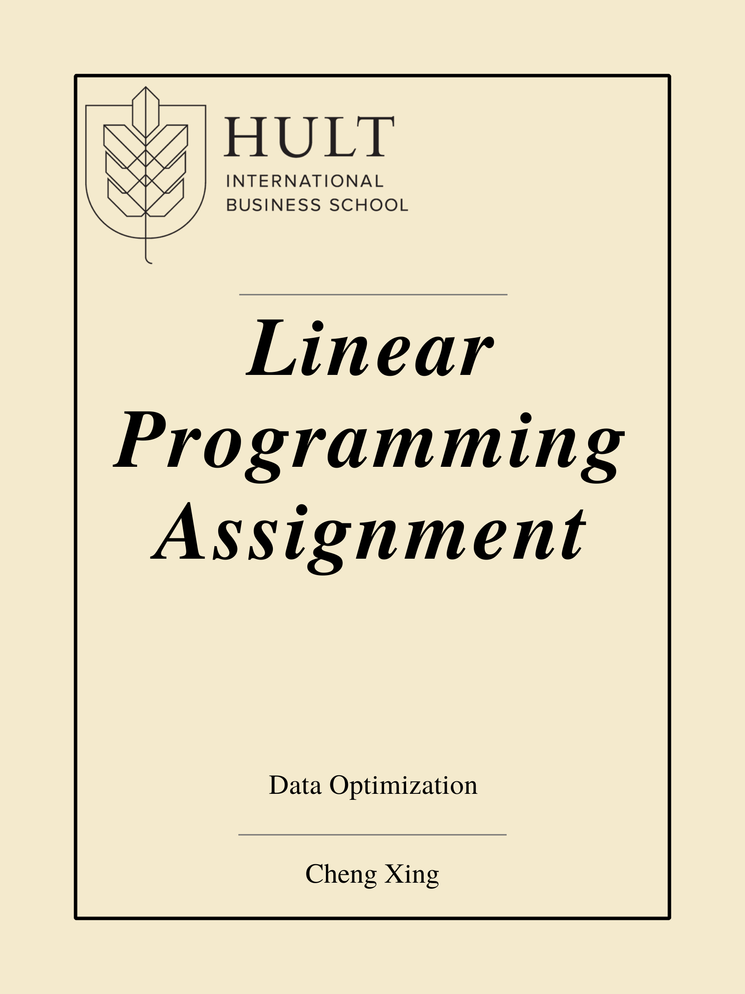

***Answer to the Questions:***

***1. What is the optimal production of bags and hours to transfer to new activities? Restrict bags produced to integer values but allow continuous shifting of labor. (15 numbers here; some will be 0). Answer with a table rather than 15 sentences.***

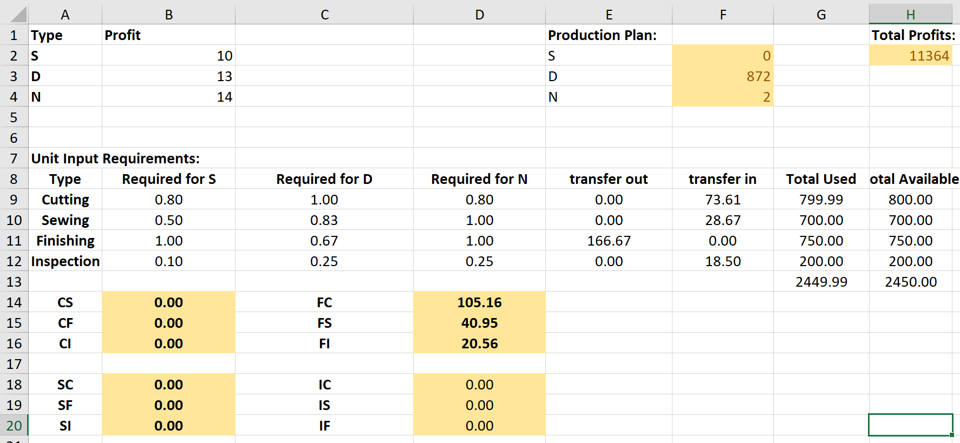

First, I loaded an excel mode to solve this question.

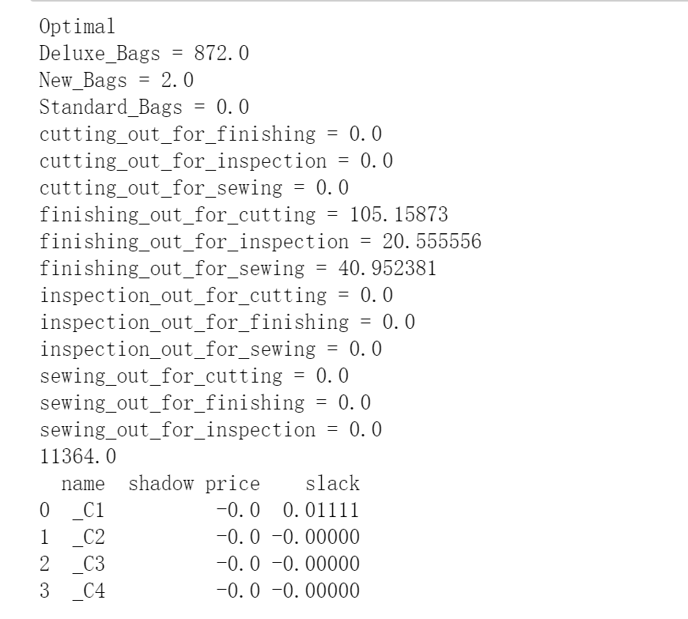

Then I also tried the Python.

They provided same answer.

***2. Are you fully utilizing all resources?***

From the excel table, you can see the Total used time is nearly equal to the total available time.

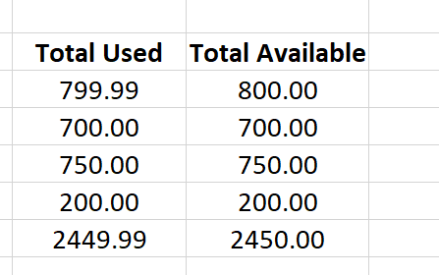

***3. Assuming all workers are equally expensive, which kind of worker should we hire more of? Explain in a sentence.***

From the result, we can find that only Finishing labor are transfer to all the other part, which means Cutting, Sewing and Inspection should hire more.

***4. How many more hours should we hire of the type answered in (3) before we re-evaluate?***

Cutting: 73.61

Sewing: 28.67

Inspection:18.50

***5. What happens if the labor transfer variables are not constrained to be non-negative? Explain in a sentence or two.***

This is a remarkably interesting question.

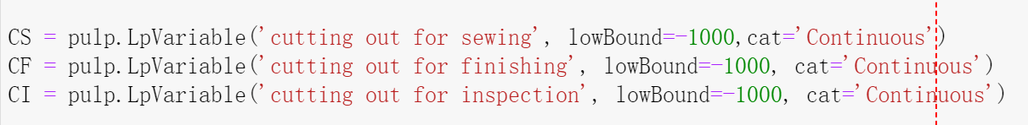

If I change the lowBound of cutting this here.

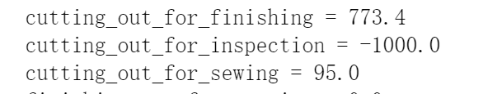

The answer will always provide an lowest number which is equal to my lowBound.

Let us review the whole system, every 1h CS (cutting to sewing) will provide 0.8h sewing time. This every 1h total cutting time decrease can increase 0.8h in total sewing time. Now if CS is negative, which means sewing time is transfer to the cutting, which is conflict to the system setting.

Why the number is equal to -1000 is because this function will always produce extra time for the whole system, which means 800h for sewing can transfer 1000h for cutting.