**Executive overview of the system**

We are a US based children's clothing company with our main operations in California and stores in San Francisco, Los Angeles, San Diego, Boston, New York, Chicago, and Seattle. We mainly sell children's tops, dresses and pants for ages 5-14. As a member of the retail industry, we need to face some pain points in inventory management, logistics information, order information management, employee performance records, store sales records, and we also have a store membership point system, and it is a major pain point to manage these member customers and update their point status in time.

**Actionable insights**

1. We assign individual numbers to each piece of children's clothing and record their style, size, color and other information, but it is difficult to count the total number and quickly find their transaction time and other dynamic information. Therefore, we need to create an order tracking form to count these clothing orders, to determine the company's monthly sales through these sales data, and to facilitate the inventory count afterwards.

2.Since an order number will often contain multiple pieces of clothing, sometimes it is necessary to track specific information about the clothing contained in each order, such as clothing style. So, we also need the detailed number of the clothes to assist us to complete this step of the statistics.

3. We have different stores in different cities, so we need to ship from our warehouse to those stores, and we also need to go through the information of which stores were assigned what clothes, what time they came out of the warehouse, and when they arrived at the stores. To better monitor this data and information, we integrate store information, as well as warehouse information, and we can also count the inventory status of the stores based on the logistics information from the warehouse.

4. For some customers who need to provide products by mail, we need to count the details of these logistics orders to ensure that our customers receive the products on time, and we also want each customer to have a salesperson who is responsible for their case. We created a special module to count this logistics information, including shipping and delivery times, as well as the number of the employee responsible.

5. The company's main business is retail, so we focus on staffing our sales staff. This is because different stores need to keep track of specific staffing situations, as well as information about positions.

6.The number of orders in each store is related to the performance of the sales staff, so we need to record the number of these employees, and personal information to correlate their closed orders, so that we can clearly reflect their performance status.

7. We will have some VIP customers, we will leave their information, including some basic personal information and their spending history in the store, and we will accumulate points for them for the amount they spend, with a mechanism of $1 worth equal to 1 point. So that staff and customers want to check their points status.

8. With a membership point system, counting points, and providing some membership discount system, it is an important strategy for the company to cultivate loyal customers. The membership point system allows some of the customers who trust the company to enjoy better services, such as each customer has a corresponding responsible sales ambassador who can ask for the logistics information and order details of the products they ordered at any time. Further, we will also set some preferential discounts, gifts, etc. according to the accumulated points of our customers.

**Flowchart**

**Key Entities in the System**

**Tables：**

1.Clothes: In this form, the "Clothes ID (INT)" helps companies to record items and track their status, such as whether they have been dispatched from the warehouse, whether they have been sold, and whether they are still in stock.

2.Warehouse: In this form, the "Warehouse ID(INT)" helps the company to record the status of goods in the warehouse, update the inventory situation, and the contact information of the warehouse.

3.Store: In this table, "Store ID (INT)" can help monitor the information of stores in different areas, "Phone, Address (VARCHAR), etc.” can provide the company with the contact information of these stores.

4.Clothestransfer: In this table, "Leave Date (DATE)" and "Arrive Date (DATE)" can show the time when the goods are sent from the warehouse to the stores in each region; "Clothes/Warehouse/Store ID" can record detailed information about the goods, warehouse information and the stores to which the goods are sent.

5.Order: In this table, "Order/Clothes ID (INT)", can show the order and goods information, "Price (VARCHAR)", you can record the price of goods sold, to facilitate the statistics "Trade Date (DATE)" can show the time the goods were traded.

6.Ordershipment: In this table, "Shipment ID (INT)" allows you to see the order that the item was sent out, and "Send/Arrived Date (DATE)" allows you to track the time the item was sent out and the time it reached the customer.

7.Employees: In this table, "Employee ID (INT)" can record employee information, and "Job Title (TEXT)" can show the employee's position.

8.Members: In this table, "Member ID (INT)" can keep the information of member customers and even add their personal information to provide better service to these customers, and "SalesRep number (INT)" can show which salesperson is responsible for this customer, so as to track the work performance of employees.

9.Membersorder: In this table, both "Add point (VARCHAR)" and "Total point (VARCHAR)" are used to add points to member customers in a timely manner, as well as to display the total number of points they have available.

**Entity- Relation（ER）Model**

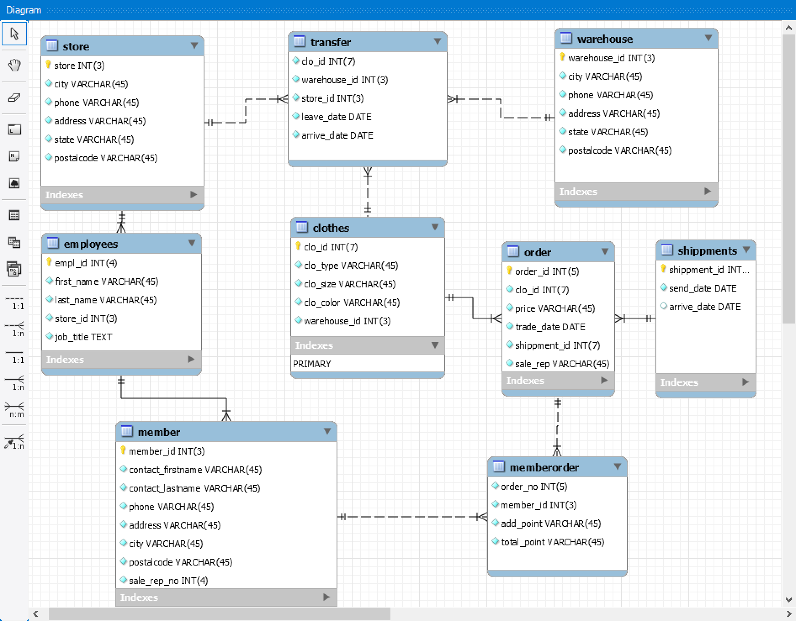

**SQL Queries**

**(1).We can calculate the amounts of each type of cloths, such as I want to find the total amount of XL black coats.**

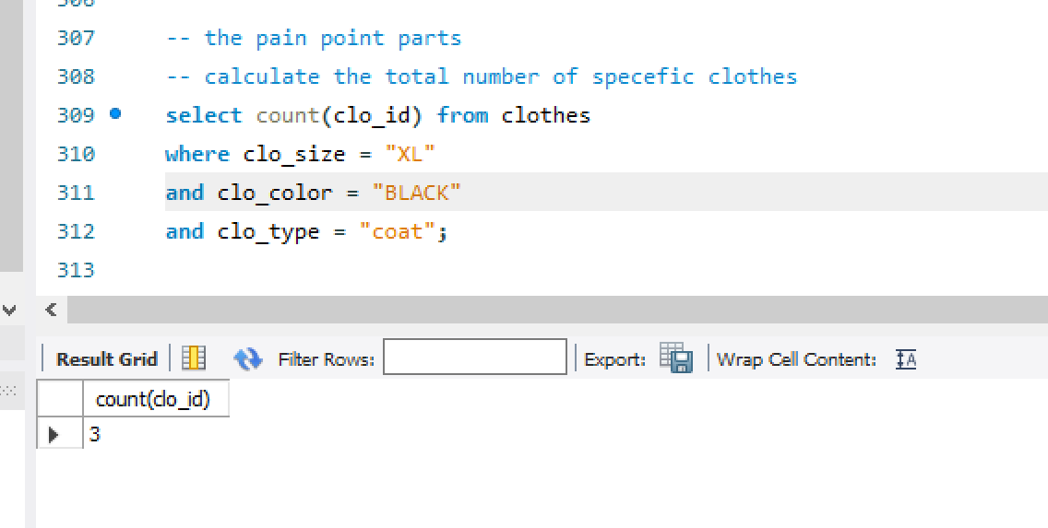

**(2)the employees want to make sure the product have left the warehouse in every warehouse, so they need to check the transfer date of the product.**

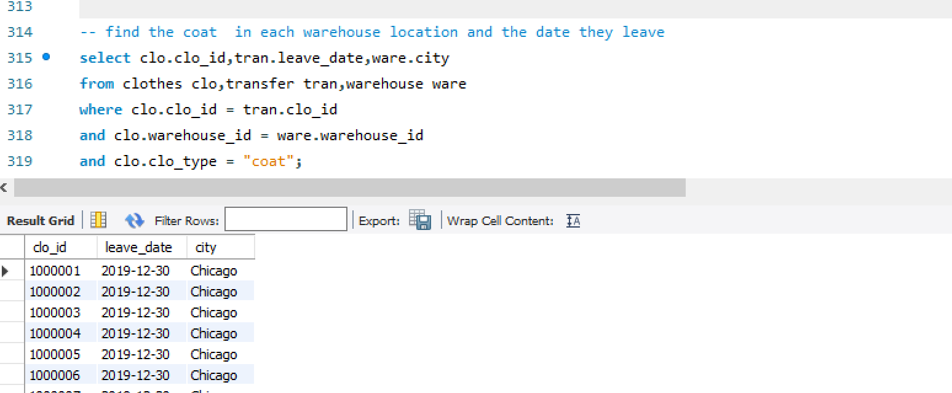

**(3).After transferring the clothes, employees want to calculate the current product amount in each store.**

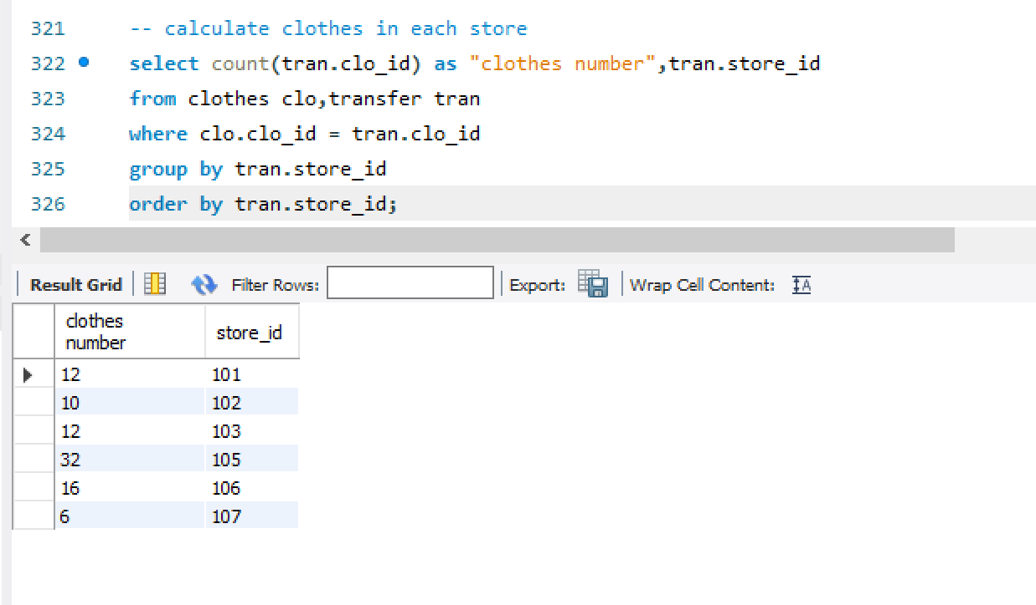

**(4).** **In order to evaluate the performance of each employee, we need to calculate the total number of transactions for each employee.**

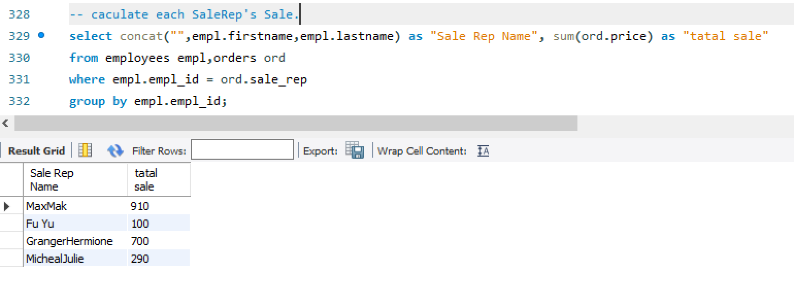

**(5).** **Managers need to see the details of each employee's transactions in the store**

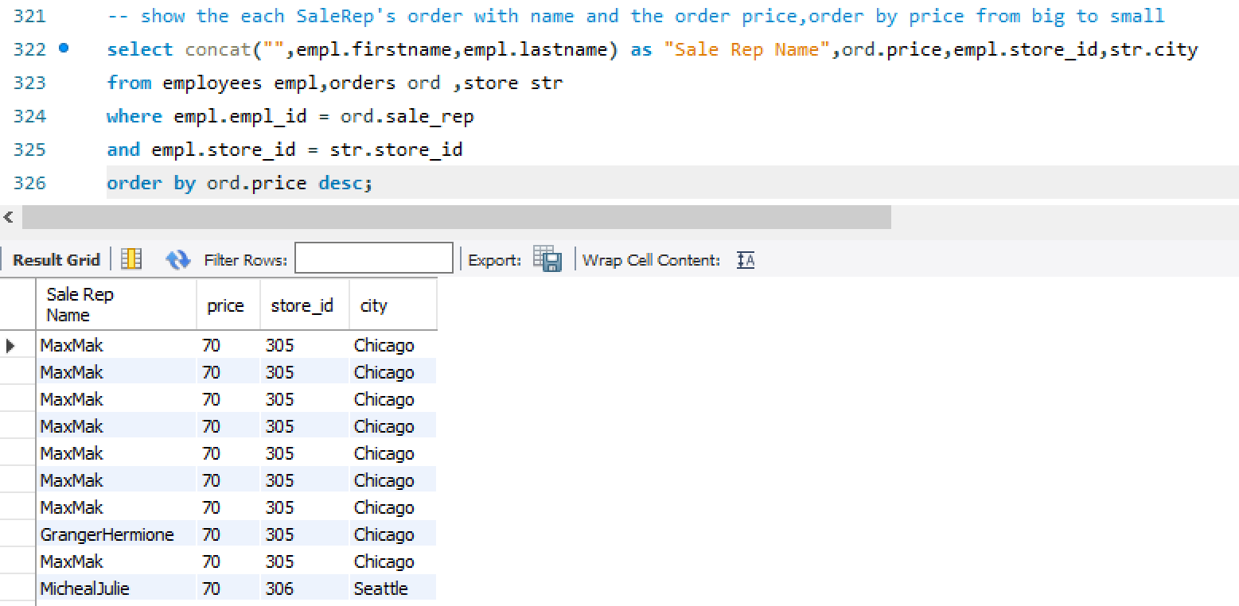

**(6).** **After completing a transaction, employees need to check that the goods have arrived and check that orders are shipped before a specific transaction time point**

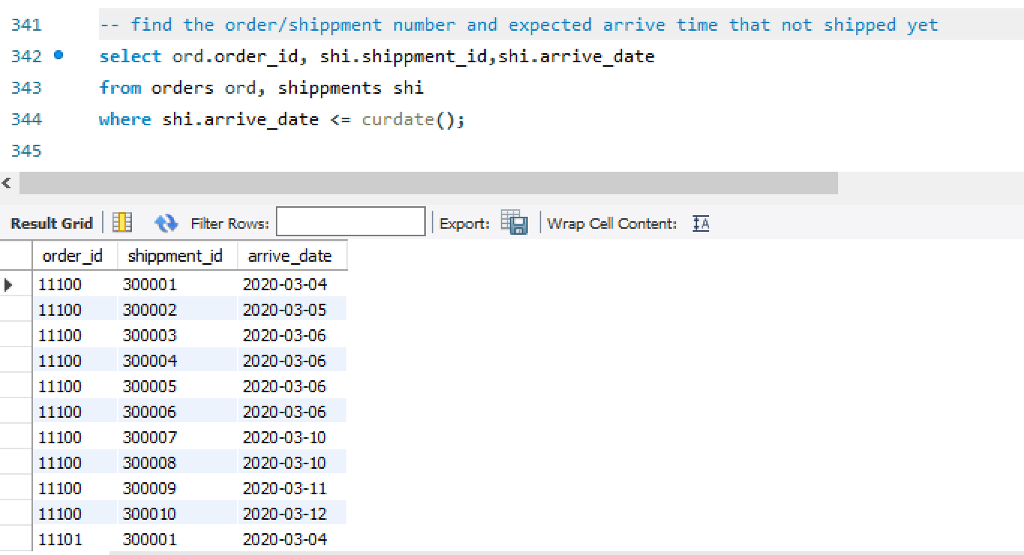

**(7).** **Sometimes our customers ask to see the status of their points and want to know the details of the points they have earned in recent transactions**

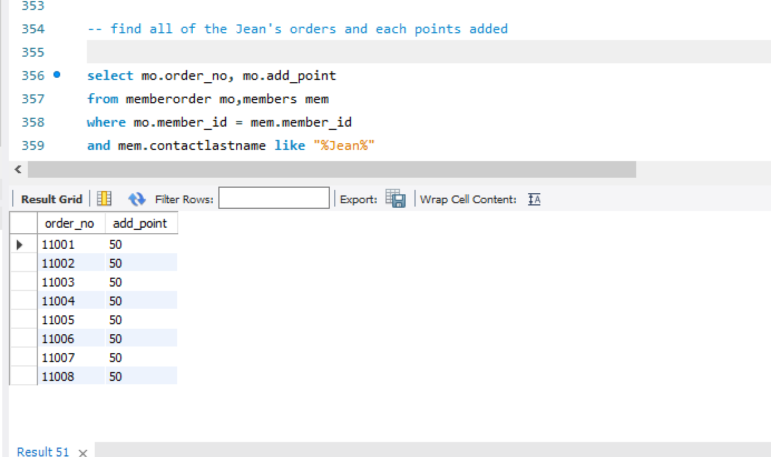

**(8).** **We need sales professionals to interface with potential customers, and we need to know which sales people are responsible for which customers.**

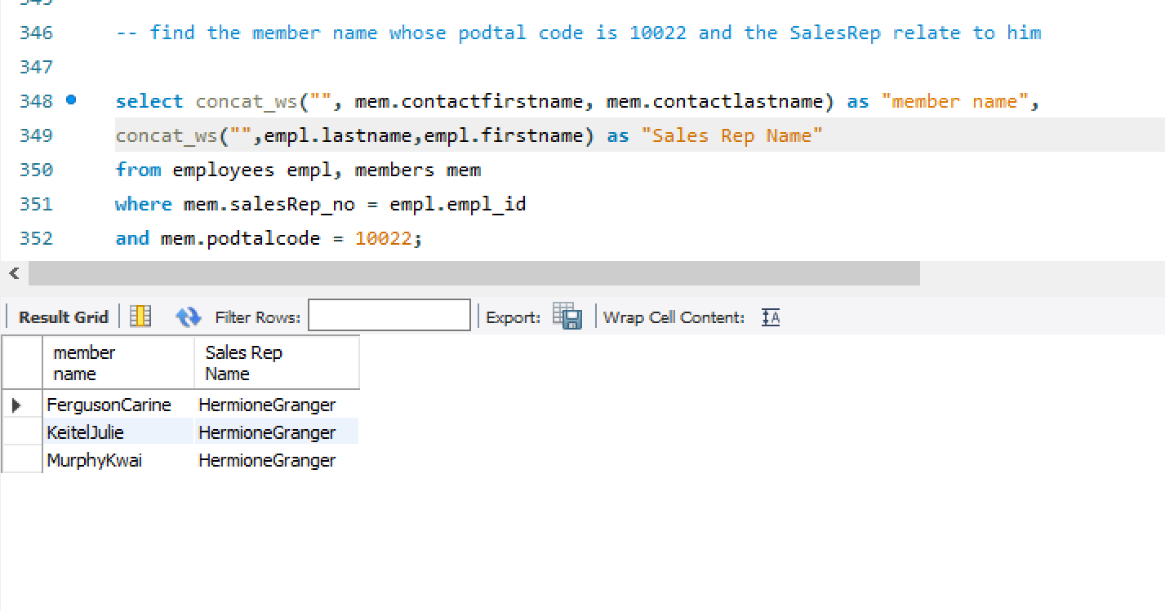

**Detailed SQL Procedures**

**(1).Make a procedure to give additional point(50%) in a order to a mumber.**

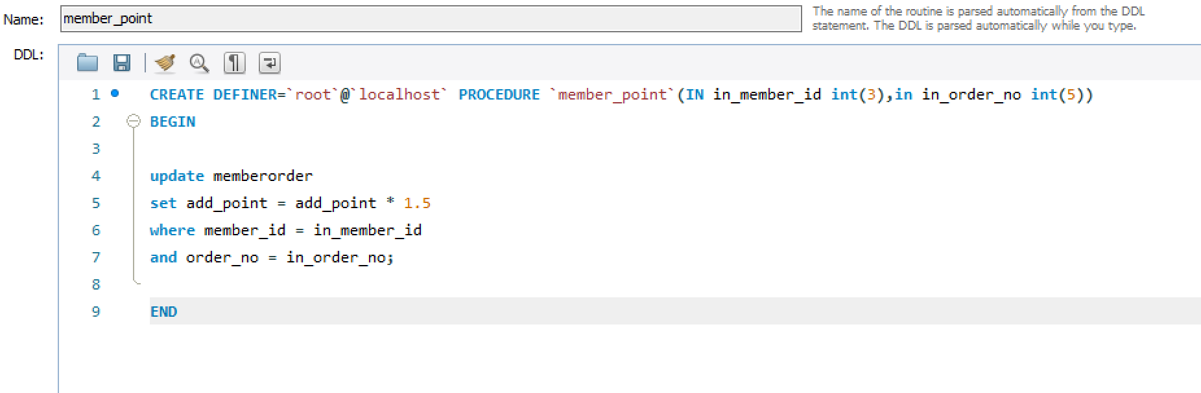

**Call the function**

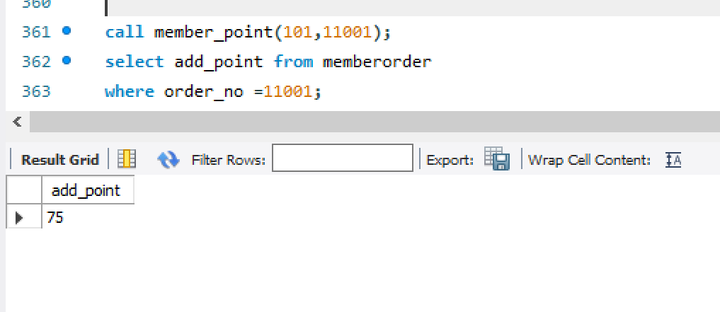

**(2). Make a procedure to calculate the total point of member and ranking them. If the ranking point larger than 400, give him the gold VIP rank, else give the silver vip rank.**

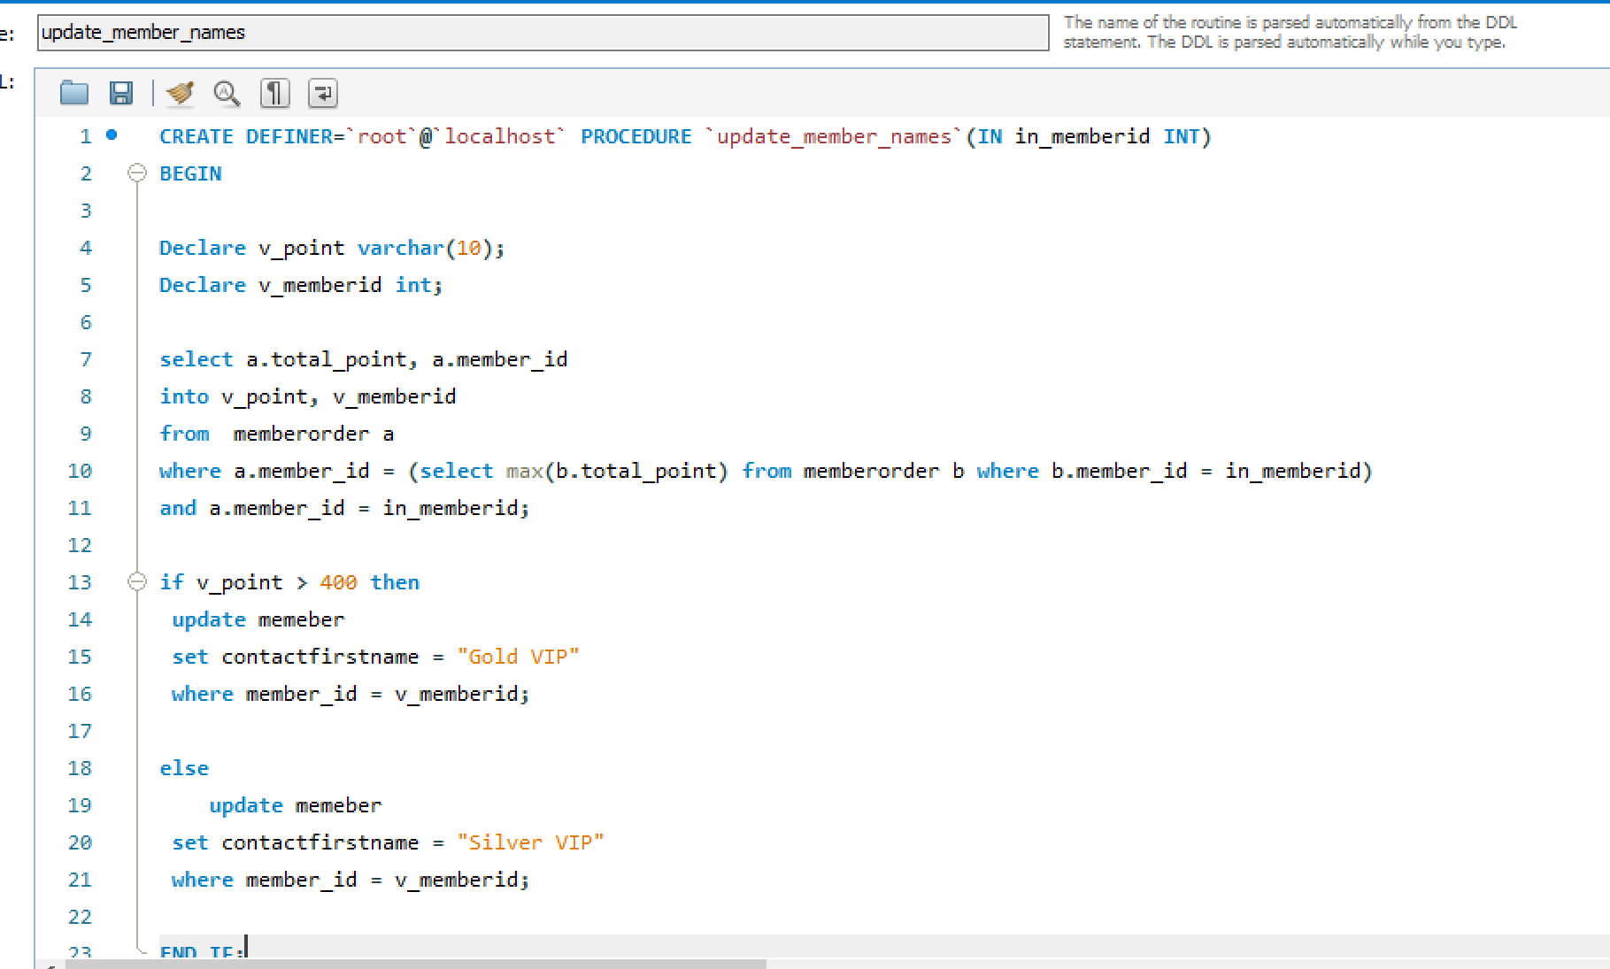

**Call the fuction to examine the update detail.**

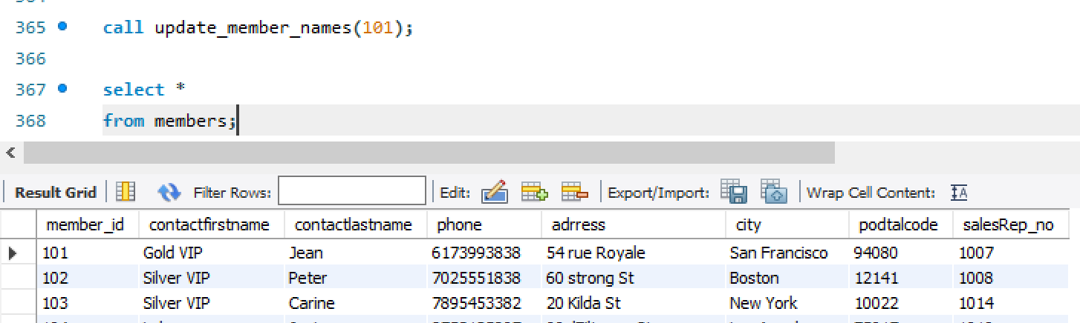

**Appendix**

select * from clothes;

CREATE TABLE clothes (

clo_id INT(7) NOT NULL AUTO_INCREMENT,

clo_type varchar(45) NOT NULL,

clo_size varchar(45) NOT NULL,

clo_color varchar(45) NOT NULL,

warehouse_id varchar(3) not null,

PRIMARY KEY (clo_id)

);

INSERT INTO clothes

VALUES

(1000001 ,"coat" ,"XL" ,"BLACK", 105 ),

(1000002 ,"coat" ,"XL" ,"BLACK", 105 ),

(1000003 ,"coat" ,"L" ,"WHITE", 105 ),

(1000004 ,"coat" ,"L" ,"BLUE", 105 ),

(1000005 ,"coat" ,"XL" ,"BLACK", 105 ),

(1000006 ,"coat" ,"L" ,"BLACK", 105 ),

(1000007 ,"coat" ,"M" ,"BLACK", 105 ),

(1000008 ,"coat" ,"M" ,"BLUE", 105 ),

(1000009 ,"coat" ,"L" ,"WHITE", 105 ),

(1000010 ,"coat" ,"XL" ,"WHITE", 105 ),

(1000011 ,"coat" ,"S" ,"BLUE", 105 ),

(1000012 ,"paints" ,"S" ,"WHITE", 105 ),

(1000013 ,"paints" ,"M" ,"WHITE", 106 ),

(1000014 ,"paints" ,"L" ,"BLUE", 106 ),

(1000015 ,"paints" ,"XL" ,"WHITE", 106 ),

(1000016 ,"paints" ,"L" ,"WHITE", 106 ),

(1000017 ,"paints" ,"L" ,"WHITE", 106 ),

(1000018 ,"paints" ,"XL" ,"WHITE", 107 ),

(1000019 ,"paints" ,"L" ,"BLACK", 107 ),

(1000020 ,"paints" ,"M" ,"BLACK", 107 ),

(1000021 ,"T-shirt" ,"M" ,"WHITE", 105 ),

(1000022 ,"T-shirt" ,"L" ,"BLUE", 105 ),

(1000023 ,"T-shirt" ,"XL" ,"BLACK", 105 ),

(1000024 ,"T-shirt" ,"S" ,"BLACK", 105 ),

(1000025 ,"dress" ,"S" ,"BLACK", 101 ),

(1000026 ,"dress" ,"M" ,"BLUE", 101 ),

(1000027 ,"dress" ,"L" ,"WHITE", 101 ),

(1000028 ,"dress" ,"XL" ,"BLUE", 102 ),

(1000029 ,"dress" ,"L" ,"BLACK", 102 ),

(1000030 ,"dress" ,"L" ,"BLACK", 102 ),

(1000031 ,"dress" ,"XL" ,"BLACK", 106 ),

(1000032 ,"dress" ,"L" ,"BLUE", 106 ),

(1000033 ,"sweater" ,"M" ,"WHITE", 106 ),

(1000034 ,"sweater" ,"M" ,"WHITE", 101 ),

(1000035 ,"sweater" ,"L" ,"BLUE", 101 ),

(1000036 ,"sweater" ,"XL" ,"WHITE", 101 ),

(1000037 ,"sweater" ,"S" ,"WHITE", 102 ),

(1000038 ,"sweater" ,"S" ,"BLUE", 102 ),

(1000039 ,"sweater" ,"M" ,"WHITE", 103 ),

(1000040 ,"sweater" ,"M" ,"WHITE", 103 ),

(1000041 ,"sweater" ,"M" ,"WHITE", 103 ),

(1000042 ,"sweater" ,"M" ,"BLACK", 103 ),

(1000043 ,"sweater" ,"M" ,"BLACK", 103 ),

(1000044 ,"sweater" ,"M" ,"BLACK", 103 );

select * from warehouse;

CREATE TABLE warehouse (

warehouse_id INT(3) NOT NULL AUTO_INCREMENT,

city varchar(45) NOT NULL,

phone varchar(45) NOT NULL,

address TEXT NOT NULL,

state varchar(8) not null,

podtalcode varchar(8) not null,

primary key(warehouse_id));

INSERT INTO warehouse

VALUES

(101,"San Francisco",16502194782 ,"100 Market St.","CA", 94080),

(102,"Boston",12158370825,"1550 Court Place","MA",12141),

(103,"New York", 12125554000 ,"523 East St.","NY",10022),

(108,"New York", 12125554001 ,"725 West St.","NY",10022),

(104,"Los Angeles",33147239999,"30 RueJouffroyDabbans","CA",75017),

(109,"Los Angeles",33147234404,"43 RueJouffroyDabbans","CA",75017),

(105,"Chicago",81332245000,"4-1 Kioicho ","IL", 102-8578),

(106,"Seattle",61292642451,"5-11 Wentworth Avenue","WA",32555),

(107,"San Diego",18051221926 ,"25 Old Handured St.","CA",25121);

select * from store;

CREATE TABLE store (

store_id INT(3) NOT NULL AUTO_INCREMENT,

city varchar(45) NOT NULL,

phone varchar(45) NOT NULL,

address TEXT NOT NULL,

state varchar(8) not null,

podtalcode varchar(8) not null,

primary key(store_id));

INSERT INTO store

VALUES

(301,"San Francisco",16512194782 ,"123 Market St.","CA", 94080),

(302,"Boston",12158332825,"144 Court Place","MA",12141),

(303,"New York", 12435554000 ,"233 East St.","NY",10022),

(304,"Los Angeles",33142239999,"355 RueJouffroyDabbans","CA",75017),

(305,"Chicago",81332333000,"3 Kioicho ","IL", 102-8578),

(306,"Seattle",61333642451,"56 Wentworth Avenue","WA",32555),

(307,"San Diego",18066621926 ,"233 Old Handured St.","CA",25121);

select * from transfer;

CREATE TABLE transfer (

clo_id INT(7) NOT NULL NOT NULL,

store_id INT(3) NOT NULL,

warehouse_id INT(3) NOT NULL,

leave_date date null,

arrive_date date null

);

INSERT INTO transfer

VALUES

(1000001 , 105 , 305 ," 2019-12-30 "," 2020-01-02 "),

(1000002 , 105 , 305 ," 2019-12-30 "," 2020-01-02 "),

(1000003 , 105 , 305 ," 2019-12-30 "," 2020-01-02 "),

(1000004 , 105 , 305 ," 2019-12-30 "," 2020-01-02 "),

(1000005 , 105 , 305 ," 2019-12-30 "," 2020-01-02 "),

(1000006 , 105 , 305 ," 2019-12-30 "," 2020-01-02 "),

(1000007 , 105 , 305 ," 2019-12-30 "," 2020-01-02 "),

(1000008 , 105 , 306 ," 2019-12-30 "," 2020-01-02 "),

(1000009 , 105 , 306 ," 2019-12-30 "," 2020-01-02 "),

(1000010 , 105 , 306 ," 2019-12-30 "," 2020-01-02 "),

(1000011 , 105 , 306 ," 2019-12-30 "," 2020-01-02 "),

(1000012 , 105 , 306 ," 2019-12-30 "," 2020-01-02 "),

(1000013 , 106 , 303 ," 2020-01-10 "," 2020-01-13 "),

(1000014 , 106 , 303 ," 2020-01-10 "," 2020-01-13 "),

(1000015 , 106 , 303 ," 2020-01-10 "," 2020-01-13 "),

(1000016 , 106 , 303 ," 2020-01-10 "," 2020-01-13 "),

(1000017 , 106 , 301 ," 2020-01-10 "," 2020-01-13 "),

(1000018 , 107 , 302 ," 2020-01-15 "," 2020-01-18 "),

(1000019 , 107 , 302 ," 2020-01-15 "," 2020-01-18 "),

(1000020 , 107 , 302 ," 2020-01-15 "," 2020-01-18 "),

(1000021 , 105 , 305 ," 2019-12-30 "," 2020-01-02 "),

(1000022 , 105 , 305 ," 2019-12-30 "," 2020-01-02 "),

(1000023 , 105 , 306 ," 2019-12-30 "," 2020-01-02 "),

(1000024 , 105 , 306 ," 2019-12-30 "," 2020-01-02 "),

(1000025 , 101 , 300 ," 2020-01-10 "," 2020-01-13 "),

(1000026 , 101 , 300 ," 2020-01-10 "," 2020-01-13 "),

(1000027 , 101 , 300 ," 2020-01-10 "," 2020-01-13 "),

(1000028 , 102 , 301 ," 2020-01-10 "," 2020-01-13 "),

(1000029 , 102 , 302 ," 2020-01-10 "," 2020-01-13 "),

(1000030 , 102 , 301 ," 2020-01-10 "," 2020-01-13 "),

(1000031 , 106 , 301 ," 2020-01-10 "," 2020-01-13 "),

(1000032 , 106 , 302 ," 2020-01-10 "," 2020-01-13 "),

(1000033 , 106 , 302 ," 2020-01-10 "," 2020-01-13 "),

(1000034 , 101 , 305 ," 2020-01-10 "," 2020-01-13 "),

(1000035 , 101 , 305 ," 2020-01-10 "," 2020-01-13 "),

(1000036 , 101 , 306 ," 2020-01-10 "," 2020-01-13 "),

(1000037 , 102 , 306 ," 2020-01-10 "," 2020-01-13 "),

(1000038 , 102 , 300 ," 2020-01-10 "," 2020-01-13 "),

(1000039 , 103 , 300 ," 2020-01-10 "," 2020-01-13 "),

(1000040 , 103 , 300 ," 2020-01-10 "," 2020-01-13 "),

(1000041 , 103 , 301 ," 2020-01-15 "," 2020-01-18 "),

(1000042 , 103 , 303 ," 2020-01-15 "," 2020-01-18 "),

(1000043 , 103 , 303 ," 2020-01-15 "," 2020-01-18 "),

(1000044 , 103 , 301 ," 2020-01-16 "," 2020-01-19 ");

select * from orders;

CREATE TABLE orders (

order_id int(5) NOT NULL auto_increment,

clo_id int(7) NOT NULL,

price varchar(10) NOT NULL,

trade_date date not null,

shippemnt_id int(7) not null,

sale_rep int(4) not null,

primary key (order_id)

);

INSERT INTO orders

VALUES

( 11100 , 1000001 , 50 ," 2020/1/1 ", 300001 , 1007 ),

( 11101 , 1000002 , 50 ," 2020/1/1 ", 300002 , 1007 ),

( 11102 , 1000003 , 50 ," 2020/1/1 ", 300003 , 1007 ),

( 11103 , 1000004 , 50 ," 2020/1/1 ", 300004 , 1007 ),

( 11104 , 1000005 , 50 ," 2020/1/1 ", 300005 , 1007 ),

( 11105 , 1000006 , 50 ," 2020/1/1 ", 300006 , 1007 ),

( 11106 , 1000007 , 50 ," 2020/1/7 ", 300007 , 1013 ),

( 11107 , 1000008 , 50 ," 2020/1/7 ", 300008 , 1013 ),

( 11108 , 1000009 , 50 ," 2020/1/9 ", 300009 , 1014 ),

( 11109 , 1000010 , 40 ," 2020/1/9 ", 300010 , 1014 ),

( 11110 , 1000011 , 40 ," 2020/1/9 ", 300009 , 1014 ),

( 11111 , 1000012 , 40 ," 2020/1/9 ", 300010 , 1014 ),

( 11112 , 1000013 , 40 ," 2020/1/9 ", 300004 , 1014 ),

( 11113 , 1000014 , 40 ," 2020/1/9 ", 300009 , 1014 ),

( 11114 , 1000015 , 40 ," 2020/1/9 ", 300010 , 1014 ),

( 11115 , 1000016 , 40 ," 2020/1/9 ", 300001 , 1014 ),

( 11116 , 1000017 , 40 ," 2020/1/9 ", 300002 , 1014 ),

( 11117 , 1000018 , 70 ," 2020/1/9 ", 300003 , 1014 ),

( 11118 , 1000019 , 70 ," 2020/1/19 ", 300004 , 1007 ),

( 11119 , 1000020 , 70 ," 2020/1/19 ", 300005 , 1007 ),

( 11120 , 1000021 , 70 ," 2020/1/19 ", 300008 , 1007 ),

( 11121 , 1000022 , 70 ," 2020/1/19 ", 300001 , 1007 ),

( 11122 , 1000023 , 70 ," 2020/1/19 ", 300002 , 1007 ),

( 11123 , 1000024 , 70 ," 2020/1/19 ", 300003 , 1007 ),

( 11124 , 1000025 , 70 ," 2020/1/19 ", 300004 , 1007 ),

( 11125 , 1000026 , 70 ," 2020/1/19 ", 300005 , 1007 ),

( 11126 , 1000027 , 50 ," 2020/2/1 ", 300010 , 1007 ),

( 11127 , 1000028 , 50 ," 2020/2/1 ", 300010 , 1008 ),

( 11128 , 1000029 , 40 ," 2020/2/1 ", 300010 , 1008 ),

( 11129 , 1000030 , 40 ," 2020/2/1 ", 300010 , 1008 ),

( 11130 , 1000031 , 70 ," 2020/2/1 ", 300010 , 1008 ),

( 11131 , 1000032 , 40 ," 2020/2/1 ", 300010 , 1008 ),

( 11132 , 1000033 , 50 ," 2020/2/1 ", 300010 , 1008 ),

( 11133 , 1000034 , 60 ," 2020/2/7 ", 300010 , 1014 ),

( 11134 , 1000035 , 50 ," 2020/2/7 ", 300010 , 1014 ),

( 11135 , 1000036 , 40 ," 2020/2/7 ", 300010 , 1014 ),

( 11136 , 1000037 , 60 ," 2020/2/7 ", 300010 , 1014 ),

( 11137 , 1000038 , 50 ," 2020/2/7 ", 300010 , 1014 );

select * from shippments;

CREATE TABLE shippments (

shippment_id int(7) NOT NULL auto_increment,

send_date date not null,

arrive_date date not null,

primary key (shippment_id)

);

INSERT INTO shippments

VALUES

( 300001 ," 2020-03-01 "," 2020-03-04 "),

( 300002 ," 2020-03-02 "," 2020-03-05 "),

( 300003 ," 2020-03-03 "," 2020-03-06 "),

( 300004 ," 2020-03-03 "," 2020-03-06 "),

( 300005 ," 2020-03-03 "," 2020-03-06 "),

( 300006 ," 2020-03-03 "," 2020-03-06 "),

( 300007 ," 2020-03-07 "," 2020-03-10 "),

( 300008 ," 2020-03-07 "," 2020-03-10 "),

( 300009 ," 2020-03-08 "," 2020-03-11 "),

( 300010 ," 2020-03-09 "," 2020-03-12 ");

select * from employees;

CREATE TABLE employees (

empl_id int(4) NOT NULL auto_increment,

firstname varchar(45) NOT NULL,

lastname varchar(45) NOT NULL,

store_id int(3) not null,

job_title varchar(45),

primary key (empl_id)

);

INSERT INTO employees

VALUES

( 1000 ," Murphy "," Diane ", 301 ," VP Sales "),

( 1001 ," Patterson "," Mary ", 301 ," VP Marketing "),

( 1002 ," Firrelli "," Jeff ", 300 ," Sales Manager "),

( 1003 ," Bondur "," William ", 301 ," Sales Manager "),

( 1004 ," Bow "," Gerard ", 302 ," Sales Manager "),

( 1005 ," Jennings "," Anthony ", 303 ," Sales Rep "),

( 1006 ," Thompson "," Leslie ", 304 ," Sales Rep "),

( 1007 ," Max "," Mak ", 305 ," Sales Rep "),

( 1008 ," Micheal "," Julie ", 306 ," Sales Rep "),

( 1009 ," Tseng "," Steve ", 300 ," Sales Rep "),

( 1010 ," Vanauf "," Micky ", 301 ," Sales Rep "),

( 1011 ," Herry "," Potter ", 302 ," Sales Rep "),

( 1012 ," Ron "," Ron ", 303 ," Sales Rep "),

( 1013 ," Fu "," Yu ", 304 ," Sales Rep "),

( 1014 ," Granger "," Hermione ", 305 ," Sales Rep "),

( 1015 ," Petty "," John ", 306 ," Sales Rep "),

( 1016 ," Brunce "," Ben ", 300 ," Sales Rep "),

( 1017 ," King "," George ", 301 ," Sales Rep "),

( 1018 ," Joe "," Loui ", 302 ," Sales Rep "),

( 1019 ," Ginny "," Larry ", 303 ," Sales Rep "),

( 1020 ," Marsh "," Barry ", 304 ," Sales Rep ");

select * from members;

CREATE TABLE members (

member_id int(3) NOT NULL auto_increment,

contactfirstname varchar(45) NOT NULL,

contactlastname varchar(45) NOT NULL,

phone varchar(45) not null,

adrress varchar(45)not null,

city varchar(45) NOT NULL,

podtalcode varchar(8) not null,

salesRep_no int(4) not null,

primary key (member_id)

);

INSERT INTO members

VALUES

( 101 ," Schmitt "," Jean ", 6173993838 ," 54 rue Royale "," San Francisco ", 94080 , 1007 ),

( 102 ," King "," Peter ", 7025551838 ," 60 strong St "," Boston ", 12141 , 1008 ),

( 103," Ferguson "," Carine ", 7895453382 ," 20 Kilda St "," New York ", 10022 , 1014 ),

( 104 ," Labrue "," Janine ", 8753125897 ," 99ulFiltrowa St "," Los Angeles ", 75017 , 1010 ),

( 105 ," Bergulfsen "," Jonas ", 9613855669 ," 4 rue des Cinquante "," Chicago ", 102-8578 , 1011 ),

( 106 ," Nelson "," Susan ", 1047458544 ," 16 Erling Skakkes gate "," Seattle ", 32555 , 1012 ),

( 107 ," Niki "," Roland ", 1133531521 ," 50 Skakkes st "," San Diego ", 25121 , 1013 ),

( 108 ," Keitel "," Julie ", 1219604498 ," 11 Moralzarzal "," New York ", 10022 , 1014 ),

( 109 ," Murphy "," Kwai ", 1305677475 ," 86Erling rue "," New York ", 10022 , 1014 );

select * from memberorder;

CREATE TABLE memberorder (

order_no int(5) NOT NULL auto_increment,

member_id int(3) NOT NULL,

add_point varchar(10) NOT NULL,

total_point varchar(10) not null,

primary key (order_no)

);

INSERT INTO memberorder

VALUES

( 11001 , 101 , 50 , 50 ),

( 11002 , 101 , 50 , 100 ),

( 11003 , 101 , 50 , 150 ),

( 11004 , 101 , 50 , 200 ),

( 11005 , 101 , 50 , 250 ),

( 11006 , 101 , 50 , 300 ),

( 11007 , 101 , 50 , 350 ),

( 11008 , 101 , 50 , 400 ),

( 11009 , 102 , 50 , 50 ),

( 11010 , 102 , 40 , 90 ),

( 11011 , 102 , 40 , 130 ),

( 11012 , 102 , 40 , 170 ),

( 11013 , 103 , 60 , 60 ),

( 11014 , 103 , 50 , 110 ),

( 11015 , 103 , 40 , 150 ),

( 11016 , 103 , 60 , 210 ),

( 11017 , 103 , 50 , 260 );

-- the pain point parts

-- calculate the total number of specefic clothes

select count(clo_id) from clothes

where clo_size = "XL"

and clo_color = "BLACK"

and clo_type = "coat";

-- find the coat in each warehouse location and the date they leave

select clo.clo_id,tran.leave_date,ware.city

from clothes clo,transfer tran,warehouse ware

where clo.clo_id = tran.clo_id

and clo.warehouse_id = ware.warehouse_id

and clo.clo_type = "coat";

-- calculate clothes in each store

select count(tran.clo_id) as "clothes number",tran.store_id

from clothes clo,transfer tran

where clo.clo_id = tran.clo_id

group by tran.store_id

order by tran.store_id;

-- show the each SaleRep's order with name and the order price,order by price from big to small

select concat("",empl.firstname,empl.lastname) as "Sale Rep Name",ord.price,empl.store_id,str.city

from employees empl,orders ord ,store str

where empl.empl_id = ord.sale_rep

and empl.store_id = str.store_id

order by ord.price desc;

-- caculate each SaleRep's Sale.

select concat("",empl.firstname,empl.lastname) as "Sale Rep Name", sum(ord.price) as "tatal sale"

from employees empl,orders ord

where empl.empl_id = ord.sale_rep

group by empl.empl_id;

-- find the order/shippment number and expected arrive time that not shipped yet

select ord.order_id, shi.shippment_id,shi.arrive_date

from orders ord, shippments shi

where shi.arrive_date <= curdate();

-- find the member name whose podtal code is 10022 and the SalesRep relate to him

select concat_ws("", mem.contactfirstname, mem.contactlastname) as "member name",

concat_ws("",empl.lastname,empl.firstname) as "Sales Rep Name"

from employees empl, members mem

where mem.salesRep_no = empl.empl_id

and mem.podtalcode = 10022;

-- find all of the Jean's orders and each points added

select mo.order_no, mo.add_point

from memberorder mo,members mem

where mo.member_id = mem.member_id

and mem.contactlastname like "%Jean%";

call member_point(101,11001);

select add_point from memberorder

where order_no =11001;

call update_member_names(101);

select *

from members;