Chengxu Zhuang Andrea Shulman

**Bayesian models for scene-level Adelson illusion**

Background:

           The visual system is one of the most astonishing systems in human bodies with its power to process and interpret the information from physical light to a contextual representation of the surrounding world. However, it can sometimes be too elaborate and leave room for confusion from carefully designed illusions. The checker shadow illusion, discovered by Edward H. Adelson of MIT, is famous for using a shadow to trick the brain into thinking two of the same shaded squares are very differently colored. Often, we would utilize the information from shadows to make inferences of related properties automatically. This illusion provides insight into how the brain fills in missing or ambiguous information by shadows or information from neighbors, where both of them perform as a form of context. The Simultaneous Contrast Illusion also uses context to trick our minds. The varying background luminescence makes the inscribed shapes appear darker or lighter than the identical other. Adelson also determined that we cannot explain brightness with low level mechanisms because geometrical changes result in drastic changes in brightness reports. A possible way of solving this is taking images one step at a time and assessing reflectance, illumination, and transparency. We will start with grayscale illusions and eventually investigate other illusions by using grayscale as a model that can be built on in a future study. Vision research shows that perception is relative to every individual. Illusions like Adelson and Simultaneous Contrast are useful for testing how the brain perceives illumination and shading and uses them to build models to understand the environment. We think by using Bayesian modeling of grayscale illusions, we could not only shed light on the underlying mechanism of brain integrating related information, but also provide an effective and generative model for making better and more illusions and to possibly explain related neural dynamics.

Question and methods:

The most important and interesting question for the checkerboard illusion is what hypothesis can we have that is simple but strong enough to explain the observed phenomenon. When we find a relevant hypothesis, we could test it systematically to try to describe what is happening across the whole checkerboard at the time we see it. The result could then lead the way to new illusions based on the same mechanism. In order to simplify the problem, we would start by evaluating a less complicated, more controlled illusion while keeping the same underlying mechanism, the Simultaneous Contrast Illusion. The Adelson illusion is generalized version of this toy illusion with the differences of backgrounds indicated by the existence of 3D objects and the shadow cast on it. There are several hypotheses trying to explain this. The general idea would be that the backgrounds are acting like the prior showing some information to influence the posterior distribution of the observed regions. We would examine possible information and related models to construe an effective hypothesis. The possible implementation of this hypothesis could be transfer functions from neighbors to center squares. Then, we would apply it on the Adelson illusion. We also need to investigate how the existence of 3D objects and the fuzzy border of cast shadows influence the posterior distribution. This could happen by changing the backgrounds or other possible rules, after which we would be able to calculate the perceptual luminance of the whole checkerboard. The new illusions could be generated if we start from the perceptual luminance map and then search for the parameters that could produce it.

Appendix

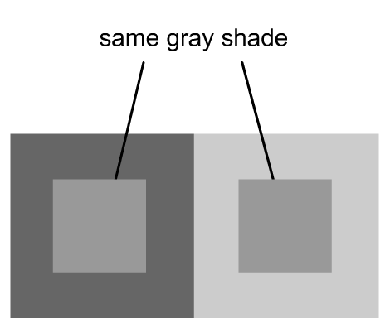

**Simultaneous Contrast Illusion**

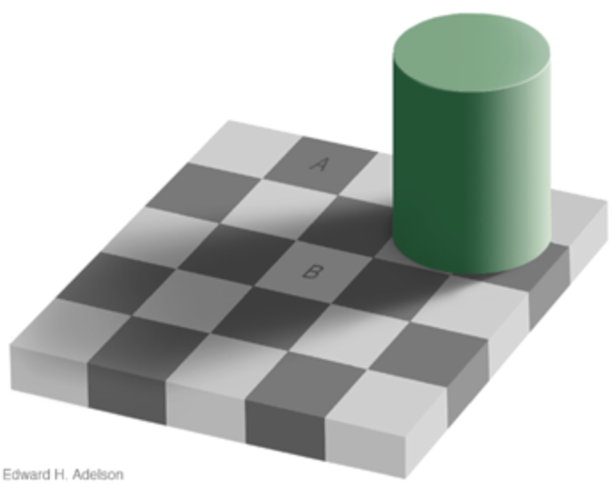

**Adelson Illusion**

