**Bayesian models for scene-level Adelson illusion**

Chengxu Zhuang (chengxuz@stanford.edu)

Department of Psychology, Stanford

Andrea Shulman (ashulman@stanford.edu)

Department of Psychology, Stanford

# Introduction

Visual system is one of the most astonishing systems in human bodies with its great ability to process and interpret the information from input as physical light to a contextual representation of the surrounding world. However, it can sometimes be too elaborate and leave room for confusion by carefully designed illusions. The checker shadow illusion, designed by Edward H. Adelson of MIT [1], is famous for using a shadow on a checkerboard to trick the brain into thinking two of the same shaded squares are very differently colored. This illusion provides insight into how our brains would utilize the information from pixel values and the existence of 3D object both as context to make inferences of related properties automatically.

The underlying neural mechanism for those illusions is still poorly understood [2]. One possible way of solving this is to model the human observers inferring the perceived colors using Bayesian models [2]. Bayesian models have been successfully used in modelling both many higher-order cognitive functions [3] or lower-order sensory systems [4]. Illusions like Adelson illusions (A-illusion) are useful for testing how the brain perceives illumination and shading and uses them to build models to understand the environment. We think by using Bayesian modeling of those illusions, we could not only shed light on the underlying mechanism of brain integrating related information, but also provide an effective and generative model for making better and more illusions and to possibly explain related neural dynamics.

As indicated by Adelson [5], A-illusion (see Fig A1 and A2) is actually a result of at least two different levels of inference by human observers. The first level is through the existence of the 3D object and darker surface near it, human observers would actively interpolate those darker surface as shadows and other areas as brighter areas without shadows. And after that, we assume that human observers would combine the local pixel value information and the judgement whether this area is under a shadow or not to infer both the local illuminance (how much light is cast on the surface) and reflectance (how much light would be reflected).

To solve this illusion step by step, we would consider a simpler illusion, Simultaneous Contrast Illusion (SC-illusion) first. The Simultaneous Contrast Illusion (see Fig 1) also uses context to trick our minds [1], where the varying background luminescence makes the inscribed shapes appear darker or lighter than the identical other. Because of the absence of 3D object, we would expect that human observers would simply use the local information for inference in the way similar to the second level of A-illusion.

After showing the modelling and results for SC-illusion, we would then come back to A-illusion, by modelling the strategies used by human observers as a hierarchical Bayesian model, where the higher level would be inferencing the shadow map for the whole picture and the lower level would be a modified version of Bayesian models for SC-illusion with shadow information better utilized.

# Background

In this section, we would briefly introduce the necessary background knowledge for this paper.

## Bayesian inference

Bayesian inference is one of statistical inference methods where Bayesian theorem is utilized to gradually update the hypothesis with incoming observations. For example, we use to represent the hypothesis we have. Then represents the *prior probability* for all the hypothesis. And given observation , we would have the probability of observing under some hypothese: , which is called *likelihood*. Bayesian theorem gives us the probability of hypothesis after observation :

As is constant for different , we usually have:

## Human observer model outline

We would briefly describe the Bayesian inference models we think human observers are using. In our hypothesis, they are actively updating two variables for an area-of-interest: illumination () and reflectance (), where denotes an area.

Both and should be a spectrum across different wavelength of light. But in our models, we only consider grayscale illusions. Therefore, we just consider those two variables as scalars where represents how much light is cast on area and represents how much of the light is reflected by area . Higher is saying that more light is reflected and therefore area is lighter, when lower means that area is darker.

For human observers, they would have some prior for both and . In our models, those prior distributions would usually be Gaussian distributions. Then they would also have a formula for luminance () (by physical rules) and likelihood function for actually observed pixel values (). And using those observations, they could infer the posterior distributions of (). And in this paper, we are especially interested in for special areas.

# Related work

There have been many works explaining the illusions in different levels using different methods.

Brainard et al. [4] has tried to use Bayesian inference models to explain those similar illusions. They proposed the illumination, reflectance, and luminance models where they used local pixel values to infer illumination. Our model for SC-illusion is similar to theirs. But they did not have a hierarchical Bayesian models for A-illusion.

It is mostly believed that the underlying neural mechanism might be related to the properties of ON-and OFF-center ganglion cells [7]. But it’s still not well understood and many details need to be filled [4].

After proposed by Adelson [1], those illusions are hot topics for vision research for many years [2,3,4]. People also proposed similar illusions under the name of color constancy [8]. There are also many other illusions such as Kanizsa's Triangle and Rabbit–duck illusion, which are possibly related to other properties of vision.

# Results

Before explaining our results, we would first introduce the basic models we currently have for human observers viewing SC-illusion and A-illusion. See Fig. 1 below for an example of SC-illusion.



Fig 1. SC-illusion

SC-illusion is comparatively easier, as there is no 3D object presenting and human observer do not need to inference anything about whether there are shadows in this area. For simplification, we would refer the two center squares as L-AOI and R-AOI (L/R for left/right, and AOI for area of interest). SC-illusion shows that human observers would perceive the color (reflectance in our model) for L/R-AOI being different, while they actually have the same pixel value (luminance in our model). Our hypothesis is that this is due to the different backgrounds of those two AOIs with the assumption that human observers are actively inferring both the illumination and reflectance based on the local luminance observed.

But for A-illusion, the existence of the 3D object is indicating that some of the surface is under shadows and should have lower illumination. Thus, we need to explicitly model the different mechanism of inferring the illumination with or without shadows, as well as the influence of different backgrounds. We would need two more steps from SC-illusion. The first step is to tell which areas are under shadows by giving the existence of 3D object. After that, we would have two different models of inferring illumination from luminance observed (for shadow areas and areas without shadows). Therefore, we are effectively modelling A-illusion using a hierarchical Bayesian model.

In the next few sections, we would first introduce the theoretic models for SC-illusion, then some experiment results supporting that, the theoretic models for A-illusion (to be finished), and the related experiment results (to be finished).

## Theoretic models for SC-illusion

The picture in Fig 1 has the size of (with the AOI in the size of ), but for theoretically simplification and as we human observers tend to give inference to a large continuous regions of the same color rather than pixel by pixel, we group the pixels into “superpixels” with each superpixel having size of and indexing them using , where ranges from 0 to 5 and ranges from 0 to 2. So the L-AOI is in the position of and R-AOI is at . As indicated above, each superpixel has its own reflectance (), illumination () and luminance (). And the pixel value observed is . If we assume that each superpixel is independent from each other, we could have a model as below ( means has a prior of a Gaussian distribution centered at with standard deviation of and is the collection of all parameters):

To introduce the influence of backgrounds, we make several assumptions. The first assumption is the existence of spatial continuity for the inference of illumination:

Here, is the set of indexes for nearby superpixels of :

We also hypothesis that human observers are inferring the illumination by the observed luminance, which could be possibly modelled as that the local illumination should be proportional to locally averaged luminance ():

Where:

Noting that the only difference between and is that includes and is a global parameter which could be used to model whether this region is in shadows or not later in A-illusion modelling. The interpolation of could be human observers’ implicit flag for whether in shadows or not.

Combining those priors and observations, we could then compute the posterior distribution of and .

## Experiment results for SC-illusion

We implement the models using webppl, with , , , and . And see Fig. 2 for the computed distribution of .



Fig 2. Distribution of , with a mean of -0.52

The result shown has already explained the illusion observed by human observers. But for further explorations of the model, we use the same mechanism to build a reverse SC-illusion (rSC-illusion) which now have different pixel values for L/R-AOIs but by utilizing the influence of backgrounds, make the human observers believe that they see the same colors.

The implementation to build this rSC-illusion is rather straight-forward. Instead of providing the observations for L/R-AOIs, we add an observation that their reflectance is the same:

And then we infer the posterior distribution for the luminance and use the inferred value to draw a new picture, see Fig 3 below:



Fig 3. rSC-illusion, with pixel value of 159 (L-AOI) and 127 (R-AOI), other pixel values are the same



Fig 4. rSC-illusion with exchanged AOI, the pixel value of R-AOI is 159 and L-AOI is 127, other pixel values are the same

To give a further illustration about this illusion and whether our rSC-illusion works, we provide another image in Fig 4, which is rSC-illusion with exchanged AOI pixel value. We could see that the differences of perceived colors for AOIs in Fig 4 is significantly different from that in Fig 3 where the pixel values of those two regions are actually the same.

## Theoretic models for A-illusion

As described above, the theoretic models for human observers viewing A-illusion should be a hierarchical Bayesian model.

In higher level of inference, they would infer a categorical variable for each location representing whether this location is under shadow or not and another global categorical variable for the direction of light. And there should also be smoothness constraint for acting like a transition function from neighbors to the concerned squares.

For examples, there could be 8 possible light directions for :

Let’s assume means the light is from to , then the transition function for would have a peak value to make .

We could also possibly do the same thing on the 3D object, with the assumption that the object should be originally the same color across the whole body. Then the difference of the colors shown would be cues for .

And in lower level of inference, they would use similar models used in SC-illusion with the modification that under shadow area, they would also have an observation saying that illumination would be lower.

# Acknowledgments

We would like to express our gratitude to Michael Henry Tessler for his patient guidance and Professor Noah Goodman for his wonderful lessons.

# References

[1] Adelson, E. H. (1993). Perceptual organization and the judgment of brightness. *Science, 262*(5142), 2042-2044.

[2] Allred, S. R., & Brainard, D. H. (2013). A Bayesian model of lightness perception that incorporates spatial variation in the illumination. *Journal of vision, 13*(7), 18-18.

[3] Chater, N., Tenenbaum, J. B., & Yuille, A. (2006). Probabilistic models of cognition: Conceptual foundations. *Trends in cognitive sciences, 10*(7), 287-291.

[4] Brainard, D., & Gazzaniga, M. S. (2009). Bayesian approaches to color vision. *The visual neurosciences, 4*.

[5] Adelson, E. H. (1995). *Checkershadow Illusion.* Retrived from <http://web.mit.edu/persci/people/adelson/checkershadow_illusion.html>.

[6] *Bayesian inference*. (2016, November 18). In Wikipedia, The Free Encyclopedia. Retrieved 18:42, November 18, 2016, from <https://en.wikipedia.org/w/index.php?title=Bayesian_inference&oldid=750266512>

[7] Famiglietti, E. V., & Kolb, H. (1976). Structural basis for ON-and OFF-center responses in retinal ganglion cells. *Science, 194*(4261), 193-195.

[8] Maloney, L. T., & Wandell, B. A. (1986). Color constancy: a method for recovering surface spectral reflectance. *JOSA A*, *3*(1), 29-33.

# Appendix

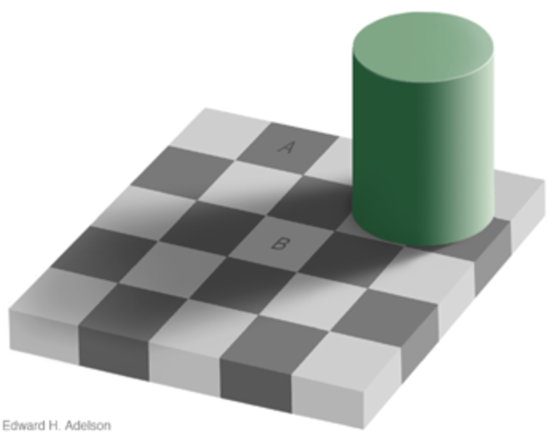

Fig A1. Adelson illusion [5]

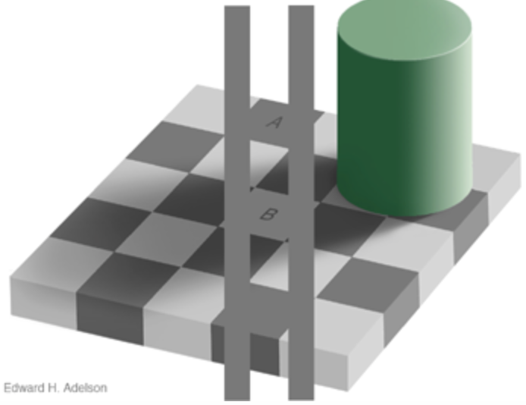

Fig A2. Explanation to Adelson illusion [5]